I have completed all the criteria mentioned by you in our previous conversations. I can assure you that you will like what I did and hopefully you will find it above your expectation. I have already given u the deployment procedure in the txt file. Here I will talk to you about setting the experiment environment.
Once u have created the website. U can directly put the URL in and will be able to visit the site for example what I have created here:
https://otree-render-project.onrender.com/
I have set admin control and converted the demo to study mode; u can change it if u want to for debugging the code in future (options are present in settings.py).
Once you get to your website page u will be redirected to the login page. As the admin with the password, you can enter it to gain admin access.
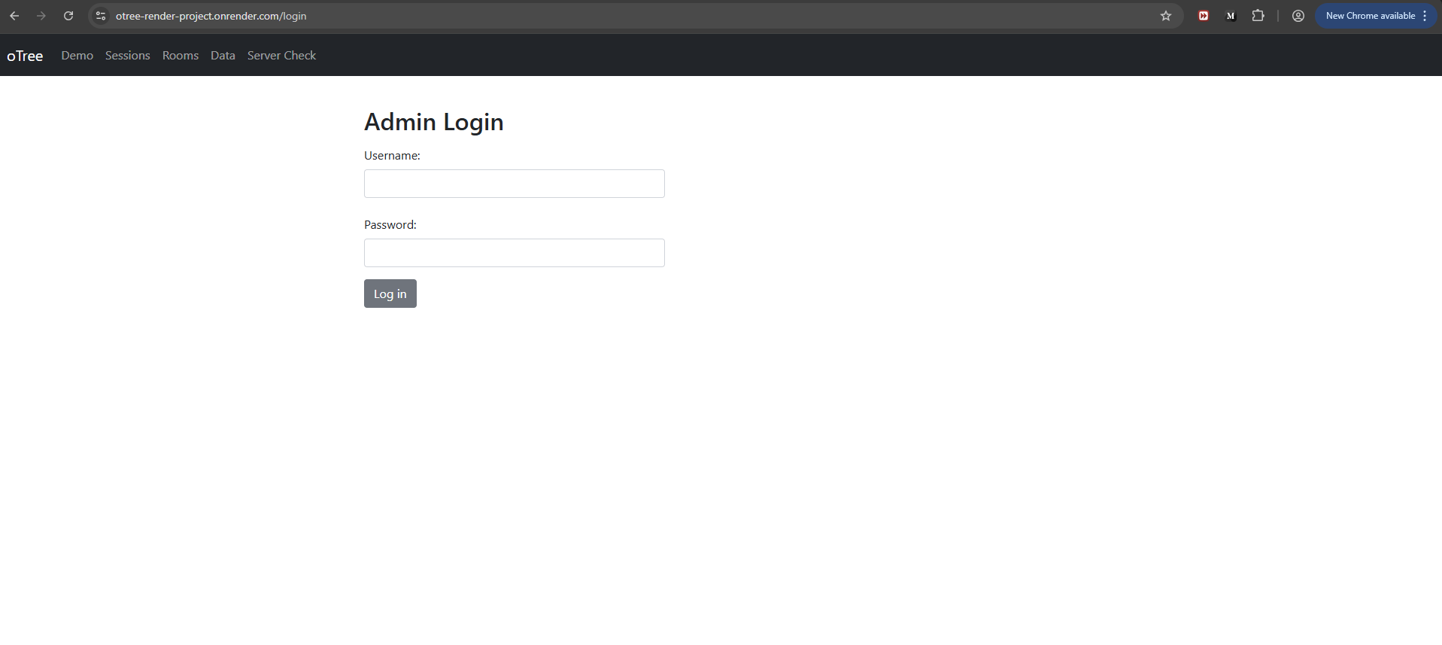
I have set username as “admin” and password is “Admin”. This can be changed.
Next once u logged in, u will get to this page:
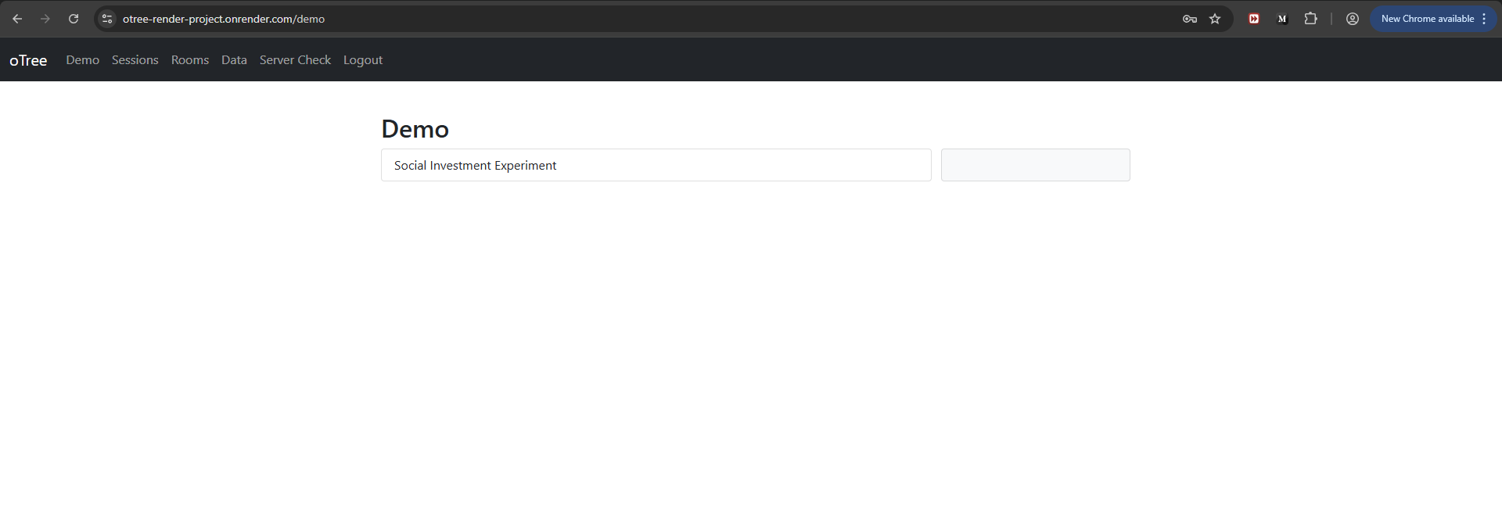
This is just the demo version (for checking program). Don’t click this since u want an actual experiment study, instead go to either rooms or sessions. I prefer u select room it is much better since u can provide room specific URL and this link will not work with multiple tabs on the same browser, because all tabs will be assigned to the same participant, using a cookie. This doesn’t happen in session, where participants can fake it by playing 2 participants. Don’t worry I will show this later. I have created a room as shown in the following image:
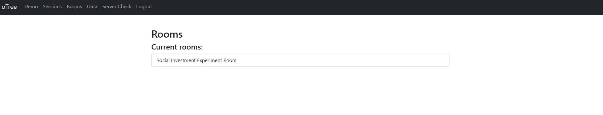
Click this room. U will get to this page:
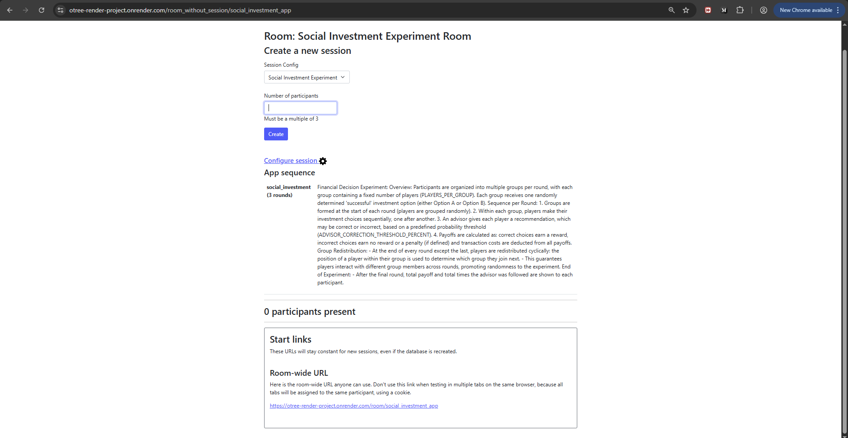
Here you can observe that the number of participants in the form field requires user input, specifically a multiple of 3, as we have designated 3 participants per group. So let’s say we write 6 here and create so we will have two groups with 3 participants each.
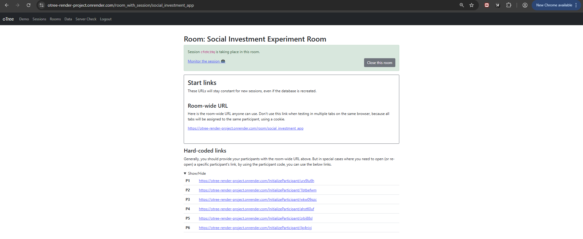
Here you can see the room-wide URL that I mentioned, which is not available for the session.
You have two options to provide URL to the participants:
- Give them room wide URL, which will assign them the participant id based on first come first serve basis
For example: https://otree-render-project.onrender.com/room/social_investment_app
They will see this:
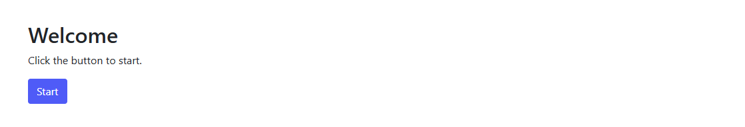
- Give them direct URL of participant:
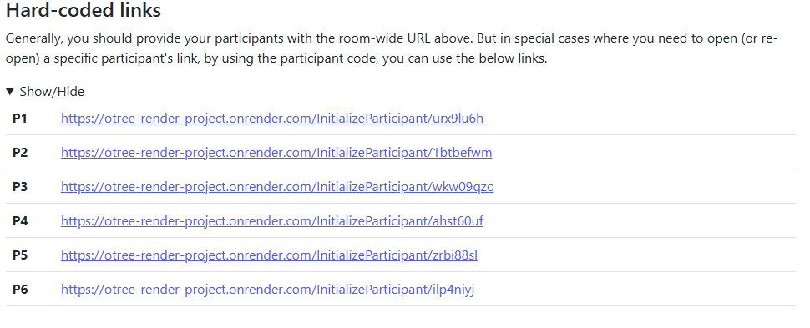
After start is pressed for option 1 or participant click the hardcoded link in option 2 they will get this page:
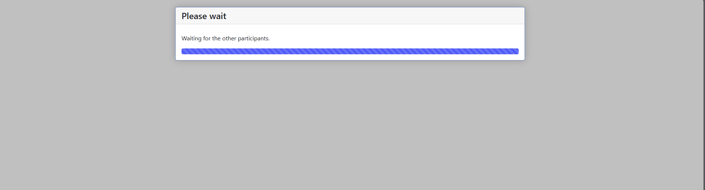
Once all 6 participants arrived, only then the experiment will begin else they will be stuck at the waiting page shown above.
Everyone will see this introduction page which provides the participants with the instruction and talk about the experiment:
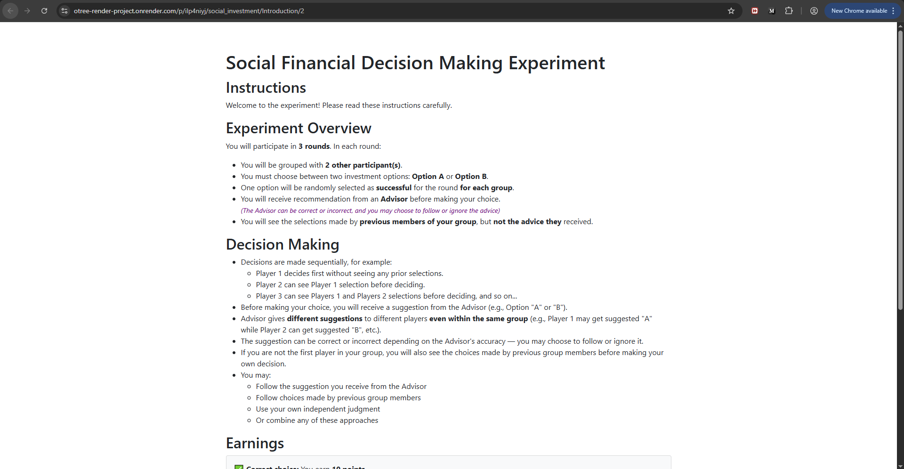
BTW this page has different values that can be changed for example correct choice points, incorrect choice points and transaction cost. Once u specify in the code it will change. For now, I have set correct choice to 10 points, incorrect choice to 0 i.e., no penalty and transaction cost to none. Also, there is advisor which is set to 70% for now. There are other variables u can also change for example number of rounds and groups etc. in other words u have the total control of experiment configuration.
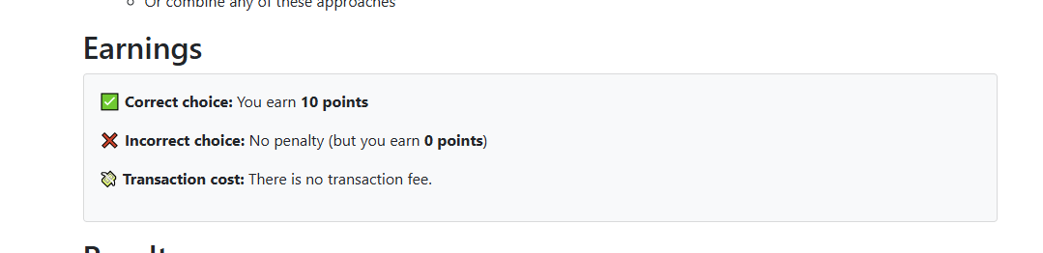
Once u click next. Depending on the position of participant in the group next page will open. If participant is not first in their respective group, then he will get this wait page:

In short the waiting page is a sequence waiting page, which prioritizes users based on their ID and make other member to wait their turn.

Else if the participant is first they will get this:
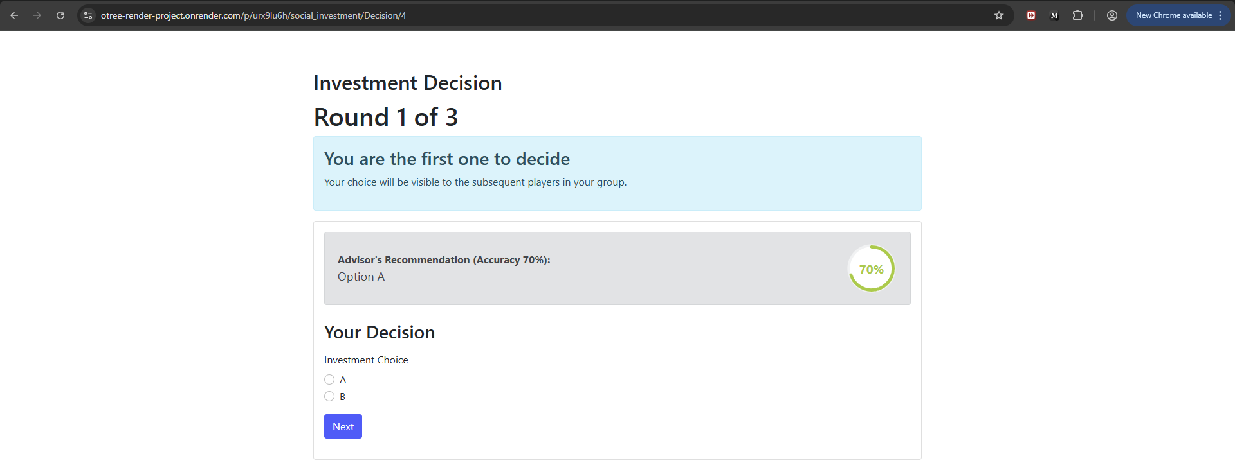
This is the decision-making page. User can select either option A or option B. since he is first participant in his group, a special prompt is also shown in blue color saying that u r first one to decide. Advisor also provides recommendation currently it is set to 70%. It remains for complete experiment. I have added different colors for the dial to show severity of advisor accuracy for example shown below:
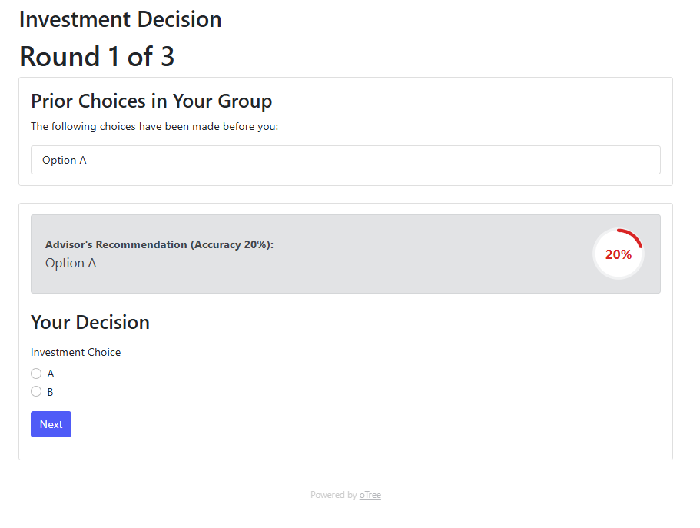
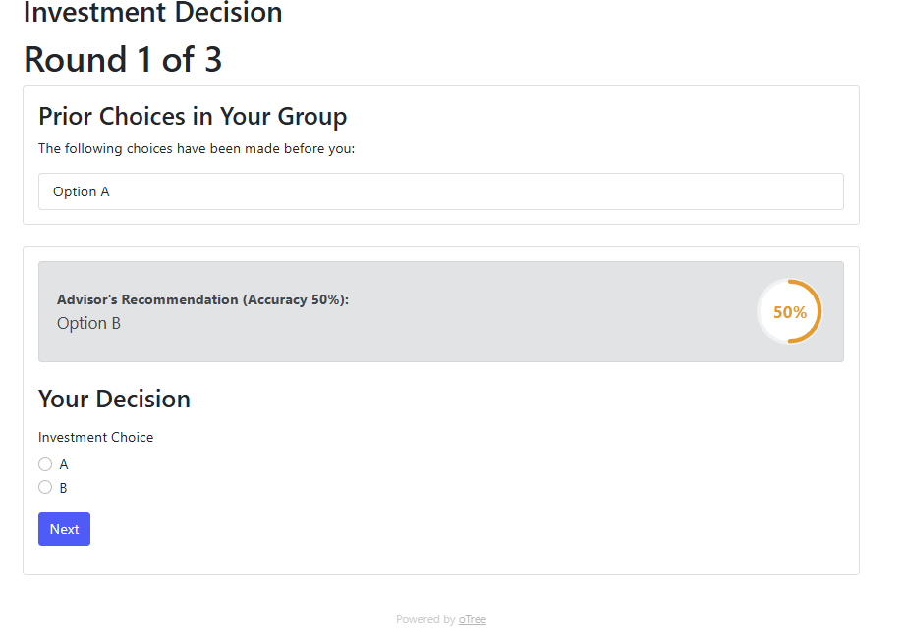
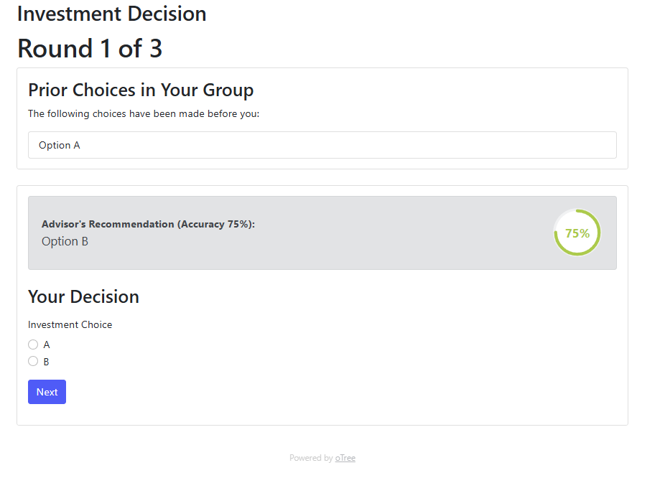
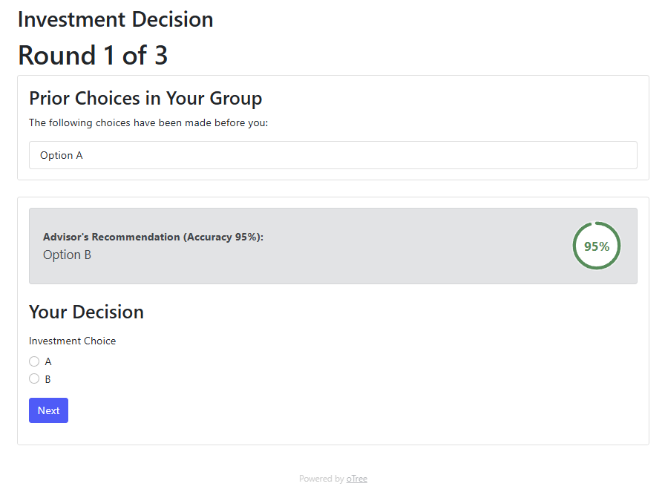
Next u can decide on the option and click next:
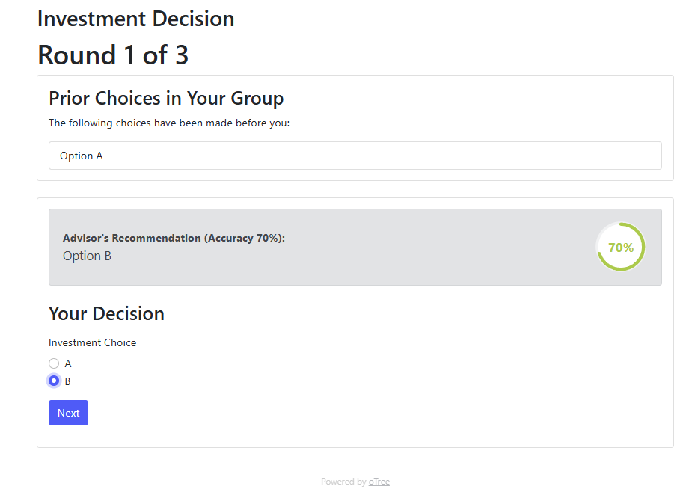
Depending on the position in the group you can see the options selected by previous member:
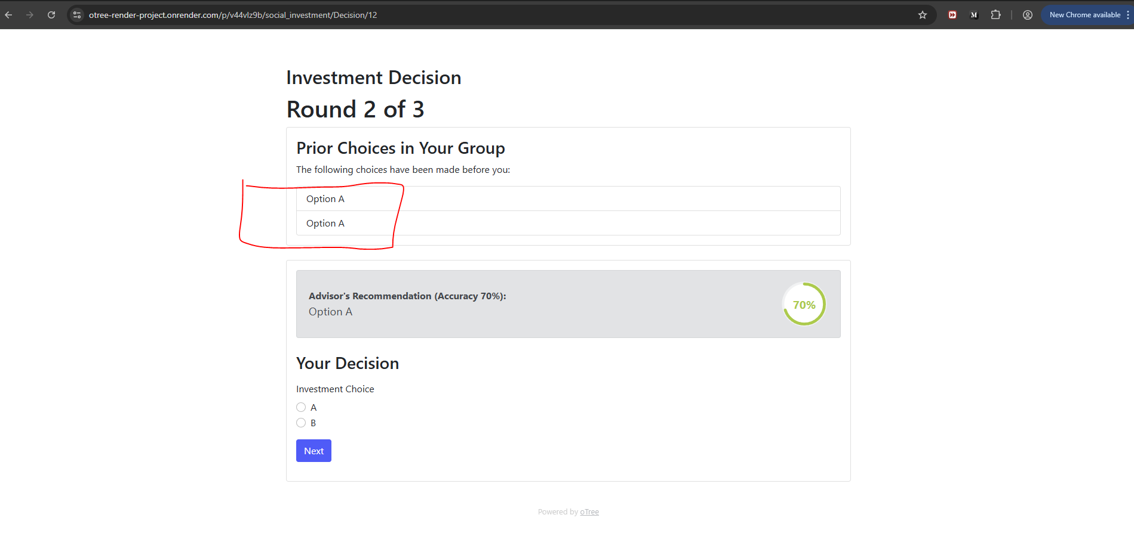
Now u will get this once u press next :
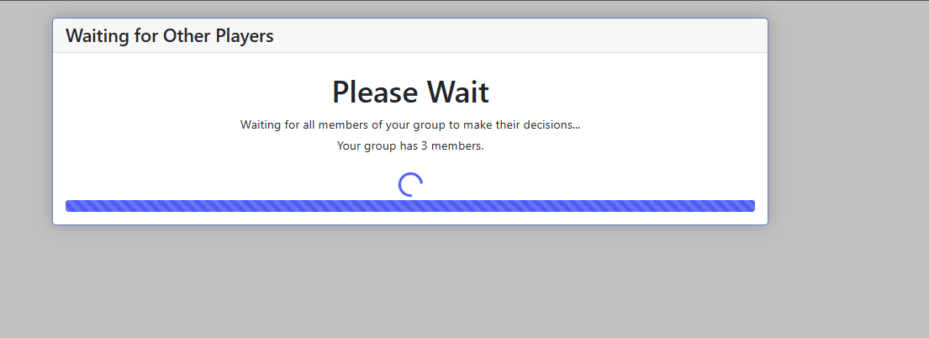
This informs the players that other participants are currently making their choices. This is the results waiting page.
Once done u will get following based on the correctness of your choice:
Wrong choice:

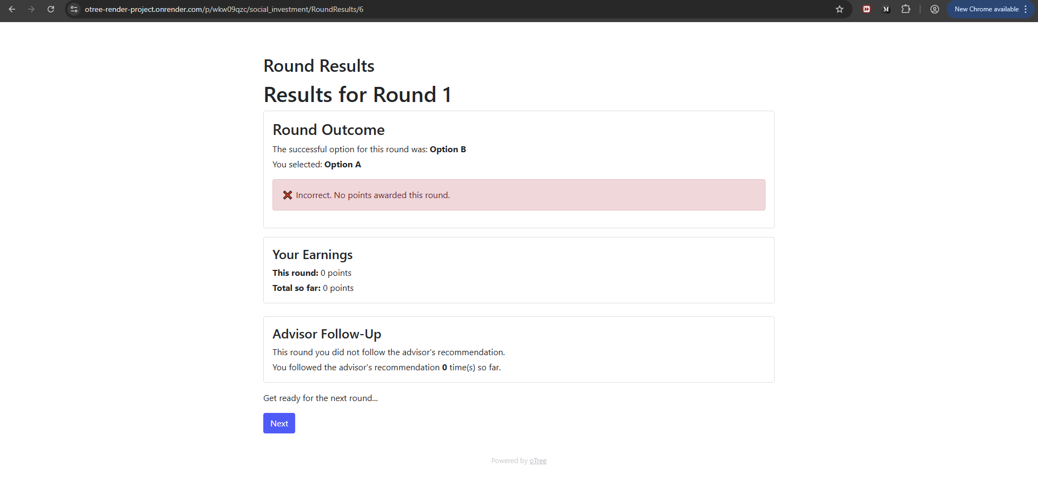
Correct choice:
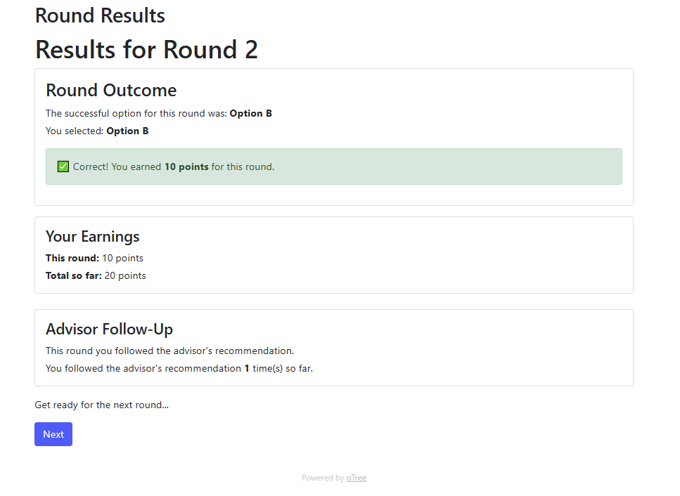
The above pages shows important stuff like earning, current round result and advisor followed or not this round and total.
By the way, the "correct choice" for the group is same (for example option B as correct option will be same for all players in the group), whereas the advisor's recommendation may vary for each player in the group, depending on the shared probability (for instance, 70%). So to create variability in experiment.
Once u click next u will get this:
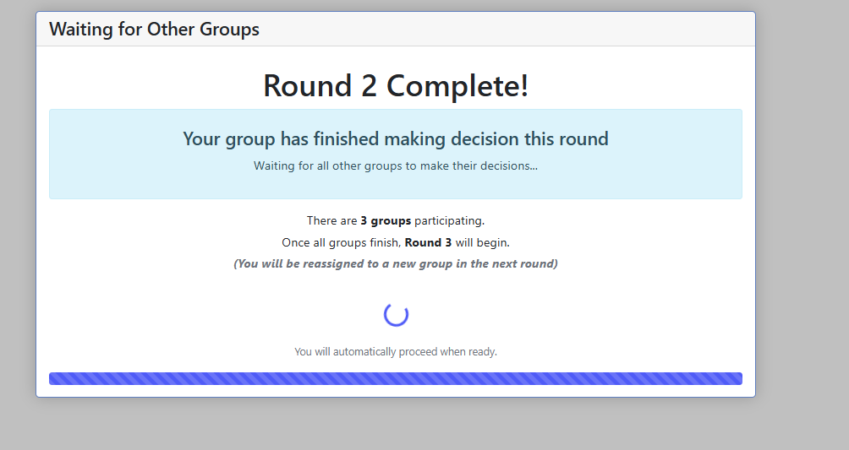
It waits for all the group present in the experiment. You could say why we need to wait here. This page is waiting for others to make decision for round completion because we need to reshuffle participant for all groups internally and externally for each round. We cannot reshuffle until all participants have made their decisions i.e., all groups are ready.
Shuffling:
For shuffle I first applied random numbering but it causes delays and errors. So I go with structured reshuffling by using round robin assignment. i have explained it in detail in code for u. else u can search net to understand how it works. It looks complicated but once u get the hang of it, it becomes simple.

Once all players are done with their selection, the cycle repeats again. The first person in every group will get this for example for round 3: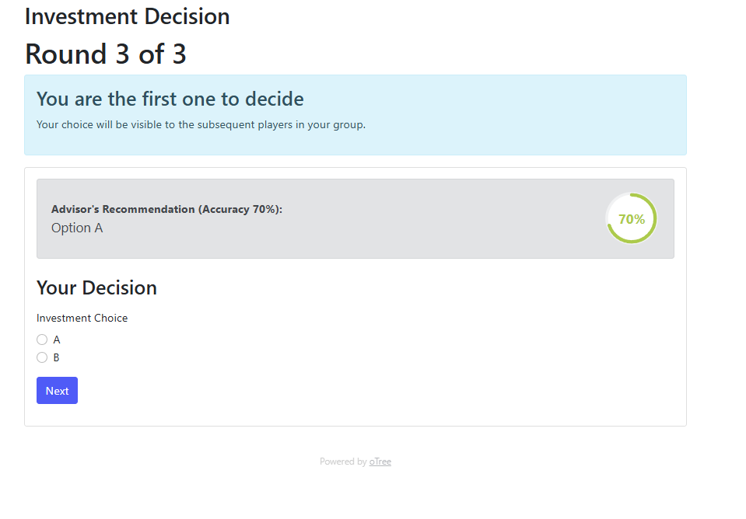
Once all rounds are done they will get this:
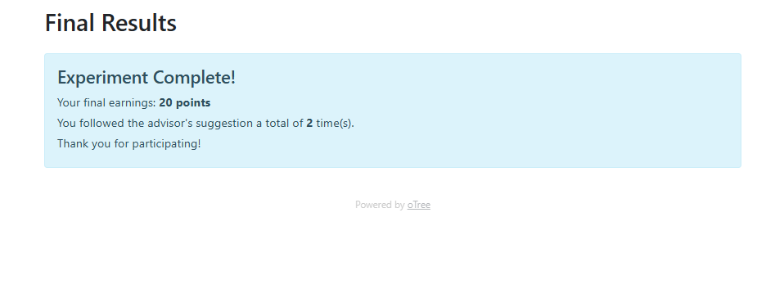
It tells the user of their final earning/payoff which includes cumulation of all the positive negative outputs. It also tells the user how many times he followed the advisors suggestion.

For comparison look at this demo output for a single group of three players:

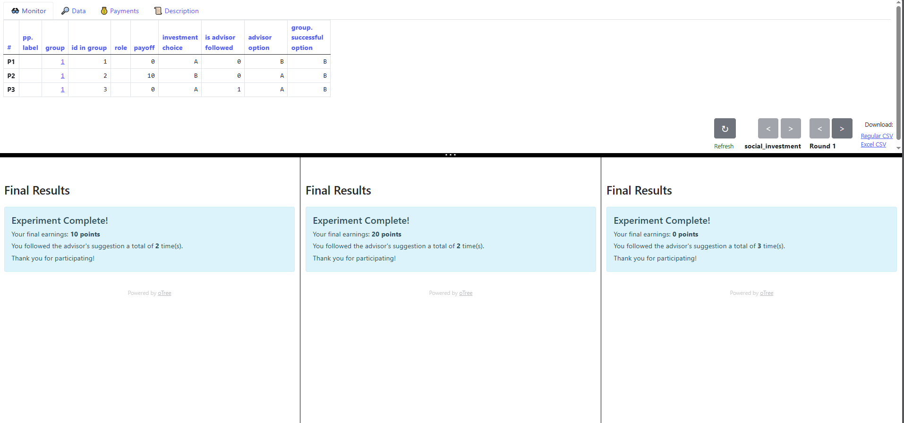

Finally, to get the data excel file. Do following click data and click csv:
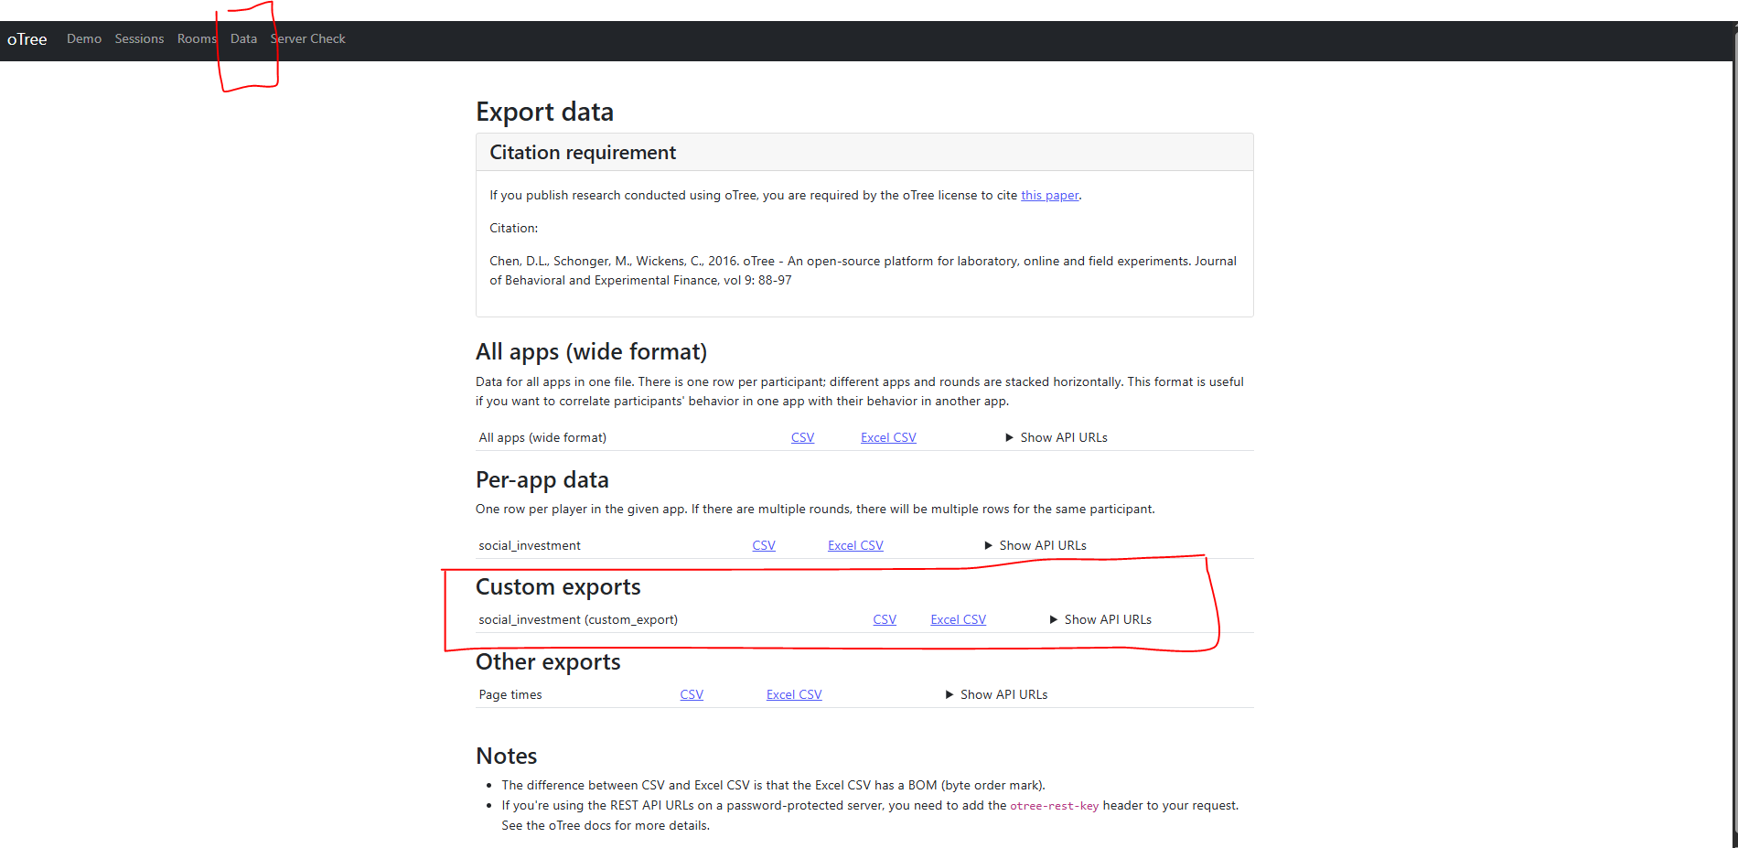
I made a custom CSV since otree really messed up the database creation. Everything is all mixed up, and it pulls in user data from every session, which means that even a new session ends up with data from the previous one.
My custom CSV also contains variables that we like and also the arrangement. It will look like this:
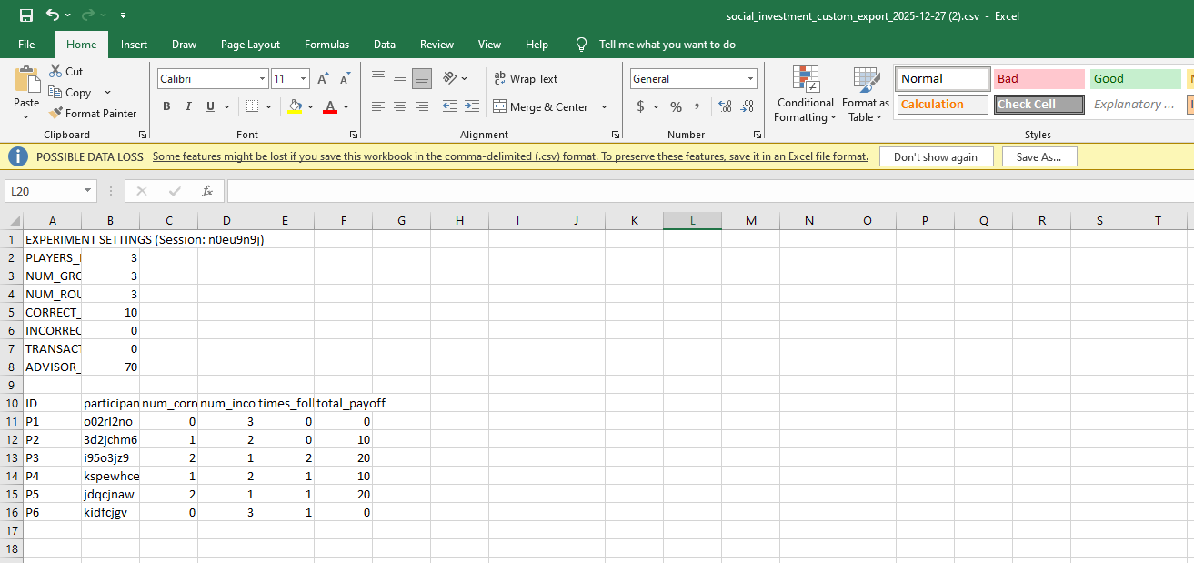
Look at this, it is from otree:
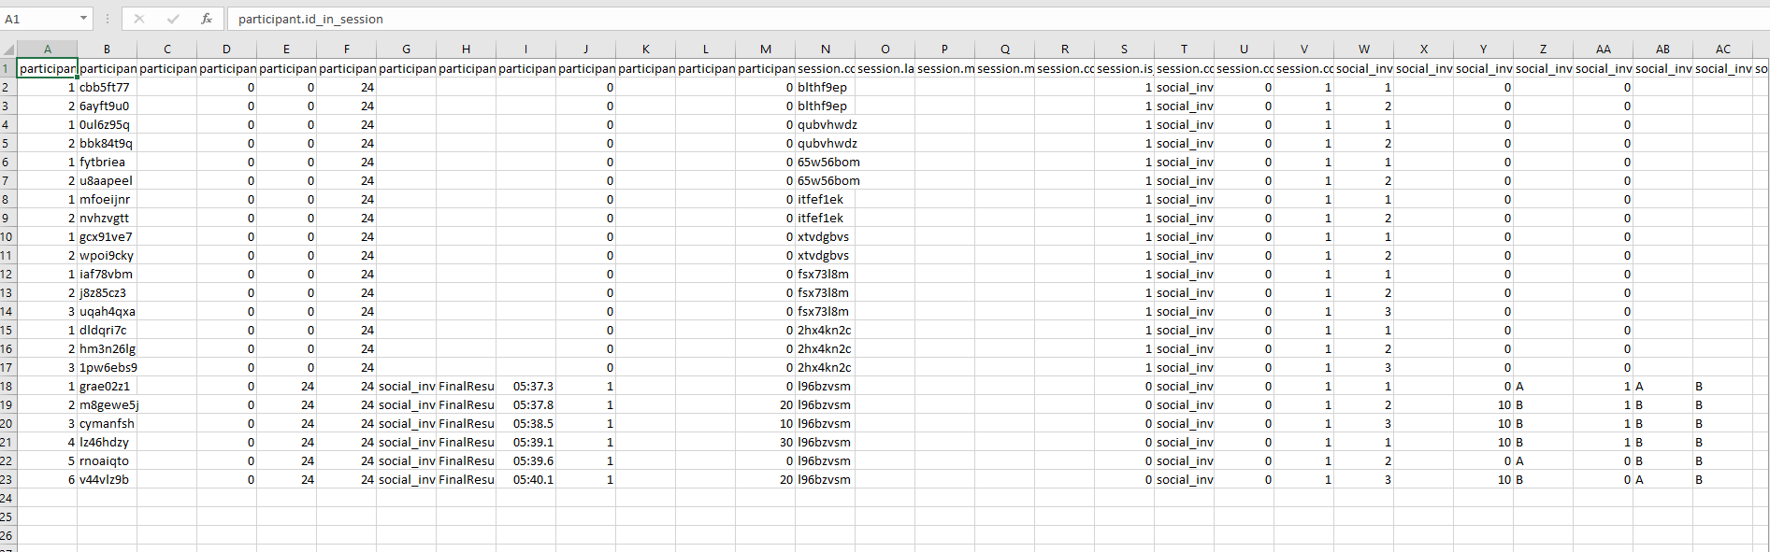

Also when u download csv file, u can check that it is the current session data as I have also included command to get the session code.
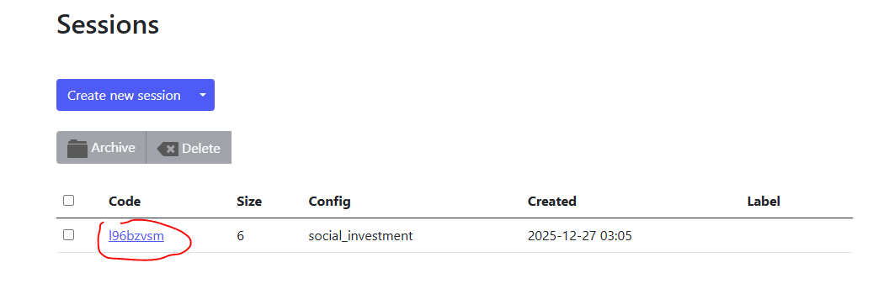
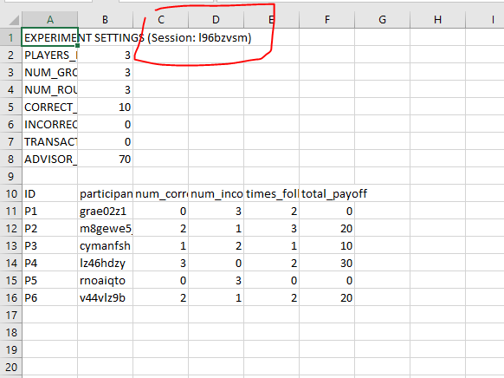

When u are all done click the close room. Ur session will still be there but room will be removed and then u can add new room for ur new experiment and new session will be created. However, remember that u will not be able to download the previous session file.

