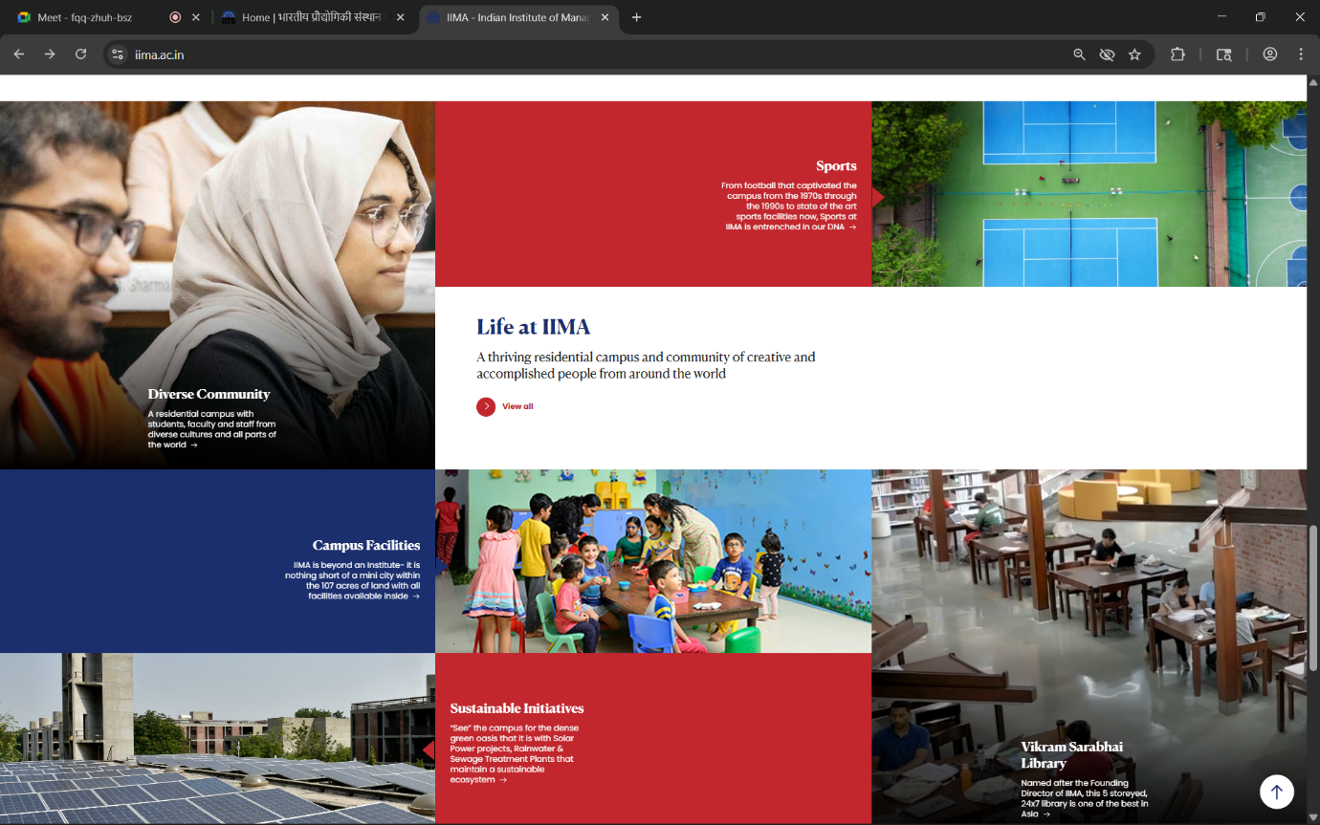
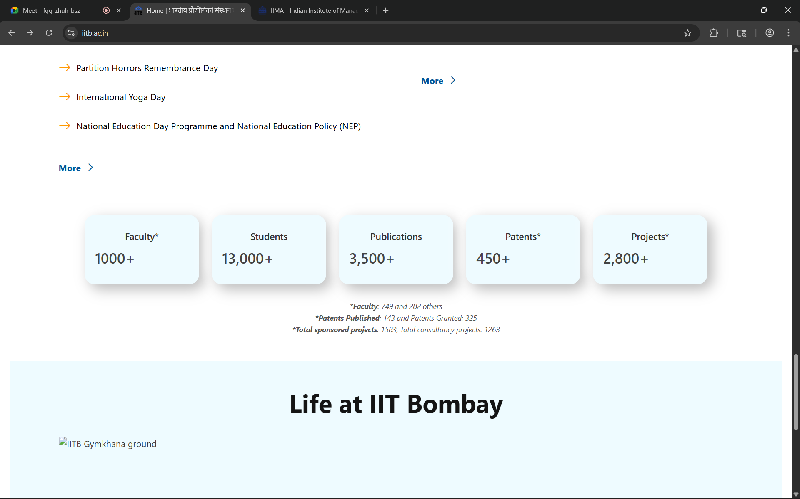
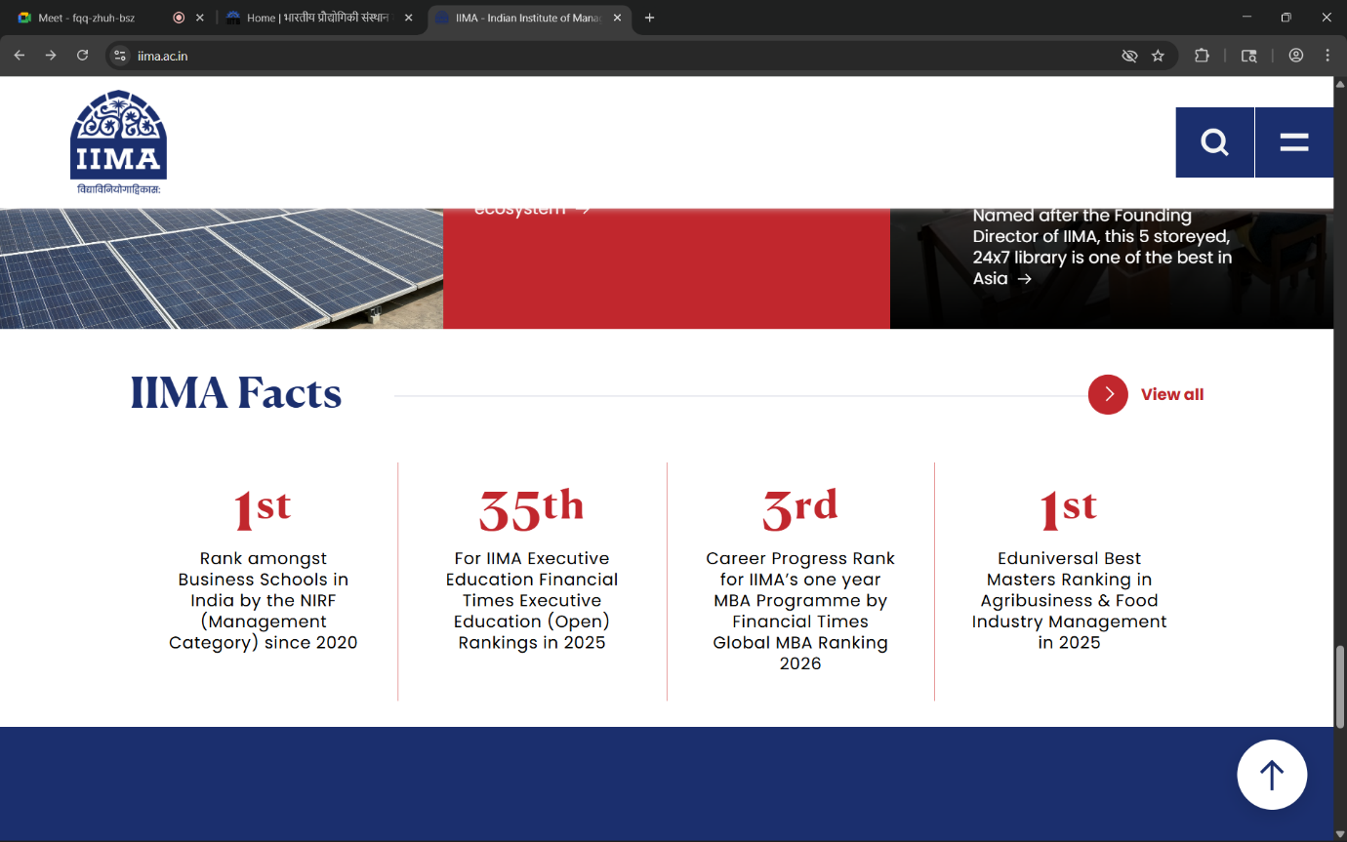

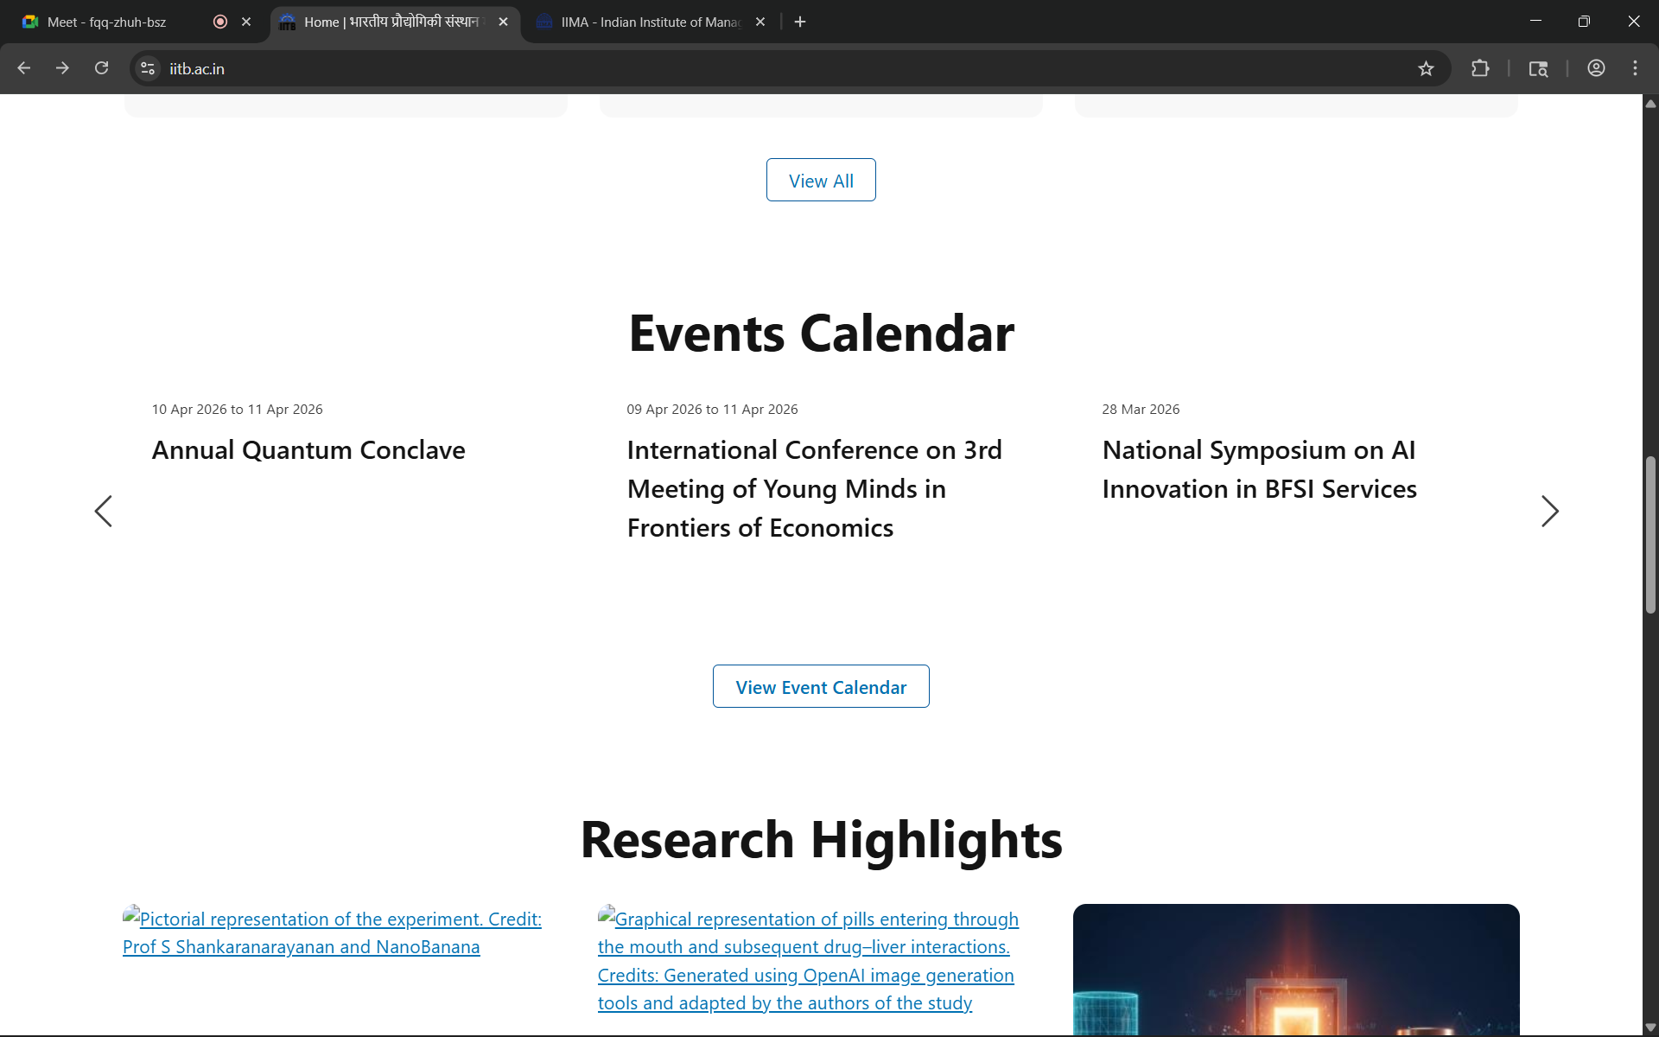
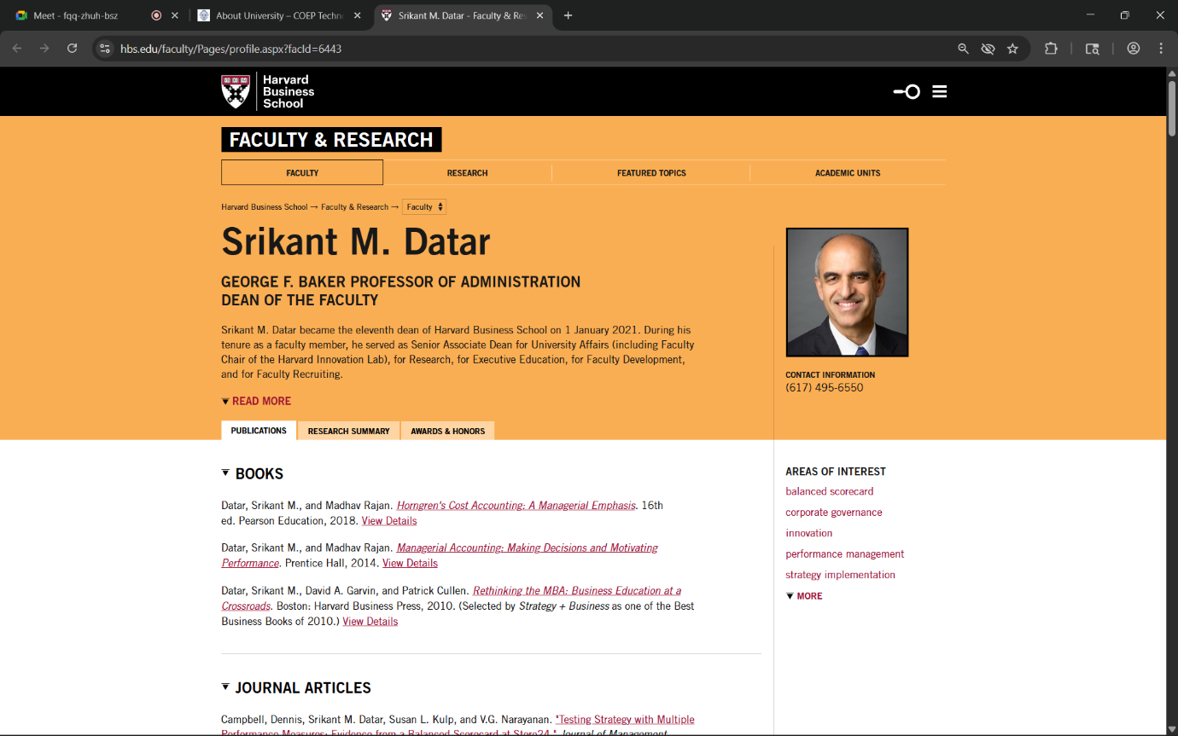

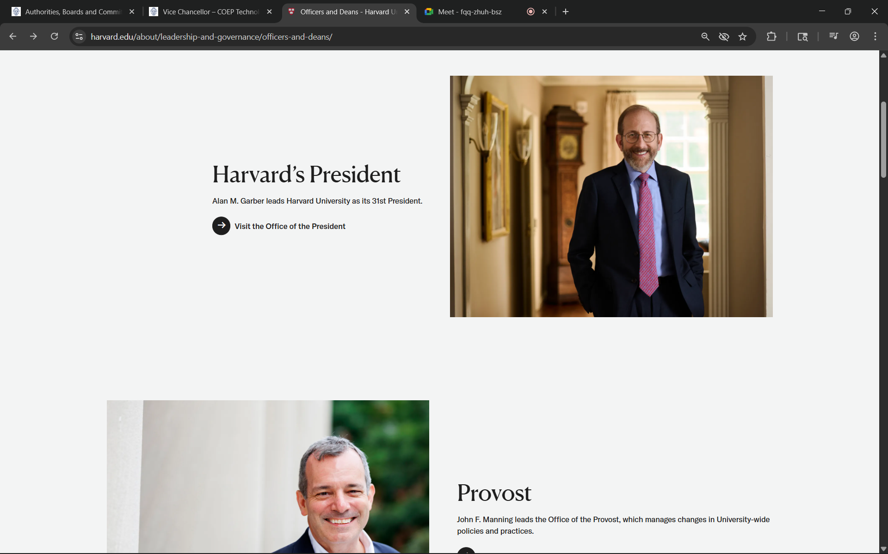
https://www.harvard.edu/about/leadership-and-governance/officers-and-deans/

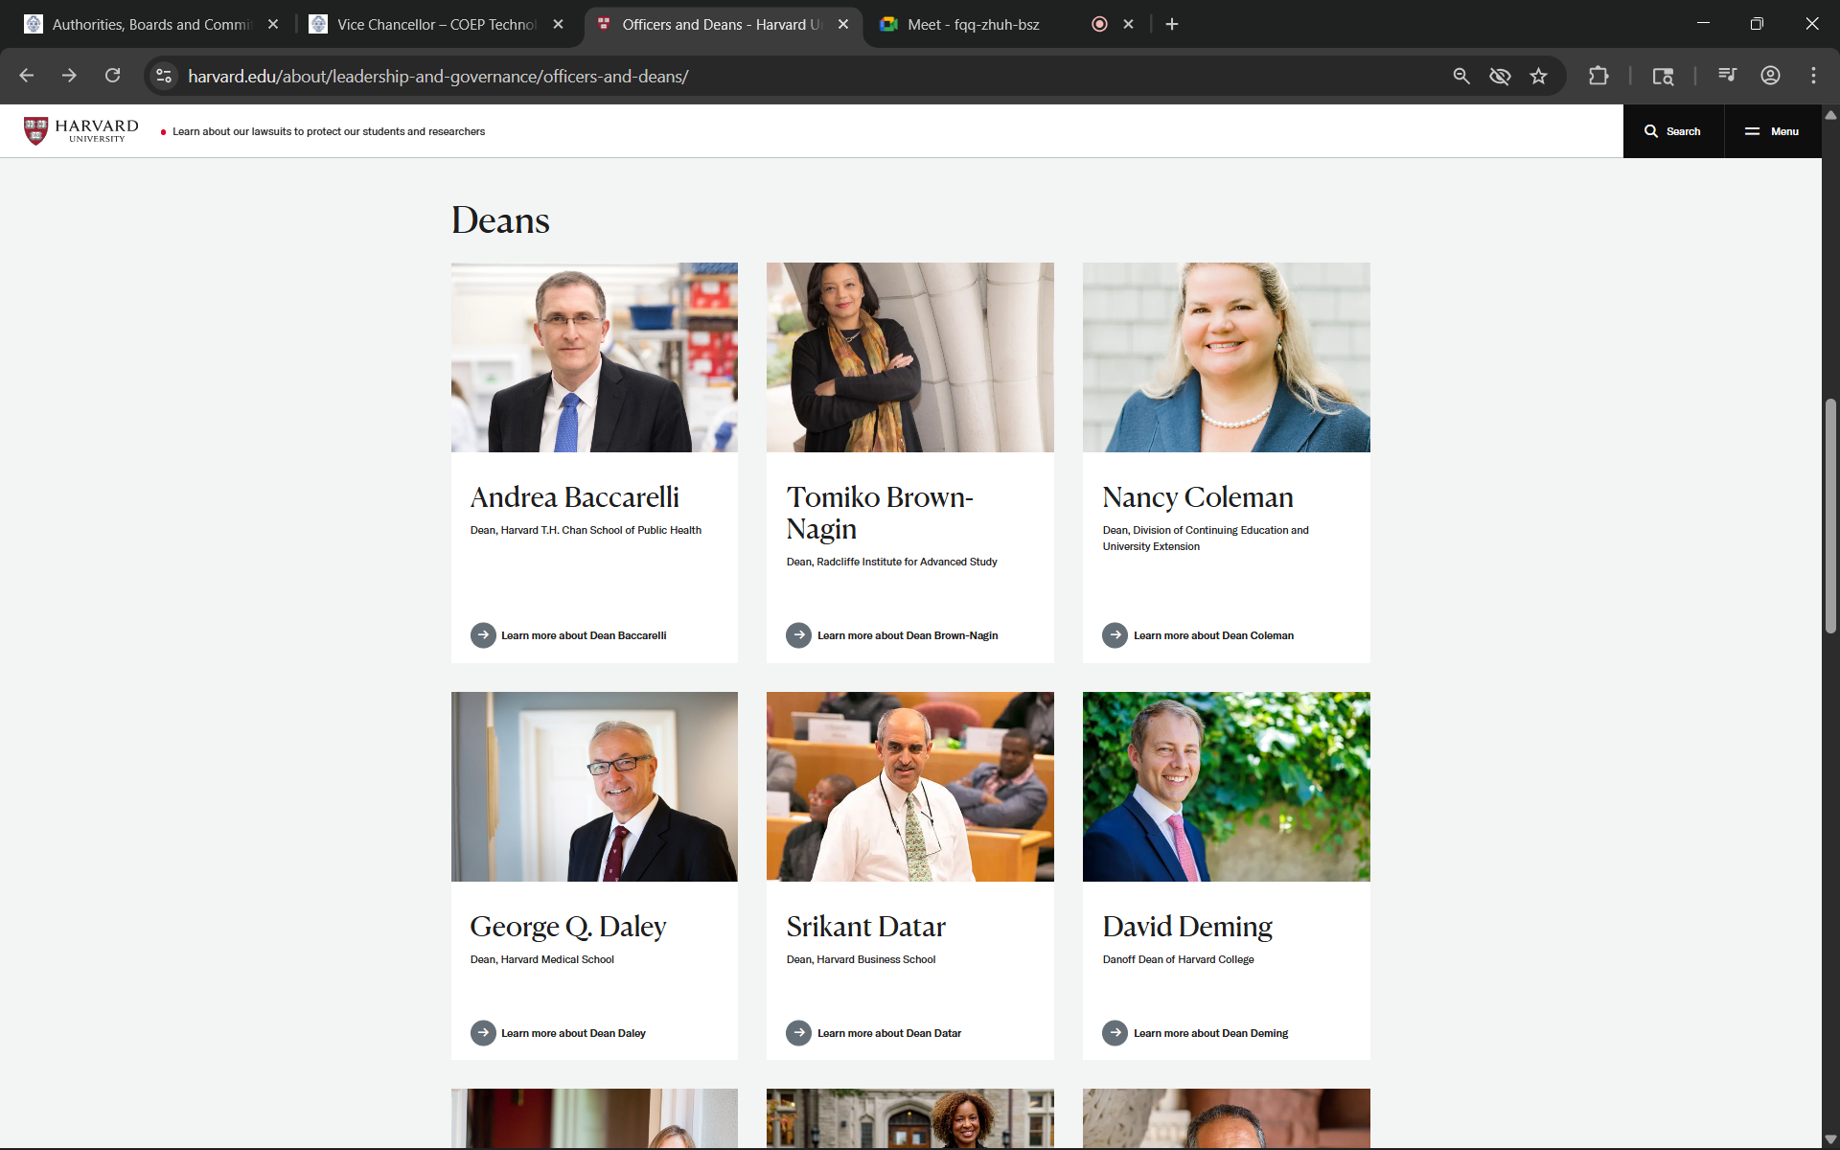

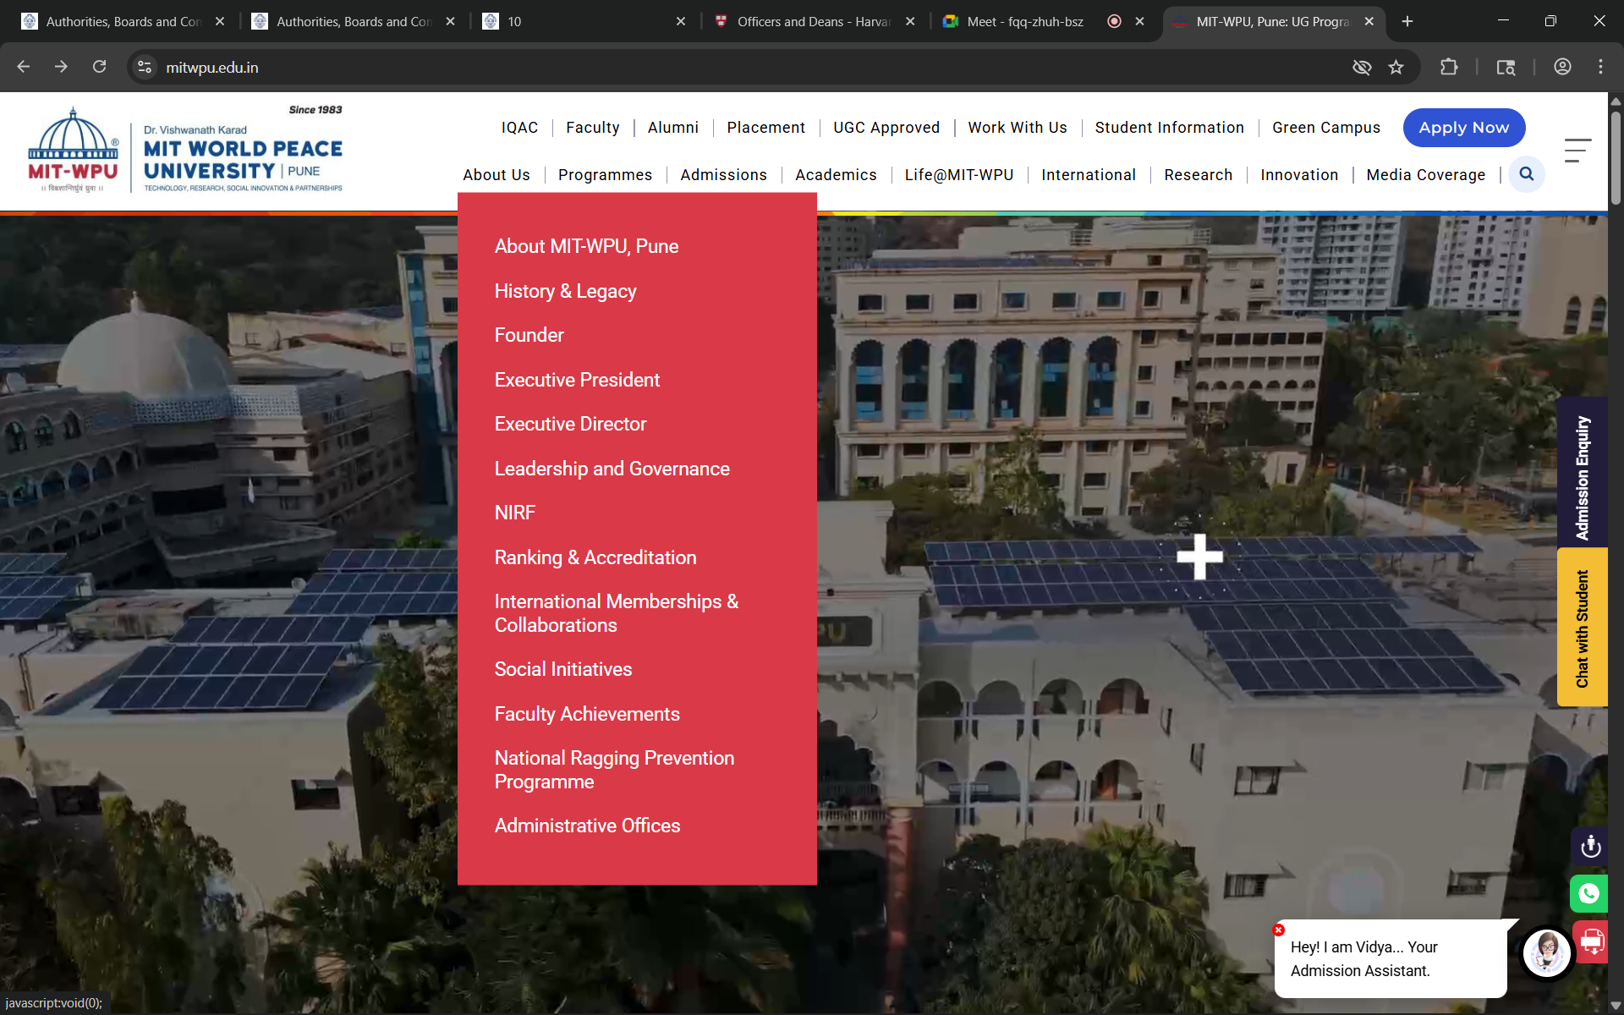

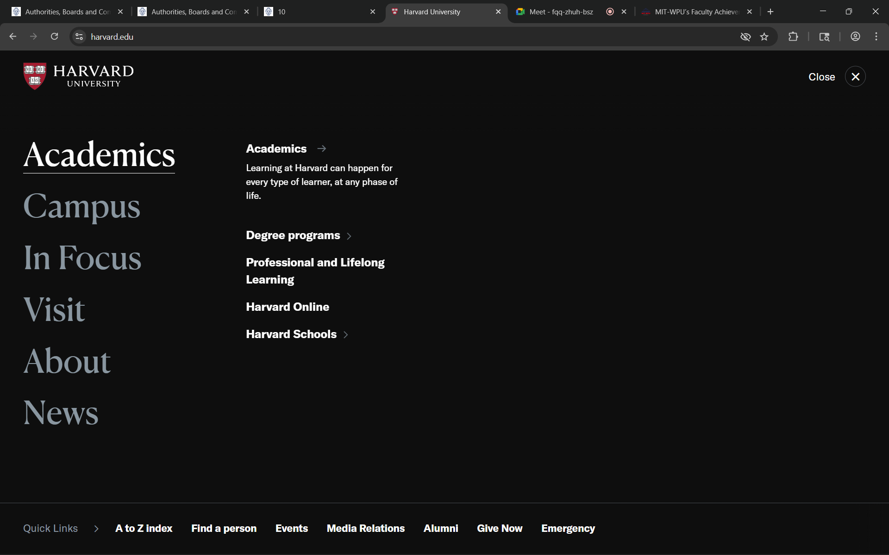

Facilities
│
├── Overview
│ ├── Staff
│ ├── Facilities for Differently Abled
│ └── General Campus Facilities
│
├── Student Grievances
│ ├── Student Grievance Redressal Committee
│ └── Grievance Form
│
├── BIS Academic Dashboard
│ └── All Links (80+ with Description & URL)
│
├── Knowledge Resource Centre
│ ├── About KRC
│ ├── Downloads
│ ├── E-Resources
│ │ ├── E-Content
│ │ └── E-Journals / Databases / E-Books
│ ├── KRC Staff
│ └── Library Facilities (Web OPAC)
│
└── Gallery

