**Algorithm:**

Bracelet will be provided to each one wants to enter. Each bracelet has its own mac address which will work always regarding if there is a network, WIFI or not (which means it is systematic). The bracelet will work directly if we took it from its place.

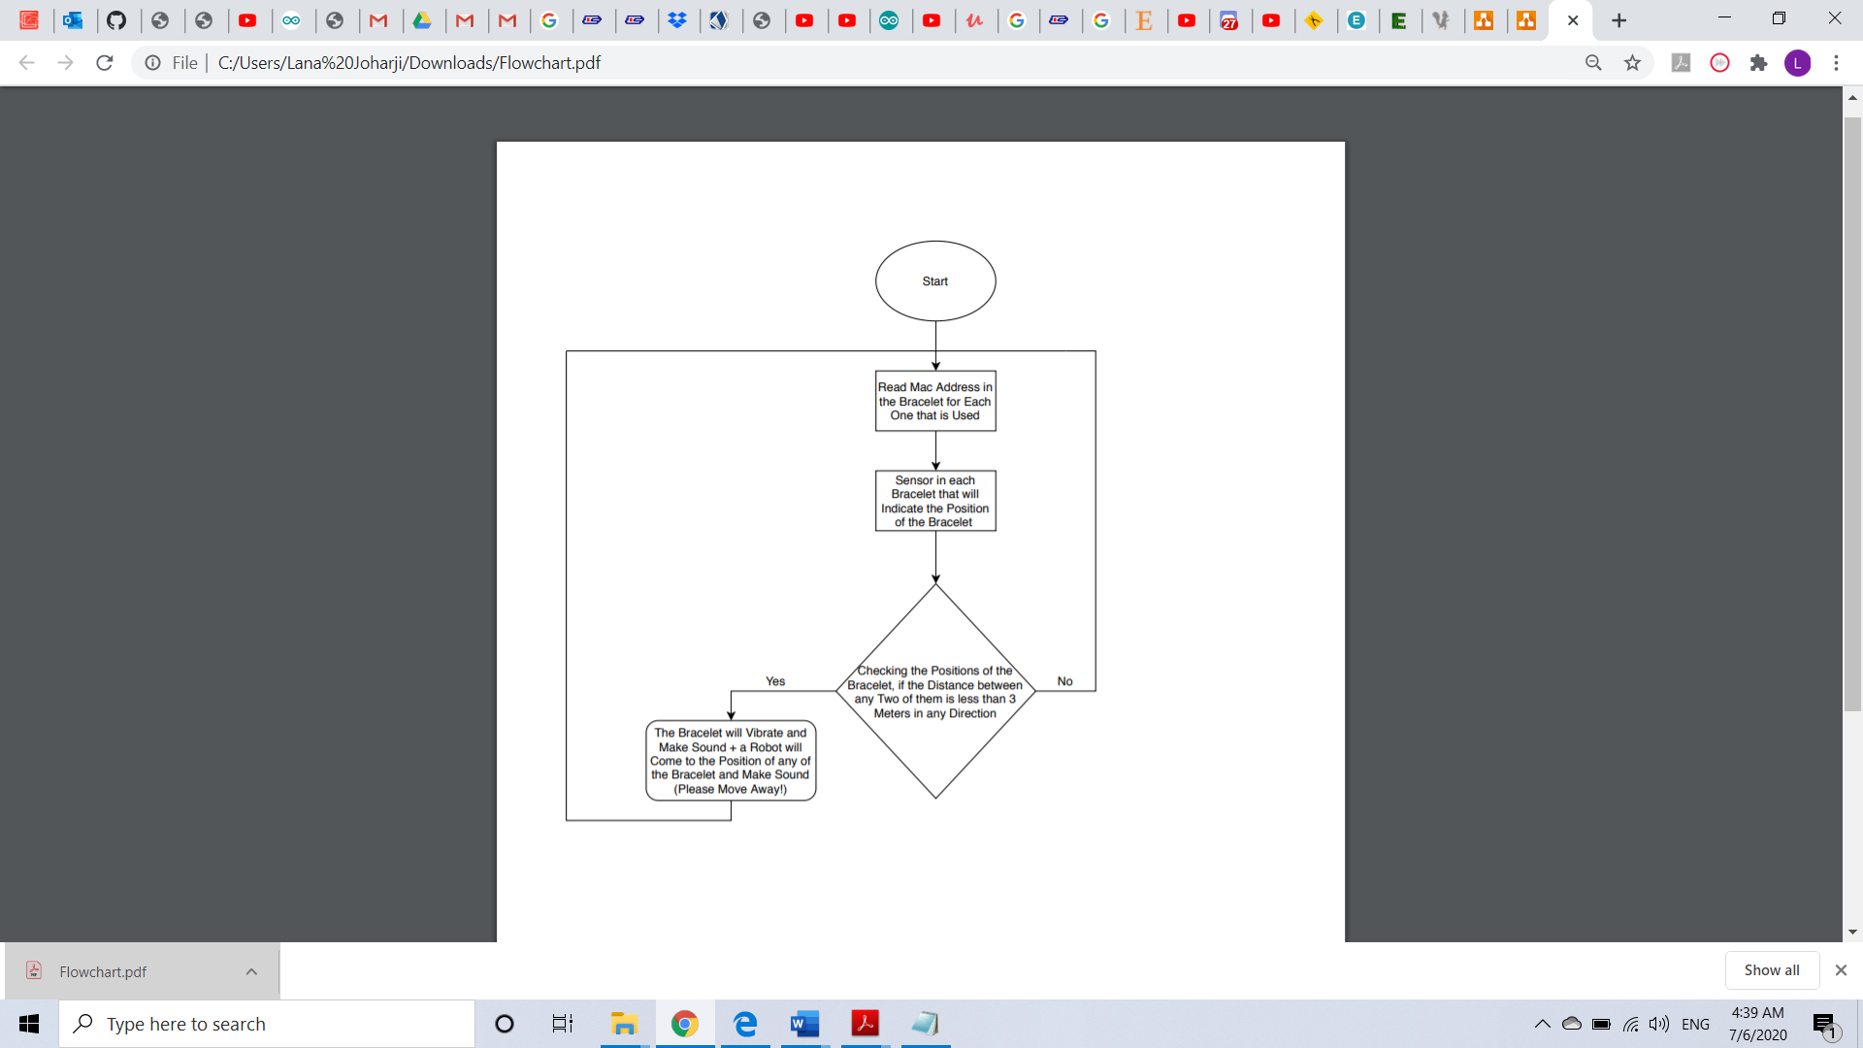

Figure : Flowchart