Lab 3.1

Refer to Chapter 2: Getting Started with CSS

1. Read pages HTML 85 to HTML 106
2. Using the data files and instructions provided, create the tss_home.html and the tss_styles.css files as directed in pages HTML 85 – HTML 106
3. Display the completed tss_home.html file in a browser as directed on page HTML 105
4. Compare your display to Figure 2-11 on page HTML 105. Correct any errors.
5. Add a screenshot of the tss_home.html file displayed in the browser.
6. Review the Section 2.1 Quick Check with a classmate.

Screenshot of tss_home.html displayed in browser.

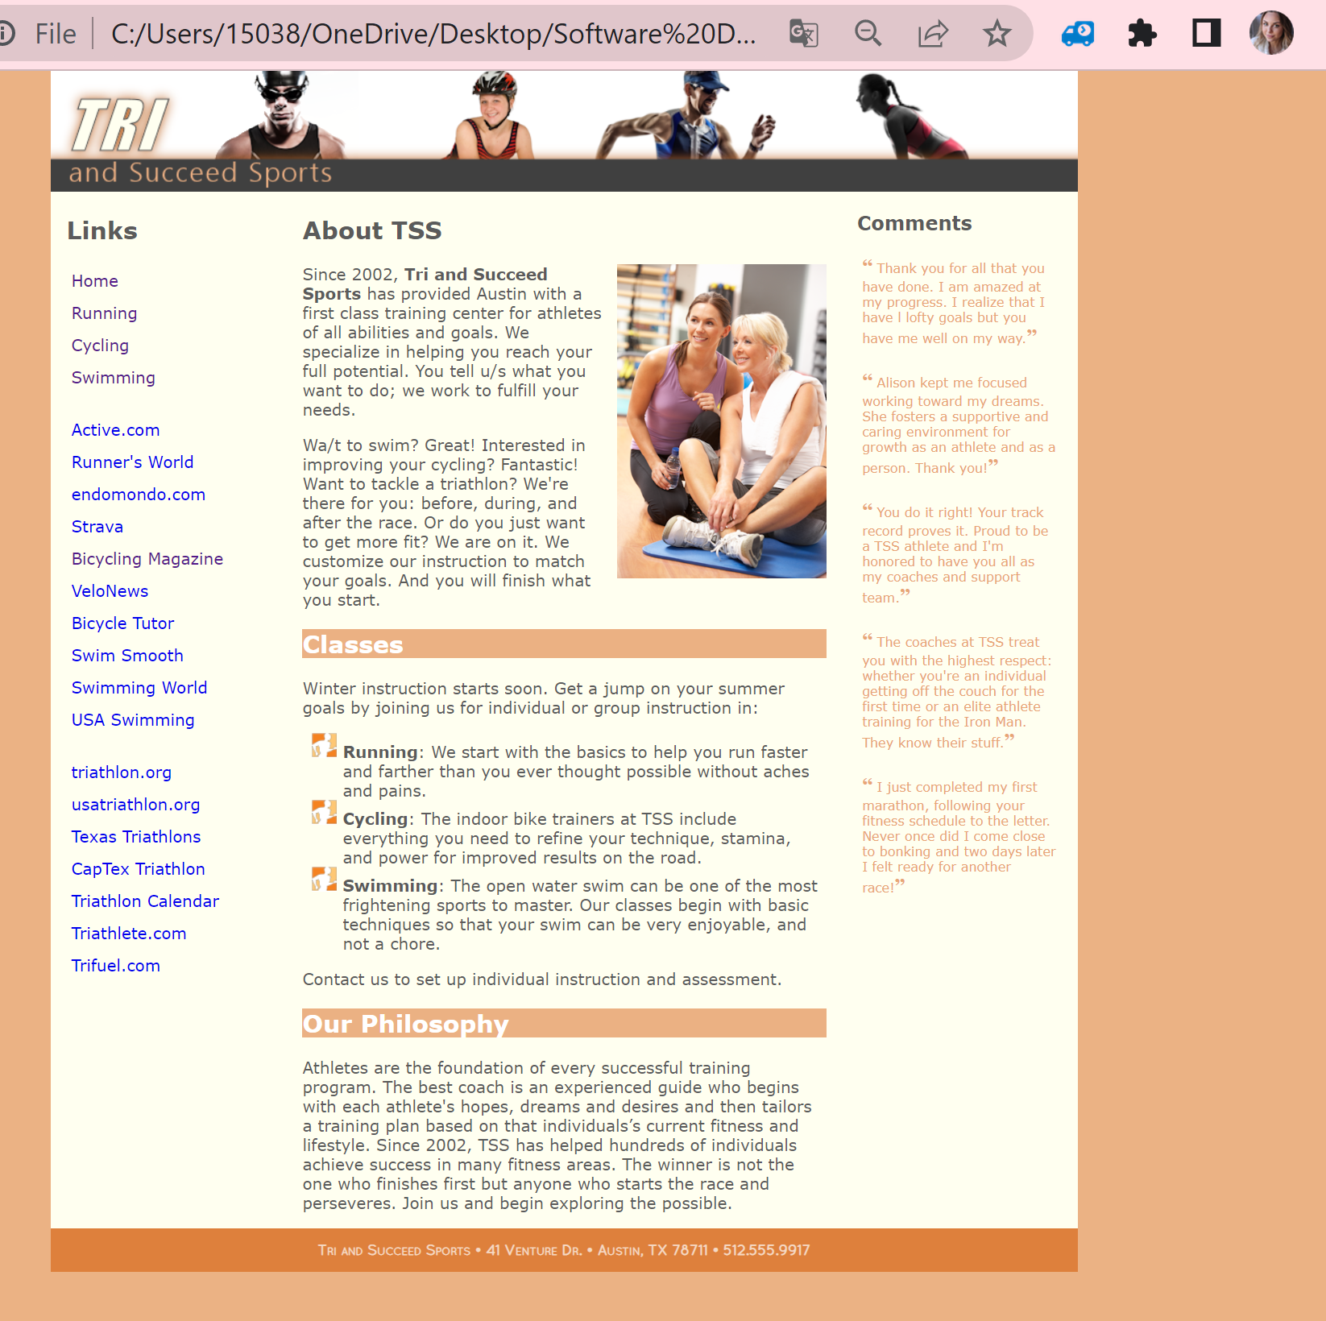

Using a numbered list, add 10 things you have learned by completing Section 2.1 of Tutorial 2.

1. Types of Style Sheets
2. How to open the developer tools window.
3. How to Create a Style Sheet
4. How to write a Style Comments /*comment*/
5. Only one @charset rule should appear in a style sheet and it should always precede any other characters, including comments.
6. HSL color values are based on a color model in which each color is determined by its hue, saturation, and lightness
7. How to create style with a contextual selector.
8. What is Attribute Selectors.
9. The general rule in CSS is that the more specific selector takes precedence over the more general selector, but the application of this rule is not always clear
10. Text characters are based on fonts that define the style and appearance of each character in the alphabet.