Design and Implementation of IS:

Assignment 1: UML Use Case and Class Diagrams

System Name: ParkWise

Semester: a
Submitted by Group: Acendent
Assigned LLM: Gimini

Link to the conversation with the LLM (in addition to the csv file uploaded to Moodle)

Assumptions:
This is an optional section for essential assumptions; Please provide concise information aimed at clarifying key aspects for the exercise evaluator; Ensure that the content does not replicate details already presented in the system description narrative.

1.1.a The Use Case Diagram:
Verify readability of the figure.

1.1.b. The Descriptions of the Use Cases:
Make sure the descriptions are short and concisely describe the responsibilities of the various use cases.

Draft:

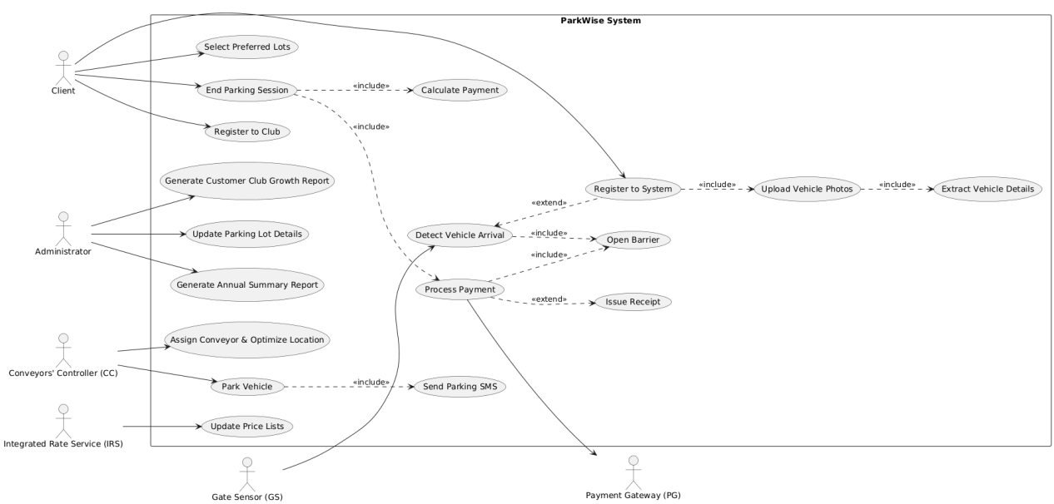
final:

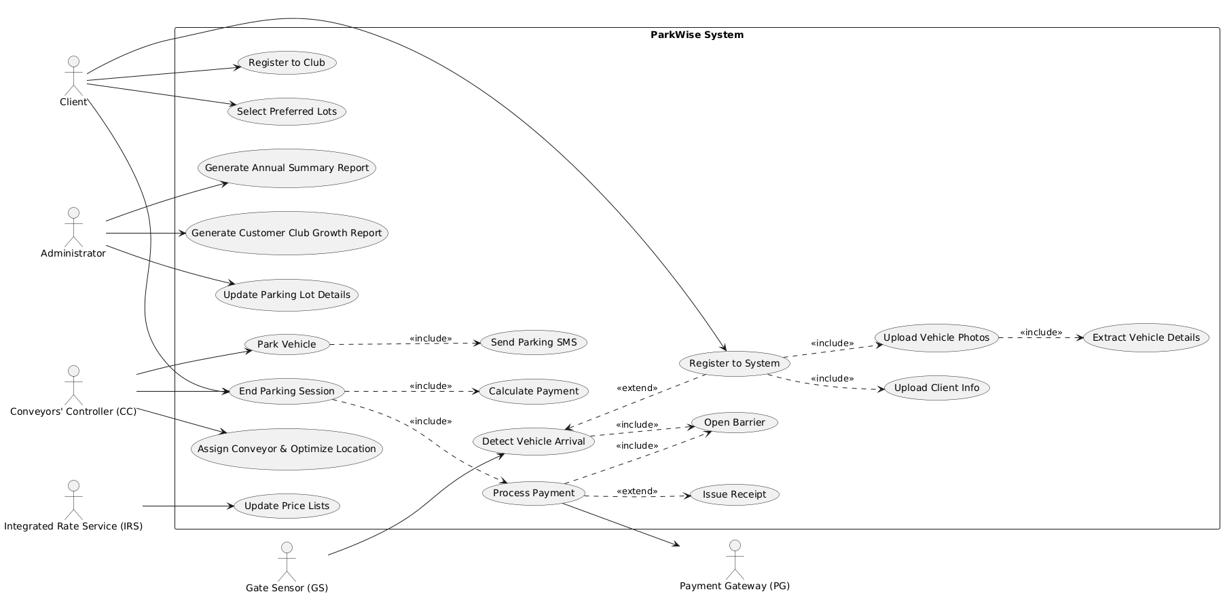
1.1.c. The UML Class Diagram:
Verify readability of the figure. The text file in PlantUML format should be uploaded to Moodle!

1.1.d. The Relational Database:

1.1.d1. The Tables:

The Tables in the Database:
Make sure to present the table in the third normal form (3NF) and supply information on primary and foreign keys.
Field list (underline primary keys; clearly specify foreign keys with the notation of FK table_name) | Table name

1.1.d2. The Mutual Relationships:
Verify the readability and completeness of the screenshot taken from Microsoft access.

1.1.e. The QBE Query:
Verify the readability and completeness of the screenshot taken from Microsoft access.

