Design and Implementation of IS:

Assignment 1: UML Use Case and Class Diagrams

System Name: | ParkWise
Semester: | a 2026
Submitted by Group: | Ascendant
Assigned LLM: | Gimini

Link to the conversation with the LLM (in addition to the csv file uploaded to Moodle)
https://gemini.google.com/share/98ef6d6c73e6 | https://gemini.google.com/share/7bee023d22f1
https://gemini.google.com/share/3ae7d9e40768 | https://gemini.google.com/share/941c043cd85b
https://gemini.google.com/share/2a7e3f26b336


Assumptions:
- Assuming each conveyer is installed in one parking lot and is stationary
- A lot will have one sole entrance and exit, hence having one barrier.
- To get to a certain lot you’d have to go through several conveyers.
- Phone number starts with 0 hence the type of the attribute is “short text”, same with the vehicle number

1.1.a The Use Case Diagram:

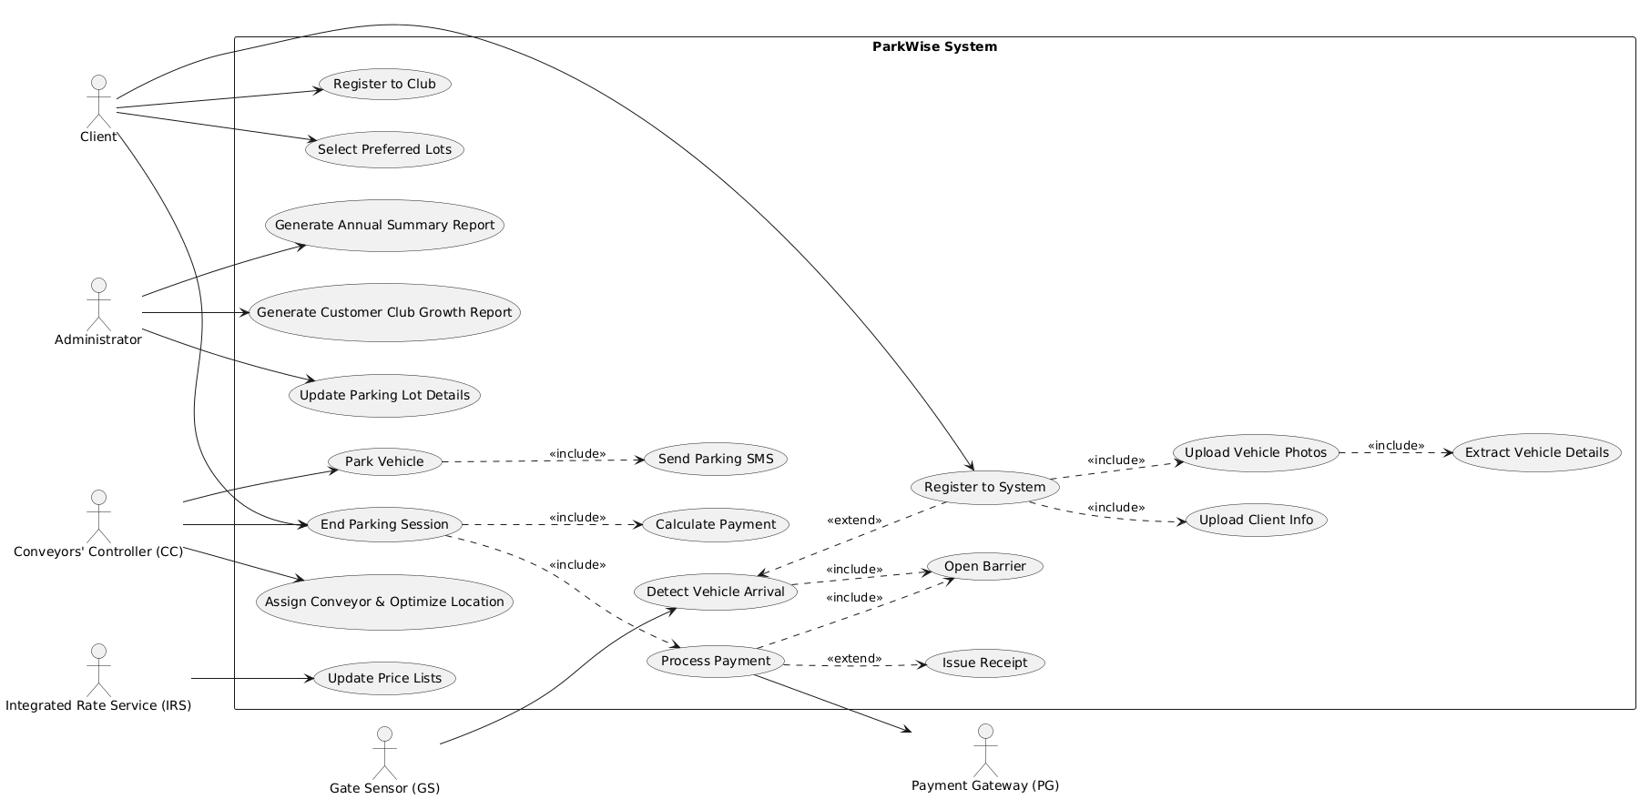

1.1.b. The Descriptions of the Use Cases:

client

Register to system:
- Input client’s info
- Input car’s photos, from which the system extracts relevant information and saves it in the DB

Register to club, buys the client one free month of parking and discount

Select preferred parking lot
End parking session:
- Calculation and processing of payment needed
- Orders the opening of the barrier
- Send parking SMS to customer
- Send receipt to PG

Administer

Generate annual summary report:

both PDF and XML files, include total incomes, some information about the cars and will be ordered by cities
- costumed club report- done monthly and reports back the sum of new recruits and the sum of the over all club members.
Update parking lot details.

Conveyer Controller
Decides on the optimal route for the car, while considering its size and weight
IRS
Updating price lists
Gate Sensor
Detects the vehicles arrival and acts in one of two case: either the vehicle is registers or not, in the former case it opens the barriers, in the latter sends it to registration
Payment Getaway
Processes payment

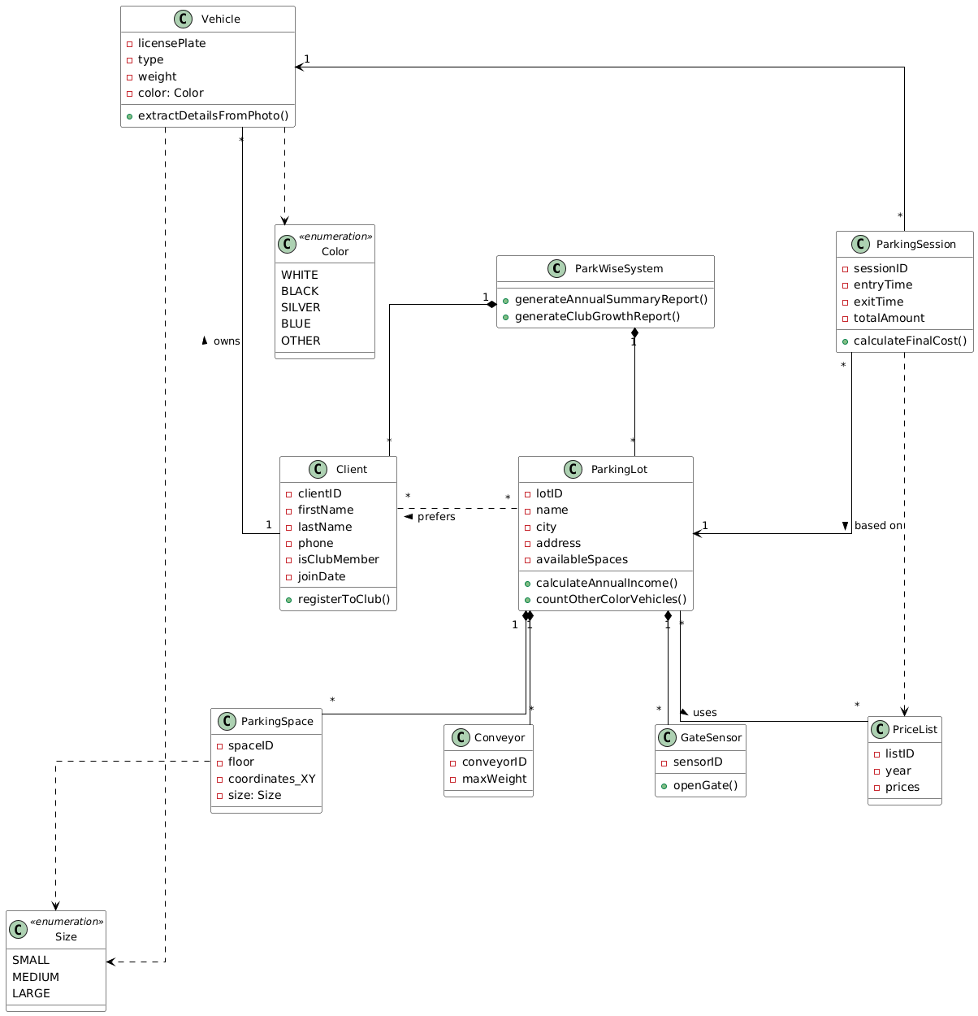
1.1.c. The UML Class Diagram:

1.1.d. The Relational Database:

1.1.d1. The Tables:

The Tables in the Database:
Field list (underline primary keys; clearly specify foreign keys with the notation of FK table_name) | Table name
ParkinglotID, lotName, adresse, city, availableSpaces | ParkingLots
clientID, firstName, lastName, phoneNum, isClubMem, memberSince | Clients
licensePlate, clientID(FK clients), type, color, size, weight | Vehicles
spaceID, ParkinglotID (FK parkingLots), floor, coordinateX, coordinateY, size | ParkingSpaces
conveyerID, maxWeight, ParkinglotID (FK parkingLots) | Conveyers
priceListID, yearAssociated, firstHour, additionalHour, extraHour, fullDay | PriceList
historyID, ParkinglotID(FK parkingLot), priceListID(FK priceList), assignedDate | LotPriceHistory
SessionID (PK), licensePlate (FK vehicles), ParkinglotID (FK parkingLots),PriceListID (FK priceList), SpaceID (FK parkingSpaces), EntryTime, ExitTime, TotalAmount | ParkingSessions
ClientID (FK), ParkinglotID (FK), SelectionDate | ClientPreferredLots

1.1.d2. The Mutual Relationships:
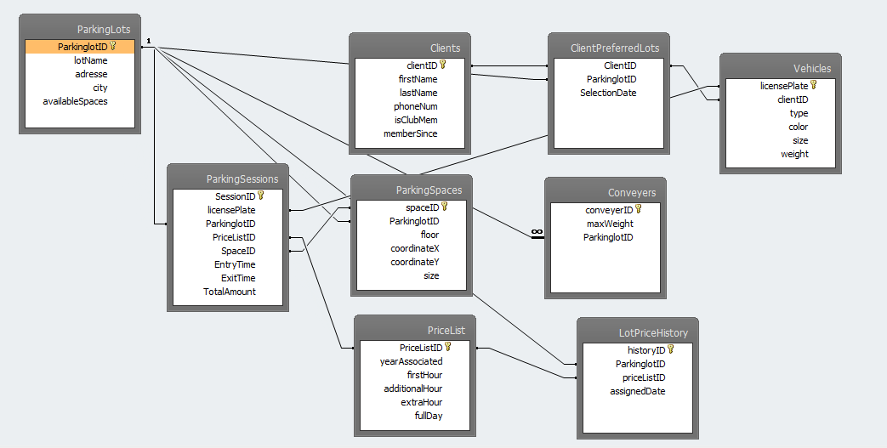

1.1.e. The QBE Query:
