The Manager's Guide to Difficult Conversations
Word-for-Word Scripts and Neuroscience Strategies
for Remote, Hybrid, and In-Person Teams
By Lana Wray

Copyright © 2026 Lana Wray. All rights reserved.
No part of this book may be reproduced without
written permission from the author.
Published via Amazon Kindle Direct Publishing

A Note on the Scripts
The scripts in this book are starting points, not rigid formulas. Adapt the language to your voice, your relationship with the employee, and your organizational culture. What matters is the structure and the intention behind each phrase.

For every manager who's ever stared at a calendar invite they created
and thought, "Maybe I should just cancel this."

Chapter 1: Introduction — Why Difficult Conversations Feel So Hard
You became a manager because you were good at your job. Maybe you were the best engineer on the team, the top-performing sales rep, or the most organized project coordinator. Then someone tapped you on the shoulder and said, "Congratulations, you're in charge now."
Nobody mentioned that "in charge" would mean sitting across from another human being and telling them something they don't want to hear.
If you've ever felt your heart rate spike before a tough conversation, you're not weak. You're human. And there's a precise neurological reason why these moments feel like walking into a lion's den — even when you're just walking into Conference Room B.

Your Brain on Conflict
Let's start with the amygdala — a small, almond-shaped structure deep in your brain that functions as your threat-detection system. It evolved to keep your ancestors alive on the savanna, and it hasn't received the memo that we now work in open-plan offices.
When you anticipate a difficult conversation, your amygdala activates your sympathetic nervous system — the famous "fight, flight, or freeze" response (your sympathetic nervous system — the branch of your autonomic nervous system that mobilizes you for action). Cortisol and adrenaline flood your bloodstream. Your heart beats faster. Your palms sweat. Your prefrontal cortex — the rational, executive-function part of your brain that you desperately need for a nuanced conversation — becomes less accessible.
This is called amygdala hijack, a term coined by psychologist Daniel Goleman (1995). It means the emotional brain has temporarily overpowered the thinking brain. And here's the critical part: it happens to the person sitting across from you, too.

The Three States of Your Nervous System
There's a deeper layer to this, and it comes from polyvagal theory — developed by neuroscientist Stephen Porges (1995). While some aspects of polyvagal theory are debated among researchers, the three-state model remains a practical and widely used framework in clinical and organizational settings. It offers a useful model for observing nervous system states.
Your autonomic nervous system — the system that runs your heartbeat, breathing, and stress responses without conscious control — operates in three distinct states. Understanding them changes how you approach every conversation in this book.
Ventral vagal state (social engagement): This is where you want both of you to be. In this state, the newest branch of the vagus nerve is active. Your voice has natural melody, your face is expressive, you can think clearly and feel empathy. This is the state where real conversation happens — where people can hear feedback, consider new perspectives, and problem-solve together.
Sympathetic state (fight or flight): Heart racing, muscles tense, thoughts accelerating. This is the employee who gets defensive, argues every point, or wants to leave the room. Their brain has decided this is a threat that requires action. They can't listen to your nuanced feedback because their nervous system is screaming at them to either fight back or escape.
Dorsal vagal state (shutdown): This is the oldest, most primitive survival response — and it's the one managers miss most often. The employee goes quiet. They nod along. They seem oddly calm or blank. They agree to everything. You walk out thinking the conversation went well. It didn't. They were in shutdown — a freeze state where the brain conserves energy by disconnecting from the experience. They won't remember half of what you said.
Why does this matter? Because your state shapes their state. This is called co-regulation. If you walk into a conversation in sympathetic activation (rushing, tense, wanting to get it over with), their nervous system will match yours. If you walk in regulated — grounded, warm, present — you create the neurological conditions for them to stay in ventral vagal, where they can actually hear you.
We can observe these states in real time, and every technique in this book is designed to keep both nervous systems in the ventral vagal zone as long as possible.

Your Brain as a Prediction Machine
Here's one more piece of neuroscience that will change how you think about difficult conversations. Your brain is fundamentally a prediction machine. Neuroscientists call this predictive coding — your brain is constantly generating forecasts about what will happen next and comparing those forecasts against reality.
When the prediction matches reality, your brain is calm. When reality violates the prediction — a surprise, an unexpected piece of information, a conversation you didn't see coming — your brain generates what scientists call a prediction error. Large prediction errors feel like alarm bells. They consume cognitive resources, spike cortisol, and push the nervous system toward sympathetic activation.
This is why "We need to talk" is the most anxiety-producing sentence in the English language. It's a prediction error generator. The brain has no idea what's coming, so it prepares for the worst.
Your role as a manager is to be an agent of prediction alignment — to reduce surprise, increase clarity, and give the other person's brain enough information to update its model without panic. When you preview the topic ("I want to talk about the Henderson project"), you give their brain a prediction it can work with. When you're specific about behavior and impact, you give their brain data it can process. When you co-create next steps, you give their brain a forecast for the future.
Every script in this book does this deliberately.
The moment an employee perceives threat — and negative feedback is absolutely perceived as threat — their brain shifts into self-protection mode. David Rock's SCARF model (2008) identifies five domains of social threat and reward that are processed by the brain with the same intensity as physical pain:
- • Status — their sense of importance relative to others
- • Certainty — their ability to predict what's coming
- • Autonomy — their sense of control over events
- • Relatedness — their sense of safety with others (friend or foe?)
- • Fairness — their perception of just exchanges
A difficult conversation can threaten all five simultaneously. When you say, "We need to talk about your performance," you've just threatened their Status (they're underperforming), Certainty (what's going to happen?), Autonomy (they may lose control over their role), Relatedness (is their manager now an adversary?), and Fairness (do they deserve this?).
No wonder people get defensive. Their brain is literally treating your words like an attack.

The Neuroscience of Why Managers Avoid
Your avoidance isn't laziness. It's your brain doing math.
Neuroscience research shows that social pain activates the same neural pathways as physical pain — specifically the dorsal anterior cingulate cortex and the anterior insula (Eisenberger, 2012). Your brain processes the anticipated discomfort of hurting someone's feelings through the same circuits it uses to process a burn or a broken bone.
So when you postpone a performance conversation for the third time, your brain is essentially saying: "That's going to hurt us. Let's not."
Additionally, humans are wired for social cohesion. We are tribal creatures. Confrontation risks social exclusion — which, for most of human history, meant death. Your reluctance to have hard conversations is a deeply ingrained survival mechanism.

The Cost of Avoidance
But here's what avoidance actually costs — and it's not just emotional. It's metabolic.
Neuroscience research on unresolved conflict reveals something counterintuitive: avoiding a difficult conversation is more expensive for your brain than having one. When a conflict remains unaddressed, it creates what cognitive scientists call a "cognitive open loop" — an unresolved item that continues to consume prefrontal cortex resources in the background. Your brain keeps simulating the conversation you're not having, generating anxiety about the confrontation you're postponing, and monitoring the situation for escalation. This background processing drains the same neural resources you need for decision-making, creativity, and focus.
In other words, every week you postpone that conversation, you're paying a metabolic tax — not just emotionally, but cognitively. The difficult conversation is not the cost. The avoidance is.
Think of each difficult conversation as an investment in cognitive economy — for you, for the employee, and for the entire team. The thirty minutes of discomfort frees up weeks of background processing.
And the organizational costs compound:
- • The problem gets worse. A small performance gap becomes a massive one. A minor behavior issue becomes a team culture problem.
- • Other team members notice. When you don't address the underperformer, your high performers feel punished. Research from Leadership IQ found that 87% of employees say working with a low performer made them want to change jobs.
- • You lose credibility. Your team watches how you handle hard things. Avoidance signals that you either don't notice or don't care. Both are damaging.
- • The eventual conversation is ten times harder. The longer you wait, the more history accumulates, the higher the emotional stakes, and the more blindsided the employee feels.

A Better Way
The good news: difficult conversations are a skill, not a talent. They can be learned, practiced, and systematized.
This book gives you a framework (CLEAR) and eleven word-for-word scripts for the most common difficult conversations managers face — including four scripts designed specifically for remote and hybrid teams. Each script includes:
- • Context — when and why to use it
- • What to Say — exact words you can adapt
- • What NOT to Say — common phrases that trigger defensiveness
- • What's Happening in Their Brain — the neuroscience, so you understand their reaction
- • Follow-up Steps — because the conversation is never the end
You don't need to become a therapist. You don't need to be perfect. You just need a plan, the right words, and an understanding of what's happening beneath the surface.
Let's start with the framework.

Chapter 2: The CLEAR Framework
Before we get into specific scripts, you need a universal structure — a mental model you can apply to any difficult conversation, even ones not covered in this book. I call it the CLEAR Framework.
C — Calm (Regulate yourself first)
L — Listen (Let them speak before you solve)
E — Empathize (Name the emotion, not just the issue)
A — Assert (State the reality clearly and kindly)
R — Resolve (Co-create the path forward)
Let's break each one down.

C — Calm: Regulate Yourself First
You cannot regulate another person's nervous system if yours is dysregulated. This is not metaphor — it's neuroscience.
Research on co-regulation shows that humans unconsciously synchronize their physiological states with those around them. If you walk into a conversation with elevated cortisol, a tight jaw, and shallow breathing, the other person's mirror neurons will pick up on your stress and amplify their own.
Before the conversation:
- • Box breathing: Inhale for 4 counts, hold for 4, exhale for 4, hold for 4. Repeat four times. This activates the parasympathetic nervous system (your "rest and digest" mode) and downregulates the amygdala.
- • Name your emotion: Research by Dr. Matthew Lieberman at UCLA (2007) shows that simply labeling an emotion ("I'm feeling anxious about this conversation") significantly reduces amygdala activation. This is called affect labeling.
- • Clarify your intention: Ask yourself: "What is my goal for this person — not just for this conversation?" If your honest answer is "I want to help them succeed," you'll show up differently than if your answer is "I want this problem to go away."
During the conversation:
- • Speak at 70% of your normal pace. Slower speech signals safety to the listener's brain.
- • Keep your hands visible and relaxed. Hidden or clenched hands trigger unconscious threat detection.
- • If you feel your own amygdala hijack coming on (racing heart, rising anger), pause. Say, "Let me take a moment to think about that." This is not weakness. It's leadership.

L — Listen: Let Them Speak Before You Solve
Most managers over-prepare what they're going to say and under-prepare how they're going to listen. But listening is where the real work happens.
When someone feels heard, their brain releases oxytocin — the neurochemical associated with trust and social bonding. Oxytocin literally counteracts cortisol. So the more genuinely you listen, the less defensive they become.
Active listening techniques:
- • Reflect content: "So what I'm hearing is that you felt the deadline was unrealistic from the start."
- • Reflect emotion: "It sounds like you're frustrated — and maybe a little caught off guard by this conversation."
- • Use silence: After they finish speaking, count to three before responding. This gives them space to add what they really wanted to say (which often comes after the initial response).
- • Ask, don't assume: "Help me understand your perspective" is one of the most powerful phrases in a manager's vocabulary.
The neuroscience principle here is cognitive load reduction. When someone is processing a threat (your feedback), their working memory is compromised. If you pile on information, they can't absorb it. Listening creates space for their prefrontal cortex to come back online.

E — Empathize: Name the Emotion, Not Just the Issue
Empathy is not agreement. This is a critical distinction.
You can empathize with someone's experience while still holding them accountable. In fact, Brené Brown's research and others show that empathy increases the likelihood of behavior change, while shame decreases it.
What empathy sounds like:
- • "I imagine this is hard to hear."
- • "I can see this matters to you, and I respect that."
- • "If I were in your position, I'd probably feel the same way."
What empathy does NOT sound like:
- • "I know exactly how you feel." (You don't.)
- • "Don't worry about it." (Dismisses their experience.)
- • "It's not personal." (Everything about their job feels personal.)
Neurologically, empathic statements activate the ventromedial prefrontal cortex — the brain region associated with self-referential processing and emotional regulation. When someone feels that you see them as a whole person (not just a problem to solve), they shift from defensive processing to reflective processing.

A — Assert: State the Reality Clearly and Kindly
This is where many managers fail. They either soften the message so much that it's unclear, or they deliver it so bluntly that it triggers a full amygdala hijack.
The key is radical clarity with radical respect.
Start with the "Third Story." This is one of the most powerful techniques in conflict communication, and it comes from the Harvard Negotiation Project. Every difficult conversation involves at least two stories — yours and theirs. The "Third Story" is how a neutral observer would describe the situation. It's the story that neither blames nor excuses.
Instead of starting with your perspective ("I've noticed you've been missing deadlines") or their likely perspective ("I know you've been busy"), start from the neutral observation: "There's been a gap between the agreed timelines and the actual delivery dates." This linguistic shift is a neurological hack — it keeps the amygdala calm because it doesn't trigger the identity-defense circuits. Nobody is being accused. A situation is being described.
From the Third Story, move into specifics:
The assertion formula:
- 1. State the observation (behavior, not character): "In the last three weeks, three project deliverables were submitted after the deadline."
- 2. State the impact: "This caused the client team to miss their own milestones, and it created extra work for your colleagues."
- 3. State the expectation: "Going forward, I need all deliverables submitted by the agreed date, or flagged at least 48 hours in advance if there's a risk."
Notice what's absent: judgment, labels, and mind-reading. Not "You're unreliable" (character judgment). Not "You obviously don't care" (mind-reading). Just observable behavior, its impact, and the clear expectation.
This approach aligns with what neuroscientists call specific feedback processing. The brain can act on specific, behavioral feedback. It cannot act on vague or character-based feedback — it can only defend against it.

R — Resolve: Co-Create the Path Forward
The conversation should end with a plan — ideally one the employee has helped create. Research on self-determination theory (Deci & Ryan, 1985) shows that people are more committed to plans they've had a hand in shaping, because it preserves their sense of autonomy.
Resolution questions:
- • "What do you think would help you get back on track?"
- • "What support do you need from me?"
- • "What does success look like for you in the next 30 days?"
- • "How would you like me to follow up — weekly check-ins, or would you prefer to come to me?"
Always end with:
- 1. A summary of what was agreed
- 2. A specific follow-up date
- 3. An expression of confidence: "I believe you can do this, and I'm here to support you."
That last piece isn't fluff. Neuroscience research on the Pygmalion effect (also called the Rosenthal effect) (Rosenthal, 1968) shows that a manager's expressed belief in an employee's capability measurably improves that employee's performance. Your belief strengthens their self-efficacy.
Now let's put CLEAR into practice with seven specific scripts.

Chapter 3: Script — The Performance Improvement Conversation

Context
An employee's work quality, output, or results have declined or failed to meet expectations over a sustained period (typically 2-4 weeks minimum). This is not a one-time mistake — it's a pattern. You've likely already given informal feedback, and the issue persists. Whether you're having this conversation in person or over video, the structure remains the same.

What to Say
Opening (Calm + set the tone):
"Thanks for sitting down with me, Alex. I want to have an honest conversation with you because I respect you and I'm invested in your success here. This might be uncomfortable, but my intention is to work through this together."
The observation (Assert with specifics):
"Over the past month, I've noticed a few things I want to talk through. The Henderson report was submitted five days late, the data in the Q3 analysis had several errors that the client caught before we did, and you've missed two of our last four team standups without notice. I want to make sure I'm seeing the full picture — can you help me understand what's been going on?"
Listen phase:
Let them respond fully. Do not interrupt. Use reflective listening:
"It sounds like you've been dealing with a lot — and I appreciate you sharing that with me."
Empathize + hold the line:
"I hear you, and I genuinely empathize with what you're going through. At the same time, I have a responsibility to be honest with you: the current level of work isn't meeting the standard we need, and if it continues, it's going to create bigger problems for you and for the team. I'd rather address it now while we can course-correct."
Resolve:
"Here's what I'd like to do. Let's put together a 30-day plan — together. I want to hear from you what you think would help. More structure? Different priorities? Adjusted timelines? I'll commit to checking in with you weekly, not to micromanage, but to make sure you have what you need. What do you think?"

What NOT to Say
- • ❌ "You've really been dropping the ball lately." → Character judgment, triggers shame.
- • ❌ "Everyone on the team has noticed." → Social threat, implies gossip.
- • ❌ "I don't know what's going on with you." → Sounds like you've given up.
- • ❌ "This is your last chance." → Unless it literally is a final warning with HR documentation. Empty threats destroy trust.
- • ❌ "I'm not sure you're cut out for this role." → Nuclear-level status threat. Almost impossible to recover from.

What's Happening in Their Brain
The moment you say "I want to have an honest conversation," their amygdala fires. Cortisol begins rising. They're scanning for the severity of the threat: Am I going to get fired? Does everyone hate me? Was I set up?
By asking for their perspective ("Help me understand"), you give their prefrontal cortex something to do — construct a narrative. This shifts neural activity from the amygdala (reactive) to the prefrontal cortex (reflective). You're literally helping them think instead of react.
The empathy statement creates an oxytocin response, which dampens the cortisol spike. And by co-creating the plan, you preserve their sense of autonomy — one of the most powerful antidotes to the threat response.

Follow-up Steps
- 1. Within 24 hours: Send a brief email summarizing what was discussed and agreed upon. Keep it supportive in tone: "Following up on our conversation — here's what we discussed and the plan we put together."
- 2. Weekly check-ins: 15-minute conversations. Ask: "How are you feeling about the plan? What's working? What's getting in the way?"
- 3. 30-day review: Formal conversation. Either celebrate progress or escalate to a formal performance improvement plan (PIP) with HR involvement.
- 4. Document everything: Keep notes on dates, conversations, and outcomes. This protects both you and the employee.

Chapter 4: Script — Delivering Negative Feedback

Context
This is a one-time or recent-event feedback conversation. Something specific happened — a presentation went poorly, a client complained, a report had significant errors — and you need to address it promptly while it's fresh. This is different from the performance improvement conversation, which addresses patterns over time. Whether you're having this conversation in person or over video, timeliness matters more than the medium.

What to Say
Opening:
"Jordan, do you have 15 minutes? I want to talk about the Whitfield presentation while it's still fresh. I've got some observations I'd like to share, and I'd like to hear your take on it too."
The feedback (specific, behavioral, impact-focused):
"I noticed a few things during the presentation. The financial projections on slides 8 and 9 didn't match the numbers in the handout, and when the client asked about it, the response was more of an improvisation than a clear explanation. The client followed up with me afterward expressing concern about accuracy. I know that's not the impression you intended to make."
Invite their perspective:
"What was your experience of how it went?"
Listen. Then respond:
"I appreciate your honesty. Here's what I want to focus on: I know you're capable of much stronger work than what showed up yesterday. I've seen it. So let's figure out what happened and how to prevent it."
Resolve:
"What would help you feel more prepared next time? Would a dry run with me or someone on the team the day before be useful? I want to set you up to succeed on these."

What NOT to Say
- • ❌ "That presentation was a disaster." → Global, catastrophic language. Triggers shame spiral.
- • ❌ "The client was really upset." → Amplifying third-party disapproval feels like social exile.
- • ❌ "You should have been more prepared." → Hindsight judgment. They already know.
- • ❌ "I'm disappointed in you." → "In you" makes it about identity, not behavior. Say "in the outcome" if you must.
- • ❌ Starting with a compliment sandwich ("Great energy, but...") → People see through it. It makes every future compliment suspect.

What's Happening in Their Brain
Negative feedback triggers an immediate status threat — their brain interprets it as a drop in social ranking. The dorsal anterior cingulate cortex (the brain's error-detection system) fires up, creating the visceral sensation of "something is wrong."
If the feedback is vague ("You need to do better"), the brain can't create an action plan, so it stays in threat mode. But if the feedback is specific and behavioral ("The numbers on slides 8 and 9 didn't match"), the prefrontal cortex can engage — it has something concrete to work with.
By saying "I know you're capable of stronger work — I've seen it," you activate what neuroscientists call a reappraisal pathway. The brain reframes the feedback from "I'm failing" to "This was a miss, but my manager still believes in me." This dramatically changes the neurochemical environment from cortisol-dominant to dopamine-accessible.

Follow-up Steps
- 1. Same day or next morning: A brief, informal check-in. "Hey, I just wanted to see how you're doing after our conversation yesterday. I meant everything I said — I'm in your corner."
- 2. Before the next similar event: Proactively offer the dry-run or prep session you discussed.
- 3. After the next similar event: If it goes well, acknowledge it explicitly. The brain learns faster from recognized improvement than from corrected mistakes (this is called positive prediction error in neuroscience).

Chapter 5: Script — Addressing Attendance and Behavior Issues

Context
An employee is chronically late, frequently absent, missing meetings without explanation, or exhibiting behavior that's disruptive — interrupting others, using an aggressive tone, being dismissive in meetings. You've noticed the pattern, and possibly others have raised concerns. Whether you're having this conversation in person or over video, approach it with curiosity first.
This is sensitive because attendance and behavior issues often have underlying causes — personal struggles, health issues, disengagement, or sometimes a legitimate grievance about workload or fairness.

What to Say
Opening (private, one-on-one, never in front of others):
"Sam, I want to check in with you on something I've been noticing. I want to approach this with curiosity, not judgment, because I think there might be more to the story than what I'm seeing on the surface."
The observation:
"Over the past three weeks, you've missed three of our last five morning standups and were offline during core hours on four days. Our team's core collaboration window is 9 to 1 PM across time zones. You also left the sprint review early on Tuesday without explanation, and I noticed you weren't on the team call yesterday. I want to understand what's going on."
Listen first. This is especially important here. There may be:
- • A health issue (theirs or a family member's)
- • A childcare or eldercare situation
- • A mental health struggle
- • Digital fatigue or always-on burnout
- • A conflict with a teammate that's causing them to disengage from shared spaces
- • Timezone misalignment they haven't raised
"Thank you for telling me that. I had no idea, and I'm glad you shared it. Let's figure out how to handle both things — supporting you and making sure the team isn't impacted."
If there's no underlying cause, or they're dismissive:
"I hear you, and I respect that. At the same time, consistent attendance during core hours is part of what the team relies on. When you're not there, it affects standups, it affects collaboration, and honestly, it affects how the team perceives fairness. I need us to get this back on track. What would that look like for you?"

What NOT to Say
- • ❌ "Are you even committed to this job?" → Questioning someone's commitment is a profound status and identity threat.
- • ❌ "Other people have complained about you." → Anonymous criticism feels like betrayal. If there are complaints, own the feedback as the manager.
- • ❌ "You need to be here at 9, period." → Starting with the demand before understanding the context makes you an adversary, not a partner.
- • ❌ "I've been keeping track." → Makes it sound like surveillance. Say "I've noticed" — it's softer and equally honest.
- • ❌ "This is really unfair to the rest of the team." → Guilt-based manipulation. State the impact neutrally.

What's Happening in Their Brain
Attendance conversations hit autonomy hard. Being told when and where to be feels like control, especially for adults who value independence. The brain processes this similarly to physical constraint.
If there's a personal issue they haven't shared, they're also experiencing concealment stress — the cognitive load of hiding something. This creates a particular kind of anxiety that makes people defensive even when they want to cooperate.
Your opening ("curiosity, not judgment") functions as a threat-dampening signal. It tells their amygdala: "This isn't an attack." Combined with genuine listening, you create a neurological environment where disclosure feels safe.
If they do open up about a personal issue, you'll notice a visible shift — shoulders drop, voice softens, sometimes tears. This is the parasympathetic nervous system taking over as the concealment stress releases. Don't rush past this moment. It's where trust is built.

Follow-up Steps
- 1. If there's a personal issue: Work with HR to explore accommodations (flexible hours, temporary remote work, EAP referral). Document the accommodation and timeline.
- 2. If it's a behavioral pattern without clear cause: Set specific expectations in writing. "Starting Monday, I need you online by 9 AM and at all scheduled team meetings unless you've flagged a conflict 24 hours in advance."
- 3. Two-week check-in: "How's it going with the new plan? Any adjustments we need to make?"
- 4. If the pattern continues: Escalate to formal documentation. At this point, you've given support and clarity — continuing the pattern is a choice.

Chapter 6: Script — Salary and Promotion Disappointment

Context
An employee asked for a raise or promotion and the answer is no — either because of budget constraints, timing, or because they're not yet ready. Or, the annual review cycle happened and their compensation increase was lower than expected. This conversation is high-stakes because it directly connects to how someone values their own worth. Whether you're having this conversation in person or over video, never deliver this news over text or email.

What to Say
Opening:
"Morgan, I want to talk honestly with you about your compensation request. You deserve a thoughtful response, not a quick email, so I wanted us to sit down together."
The decision:
"I've reviewed your request carefully and advocated for you in our planning discussions. The decision this cycle is that we're not able to move forward with the promotion right now. I know that's not what you wanted to hear, and I don't want to sugarcoat it."
The honest why:
"There are two factors at play. First, there's an organizational budget constraint this quarter that's affecting everyone, not just you — and I want to be transparent about that. Second, and more importantly for your growth, there are a couple of areas where I'd like to see you stretch before you move into that next level. Specifically, leading cross-functional initiatives end-to-end and mentoring more junior team members. These are the criteria the leadership team looks at for that level."
Empathize:
"I know this is frustrating, especially when you've been working as hard as you have. Your effort is not in question — I want to be very clear about that."
Resolve:
"Here's what I want to commit to: let's build a specific development plan together. I want to map out exactly what 'ready for promotion' looks like so there's no ambiguity. And I'm going to commit to revisiting this with you in six months — not as a vague promise, but as a specific date on the calendar. Can we do that?"

What NOT to Say
- • ❌ "It's not in the budget." (Full stop, with no further context.) → Feels like a wall, not an explanation.
- • ❌ "Maybe next year." → Vague. Creates uncertainty, which the brain processes as threat.
- • ❌ "You're doing great, it's just timing." → If they're "doing great," why no promotion? This creates cognitive dissonance.
- • ❌ "Lots of people don't get promoted this cycle." → Minimizing. They don't care about lots of people right now.
- • ❌ "You should be grateful for what you have." → Patronizing and tone-deaf. Shuts down the conversation immediately.
- • ❌ "I fought for you but leadership said no." → Throwing leadership under the bus undermines the organization and your own authority.

What's Happening in Their Brain
Compensation is deeply tied to status and fairness — two of the most potent SCARF domains (Rock, 2008). The brain processes an unexpected pay or promotion disappointment similarly to how it processes social rejection. fMRI studies show activation in the anterior insula — the same region activated by physical disgust.
The employee is also running social comparison algorithms: "If I didn't get it, who did? Am I valued less than them?" This is automatic and unconscious — you can't stop it, but you can address it by being specific about their path rather than comparing them to others.
By providing specific criteria and a timeline, you restore certainty — one of the brain's most calming signals. The brain can tolerate "not yet" much better than "not now" when "yet" comes with a plan.

Follow-up Steps
- 1. Within one week: Send the development plan in writing. Include specific milestones, resources, and the six-month review date.
- 2. Monthly touchpoints: Brief conversations about progress toward promotion criteria. This shows you haven't forgotten.
- 3. At the six-month mark: A formal review. If they've met the criteria, advocate aggressively. If not, have an honest conversation about what's still needed.
- 4. Watch for disengagement: Compensation disappointment is a top driver of turnover. If you notice withdrawal, have a proactive check-in: "I want to make sure you're feeling supported and that our plan is still working for you."

Chapter 7: Script — Letting Someone Go

Context
This is the hardest conversation in management. The decision has been made — through a performance improvement process that didn't succeed, a restructuring, or another business reason. This is not a conversation about whether to let someone go; that decision is already final. This is about how you conduct the termination with dignity and humanity. Whether you're having this conversation in person or over video, every word carries weight.
Important: Always coordinate with HR and legal before this conversation. Adapt the process to your local employment laws and company policies. Have the logistics pre-arranged: final paycheck, benefits information, severance details if applicable, equipment return process.

What to Say
Opening (direct, within the first 30 seconds):
"Riley, thank you for coming in. I need to share some difficult news with you. We've made the decision to end your employment, effective today. I know this is a shock, and I want to walk through everything with you."
Do not bury the lead. Do not spend five minutes on small talk. The kindest thing you can do is be direct.
The reason (brief, honest, previously discussed):
"As we discussed during our performance improvement process over the past 90 days, there were specific areas where we needed to see significant progress — particularly in project delivery timelines and stakeholder communication. Despite the support and resources we put in place, we haven't seen the sustained improvement that's needed for this role. This is a business decision, and it's final."
Empathy (genuine, not performative):
"I want you to know that I don't take this lightly. This is the hardest part of my job, and I recognize this affects your life in a significant way. You've contributed real things to this team, and that's not erased by this decision."
Logistics:
"HR is here to walk you through the details — your severance package, benefits continuation, and how the transition will work. I want to make sure all your questions get answered today."
Close:
"I wish you genuinely well, Riley. I mean that."

What NOT to Say
- • ❌ "This is really hard for me too." → It's exponentially harder for them. Don't center your discomfort.
- • ❌ "We're going in a different direction." → Corporate jargon that dehumanizes the moment. Be real.
- • ❌ "I'm sure you'll land on your feet." → Premature optimism. They haven't processed the loss yet.
- • ❌ "If it were up to me..." → You're the manager. As far as they're concerned, it was up to you. Don't deflect.
- • ❌ "We can still be friends." → Inappropriate. The power dynamic makes this uncomfortable.
- • ❌ Any criticism of their work in this moment. → The feedback phase is over. This is not a teaching moment. This is a human moment.

What's Happening in Their Brain
Termination triggers the most extreme stress response in workplace neuroscience. Research suggests that job loss can activate brain regions associated with grief and social loss — the same neural pathways involved in processing the death of a loved one. This is not an exaggeration; neuroimaging studies confirm it.
In the first 30-60 seconds, the employee may experience:
- • Dorsal vagal shutdown: A "freeze" response where they go blank, numb, or dissociate. They may stare, go quiet, or seem oddly calm. This is not acceptance — it's shock.
- • Sympathetic activation: Fight (anger, argument) or flight (wanting to leave immediately).
- • Cognitive flooding: An inability to process information. This is why you should never deliver the logistics verbally and expect them to remember. Have everything in writing.
Their brain will replay this conversation hundreds of times. The exact words you use will become a memory they carry. This is why every word matters.

Follow-up Steps
- 1. In the meeting: Have HR present. Provide all logistics in a written document. Do not make them take notes.
- 2. Team communication: Brief the team promptly and honestly. "Riley is no longer with the team, effective today. I want to respect their privacy, so I won't go into details. If you have questions or concerns about how this affects your work, my door is open."
- 3. Team morale: Watch your remaining team closely for the next 1-2 weeks. Terminations trigger survivor anxiety — "Am I next?" Have brief, reassuring one-on-ones.
- 4. Your own processing: Get support. Talk to a peer manager, your own manager, or a coach. The emotional toll on the person who delivers the termination is real and often unacknowledged. You don't process it by being tough. You process it by being honest about how it felt.

Chapter 8: Script — Addressing Team Conflict

Context
Two or more team members are in conflict — it might be a personality clash, a disagreement about approach, credit-taking, passive-aggressive behavior, or outright hostility. It's affecting team productivity and morale. You've decided it's time to intervene. Whether you're having this conversation in person or over video, individual pre-talks are essential before bringing people together.
You may address this in individual one-on-ones first, then bring the parties together — or address it directly in a mediated conversation. This script covers the mediated approach.

What to Say
Individual pre-conversations (do these first, separately):
"Taylor, I want to have a candid conversation with you about something I've been observing on the team. I've noticed some tension between you and Jamie, and I want to hear your perspective before I jump to any conclusions. What's been going on from your point of view?"
Listen fully. Then:
"Thank you for sharing that. I hear your frustration, and I understand why you feel that way. I'm going to talk with Jamie separately as well, because I want to understand both sides. Then I'd like to bring you both together to work through this — not to assign blame, but to find a path forward. Are you open to that?"
Mediated conversation:
"Thank you both for being here. I want to set some ground rules for this conversation. First, this isn't a trial — I'm not here to decide who's right. Second, each of you will have uninterrupted time to share your perspective. Third, the goal is to leave with a workable agreement, not to rehash every frustration. Sound fair?"
"Taylor, would you start? Share what's been challenging for you, focused on specific situations rather than generalizations."
After Taylor speaks:
"Jamie, before you respond, I'd like you to reflect back what you heard Taylor say — not to agree with it, just to show that you heard it."
Then reverse the process.
Finding common ground:
"Here's what I'm hearing from both of you: you both care about the quality of this project and you both feel your contributions aren't being fully recognized. Is that fair? So the conflict isn't really about whether the work matters — it's about how you're working together on it. Let's focus there."
Resolve:
"What's one specific thing each of you could do differently in the next two weeks that would improve how you work together? I'm not asking for a personality overhaul — just one concrete change."

What NOT to Say
- • ❌ "You two need to figure this out." → Abdicating your role. They've already tried and failed.
- • ❌ "I'm sure it's a misunderstanding." → Minimizing. The conflict is real to them.
- • ❌ "Taylor says you did X — is that true?" → Playing prosecutor. This isn't a deposition.
- • ❌ "Who started this?" → Irrelevant and childish framing. It doesn't matter who started it.
- • ❌ "You're both professionals, act like it." → Shaming. This guarantees the conflict goes underground instead of resolving.

What's Happening in Their Brain
Interpersonal conflict activates the relatedness threat domain intensely. When we perceive a colleague as an adversary, the brain categorizes them as "foe" rather than "friend" — and once that categorization happens, every interaction is filtered through a threat lens. Neutral emails seem aggressive. Reasonable requests seem demanding. This is called negative attribution bias, and it's self-reinforcing.
The act of reflective listening (having each person mirror what the other said) interrupts this cycle. It forces the prefrontal cortex to engage with the other person's perspective, which is nearly impossible to do when the amygdala is running the show. Research shows that perspective-taking literally changes the neurochemical environment — oxytocin increases, cortisol decreases.
By reframing the conflict around a shared value ("you both care about quality"), you activate the brain's coalition-detection circuitry. Humans are wired to cooperate when they perceive a shared goal. This reframing can shift two adversaries into two allies facing the same problem.

Follow-up Steps
- 1. Write down the agreed changes. Email both parties: "Here's what we all committed to."
- 2. One-on-one check-ins with each person at the one-week mark. "How's it going? Any concerns?"
- 3. Joint check-in at the two-week mark. Keep it brief and forward-looking.
- 4. If the conflict continues: Have direct, separate conversations about impact and consequences. Persistent, unresolved conflict that affects the team may require role changes, team restructuring, or, in extreme cases, separation.

Chapter 9: Script — The "Are You OK?" Burnout Check-in

Context
You've noticed signs that an employee may be burning out: declining energy, withdrawal from social interactions, cynicism, reduced quality of work, increased sick days, emotional volatility, or a flat affect where they used to be engaged. You're not their therapist, but you are their manager, and you have a responsibility to notice and to ask. Whether you're having this conversation in person or over video, the setting matters — keep it informal and low-pressure.
This is perhaps the most delicate conversation in this book because you're entering personal territory uninvited. Done poorly, it feels intrusive. Done well, it can be the conversation that keeps someone from breaking.

What to Say
Opening (casual, low-pressure setting — a walk, a coffee, or a casual video call with cameras on - not a formal conference room or a calendar invite titled 'Urgent: Discussion'):
"Casey, I wanted to check in with you — not about any project or deliverable, just about you. I've noticed you've seemed a bit more drained lately, and I wanted to ask: how are you really doing?"
The key word is "really." It signals that you want the honest answer, not the reflexive "I'm fine."
If they say "I'm fine" (and you don't believe it):
"Okay. I hear you. I just want you to know that if there ever is something going on — work-related or not — I'm here to listen. No judgment, no consequences for being honest. I ask because I've seen a shift in your energy over the past few weeks, and I care about your wellbeing, not just your output."
If they open up:
"Thank you for trusting me with that. That takes courage. I don't have all the answers, but I want to help. Let me ask: what's weighing on you most right now? Is it workload? Is it something outside of work? Is it everything at once?"
Depending on their answer:
For workload issues:
"Let's look at your plate together. I'd rather we cut or delay something now than run you into the ground. What's one thing we could take off your plate this week?"
For personal struggles:
"I want to respect your privacy, so I won't pry. But I do want to make sure you know about our Employee Assistance Program — it's confidential, and they can help with just about anything. Would it be useful if I sent you the details?"
For general burnout:
"Burnout is real, and it's not a character flaw — it's usually a sign that someone has been giving more than they've been replenishing. What would help you recharge? Can we look at your PTO balance? Would a lighter week help?"

What NOT to Say
- • ❌ "You seem off." → Vague and slightly clinical. Makes them feel observed like a specimen.
- • ❌ "Is everything okay at home?" → Too invasive. Let them volunteer personal details.
- • ❌ "You need to take better care of yourself." → Patronizing. They know. That's like telling someone with insomnia to just sleep.
- • ❌ "We all go through tough times." → Minimizing. This dismisses their specific experience.
- • ❌ "I need you at 100%." → Makes it about your needs, not theirs. This is the opposite of what this conversation should be.
- • ❌ "You're not going to have a breakdown on me, are you?" → Just... no.

What's Happening in Their Brain
Burnout is not just a psychological state — it's a neurological one. Chronic stress is associated with structural and functional changes in the brain — including reduced connectivity in the prefrontal cortex and increased reactivity in the amygdala. The brain of a burned-out person has a diminished capacity for executive function, emotional regulation, and creative thinking, and a heightened sensitivity to threat.
When you ask "How are you really doing?", you're offering something neuroscientists call a safe harbor signal. The brain of a stressed person is constantly scanning for safety. Your genuine concern activates the ventral vagal complex — the newest part of the autonomic nervous system, which governs social engagement and calm. This is the neurological basis of why "someone cares" can feel calming and supportive on a physical level.
If they open up, they may experience emotional release — tears, shaky voice, sudden silence. This is the parasympathetic nervous system discharging accumulated stress. Don't fix it. Don't rush it. Just be present. Neuroscience research on social buffering shows that the mere presence of a trusted person during emotional distress is linked to reduced activity in threat-related brain regions and lower reported stress.

Follow-up Steps
- 1. Send the EAP information within an hour, even if they said they don't need it. Frame it as: "Just in case — no pressure."
- 2. If you agreed to reduce workload: Follow through immediately. Nothing destroys trust faster than an empathetic conversation followed by no action.
- 3. Check in again in one week. Keep it light: "Hey, just wanted to see how you're doing. No agenda."
- 4. Watch for improvement or deterioration. If the signs worsen, have a more direct follow-up: "I'm still concerned about you. I want to help, but I need you to help me understand what you need."
- 5. If you ever have any concern about self-harm or safety, involve HR immediately and follow your company's crisis escalation policy. You are not a therapist — your role is to notice, ask, provide resources, and escalate when needed.
- 6. Protect their privacy. Do not share what they told you with anyone (except HR if there's a safety concern). Trust is the currency of this conversation.

Chapter 10: Scripts for Remote and Hybrid Teams

When the Screen Changes Everything
Here is the thing nobody warned you about when your team went remote: difficult conversations did not get easier because you could mute yourself and take a breath. They got harder. Significantly, measurably, neurologically harder.
And if you are managing a hybrid or fully remote team, you already feel this in your bones. That performance conversation over Zoom that went sideways. The Slack message you agonized over for 40 minutes. The written review that somehow read as ten times harsher than you intended. You are not imagining it. Your brain - and theirs - is processing these interactions through a fundamentally different neurological pathway than it would across a desk.
Research increasingly shows that video-mediated communication imposes unique cognitive demands. Jeremy Bailenson's 2021 Stanford research on "Zoom fatigue" (Bailenson, 2021) identified four key mechanisms that drain cognitive resources during video calls: excessive close-up eye contact (which your amygdala reads as confrontation), the cognitive load of monitoring your own face in real time, reduced physical mobility, and the constant effort of producing exaggerated nonverbal cues so they "read" on camera. Your prefrontal cortex - the part responsible for executive function, emotional regulation, and thoughtful response - is already depleted before the difficult conversation even begins.
It gets worse. Studies on the mirror neuron system suggest that live, in-person interactions generally evoke stronger mirroring responses than actions seen on a screen. Your natural empathy hardware may run at lower intensity during video calls. The subtle micro-expressions that would normally help you calibrate your message in real time - the slight jaw clench, the shift in posture, the micro-second eyebrow raise - are either invisible, delayed, or compressed into a tiny rectangle.
And then there is async. When someone reads difficult feedback alone at their kitchen table at 11pm, there is zero social buffering. No warm tone of voice. No reassuring body language. Just words on a screen and a brain that defaults to threat detection when ambiguity is present. Research on social pain (Eisenberger, 2012) shows that social rejection and exclusion activate regions like the anterior cingulate cortex in ways that overlap with physical pain processing. When someone reads critical feedback alone, their brain can engage similar circuitry — but without the regulating cues of tone and facial expression.
This chapter gives you four scripts designed specifically for the remote and hybrid reality. They are built from the ground up for the medium, because the medium is the message - especially when the message is hard to hear.

Script: The Difficult Slack/Teams Message
Context: Your direct report is in a different time zone, or your team operates primarily asynchronously. You need to deliver constructive feedback in writing. Whether you're primarily remote or hybrid, async feedback is sometimes the most practical option — but it requires extra care.
What to Say
Structure your message using the Signal-Context-Specific-Forward framework:
Signal (tell them what kind of message this is): "Hey Alex, I want to share some thoughts on the Henderson project. This isn't urgent and nothing is wrong overall - I just want to flag something so we can get ahead of it."
Context (ground them in shared reality): "The client feedback from last week's sprint review was mostly positive, and I know you put a lot into the presentation."
Specific (name the behavior, not the person): "One thing I noticed: the two follow-up emails to the client went out without the updated timeline we discussed. That created some confusion on their end about the delivery date."
Forward (make it actionable, not punitive): "Going forward, can we add a quick check on follow-up emails before they go out? Happy to set up a lightweight process if that helps. Let me know what you think - no rush on replying, just wanted to get this to you while it's fresh."
What NOT to Say
- • "We need to talk about something." - Activates maximum threat response. They will assume they are being fired.
- • "I've noticed a pattern of..." - In text, "pattern" reads as an indictment. Save pattern conversations for video.
- • "Going forward, I need you to..." - The word "need" in written feedback creates a power-dominance frame that triggers the brain's status-threat response.
- • "I don't want to make a big deal of this, but..." - Their brain deletes everything before "but" and amplifies everything after it.
- • Sending it at 6pm on Friday. They will ruminate all weekend with no ability to respond.
What's Happening in Their Brain
When someone opens a message from their manager that starts with anything resembling criticism, the amygdala hijacks the reading process (Goleman, 1995). The thalamus routes the incoming information through the threat-detection pathway before the prefrontal cortex can apply context or nuance.
In person, this hijack gets modulated almost instantly by social cues. In text, there is no modulation. The threat response runs unchecked. They will re-read the message multiple times. Each re-reading reinforces the threat pathway. The negativity bias (our brain's tendency to weigh negative information more heavily than positive) means they will anchor on the single hardest sentence and barely register the rest.
Follow-up Steps
- 1. Send Tuesday through Thursday, morning their time. Give their brain daylight and workday structure for processing.
- 2. Do not follow up the same day. Let them sit with it.
- 3. If they respond defensively, do not engage in text. Write: "I hear you - this is easier to talk through. Can we hop on a quick call tomorrow?"

Script: The Video 1:1 Difficult Conversation
Context: You need to address a serious performance issue or deliver unwelcome news over video because one or both of you are remote. Whether you're having this conversation in person or over video, the structure is the same — but video requires extra attention to nonverbal cues.
Before You Start
- • Turn off self-view. Research shows self-view creates a dual-processing burden (Bailenson, 2021).
- • Position your camera at eye level and sit back slightly. Close-up faces trigger the amygdala's personal-space violation response.
- • Close every other tab. Notification sounds or eye movements toward other windows are instantly detectable.
What to Say
Opening (first 30 seconds are everything):
"Thanks for making time for this. I want to talk about something that matters to me because your work matters to me. I want to be straightforward with you, and I also want to hear your perspective - this is a two-way conversation."
Pause here. Count to three silently. On video, your instinct will be to fill silence because silence on video feels broken. It is not. Their brain needs 2-3 seconds to shift from "what is this about" to "okay, I am listening."
Delivery:
"Over the past three weeks, I have noticed [specific observable behavior]. For example, [concrete instance]. The impact this is having is [specific consequence]. I want to understand what is going on from your side."
Then stop talking. The slight audio-visual delay common in video platforms means their response will feel late. Do not keep talking to fill the gap.
Reading muted cues on video:
- • Jaw tightening or lip pressing - fight response
- • Eyes shifting up and to the right - cognitive overload
- • Sudden stillness - freeze response (most common, most missed on video)
- • Camera angle shift - they are physically pulling back
If you see freeze:
"I can see this is a lot to take in. That is okay. We do not need to solve this right now."
Closing:
"Here is what I would like us to do: [one specific next step]. Can you think about it and we can follow up [specific day]? I am on your side here."
What NOT to Say
- • "I'll share my screen to show you the data." - Sharing your screen during an emotional conversation removes their face from your view. You lose the only empathy channel you have.
- • "I know this is awkward over Zoom..." - Naming the medium's limitations makes them more salient.
- • "Let me know if you have questions." - This is a closing line for a webinar, not a difficult conversation.
Follow-up Steps
- 1. Send a brief written summary within 2 hours. Video conversations degrade quickly in memory.
- 2. Check in within 48 hours - casually. A quick "How is your week going?" signals continuity, not surveillance.

Script: Written Performance Review Feedback
Context: You are writing formal performance review comments that the employee will read, re-read, screenshot, and possibly share with their partner, therapist, or career coach. Every word matters. Whether your team is remote, hybrid, or in-person, written reviews carry outsized weight because they feel permanent.
What to Say
Use the Anchor-Evidence-Path structure:
Anchor (lead with what is working): "Your client relationship management this quarter has been consistently strong. The way you handled the Mercer escalation in January showed real maturity and composure under pressure."
Evidence (specific observation, not judgment): "The area where I see the most opportunity for growth is in project documentation. In three of our last five deliverables, key details were missing from the handoff documents - specifically timeline updates and dependency mapping. This created rework for the QA team and delayed two client deliveries."
Path (what success looks like): "For Q2, I would like to see complete handoff documentation on every deliverable, using the template we discussed in February. I am confident you can do this - the quality of your client-facing work tells me the skill is there. Let us make sure the internal processes match."
What NOT to Say
- • "You need to improve in..." - Opens with deficit framing. The brain reads this as "you are broken."
- • "Sometimes you..." - Vague frequency words create uncertainty. How often? When? The brain fills in "always."
- • "Compared to others on the team..." - Social comparison is the fastest path to status threat.
- • "I would rate this a 3 out of 5." - Numbers without narrative feel like a verdict without a trial.
What's Happening in Their Brain
Written reviews are processed by the brain as permanent records — unlike spoken feedback, which the hippocampus files as episodic memory (and gradually softens), written words are encoded as semantic memory, which preserves them with near-original emotional intensity. They will remember the exact phrasing of a written review years later.
Negative written feedback can feel more intense than spoken feedback, partly because people re-read it multiple times without the buffering effect of tone and body language. Each re-reading can reinforce the threat response. Starting with genuine acknowledgment is not a "compliment sandwich" — it is a neurological primer that activates reward circuitry (dopamine in the ventral striatum) before the brain encounters the challenging content.
Follow-up Steps
- 1. Schedule a live conversation (video or in-person) within 48 hours of them reading it.
- 2. Open with: "I wanted to make sure we talk through the review together. What stood out to you? What resonated and what did you want to discuss?"
- 3. Never let written feedback be the final word. The conversation after the document is where understanding actually happens.

Script: The "Camera-Off Culture" Intervention
Context: Your remote team has gone dark. Cameras are off in every meeting. Participation is minimal. People respond to questions with one-word answers. The energy feels flat, disengaged, or even hostile. This is a team-level conversation, not an individual one.
What to Say
In a team meeting (cameras optional for this one - yes, really):
"I want to talk about something that I have been noticing, and I want to start by being honest: I am part of this too. Over the past few weeks, our meetings have felt different. Less energy, less participation, more silence. I am not here to point fingers - I am genuinely curious about what is going on, because I think we can do better and I think you all deserve better."
"I have a specific ask: I would like each of you to tell me, anonymously if you prefer, one thing that would make our team meetings more worth your time. You can Slack it to me, email it, or drop it in a form I will send after this meeting. No wrong answers."
In the follow-up (after collecting responses):
"Thank you for the honest feedback. Here is what I heard: [summarize top 3 themes]. Here is what I am going to change: [specific action]. And here is what I am asking from you: [one specific request]. Let us try this for two weeks and check in again."
What NOT to Say
- • "I need everyone to turn their cameras on." - Mandating cameras creates compliance, not engagement. It also triggers autonomy threat.
- • "This team used to be more collaborative." - Nostalgia shaming. Comparing the team to a past version implies they have degraded.
- • "I feel like nobody cares anymore." - Making it about your feelings puts the emotional burden on them.
- • "Is everyone burned out or something?" - Even if true, this framing pathologizes the team.
What's Happening in Their Brain
Camera-off culture is often a collective dorsal vagal response — the nervous system's most primitive survival mode, characterized by shutdown, withdrawal, and energy conservation. When the brain perceives that engagement is unsafe (criticism for speaking up, meetings that waste time, lack of psychological safety), it conserves resources by disengaging.
By making your ask small and anonymous, you bypass the bystander effect (nobody speaks first because nobody else is speaking) and reduce the social risk of honesty. By changing your own behavior first, you model vulnerability — which activates the ventral vagal system (the social engagement circuit) in observers.
Follow-up Steps
- 1. Actually change something. The fastest way to kill engagement recovery is to ask for feedback and then ignore it.
- 2. Make the next meeting noticeably different. Shorter, better agenda, more interactive, or different format entirely.
- 3. Acknowledge cameras-on when it happens naturally. "Good to see everyone" is enough.
- 4. Do not track or report on camera usage. This is surveillance, not leadership.

Comparison Tables
#### In-Person vs Video vs Async: What Changes Neurologically
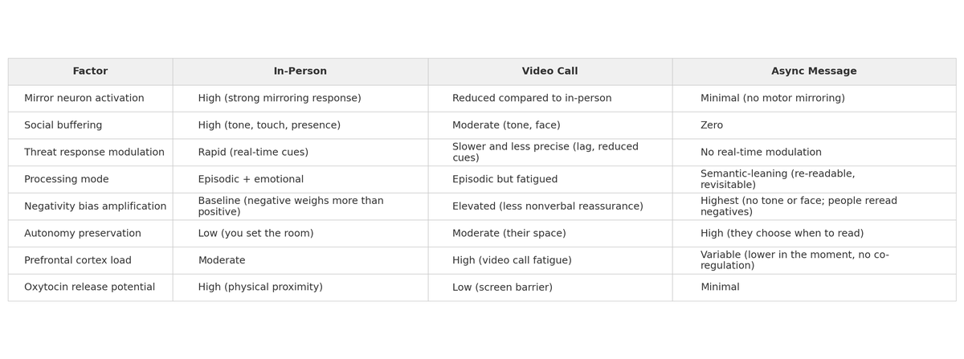
#### What Managers Usually Say vs What to Say Instead
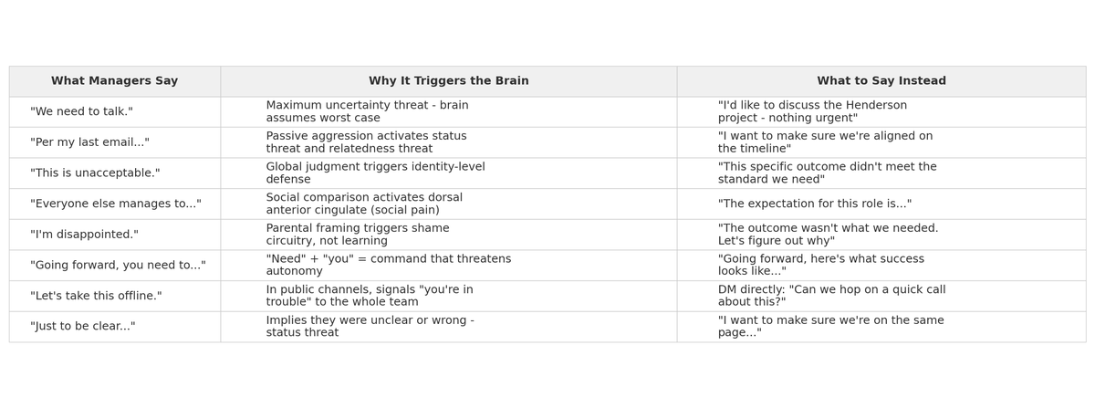
#### Remote Conversation Decision Matrix
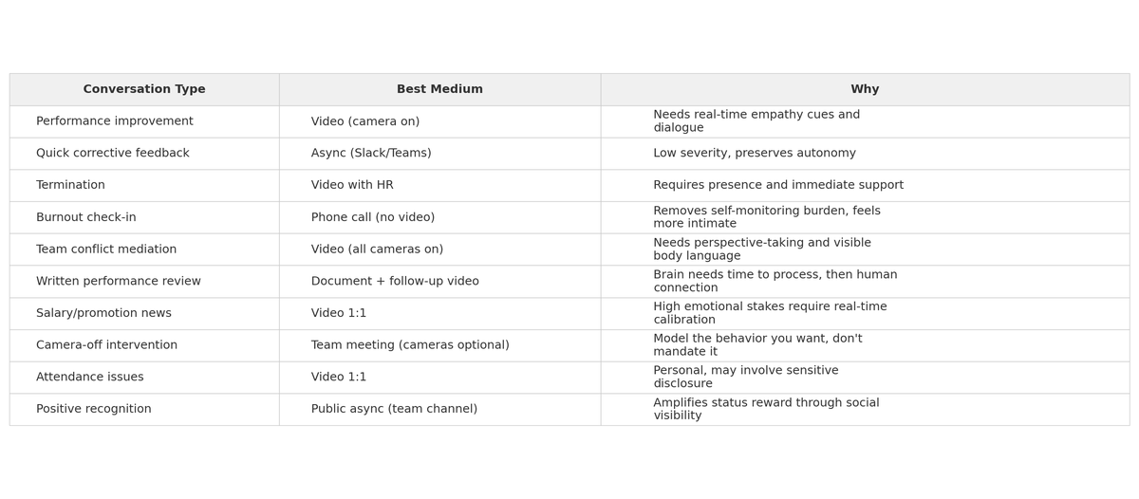

Chapter 11: After the Conversation — The Follow-up Framework
The conversation itself is only 20% of the work. The other 80% is what happens after.
Most managers feel relief when a difficult conversation ends — and that relief becomes inaction. The employee, meanwhile, is processing, re-processing, and watching to see if anything actually changes.

The 48-Hour Rule
Within 48 hours of any difficult conversation, do three things:
1. Document what was discussed.
Send a brief email or message summarizing:
- • What was discussed (factual, not emotional)
- • What was agreed upon
- • What the next steps are
- • When you'll follow up
This serves two purposes: it creates a paper trail (important for HR processes), and it shows the employee that you took the conversation seriously.
Keep the tone warm but professional:
"Hi Alex — I wanted to follow up on our conversation from yesterday. Here's my summary of what we discussed and agreed to: [bullet points]. Let me know if I missed anything or if you'd frame anything differently. Our next check-in is scheduled for [date]. I'm here if you need anything before then."
2. Reflect on your own performance.
Ask yourself:
- • Did I listen more than I spoke?
- • Did I stay calm, or did I get reactive at any point?
- • Was I clear about the expectations and next steps?
- • Did I show genuine empathy?
- • Is there anything I wish I'd said differently?
This isn't self-flagellation — it's calibration. You'll have hundreds of difficult conversations in your career. Each one is a data point for getting better.
3. Check your emotional state.
Difficult conversations are draining. Your own cortisol levels were elevated too. Take five minutes to decompress — walk, breathe, step outside. Don't immediately jump into your next meeting carrying the residue of the previous one.

The Follow-up Cadence
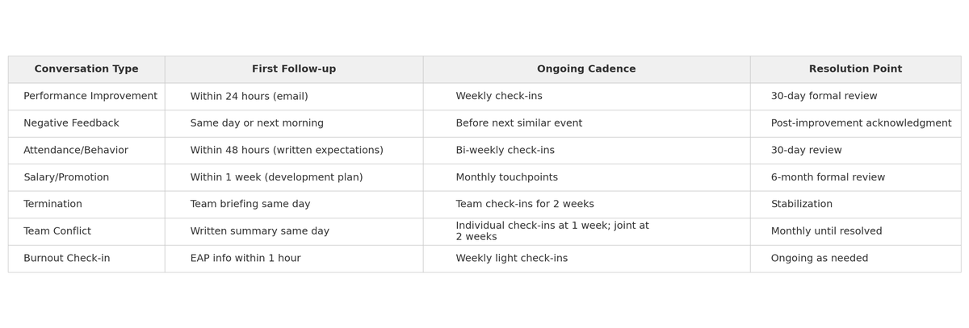

The Critical Principle: Follow-through Is Trust
Neuroscience research on trust formation shows that trust is built through repeated prediction confirmation — the brain trusts people whose behavior matches their words over time. Every time you say "I'll follow up" and then do, you deposit into the trust account. Every time you don't, you withdraw.
After a difficult conversation, the employee's brain is running a prediction: "Did they mean what they said?" Your follow-through is the answer to that question.

Chapter 12: Common Mistakes and How to Avoid Them
After coaching hundreds of managers through difficult conversations, I've seen the same mistakes appear again and again. Here are the most damaging ones, and how to avoid them.

Mistake #1: The Feedback Sandwich
What it is: Wrapping negative feedback between two compliments. "You're great at client relationships. Your reports have had a lot of errors. But you've got such great energy!"
Why it fails: The brain is a pattern-recognition machine. After one or two sandwiches, people start to associate praise with incoming criticism. Over time, this can make them tense up when they hear positive feedback, instead of relaxing into it — the opposite of what you want. They stop trusting your positive feedback entirely.
Instead: Deliver feedback directly and separately from praise. Give positive feedback frequently and genuinely on its own. When you need to give critical feedback, be straightforward: "I need to talk about something that's not working, and I want to address it directly."

Mistake #2: Having the Conversation When You're Angry
What it is: Something happens that frustrates you, and you address it immediately while you're still emotionally activated.
Why it fails: When your amygdala is firing, you lose access to nuance, empathy, and precise language. You say things you don't mean or mean but shouldn't say. Emotions are contagious — when you're visibly angry, their nervous system tends to mirror your state (one proposed mechanism involves the mirror neuron system), and now you have two dysregulated people in a room.
Instead: The 24-hour rule. Unless it's a safety issue, wait at least 24 hours before having a difficult conversation prompted by an emotional trigger. This gives your nervous system time to settle and your prefrontal cortex to come fully back online.

Mistake #3: Being Vague to Be Kind
What it is: Softening the message so much that the employee doesn't actually understand there's a problem. "You might want to think about maybe being a little more mindful of deadlines when you get a chance."
Why it fails: The brain doesn't process hedged language as urgent or important. If everything is "maybe" and "a little," the employee's brain categorizes it as optional. Then when you escalate later, they feel blindsided: "Why didn't you tell me this was serious?"
Instead: Be clear AND kind. They're not opposites. "I need to see all deliverables on time starting this week. I'm telling you this because I want to address it now while it's manageable."

Mistake #4: Having the Conversation in Public
What it is: Giving critical feedback in a meeting, on a group call, in an open office, or even in a Slack channel.
Why it fails: Public criticism is the most potent social threat possible. It combines status threat, relatedness threat, and fairness threat in a single moment. The brain processes public humiliation as one of the most painful experiences a person can have — research on social pain suggests it can activate the same brain systems as physical pain and leave a deep emotional imprint.
Instead: Always in private. Always one-on-one. Even if "everyone knows." Even if you're frustrated. Even if they did it in public. Praise in public, correct in private. This is non-negotiable.

Mistake #5: Not Having the Conversation at All
What it is: Hoping the problem will resolve itself. Telling yourself it's not that bad. Waiting for the annual review.
Why it fails: Problems don't age well. A small gap becomes a chasm. And the employee is denied the opportunity to course-correct, which is fundamentally unfair. If they eventually get fired for something you never clearly communicated, that's on you — not them.
Instead: The 2x rule. If you notice something concerning twice, it's a conversation. Not an email. Not a hint. A direct, private, compassionate conversation.

Mistake #6: Making It Personal
What it is: "You're lazy." "You're disorganized." "You don't care." "You're not a team player."
Why it fails: Character labels activate the brain's self-concept defense — a deep, identity-level threat that triggers the most intense amygdala response. People can change behavior. They cannot change who they fundamentally are (or at least, that's how the brain processes it). So when you label them, their brain hears: "You're defective and there's nothing you can do about it." The only option left is to defend, deny, or withdraw.
Instead: Always behavior and impact. "When you submit reports after the deadline, the client team loses confidence in our accuracy." This gives the brain a solvable problem instead of an existential crisis.

Mistake #7: Failing to Follow Up
What it is: Having the conversation and then never mentioning it again.
Why it fails: Without follow-up, the conversation fades. The employee's brain, seeking to reduce discomfort, will reinterpret the conversation as less serious than it was (this is called motivated reasoning). When the problem recurs and you bring it up again, they're genuinely surprised because their brain has filed it away as resolved.
Instead: Calendar the follow-up before the conversation ends. "Let's plan to check in next Thursday. I'll send a calendar invite." Then show up.

Chapter 13: Quick Reference Card
Print this page and keep it in your notebook, on your desk, or in your phone. These are the essentials.

THE CLEAR FRAMEWORK
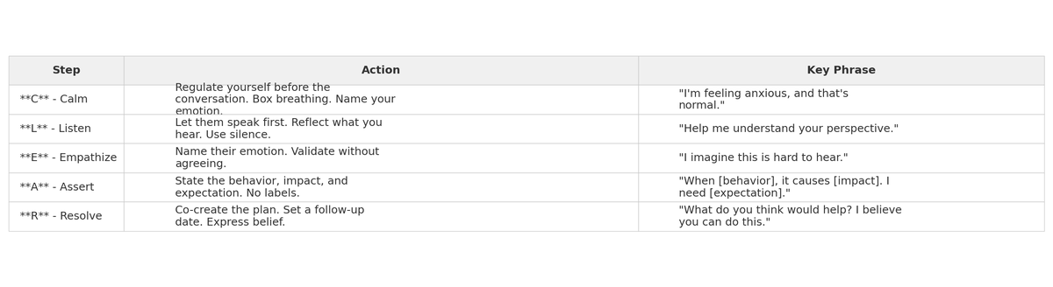

THE SCARF THREAT MODEL (Rock, 2008)
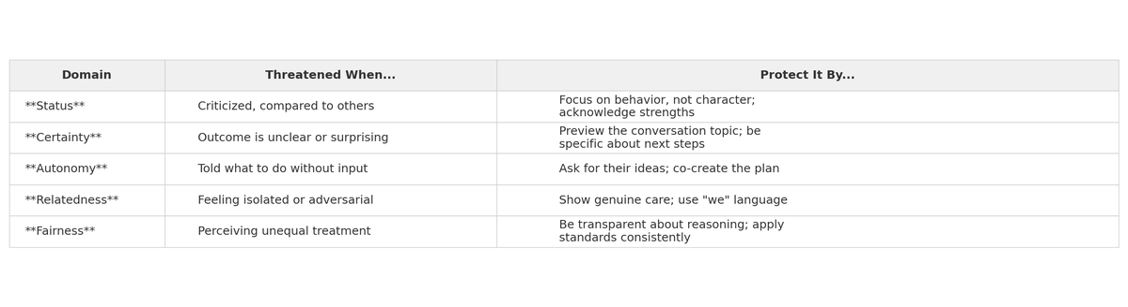

POLYVAGAL STATES — READ THE ROOM (Porges, 1995)
While some aspects of polyvagal theory are debated among researchers, the three-state model remains a practical and widely used framework in clinical and organizational settings.
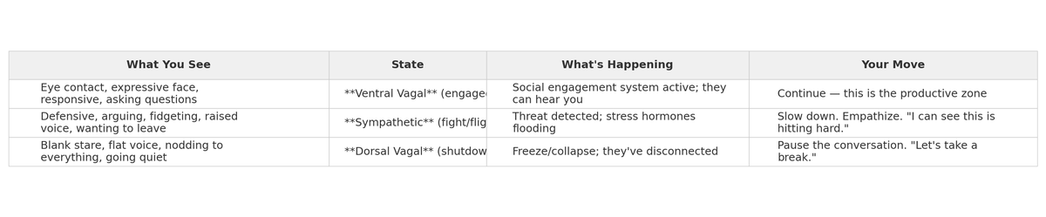

POWER PHRASES FOR DIFFICULT CONVERSATIONS
To open:
- • "I want to have an honest conversation because I respect you."
- • "I've been noticing something I want to talk through with you."
- • "This might be uncomfortable, but my intention is to help."
To listen:
- • "Help me understand your perspective."
- • "Tell me more about that."
- • "What else should I know?"
To empathize:
- • "I imagine this is hard to hear."
- • "I can see this matters to you."
- • "Your feelings make sense to me."
To assert:
- • "When [specific behavior], it creates [specific impact]."
- • "I need to see [specific change] by [specific date]."
- • "I'm telling you this now because I want us to address it while it's still manageable."
To resolve:
- • "What do you think would help?"
- • "What support do you need from me?"
- • "Let's check in on [date]. I'm committed to working through this with you."

PHRASES TO ELIMINATE
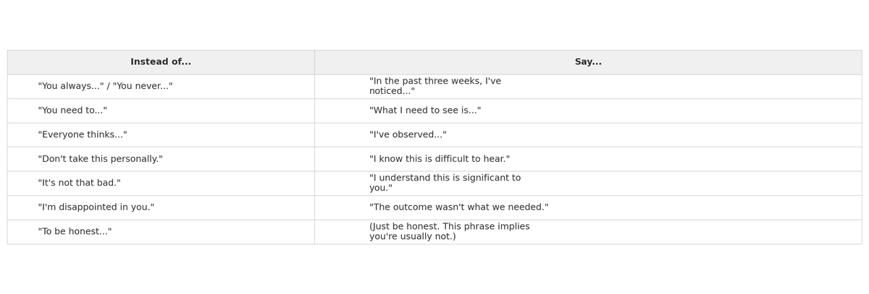

THE 48-HOUR FOLLOW-UP CHECKLIST
- ☐ Send written summary of the conversation
- ☐ Reflect on your own performance
- ☐ Check your emotional state and decompress
- ☐ Calendar the next follow-up conversation
- ☐ Follow through on any commitments you made
- ☐ Watch for changes (positive or negative) in the employee

WHEN TO ESCALATE TO HR
- • The issue involves harassment, discrimination, or safety
- • You're considering termination
- • The employee mentions legal action
- • You've had two clear conversations and the behavior hasn't changed
- • The employee discloses a health, mental health, or personal crisis that requires accommodation
- • You're unsure about the right approach (HR is a resource, not just a last resort)

CONVERSATION TYPE DECISION GUIDE
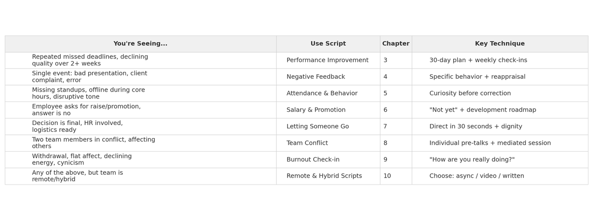

Closing Note
Difficult conversations don't get easy. They get easier. There's a difference.
The first time you sit across from someone and deliver hard feedback, your heart will pound and your mouth will go dry. The fiftieth time, it still won't be comfortable — but you'll have a framework, you'll have the words, and you'll trust yourself to hold the space.
The fact that these conversations are hard is not evidence that you're doing something wrong. It's evidence that you care. The managers who should worry are the ones who feel nothing.
Every difficult conversation you have — done with clarity, empathy, and follow-through — makes your team stronger, your relationships more honest, and your leadership more credible.
You've got the scripts. You've got the science. Now go have the conversation you've been avoiding.
Your team is waiting.

About the Author
Lana Wray is a leadership development strategist and organizational psychologist specializing in remote and hybrid team dynamics. Drawing on neuroscience research and years of hands-on management experience, she creates practical tools that help managers lead difficult conversations with both courage and compassion. Her work focuses on the intersection of brain science and everyday leadership - turning complex research into scripts and frameworks that managers can use immediately. Connect with Lana at lana-wray.com

Did This Book Help You?
If you found these scripts and frameworks useful, please consider leaving a review on Amazon. Reviews help other managers find these tools when they need them most. Even a short review makes a real difference. Thank you for reading.

