SQL RDBMS Implementation for Ecommerce

(with Front End)

# Nabeel Khan

School of Engineering and Applied Science – Data Science

Buffalo, USA

nkhan6@buffalo.edu

# Imran Anwar Rahman Khan

# School of Engineering and Applied Science – Data Science

# Buffalo, USA

# imrananw@buffalo.edu

# Vijaya Rana

# School of Engineering and Applied Science – Data Science

# Buffalo, USA

# vrana3 @buffalo.edu

**ABSTRACT*— In this paper, we discuss the Relational Database implementation for an e-commerce platform. An e-commerce platform needs to store many data points, of users, sellers, customers, orders, delivery times, etc. In this paper, we explain our approach to implementing an RDBMS system for application in an eCommerce system scenario.***

**I. INTRODUCTION**

Storing information in an RDBMS system is helpful for any business, especially e-commerce businesses. It can help them solve many business analytics related problems, such as:

● Top Selling Category of products (Daily, Weekly, Monthly, Yearly)

● Most purchased category by location (city, state)

● Most Popular/Frequent payment method for the users over time:

● Most Valuable payment method of the users over time

● Breakdown of payment type per category

● Breakdown of payment type by location

These figures can help in providing useful insights into the performance of the business and help with important decisions.

**II. E/R DIAGRAM**

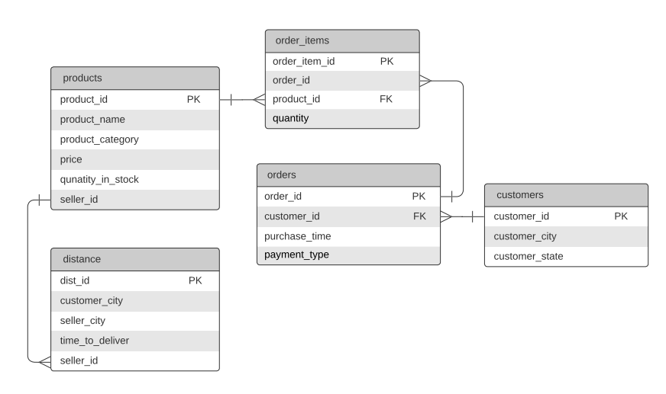

**III. TASKS FOR THE PROJECT**

These are the important listed tasks for the project

* Extract Data from Kaggle and augmented it using Python.
* Data wrangling & cleaning with pandas.
* Validations to maintaining referential integrity
* Dashboard creation to implement run time functionalities
* Unit Testing with all scenarios for the two dashboards results

**IV. STRUCTURE FOR THE DATABASE**

In our database we have final tables with the below functionalities

Products - This table stores the following information:

* product_name
* product_category
* price
* quantity_in_stock.

Orders-This table stores the following information

* payment type
* order id
* customer_id
* purchase time

Customers -This table stores the following information:

* customer_id
* customer_city
* customer_state

Order_items--This table stores the following information:

* order_item_id
* order_id
* product_id
* quantity

Distance-This table store the following information

* distance_id
* customer_city
* seller_city
* time_to_deliver
* seller_id

We **assume** that we have a fixed number of repeated customers who will be placing repeated orders with the business.

**V. FINAL LIST OF TABLES**

To satisfy the BCNF conditions and to implement some new functionalities we modified the existing tables and below is the final 5 tables we are using

* products
* order_items
* distance
* orders
* customers

**VI. JUSTIFICATION OF RELATIONS IN BCNF**

**1 - Customers Relation:**

CREATE TABLE customers(customer_id INT PRIMARY KEY,customer_city VARCHAR(20),customer_state VARCHAR(3));

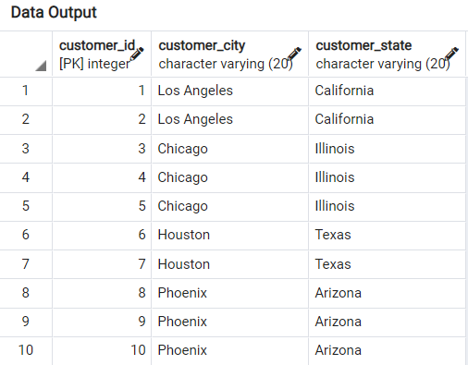

*Valid Functional Dependencies :*

**customer_id → {customer_id, customer_city, customer_state}**

Only one real FD exists with others being subsets or derivations from the above FD.

We can see that here that

* There exists no multi-valued attribute, hence the relation customers is in **1st Normal Form (1NF)**.
* The relation is in 1NF and there exists no partial dependency. There exists no proper subset of the candidate key customer_id, hence there can exist no partial dependency which indicates that the relation is in **2nd Normal Form (2NF).**
* The relation is in 2NF and there also exists no transitive functional dependency for Non Prime Attributes which means that the relation customers in in **3rd Normal Form (3NF).**
* Hence relation is in **3NF**
* If we closure of customer_id

{ customer_id}+ = {customer_city, customer_state}

Therefore, the LHS is a super key as its closure includes all the attributes.

* **Thus we can say relation in BCNF**

**2 - Order_items Relation:**

CREATE TABLE order_items

(

order_item_id UUID PRIMARY KEY DEFAULT uuid_generate_v4(),

order_id INT,

product_id INT,

quantity INT,

FOREIGN KEY (product_id) REFERENCES products(product_id)ON UPDATE CASCADE ON DELETE SET NULL

);

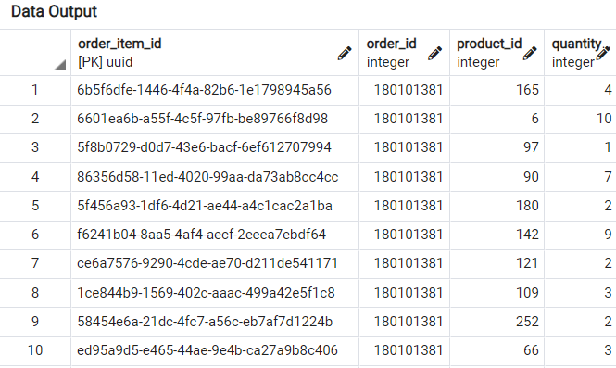

*Valid Functional Dependencies :*

**order_item_id → {order_item_id**, **order_id**, **product_id**, **quantity**}

Only one real FD exists with others being subsets or derivations from the above FD.

We can see that here that

* There exists no multi-valued attribute, hence the relation order_items is in **1st Normal Form (1NF)**.
* The relation is in 1NF and there exists no partial dependency. There exists no proper subset of the candidate key order_items_id, hence there can exist no partial dependency which indicates that the relation is in **2nd Normal Form (2NF).**
* The relation is in 2NF and there also exists no transitive functional dependency for Non Prime Attributes which means that the relation order_items is in **3rd Normal Form. (3NF).**
* Hence relation is in **3NF**
* If we closure of order_item_id

{ order_item_id }+ = {order_item_id, order_id, product_id, quantity}

Therefore, the LHS is a super key as its closure includes all the attributes.

* **Thus we can say relation in BCNF**

**3 - Orders Relation:**

CREATE TABLE orders ( order_id INT PRIMARY KEY,customer_id INT, purchase_time DATE, payment_type VARCHAR(20),FOREIGN KEY (customer_id)

REFERENCES customers(customer_id),FOREIGN KEY (order_id) REFERENCES orders(order_id)ON UPDATE CASCADE ON DELETE SET NULL**);**

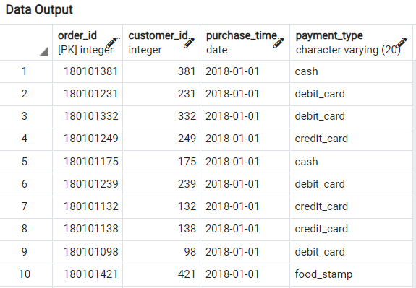

*Valid Functional Dependencies* :

**order_id → {order_id, customer_id, purchase_time,payment_type}**

Only one real FD exists with others being subsets or derivations from the above FD.

We can see that here that

* There exists no multi-valued attribute, hence the relation orders is in **1st Normal Form (1NF)**.
* The relation is in 1NF and there exists no partial dependency. There exists no proper subset of the candidate key order_id, hence there can exist no partial dependency which indicates that the relation is in **2nd Normal Form (2NF).**
* The relation is in 2NF and there also exists no transitive functional dependency for Non Prime Attributes which means that the relation orders is in **3rd Normal Form. (3NF).**
* Hence relation is in **3NF**
* If we closure of **order_id**

{ order_id }+ = {order_id, customer_id, purchase_time,payment_type}Therefore, the LHS is a super key as its closure includes all the attributes.

* **Thus we can say relation in BCNF**

**4 - Products Relation:**

CREATE TABLE products(product_id SERIAL PRIMARY KEY,product_name VARCHAR(32),product_category VARCHAR(32),price REAL,quantity_in_stock INT, seller_id INT );

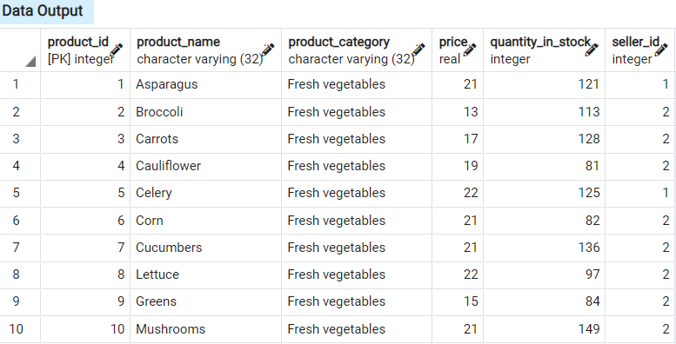

*Valid Functional Dependencies :*

**product_id →**

**{product_id, product_name, product_category, price, quantity_in_stock, seller_id}**

Only one real FD exists with others being subsets or derivations from the above FD.

We can see that here that

* There exists no multi-valued attribute, hence the relation Orders is in **1st Normal Form (1NF)**.
* The relation is in 1NF and there exists no partial dependency. There exists no proper subset of the candidate key product_id, hence there can exist no partial dependency which indicates that the relation is in **2nd Normal Form (2NF).**
* The relation is in 2NF and there also exists no transitive functional dependency for Non Prime Attributes which means that the relation products is in **3rd Normal Form. (3NF).**
* Hence relation is in **3NF**
* If we closure of customer_id

{ product_id }+ = { product_id, product_name, product_category, price quantity_in_stock, seller_id}

Therefore, the LHS is a super key as its closure includes all the attributes.

* **Thus we can say relation in BCNF**

**5 - Distances Relation:**

CREATE TABLE distances

(dist_id INT PRIMARYKEY, customer_city VARCHAR(20), seller_city VARCHAR(20), time_to_deliver INT, seller_idINT **);**

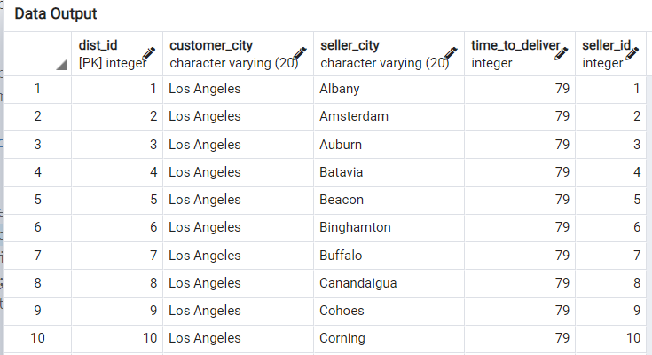

*Valid Functional Dependencies* :

**dist_id → {customer_city, seller_city, time_to_deliver, seller_id}**

Only one real FD exists with others being subsets or derivations from the above FD.

We can see that here that there exists no multi-valued attribute, hence the relation Distances is in **1st Normal Form (1NF)**.

* The relation is in 1NF and there exists no partial dependency. There exists no proper subset of the candidate key transaction_id, hence there can exist no partial dependency which indicates that the relation is in **2nd Normal Form (2NF).**
* The relation is in 2NF and there also exists no transitive functional dependency for Non Prime Attributes which means that the relation transactions is in **3rd Normal Form. (3NF).**
* Hence relation is in **3NF**

**VII. DATASET CHALLENGES FACED & RESOLUTION**

* ***Challenge 1*** *-* Our dataset contains 100,000 orders, and due to scale we found it challenging to insert data in our database, due to erroneous entries.
* ***Solution.*** We used Python for data prepping, missing value handling, erroneous value handling, and datatype correction. Additionally we had to do brainstorming to figure out which attributes we needed to filter out.
* ***Challenge 2 -*** Generating the unique and consistent order_id but different order_item_id at run time from the dashboard was challenging.
* ***Solution -*** We assumed order_id to be a combination of date and customer id, hence all order_items from a customer on a single day will automatically fall into a single unique order_id. This allowed us to keep our frontend simple by only keeping a single order item.

**VIII. DATABASE QUERIES WITH EXECUTION RESULTS**

**Note:** Few variables in these queries were selected from the frontend

**1 - Top N most frequent customers:**

SELECT

orders.customer_id, sum(order_items.quantity * products.price) as total_value FROM orders INNER JOIN order_items ON orders.order_id = order_items.order_id

INNER JOIN products

ON order_items.product_id=products.product_id

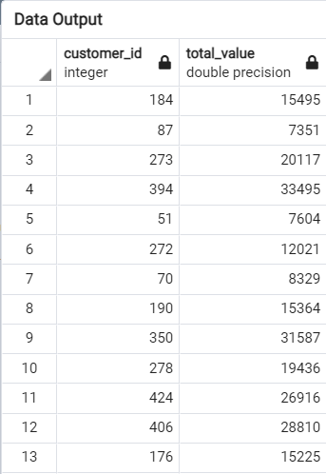

**2 - Top N most selling product_categories (in past M days):**

SELECT

products.product_category, sum(order_items.quantity * products.price) as total_value

FROM order_items

INNER JOIN products ON order_items.product_id = products.product_id

INNER JOIN orders ON orders.order_id = order_items.order_id

WHERE orders.purchase_time > current_date - {m} GROUP BY products.product_category ORDER BY total_value DESC LIMIT {n}

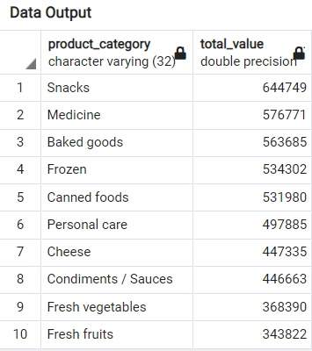

**3 - Mapping of customer IDs with the products that they have bought:**

SELECT customers.customer_id, products.product_name FROM products

INNER JOIN order_items ON products.product_id = order_items.order_id INNER JOIN orders ON order_items.order_id = orders.order_id

INNER JOIN customers ON orders.customer_id = customers.customer_id

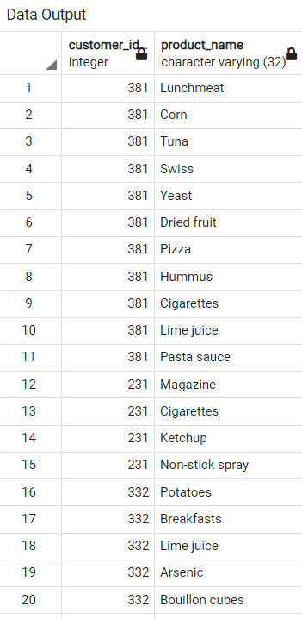

**4 - Inserting data into orders table:**

INSERT into orders (order_id, customer_id, purchase_time, payment_type) VALUES (""" + vals_1 + ") ON CONFLICT DO NOTHING

* These values are taken from the front-end panel

(from the data which the user enters)

**5 - Inserting data into order_items table:**

INSERT into order_items (order_id ,product_id, quantity) VALUES(""" + vals_2 + ")”

* These values are taken from the front-end panel

(from the data which the user enters)

**6 - Calculating the delivery time between seller and customer cities:**

SELECT time_to_deliver, seller_city

FROM distances

WHERE seller_id = {} AND customer_city = {}

**7 - Getting Various Products options**

**(to show on front-end - after user selects the category):**

SELECT DISTINCT product_id, product_name, price, seller_id from products WHERE product_category = '{}'

**IX. QUERY EXECUTION ANALYSIS AND WAYS TO IMPROVE THEM**

**Problematic Query #1:**

Query to get the product_name and product_category for the products sold to customers in states (New York)

SELECT product_name, product_category

FROM products

WHERE product_id IN (SELECT product_id

FROM order_items

WHERE order_id IN(SELECT order_id FROM orders

WHERE customer_id IN(SELECT customer_id

FROM customers

WHERE customer_state IN ('New York'))))

**Run Time = 189 ms**

**OUTPUT**

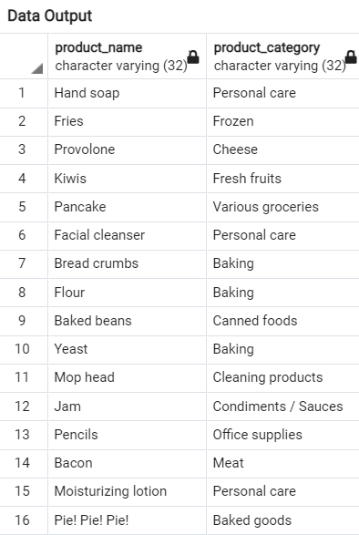

**EXECUTION PLAN**

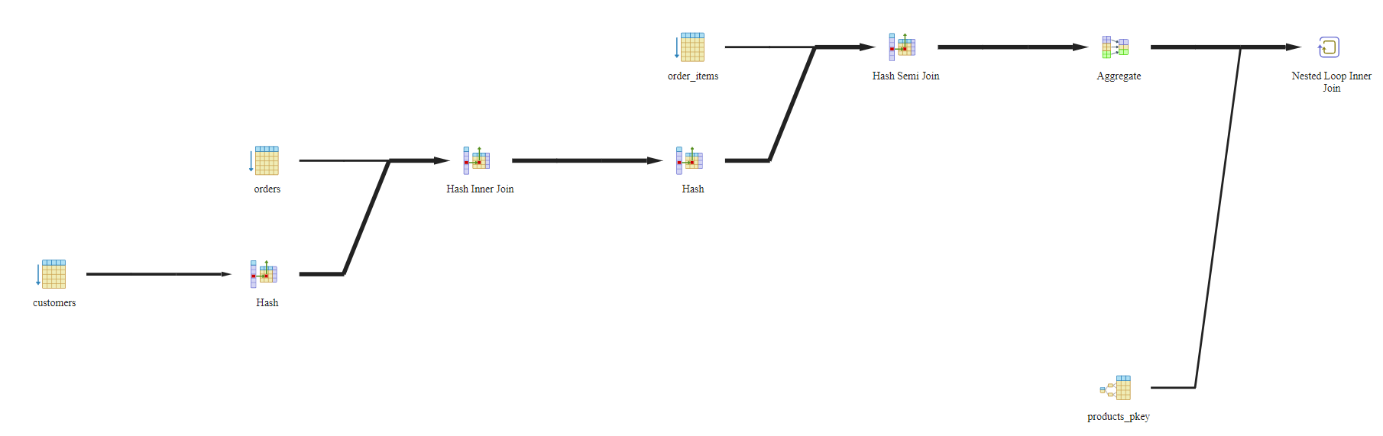

**QUERY PLAN**

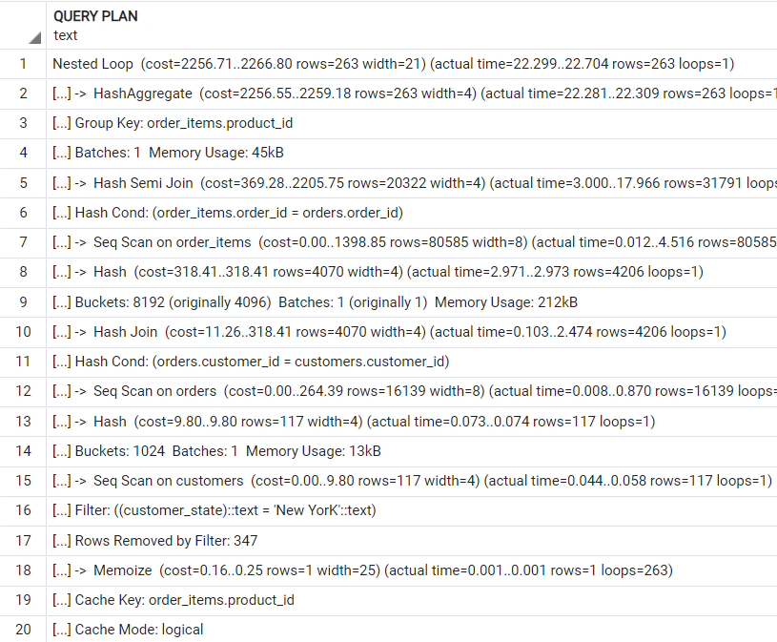

**ANALYSIS**

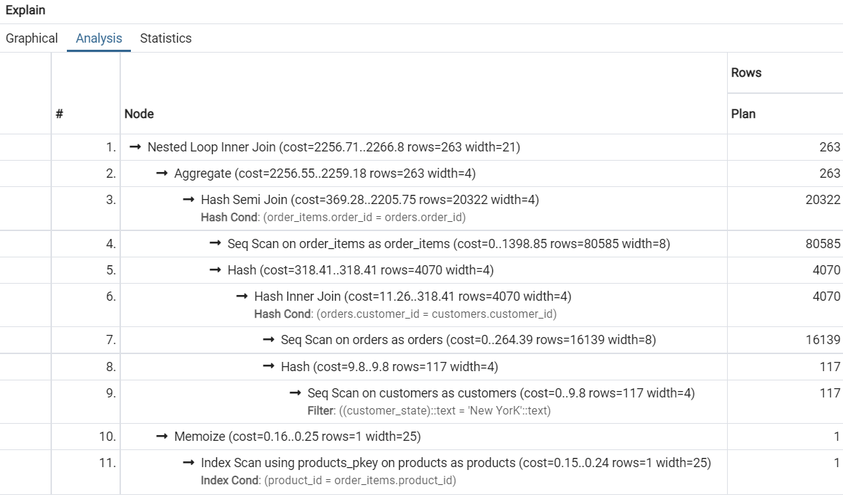

**STATISTICS**

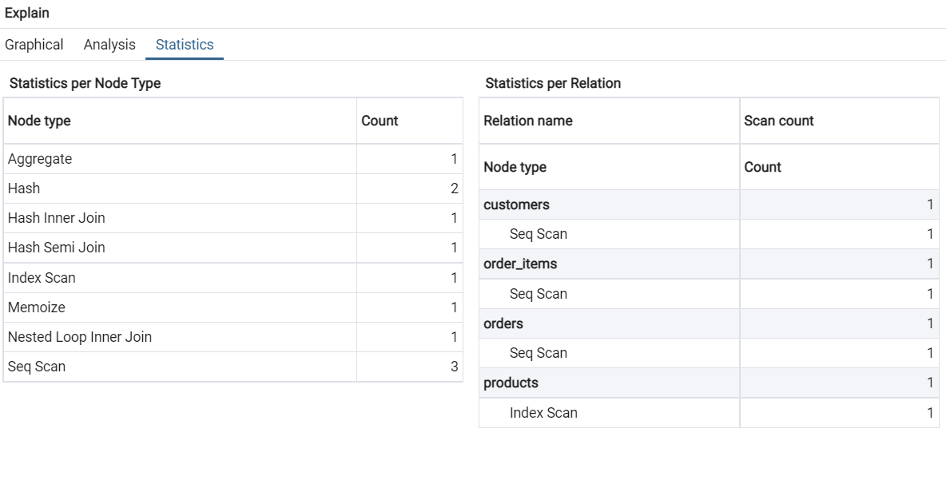

**Note: We achieved the cost of 2256.71 ,which we will try to improve**

**Improvement for Problematic Query #1:**

CREATE INDEX ind ON products(product_id)

SELECT product_name,product_category FROM products

INNER JOIN order_items ON products.product_id = order_items.product_id

INNER JOIN orders ON orders.order_id = order_items.order_id INNER JOIN customers ON customers.customer_id = orders.customer_id

WHERE customers.customer_state IN ('New York')

**Run Time = 70ms**

**EXECUTION PLAN**

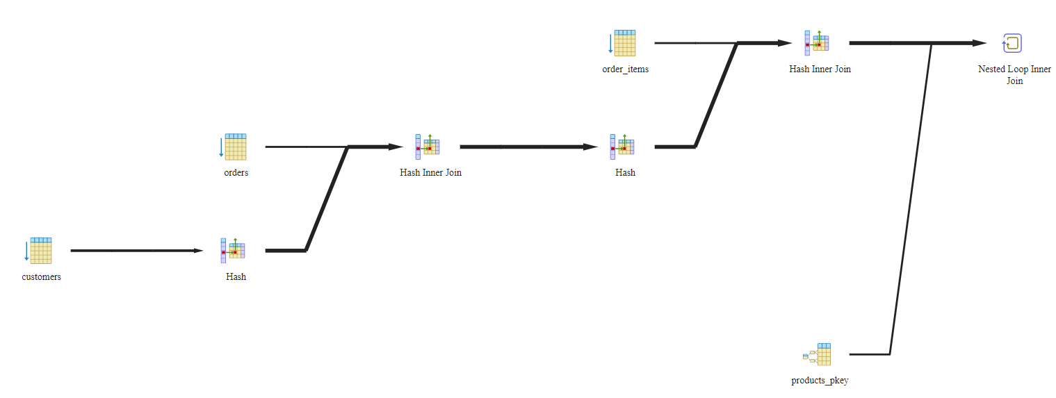

**STATISTICS**

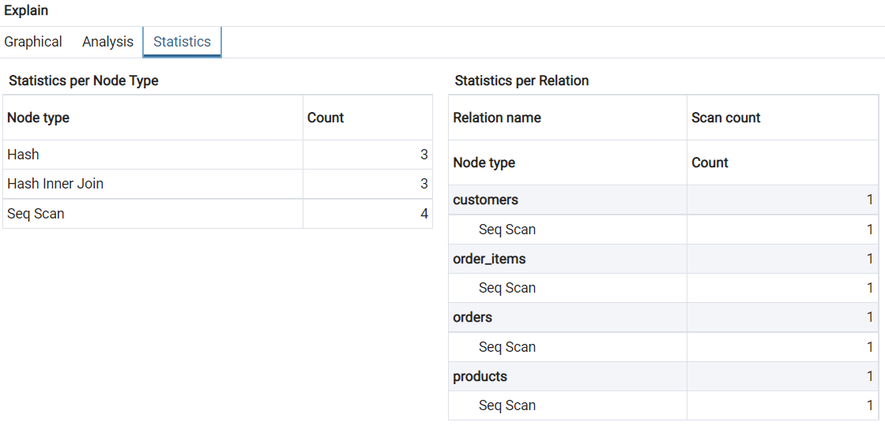

The nested query is seen to take a lot of cost. This can be improved. We made the nested query into a natural join query in addition to adding an index for the product_id column in the products relation.

Note:We achieved the cost of 378.22 ,which is highly improved

**Problematic Query #2:**

SELECT DISTINCT distances.seller_id, distances.seller_city FROM distances

INNER JOIN products ON distances.seller_id = products.seller_id

INNER JOIN order_items ON products.product_id =order_items.product_id

INNER JOIN orders ON order_items.order_id = orders.order_id

INNER JOIN customers ON customers.customer_id = orders.customer_id

WHERE customers.customer_state = 'NY'

SELECT DISTINCT seller_id,seller_city

**Run Time = 965ms**

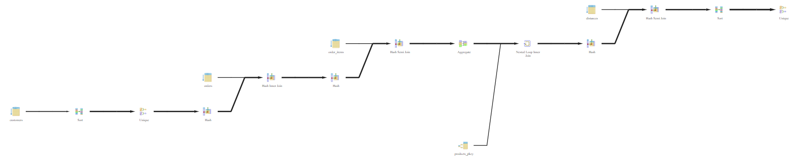

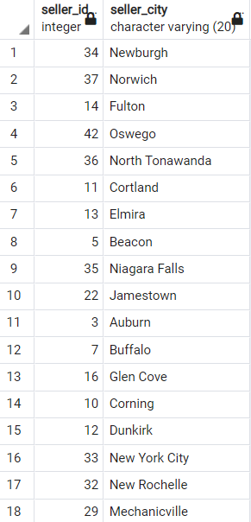

**ANALYSIS**

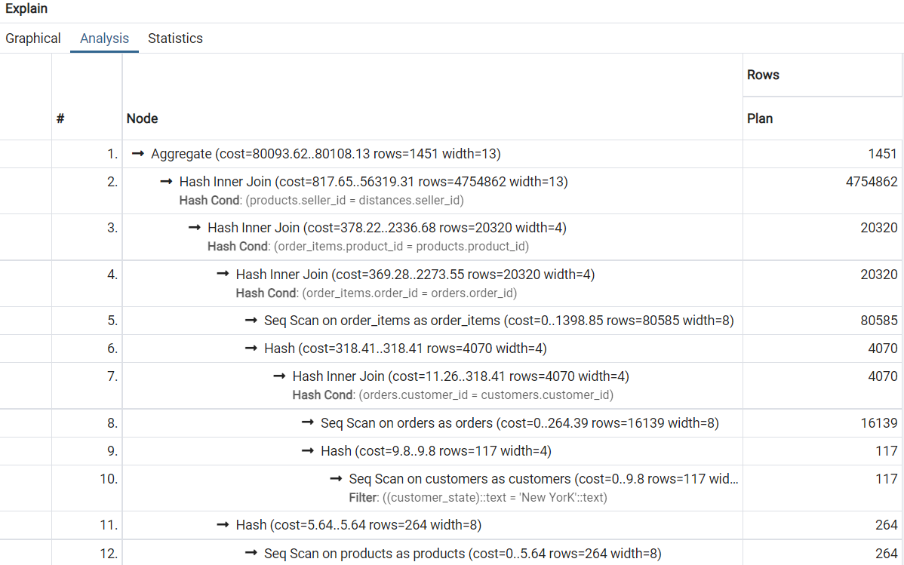

**STATISTICS**

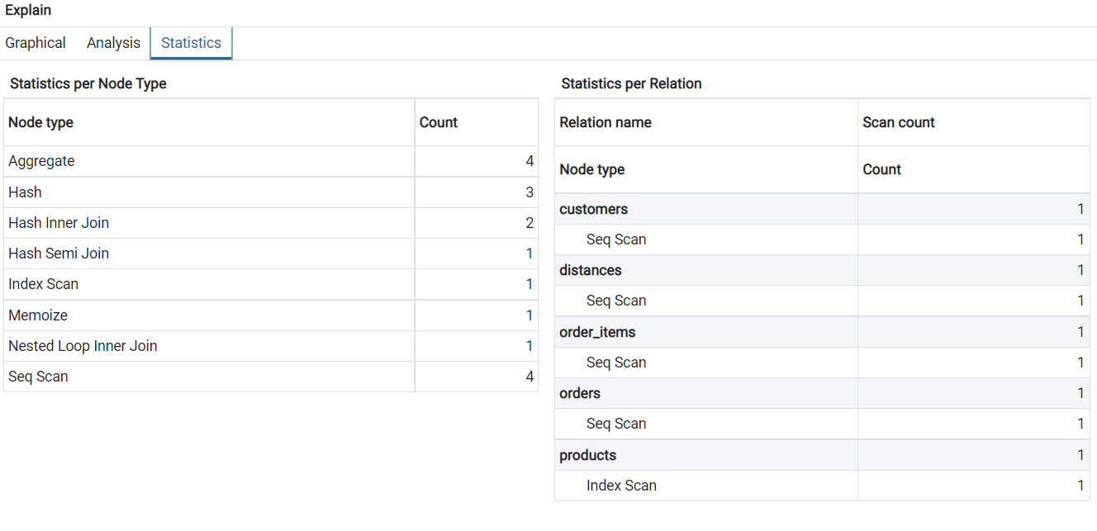

Note:We achieved the cost of 2725.68 ..2740 ,which we will try to improve

**Improvement for Problematic Query #2:**

FROM distances WHERE seller_id IN

(SELECT seller_id FROM products

WHERE product_id IN

(SELECT product_id FROM order_items

WHERE order_id IN(SELECT order_id FROM ORDERS WHERE customer_id IN

(SELECT DISTINCT customer_id FROM customers WHERE customer_state = 'NY'))))

**RUN TIME: 65 ms**

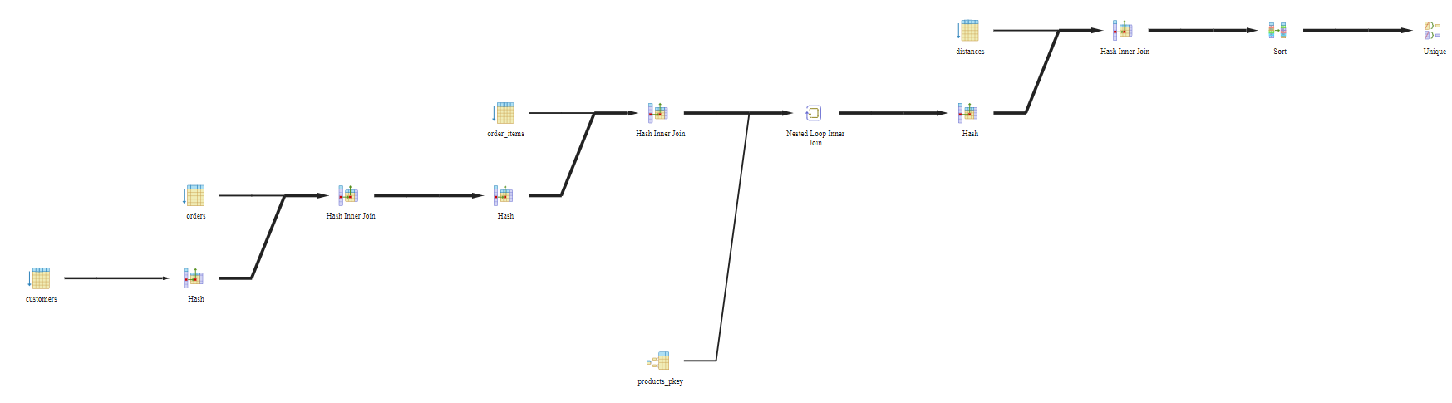

**ANALYSIS**

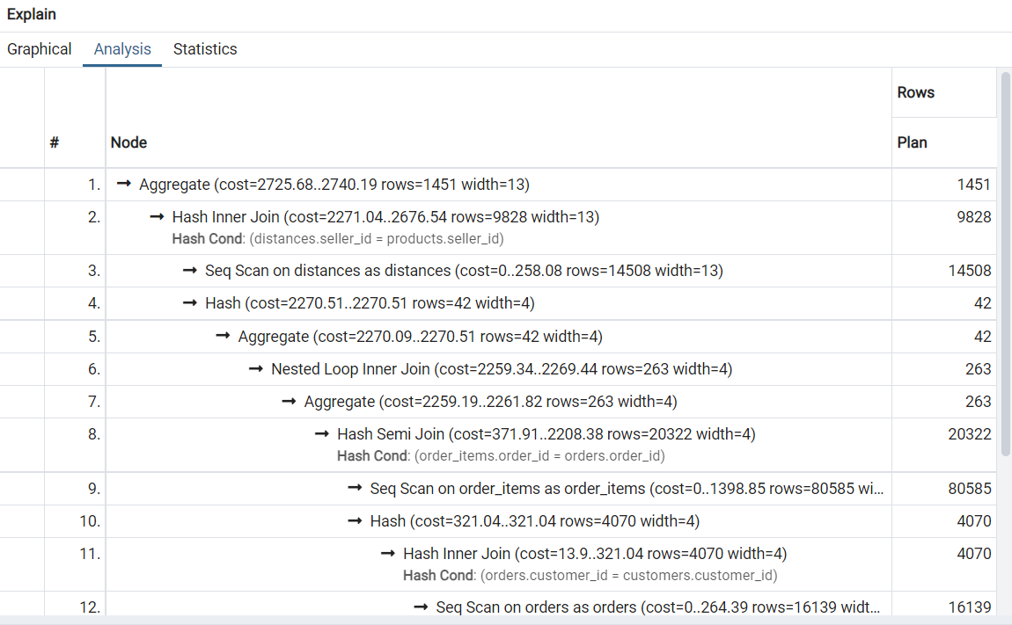

**STATISTICS**

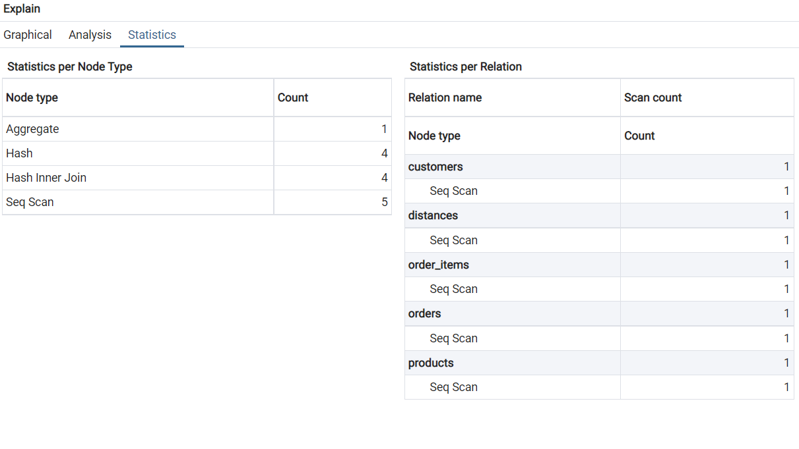

**SOLUTION APPROACH**

The nested query is seen to take a lot of cost. This can be improved. This can be improved.We made the second nested query into a natural join query in addition to adding an index for the num purchases column in the places relation.

**Problematic Query #3:**

SELECT customers.customer_id, products.product_name FROM products

INNER JOIN order_items ON products.product_id = order_items.order_id INNER JOIN orders ON order_items.order_id = orders.order_id

INNER JOIN customers ON orders.customer_id = customers.customer_id

**Run Time = 103 ms**

**OUTPUT**





**ANALYSIS**

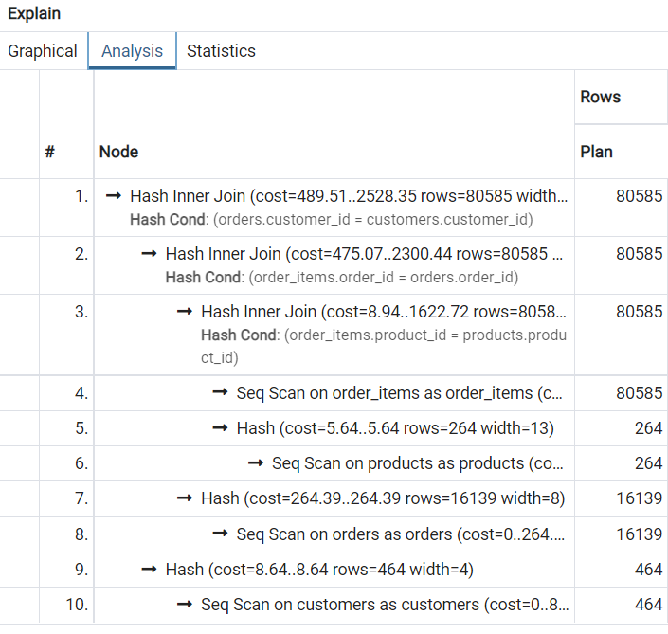

**STATISTICS**

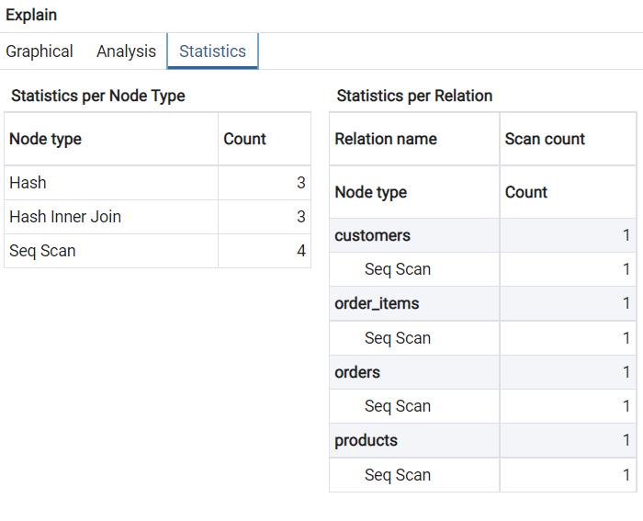

**Improvement for Problematic Query #3:**

SELECT customers.customer_id, products.product_name FROM products

INNER JOIN order_items ON products.product_id = order_items.product_id INNER JOIN orders ON order_items.order_id = orders.order_id

INNER JOIN customers ON orders.customer_id = customers.customer_id

**Run Time = 48 ms**

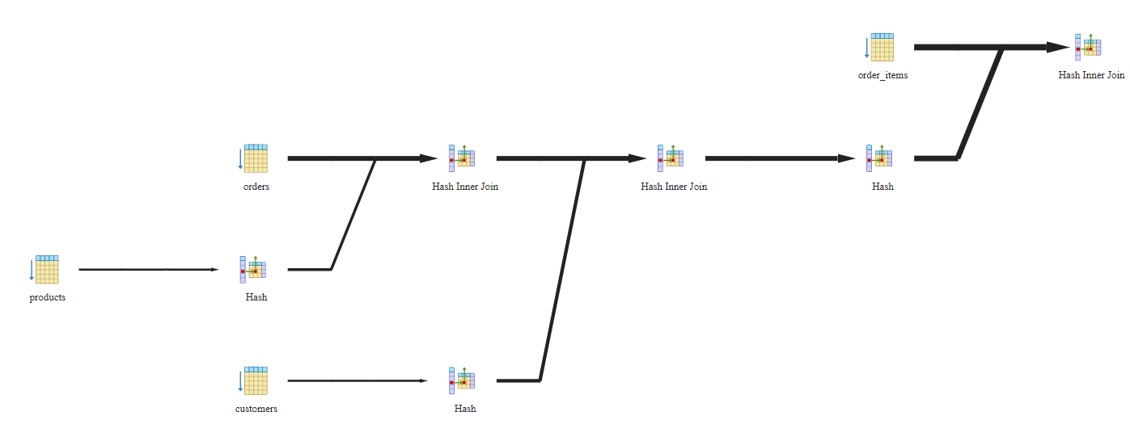

**ANALYSIS**

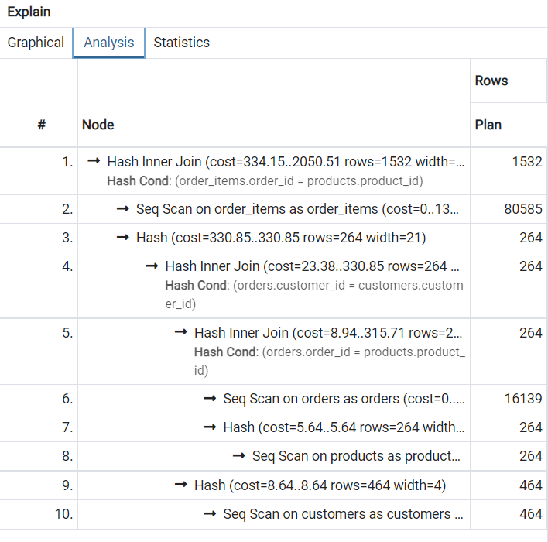

**STATISTICS**

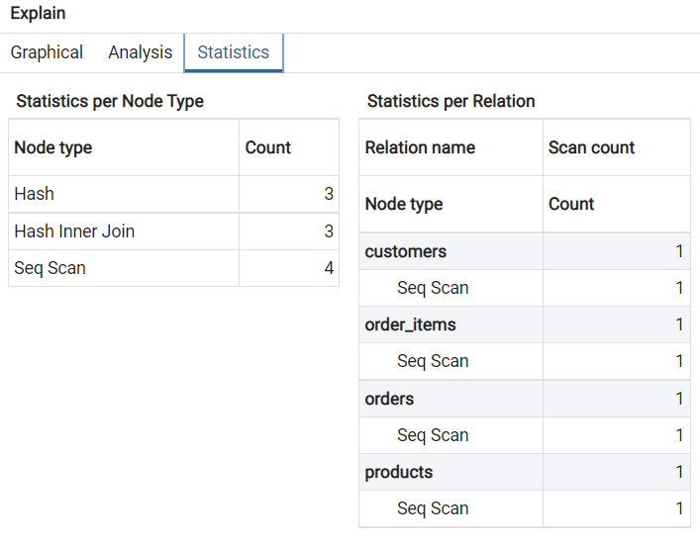

**SOLUTION APPROACH**

The nested query is seen to take a lot of cost. This can be improved. The filter places.numwebpurchases > 15 also takes a considerable amount of time. This can be improved.

We made the second nested query into a natural join query in addition to adding an index for the numwebpurchases column in the places relation.

**X. FRONT END**

We have implemented two dashboard functionality for end to end process to give more realistic impact

**1- Customer portal**

This helps the customer this help customer to place the order.We have implemented additional 3 functionality (highlighted yellow) as below

* Functionality to calculate the delivery time
* Functionality to calculate the total price
* Functionality to add more items to cart and accordingly new price will be updated 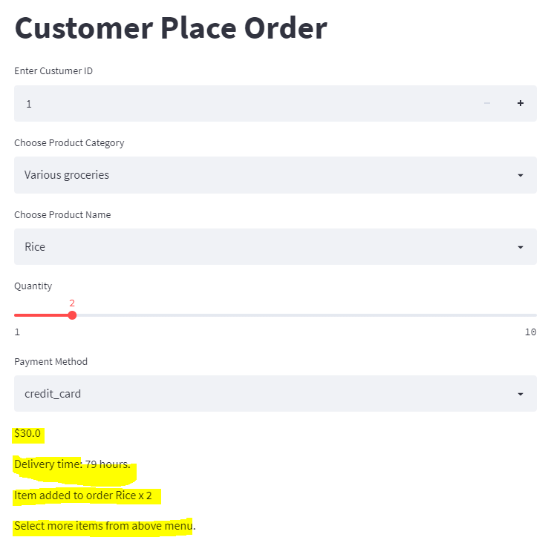

Fig 1.1

***2:* Summary dashboard**

This helps to give the overall picture of the customer and purchase and revenue.We implement below functionalities

* On the basis of the number of previous days selected,we can choose the number of records we want to see.

Now using this we can see the top n customers,products_categories

* Additionally we are calculating the total purchase of top

customers,and total purchase within each top product category

* Functionality to view the above statistics as bar graph
* Functionality to view the monthly revenue generated on the basis of number of orders placed and there price.

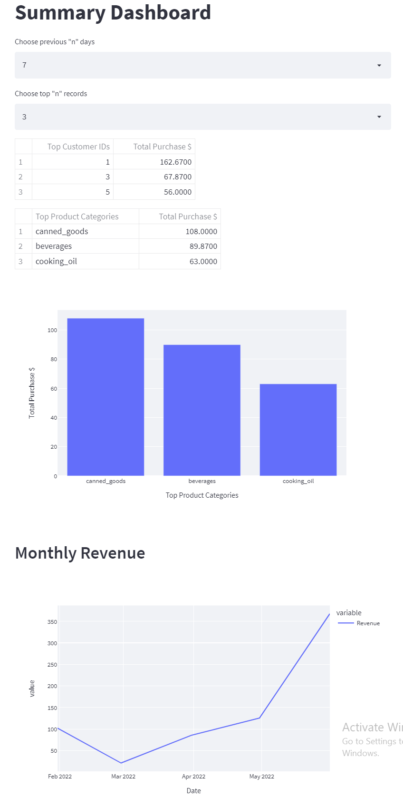

Fig 1.2

**WEBSITE URL REFERENCES**

* Hosted Static version of the frontend <https://lanbeee.github.io/DMQL>
* Olist dataset <https://www.kaggle.com/datasets/olistbr/brazilian-ecommerce>
* Olist company profile

<https://pitchbook.com/profiles/company/102473-65#signals>

* Brazil - Market Challenges. Retrieved July 01, 2021

<https://www.trade.gov/country-commercial-guides/brazil-market-challenges>

**M .TEAM MEMBERS CONTRIBUTION**

We all contributed equally overall. Nabeel mostly handled frontend, Imran handled problematic queries, and Vijaya handled database and frontend interaction.