第二次作业

42312229 常馨

#### 数据记录与分析

记录以下场景的 Log 输出：

应用启动



Main→SecondActivity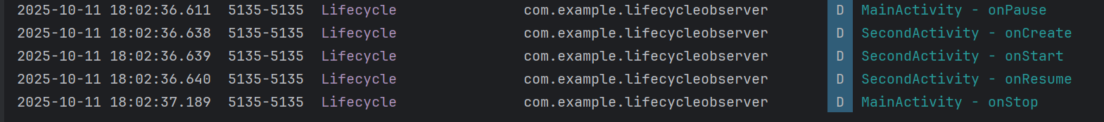

SecondActivity 返回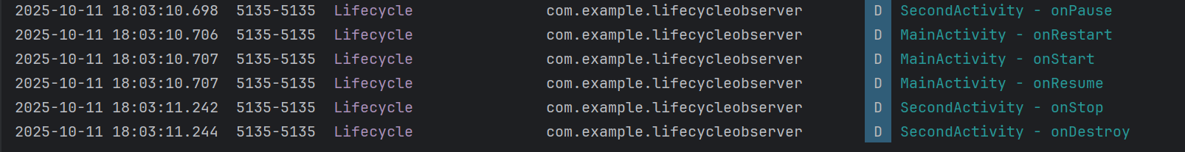

Main→DialogActivity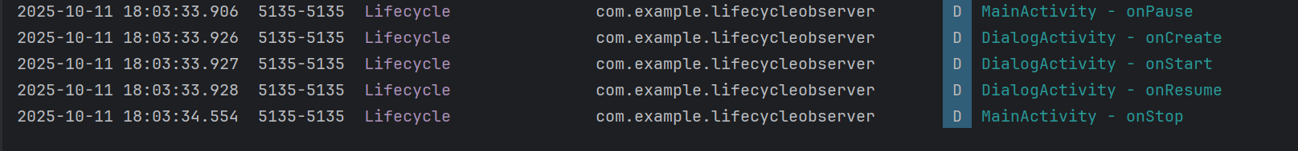

Dialog Activity 返回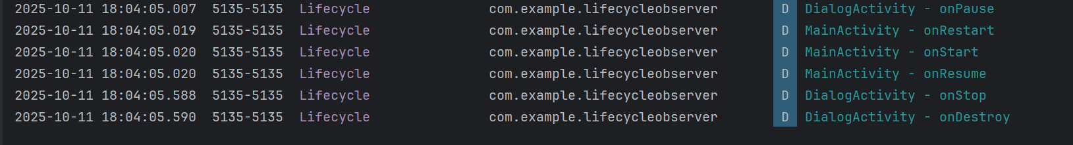

| **场景** | **MainActivity 生命周期顺序** | **目标Activity 生命周期顺序** |
| --- | --- | --- |
| 应用启动 | MainActivity - onCreate  MainActivity - onStart  MainActivity - onResume |  |
| Main → SecondActivity | MainActivity - onPause  MainActivity - onStop | SecondActivity - onCreate  SecondActivity - onStart  SecondActivity - onResume |
| SecondActivity 返回 | MainActivity - onRestart  MainActivity - onStart  MainActivity - onResume | SecondActivity - onPause  SecondActivity - onStop  SecondActivity - onDestroy |
| Main → Dialog Activity | MainActivity - onPause | DialogActivity - onCreate  DialogActivity - onStart  DialogActivity - onResume |
| Dialog Activity 返回 | MainActivity - onResume | DialogActivity - onPause  DialogActivity - onStop  DialogActivity - onDestroy |