结果截图：
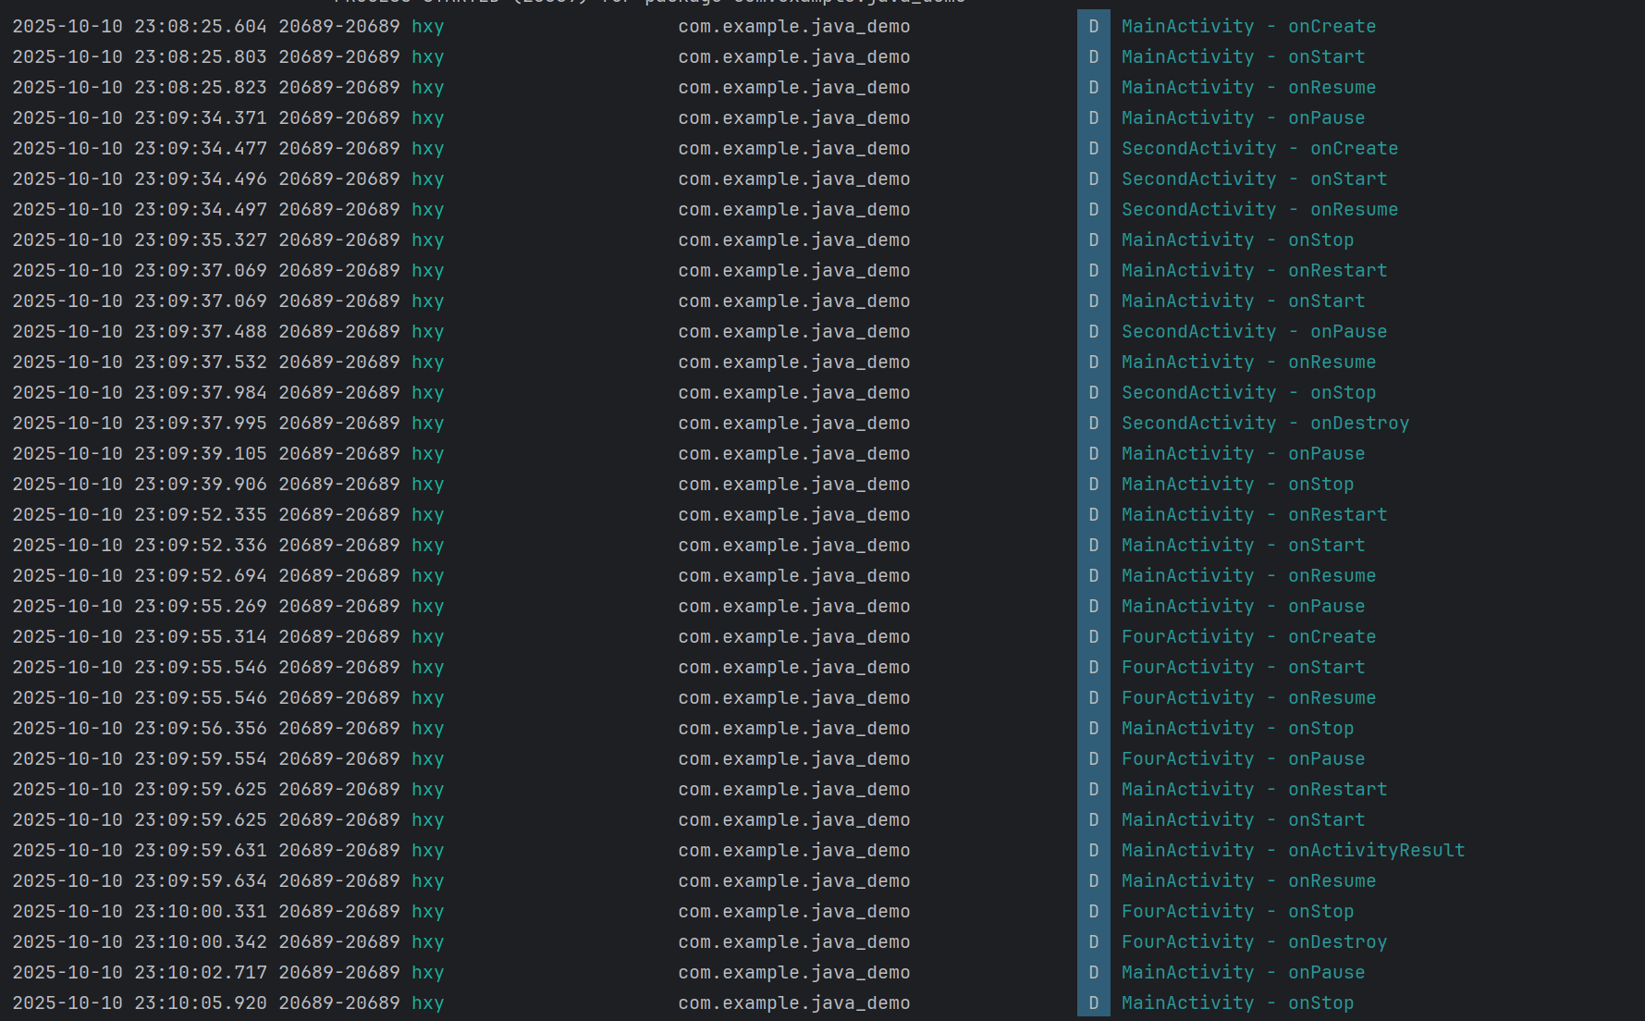

记录以下场景的 Log 输出：

场景 | MainActivity 生命周期顺序 | 目标Activity 生命周期顺序
应用启动 | onCreate → onStart → onResume | -
Main → SecondActivity | onPause → onStop | onCreate → onStart → onResume
SecondActivity 返回 | onRestart → onStart → onResume | onPause → onStop → onDestroy
Main → Dialog Activity | onPause | onCreate → onStart → onResume
Dialog Activity 返回 | onRestart → onStart → onResume | onPause → onStop → onDestroy

