结果截图：

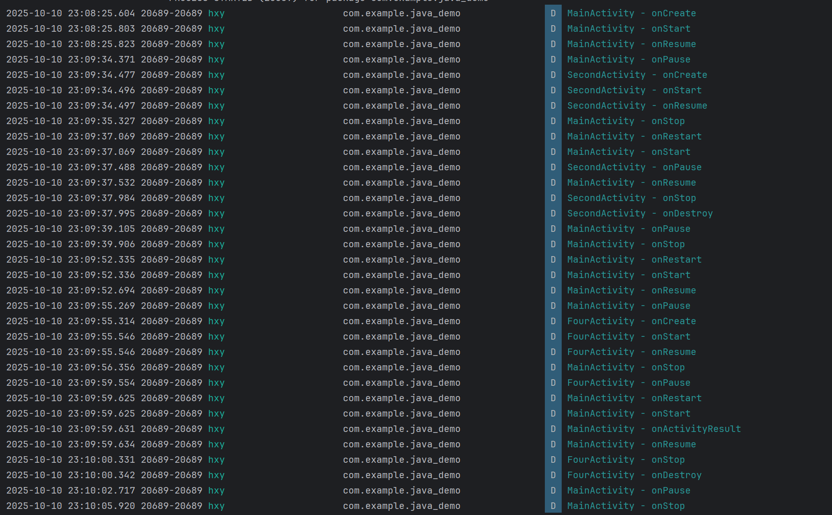

记录以下场景的 Log 输出：

| 场景 | MainActivity 生命周期顺序 | 目标Activity 生命周期顺序 |
| --- | --- | --- |
| 应用启动 | onCreate → onStart → onResume | - |
| Main → SecondActivity | onPause → onStop | onCreate → onStart → onResume |
| SecondActivity 返回 | onRestart → onStart → onResume | onPause → onStop → onDestroy |
| Main → Dialog Activity | onPause | onCreate → onStart → onResume |
| Dialog Activity 返回 | onRestart → onStart → onResume | onPause → onStop → onDestroy |