## Android第二次作业

实验截图：

1、启动应用：

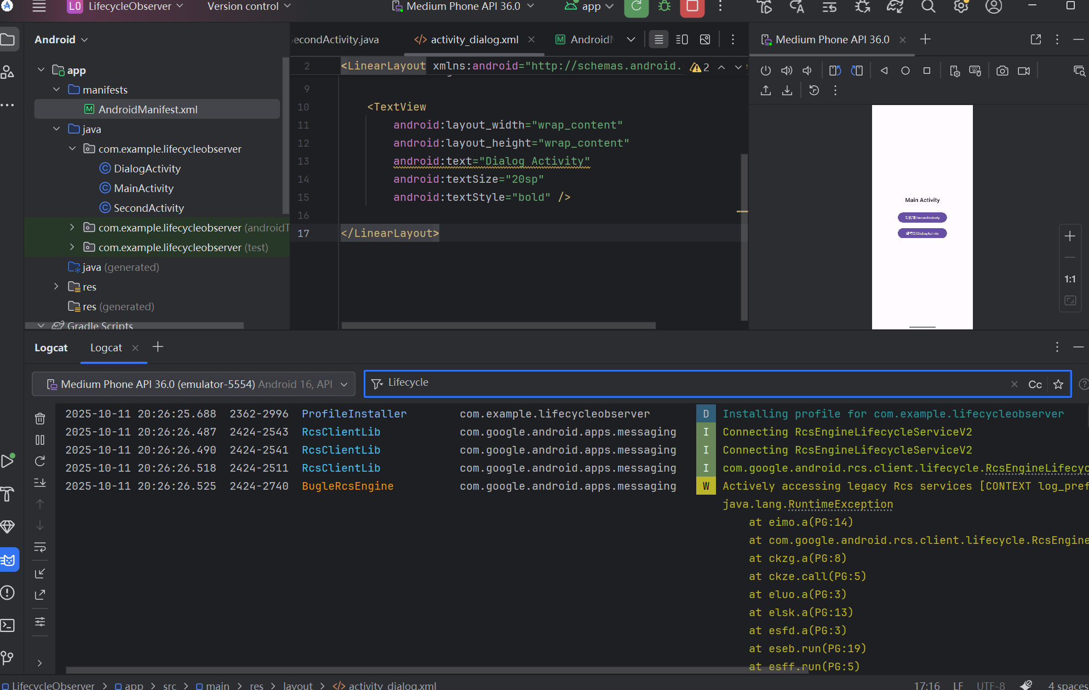

2、跳转到SecondActivity

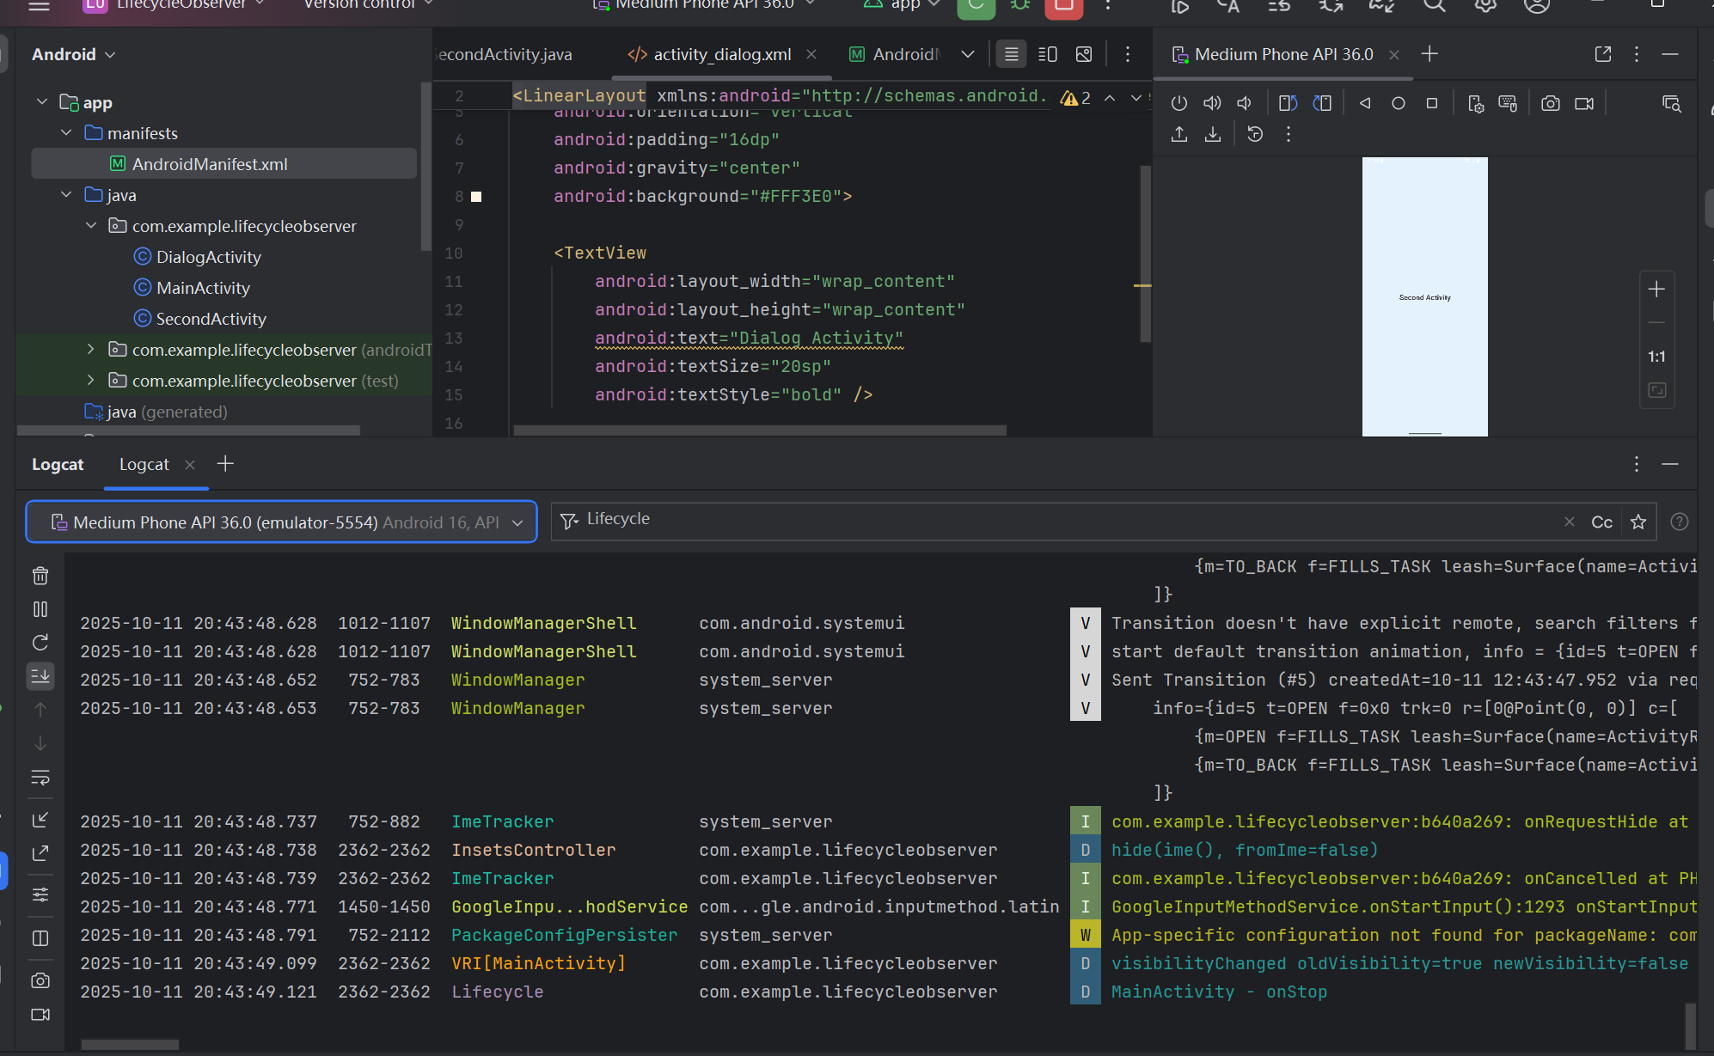

3、跳转到DialogActivity

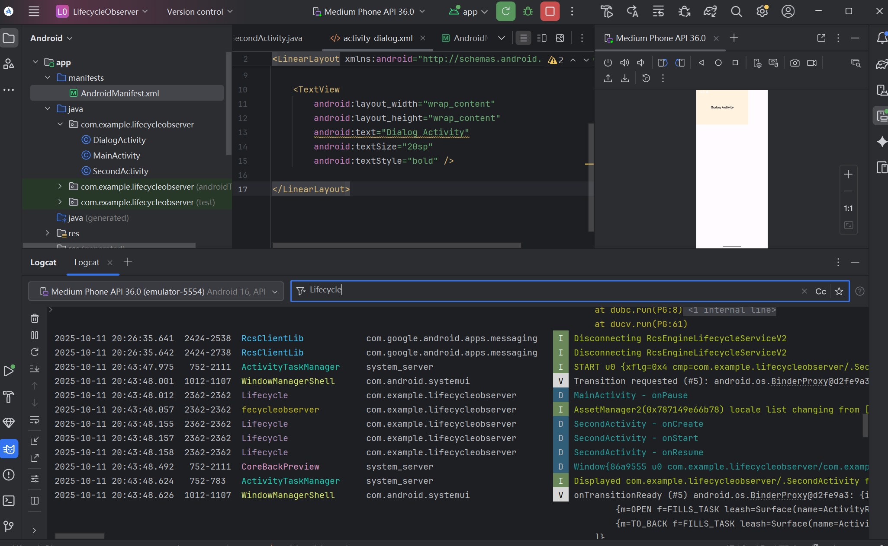

| **场景** | **MainActivity 生命周期顺序** | **目标Activity 生命周期顺序** |
| --- | --- | --- |
| 应用启动 | onCreate → onStart → onResume |  |
| Main → SecondActivity | onPause → onStop | onCreate → onStart → onResume |
| SecondActivity 返回 | onRestart → onStart → onResume | onPause → onStop → onDestroy |
| Main → Dialog Activity | onPause | onCreate → onStart → onResume |
| Dialog Activity 返回 | onResume | onPause → onStop → onDestroy |