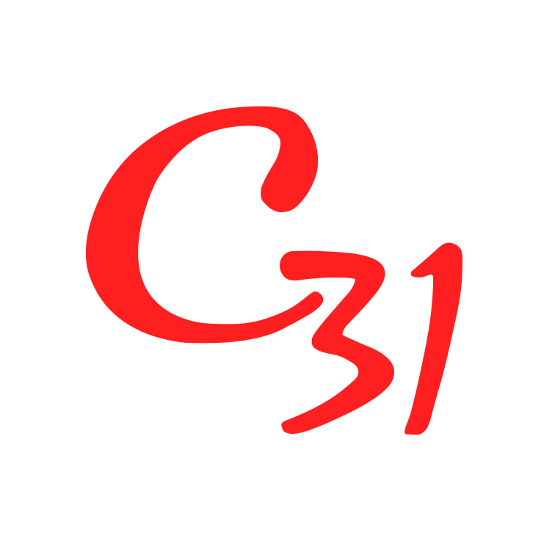
SOCIAL MEDIA & INTELLECTUAL PROPERTY MANAGEMENT AGREEMENT
(Constitution & Class Secretary Aligned Version)

This Agreement is entered into on this ___ day of __________ 202__ (“Effective Date”).
BETWEEN
CAPE PERFORMANCE SAILING (PTY) LTD (“CPS”)
and
CAPE 31 INTERNATIONAL CLASS ASSOCIATION, acting through its International Executive Committee (“Ex Comm”) (the “Association”).
CPS and the Association are collectively referred to as the “Clients”.
AND
[Full Legal Name], acting in their professional capacity and, where applicable, appointed as Class Secretary (the “Manager”).

1. Status & Constitutional Alignment
This Agreement supplements and operates in conjunction with:
• the Cape 31 International Class Constitution
• the Class Secretary Appointment Agreement
• any governance policies adopted by the International Executive Committee.
If any inconsistency arises:
1. The Constitution shall prevail
2. The Class Secretary Appointment Agreement shall prevail next
3. This Agreement shall apply to the extent consistent with the above.
Nothing in this Agreement modifies the governance authority of the International Executive Committee.

2. Authority
The Manager acts under the oversight of:
• the International Executive Committee for Association matters
• Cape Performance Sailing (Pty) Ltd for builder and commercial matters.
The Manager shall not bind either Client to contractual obligations without written authority.

3. Scope of Services
The Manager shall provide digital communications and media management services including:
• content creation for official communication channels
• newsletter administration and distribution
• management of official social media platforms
• coordination of digital media relating to class activities
• support for communications relating to regattas and class initiatives
Official channels may include Instagram, Facebook, LinkedIn, the class website and one monthly newsletter unless otherwise agreed.
All strategic communications or official announcements must be approved by the Executive Committee or CPS prior to publication unless agreed communication guidelines apply.

4. Third‑Party Media & Licensed Assets
Where third‑party assets are used including photography, music, fonts, licensed media or video content, ownership shall remain with the original rights holder and use shall be governed by the applicable licence.
The Manager shall take reasonable steps to ensure such assets are properly licensed.

5. Intellectual Property
Association Intellectual Property
The Association retains ownership of governance‑related intellectual property including class documents, communications and publications.
CPS Intellectual Property
CPS retains ownership of builder and commercial intellectual property including yacht design rights, trademarks and commercial branding.
Created Content
Content created under this Agreement shall vest in the relevant Client depending on subject matter.
The Manager may retain copies of non‑confidential work for portfolio purposes.

6. Sponsorship & Brand Protection
Sponsorship and promotional rights relating to the Cape 31 brand remain subject to:
• the intellectual property rights of CPS as builder and brand owner
• the governance authority of the Cape 31 International Class Association.
Where sponsorship agreements exist, media content produced under this Agreement may support sponsor promotion in accordance with class marketing plans approved by the Executive Committee.

7. Data Protection
Association – Data Controller for membership data.
CPS – Data Controller for commercial data.
Manager – Data Processor when handling personal data.
The Manager shall comply with applicable data protection legislation including GDPR and POPIA.

8. Account Security
All official accounts must use official email addresses and two‑factor authentication.
At least one administrator appointed by the Executive Committee must retain administrative access to all official digital platforms.

9. Handover
Upon termination or removal of the Manager, all account credentials, archives, databases and access rights must be transferred immediately to the Clients and confirmed in writing.

10. Confidentiality
Confidential information obtained under this Agreement must not be disclosed.
Confidentiality obligations survive termination for five (5) years.
The Manager may display non‑confidential work for professional portfolio purposes.

11. Force Majeure
Neither party shall be liable for failure to perform obligations due to events beyond reasonable control.

12. Indemnity & Liability
The Manager indemnifies the Clients against claims arising from unauthorized representations, willful misconduct, gross negligence or knowing infringement of intellectual property rights.
The Clients indemnify the Manager against claims arising from materials or instructions provided by the Clients.
The Manager’s liability shall not exceed the total fees paid in the preceding twelve (12) months.

13. Termination
Either party may terminate this Agreement with thirty (30) days written notice.
Where the Manager also holds the role of Class Secretary, removal must comply with Clause 7.10 of the Constitution.

14. Governing Law
This Agreement is governed by the laws of the Republic of South Africa.

Signatures
For Cape Performance Sailing (Pty) Ltd
Signature: __________________
Date: __________
For Cape 31 International Class Association
Signature: __________________
Date: __________
For the Manager
Signature: __________________
Date: __________

