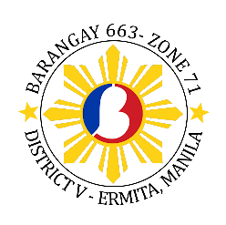
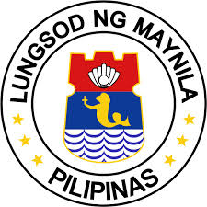

REPUBLIC OF THE PHILIPPINES
City of Manila
Barangay 663 Zone 71 District V

OFFICE OF THE Sangguniang BARANGAY

BARANGAY OFFICIALS

Nixon C. Constantino
Punong Barangay

KAGAWAD

Erlinda C. Constantino

Myra Mildred L. Tolentino

Ferdinand D. Dulatre

Paulo R. Lopez

Jerry A. Urgel

Dianalyn L. Julio

Rio R. Manikad

Jonas E. Labrador
SK Chairman

Fria Karthe L. Shapit
Secretary

Agnes S. Fuentes
Treasurer

Not valid if no official
Barangay 663 Seal here

CERTIFICATE OF INDIGENCY

This is to certify that {firstName} {middleName} {lastName}, of legal age, is a resident and registered voter of this barangay with a postal address of {address}, Ermita, Manila, whose income is not enough to meet their day-to-day needs. !(Edit Pronoun) is known to me as a person with good moral character.

This certification is issued upon the request of the above- mentioned person for {purposeOfRequest} only.

Issued this {currentDate} in the City of Manila.

NIXON C. CONSTANTINO
Punong Barangay

