**HW6a — Task Selection Report**

Tae-Woong Lance Choe  
[lancecho@umich.edu](mailto:lancecho@umich.edu)

**Overview and Justification:**

I have chosen to contribute to the project "Xournal++" for this assignment. Xournal++ is an open-source note-taking software designed for Unix-like operating systems. It offers users the ability to take handwritten notes, annotate PDF files, and sketch diagrams, providing a versatile platform for digital note-taking and organization. The project has caught my interest due to its active community, diverse feature set, and alignment with my personal interest in productivity tools and software development. By contributing to Xournal++, I aim to enhance the software's functionality and usability while gaining valuable experience in open-source collaboration and software development.

**Successful Build:**

I have successfully built and run the Xournal++ software on my local machine. Below is a screenshot demonstrating the successful build and the Xournal++ application running:

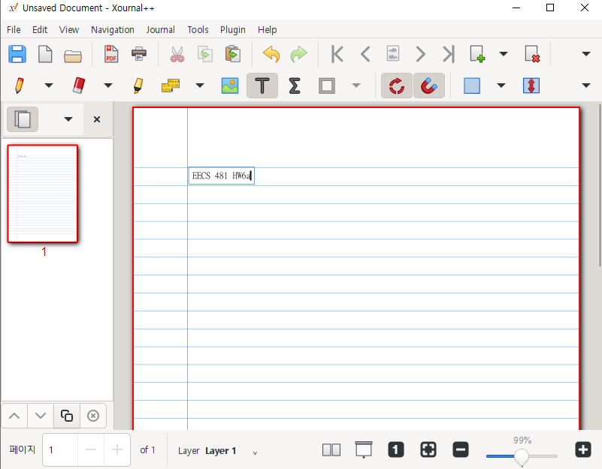

**Task Description:**

For my proposed contribution to Xournal++, I have identified the following tasks:

1. Implementing a dark mode theme option for the user interface.
2. Adding support for exporting notes to popular cloud storage services such as Google Drive and Dropbox.

**Task Links:**

  
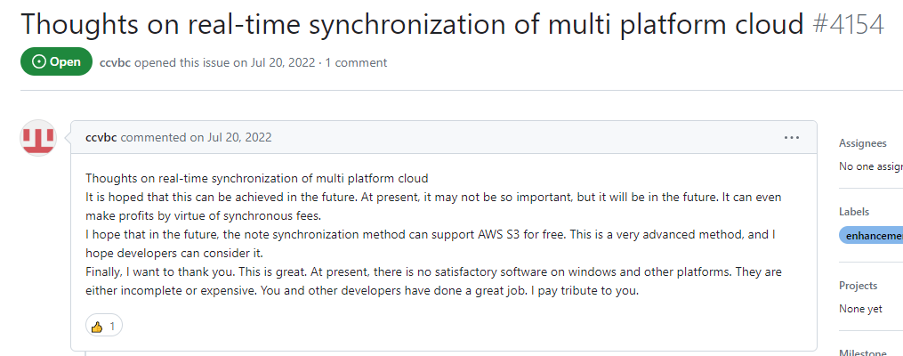

**Requirements:**

1) Dark Mode Theme Option:

Functional Requirement: Develop a toggle switch in the settings menu to enable/disable dark mode.

Quality Requirement: Ensure that the dark mode theme maintains readability and consistency across all UI elements and is visually appealing to users.

2) Export to Cloud Storage:

Functional Requirement: Integrate APIs for popular cloud storage services (e.g., Google Drive, Dropbox) to enable exporting notes directly to user accounts.

Quality Requirement: Ensure seamless integration with cloud storage platforms, with clear authentication and export options for users.

**Initial Time Plan:**

Task 1: Implement dark mode theme option (estimated effort: 12 hours)

Milestone: Complete implementation and submit pull request.

Task 2: Add support for exporting notes to cloud storage (estimated effort: 18 hours)

Milestone: Complete integration with Google Drive API and submit pull request.

Milestone: Complete integration with Dropbox API and submit pull request.

QA Activities: Test functionality, address feedback, and ensure code quality throughout the development process.

**Short Risk Assessment:**

Task 1: There is a risk of encountering compatibility issues with dark mode implementation across different operating systems and platforms. To mitigate this risk, I will conduct thorough testing on various environments and seek feedback from the community.

Task 2: There is a risk of API changes or limitations affecting the integration with cloud storage services. To mitigate this risk, I will closely monitor API documentation, implement robust error handling, and provide clear user guidance for authentication and usage.

**Initial Process Plan:**

I plan to follow an Agile development process, working in iterative cycles of development, testing, and feedback. Communication and collaboration will primarily occur through GitHub, utilizing pull requests, issues, and discussions to track progress and address any issues that arise. As I am working alone, I will ensure regular self-checks and code reviews to maintain code quality and consistency throughout the development process.

**Task Scope Justification:**

Both tasks are of reasonable size and complexity for an individual contributor, offering opportunities for learning and skill development while still being achievable within the scope of this assignment. The tasks are aligned with the project's objectives and user needs, making them suitable for contribution to Xournal++.