**Lance Go**

**Quiz #5**

**1. Draw the voltage that is generated by a “bouncy” push button, and describe a method for debouncing it using code in an interrupt.**

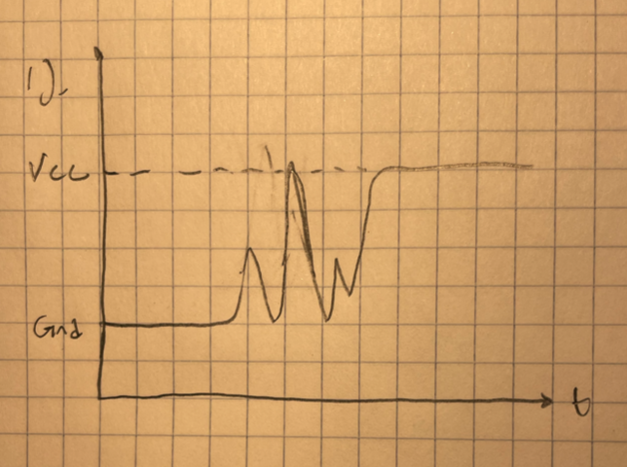

One way you could debounce the push button is to save a few previous states of the button. The code could then check if the button has been high consecutively before an action is triggered. Since debounces are only one time events and are not persistent, this will catch them and not falsely trigger an action.

**2. What are each of the IFSx, IECx, and IPCx registers used for?**

IFSx: Interrupt flag status SFR. Clearing to 0 means that there is no interrupt requested and setting to 1 means that an interrupt is requested.

IECx: Interrupt enable control SFR. Clearing to 0 means interrupt is disabled, setting to 1 means it is enabled.

IPCx: Interrupt priority control SFR. 5-bit number that lets you set the priority and subpriority numbers for the interrupt. Priority number determines when the CPU will handle the interrupt.

**3. What is “context save and restore”, and how do you avoid using it?**

Context save and restore happens when an interrupt occurs. To preserve the state of the CPU, all of the contents of the internal CPU registers are saved into RAM so that the ISR can use the registers while executing. After the interrupt is complete, the contents saved in RAM is returned back to the CPU so the previous process can continue. You can use the shadow register set (SRS) to avoid this. SRS are an entirely separate set of registers for ISR so you don’t have to save the state of the CPU into RAM.

**4. The following methods of calculating velocity produce about the same results. What is the advantage of the second method, and how could you use the .dis file to prove it?**

The second method will be faster, despite the fact there is an extra “mul” instruction in the second. To prove this, look into the .dis file. Within the assembly code with the float instructions, there will be a “jal” instruction to another subroutine. This will significantly increase the runtime since the subroutine will add many more cycles to the execution. With the int operation, there is no subroutine, and thus less cycles and less time.