InGen Physical AI Capstone Analytics Report
Market intelligence and evidence for platform decisions
Yincheng Zhang | 29 October 2026

Executive Summary
The work identifies three priorities for InGen: establish traceable operational measures, validate Fari use cases with users, and size Aido Rover deployments against achievable cash savings. These priorities connect the market comparison, KPI prototype, public-text analysis, and financial model.

Operational measures need verified denominators. The project defines 15 key performance indicators (KPIs) and demonstrates their analysis with 180 synthetic platform-month records. The prototype supports monitoring design, while actual performance remains unmeasured. I recommend a common event and exposure record for patrol, detection, availability, and human response. [1,3,4]

Caregiver support is prominent messaging rather than verified demand. It is the dominant topic in 12 of 20 documents, but company content accounts for 55% of the corpus. Full-document sentiment also hides opposing product judgments. I recommend a small Fari feasibility pilot and a register linking product claims to evidence. [5,6]

Fleet expansion requires a financial capacity check. Robot units and baseline staffing account for 81.26% of the selected model's importance. In one scenario, moving from one to two robots reduces calculated net present value (NPV) from $2,939 to -$17,733. I recommend verifying site costs and cashable labor savings before expanding a deployment. These are simulation findings, not demonstrated returns. [7]

InGen Data Landscape
I prioritize Aido Rover and Fari for further analytics investment. Aido Rover connects measurable patrol activity to enterprise costs, making it suitable for operational and deployment-economics analysis. Its main data-quality risk is incident selection bias: alerts alone cannot reveal missed incidents or represent routine patrol exposure. Independent incident verification, scheduled hours, and designated-area records are required. [1]

Fari offers a complementary engagement and care-workflow question. Public company descriptions, editorial reviews, and news stories differ in purpose and cannot substitute for observed user outcomes. Record session purpose, eligible user-days, completion, consent, and caregiver follow-up alongside user feedback. Sentinel Prime AI shares the security measurement challenge; Senpai and Aido Humanoid remain landscape context requiring separate learning-outcome and controlled-task validation. [1]

Competitive Market Position
KSCP's consolidated growth is a business-mix signal as well as a commercial signal. Q2 2026 revenue rose from $2.749M to $9.024M year over year, while calculated gross margin reached 7.36%. Its Security Force business supplied $6.830M of that quarter's revenue; ASRs supplied $0.919M. The acquisition therefore limits interpretation of total revenue as robot demand. These are historical reporting-period results. [2,8]

KSCP measure | FY2025 | Q2 2026
Revenue in USD millions | 11.335 | 9.024
Gross margin | -42.1% | 7.36%
R&D plus SG&A as a share of revenue | 256.8% | 152.4%

Source: Week 2 calculations and SEC filings. Annual and quarterly columns cover different periods and should not be read as like-for-like growth. Q2 expense share is calculated from the filing. [2,8]

The cost base remained material despite positive quarterly gross margin. FY2025 R&D and SG&A totaled $29.105M against $11.335M revenue. Consolidated margins alone do not establish profitable robot deployments. Comparable ASR deployment counts were unavailable in the prepared analysis, so revenue per deployed robot was left uncalculated. [2,8]

Separate deployment economics from service scale
For InGen, the practical response is to track hardware, software, maintenance, monitoring, integration, and human support separately. Report recurring revenue and direct service cost per deployment alongside uptime, maintenance visits, and retention. A bundled contract can simplify purchasing, but its pricing must cover the services actually delivered. This recommendation follows from KSCP's changed revenue mix rather than assuming that its consolidated ratios apply to InGen.

Use platform outcomes to compare commercial models
The Week 2 comparison covers Knightscope, Intuition Robotics, iRobot, Unitree, and SoftBank Robotics. Their customer groups, product maturity, accounting periods, and disclosure levels differ. The useful comparison is how each combines a device with ongoing functionality, engagement, or support. It is less useful to rank all five by a single revenue or margin figure. [2]

The market-sizing work also separates broad market direction from InGen's serviceable opportunity. Service robotics and security robotics overlap and include applications outside the target portfolio. A bottom-up commercial estimate should use target sites, units per site, annual contract value, and adoption assumptions, with each assumption visible. [2]

PIC 2.0 could support consistent reporting across deployments by retaining shared identifiers and an event dictionary. Platform-specific outcomes should remain separate: patrol coverage and cost for Aido Rover, verified alert handling for Sentinel Prime AI, and sustained engagement with manageable caregiver effort for Fari. This is a proposed analytics role, not evidence that the integration has been implemented.

Robot Performance Analytics
The Week 3 pipeline links 15 KPI definitions to documented assumptions and creates 180 monthly deployment records: three platforms, five units or cohorts each, and twelve simulated months. It retains 900 supporting KPI measurements. Week 4 reshapes those records into 900 long-format rows for Tableau and analyzes distributions, correlations, monthly variation, and outliers. Every operational observation is synthetic. [3,4]

Platform and primary KPI | Mean | Proposed target
Aido Rover patrol coverage | 93.3% | At least 95%
Sentinel Prime AI incident detection | 92.5% | At least 95%
Fari active-day engagement | 77.0% | At least 80%
Source: Week 4 data, 60 records per platform. Means equally weight unit/cohort-month records; they are not pooled exposure-weighted rates. Targets are internal proposals informed by partial proxies, not validated industry standards. [3,4]

The prototype highlights a useful monitoring distinction. None of the three primary KPI distributions contains a 1.5-times-IQR outlier, yet each mean is below its proposed target. A dashboard therefore needs both distribution-based anomaly checks and explicit target comparisons. Neither check alone establishes satisfactory operation. [4]

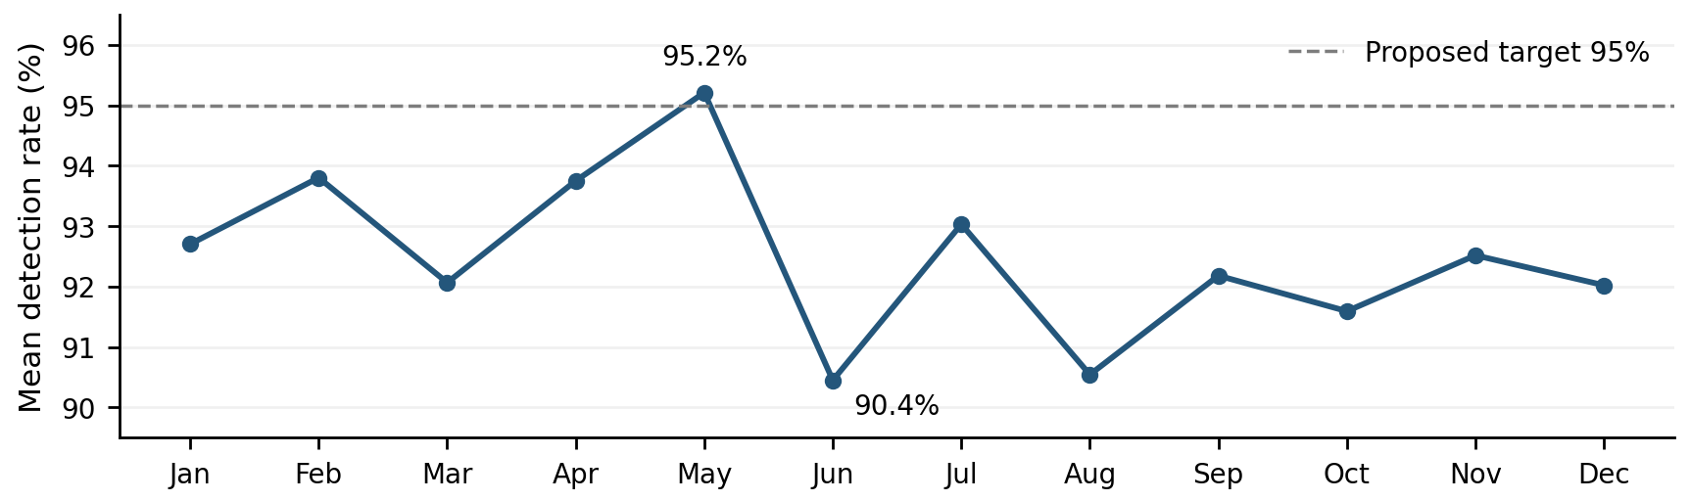
Figure 1. Sentinel detection varies across simulated months. The May and June values are 95.2% and 90.4%. Source: Week 4 Tableau data and Week 3 proposed target. SYNTHETIC. [3,4]

Sentinel's monthly variation illustrates why lower-performing windows should be reviewed with incident type, operating conditions, thresholds, and staffing records. It does not establish a seasonal effect: the generator imposes no seasonal or improvement trend. In production, investigate missed verified incidents and alert-review workload together, rather than interpreting a higher alert count as improved detection. [3,4]

Metric meaning must also remain consistent. The implemented false-alert measure is false alerts divided by all generated alerts. It is not the conventional false-positive rate using verified negative cases as its denominator. Platform-specific blanks indicate non-applicable metrics and are preserved. Correlations are exploratory; unrelated primary KPIs should not be combined into a single performance ranking. [3,4]

Physical AI Product Discourse
The NLP corpus contains 20 English documents from eight publishers: 11 company documents, six press articles, two government releases, and one editorial review. It mainly concerns ElliQ and broader care technology, with one Fari design page. The collection supports product questions and messaging analysis, not an estimate of public opinion or customer satisfaction. [5,6]

Preprocessing preserves reviewed text for sentiment analysis and creates a model view using tokenization, negation retention, stopwords, and lemmatization informed by part of speech. All documents remain nonempty, yielding 11,683 tokens and a 20 by 2,441 term frequency-inverse document frequency (TF-IDF) matrix. Company and press centroids have cosine similarity 0.4613, indicating vocabulary overlap rather than agreement. Latent Dirichlet allocation (LDA) organizes the corpus into topics. [5]

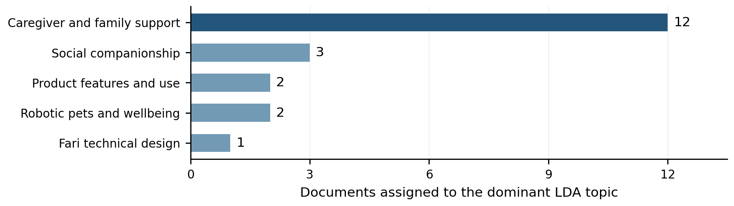Figure 2. Caregiver and Family Support dominates 12 documents. Dominant topic assigns each article to its highest-weight topic; articles may contain several themes. Source: saved Week 5 LDA results. [5]

LDA compared three to eight topics. Six achieved the lowest training perplexity, 1,154.94; five was selected after keyword and excerpt review for interpretability, with perplexity 1,161.88. No formal coherence score or held-out topic evaluation was performed. The topic labels are analyst interpretations, and the single Fari technical topic cannot establish product or clinical effectiveness. [5]

VADER labeled 19 documents positive and one negative. Targeted reading found a critical Senior List review scored +0.9986, while a broadly favorable WHYY companionship story scored -0.6316 amid bereavement and isolation. Full-document polarity therefore differs from product evaluation. These two selected cases illustrate a limitation; they do not estimate a sentiment error rate. [6]

Functional rules assigned unique labels to 12 documents; seven disagreed with AI-assisted, human-reviewed annotations. The Decision Tree matched one of three test rule labels. K-Means selected five clusters with silhouette 0.0558, indicating weak separation. Source concentration and noisy labels limit both results. The findings support a Fari pilot around reminders, daily engagement, and family updates, plus usability tests covering failed conversations, alerts, and human-care boundaries. They do not establish demand or efficacy. [6]

Deployment ROI Estimation
Week 7 predicts three-year NPV in USD for 250 simulated Aido Rover deployments. Eight inputs describe fleet size, area, baseline staffing in full-time equivalents (FTE), regional wage index, uptime, detection, annual energy cost, and subscription tier. BLS May 2025 Security Guards wages provide the regional index; operational inputs are jointly resampled from 60 synthetic Week 3 Aido Rover records. [7,9]

The target discounts cash savings less operating costs at 10%, with investment at year zero. Assumptions include a $30,000 robot purchase price, $5,000 fixed setup plus $1,000 per robot, 8% annual maintenance, and $250/$500/$750 monthly software tiers. Coverage and capacity cap eligible labor savings, and only 50% of achievable savings becomes cash savings. These are analyst assumptions, not verified vendor prices. [7]

Model | Mean CV RMSE USD | Mean CV R squared
Gradient Boosting | $28,357.41 | 0.9403
Linear Regression | $39,568.64 | 0.8843
Random Forest | $41,057.68 | 0.8768

All models used identical five-fold cross-validation (CV) splits. Preprocessing was fitted within folds. After selection by validation root mean squared error (RMSE), Gradient Boosting was fitted on all 200 training scenarios and evaluated on 50 held-out cases: test RMSE $24,205.13 and R² 0.9589. [7]
Robot units and baseline staffing contribute 46.94% and 34.32% of normalized Gradient Boosting importance. Their combined 81.26% describes model dependence, not cash-flow contributions or causal effects. Detection is not monetized in the financial formula, so its small importance does not establish avoided-loss value. [7]

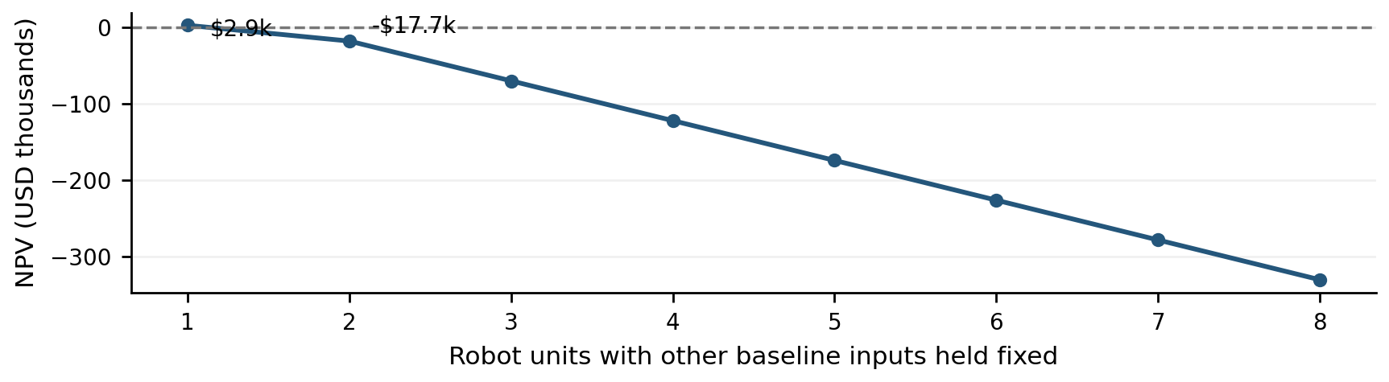Figure 3. Adding robots lowers NPV for SCN_0001 with four staff FTE, 7.62 hectares, and Standard subscription. Source: Week 7 one-at-a-time formula sensitivity. SYNTHETIC. [7]

The second robot improves coverage but its added costs exceed incremental savings. Beyond two robots, coverage is complete and savings no longer rise. Increasing baseline staffing instead approaches a capacity limit around six to seven FTE. These results are scenario-specific. Near break-even, use the direct calculator: test RMSE is substantial relative to the baseline NPV and is not an individual prediction interval. Strong fit to simulated targets does not validate actual returns. [7]

Per Platform Recommendations

Aido Rover should validate cash savings before fleet expansion
The Week 7 sensitivity result shows why additional units need a marginal-cost test. I recommend a site-level assessment that combines a verified purchase or subscription quote, local staffing costs, patrol-area requirements, measured availability, and the hours that can actually be reduced or reassigned. Compare the current staffing baseline with feasible fleet sizes using the direct financial calculator. Keep human oversight and tasks outside robot capability explicit. [7]

Record realized labor hours, maintenance visits, uptime, and total operating cost during a trial, then compare them with the original assumptions. Treat benefits that improve coverage or safety separately until their financial value can be justified. Review expansion only after the estimated incremental benefit covers incremental cost under plausible downside assumptions.

Fari should test caregiver value and document capability evidence
Caregiver support dominates the collected content, but the source imbalance and sentiment mismatches leave customer value unverified. I recommend a small, consented feasibility pilot with older adults and caregivers, focused on available reminder, interaction, and family-update functions. Record completion, continued use, reasons for nonuse, and caregiver time spent operating or correcting the system. Compare these observations with participants' baseline routines. [5,6]

Maintain a capability register marking claims as planned, demonstrated under stated conditions, or evaluated in a pilot. Test communication failures, delayed responses, caregiver alerts, consent controls, and emergency-support expectations. Use the pilot to prioritize features and revise claims. A feasibility exercise should not be presented as proof of clinical efficacy.

Sentinel Prime AI should link detection to verified response outcomes
The audit identifies context-sensitive false-alert measurement, while the KPI prototype shows how target comparisons and monthly review can expose questions for investigation. I recommend event records linking ground truth, detection confidence, threshold, alert tier, acknowledgement, escalation, and resolution, with site and environmental conditions retained. Define false alerts per generated alert separately from false-positive rates on verified negatives. [1,3,4]

Report detection and review workload by incident type and severity. Pair availability with response latency and unresolved alerts so that technically active systems are not assumed operationally effective. Validate thresholds across sites before treating research benchmarks as service commitments.

Sequence the next analytical work
First agree the metric definitions and install the required event records. Then collect a limited deployment or feasibility dataset with documented conditions. Finally, evaluate on independent sites or time periods, update financial assumptions and labels, and revise the dashboard and models. Assigning owners, schedules, and budgets for this proposed work requires agreement with the relevant product and operations teams.

Methodology and Evidence Limits
The programme combines public-data comparison with analytical prototypes. Public filings and wage tables provide financial context. Operational observations and deployment scenarios are synthetic. Article-level NLP results describe a purposively selected corpus; public claims, reported experiences, and independently verified outcomes remain different evidence types. Recommendations are proposed actions derived from these analyses.

The notebooks use relative paths, documented definitions, fixed seeds for stochastic steps, document-ID alignment, and saved export checks. Those controls improve traceability, but saved outputs alone do not certify a clean-environment run. Release checks should preserve source CSVs, HTML snapshots, annotations, matrix indexes, configuration files, package versions, and source hashes, including the actual reviewed and preprocessed corpus CSVs. [3,5,6,7]

The small text corpus, AI-assisted annotation reference, three-document classification test, source-driven clusters, and repeated synthetic operating reference limit generalization. Larger simulated samples alone do not replace verified prices, measured operations, independently reviewed labels, or external evaluation. Senpai and Aido Humanoid would require separate outcome definitions and validation designs before extending these results. [1,5,6,7]

Sources and Analytical Records
[1] Zhang, Y. Week 1. W01_InGen_Data_Ecosystem_Audit and W01_Analytical_Framework. Platform data profiles, proxy boundaries, and analytical priorities.
[2] Zhang, Y. Week 2. W02_Market_Intelligence_Report, W02_Market_Data, and W02_KSCP_Data_Analysis. Historical comparable-company and SEC-based financial analysis.
[3] Zhang, Y. Week 3. W03_KPI_Framework and W03_Data_Pipeline. Fifteen KPI definitions, numerator and denominator logic, proposed targets, and synthetic-data assumptions.
[4] Zhang, Y. Week 4. W04_Analytics_Notebook, W04_Tableau_Data, and W04_KPI_Dashboard. Distributions, correlations, trends, and outlier checks.
[5] Zhang, Y. Week 5. W05_Text_Data_Collection and W05_NLP_Pipeline. Corpus provenance, preprocessing, TF-IDF exports, LDA comparison, and selected topic labels.
[6] Zhang, Y. Week 6. W06_NLP_Technical_Report, W06_Sentiment_Classification, and W06_Clustering_Analysis. Sentiment examples, label audit, classifier evaluation, and cluster interpretation.
[7] Zhang, Y. Week 7. W07_Predictive_Model and W07_Model_Card. Financial assumptions, frozen split, CV and test metrics, feature importance, and sensitivity results.
[8] Knightscope SEC filings. FY2025 Form 10-K and Q2 2026 Form 10-Q. Consolidated financial statements and disaggregated revenue. FY2025 filing | Q2 2026 filing
[9] U.S. Bureau of Labor Statistics. May 2025 OEWS national and state tables, Security Guards, SOC 33-9032. BLS data tables
Source versions correspond to the files reviewed for this capstone. Week 2 financial periods end June 2026. Synthetic monthly labels cover January–December 2025 and do not represent InGen historical operations.

