SafeRoute: An Event-Driven Information System for Crowdsourced Pedestrian Hazard Reporting and Municipal Response
Lance Ethan B. Luy  School of Information Technology  Mapúa University, Philippines  lebluy@mymail.mapua.edu.ph | Christine Cjentani A. Mendoza  School of Information Technology  Mapúa University, Philippines  ccamendoza@mymail.mapua.edu.ph | Kenn Gerald R. Follosco  School of Information Technology  Mapúa University, Philippines  kgrfollosco@mymail.mapua.edu.ph
Marcus Jiro G. Villanueva  School of Information Technology  Mapúa University, Philippines  mjgvillanueva@mymail.mapua.edu.ph | Prince Leanard V. Vargas  School of Information Technology  Mapúa University, Philippines  plvillanueva@mymail.mapua.edu.ph | Richard N. Monreal  School of Information Technology  Mapúa University, Philippines  rmonreal@mapua.edu.ph

Abstract—Pedestrians in Metro Manila encounter localized hazards such as flooded walkways and open manholes, while reports and municipal responses are spread across separate channels. SafeRoute is an event-driven information system linking a native iPhone app, a Java/Spring Boot backend, and a municipal web portal. Its contribution is at the application level: a hazard verification lifecycle, location- and route-targeted updates, and an auditable staff workflow, built on established mechanisms (Kafka, PostGIS, and WebSockets). In local tests, WebSocket updates reached clients in a median of 23–68 ms depending on machine load, against 1,217–1,441 ms for three-second polling; road-closure updates reached all 6,000 expected nearby sessions and no distant ones; and a single backend delivered every frame to up to 5,000 concurrent connections. An offline analysis of 300 OpenStreetMap walking trips in Makati with seeded hazards showed that the route score avoided 22–42% of hazard encounters for walks 5–7% longer, with severity weights protecting mainly against high-severity hazards. Background push delivery, multi-node scaling, and field use remain to be validated.
Keywords—crowdsourcing, design science, event-driven architecture, municipal information systems, pedestrian hazards

Introduction
Pedestrians in Metro Manila routinely encounter flooded walkways, broken sidewalks, open manholes, and accessibility barriers. These hazards are local and often short-lived, yet warnings travel through social media and area-wide advisories, and municipal follow-up happens in separate channels. Citizens can act as geographic sensors [1], and crowdsourcing has been used for flood reporting in the Philippines [2] and for mapping pedestrian barriers [3], but volunteered reports need explicit quality controls [4]. SafeRoute treats this as an information-management problem: one workflow for reporting, verification, targeted notification, and municipal response, demonstrated in Makati and relevant to SDG target 11.2 [5].
Following Design Science Research [6], [7], the study derives requirements from literature and pedestrian-hazard scenarios, builds the platform, and evaluates it. Existing systems each cover part of the loop from report to response (Table I); SafeRoute closes it for pedestrians and measures the design choices this requires. It contributes (1) a model of pedestrian hazards as transient, verifiable objects, with spatial duplicate merging, confirmations, disputes, type-specific expiry, and staff resolution; (2) a single route corridor that decides both which users are alerted and which route is recommended, so alerts and routing stay consistent, linked to department assignment and audit records; (3) evidence that this design delivers updates only to affected users, within tens of milliseconds, to thousands of connections; and (4) parameter guidance from a sensitivity analysis on real Makati streets. The novelty lies in this application-level design and the knowledge gained from evaluating it, not in new middleware.

Related Work

Crowdsourced Hazards and Civic Reporting
Waze lets drivers report road hazards such as construction, potholes, and broken traffic lights [8]. Project Sidewalk collects remote labels of sidewalk accessibility and evaluates their quality [9]. WalkRollMap.org crowdsources pedestrian barriers and received 897 reports in its first nine months, 53% of them hazards [3]. FloodPatrol reports were used to profile flood risk across Philippine sites [2], and NYC311 links service requests to agency status updates [10]. Crowdsourcing, verification, and status tracking are thus not new on their own; SafeRoute combines them for transient pedestrian hazards with route-relevant updates and staff handling (Table I). Pedestrian route personalization [11] motivates its route scoring.
- Documented Emphases of Related Systems
System | Information focus | Feedback or action
Waze [8] | Driving and road hazards | Driver reports and feedback
Project Sidewalk [9] | Sidewalk accessibility from imagery | Remote labels, quality evaluation
WalkRollMap.org [3] | Pedestrian barriers and incidents | Open crowdsourced map
NYC311 [10] | Municipal service requests | Agency actions and status updates
SafeRoute | Transient pedestrian hazards | Verification, route-targeted updates, staff audit trail

Event Distribution and Delivery Options
Publish/subscribe separates producers from consumers [12], and Kafka supplies partitioned event logs [13]; transactional outboxes and idempotent processing address coordination and redelivery [14], [15], [16]. Push-versus-pull performance has been studied for AJAX [17] and Open Data interfaces [18], so lower push latency is expected. Table II compares delivery options from their specifications. Conditional requests make unchanged polls cheaper but leave delay bounded by the interval. Cell Broadcast suits area-wide official warnings but targets cell areas, not routes, so it cannot carry verified, street-level crowd reports; SafeRoute complements such alerts.
- Options for Delivering Hazard Updates
Mechanism | Update delay | Reaches app in background | Targeting
Fixed polling [17] | Up to one interval | No | Client query area
Polling + ETag [19] | Up to one interval; smaller responses | No | Client query area
Long polling [20] | Near-immediate | No | Server-side, per client
Server-Sent Events [21] | Near-immediate; one-way | No | Server-side, per connection
WebSocket [22] (SafeRoute) | Near-immediate; two-way | Only during navigation | Server-side, per session
APNs [23] | Via Apple’s service | Yes | Per device
Cell Broadcast [24] | Network broadcast | Yes (operating system) | Cell area
Qualitative, from the cited specifications; only WebSocket and fixed polling were measured.

System Design

Architecture and Delivery
The backend uses Java 21, Spring Boot 3, Kafka 3.8, and PostgreSQL 16 with PostGIS; the app uses SwiftUI and MapKit; and the portal uses React and Leaflet. The backend is a modular monolith whose processing and notification modules communicate through Kafka topics in separate consumer groups (Fig. 1). The API publishes commands (report, verify or dispute, resolution vote, staff resolution); processing commits hazard state and an outbox record in one transaction, and a relay publishes outcome topics. Handlers are idempotent, and failed events go to dead-letter topics.
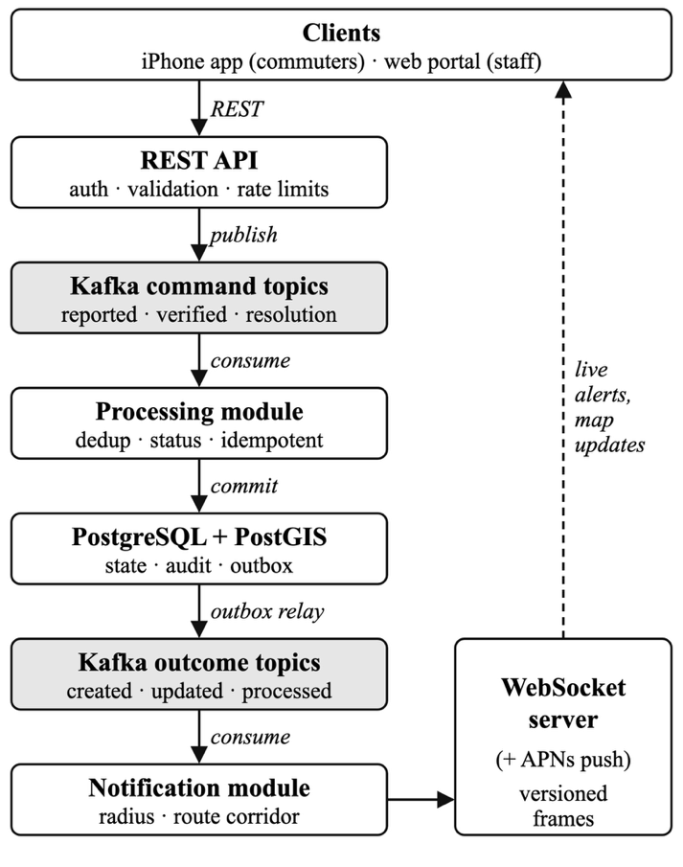
- SafeRoute architecture. The APNs path is implemented but was disabled in all tests.
WebSockets [22] deliver live updates to sessions selected by location, enabled hazard types, and active walking route. Sessions are held by the instance a client connects to, while notification consumers share one group. During navigation the app keeps its socket open in the background; for other opted-in users, an APNs path [23] sends nearby-hazard alerts, but it requires a paid Apple Developer account and was disabled in all tests.

Hazard Lifecycle
Severity comes from one rule-based question per hazard type, such as water depth. A same-type report within 30 m of an active hazard merges into it after the reporter confirms the match. Two independent confirmations verify a hazard; it becomes disputed when at least two disputes equal or exceed confirmations (Fig. 2). Two “gone” votes or staff action resolve it, and reporters cannot confirm their own reports. Hazards expire 12 hours (flooding) to 90 days (accessibility barriers) after the last confirmation. Reputation tiers order the moderation queue but never decide validity, and staff actions are audited.
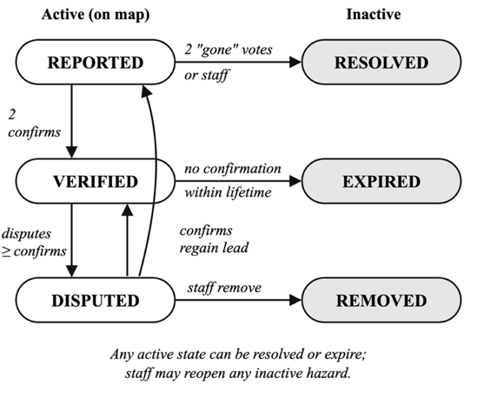
- Hazard status lifecycle.

Route Scoring and Municipal Workflow
SafeRoute scores MapKit’s alternative walking routes: each hazard within a 40 m corridor adds 10, 3, or 1 for high, medium, or low severity, at half weight if disputed. The lowest-scoring alternative is offered if it takes at most twice as long as MapKit’s first route, and the same corridor decides on-route alerts. Staff-marked road closures are pushed to nearby sessions and outweigh any hazard score. The portal provides a live hazard map, a moderation queue with department assignment and priority, analytics by barangay, weather with PAGASA rainfall bands, and an audit log, giving each report a traceable path from intake to city response.

Evaluation Method
Setup A ran on an Apple M1 Max (10 cores, 32 GB) with one backend, one Kafka broker, an initially empty database, and rate limiting disabled, with the load generator on the same machine. Five ingestion scenarios ran three times each, and k6 HTTP tests ran with up to 500 virtual users. For push versus polling, one WebSocket client and clients polling every 1, 3, and 5 s watched 50 hazards reported about 2 s apart, in eight runs. A road-closure test created and lifted 20 closures per round, in three rounds, with 50 sessions within 150 m and 20 about 11 km away. Setup B ran on Apple Silicon M4 with one backend and broker; database state and rate limiting were not recorded. Tiers of 100 to 5,000 WebSocket connections each received four broadcasts, and a separate run stopped the only backend.
Setup C used the walkable network of central Makati from OpenStreetMap [25] (30 October 2026; 284 km, 10,401 nodes). Each of 300 trips 0.4–1.5 km apart received up to three alternatives within twice the shortest length, generated by edge penalties because MapKit is unavailable offline; the app’s waypoint-detour fallback was omitted. Hazards were seeded uniformly at 50, 100, and 200 in the area (20% high, 40% medium, 40% low severity; 15% disputed), with five seeds each. The outcome is the share of hazards within 10 m of the shortest route that the chosen route avoids. For merging, each hazard was reported five times with 5 or 15 m Gaussian position error, since sky blockage reduces GPS accuracy [26].
Update latency runs from report submission to WebSocket receipt; processing latency from acceptance to commit. Throughput is completed reports divided by the time from the first report to the last outcome. Complete fan-out ends when the last subscriber receives a broadcast.

Results

Push Versus Polling
Every client detected every hazard. On an idle machine, the WebSocket median was 26 ms against 1,441 ms for three-second polling (Table III), and three runs against a database of 77,000 hazards gave 23 ms. On a busier machine it rose to 60–68 ms; earlier code gave 39–64 ms that day, so the change reflects load, not code. Push was 8–17 times faster than 1 s polling and 19–55 times faster than 3 s polling, while 53% of 1 s polls returned nothing new. Polling medians match half the interval, so this confirms lower delay for the push path, not a benefit of Kafka itself.
- Update Latency, Setup A (Median / p95, ms)
Client | Idle, 2 runs | Busier machine, 3 runs
WebSocket push | 26 / 56 | 60–68 / 88–106
Polling, 1 s | 442 / 908 | 541–621 / 951–1,037
Polling, 3 s | 1,441 / 2,883 | 1,217–1,330 / 2,838–2,904
Polling, 5 s | 2,572 / 4,842 | 2,277–2,959 / 4,550–4,922

Ingestion, Bursts, and Recovery
No accepted report was lost and no HTTP error occurred in 15 executions (Table IV). Throughput is a completion rate and falls below the generator target; capacity was observed separately, as a backlog of 11,800 queued reports drained at about 125 reports/s. The k6 tests had at most 0.6% failed requests. On an empty database, the 300-report burst produced five hazards and 295 merges, and with the consumer paused, 100 queued reports drained 1.1–2.9 s after restart without duplicates.
- Ingestion Scenarios, Setup A (3 Runs Each)
Scenario | Target (/s) | Reports per run | Observed (/s) | Processing latency median / p95 (ms)
Normal | 1 | 17–21 | 0.6–0.7 | 11–17 / 23–50
Rush hour | 10 | 347–377 | 5.8–6.3 | 10–15 / 21–34
Severe weather | 50 | 785–802 | 38.8–39.6 | 5–10 / 8–16
Duplicate burst | 20 | 300 | 19.9 | 12–15 / 19–28
Consumer pause | — | 100 | 6.1–6.9 | Drain 1.1–2.9 s

Targeted Delivery and Concurrency
In the road-closure test, all 6,000 expected frames reached nearby sessions, none were missed or duplicated, and none reached distant sessions; the median time from staff action to frame was 27–36 ms. An accelerated archive job archived 400 of 400 hazards in each of three rounds. In Setup B, every tier received all frames within 30 s (Table V); at 5,000 connections, the largest tier tested, complete fan-out took 268–481 ms, and no connection ceiling was reached. Median CPU stayed below 10%, with peaks near two logical cores. Backend memory rose from an idle 0.65 GB to 1.3 GB at 2,000 connections and from 1.3 GB to 2.0 GB at 5,000, roughly 140–330 kB per connection; the memory counter was not recorded, so these figures indicate scale only. Stopping the only backend disconnected all sessions, as expected for a single node.
- WebSocket Delivery, Setup B (4 Broadcasts per Tier)
Connections | Frames received / expected | Pooled median (ms)
100 | 400 / 400 | 34
1,000 | 4,000 / 4,000 | 82
2,000 | 8,000 / 8,000 | 85
5,000 | 20,000 / 20,000 | 241

Route-Scoring and Merge Sensitivity
With 100 hazards, the default rule rerouted 45% of trips and avoided 33% of encounters and 48% of high-severity encounters, for walks 6% longer (Table VI). A 20 m corridor avoided more close encounters (45%) than 60 m (25%), because wide corridors penalize hazards the walker would not pass; results depend on the 10 m threshold. Equal weights avoided only 27% of high-severity encounters. Across 50 to 200 hazards, the default avoided 42% down to 22% of encounters for 5–7% longer walks. The 30 m merge radius combined all repeat reports at 5 m error but split 76% of hazards at 15 m error (44% at 40 m), with under 1% wrong merges (Table VII); reporter confirmation of matches is not modeled.
- Route-Scoring Sensitivity, Setup C (100 Hazards)
Corridor, weights | Rerouted (%) | Encounters avoided (%) | High-severity avoided (%) | Added length (%)
20 m, 10/3/1 | 43 ± 3 | 45 ± 6 | 67 ± 16 | 5.8 ± 0.6
40 m, 10/3/1 (default) | 45 ± 2 | 33 ± 7 | 48 ± 11 | 6.1 ± 0.3
60 m, 10/3/1 | 45 ± 2 | 25 ± 8 | 49 ± 11 | 6.2 ± 0.5
40 m, 3/2/1 | 45 ± 2 | 35 ± 7 | 41 ± 14 | 6.0 ± 0.5
40 m, 1/1/1 | 42 ± 2 | 37 ± 6 | 27 ± 7 | 5.4 ± 0.3
40 m, 100/10/1 | 45 ± 2 | 30 ± 8 | 49 ± 12 | 6.1 ± 0.3
Mean ± standard deviation over five hazard seeds.
- Hazards Split Into Duplicates (%), Setup C
Position error | Radius 20 m | 30 m (default) | 40 m
5 m | 7.8 ± 4.8 | 0.0 | 0.0
15 m | 96.2 ± 2.9 | 75.8 ± 5.6 | 44.4 ± 10.2
100 hazards, five reports each; 200 hazards gave similar values.

Functional Results
The prototype implements live mapping, guided reporting with duplicate warnings and an offline queue, voting, city response, route comparison and navigation, and a live staff portal (Figs. 3 and 4), with 118 backend and 57 iOS automated tests.
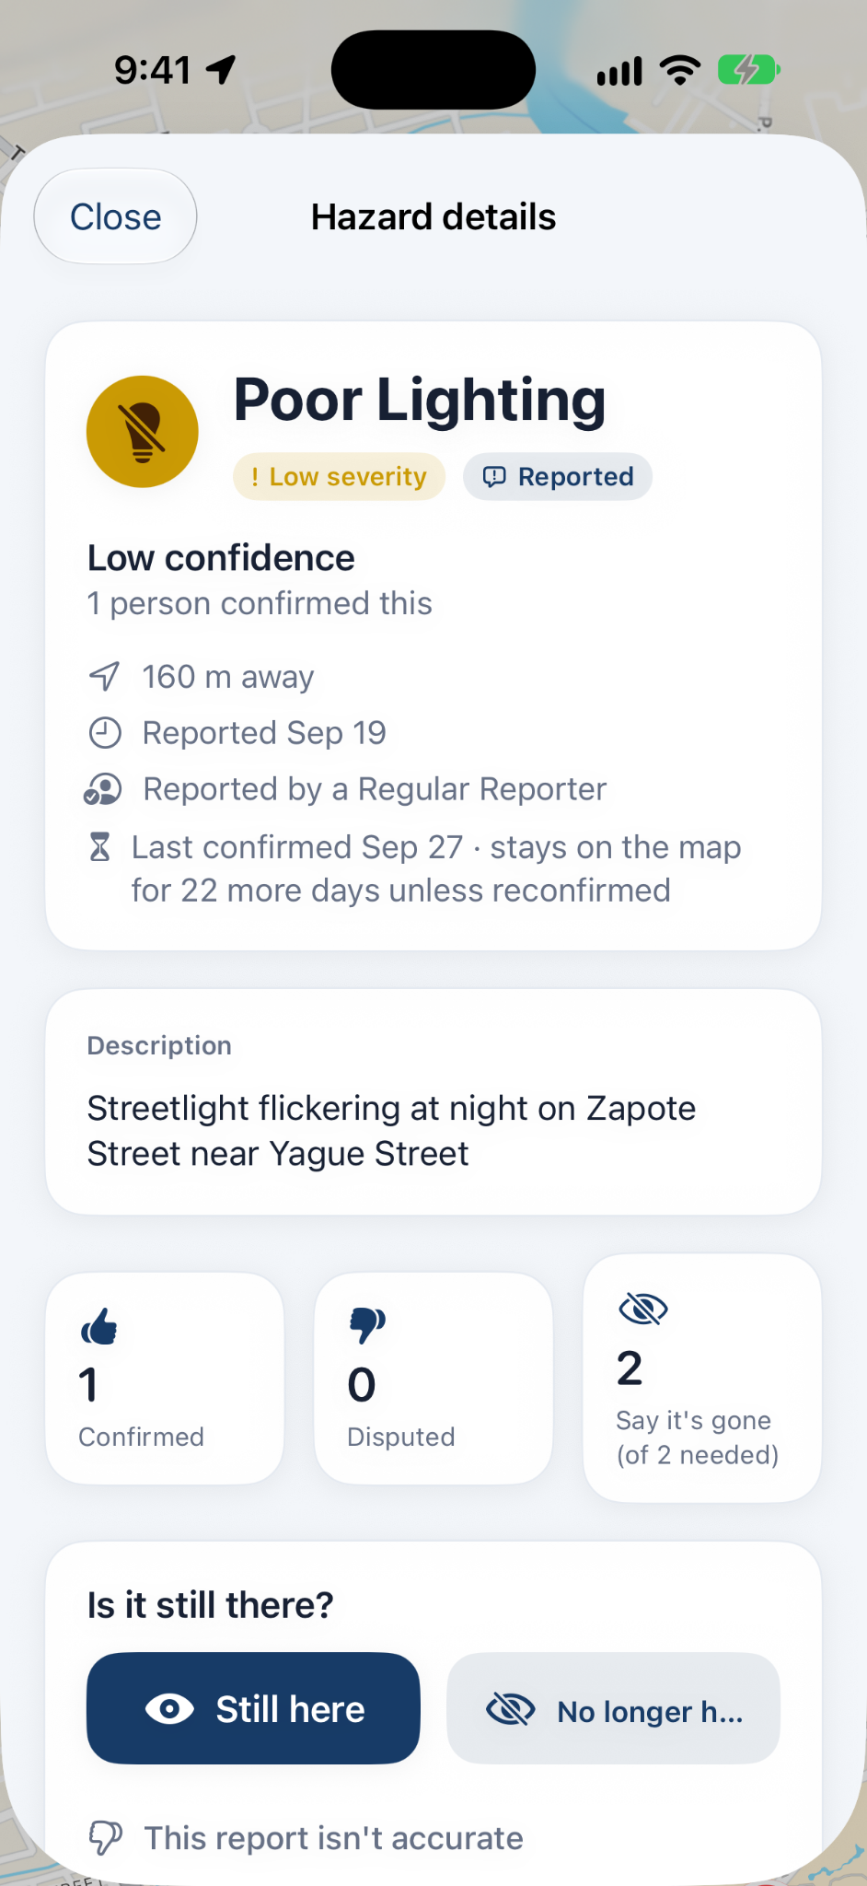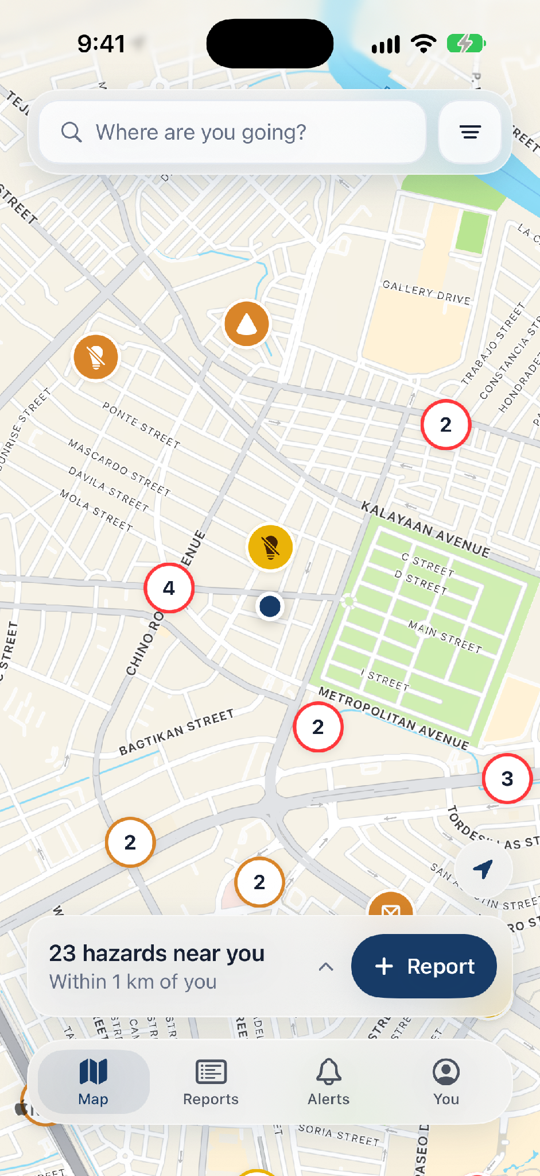
- Commuter app: hazard map (left) and hazard details (right).
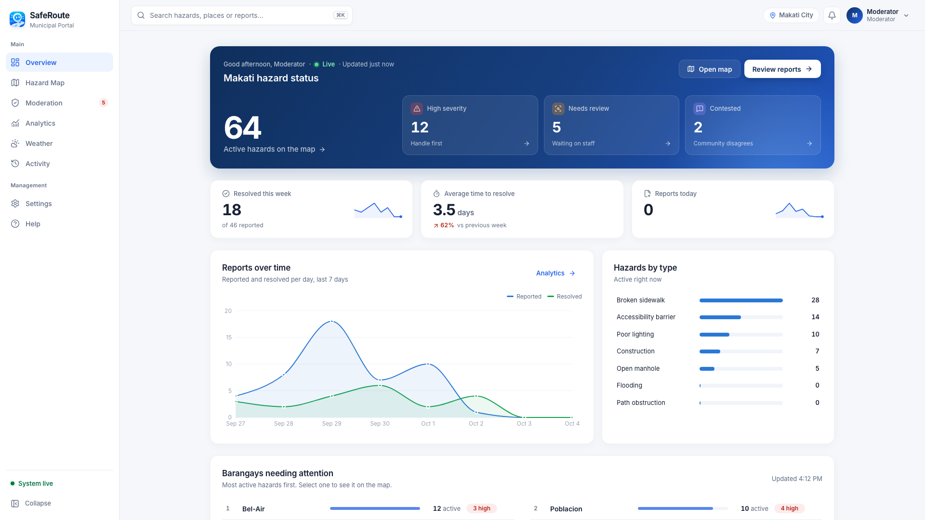
- Municipal portal overview dashboard.

Discussion
Three lessons apply to location-based alert platforms beyond SafeRoute. First, push improves on polling only by about half the polling interval, so its value for safety alerts lies in precise targeting, which spatial filtering delivered without misdirected updates. Second, decoupled intake turns overload and consumer outages into delay rather than loss, so capacity should be sized by processing rate. Third, per-instance sessions with a shared notification group mean that replicas need cross-instance fan-out before they add capacity; a single backend served 5,000 connections but remains a single point of failure. For routing, a narrower corridor (about 20 m) with severity weights best avoided close and severe hazards, and a 30 m merge radius needs reporter confirmation under poor GPS.
For municipal decision support, every report carries a traceable state, confirmation history, department, and resolution, so officials can prioritize by verified severity, see recurring hazards by barangay, and audit response, which social media posts and area-wide advisories cannot provide. The main limitations are local synthetic tests, an untested APNs path, seeded rather than real hazards in the routing analysis, and no field study.

Conclusion
SafeRoute links pedestrian hazard reports, verification, targeted updates, and municipal response in one traceable workflow. In local tests, push updates arrived in 23–68 ms, reached only nearby users, and scaled to 5,000 connections on one backend, and on real Makati streets the route rule avoided a third of hazard encounters for 6% longer walks. Future work with Makati officials and commuters should test background alerts, multi-node fan-out, and field use. Code, benchmark scripts, and metric definitions are available at https://github.com/lanceluy/SafeRoute.

References
- M. F. Goodchild, “Citizens as sensors: The world of volunteered geography,” GeoJournal, vol. 69, no. 4, pp. 211–221, 2007, doi: 10.1007/s10708-007-9111-y.
- J. N. C. Victorino and M. R. J. E. Estuar, “Profiling flood risk through crowdsourced flood level reports,” in Proc. Int. Conf. IT Convergence and Security (ICITCS), 2014, pp. 1–4, doi: 10.1109/ICITCS.2014.7021800.
- K. Laberee, T. Nelson, D. Boss, C. Ferster, K. Hosford, D. Fuller, M.-S. Cloutier, and M. Winters, “WalkRollMap.org: Crowdsourcing barriers to mobility,” Front. Rehabil. Sci., vol. 4, Art. no. 1023582, 2023, doi: 10.3389/fresc.2023.1023582.
- M. F. Goodchild and L. Li, “Assuring the quality of volunteered geographic information,” Spatial Statistics, vol. 1, pp. 110–120, 2012, doi: 10.1016/j.spasta.2012.03.002.
- United Nations, “Transforming our world: The 2030 Agenda for Sustainable Development,” UN General Assembly Res. A/RES/70/1, 2015.
- A. R. Hevner, S. T. March, J. Park, and S. Ram, “Design science in information systems research,” MIS Quarterly, vol. 28, no. 1, pp. 75–106, 2004, doi: 10.2307/25148625.
- K. Peffers, T. Tuunanen, M. A. Rothenberger, and S. Chatterjee, “A design science research methodology for information systems research,” J. Manage. Inf. Syst., vol. 24, no. 3, pp. 45–77, 2007.
- Waze, “Report road hazards,” Waze Help. [Online]. Available: https://support.google.com/waze/answer/13739290. Accessed: Oct. 30, 2026.
- M. Saha et al., “Project Sidewalk: A web-based crowdsourcing tool for collecting sidewalk accessibility data at scale,” in Proc. CHI Conf. Human Factors in Computing Systems, Glasgow, U.K., 2019, pp. 1–14, doi: 10.1145/3290605.3300292.
- NYC311, “Service requests.” [Online]. Available: https://portal.311.nyc.gov/article/?kanumber=KA-03116. Accessed: Oct. 30, 2026.
- T. Novack, Z. Wang, and A. Zipf, “A system for generating customized pleasant pedestrian routes based on OpenStreetMap data,” Sensors, vol. 18, no. 11, Art. no. 3794, 2018, doi: 10.3390/s18113794.
- P. T. Eugster, P. A. Felber, R. Guerraoui, and A.-M. Kermarrec, “The many faces of publish/subscribe,” ACM Comput. Surv., vol. 35, no. 2, pp. 114–131, 2003, doi: 10.1145/857076.857078.
- J. Kreps, N. Narkhede, and J. Rao, “Kafka: A distributed messaging system for log processing,” in Proc. NetDB Workshop, Athens, Greece, Jun. 2011.
- G. Hohpe and B. Woolf, Enterprise Integration Patterns: Designing, Building, and Deploying Messaging Solutions. Boston, MA, USA: Addison-Wesley, 2003.
- C. Richardson, Microservices Patterns: With Examples in Java. Shelter Island, NY, USA: Manning, 2018.
- M. Kleppmann, Designing Data-Intensive Applications. Sebastopol, CA, USA: O’Reilly Media, 2017.
- E. Bozdag, A. Mesbah, and A. van Deursen, “A comparison of push and pull techniques for AJAX,” in Proc. 9th IEEE Int. Workshop Web Site Evolution (WSE), 2007, pp. 15–22, doi: 10.1109/WSE.2007.4380239.
- B. Van de Vyvere, P. Colpaert, and R. Verborgh, “Comparing a polling and push-based approach for live Open Data interfaces,” in Web Engineering, LNCS, vol. 12128, 2020, pp. 87–101, doi: 10.1007/978-3-030-50578-3_7.
- R. Fielding, M. Nottingham, and J. Reschke, “HTTP semantics,” Internet Engineering Task Force, RFC 9110, Jun. 2022.
- S. Loreto, P. Saint-Andre, S. Salsano, and G. Wilkins, “Known issues and best practices for the use of long polling and streaming in bidirectional HTTP,” Internet Engineering Task Force, RFC 6202, Apr. 2011.
- WHATWG, “HTML Living Standard, Section 9.2: Server-sent events.” [Online]. Available: https://html.spec.whatwg.org/multipage/server-sent-events.html. Accessed: Oct. 30, 2026.
- I. Fette and A. Melnikov, “The WebSocket protocol,” Internet Engineering Task Force, RFC 6455, Dec. 2011.
- Apple, “User Notifications,” Apple Developer Documentation. [Online]. Available: https://developer.apple.com/documentation/usernotifications/. Accessed: Oct. 30, 2026.
- 3GPP, “Technical realization of Cell Broadcast Service (CBS),” 3rd Generation Partnership Project, TS 23.041.
- OpenStreetMap contributors, “OpenStreetMap,” data retrieved through the Overpass API, Oct. 30, 2026. [Online]. Available: https://www.openstreetmap.org. Licensed under the Open Database License (ODbL).
- GPS.gov, “GPS accuracy.” [Online]. Available: https://www.gps.gov/systems/gps/performance/accuracy/. Accessed: Oct. 30, 2026.

