**Quantitative Biology Lab II – February 23, 2024**

1. **Electrostatic Interactions**

**I.1** Oppositely charged groups in proteins can form electrostatic interactions that are called salt bridges, which is just another word for ion-ion interactions. For instance, an arginine residue (charge of +1 at neutral pH) can form a salt bridge with aspartate (charge of –1 at neutral pH).

**a.** How close do the two charged groups need to be to form a stable interaction in water at 20°C?

We will consider “stable” to be twice the thermal energy. (**5 points**)

**b.** Does the value of the maximum distance for a stable interaction change if the temperature is raised to 37°C? If yes, by how much? If not, why not? (**5 points**)

**I.2** DNA duplexes (helical structures made from two strands of DNA that have negatively charged sugar-phosphate backbones) can be precipitated from aqueous solution that contains monovalent salt ions by the addition of ethanol. Ethanol lowers the dielectric constant of the solvent. Calculate the relative change in the energy of electrostatic interactions between the DNA and cations in solution.

Based on the number that you get, does the interaction become more favorable or more unfavorable? (**5 points**)

The dielectric constants are εH2O = 80 and εEtOH = 24.5.

For simplicity, we are assuming transfer from pure water to pure ethanol (although in practice, the ethanol concentration is 70 – 80%).

**II. Dipoles**

**II.1** Please address questions in Jupyter notebook section II.1Dipoles (**10 points**)

**II.2** 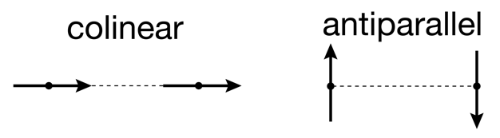Consider two adenine molecules that are oriented in a colinear or in an antiparallel fashion. The distance between their centers is the same in both cases.

For each orientation, is interaction between the dipoles attractive or repulsive? How do their magnitudes compare? (**10 points**)

**II.3** Please address questions in Jupyter notebook section II.3 Dipole-Dipole vs. Ion-Ion interactions. (**5 points**)