

实验报告 实践报告□

课程名称： Web系统和技术

实验项目： 实验一 HTML、CSS和JavaScript
实验二 Servlet与会话技术
实验三 JSP技术
实验四 JDBC访问数据库

实验地点： 实验楼209

专业班级： 学号：

学生姓名：

指导教师：

2025年 月 日

实验名称 | 实验一 HTML CSS和JavaScript
实验目的与要求
- 掌握HTML常用标签的使用。
- 掌握CSS常用属性的使用。
- 掌握JavaScript 的基本使用。
4．熟练在HTML中添加并使用CSS和JavaScript。
独立完成实验 书写实验报告

实验环境
Windows 11
VSCode
edge浏览器

实验记录(写出实验过程中各步骤的具体实现代码和结果截图)(可分栏或加页)
Index.html

<!DOCTYPE html>
<html lang="zh-CN">
<head>
<meta charset="UTF-8">
<title>技术论坛首页</title>
<link rel="stylesheet" href="css/common.css">
</head>
<body>
<div class="header">
<h1>技术论坛</h1>
<p>分享知识，建立社区</p>
</div>

<div class="container">
<div class="nav">
<a href="index.html" style="background:#0066cc;color:white;">首页</a>
<a href="login.html">登录</a>
<a href="register.html">注册</a>
</div>

<!-- 热门话题 -->
<div class="content">
<h2>🔥 热门话题</h2>
<table>
<tr><th>话题标题</th><th>发起人</th><th>浏览</th><th>回复</th></tr>
<tr><td>如何学好Java Web开发？</td><td>张三</td><td>1230</td><td>45</td></tr>
<tr><td>MySQL性能优化实战经验分享</td><td>李四</td><td>980</td><td>32</td></tr>
<tr><td>前端框架选择：React vs Vue</td><td>王五</td><td>756</td><td>28</td></tr>
</table>
</div>

<!-- 最新帖子 -->
<div class="content">
<h2>📝 最新帖子</h2>
<table>
<tr><th>发布者</th><th>帖子内容</th><th>发布时间</th></tr>
<tr><td>赵六</td><td>今天学习了Servlet和JSP，感觉很有收获！</td><td>刚刚</td></tr>
<tr><td>孙七</td><td>分享一个很不错的在线编程学习网站！</td><td>10分钟前</td></tr>
<tr><td>周八</td><td>有人可以帮忙解答一下HTML5的问题吗？</td><td>30分钟前</td></tr>
</table>
</div>

<!-- 论坛分类 -->
<div class="content">
<h2>💻 论坛分类</h2>
<table>
<tr><th>分类名称</th><th>主题数</th><th>帖子数</th></tr>
<tr><td>Java技术</td><td>1,234</td><td>12,345</td></tr>
<tr><td>前端开发</td><td>2,456</td><td>23,456</td></tr>
<tr><td>数据库</td><td>890</td><td>8,901</td></tr>
<tr><td>开发工具</td><td>567</td><td>5,678</td></tr>
</table>
</div>
</div>

<div class="page-footer">
<p>&copy; 2025 技术论坛 | 太原理工大学 Web系统和技术实验一 | 当前时间：<span id="currentTime"></span></p>
</div>

<script>
function updateTime() {
var now = new Date();
var str = now.getFullYear() + '-' +
String(now.getMonth()+1).padStart(2,'0') + '-' +
String(now.getDate()).padStart(2,'0') + ' ' +
String(now.getHours()).padStart(2,'0') + ':' +
String(now.getMinutes()).padStart(2,'0') + ':' +
String(now.getSeconds()).padStart(2,'0');
document.getElementById('currentTime').textContent = str;
}
updateTime();
setInterval(updateTime, 1000);
</script>
</body>
</html>

Login.html

<!DOCTYPE html>
<html lang="zh-CN">
<head>
<meta charset="UTF-8">
<title>用户登录</title>
<link rel="stylesheet" href="css/common.css">
</head>
<body>
<div class="header">
<h1>技术论坛</h1>
<p>登录您的账号</p>
</div>

<div class="container">
<div class="nav">
<a href="index.html">首页</a>
<a href="login.html" style="background:#0066cc;color:white;">登录</a>
<a href="register.html">注册</a>
</div>

<div class="success-msg" id="successMsg">✓ 登录成功！欢迎回来。</div>

<div class="form-container">
<h2>用户登录</h2>
<form id="loginForm" onsubmit="return handleLogin(event)">
<div class="form-group">
<label>用户名 <span style="color:red;">*</span></label>
<input type="text" id="username" placeholder="请输入用户名">
<span class="error-msg" id="err_username">用户名不能为空</span>
</div>
<div class="form-group">
<label>密码 <span style="color:red;">*</span></label>
<input type="password" id="password" placeholder="请输入密码">
<span class="error-msg" id="err_password">密码至少需要6位</span>
</div>
<div class="form-group">
<input type="checkbox" id="remember">
<label for="remember" style="display:inline;font-weight:normal;">记住我</label>
</div>
<div class="button-group">
<button type="submit" class="btn-primary">登录</button>
<button type="reset" class="btn-secondary">取消</button>
</div>
</form>
<div class="footer-links">还没有账号？<a href="register.html">立即注册</a></div>
</div>
</div>

<div class="page-footer">
<p>&copy; 2025 技术论坛 | 太原理工大学 Web系统和技术实验一</p>
</div>

<script>
function handleLogin(event) {
event.preventDefault();
var username = document.getElementById('username').value.trim();
var password = document.getElementById('password').value;

document.querySelectorAll('.error-msg').forEach(e => e.classList.remove('show'));
var valid = true;

if (username === '') {
document.getElementById('err_username').classList.add('show');
valid = false;
}
if (password.length < 6) {
document.getElementById('err_password').classList.add('show');
valid = false;
}

if (valid) {
document.getElementById('successMsg').classList.add('show');
setTimeout(function() {
document.getElementById('loginForm').reset();
document.getElementById('successMsg').classList.remove('show');
}, 2000);
}
return false;
}
</script>
</body>
</html>

Register.html
<!DOCTYPE html>
<html lang="zh-CN">
<head>
<meta charset="UTF-8">
<title>用户注册</title>
<link rel="stylesheet" href="css/common.css">
</head>
<body>
<div class="header">
<h1>技术论坛</h1>
<p>欢迎加入我们的社区</p>
</div>

<div class="container">
<div class="nav">
<a href="index.html">首页</a>
<a href="login.html">登录</a>
<a href="register.html" style="background:#0066cc;color:white;">注册</a>
</div>

<div class="success-msg" id="successMsg">✓ 注册成功！您的账号已创建。</div>

<div class="form-container">
<h2>用户注册</h2>
<form id="registerForm" onsubmit="return handleRegister(event)">
<div class="form-group">
<label>用户名 <span style="color:red;">*</span></label>
<input type="text" id="username" placeholder="请输入用户名">
<span class="error-msg" id="err_username">用户名不能为空</span>
</div>
<div class="form-group">
<label>邮箱 <span style="color:red;">*</span></label>
<input type="email" id="email" placeholder="请输入邮箱地址">
<span class="error-msg" id="err_email">请输入有效的邮箱</span>
</div>
<div class="form-group">
<label>密码 <span style="color:red;">*</span></label>
<input type="password" id="password" placeholder="至少6位密码">
<span class="error-msg" id="err_password">密码至少需要6位</span>
</div>
<div class="form-group">
<label>确认密码 <span style="color:red;">*</span></label>
<input type="password" id="confirm" placeholder="再次输入密码">
<span class="error-msg" id="err_confirm">两次密码不一致</span>
</div>
<div class="form-group">
<label>性别</label>
<div>
<input type="radio" id="male" name="gender" value="男"> 男
<input type="radio" id="female" name="gender" value="女" style="margin-left:15px;"> 女
</div>
</div>
<div class="form-group">
<input type="checkbox" id="agree">
<label for="agree" style="display:inline;font-weight:normal;">我同意用户协议</label>
<span class="error-msg" id="err_agree">必须同意协议</span>
</div>
<div class="button-group">
<button type="submit" class="btn-primary">注册</button>
<button type="reset" class="btn-secondary">重置</button>
</div>
</form>
<div class="footer-links">已有账号？<a href="login.html">立即登录</a></div>
</div>
</div>

<div class="page-footer">
<p>&copy; 2025 技术论坛 | 太原理工大学 Web系统和技术实验一</p>
</div>

<script>
function handleRegister(event) {
event.preventDefault();
var username = document.getElementById('username').value.trim();
var email = document.getElementById('email').value.trim();
var password = document.getElementById('password').value;
var confirm = document.getElementById('confirm').value;
var agree = document.getElementById('agree').checked;

document.querySelectorAll('.error-msg').forEach(e => e.classList.remove('show'));
var valid = true;

if (username === '') { document.getElementById('err_username').classList.add('show'); valid = false; }
if (!email || !email.includes('@')) { document.getElementById('err_email').classList.add('show'); valid = false; }
if (password.length < 6) { document.getElementById('err_password').classList.add('show'); valid = false; }
if (password !== confirm) { document.getElementById('err_confirm').classList.add('show'); valid = false; }
if (!agree) { document.getElementById('err_agree').classList.add('show'); valid = false; }

if (valid) {
document.getElementById('successMsg').classList.add('show');
setTimeout(function() {
document.getElementById('registerForm').reset();
document.getElementById('successMsg').classList.remove('show');
}, 2000);
}
return false;
}
</script>
</body>
</html>

Style.css
/* 基础样式 */
* {
margin: 0;
padding: 0;
box-sizing: border-box;
}

body {
font-family: 'Microsoft YaHei', Arial, sans-serif;
line-height: 1.6;
color: #333;
background-color: #f5f5f5;
}

.container {
max-width: 1000px;
margin: 0 auto;
padding: 0 20px;
}

/* 头部 */
.header {
background: #3498db;
color: white;
padding: 20px 0;
text-align: center;
}

.header h1 {
font-size: 2em;
margin-bottom: 10px;
}

/* 导航 */
.nav ul {
list-style: none;
display: flex;
justify-content: center;
flex-wrap: wrap;
}

.nav li {
margin: 5px 10px;
}

.nav a {
color: white;
text-decoration: none;
padding: 5px 12px;
}

.nav a:hover {
background: rgba(255, 255, 255, 0.2);
border-radius: 4px;
}

/* 区块 */
.section {
background: white;
margin: 20px 0;
padding: 25px;
border-radius: 5px;
box-shadow: 0 1px 3px rgba(0, 0, 0, 0.1);
}

.section h2 {
color: #3498db;
font-size: 1.5em;
margin-bottom: 15px;
padding-bottom: 8px;
border-bottom: 2px solid #3498db;
}

/* 个人简介 */
.profile {
display: flex;
flex-wrap: wrap;
gap: 20px;
align-items: center;
}

.profile-image img {
width: 150px;
height: 150px;
border-radius: 50%;
border: 3px solid #3498db;
}

.info-table {
width: 100%;
border-collapse: collapse;
}

.info-table th, .info-table td {
padding: 8px 10px;
text-align: left;
border-bottom: 1px solid #eee;
}

.info-table th {
width: 80px;
color: #3498db;
}

/* 页脚 */
.footer {
background: #333;
color: white;
text-align: center;
padding: 15px;
margin-top: 20px;
}

Script.js
/**
* 个人主页 JavaScript 交互脚本
* 实验一：HTML、CSS和JavaScript
*/

// 页面加载完成后执行
document.addEventListener('DOMContentLoaded', function() {
initCurrentTime();
initSkillBars();
});

// 显示当前时间
function initCurrentTime() {
var timeElement = document.getElementById('currentTime');
if (!timeElement) return;

function updateTime() {
var now = new Date();
timeElement.textContent = now.toLocaleString('zh-CN');
}
updateTime();
setInterval(updateTime, 1000);
}

// 技能进度条动画
function initSkillBars() {
var skillBars = document.querySelectorAll('.skill-progress');
skillBars.forEach(function(bar) {
var progress = bar.getAttribute('data-progress');
if (progress) {
bar.style.width = progress + '%';
}
});
}

// 表单验证
function validateForm(formId) {
var form = document.getElementById(formId);
if (!form) return true;

var inputs = form.querySelectorAll('input[required]');
var valid = true;

inputs.forEach(function(input) {
if (input.value.trim() === '') {
input.style.borderColor = '#e74c3c';
valid = false;
} else {
input.style.borderColor = '#2ecc71';
}
});

return valid;
}

// 显示消息提示
function showMessage(message, type) {
alert(message);
}

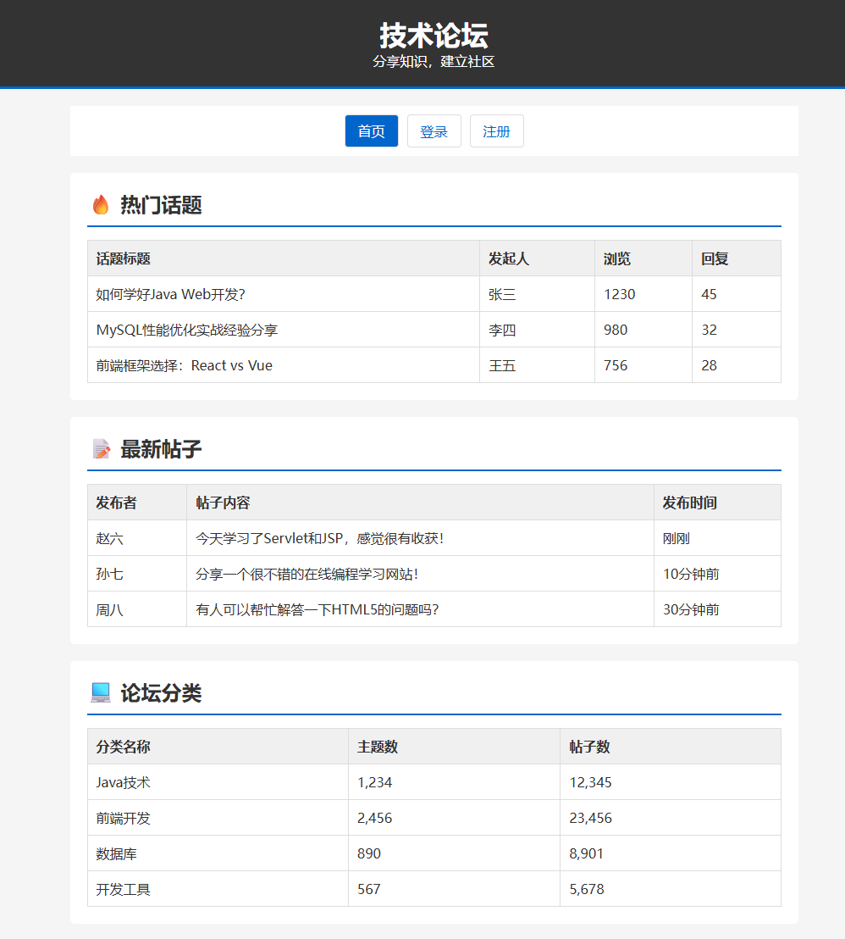
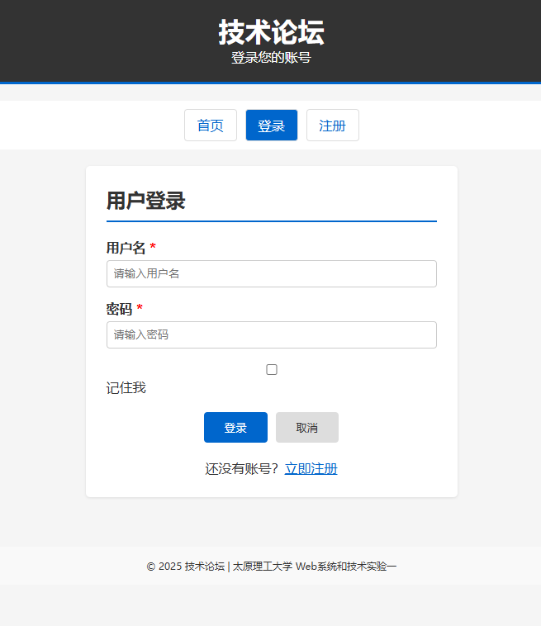
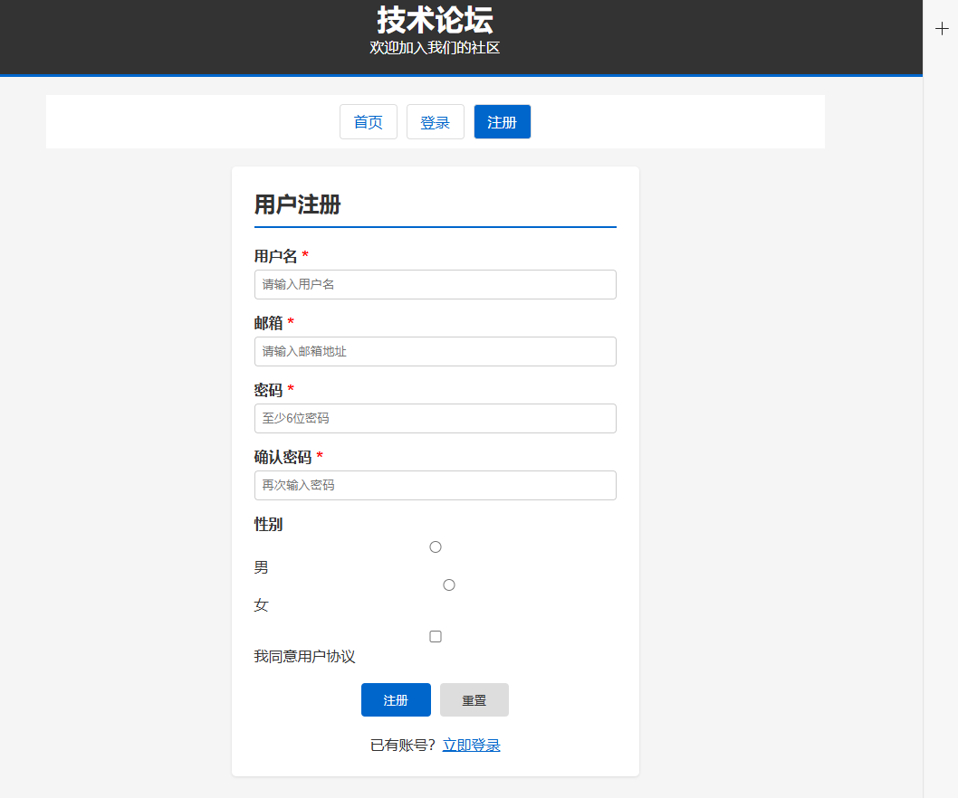

遇到的问题及解决方法
页面布局错乱，元素消失 加载异常。发现是元素未设置闭合，同时资源路径设置错误
跳转错误，发现是跳转文件名路由设置错误

实验名称 | 实验二 Servlet 与会话技术
实验目的与要求
1．理解 Servlet 的工作原理。
2．掌握 Servlet 的创建及使用。
3. 掌握请求与相应对象的使用。
4. 掌握 Session 与 Cookie 对象的使用

实验环境
Vscode,Tomcat WSL2 Ubuntu2204

实验记录(写出实验过程中各步骤的具体实现代码和结果截图)(可分栏或加页)
项目结构：
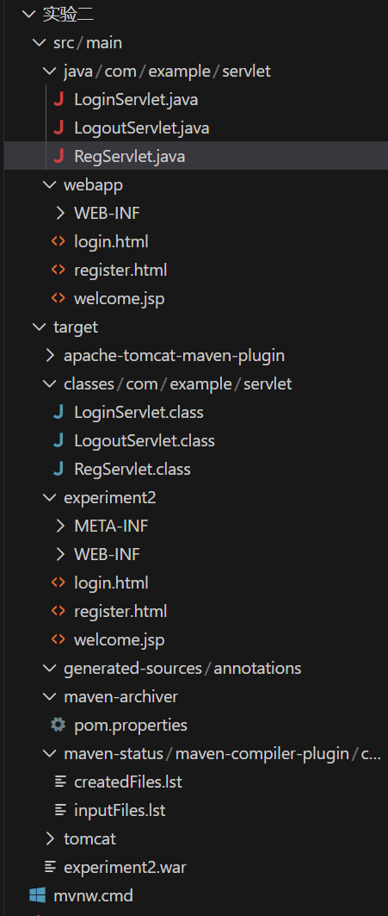
LoginServlet.java
package com.example.servlet;

import javax.servlet.ServletException;
import javax.servlet.annotation.WebServlet;
import javax.servlet.http.Cookie;
import javax.servlet.http.HttpServlet;
import javax.servlet.http.HttpServletRequest;
import javax.servlet.http.HttpServletResponse;
import javax.servlet.http.HttpSession;
import java.io.IOException;
import java.io.PrintWriter;
import java.net.URLDecoder;
import java.net.URLEncoder;

/**
* 用户登录Servlet
* 实验二：Servlet与会话技术
* 使用Cookie验证登录，使用Session保存登录状态
*/
@WebServlet("/LoginServlet")
public class LoginServlet extends HttpServlet {

@Override
protected void doPost(HttpServletRequest request, HttpServletResponse response)
throws ServletException, IOException {

// 设置请求和响应的编码
request.setCharacterEncoding("UTF-8");
response.setContentType("text/html;charset=UTF-8");

// 获取表单参数
String username = request.getParameter("username");
String password = request.getParameter("password");
String remember = request.getParameter("remember");

PrintWriter out = response.getWriter();

// 验证参数
if (username == null || username.trim().isEmpty() ||
password == null || password.trim().isEmpty()) {

outputError(out, "登录失败：请输入用户名和密码！");
return;
}

// 从Cookie中查找用户信息
Cookie[] cookies = request.getCookies();
String storedInfo = null;

if (cookies != null) {
for (Cookie cookie : cookies) {
if (cookie.getName().equals("user_" + username)) {
storedInfo = URLDecoder.decode(cookie.getValue(), "UTF-8");
break;
}
}
}

// 验证用户是否存在
if (storedInfo == null) {
outputError(out, "登录失败：用户不存在，请先注册！");
return;
}

// 解析存储的信息：密码|邮箱
String[] parts = storedInfo.split("\\|");
String storedPassword = parts[0];
String storedEmail = parts.length > 1 ? parts[1] : "";

// 验证密码
if (!password.equals(storedPassword)) {
outputError(out, "登录失败：密码错误！");
return;
}

// 登录成功，创建Session保存用户信息
HttpSession session = request.getSession();
session.setAttribute("username", username);
session.setAttribute("email", storedEmail);
session.setAttribute("loginTime", System.currentTimeMillis());
session.setMaxInactiveInterval(30 * 60); // Session有效期30分钟

// 如果选择"记住我"，保存Cookie
if ("true".equals(remember)) {
Cookie savedUsername = new Cookie("savedUsername", URLEncoder.encode(username, "UTF-8"));
savedUsername.setMaxAge(60 * 60 * 24 * 7); // 7天有效期
savedUsername.setPath("/");
response.addCookie(savedUsername);
} else {
// 清除保存的用户名Cookie
Cookie savedUsername = new Cookie("savedUsername", "");
savedUsername.setMaxAge(0);
savedUsername.setPath("/");
response.addCookie(savedUsername);
}

// 登录成功，输出结果页面
out.println("<!DOCTYPE html>");
out.println("<html><head><meta charset='UTF-8'><title>登录成功</title>");
out.println("<style>");
out.println("body{font-family:'Microsoft YaHei';display:flex;justify-content:center;align-items:center;height:100vh;background:linear-gradient(135deg, #667eea 0%, #764ba2 100%);}");
out.println(".msg{background:white;padding:40px;border-radius:10px;text-align:center;box-shadow:0 15px 35px rgba(0,0,0,0.2);min-width:400px;}");
out.println(".success{color:#27ae60;font-size:24px;margin-bottom:20px;}");
out.println(".info{color:#666;margin:10px 0;text-align:left;padding:10px;background:#f8f9fa;border-radius:5px;}");
out.println(".info strong{color:#333;}");
out.println("a{display:inline-block;margin-top:20px;padding:10px 30px;background:linear-gradient(135deg, #667eea 0%, #764ba2 100%);color:white;text-decoration:none;border-radius:5px;margin-right:10px;}");
out.println("a:hover{transform:translateY(-2px);box-shadow:0 5px 20px rgba(102,126,234,0.4);}");
out.println("a.logout{background:#e74c3c;}");
out.println("</style></head>");
out.println("<body>");
out.println("<div class='msg'>");
out.println("<p class='success'>🎉 登录成功！</p>");
out.println("<div class='info'><strong>用户名：</strong>" + username + "</div>");
out.println("<div class='info'><strong>邮箱：</strong>" + storedEmail + "</div>");
out.println("<div class='info'><strong>Session ID：</strong>" + session.getId() + "</div>");
out.println("<div class='info'><strong>登录时间：</strong>" + new java.util.Date() + "</div>");
if ("true".equals(remember)) {
out.println("<div class='info'><strong>记住登录：</strong>已启用（7天内免登录）</div>");
}
out.println("<a href='welcome.jsp'>进入主页</a>");
out.println("<a href='LogoutServlet' class='logout'>退出登录</a>");
out.println("</div>");
out.println("</body></html>");
}

@Override
protected void doGet(HttpServletRequest request, HttpServletResponse response)
throws ServletException, IOException {
// GET请求重定向到登录页面
response.sendRedirect("login.html");
}

/**
* 输出错误信息页面
*/
private void outputError(PrintWriter out, String message) {
out.println("<!DOCTYPE html>");
out.println("<html><head><meta charset='UTF-8'><title>登录失败</title>");
out.println("<style>body{font-family:'Microsoft YaHei';display:flex;justify-content:center;align-items:center;height:100vh;background:#f5f5f5;}");
out.println(".msg{background:white;padding:40px;border-radius:10px;text-align:center;box-shadow:0 5px 20px rgba(0,0,0,0.1);}");
out.println(".error{color:#e74c3c;font-size:24px;margin-bottom:20px;}");
out.println("a{color:#667eea;text-decoration:none;display:block;margin-top:10px;}</style></head>");
out.println("<body><div class='msg'><p class='error'>" + message + "</p>");
out.println("<a href='login.html'>返回登录</a>");
out.println("<a href='register.html'>去注册</a></div></body></html>");
}
}

RegServlet.java
package com.example.servlet;

import javax.servlet.ServletException;
import javax.servlet.annotation.WebServlet;
import javax.servlet.http.Cookie;
import javax.servlet.http.HttpServlet;
import javax.servlet.http.HttpServletRequest;
import javax.servlet.http.HttpServletResponse;
import java.io.IOException;
import java.io.PrintWriter;
import java.net.URLEncoder;

/**
* 用户注册Servlet
* 实验二：Servlet与会话技术
* 使用Cookie保存注册信息
*/
@WebServlet("/RegServlet")
public class RegServlet extends HttpServlet {

@Override
protected void doPost(HttpServletRequest request, HttpServletResponse response)
throws ServletException, IOException {

// 设置请求和响应的编码
request.setCharacterEncoding("UTF-8");
response.setContentType("text/html;charset=UTF-8");

// 获取表单参数
String username = request.getParameter("username");
String password = request.getParameter("password");
String email = request.getParameter("email");

PrintWriter out = response.getWriter();

// 验证参数
if (username == null || username.trim().isEmpty() ||
password == null || password.trim().isEmpty() ||
email == null || email.trim().isEmpty()) {

out.println("<!DOCTYPE html>");
out.println("<html><head><meta charset='UTF-8'><title>注册失败</title>");
out.println("<style>body{font-family:'Microsoft YaHei';display:flex;justify-content:center;align-items:center;height:100vh;background:#f5f5f5;}");
out.println(".msg{background:white;padding:40px;border-radius:10px;text-align:center;box-shadow:0 5px 20px rgba(0,0,0,0.1);}");
out.println(".error{color:#e74c3c;font-size:24px;margin-bottom:20px;}");
out.println("a{color:#667eea;text-decoration:none;}</style></head>");
out.println("<body><div class='msg'><p class='error'>注册失败：请填写完整信息！</p>");
out.println("<a href='register.html'>返回注册</a></div></body></html>");
return;
}

// 检查用户名是否已存在（通过Cookie）
Cookie[] cookies = request.getCookies();
if (cookies != null) {
for (Cookie cookie : cookies) {
if (cookie.getName().equals("user_" + username)) {
out.println("<!DOCTYPE html>");
out.println("<html><head><meta charset='UTF-8'><title>注册失败</title>");
out.println("<style>body{font-family:'Microsoft YaHei';display:flex;justify-content:center;align-items:center;height:100vh;background:#f5f5f5;}");
out.println(".msg{background:white;padding:40px;border-radius:10px;text-align:center;box-shadow:0 5px 20px rgba(0,0,0,0.1);}");
out.println(".error{color:#e74c3c;font-size:24px;margin-bottom:20px;}");
out.println("a{color:#667eea;text-decoration:none;}</style></head>");
out.println("<body><div class='msg'><p class='error'>注册失败：用户名已存在！</p>");
out.println("<a href='register.html'>返回注册</a></div></body></html>");
return;
}
}
}

// 创建Cookie保存用户信息
// 格式：user_用户名 = 密码|邮箱
String userInfo = password + "|" + email;
Cookie userCookie = new Cookie("user_" + username, URLEncoder.encode(userInfo, "UTF-8"));
userCookie.setMaxAge(60 * 60 * 24 * 30); // 30天有效期
userCookie.setPath("/");
response.addCookie(userCookie);

// 注册成功，输出结果页面
out.println("<!DOCTYPE html>");
out.println("<html><head><meta charset='UTF-8'><title>注册成功</title>");
out.println("<style>");
out.println("body{font-family:'Microsoft YaHei';display:flex;justify-content:center;align-items:center;height:100vh;background:linear-gradient(135deg, #667eea 0%, #764ba2 100%);}");
out.println(".msg{background:white;padding:40px;border-radius:10px;text-align:center;box-shadow:0 15px 35px rgba(0,0,0,0.2);}");
out.println(".success{color:#27ae60;font-size:24px;margin-bottom:20px;}");
out.println(".info{color:#666;margin:10px 0;}");
out.println("a{display:inline-block;margin-top:20px;padding:10px 30px;background:linear-gradient(135deg, #667eea 0%, #764ba2 100%);color:white;text-decoration:none;border-radius:5px;}");
out.println("a:hover{transform:translateY(-2px);box-shadow:0 5px 20px rgba(102,126,234,0.4);}");
out.println("</style></head>");
out.println("<body>");
out.println("<div class='msg'>");
out.println("<p class='success'>🎉 注册成功！</p>");
out.println("<p class='info'>用户名：" + username + "</p>");
out.println("<p class='info'>邮箱：" + email + "</p>");
out.println("<p class='info'>您的信息已保存到Cookie中</p>");
out.println("<a href='login.html'>立即登录</a>");
out.println("</div>");
out.println("</body></html>");
}

@Override
protected void doGet(HttpServletRequest request, HttpServletResponse response)
throws ServletException, IOException {
// GET请求重定向到注册页面
response.sendRedirect("register.html");
}
}

效果：
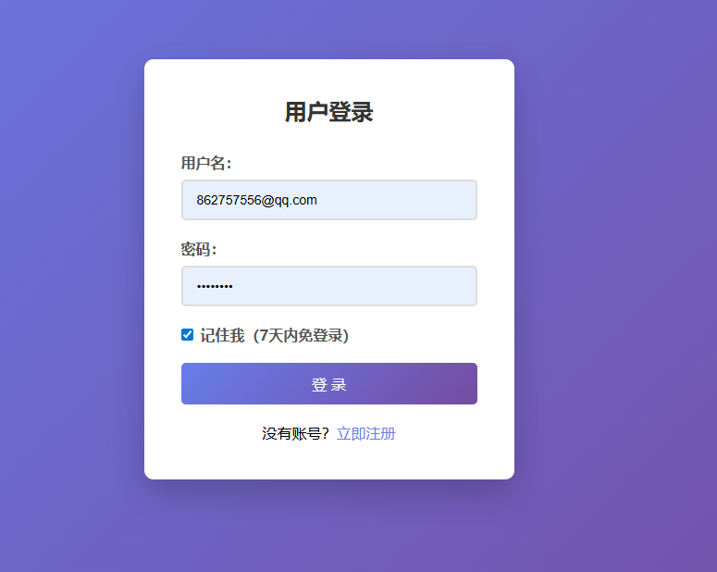
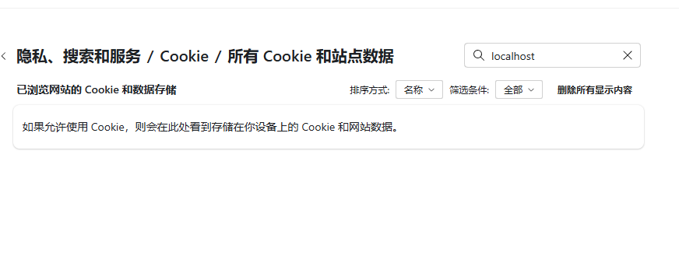

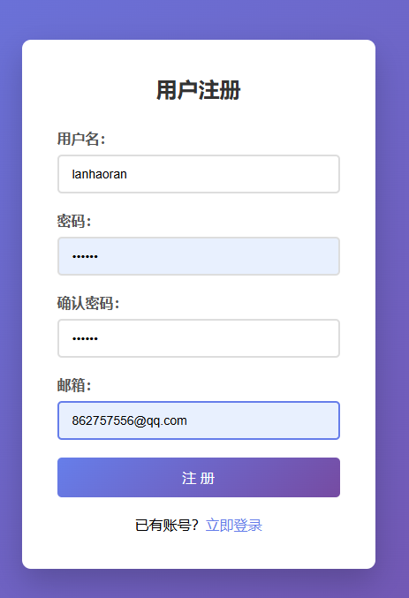

注册后



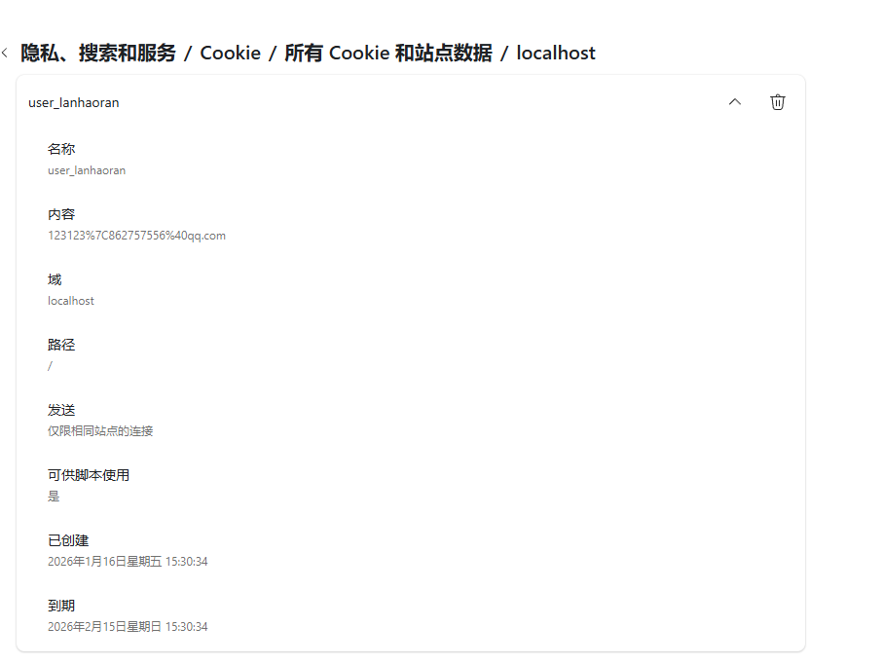

遇到的问题及解决方法
Webapp的tomcat起不来 使用 mvn tomcat7:run尝试成功
表单提交后出现中文乱码 在获取参数前设置 request.setCharacterEncoding("UTF-8")解决

实验名称 | 实验三 JSP 技术
实验目的与要求
1．掌握在 JSP 中添加 Java 脚本。
2．掌握 JSP 中常用的指令和动作标签。
3. 掌握 JSP 中 9 个隐式对象的使用。

实验环境
VSCode Tomcat WSL Ubuntu22

实验记录(写出实验过程中各步骤的具体实现代码和结果截图)(可分栏或加页)
项目结构
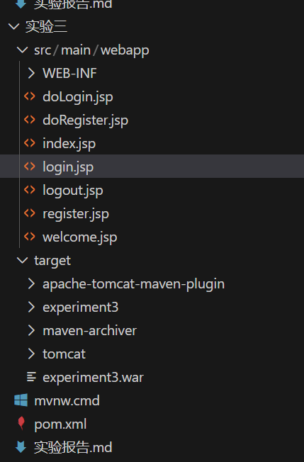

register.jsp
<%@ page contentType="text/html;charset=UTF-8" language="java" %>
<%@ page import="java.net.URLDecoder" %>
<%
// 判断用户是否注册过（从Cookie中获取用户注册信息）
String registeredUser = null;
Cookie[] cookies = request.getCookies();
if (cookies != null) {
for (Cookie c : cookies) {
if (c.getName().startsWith("user_")) {
registeredUser = c.getName().substring(5);
break;
}
}
}
String error = request.getParameter("error");
%>
<!DOCTYPE html>
<html lang="zh-CN">
<head>
<meta charset="UTF-8">
<title>用户注册</title>
<style>
* { margin: 0; padding: 0; box-sizing: border-box; }
body { font-family: 'Microsoft YaHei'; background: linear-gradient(135deg, #667eea, #764ba2);
min-height: 100vh; display: flex; justify-content: center; align-items: center; }
.container { background: white; padding: 30px; border-radius: 10px; width: 360px;
box-shadow: 0 10px 30px rgba(0,0,0,0.2); }
h2 { text-align: center; margin-bottom: 20px; color: #333; }
.form-group { margin-bottom: 15px; }
label { display: block; margin-bottom: 5px; color: #555; }
input[type="text"], input[type="password"], input[type="email"] {
width: 100%; padding: 10px; border: 1px solid #ddd; border-radius: 5px; }
input:focus { outline: none; border-color: #667eea; }
.btn { width: 100%; padding: 12px; background: linear-gradient(135deg, #667eea, #764ba2);
color: white; border: none; border-radius: 5px; cursor: pointer; font-size: 16px; }
.link { text-align: center; margin-top: 15px; }
.link a { color: #667eea; text-decoration: none; }
.msg { padding: 10px; border-radius: 5px; margin-bottom: 15px; text-align: center; }
.warning { background: #fff3cd; color: #856404; }
.error { background: #f8d7da; color: #721c24; }
</style>
</head>
<body>
<div class="container">
<h2>用户注册</h2>

<%-- 如果用户注册过，显示警告 --%>
<% if (registeredUser != null) { %>
<div class="msg warning">⚠️ 您之前已注册过用户 <strong><%= registeredUser %></strong>，重新注册将覆盖之前的信息！</div>
<% } %>

<% if ("empty".equals(error)) { %><div class="msg error">请填写完整信息！</div>
<% } else if ("exists".equals(error)) { %><div class="msg error">用户名已存在！</div>
<% } else if ("password".equals(error)) { %><div class="msg error">两次密码不一致！</div><% } %>

<form action="doRegister.jsp" method="post" id="regForm">
<div class="form-group">
<label>用户名：</label>
<input type="text" name="username" required>
</div>
<div class="form-group">
<label>密码：</label>
<input type="password" name="password" id="pwd" required>
</div>
<div class="form-group">
<label>确认密码：</label>
<input type="password" name="confirmPassword" id="cpwd" required>
</div>
<div class="form-group">
<label>邮箱：</label>
<input type="email" name="email">
</div>
<button type="submit" class="btn">注 册</button>
</form>
<div class="link">已有账号？<a href="login.jsp">立即登录</a></div>
</div>
<script>
document.getElementById('regForm').onsubmit = function() {
if (document.getElementById('pwd').value !== document.getElementById('cpwd').value) {
alert('两次密码不一致！'); return false;
}
return true;
};
</script>
</body>
</html>

login.jsp
<%@ page contentType="text/html;charset=UTF-8" language="java" %>
<%@ page import="java.net.URLDecoder" %>
<%
// 检查Cookie中保存的用户名（记住我功能）
String savedUser = "";
Cookie[] cookies = request.getCookies();
if (cookies != null) {
for (Cookie c : cookies) {
if ("savedUsername".equals(c.getName())) {
savedUser = URLDecoder.decode(c.getValue(), "UTF-8");
}
}
}
String error = request.getParameter("error");
String msg = request.getParameter("msg");
%>
<!DOCTYPE html>
<html lang="zh-CN">
<head>
<meta charset="UTF-8">
<title>用户登录</title>
<style>
* { margin: 0; padding: 0; box-sizing: border-box; }
body { font-family: 'Microsoft YaHei'; background: linear-gradient(135deg, #667eea, #764ba2);
min-height: 100vh; display: flex; justify-content: center; align-items: center; }
.container { background: white; padding: 30px; border-radius: 10px; width: 360px;
box-shadow: 0 10px 30px rgba(0,0,0,0.2); }
h2 { text-align: center; margin-bottom: 20px; color: #333; }
.form-group { margin-bottom: 15px; }
label { display: block; margin-bottom: 5px; color: #555; }
input[type="text"], input[type="password"] { width: 100%; padding: 10px; border: 1px solid #ddd; border-radius: 5px; }
input:focus { outline: none; border-color: #667eea; }
.btn { width: 100%; padding: 12px; background: linear-gradient(135deg, #667eea, #764ba2);
color: white; border: none; border-radius: 5px; cursor: pointer; font-size: 16px; }
.link { text-align: center; margin-top: 15px; }
.link a { color: #667eea; text-decoration: none; }
.msg { padding: 10px; border-radius: 5px; margin-bottom: 15px; text-align: center; }
.success { background: #d4edda; color: #155724; }
.error { background: #f8d7da; color: #721c24; }
</style>
</head>
<body>
<div class="container">
<h2>用户登录</h2>
<% if ("logout".equals(msg)) { %><div class="msg success">您已成功退出登录！</div><% } %>
<% if ("empty".equals(error)) { %><div class="msg error">请输入用户名和密码！</div>
<% } else if ("notfound".equals(error)) { %><div class="msg error">用户不存在，请先注册！</div>
<% } else if ("password".equals(error)) { %><div class="msg error">密码错误！</div><% } %>

<form action="doLogin.jsp" method="post">
<div class="form-group">
<label>用户名：</label>
<input type="text" name="username" value="<%= savedUser %>" required>
</div>
<div class="form-group">
<label>密码：</label>
<input type="password" name="password" required>
</div>
<div class="form-group">
<input type="checkbox" name="remember" value="true" <%= !savedUser.isEmpty() ? "checked" : "" %>> 记住我
</div>
<button type="submit" class="btn">登 录</button>
</form>
<div class="link">没有账号？<a href="register.jsp">立即注册</a></div>
</div>
</body>
</html>

index.jsp
<%@ page contentType="text/html;charset=UTF-8" language="java" %>
<%@ page import="java.text.SimpleDateFormat, java.util.Date" %>
<%
// 从Session获取用户信息
String username = (String) session.getAttribute("username");
String email = (String) session.getAttribute("email");
Long loginTime = (Long) session.getAttribute("loginTime");

SimpleDateFormat sdf = new SimpleDateFormat("yyyy-MM-dd HH:mm:ss");
String loginTimeStr = loginTime != null ? sdf.format(new Date(loginTime)) : "未知";
%>
<div class="content" style="background:linear-gradient(135deg,#667eea,#764ba2);color:white;">
<h2 style="color:white;border-bottom-color:white;">👋 欢迎回来！</h2>
<p style="font-size:18px;">当前登录用户：<strong><%= username %></strong></p>
<p>邮箱：<%= email != null && !email.isEmpty() ? email : "未设置" %></p>
<p>登录时间：<%= loginTimeStr %></p>
<p>Session ID：<span style="font-size:11px;"><%= session.getId() %></span></p>
</div>

Welcome.jsp

<%@ page contentType="text/html;charset=UTF-8" language="java" %>
<%
// 判断用户是否已登录（从Session中获取）
String username = (String) session.getAttribute("username");
if (username == null) {
// 未登录，提示并跳转到登录页面
%>
<!DOCTYPE html>
<html><head><meta charset="UTF-8"><title>提示</title>
<style>body{font-family:'Microsoft YaHei';display:flex;justify-content:center;align-items:center;height:100vh;background:#f5f5f5;}
.box{background:white;padding:30px;border-radius:8px;text-align:center;box-shadow:0 2px 10px rgba(0,0,0,0.1);}
.btn{display:inline-block;margin-top:15px;padding:10px 20px;background:#0066cc;color:white;text-decoration:none;border-radius:4px;}</style>
</head><body>
<div class="box">
<h2>⚠️ 您还未登录</h2>
<p>请先登录后再访问主页面</p>
<a href="login.jsp" class="btn">去登录</a>
</div>
</body></html>
<%
return;
}
%>
<!DOCTYPE html>
<html lang="zh-CN">
<head>
<meta charset="UTF-8">
<title>技术论坛 - 首页</title>
<style>
* { margin: 0; padding: 0; box-sizing: border-box; }
body { font-family: 'Microsoft YaHei', Arial, sans-serif; background: #f5f5f5; }
.header { background: #333; color: white; padding: 15px 20px; }
.header h1 { display: inline; }
.nav { float: right; }
.nav a { color: white; margin-left: 15px; text-decoration: none; }
.container { max-width: 900px; margin: 20px auto; padding: 0 20px; }
.content { background: white; padding: 20px; border-radius: 5px; margin-bottom: 20px; }
.content h2 { border-bottom: 2px solid #0066cc; padding-bottom: 10px; margin-bottom: 15px; }
table { width: 100%; border-collapse: collapse; }
th, td { border: 1px solid #ddd; padding: 10px; text-align: left; }
th { background: #f0f0f0; }
</style>
</head>
<body>
<div class="header">
<h1>技术论坛</h1>
<div class="nav">
<a href="logout.jsp">退出登录</a>
</div>
</div>

<div class="container">
<!-- 包含欢迎页面 -->
<jsp:include page="welcome.jsp" />

<div class="content">
<h2>🔥 热门话题</h2>
<table>
<tr><th>话题</th><th>作者</th><th>浏览</th></tr>
<tr><td>如何学好Java Web开发？</td><td>张三</td><td>1230</td></tr>
<tr><td>MySQL性能优化经验</td><td>李四</td><td>980</td></tr>
</table>
</div>

<div class="content">
<h2>📝 最新帖子</h2>
<table>
<tr><th>内容</th><th>发布者</th><th>时间</th></tr>
<tr><td>学习了Servlet和JSP</td><td>赵六</td><td>刚刚</td></tr>
<tr><td>分享编程学习网站</td><td>孙七</td><td>10分钟前</td></tr>
</table>
</div>
</div>
</body>
</html>

实现效果
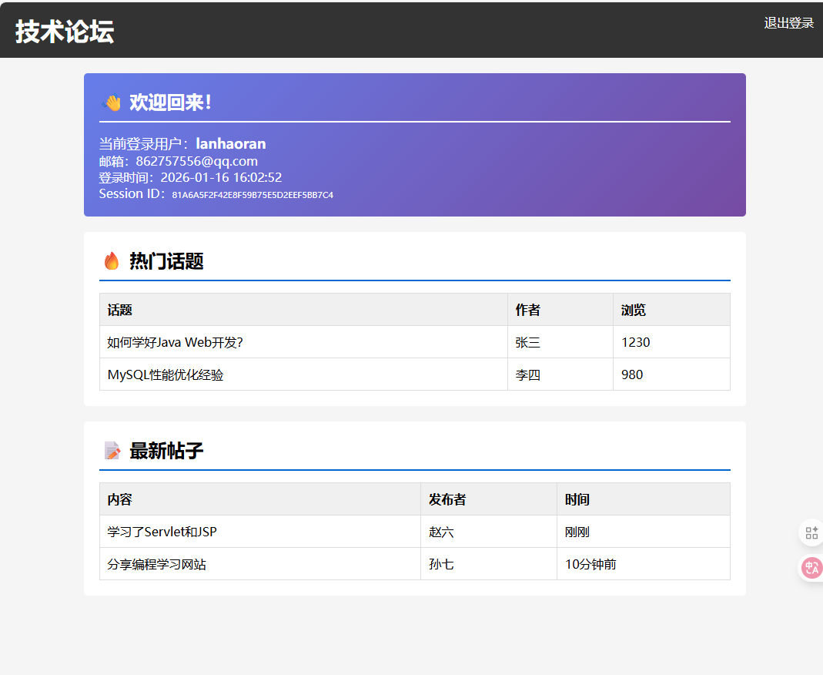

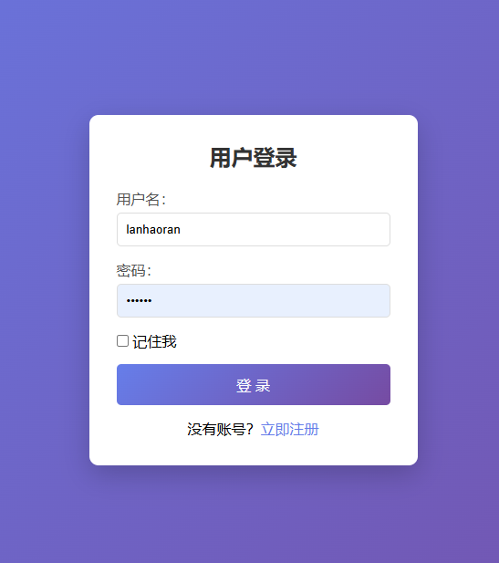

遇到的问题及解决方法
session在不同页面数据不一致，这个需要确保是否错误调用了session.invalidate

实验名称 | 实验四 JDBC 访问数据库
实验目的与要求
1．掌握 JDBC 常用 API 的使用。
2．掌握 JDBC 访问数据库的步骤。

实验环境
VSCode TomCat Ubuntu2204

实验记录(写出实验过程中各步骤的具体实现代码和结果截图)(可分栏或加页)
目录结构：
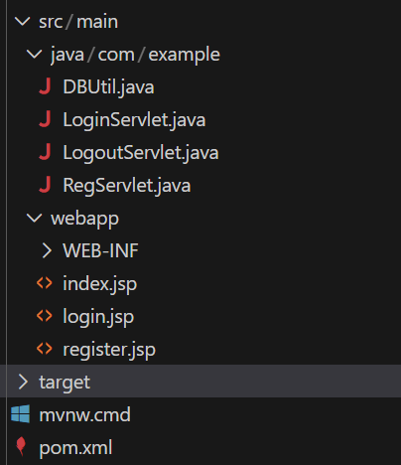

DBUtil.java
package com.example;

import java.sql.*;

/**
* 数据库工具类 - 使用H2内嵌数据库
*/
public class DBUtil {
private static final String URL = "jdbc:h2:./data/experiment4;MODE=MySQL;AUTO_SERVER=TRUE";
private static final String USER = "sa";
private static final String PASS = "";

static {
try {
Class.forName("org.h2.Driver");
initDB();
System.out.println("数据库初始化成功！");
} catch (Exception e) {
e.printStackTrace();
}
}

public static Connection getConnection() throws SQLException {
return DriverManager.getConnection(URL, USER, PASS);
}

// 初始化数据库表
private static void initDB() throws SQLException {
try (Connection conn = getConnection();
Statement stmt = conn.createStatement()) {
// 创建users表（避免使用user保留字）
stmt.execute("CREATE TABLE IF NOT EXISTS users (" +
"id INT AUTO_INCREMENT PRIMARY KEY," +
"username VARCHAR(50) UNIQUE NOT NULL," +
"password VARCHAR(100) NOT NULL," +
"email VARCHAR(100)," +
"create_time TIMESTAMP DEFAULT CURRENT_TIMESTAMP)");

// 插入测试用户（如果不存在）
stmt.execute("MERGE INTO users (username, password, email) KEY(username) " +
"VALUES ('admin', '123456', 'admin@test.com')");
}
}

public static void close(AutoCloseable... resources) {
for (AutoCloseable r : resources) {
if (r != null) try { r.close(); } catch (Exception ignored) {}
}
}
}

LoginServlet.java
package com.example;

import javax.servlet.ServletException;
import javax.servlet.annotation.WebServlet;
import javax.servlet.http.*;
import java.io.IOException;
import java.sql.*;

/**
* 登录Servlet - 从数据库验证用户信息
*/
@WebServlet("/LoginServlet")
public class LoginServlet extends HttpServlet {

@Override
protected void doPost(HttpServletRequest request, HttpServletResponse response)
throws ServletException, IOException {
request.setCharacterEncoding("UTF-8");

String username = request.getParameter("username");
String password = request.getParameter("password");

// 验证参数
if (username == null || username.trim().isEmpty() ||
password == null || password.trim().isEmpty()) {
response.sendRedirect("login.jsp?error=empty");
return;
}

Connection conn = null;
PreparedStatement ps = null;
ResultSet rs = null;

try {
conn = DBUtil.getConnection();

// 查询用户
ps = conn.prepareStatement("SELECT * FROM users WHERE username = ? AND password = ?");
ps.setString(1, username);
ps.setString(2, password);
rs = ps.executeQuery();

if (rs.next()) {
// 登录成功，保存用户信息到Session
HttpSession session = request.getSession();
session.setAttribute("username", rs.getString("username"));
session.setAttribute("email", rs.getString("email"));
session.setAttribute("userId", rs.getInt("id"));
session.setMaxInactiveInterval(30 * 60); // 30分钟

// 跳转到主页面
response.sendRedirect("index.jsp");
} else {
// 用户名或密码错误
response.sendRedirect("login.jsp?error=notfound");
}

} catch (SQLException e) {
e.printStackTrace();
response.sendRedirect("login.jsp?error=error");
} finally {
DBUtil.close(rs, ps, conn);
}
}

@Override
protected void doGet(HttpServletRequest request, HttpServletResponse response)
throws ServletException, IOException {
response.sendRedirect("login.jsp");
}
}

RegServlet.java
package com.example;

import javax.servlet.ServletException;
import javax.servlet.annotation.WebServlet;
import javax.servlet.http.*;
import java.io.IOException;
import java.sql.*;

/**
* 注册Servlet - 将用户信息保存到数据库
*/
@WebServlet("/RegServlet")
public class RegServlet extends HttpServlet {

@Override
protected void doPost(HttpServletRequest request, HttpServletResponse response)
throws ServletException, IOException {
request.setCharacterEncoding("UTF-8");

String username = request.getParameter("username");
String password = request.getParameter("password");
String email = request.getParameter("email");

// 验证参数
if (username == null || username.trim().isEmpty() ||
password == null || password.trim().isEmpty()) {
response.sendRedirect("register.jsp?error=empty");
return;
}

Connection conn = null;
PreparedStatement ps = null;
ResultSet rs = null;

try {
conn = DBUtil.getConnection();

// 检查用户名是否已存在
ps = conn.prepareStatement("SELECT id FROM users WHERE username = ?");
ps.setString(1, username);
rs = ps.executeQuery();

if (rs.next()) {
// 用户名已被占用
response.sendRedirect("register.jsp?error=exists");
return;
}

DBUtil.close(rs, ps);

// 插入新用户
ps = conn.prepareStatement("INSERT INTO users (username, password, email) VALUES (?, ?, ?)");
ps.setString(1, username);
ps.setString(2, password);
ps.setString(3, email);
ps.executeUpdate();

// 注册成功，跳转到登录页面
response.sendRedirect("login.jsp?msg=register");

} catch (SQLException e) {
e.printStackTrace();
response.sendRedirect("register.jsp?error=error");
} finally {
DBUtil.close(rs, ps, conn);
}
}

@Override
protected void doGet(HttpServletRequest request, HttpServletResponse response)
throws ServletException, IOException {
response.sendRedirect("register.jsp");
}
}

import java.io.IOException;

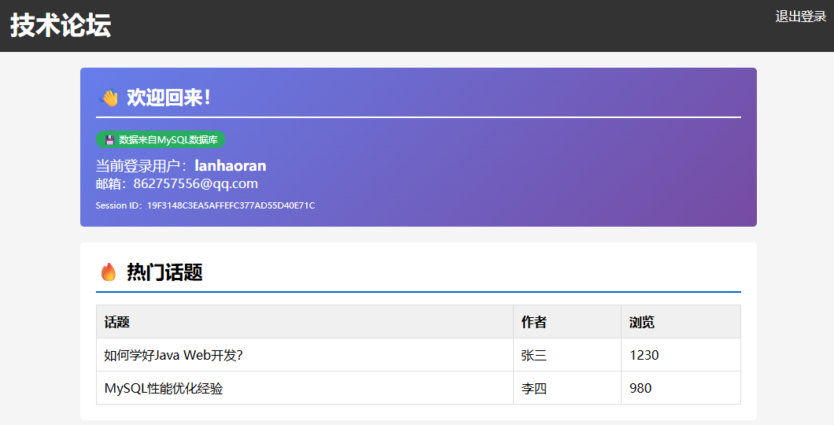

查看数据库 发现登录信息已经储存
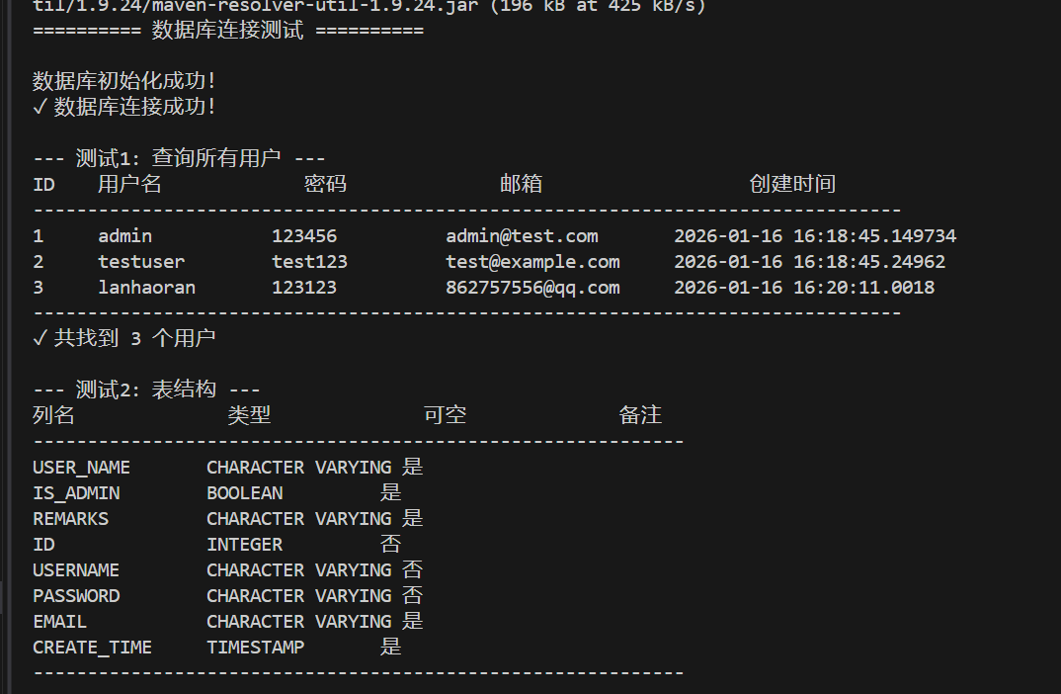

遇到的问题及解决方法
- 数据库连接失败，报"Communications link failure"
检查MySQL服务是否启动，检查连接URL中的主机名和端口
- 驱动类找不到
确保MySQL驱动jar包已添加到项目依赖中即可

