Data Building && Training Manual

Okay. Now that you want to build synthetic data from your own collection of fonts
and train your own models… Here is how.

Word data building
Please refer to https://github.com/lancercat/OSOCR

Cotraining Data Building
Use this script: neko_2021_mjt/character_recognition_side_task_maker/make_charset_oss.py
1. set render cache (depending on # fonts you have, can be super large…)
Recommendation would be purchase a bearing 240GiB SSD for as cheap as you can, and set it to the disk. The script will write like A LOT to that disk, make sure don’t wear your expensive main drive off.

2. Set font paths. Put all your fonts in this folder.
3. Setup font file index:
the file is a text file name all.txt under FROOT.
Each line is a relative path ot a font file from FROOT.
For example, if you chose to use google fonts like us, after uncompression you get something like:
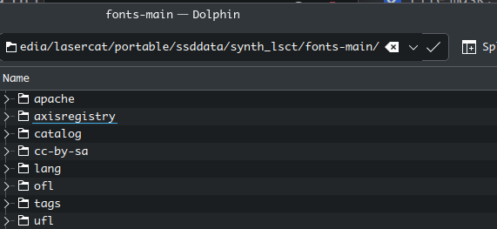
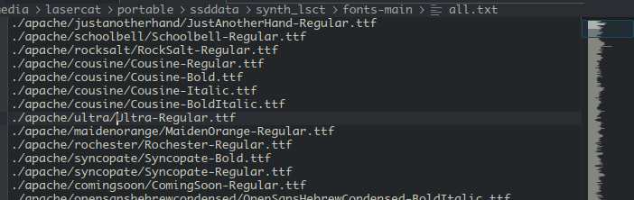
if you don’t have ttc files, use this in bash to creat the index file
find . | grep tf$ | less > all.tex
Whatever you use, be aware that not all fonts on the internet are free.

5. Setup the lmdb folder and launch the script
it will generate a file called compact.pt to store some index. Remove it if you need to start fresh
Also, render cache needs to be emptied if you need a re-generation.

Q. But wait, you didn’t exclude testing set characters here, did you make a data leak?
A. No. The testing characters are filtered from data loader via the "chars_to_avoid" parameter in
neko_2021_mjt/configs/data/large_scale_synch_data.py
These characters are not exclude on dataset level bcs we don’t want to keep sever versions of ~10Gib lmdbs floating around for each individual protocols.
Although we only released the CHS to JPN/KR protocol in this paper, however some other protocols are maturing and will come in 2025 and 2026.

