Handbook

Setup Environment
1. Make a fresh installation of Manjaro.
2. Download the repo from Github.
3. a) Download models from the github links, and put them in a folder, say /run/media/xxx/data/c491/c4-models-work/.
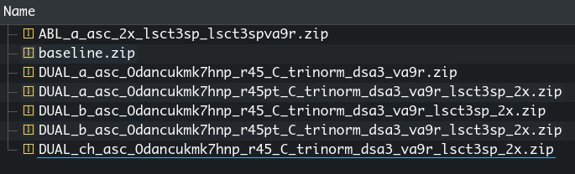
b) Run for i in $(ls); do unzip $i; done; to uncompress them
4. Download datasets from the github links and uncompress it to /run/media/xxx/data/xxx/ssddata/
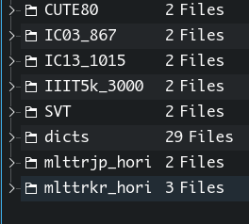

5. Uncompress the Athena.zip file to /run/media/xxx/data/xxx/ssddata/

6. Install dependencies
a) Install packages on paclist.txt in the git repo
b) Install pip packages on the piplist.txt in the git repo
c) Install pylcs-laser.zip
pylcs modded by a Github user, adds support to return the exact LCS
Source: https://github.com/Meteorix/pylcs/issues/4,
7. Change the paths in neko_sdk/root.py to the data and models uncompressed. If you do NOT want intermediate results, return None for find_export_root.
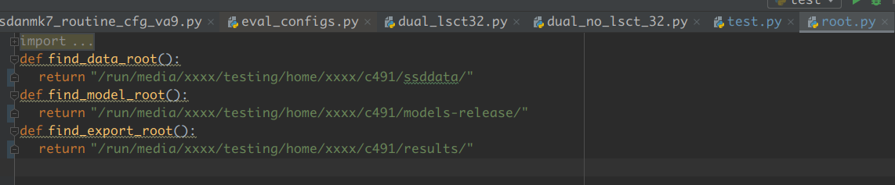
All done! You can now go to the next steps to check out if our framework lives up to its name.

Evaluation:
Going ~100 FPS on a laptop single batched is what we reported in the paper, now let’s go 280+ FPS on that laptop going multi-batched. We actually liked the OSOCR way of testing on laptops so we also perform evaluations on laptops consuming around 230w (120w GPU+65W CPU + a little bit extra). This gives an insight into how the model may behave when deployed on a mobile platform that fits into vehicles or other power-consumption-sensitive computing platforms.

Reproducing Ablative Study
Base model: Run test_rej.py under DUAL_a_asc_Odancukmk7hnp_r45_C_trinorm_dsa3
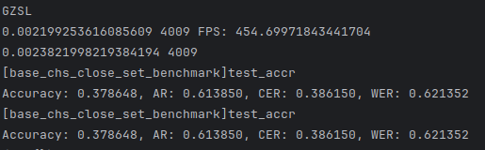
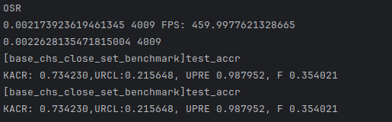
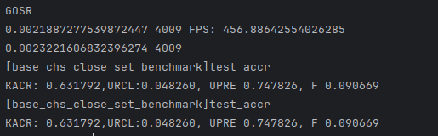
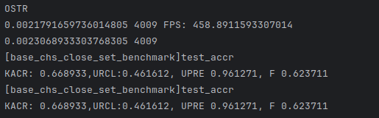

CIL only: Run test_rej.py under DUAL_a_asc_Odancukmk7hnp_r45_C_trinorm_dsa3_va9r
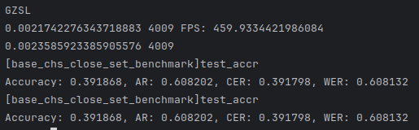
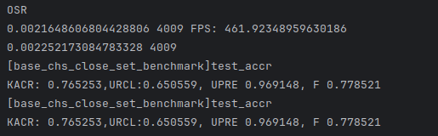
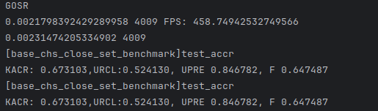
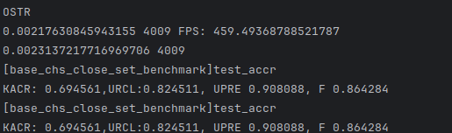

ICL only and full model: Run test_rej.py under ABL_a_asc_2x_lsct3sp_lsct3spva9r
GZSL OSR GOSR OSTR
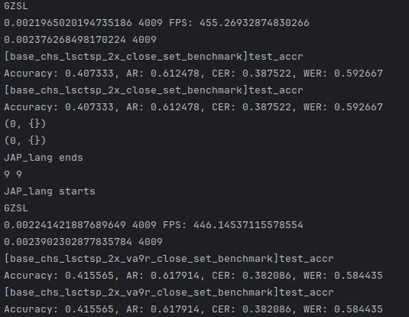
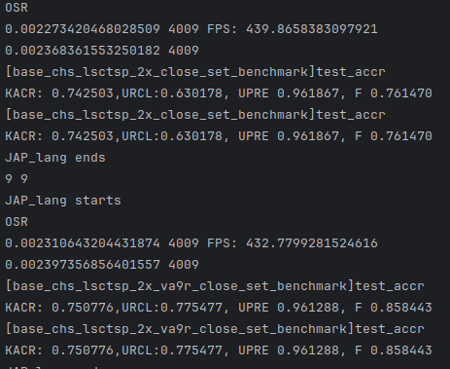
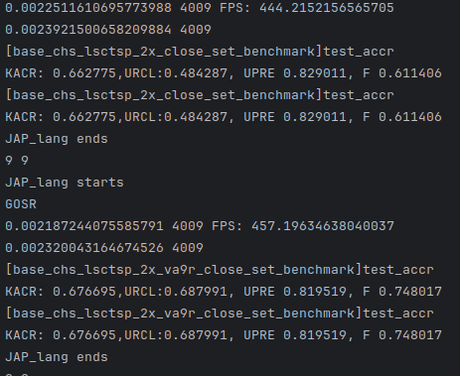
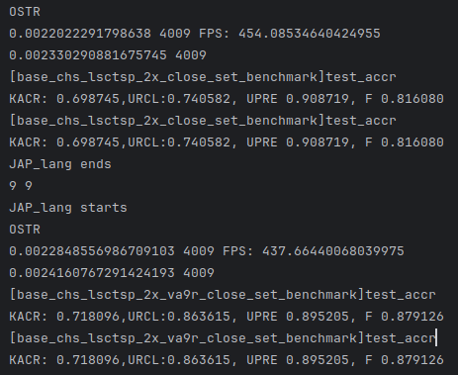

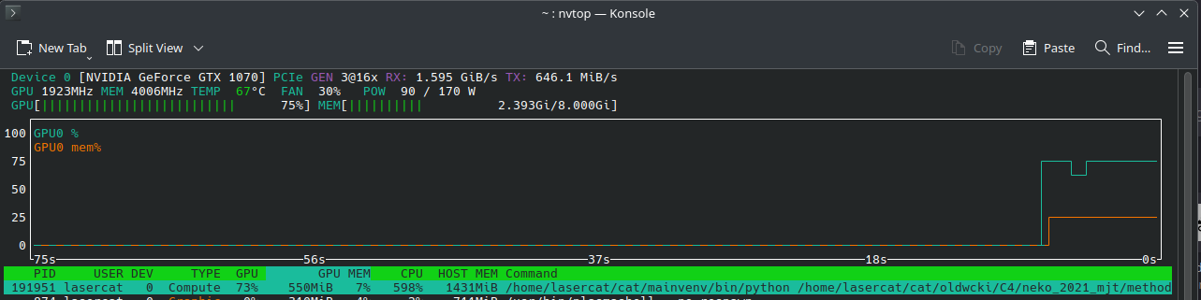
459 fps on 1070/12400f… This thing is darn CPU bounded. Or did torch get better again?
Xeons are super pricy in the nordic. Damn.

Reproducing Results On English, Japanese, and Korean
Regular model: Run test.py under ABL_a_asc_2x_lsct3sp_lsct3spva9r
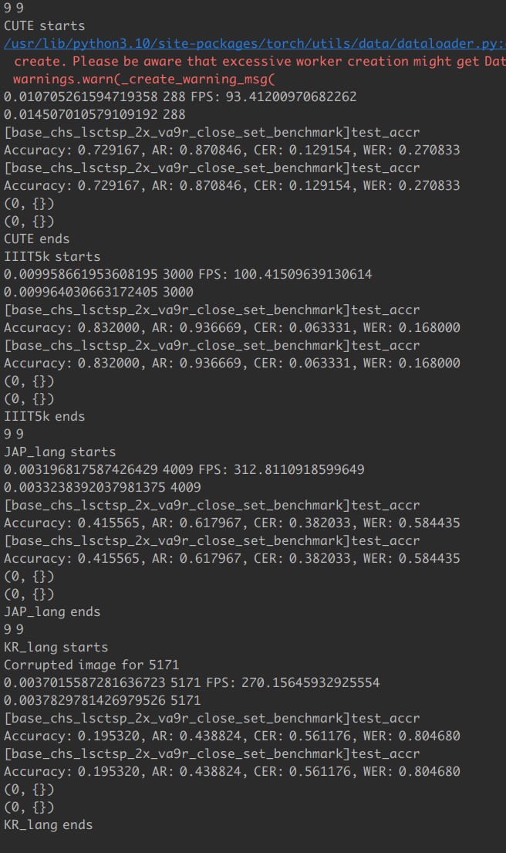
The FPSs are incoherent due to batch size.
Also note the running time includes prototype caching time, hence CUTE(288) has a lower FPS than IIIT5k(3000). In practical use, the FPS will be close to IIIT5k performance.

Large: Run test.py under DUAL_a_asc_Odancukmk7hnp_r45pt_C_trinorm_dsa3_va9r_lsct3sp_2x
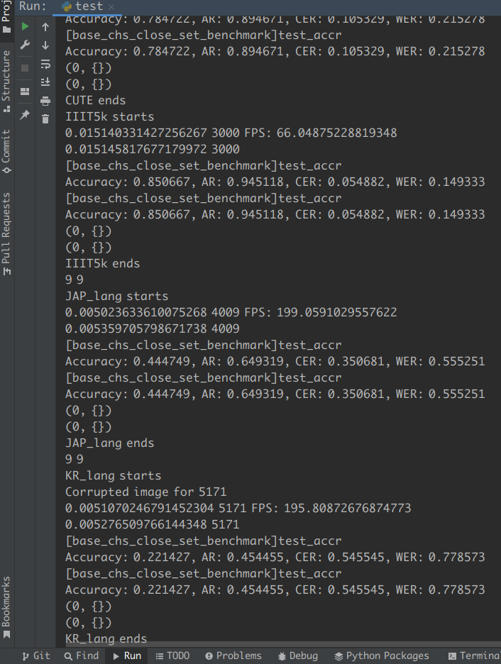

Reproducing Close-set Benchmarks
Regular: run test.py under DUAL_b_asc_Odancukmk7hnp_r45_C_trinorm_dsa3_va9r_lsct3sp_2x
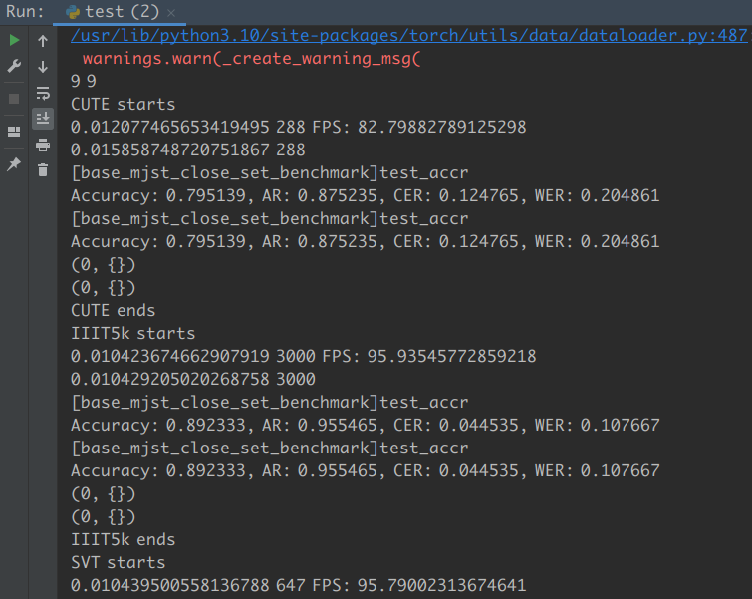
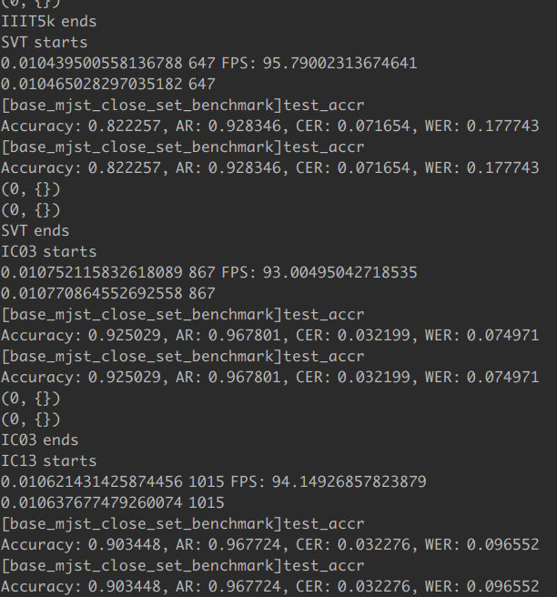
Large: run test.py under DUAL_b_asc_Odancukmk7hnp_r45pt_C_trinorm_dsa3_va9r_lsct3sp_2x
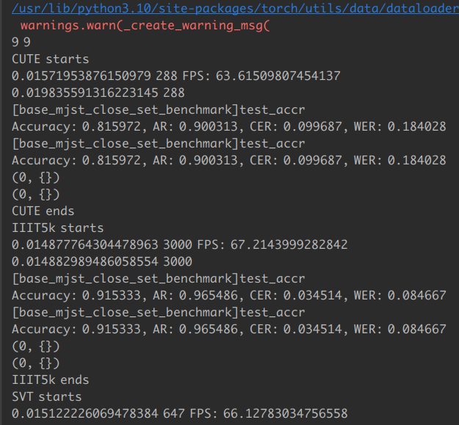
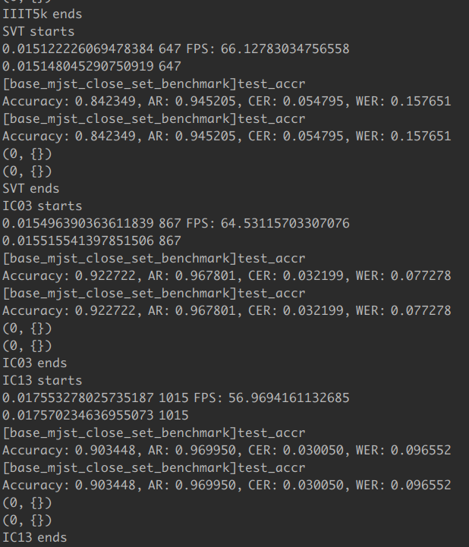

Reproducing Zero-shot Character Benchmarks
Run test.py under DUAL_ch_asc_Odancukmk7hnp_r45_C_trinorm_dsa3_va9r_lsct3sp_2x
Note the datasets are not uploaded for review due to the size limitation.
500 1000 1500 2000
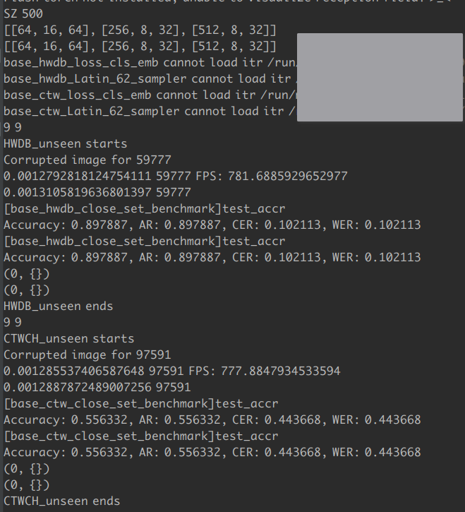
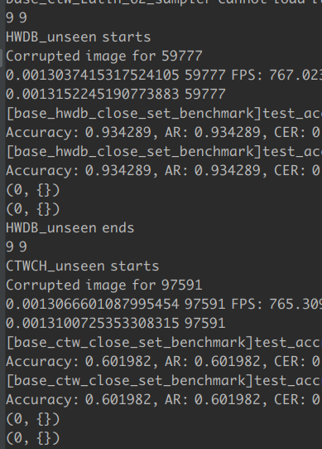
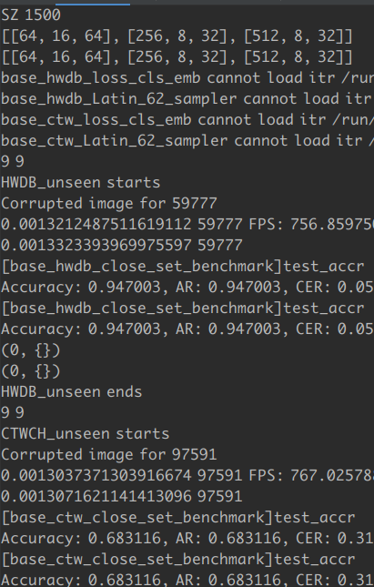
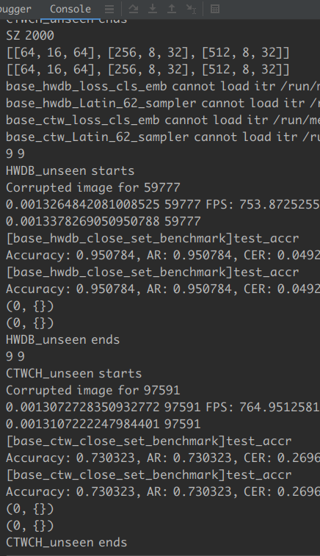

Speed drops after the card overheats, poor little card.
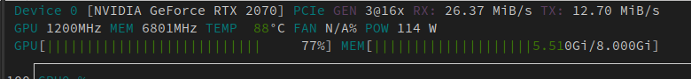

Recognition of some Greek Family Languages
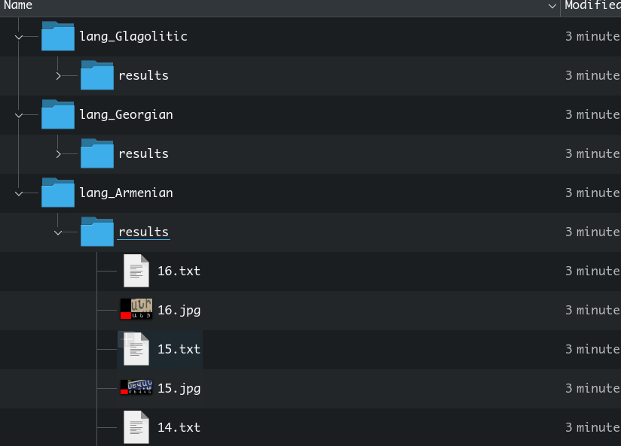
Run test_athena.py under DUAL_a_asc_Odancukmk7hnp_r45pt_C_trinorm_dsa3_va9r_lsct3sp_2x

If you have your own language in mind, say xxxx language, you can test it with the following steps:
a) add a folder named lang_xxxx in the Athena folder (the lang_xxxx part is mandatory for the testing script to pick it up)
b) add the images in question to the folder
c) Add a folder name meta (again it has to be named as `meta’)
d) Download Noto sans regular font in question to the meta folder and name it as `notofont.ttf’
e) add the alphabets file, each character per line
if the character has more than one possible shape, write all of them in one line
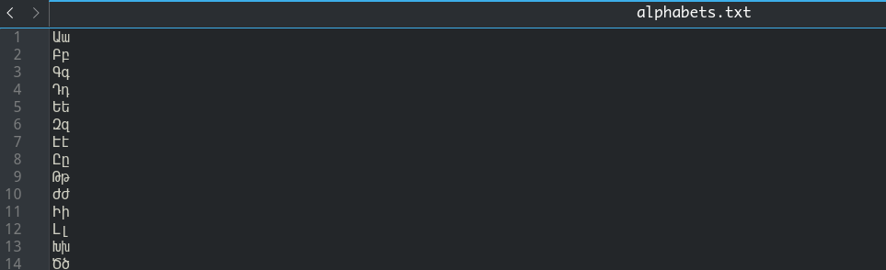

f) Done! Don’t worry about the dict file, the framework will build it from notofont and alphabets
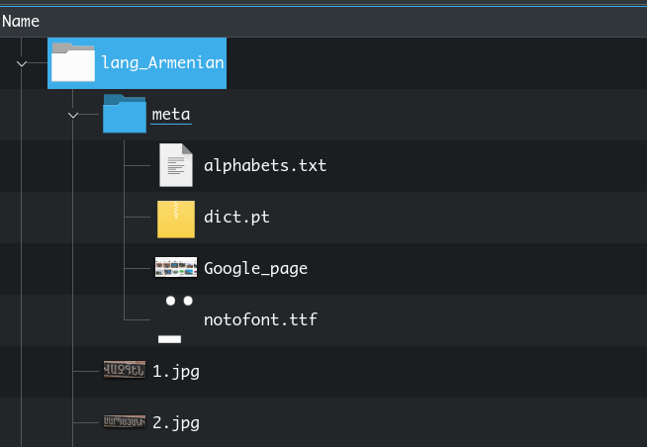

System information
