Manual

Get the code and data
1. clone the repo
git clone https://github.com/lancercat/Moose.git
2. Get data from
1. https://www.kaggle.com/datasets/vsdf2898kaggle/osocrtraining?rvi=1
and
2. https://www.kaggle.com/datasets/object300/mose-extra
Unzip 1 first, then override it with 2. you should get around 25 folders
E: You will miss mlttrjp and mlttrjp_raw. They are files generated while I was testing the data builder.
mlttrjp_raw is whatever annotated as japan in the mltdataset.
Mlttrjp is mlttrjp_hv. It is a filtered version of mlttrjp_raw, by removing samples include symbols and korean characters.
If you have one or two missing or something fails to run, please email me
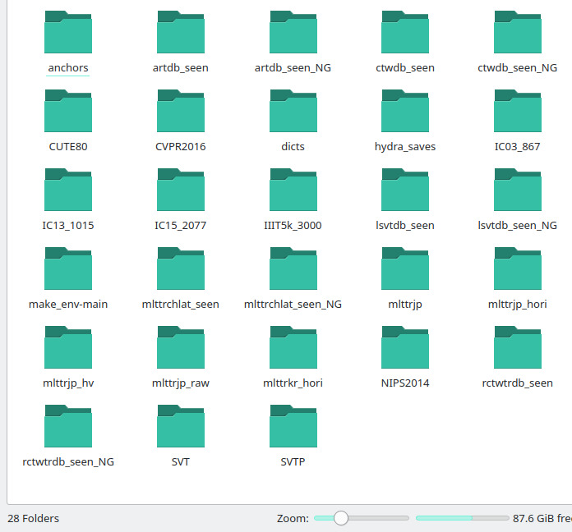

3. make a folder named anchors in the data dir, now you have 28
mkdir -p ~/ssddata/anchors/
4. Put a “hydra_saves” folder in your home directory.
mkdir -p ~/hydra_saves
5. Try training a moose from pycharm. If it works, it works.
Allow it some time for the first runs. It will build index files if it fails to load them from the disk.
It will also launch a testing dry run so we don’t fail midway.
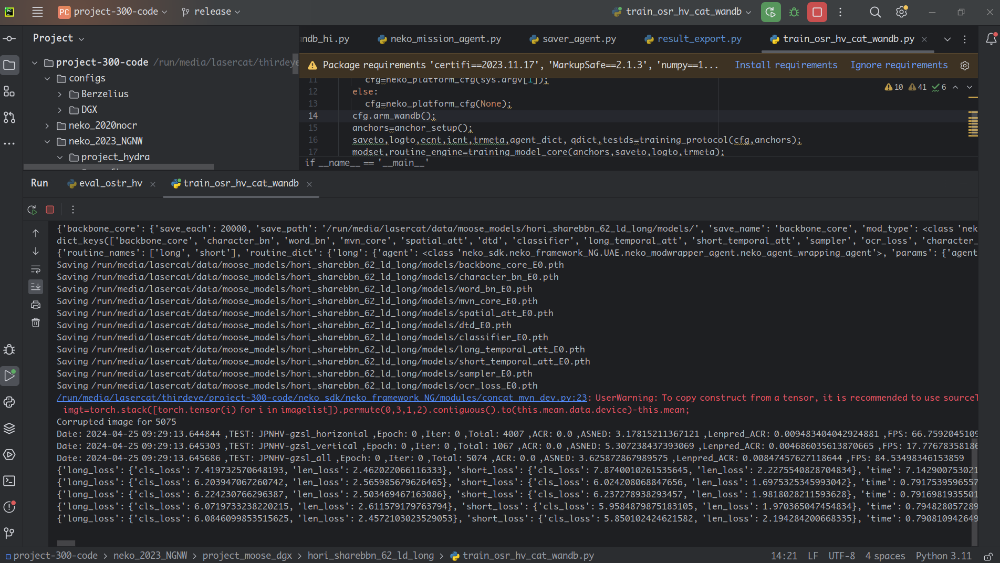
OK, that’s all. If it fails, open an issue or mail lasercat@gmx.us
Enjoy.

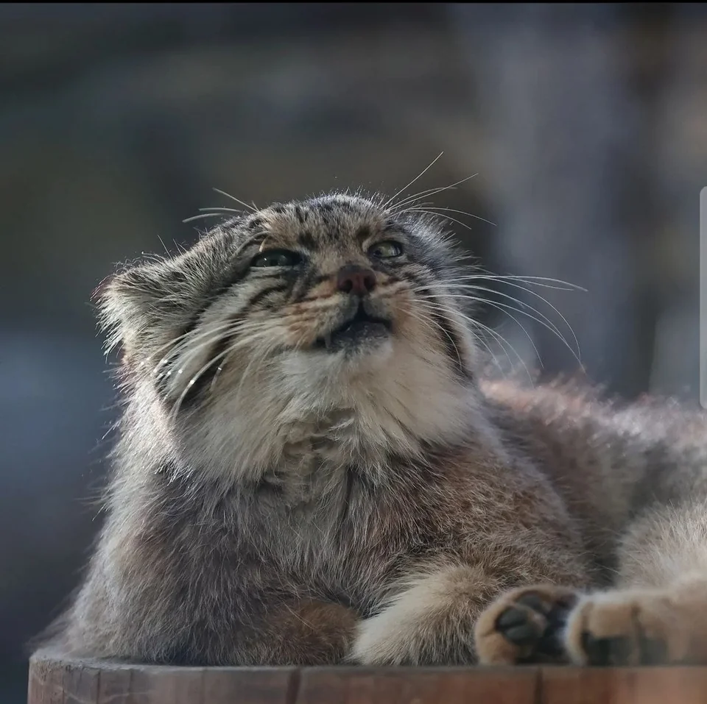

Reproducing Ablative Studies
1. Download the logs
https://www.kaggle.com/datasets/object300/log-moose-release
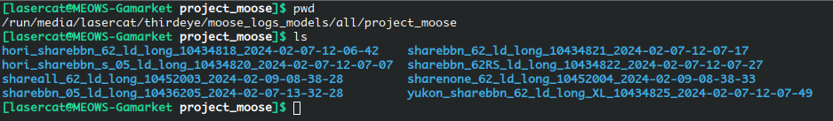
2 Download the visualizer:
git clone https://github.com/lancercat/minijinja.git
Set your working path in scancfg/metacfg.json
WARNING: I forgot if this thing will or will not drop your workingdir,
check yourself, put it in a sandbox, or make sure the workingdir is set right.
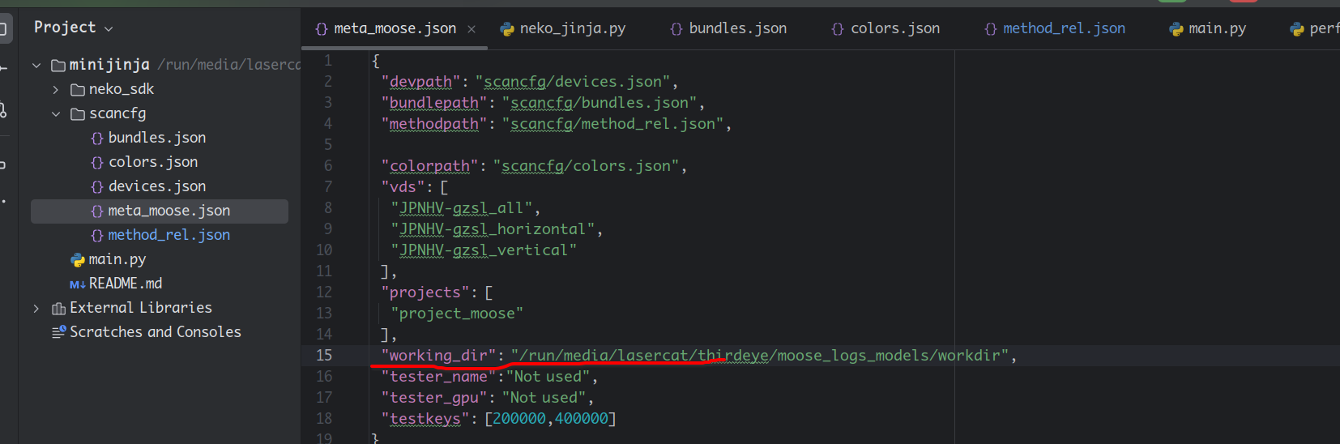
Also set your device info in devices.json
a) Specifically, set your username, sshkey (that can allow you access localhost, or wherever you store the downloaded logs)
b) Set root to where your downloaded logs are (pwd in step 1)
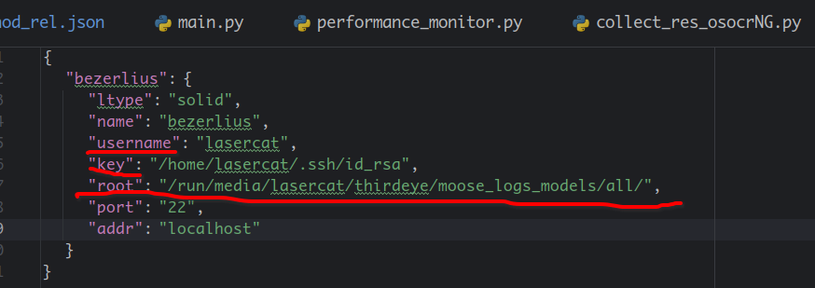
Trivia: This library is designed by me to periodically monitor, grab logs from, and issue commands to a fleet of servers located in different places, thus it uses ssh/rsync/paramiko.

3. Go run the script main.py You are golden if you see the curves we presented in SSBA.
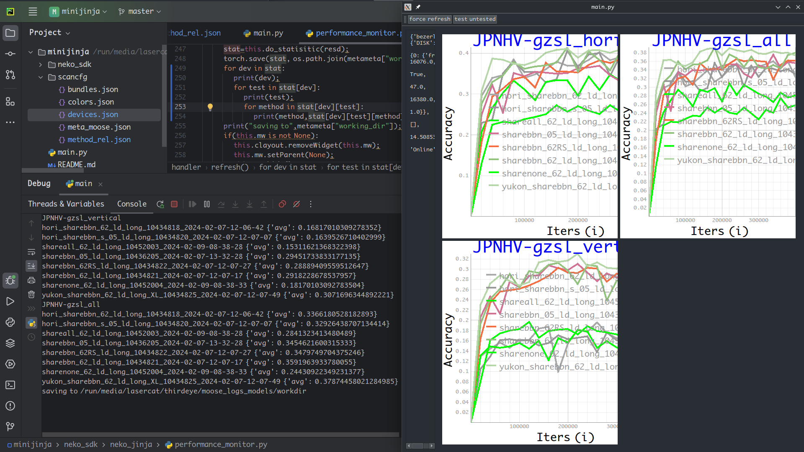
Note for sharebbn_62RS_ld_long_10434822_2024-02-07-12-07-27 the horizontal/vertical stats DO NOT make sense, because the vertical images with aspect ratio >2 are rotated without the logger knowing, so the numbers come from a different split of all test images. That’s why we only report overall accuracy in Table 3.
4. Now let’s match the statistical data to the logs in the tables in the paper.
Table2, Row 1
Table 2, Row 2
Table 2, Row 3
Table 2, Row 4

Table 3, Row 1
Table 3, Row 2
Table 3, Row 3
Table 3, Row 4
Table 4, Row 1
Table 4, Row 2
Table 4, Row 3
Done.
For those who believe that performances from different iterations subject to Normal Distribution, you can meddle the code to enable the output of pair-wise t-tests.

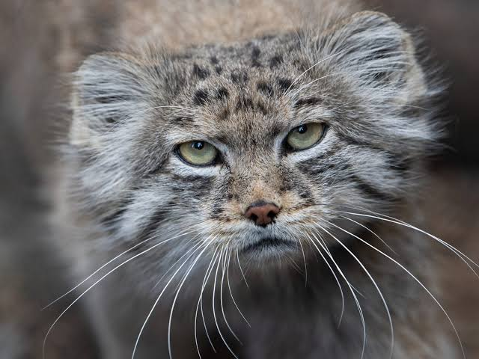

Reproducing the Benchmarks
Great, now we want to check the remaining tables, and if our released models match the logs.
1. Download the models (40+Gib):
https://www.kaggle.com/datasets/object300/model-moose-release
2. The general approach:
a. Edit the test file (*/eval_*.py) to choose the iteration you want to run from
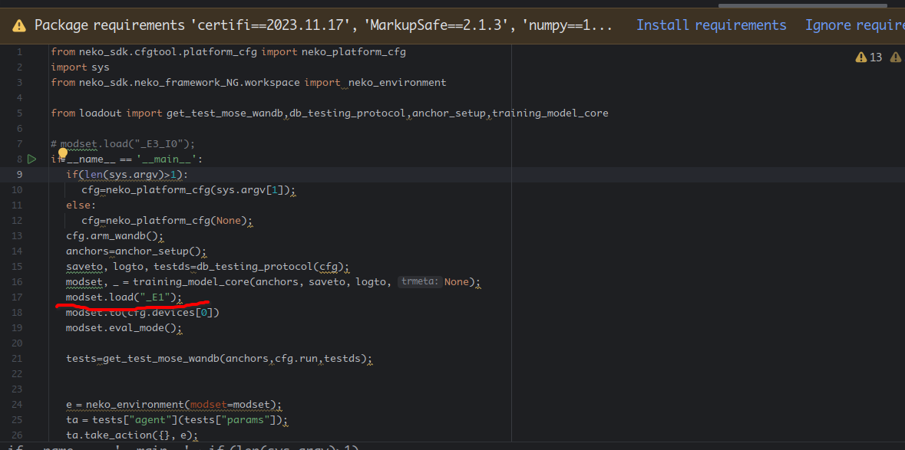
b. Run them.
3. Now let’s verify the tables:
Table 5 (Note this will take a while as it will render results and dump them to your disk)
For the regular model, run sharebbn_62_ld_long/eval_ostr_hv.py
For the large model, run yukon_sharebbn_62_ld_long_XL/eval_ostr_hv.py
And if the fonts are too small try zooming it up. That’s why PDFs are always better than paperbacks
Trivia: Yukon is the largest subspecies of the moose family.
Now, match these lines with our log
You can now test other models to verify if they match the logs we uploaded.
Table 6:
Run yukon_sharebbn_62_ld_long_XL/eval_ostr_g1.py
You may have noticed that single batch FPS reaches 144 now, fast, but if you want to meddle with the code you may reach faster results at multibatch.
Because it no longer renders individual results or writes to my cheap wearing-SSD.
HW: 4060Ti 16G on Thunderbolt3(TH3P4G3), 12400, 4*8GiB DDR5 @4000, Lenovo P360 Ultra.
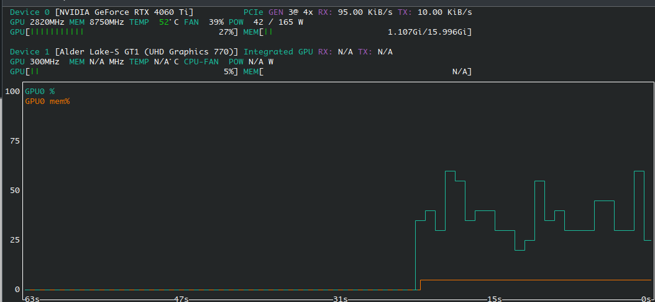

Done. All numbers reported.

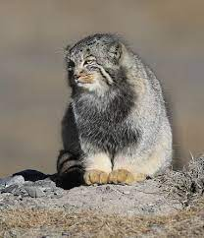

Testing Single images
Okay, now you are curious about our web pictures in Figure 1.
1. Grab the files from
https://www.kaggle.com/datasets/object300/mose-extra?select=athenaNG
2. Set paths in yukon_sharebbn_62_ld_long_XL/eval_ostr_athena.py
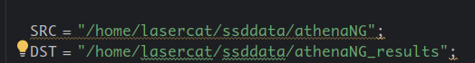
2. Run yukon_sharebbn_62_ld_long_XL/eval_ostr_athena.py and collect results from DST

3. To add a language:
a. You need a folder like this
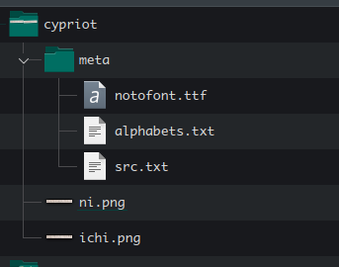

You first make a folder for the data and then you make a meta folder in it. For the meta folder
1) You download the corresponding noto font from google, and rename it to notofont.ttf
E.g. https://fonts.google.com/noto/fonts?noto.query=Cypriots
2) you scrape wikipedia to get the characterset:
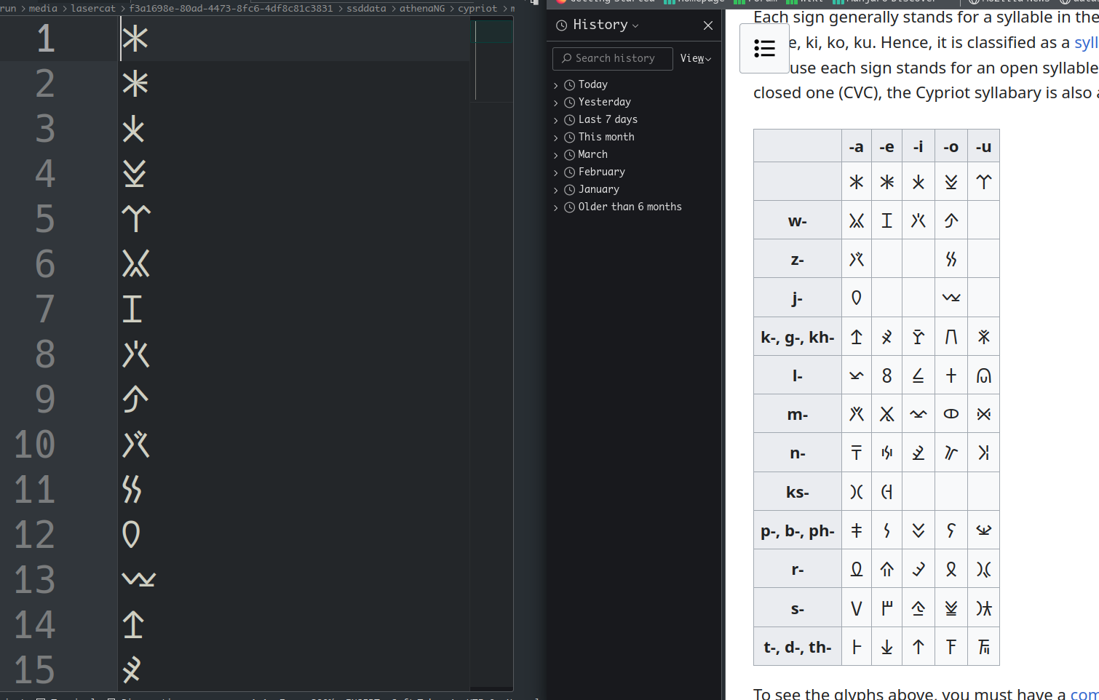

3) Then register it in your script: yukon_sharebbn_62_ld_long_XL/eval_ostr_athena.py

4) Finally, run the script and collect the results
(It will automatically generate the pt file if it's not there so don’t worry)
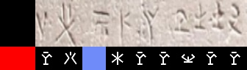

Hit and miss, due to the carving style is not covered by the training set.
We will work on this in the future

Why we are not using this to benchmark the model? I don’t read or type Cypriots, nor do have enough data to benchmark the model with. Never bench a model with 10 samples.

It’s not like I pick Japanese simply out of my personal preference. It’s more or less a data availability issue.

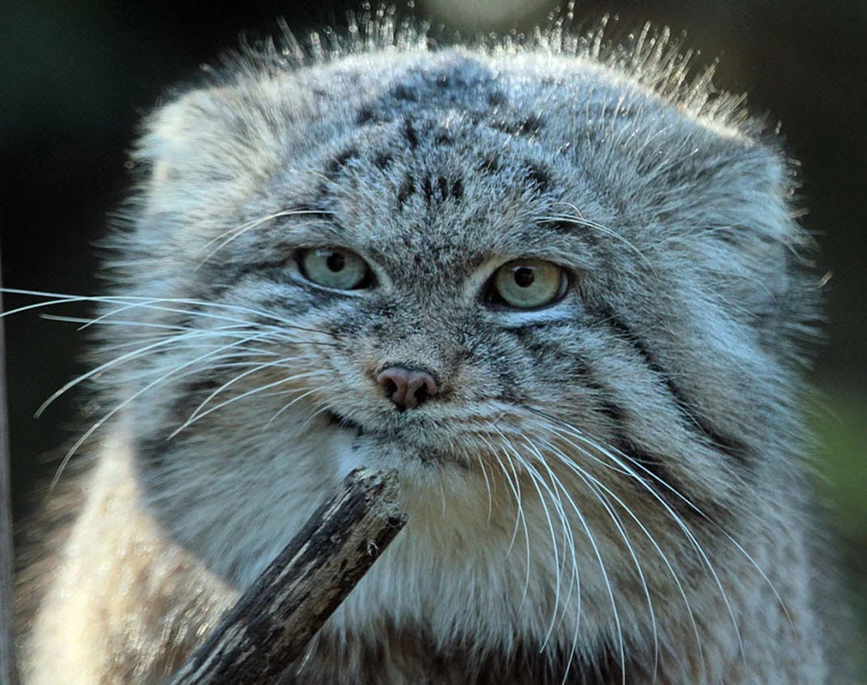

Training your own model
Get your data from kaggle, and run yukon_sharebbn_62_ld_long_XL/train_osr_hv_cat_wandb.py
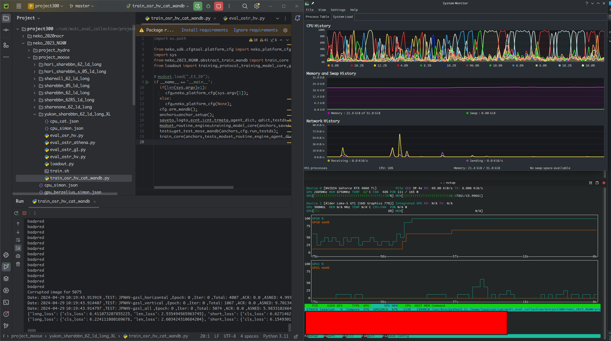
If you see the “long_loss” lines, you are good.
The program takes 12 GB of FREE main memory, thus we recommend having 32GiB or more
You will roughly need 10-11 GB VRAM for training the large model.
We recommend Tesla P40s (server line) / 4060Ti (desktop line) or later models, though they are currently more expensive than they should be.
For extremely low-budget options, you may use M40-12GB, or if lucky it may run on a P102-10G GPU, which should be dirt cheap now.
WE DO NOT RECOMMEND THEM, but if you have to, you have to.
If anyone has P102s please confirm if that thing works or not.
If anyone has any luck on AMD GPUs, please let us know...

That’s all for now.
This work only sets the stage, and we will be back with something far more interesting.

