Manual

Setup your Environment:
0. Fresh install Manjaro, set your mirrorlist straight, and grab some snacks
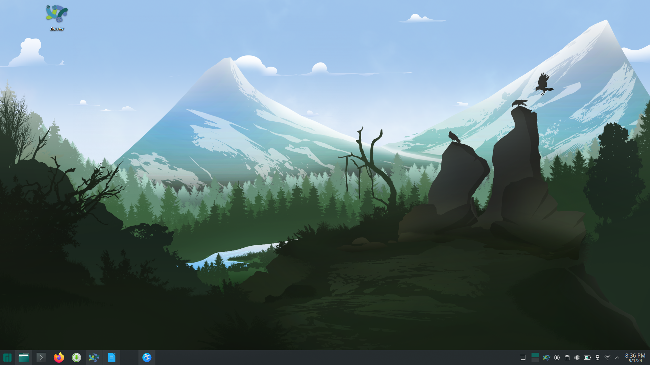
1. Download the environment making scripts
https://github.com/lancercat/make_envNG
2. execute 01-pacman.sh and give password for once or twice.
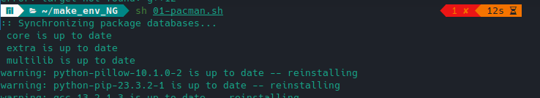
3 Reboot.
4. execute 02-pip.sh

5. Enjoy,

Code, model and data
Get the data:
Follow the data section here to get your data:
https://github.com/lancercat/VSDF/blob/master/manul.pdf

Download the code:
git clone https://github.com/lancercat/OAPR.git

Download the model:
https://drive.google.com/file/d/1Zw9ylDvOuJ7IP6vM1l8kvr94kbGOpahU/view?usp=sharing

and replace the DROOT with your model path.
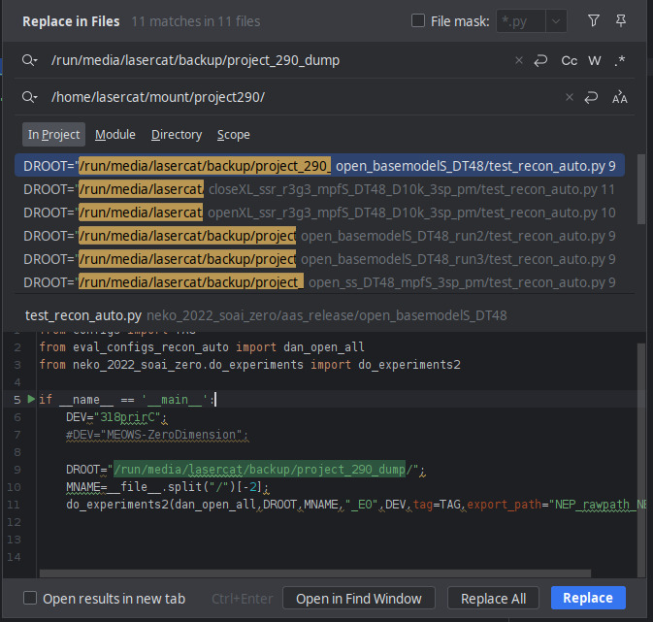



Ablative Experiments
Base model:
Run open_basemodelS_DT48/test_recon_auto.py
Run open_basemodelS_DT48_run2/test_recon_auto.py
Run open_basemodelS_DT48_run3/test_recon_auto.py
And collect the base_chs_GZSL-CHS-JP-KR_JAP section (the name got messy but nvm)
Run1: Accuracy: 0.334996
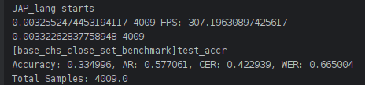

Run2: Accuracy: 0.331754
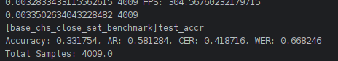

Run3: 0.354452
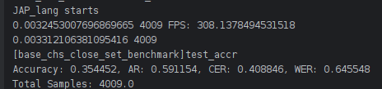

See, I shit you not.

Hella fast, eh? bcs it has a small backbone, and a faster device, when you batch it and run on SOTA hardwares (1240P + 4060ti on TB4), boom.

Part representation only:
Run open_ss_DT48_mpfS_3sp_pm/test_recon_auto.py
Run open_ss_DT48_mpfS_3sp_pm/test_recon_auto.py
Run open_ss_DT48_mpfS_3sp_pm/test_recon_auto.py
Run1: Accuracy: 0.395610
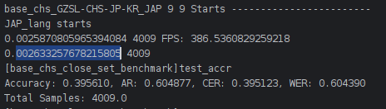

Run2: Accuracy: 0.352706
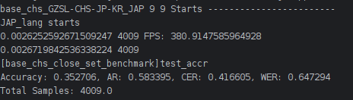

Run3 Accuracy: 0.418059
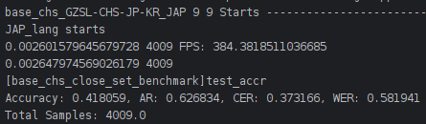

A 0.02 difference, marginable, should be caused by how different softwares process float numbers.

See, it’s ~80fps FASTER the the prev one! Again I shit you not on the faster claim.
Any one haz a 4090? Tell me if this goes 1000FPS!

Full model:
Run open_ssr_r3g3_mpfS_DT48_D10k_3sp_pm/test_recon_auto.py
Run open_ssr_r3g3_mpfS_DT48_D10k_3sp_pm/test_recon_auto.py
Run open_ssr_r3g3_mpfS_DT48_D10k_3sp_pm/test_recon_auto.py
Run1: 0.392118
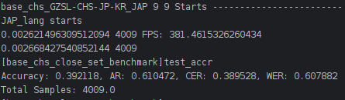

Run2: 0.422799
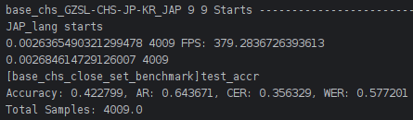

Run3: 0.373909
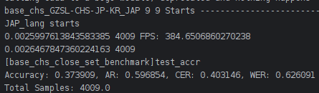

A 0.01 difference, marginable, should be caused by how different

softwares process float numbers.

High five! The ablative reproduced!

Open-Set benchmark

Large model:Run openXL_ssr_r3g3_mpfS_DT48_D10k_3sp_pm/test_recon_auto.py
GZSL
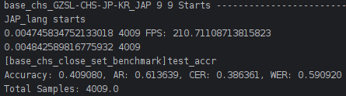

OSR
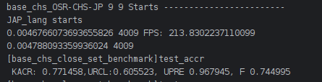

GOSR
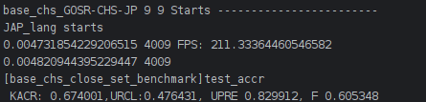

OSTR
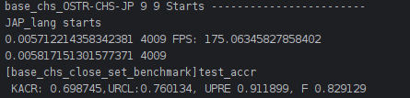



Close-Set benchmark
Run closeXL_ssr_r3g3_mpfS_DT48_D10k_3sp_pm/speedbench.py
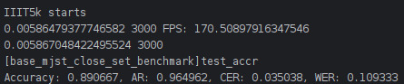

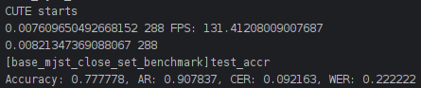

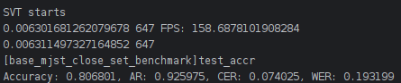

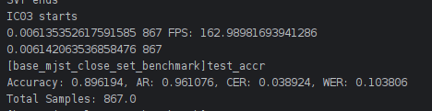

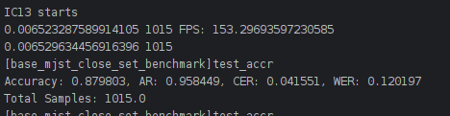

It’s much faster on 4060ti due to its high freq.


The NG framework will likely come this year.
See you in the next manual

