Manual
This manual guides a reproduction of main experiment results. For data production, please refer to the manul.pdf shipped in the OSOCR-data repo.

I. Setting up environments.
Step 1A. Install a clean Manjaro Linux (Archlinux should do as well)

Step 1B. Install dependencies using scripts from:
https://github.com/lancercat/make_env

Step2. While waiting, grab the code and data.
1) Grab the data from kaggle (https://www.kaggle.com/vsdf2898kaggle/osocrtraining):
CVPR2016.zip,NIPS2014.zip,ssddata_2.zip,ctwcheval.zip,ssddata_1.tar.gz,ssddata.tar.gz
2) Unzip & remove the packages.
for i in $(ls | grep zip); do unzip $i; done
tar -xvf ssddata_1.tar.gz;
tar -xvf ssddata.tar.gz
mkdir ../packs; mv *.* ../packs;

Step 3C. Stop and check if you have all the following folders

Data:

Models:

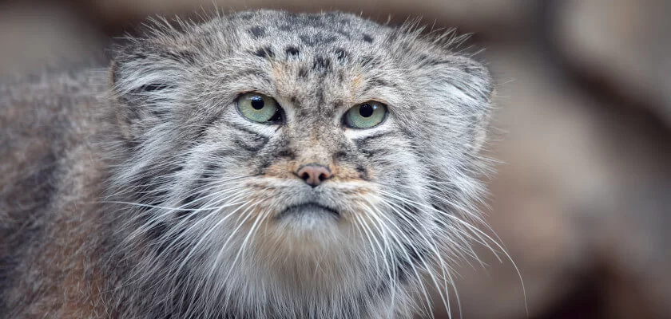

II. Evaluate the Trained models.

1. Zero-shot Chinese character recognition

CTW dataset (ZSL) CTW dataset (OSTR)
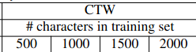
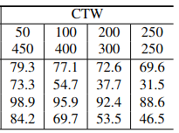
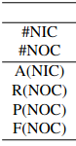
basic_ctwch_CE_alter/testg2.py basic_ctwch_CE_alter/testg2-rej.py
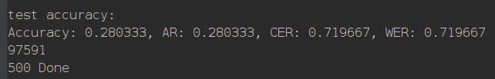
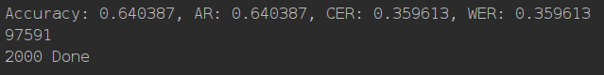
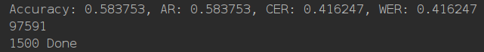
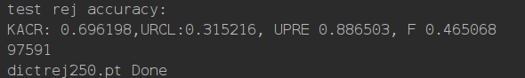
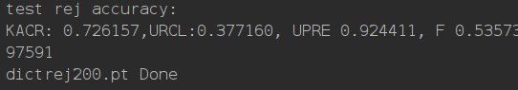
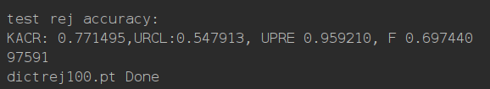
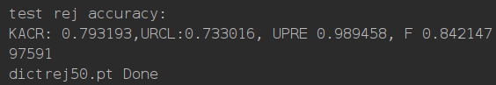

HWDB dataset (ZSL) HWDB dataset(OSTR)
basic_hwdb_CE_alter/testg2.py basic_hwdb_CE_alter/testg2-rej.py
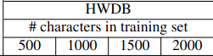
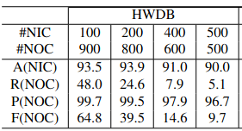

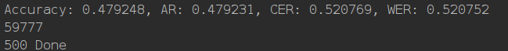
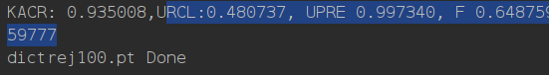

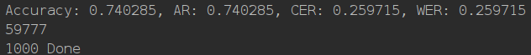
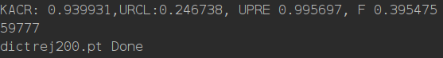

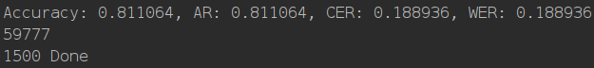
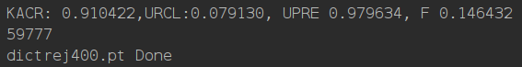
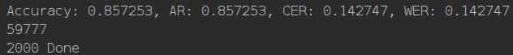
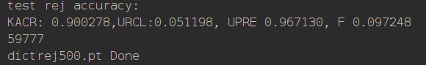

2. Close-set text recognition
Close-set (Regular) basic_mjst_CE_alter/test.py
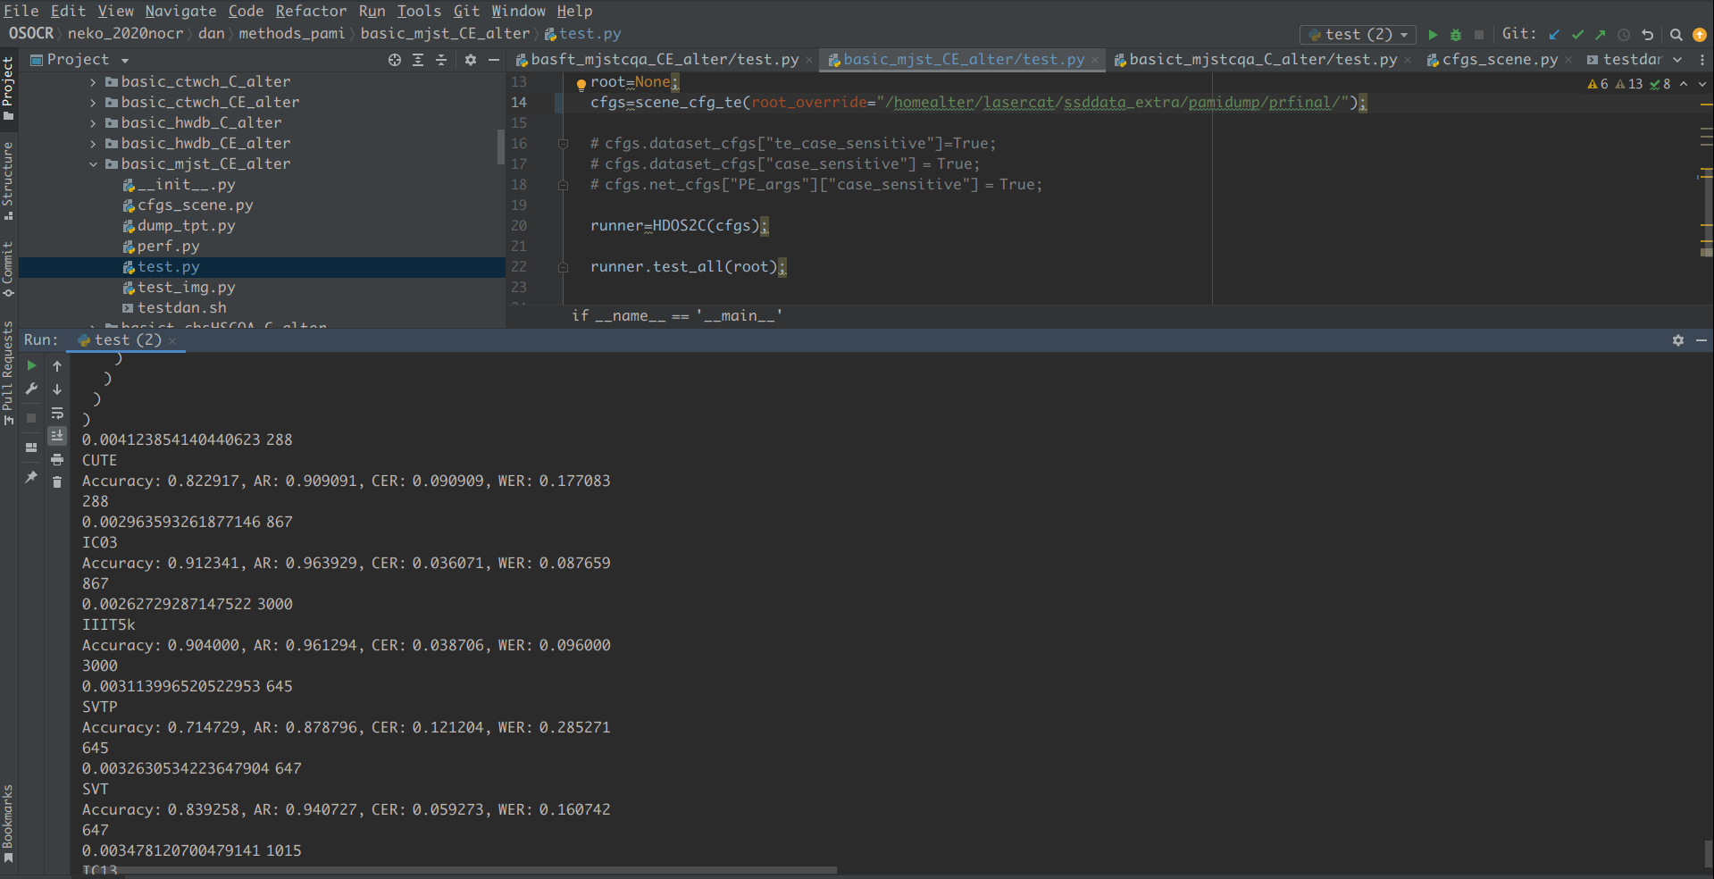
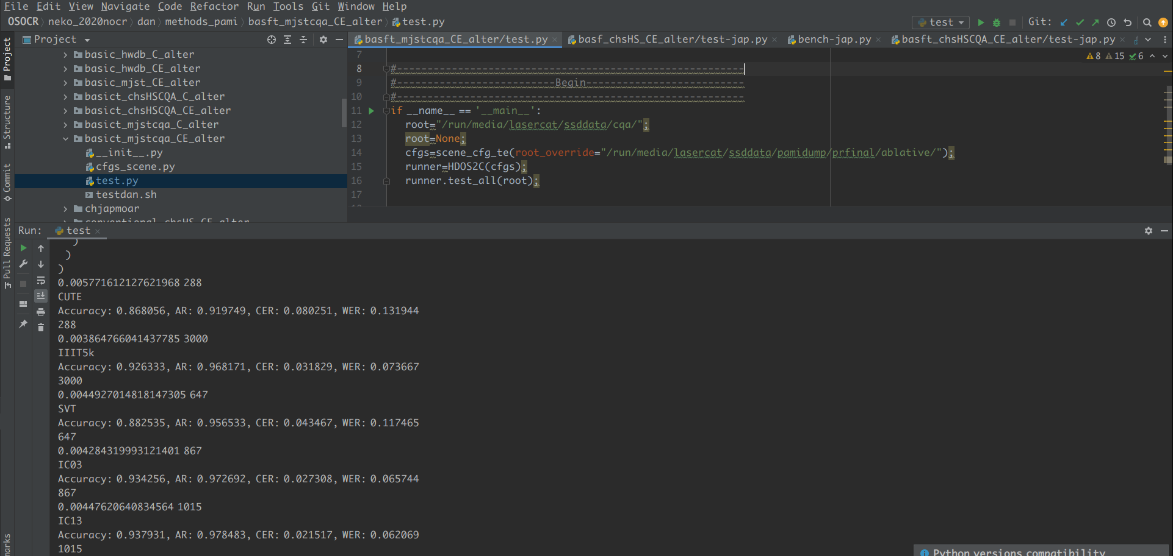
Close-set (Ours-large) basict_mjstcqa_CE_alter/test.py

3. Open-set Text Recognition

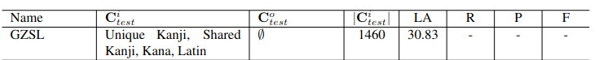
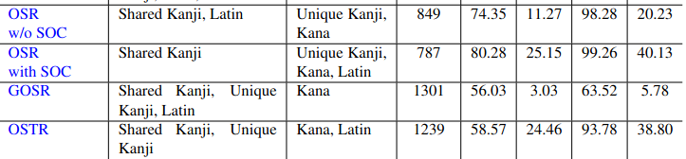
GZSL Others:
basict_chsHSCQA_CE_alter/test-jap.py basict_chsHSCQA_CE_alter/test-jap-rej.py
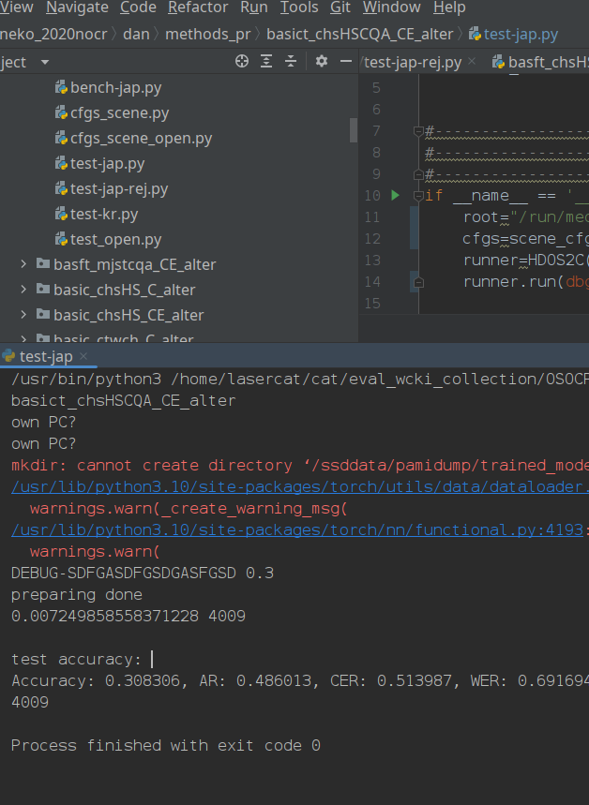
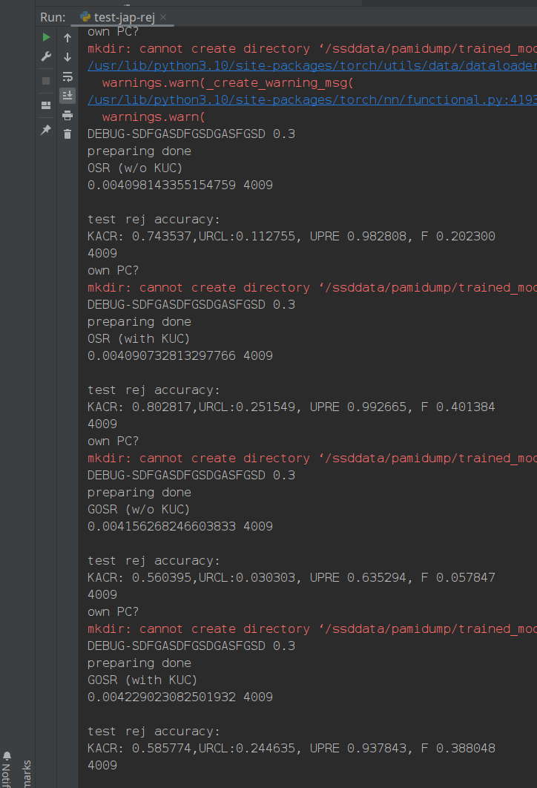

Details:
chjapmoar/accr_folder.py (make sure you have results from basict_chsHSCQA_CE_alter/test-jap.py)
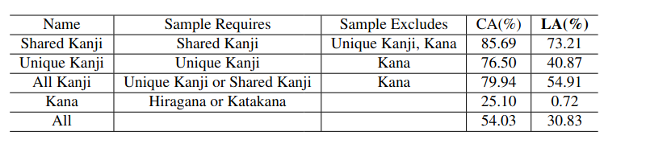
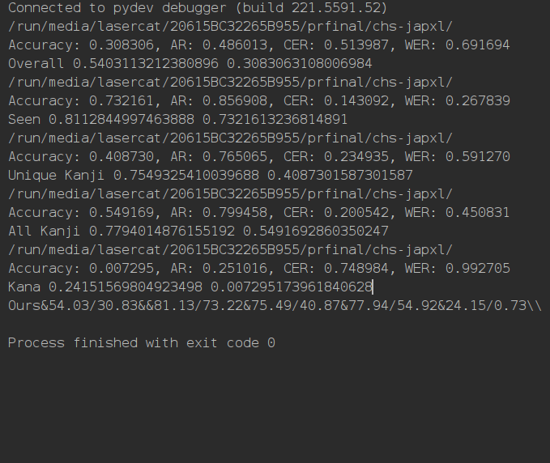
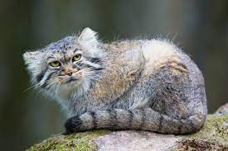

III. Train your own models.
Overall, training model can be done by running the playdan.sh script in the method path. Here is a guide to train the OSOCR-Large model for open-set text recognition.

1. Setup paths in neko_sdk/root.py

Point the return values of thhe find_data_root function
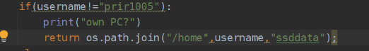

to the folder containing the data you just dowloaded.

2. Set up model saving path with root_override in neko_2020nocr/dan/methods_pr/basict_chsHSCQA_CE_alter/main.py
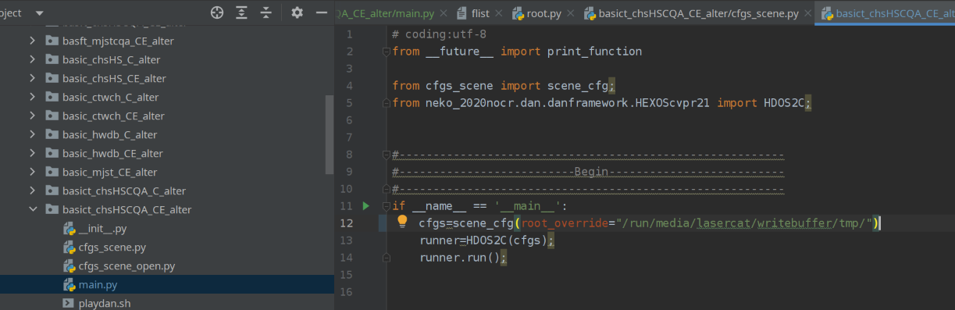
3. Run the script
or run neko_2020nocr/dan/methods_pr/basict_chsHSCQA_CE_alter/playdan.sh
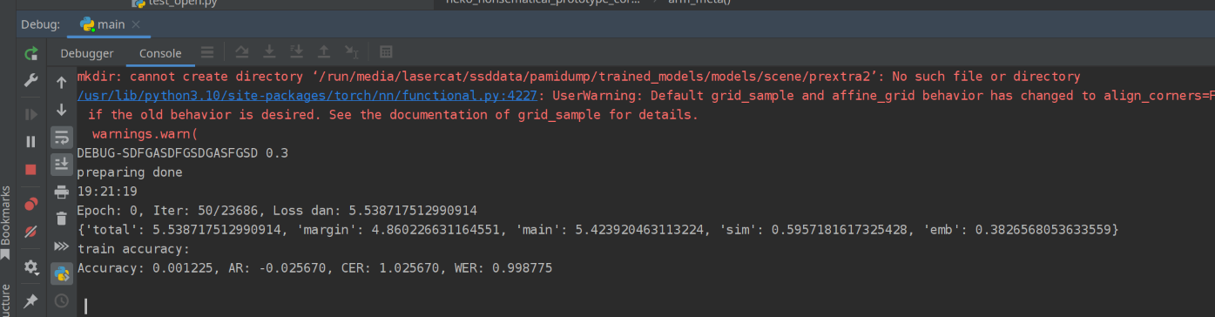
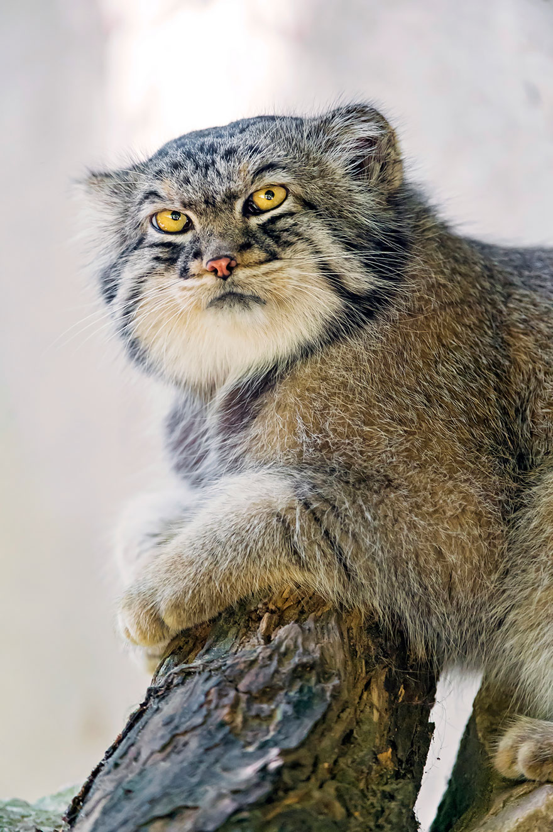
That’s it.

