Manul

1. Preparation
Step 0: Get some BGM
Step 1: Download training and testing data
https://www.kaggle.com/datasets/vsdf2898kaggle/osocrtraining
Step 2: Setting up environment
https://github.com/lancercat/make_env/
Step 3: Download code
https://github.com/lancercat/OpenSAVR
Step 4: Download pretrained models
(Well the link is for now---ummm--private unless I provide a phone number…)
Step 5: Check that you have the files illustrated in the figure below.
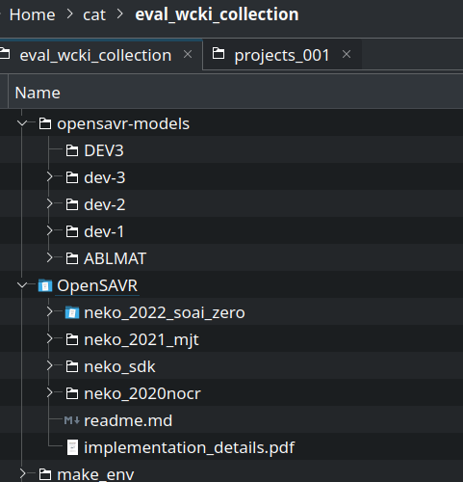

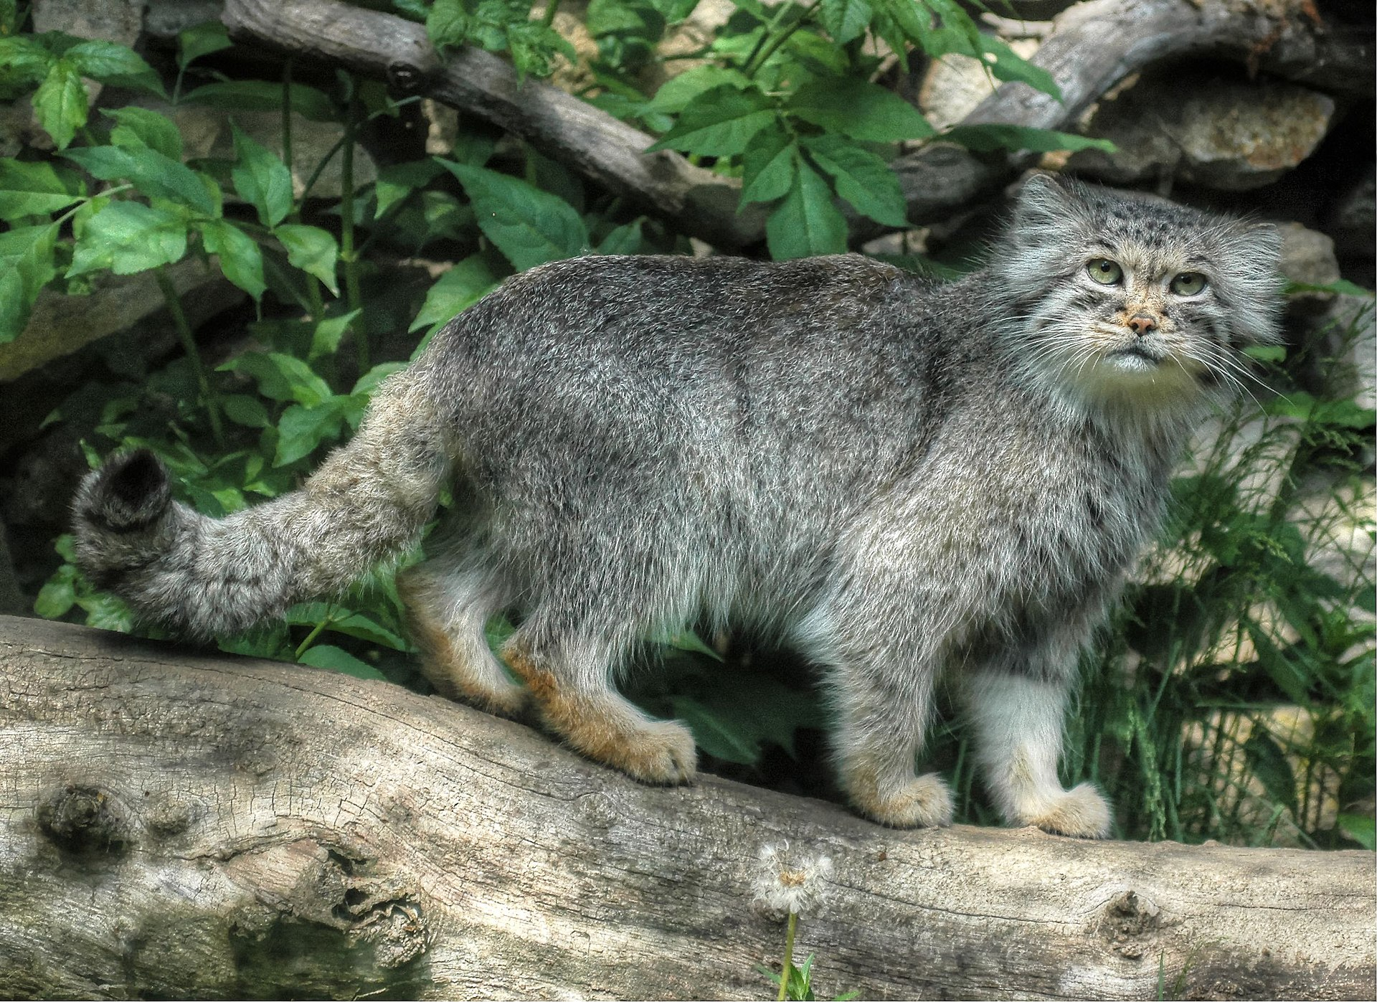

2. Running the Ablative & Sensitivity Experiments
Step 1: Run basemodel:
neko_2022_soai_zero/project283/open_basemodel/test_recon.py
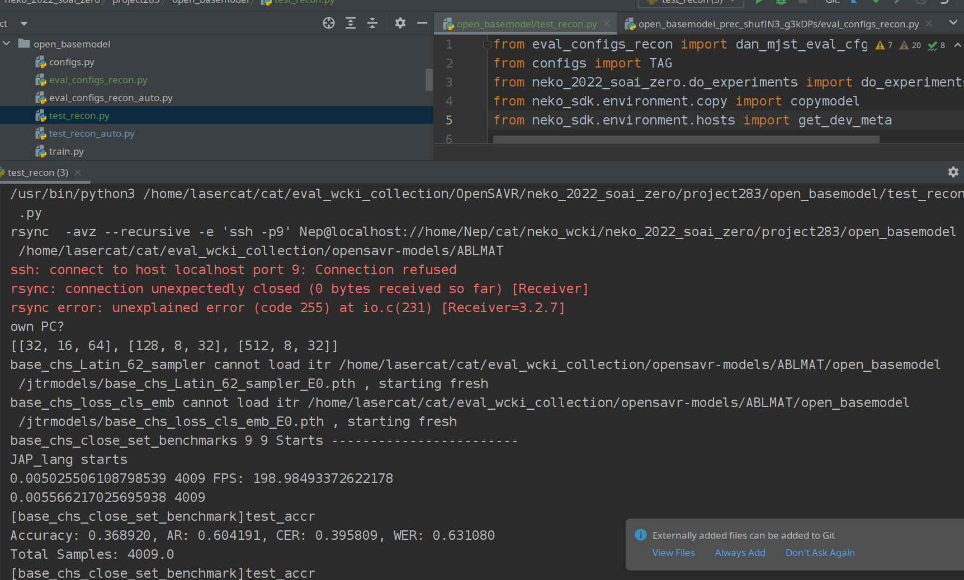
Step 2. Run Lpro: neko_2022_soai_zero/project283/open_basemodel_precIN3_g3kDPs/test_recon.py
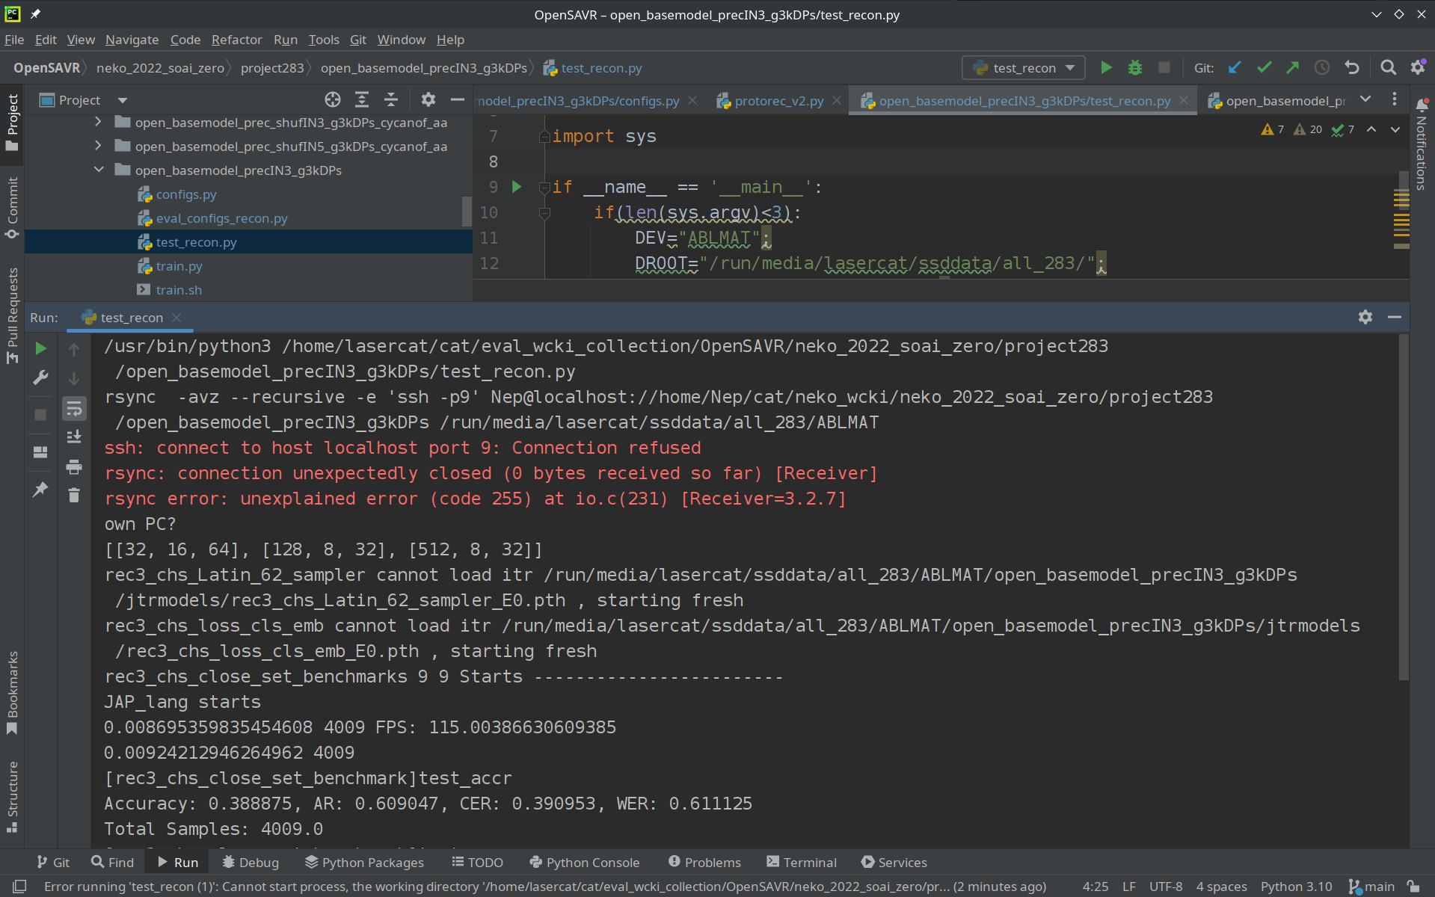
We compared to a slightly stale version pre camera-ready version, so the number slightly improved a bit.
Step 3 Run Lpro+Lshuf
neko_2022_soai_zero/project283/open_basemodel_prec_shufIN3_g3kDPs/test_recon.py
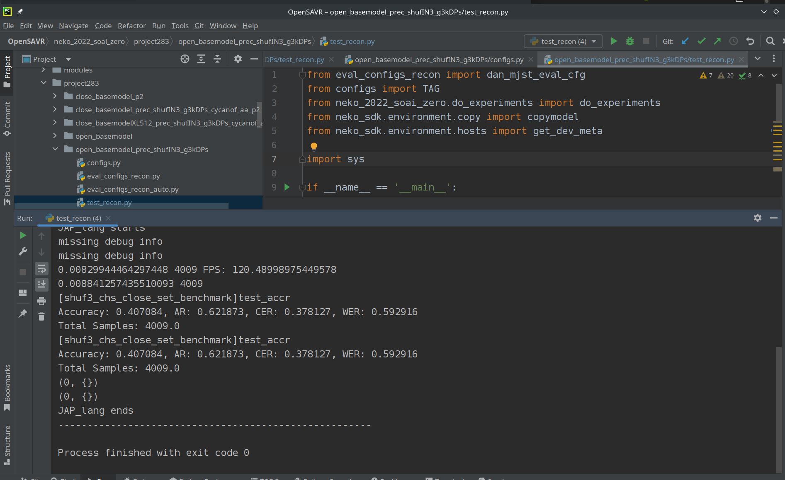
Step 4. Run full model neko_2022_soai_zero/project283/open_basemodel_prec_shufIN3_g3kDPs_cycanof_aa/test_recon.py
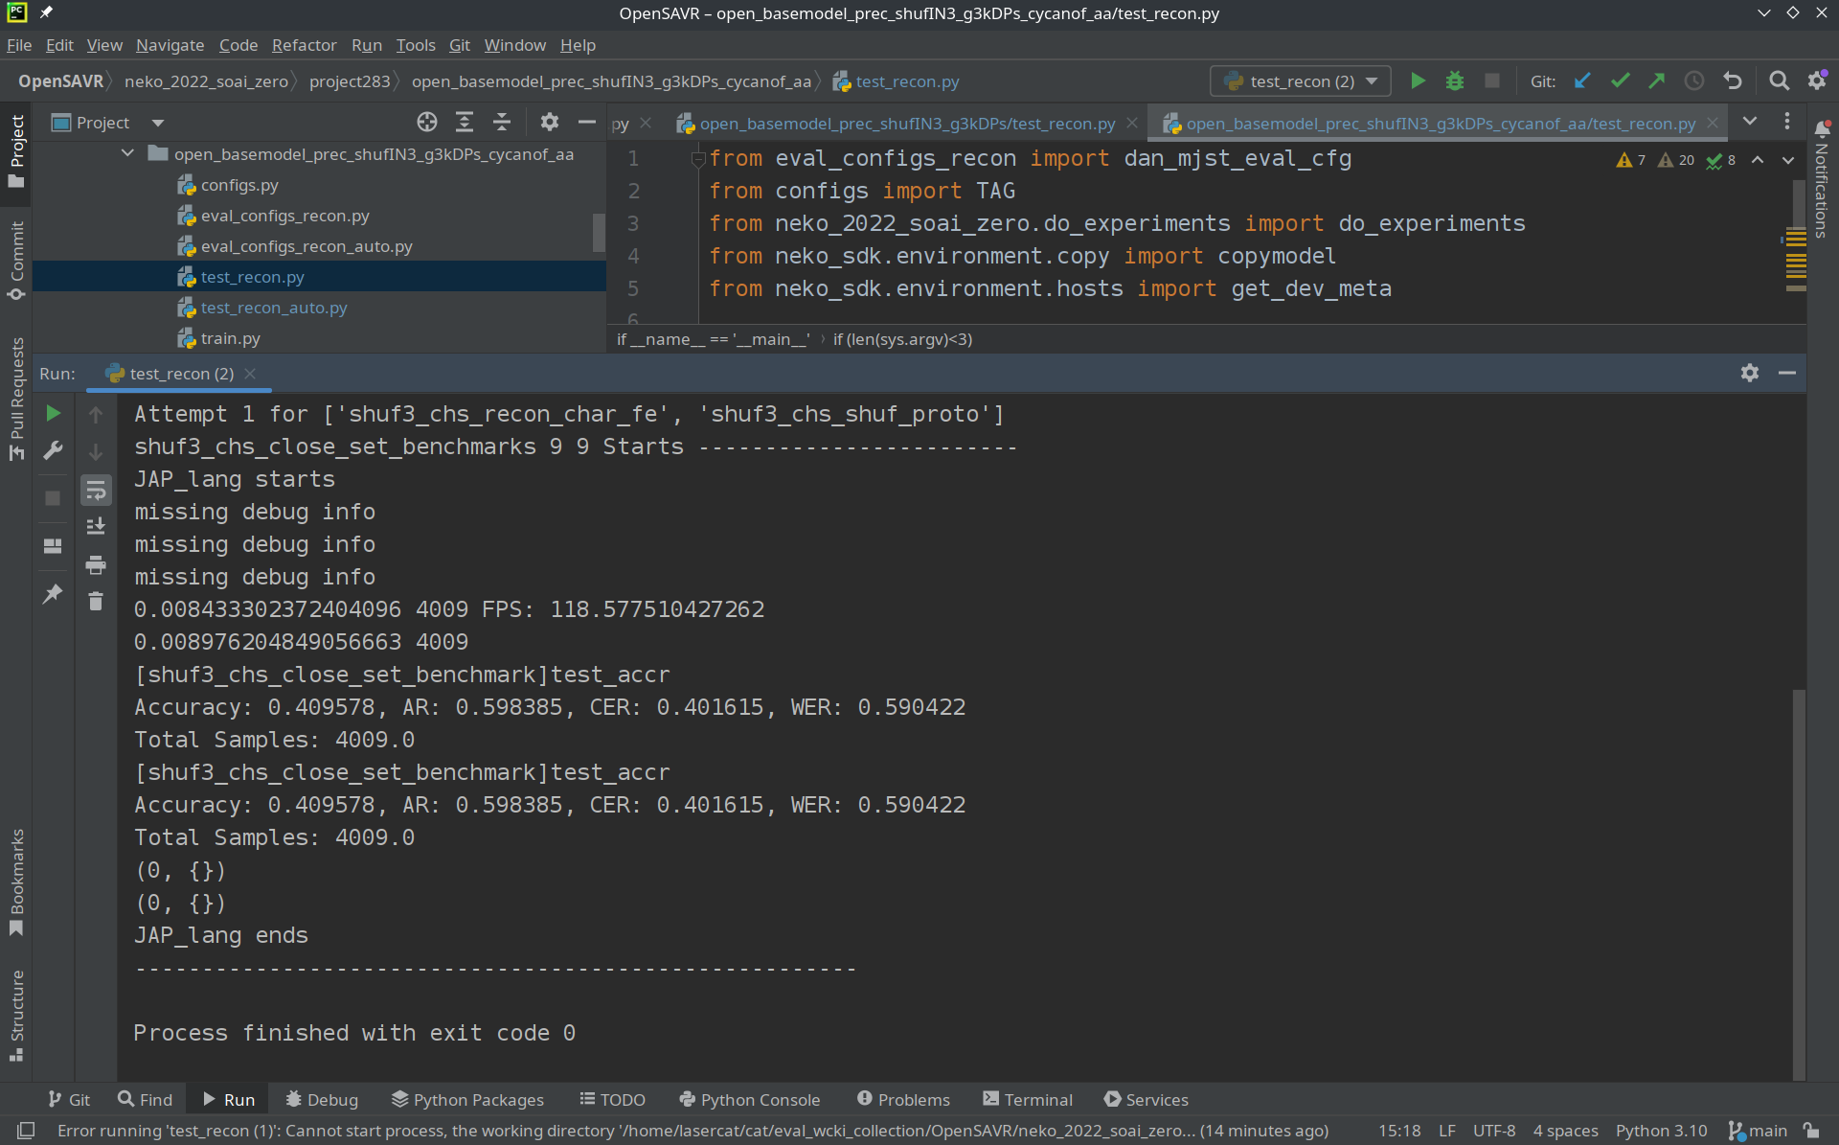

Step 5: Run Full model-0.1
neko_2022_soai_zero/project283/open_basemodel_prec_shufIN1_g3kDPs_cycanof_aa/test_recon_auto.py
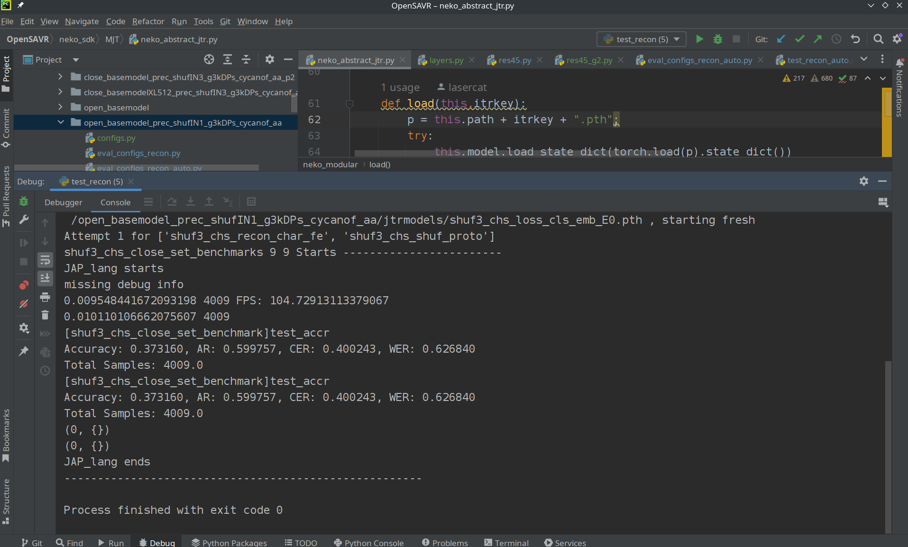
Step 6: Run Full model-0.5
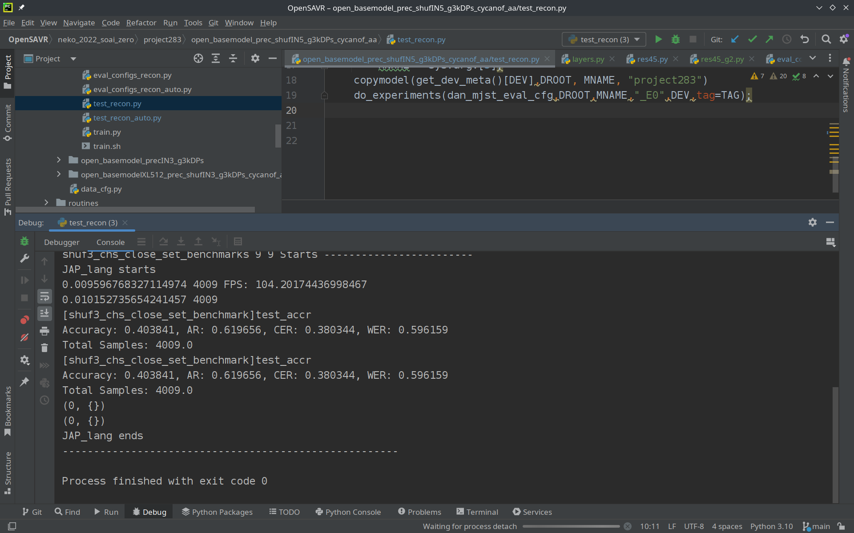
neko_2022_soai_zero/project283/open_basemodel_prec_shufIN5_g3kDPs_cycanof_aa/test_recon.py
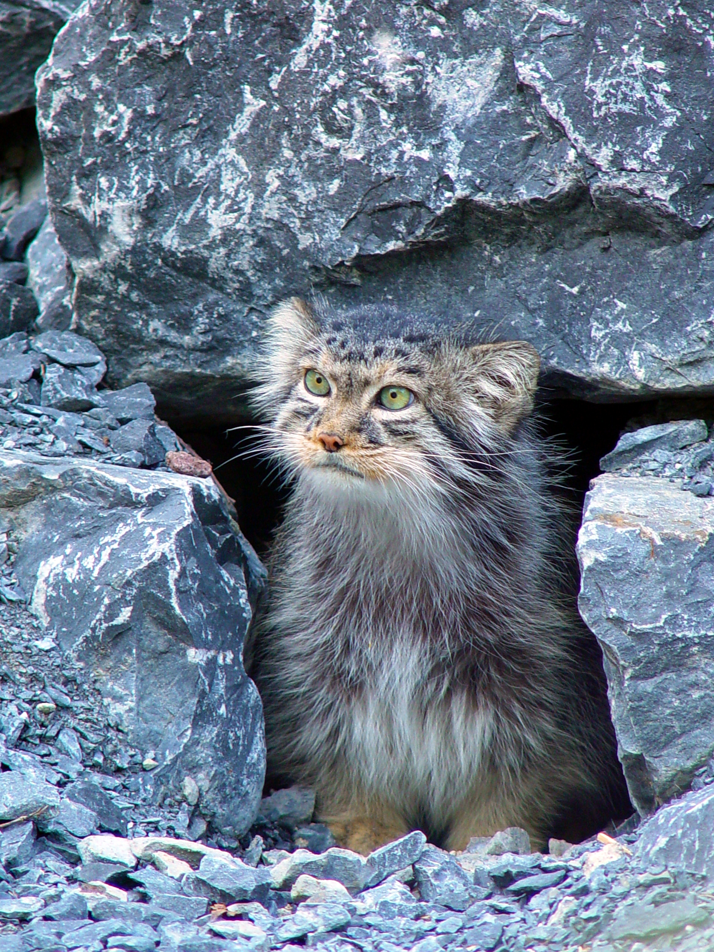

3. Running the Open-Set benchmark
Step 1: Run the regular model:
neko_2022_soai_zero/project283/open_basemodel_prec_shufIN3_g3kDPs_cycanof_aa/test_recon_auto.py
OSR
GZSL
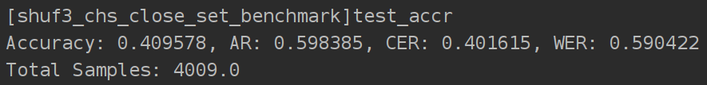
GOSR
OSTR

Step 2: Run the Large model:
neko_2022_soai_zero/project283/open_basemodelXL512_prec_shufIN3_g3kDPs_cycanof_aa/test_recon_auto.py
OSR
GZSL
GOSR
OSTR
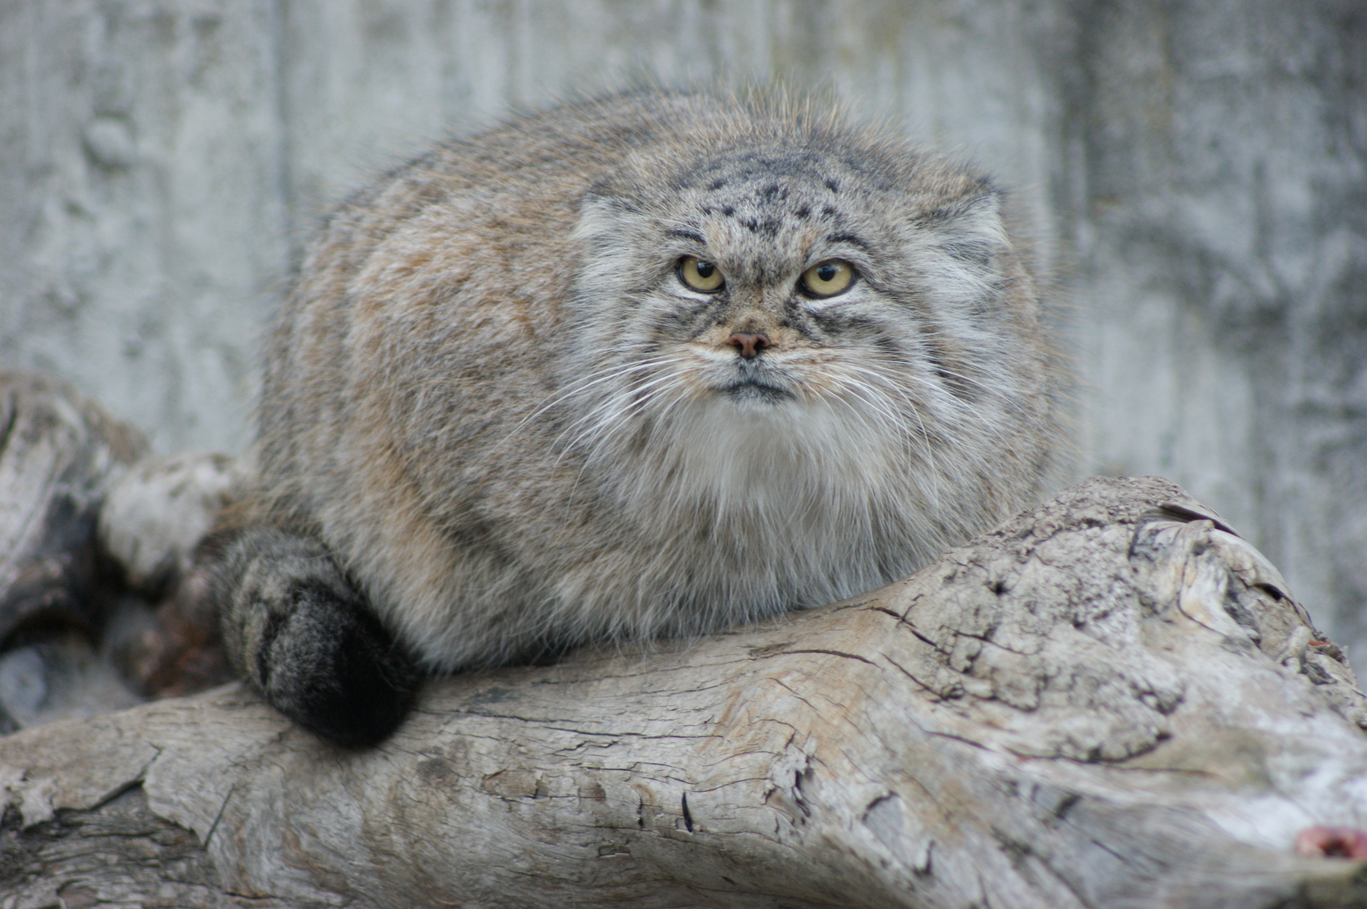
Mhew… That’s so much for openset.

4. Running the Close-Set benchmark
Step 1: Run the regular model
neko_2022_soai_zero/project283/close_basemodel_prec_shufIN3_g3kDPs_cycanof_aa_p2/test_recon.py
I am running on a 1070 writing the docu so the speed is slower.
The p40 station is back in my den, um, I mean home. The lockdown ends so I am back to my post.
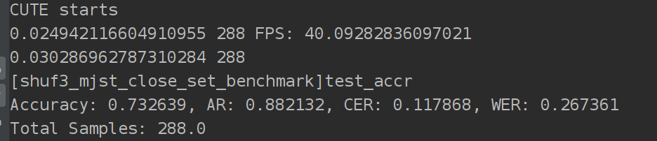
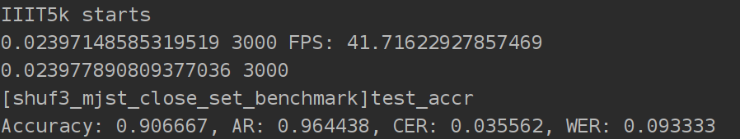
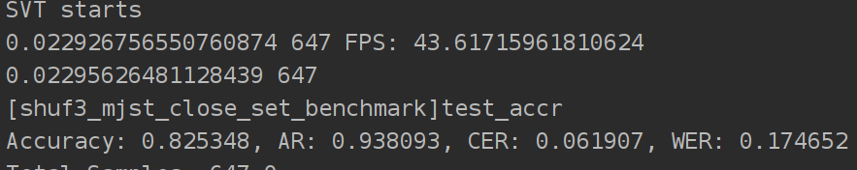
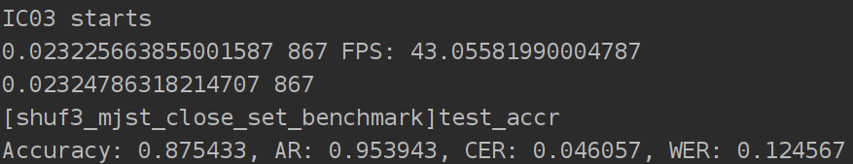
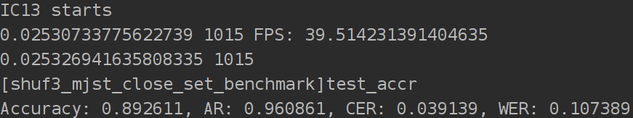

Step 2: Run the large model:
neko_2022_soai_zero/project283/close_basemodelXL512_prec_shufIN3_g3kDPs_cycanof_aa_p3/test_recon.py
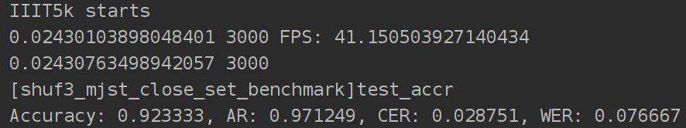
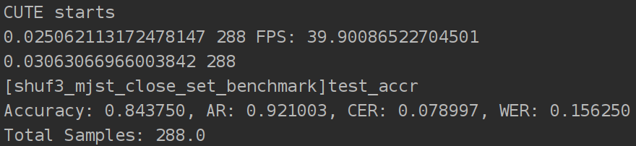
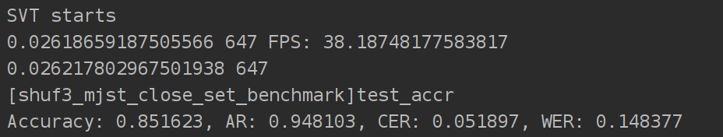
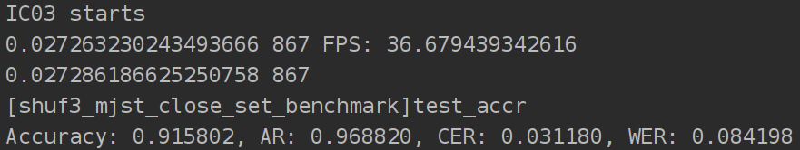
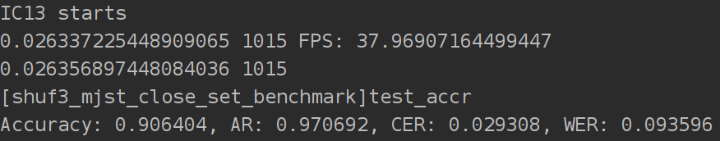
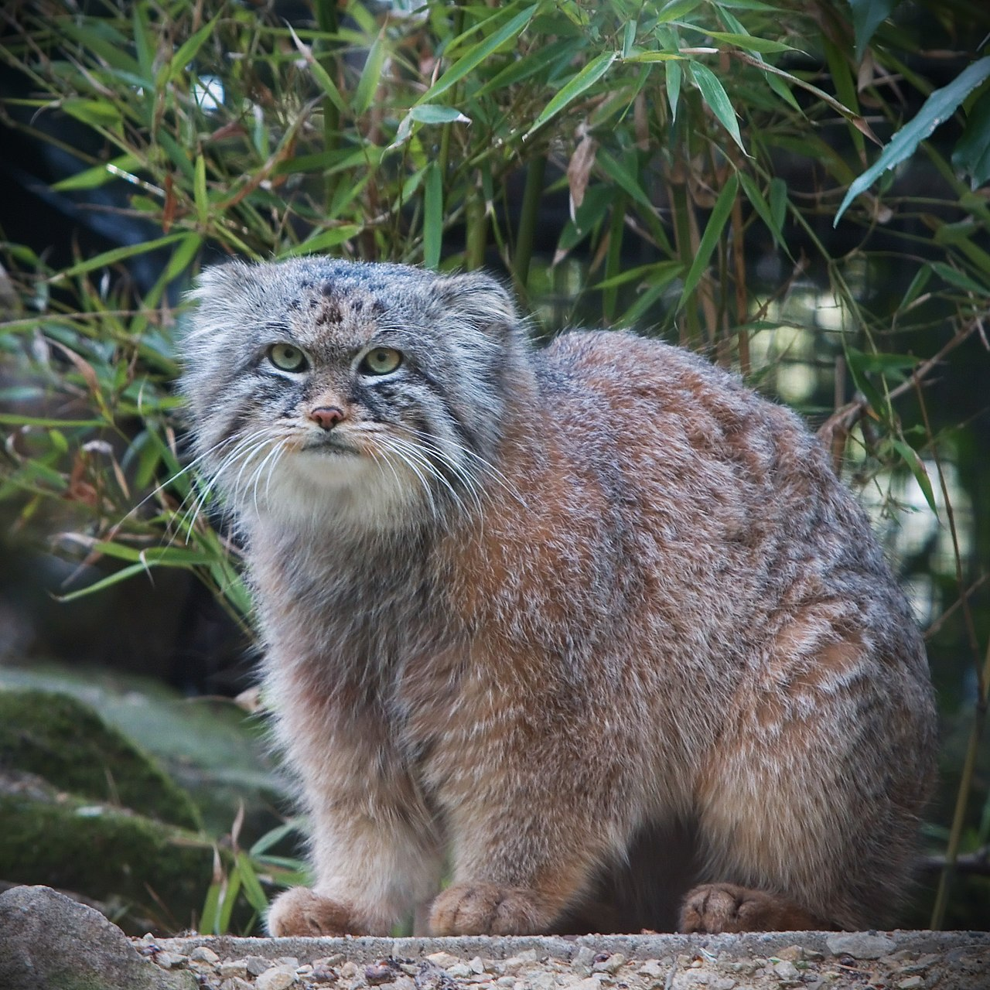
So the speed is not much lower, why? This is the nature of single batched test. You may set a larger batchsize, and you will find out that this babe can hit 100+/80+ FPS on a mere 1070. But heck we need to be fair when comparing, so in the paper we report single-batched speed.

5. Experiments on Close-set Impacts.
Step 1. Run close-set base model:
neko_2022_soai_zero/project283/close_basemodel_p2/test_recon.py
CUTE
IIIT5k
SVT
IC03
IC13
Step 2. Check open-set results
Note this would require you to configure valid export_path in “testrecon.py” files in the previous sections. It should point to no-exist directory make sure the program has the permission to create the path.
!!!!!!!!!Warning!!!!!!!!!!!!!!!!
The program may try to remove whatever inside that directory… Don’t let it ruin your day!
I use “may” bcs I wrote this months ago and I can remember the details.
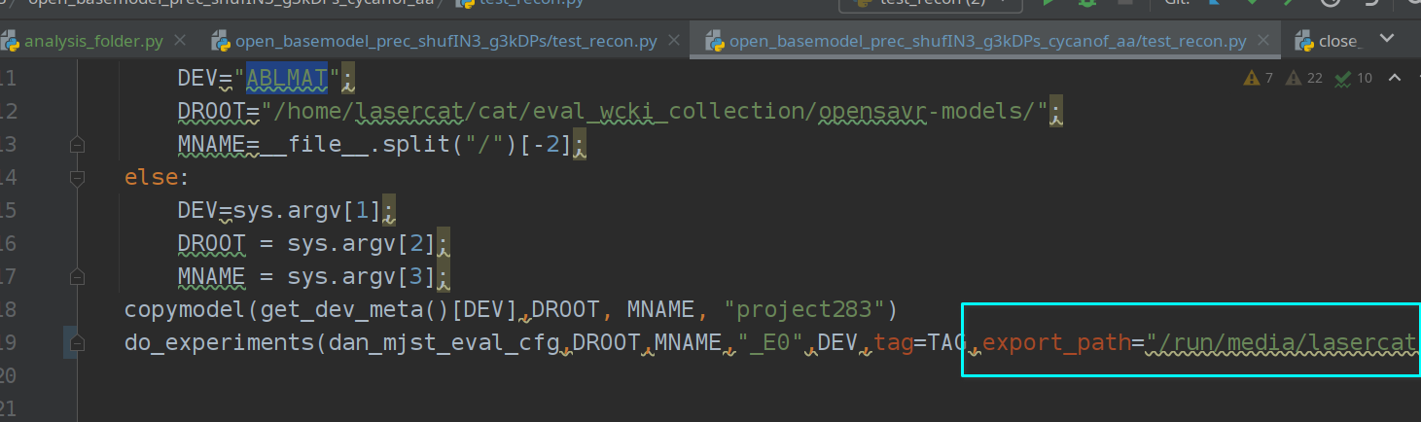
Step 3. Build details:
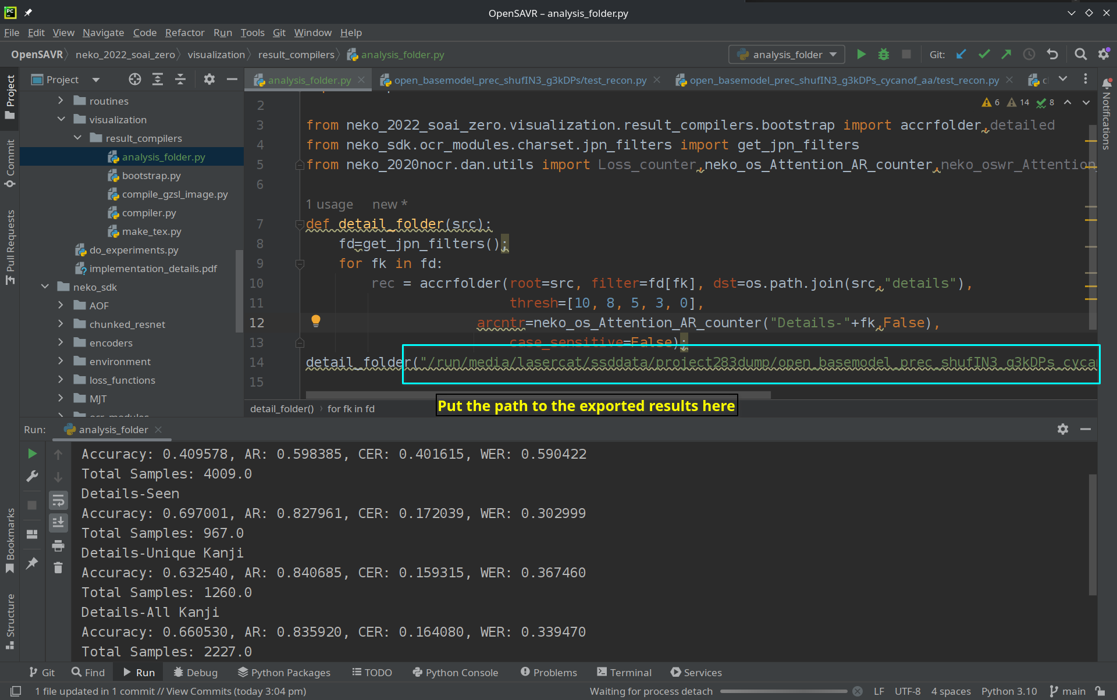
neko_2022_soai_zero/visualization/result_compilers/analysis_folder.py
Base model
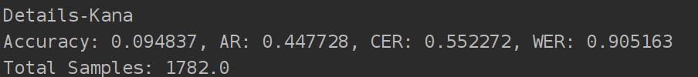
Ours
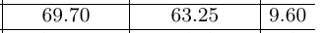

Ours-Large
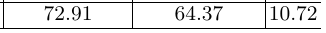
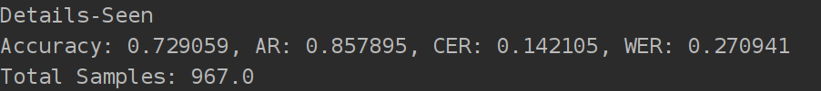
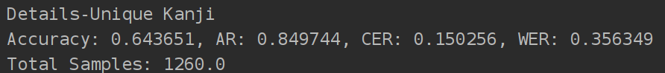
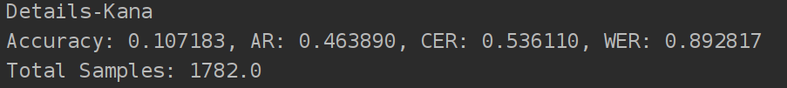
Well we have all the important numbers in the main paper and appendix, cheerz!

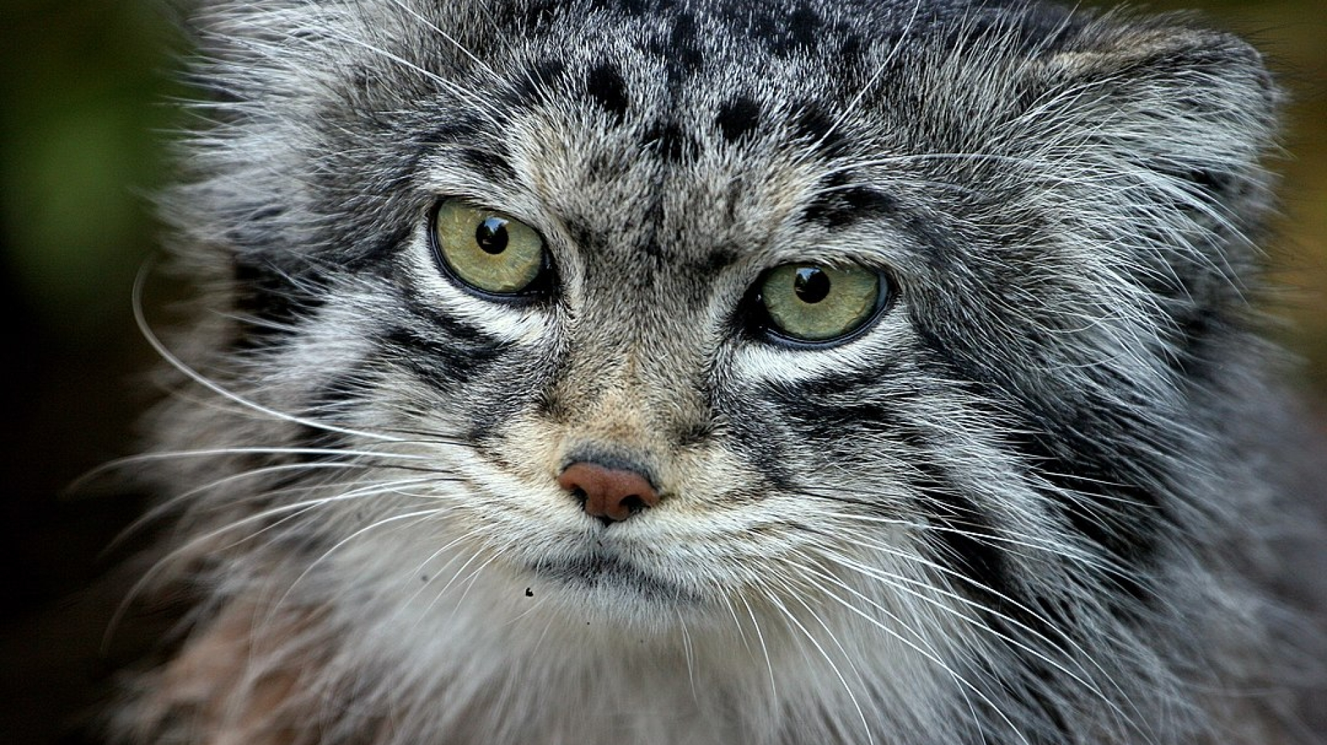

6. Training models
Basically, you run train.sh+GPUID under each directory.
Generally, the large models can be trained with 24G cards due to larger network and batch sizes. P40s and M40s are totally fine as we are using fp32.
Regular models can be fit into 8 GB cards, you may have luck with P104s.
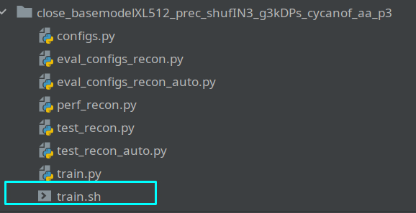

GLHF

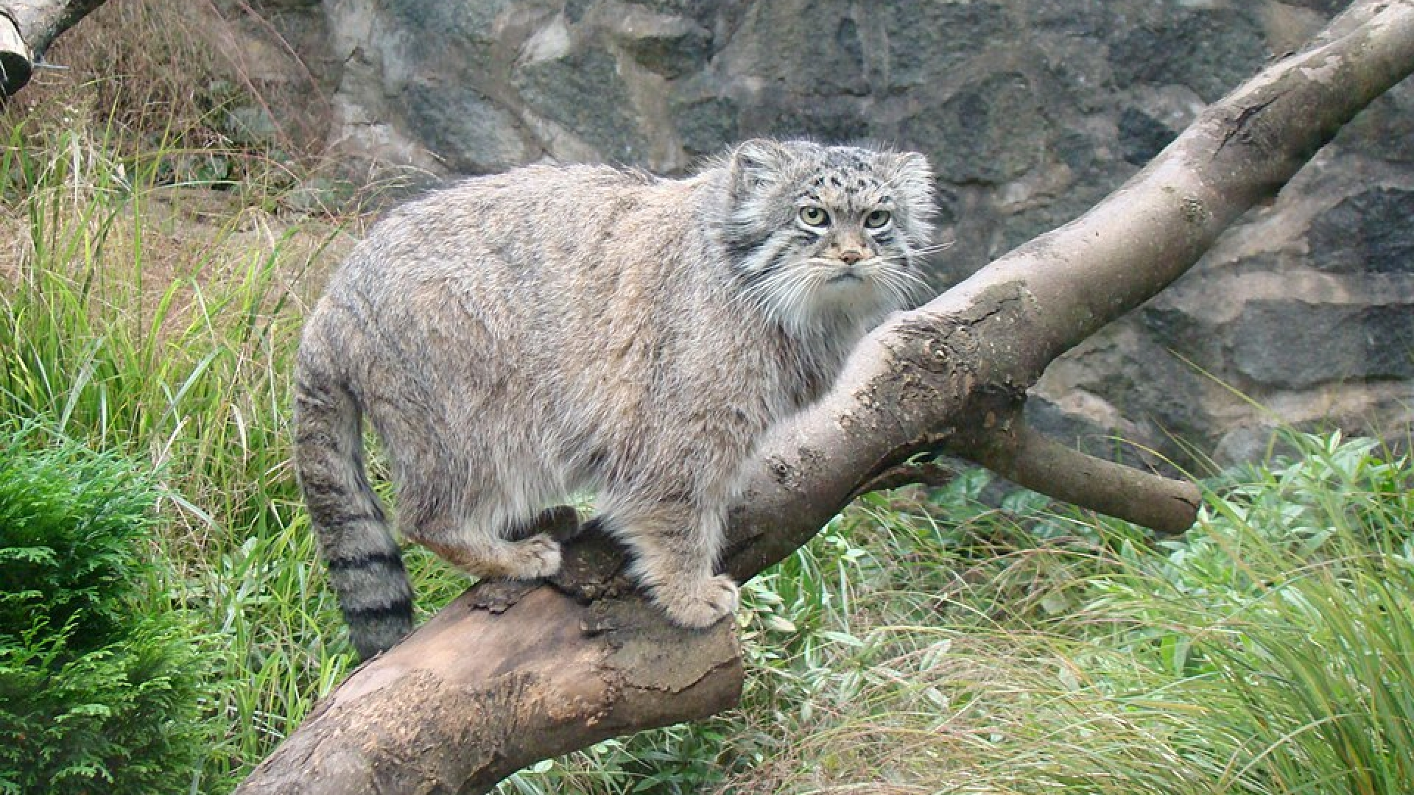

Cat @ 24/Apr/2023 (International Manul Day).

7. Happy International Manul Day

