Manual
I. Setting up environments.
Step 1. Install a clean Manjaro Linux (Archlinux should do as well) and download code and data.
You should have 3 data folders and 1 model folder from Kaggle (here we use the 4 archives we uploaded to Kaggle to save time) and a source code folder from Github.
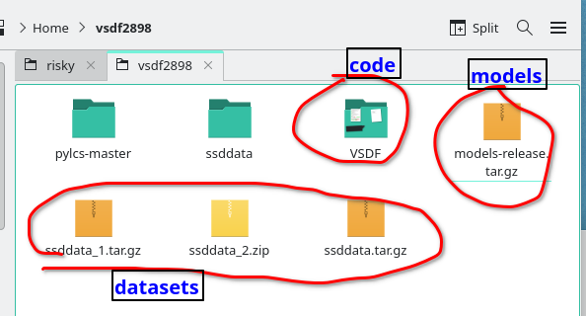

Step 2. Configure mirror, update the system, install a building requirements and reboot via

sudo pacman -Syyu pybind11; reboot

Step3A. Install PyTorch, Pycharm

sudo pacman -S pycharm-community-edition python-pytorch-cuda

Step3B. While waiting, grab the code, data, and the modified pylcs.
1) Merge the 3 data folders on Kaggle to the ssddata folder.
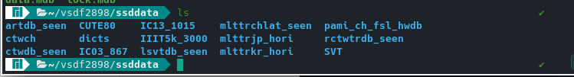

2) While waiting, install the modded pylcs shipped in the repo.
a.Extract pylcs-master-getlcs.zip
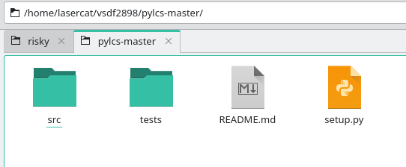

b. Run setup.py
python setup.py install --user
3) Extract released models into the models-release folder (Skip if it’s already there)

Step 3C. Stop and check if you have all the following folders
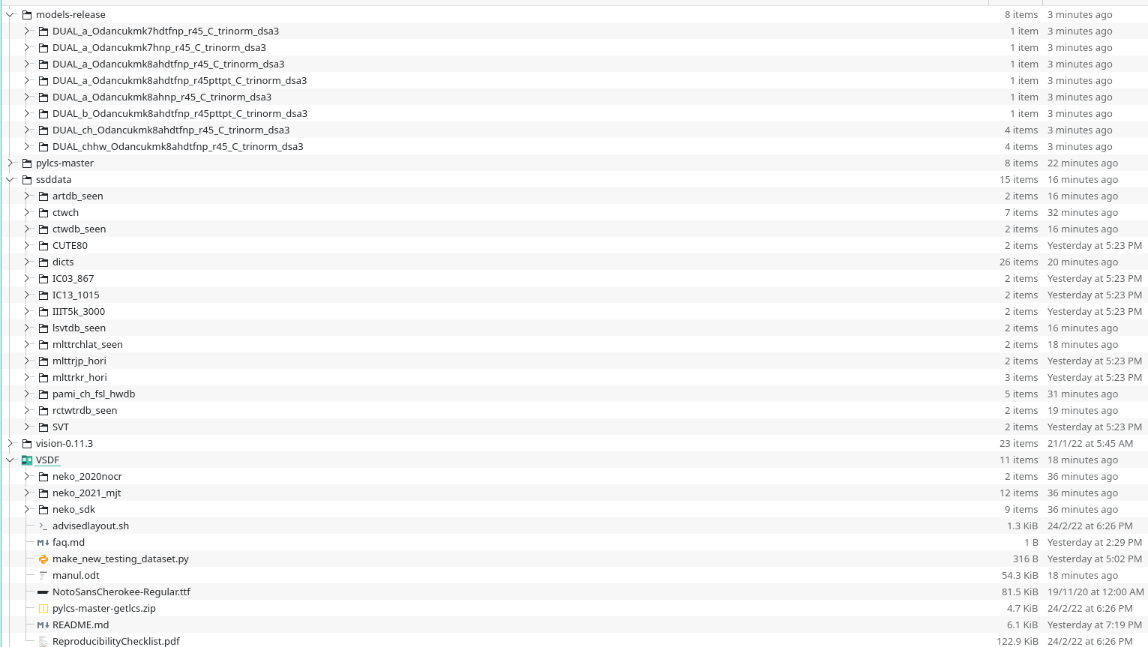

Step 4. Prepare and mod the torchvision code (as of 2022 03 09, it refuses to compile without disabling ffmpeg)
a) Download and unzip the torchvision
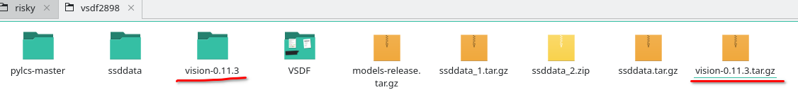
b) Mod line 359 of the setup.py to disable ffmpeg
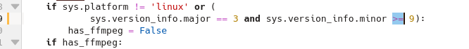
c) Build and install ffmpeg
python setup.py install --user

Step 5. Reboot your PC and Install other dependencies:
a) Via pacman
sudo pacman -S python-lmdb scipy python-opencv python-regex python-matplotlib
sudo pacman -S python-editdistance
b) Via Pip
pip install torch-scatter
Note that you may have trouble building CUDA support of torch-scatter if you did not reboot

Step 6. Open the project in pycharm and configure pycharm for running.
a) Open the project at its root folder
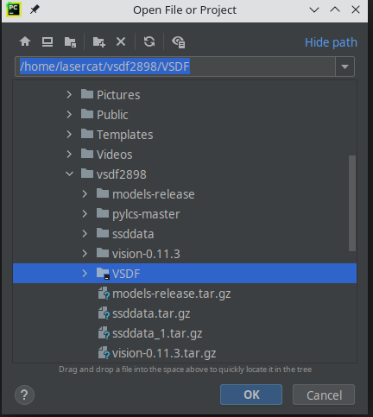

b) Set the paths in the $PROJ_ROOT/neko_sdk/roots.py
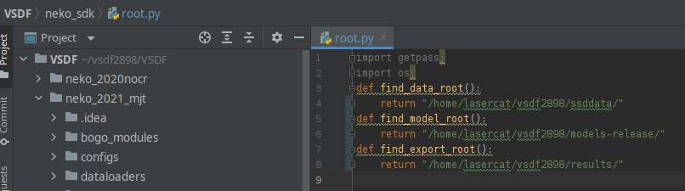

c) Run $PROJ_ROOT/neko_2021_mjt/standardbench2_candidates/DUAL_a_Odancukmk8ahdtfnp_r45pttpt_C_trinorm_dsa3/test.py
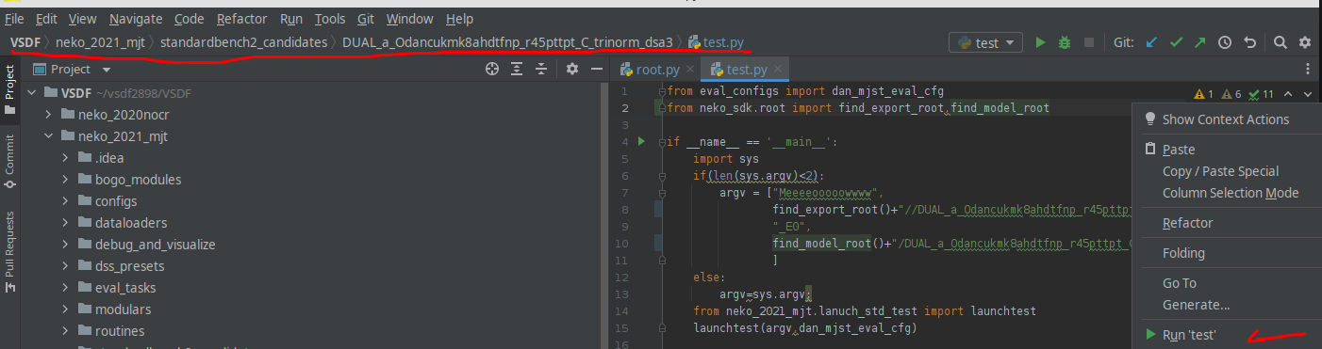

d) At the end of a bunch of warnings, you will get the Accuracy and FPS,
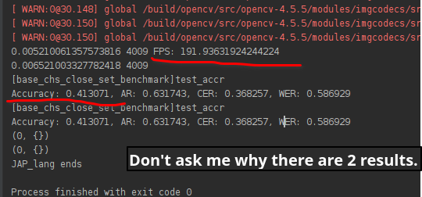

The results will be dumped into your result path as well.

Note you should ignore these warnings ^_^

And if you get the accuracies correct, the environment is all good for ya.

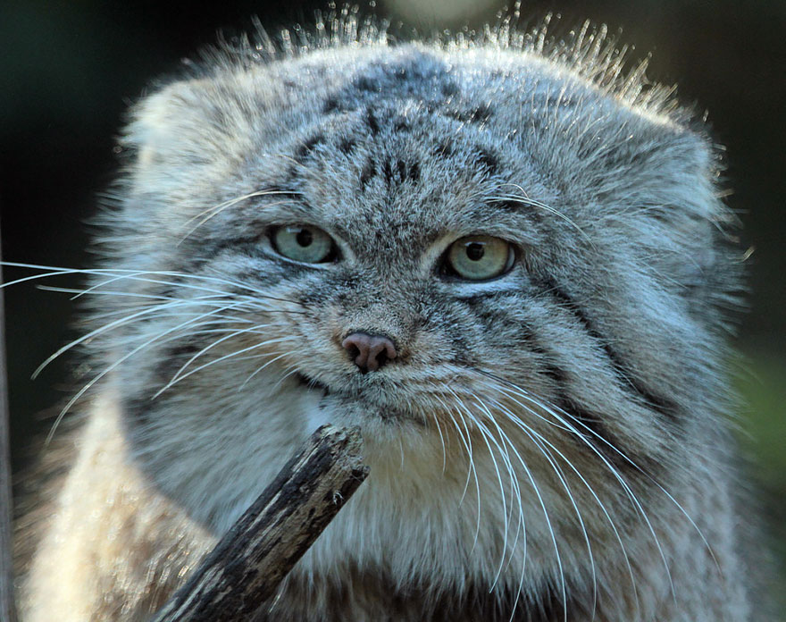

II. Evaluate downloaded models.

Performance Benchmarks:
With the environments properly set, you are now able to reproduce most cells in the paper. The steps to run each experiment are shown in Section I and this section explains which experiment one should run to reproduce each individual result.
The open-set text recognition.
Regular=DUAL_a_Odancukmk8ahdtfnp_r45_C_trinorm_dsa3
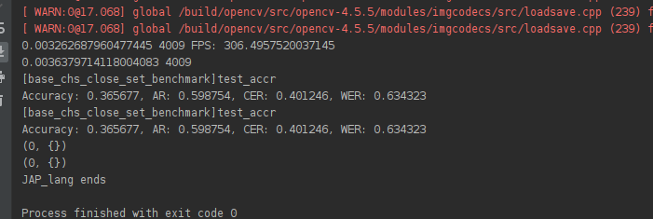
Large=DUAL_a_Odancukmk8ahdtfnp_r45pttpt_C_trinorm_dsa3*

Note a TPT module from OSOCR is loaded, but it is not used by the network due to … an implementation blunder – since it has nothing to do with the contribution or ablative studies of the paper, we left it be.

Ablative studies
Base=DUAL_a_Odancukmk7hnp_r45_C_trinorm_dsa3
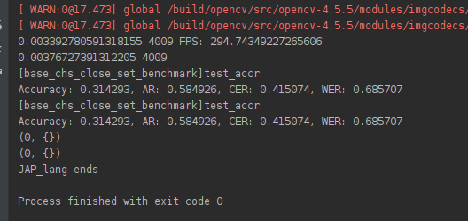
DTA=DUAL_a_Odancukmk7hdtfnp_r45_C_trinorm_dsa3
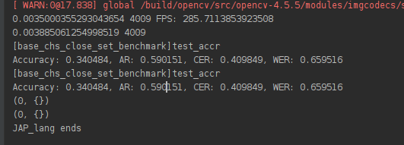
FULL=DUAL_a_Odancukmk8ahdtfnp_r45_C_trinorm_dsa3
See the Regular Fig. above

The close-set benchmarks.
Ours-Large=DUAL_b_Odancukmk8ahdtfnp_r45pttpt_C_trinorm_dsa3
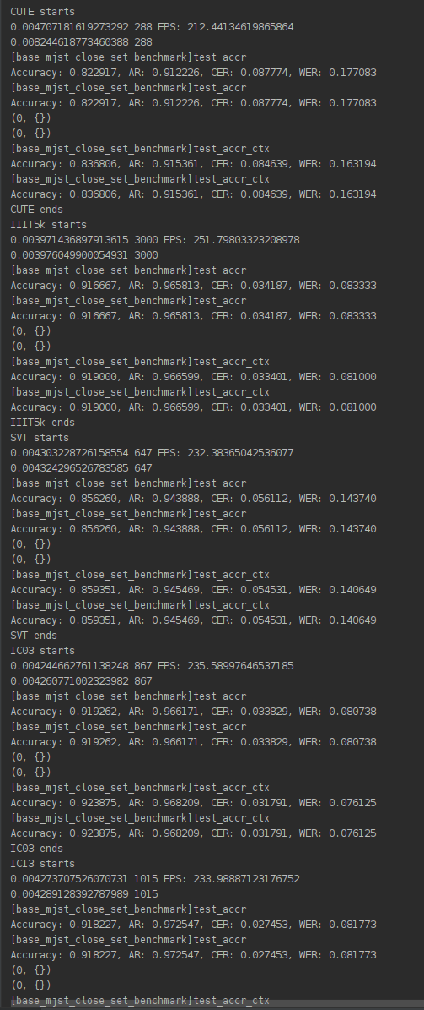

Well if you do want to reproduce the dictionary-based close-set experiments, pls open a Github issue or hack it thru. The codes and the models are there but a few quirks may need ironing out as we updated the interface of image-based testing to allow users to add their own languages.
The zero-shot Chinese character recognitions

CTW=DUAL_ch_Odancukmk8ahdtfnp_r45_C_trinorm_dsa3

HWDB=DUAL_chhw_Odancukmk8ahdtfnp_r45_C_trinorm_dsa3

CTW HWDB
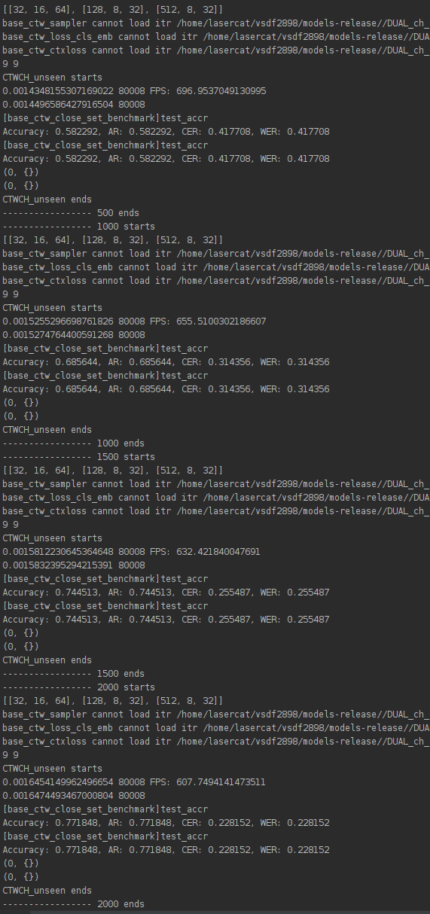
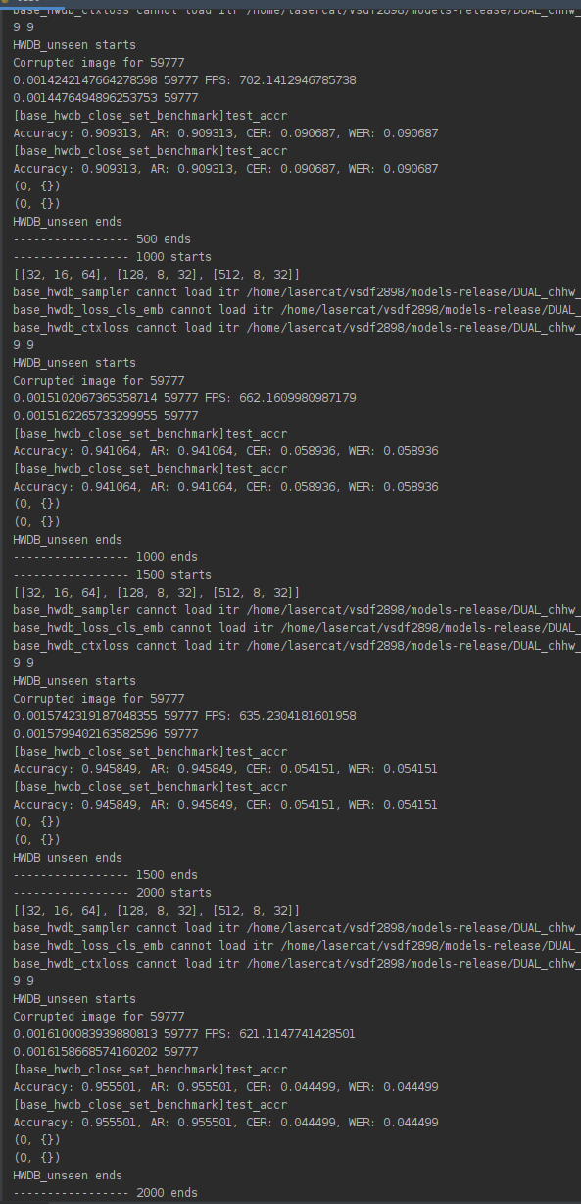

Extra Benchmarks:
Now perhaps you want to see the results on completely unseen language. Well, you can actually have it by running the test_kr.py scripts in *_a_* folders.

Despite we had run that for you on regular models, you may want to rerun it and see the individual images.
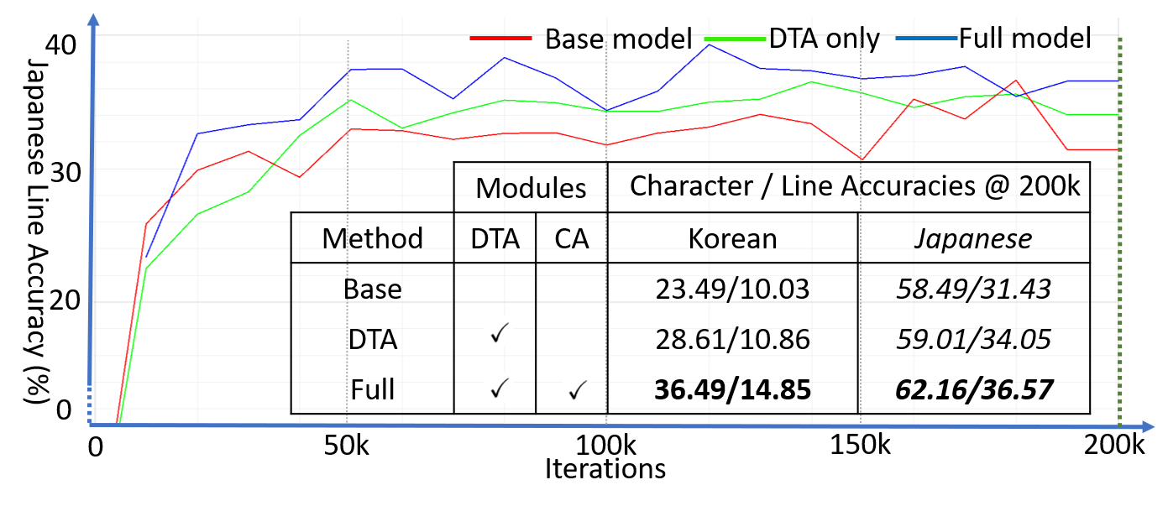

And the large model :
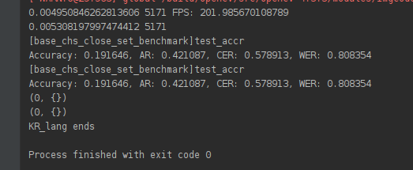

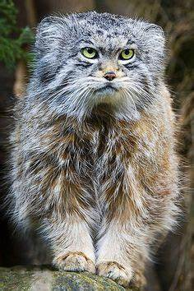

III. Training with downloaded datasets
Now you may want to see if this framework works with your novel MaGicNeT and here is where to start. Before that, you may want to train the model as is to get a baseline on your machine and confirm if everything you need is in place.
Training the model as is
Step 1: Grab NIPS14 and CVPR16 datasets from Kaggle our repo.
Alternatively, you can download them from DAN (AAAI 20) and put them in the ssddata folder.
https://github.com/Wang-Tianwei/Decoupled-attention-network

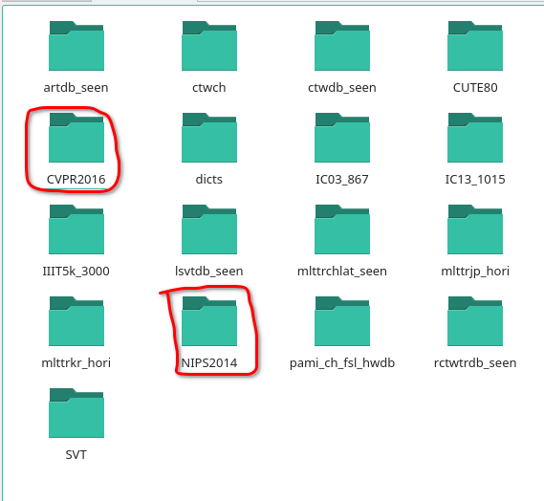

For open-set benchmarks, they are loaded but not used for coding convenience. You may hack the following dataloader configurations if you think you don’t want to load them when you don’t use them. (Or you can just fake these datasets with empty ones.)
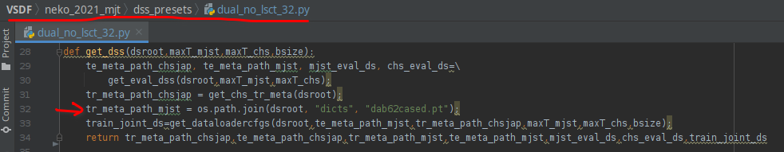
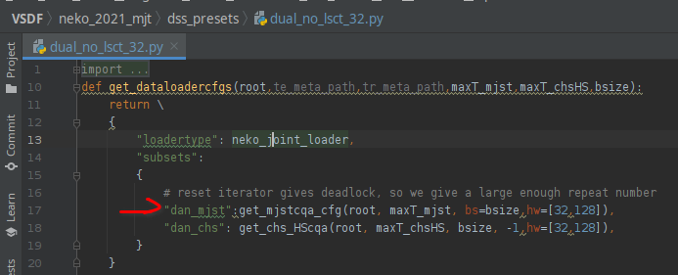

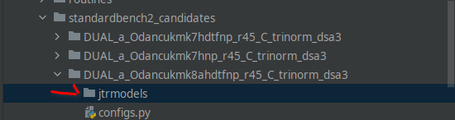
Step 2: Now that everything is in place, make a directory named jtrmodels in the baseline folder:

Step 3: Fire up train.py in pycharm
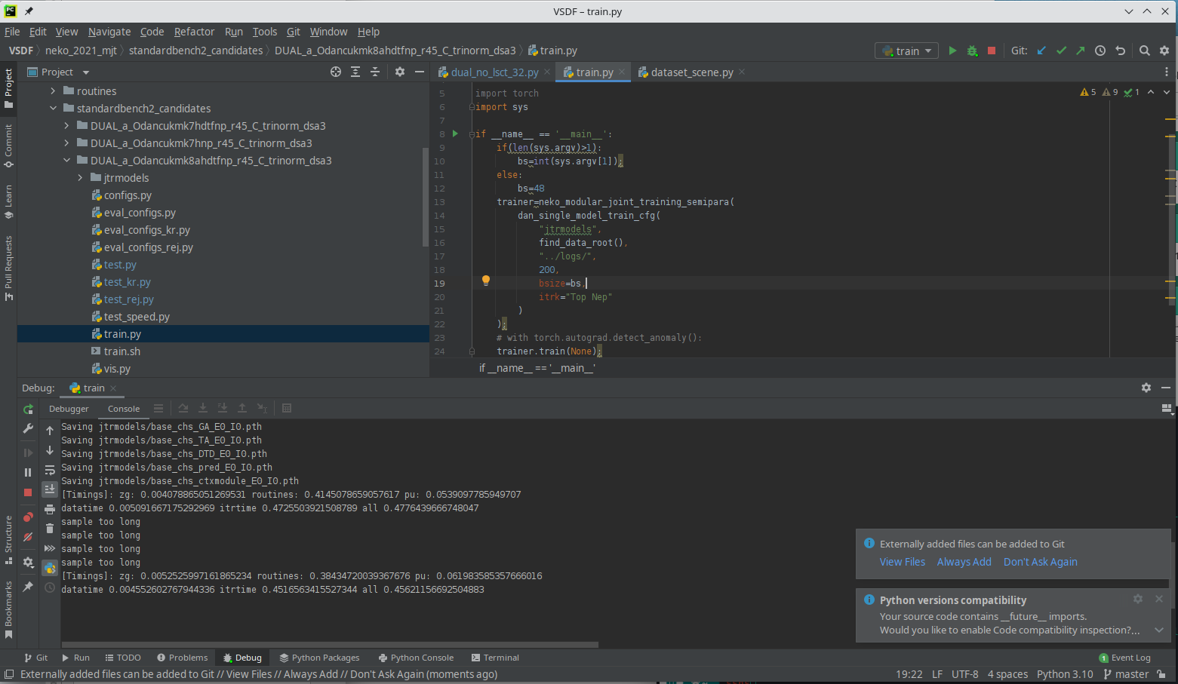
If it trains, it’s good.

Step 4. Install screen, stop the pycharm, and train it with screen.
1) Install screen via pacman -S screen
2) Change into the directory and run the training speed with your GPUID (0 here).
mkdir jtrmodels; screen -dmS $(basename ${PWD})GID0 sh train.sh 0
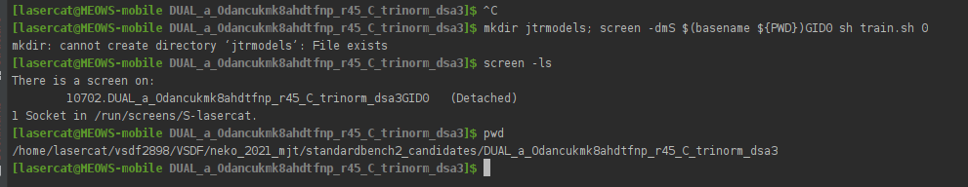
You can check on the PLAYDAN.log to check on the training process. Expect some delay due to buffering

Adding the modules
The framework uses a configure file for each module to achieve complex model sharing, and this design also makes controlling variables simpler. Here are the steps to add your own modular. Let’s say you want to have something better than the transformer for the CA.

Step 1. make a working directory, say mao_2022_magic, and add a modular subfolder and a config subfolder.
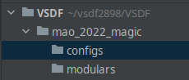

Step 2. Implement it! (Well I am just duplicating the existing one and changing its name=_=)
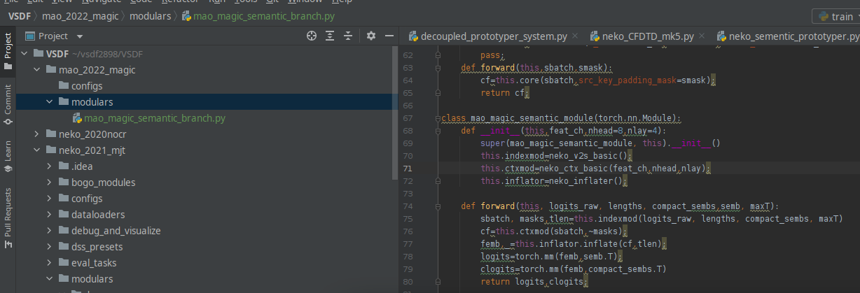

Step 3. Write a config file, specifying if it needs optimizing and if it needs saving.
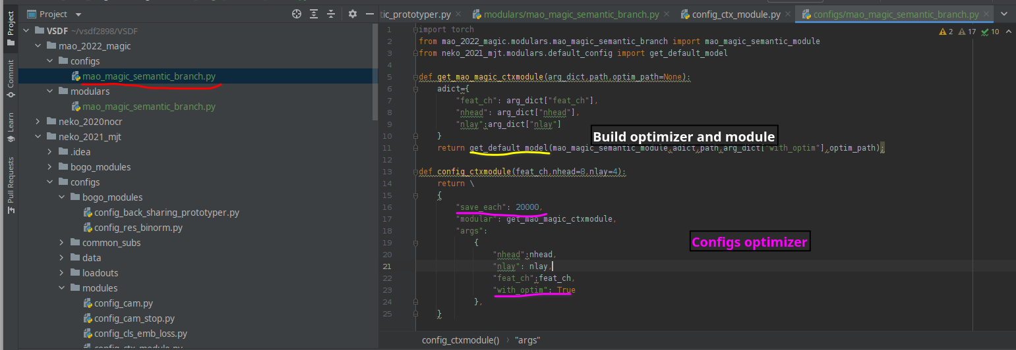
Step 4. Write a network config file including the module. Now we only changed the context module (CA), so we can reuse most of the old network.
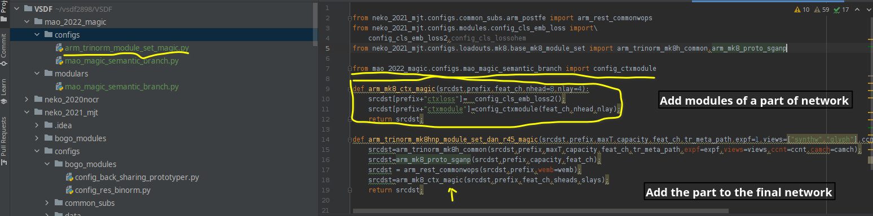

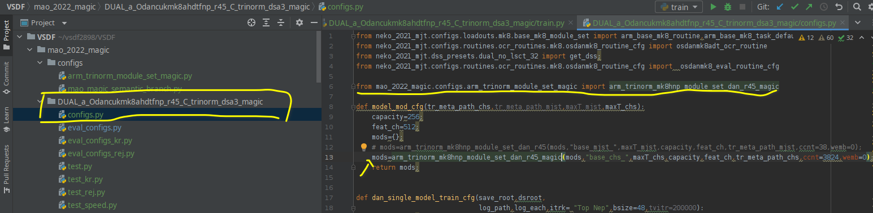
Step 5. Duplicate a model folder, replace the modules and run it

Other modding
You may have noticed the DTA is implemented via routines rather than modules (osdanmk8adt_ocr_routine, osdanmk7dt_ocr_routine), these moddings are somewhat different, however, will not be included in this manual due to the amount of effort to document all the details. Feel free to open an issue if you encounter any trouble building your own routines.

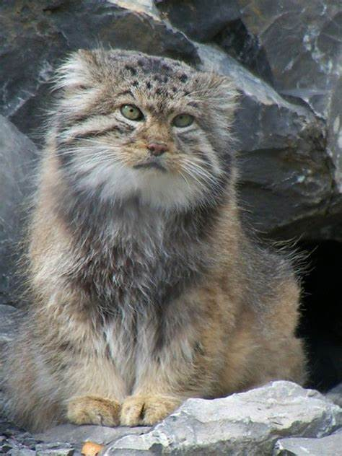

IV. Add a new language for evaluation
Say just having CJK is boring and you want to run some languages at your own preference. Here we give an example of how this may or may not work out with the Greek language.

Step 1. Make the charset
a) Find charset on Wikipedia
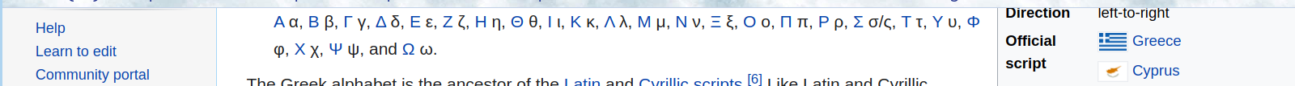
b) Make a list of upper cases and lower cases, note how they are corresponded.
c) Find noto-sans on greeks.


d) Build the dictionary file.
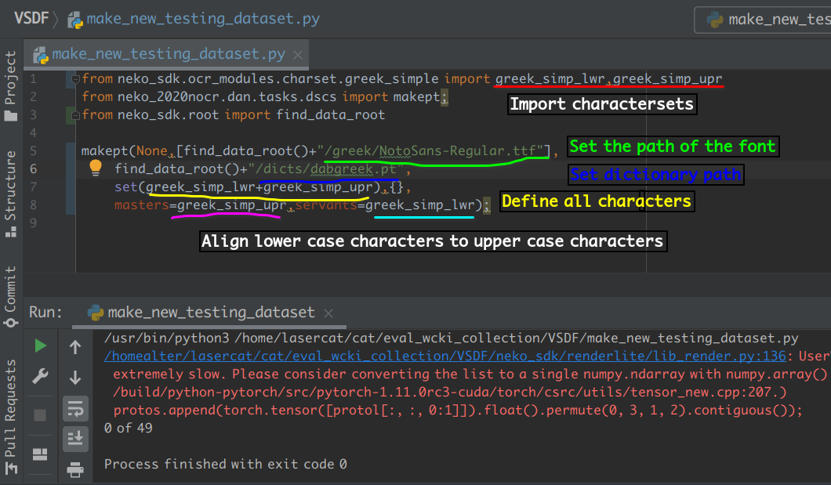

Step 2. Find some data and make a result dir.
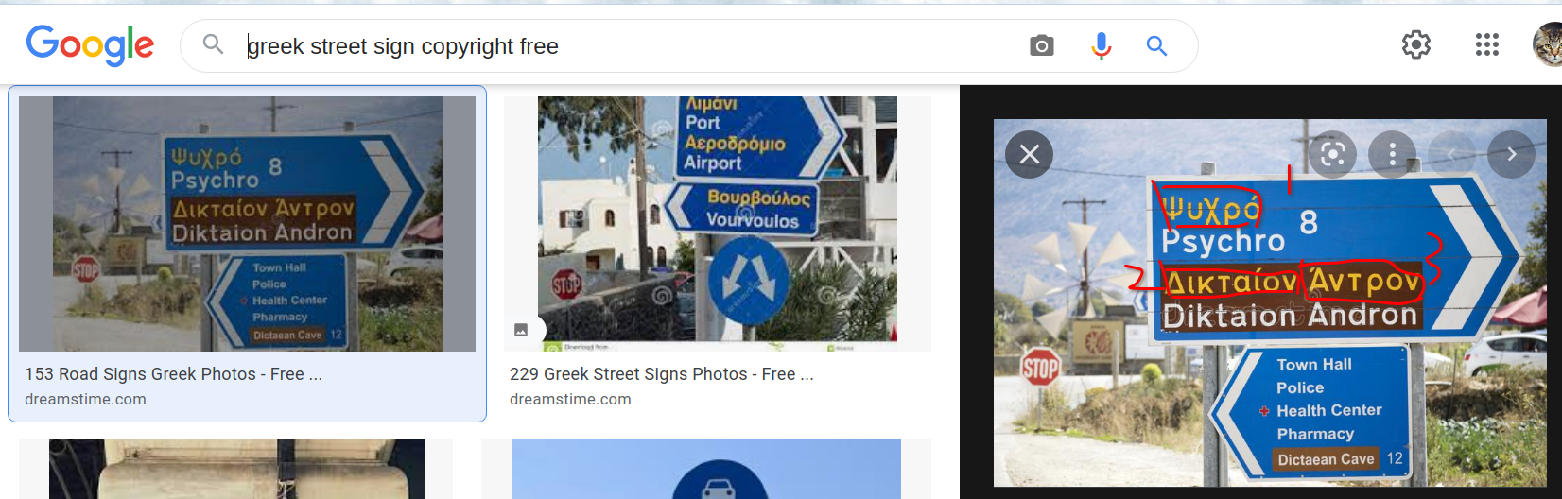

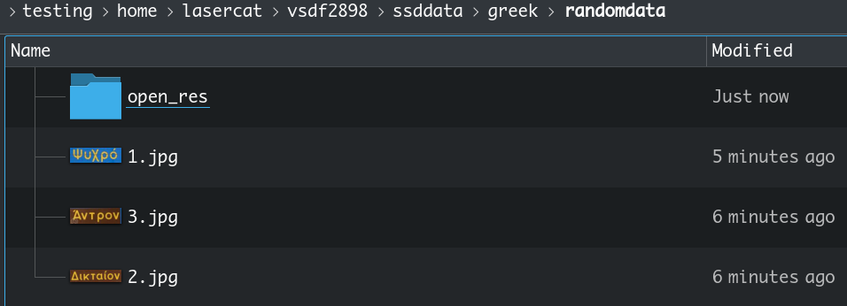

Step 3. Setup paths and run it~
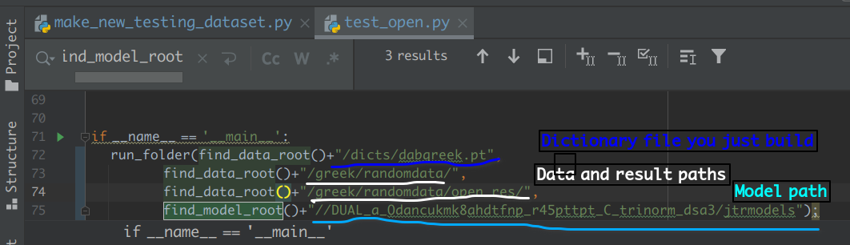

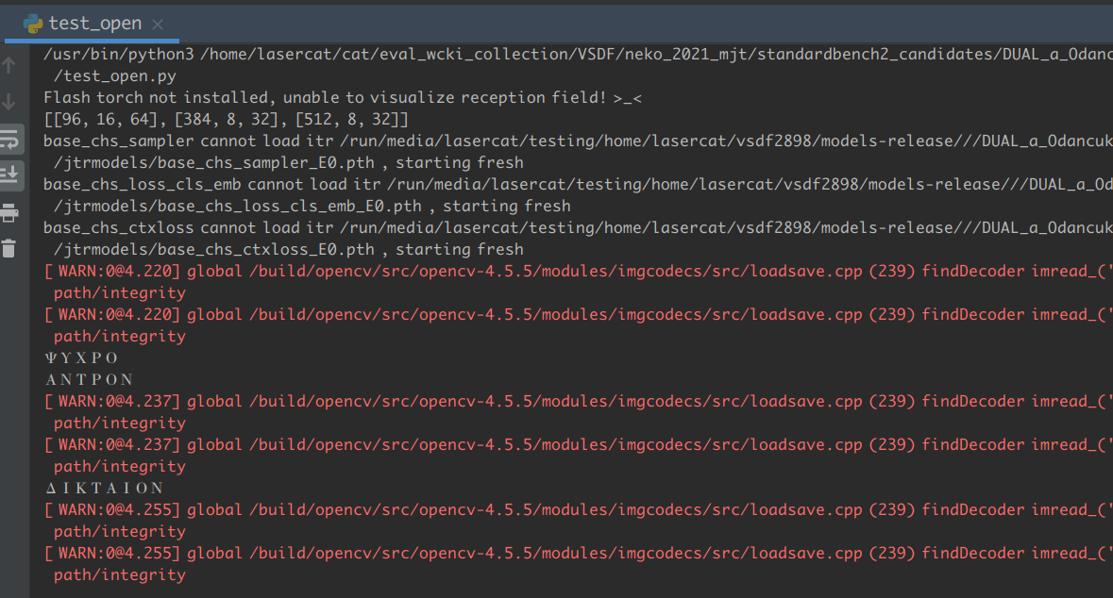

Now why v is recognized as n I wonder? (Because 'Ν'-'ν') Well, it’s not bad eh.

Step 4. Harvest text results and prediction in the result folder.
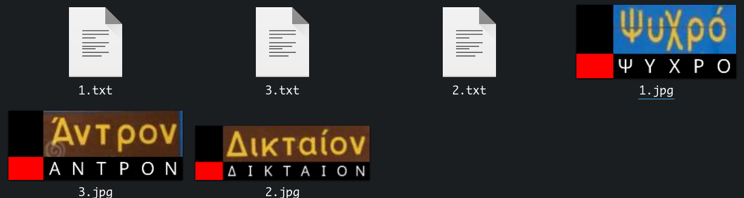
Step 6, you may actually try some thing more complex like this:
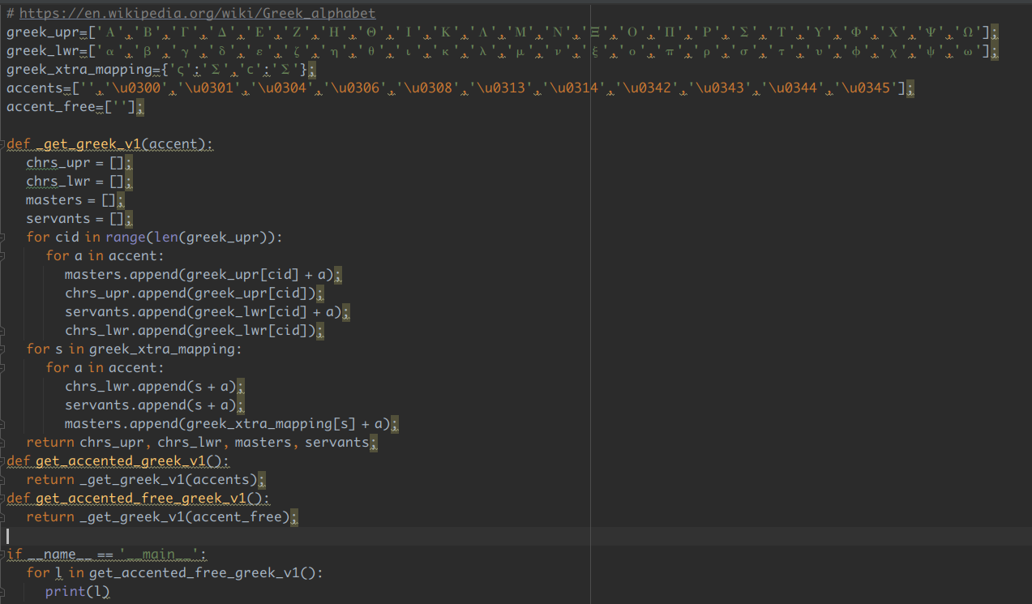

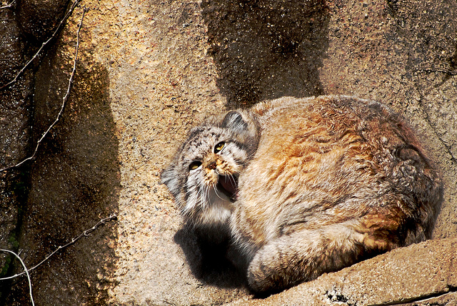
We won’t demo it here, but it is definitly on our schedule for near future.

