Manual

Setup your Environment:
0. Fresh install Manjaro, set your mirrorlist straight, and grab some snacks
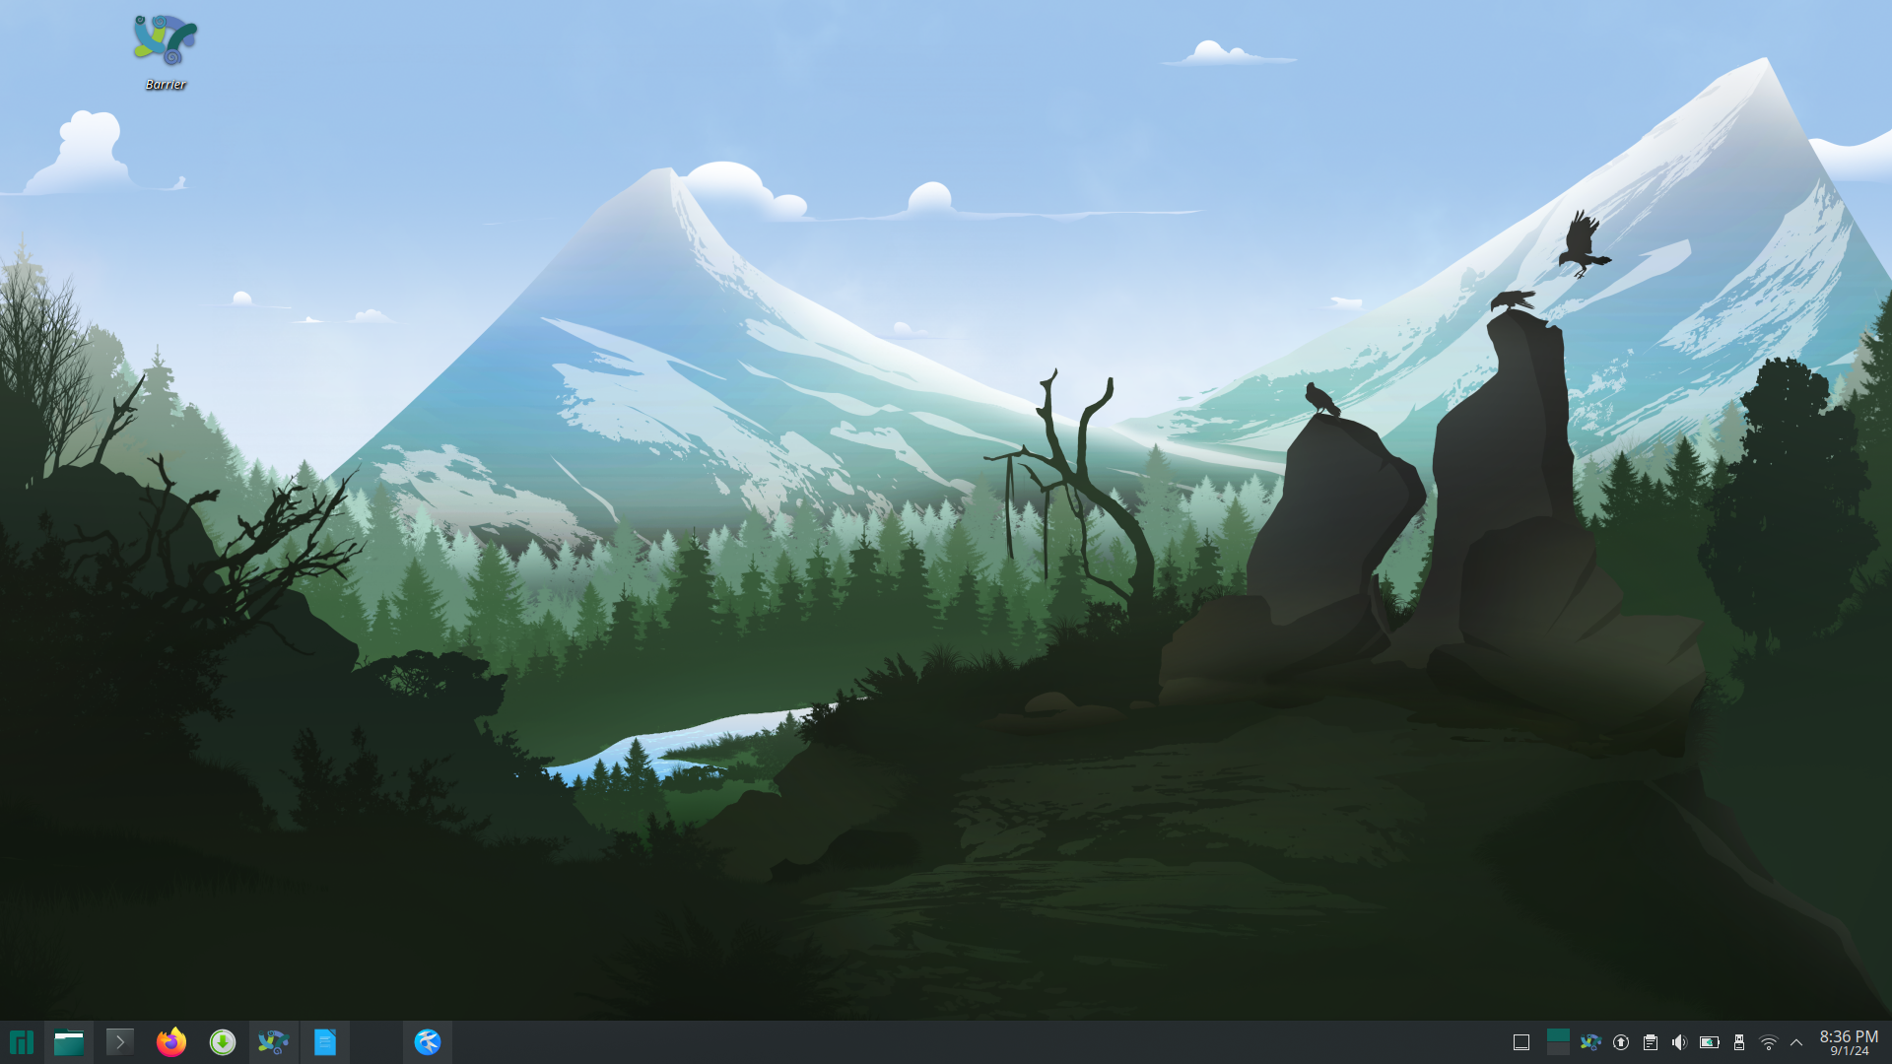
1. Download the environment making scripts
https://github.com/lancercat/make_envNG
2. execute 01-pacman.sh and give password for once or twice.
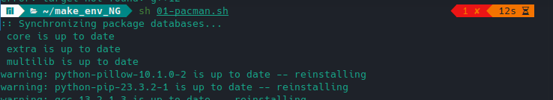
3 Reboot.
4. execute 02-pip.sh
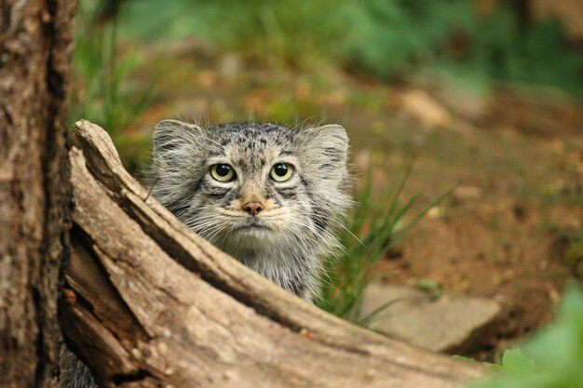
5. Enjoy,

