Manual && Reproduction Report for
Watch and Act: Multi-orientation Open-set Scene Text Recognition via Dynamic Expert Routing

Hardware requirements
GPU:
Testing: NVIDIA GPU with Turing or later structure and more than 4 Gib of vram.
(yes pascals, maxwells or even fermis may work, but you gonna need to know what you are doing)
Training: 24GiB GPU with Turing or later structure
(In theory, 16GiB ones work too but I am not promising that.)
CPU: X86 cpus with AVX2 instruction set
(CPUs without AVX2 may or may not work with different versions of torch, I don’t know)
RAM: 16GiB (Testing) 32Gib (Training)
Disk: 500GiB (well just dig out one old hdd from your bucket, or ebay and that’s it)
Internet: Yes

Software Requirements
1. Fresh installed Archlinux with these packages:
sudo vim plasma-meta nvidia openssh firefox dolphin konsole wget git less
2. The user name is set to lasercat and it has to be a sudoer (or you may need to go through the code to replace paths if something went south).
3. Keep important data off this device!
I don’t want to wipe your data due to one or two failed cd commands followed by mv and/or rm

Trivia: Manul, aka the Pallas’ cat, is the oldest cat species still alive on the earth.

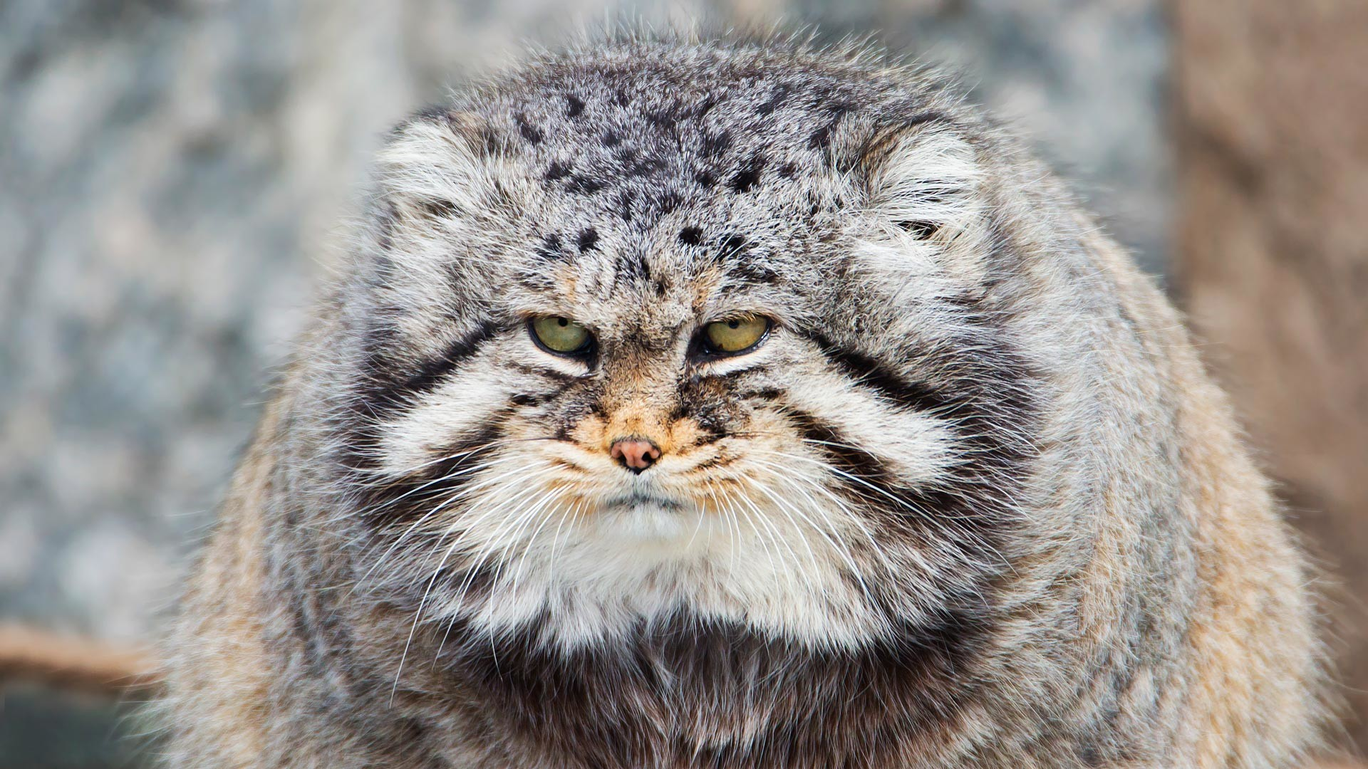

Environment setup
1. install the following packages once you boot in.
sudo pacman -Syu pycharm-community-edition plasma-meta python-paramiko python-lmdb python-numba python-opencv python-pillow python-pip python-pyqtgraph python-pytorch-opt-cuda python-regex python-scikit-learn python-scipy python-torchvision-cuda python-tqdm python-xmltodict make gcc cmake unzip python-setuptools kate firefox
2. make dirs
mkdir ~/cat ~/ssddata ~/hydra_saves ~/ssddata/anchors ~/Downloads
3. setup python stuff
mkdir ~/catvenv/; python3 -m venv ${PWD}/catvenv --system-site-packages;
source ~/catvenv/bin/activate; pip install easydict editdistance wandb
cd ~/cat; git clone https://github.com/lancercat/make_envNG.git
cd make_envNG/ ; sh pylcs.sh ;
unzip pytorch_scatter-laser.zip ; cd pytorch_scatter-2.1.2/; python setup.py install
4. download the data
cd ~/Downloads;
wget https://www.kaggle.com/api/v1/datasets/download/object300/mose-extra;
wget https://www.kaggle.com/api/v1/datasets/download/vsdf2898kaggle/osocrtraining;
5. download models to ~/Downloads:
310-rel.tgz from https://www.kaggle.com/models/object300/wna-zero
6. check the md5sum:
cd ~/Download; md5sum *;
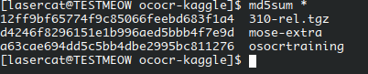

12ff9bf65774f9c85066feebd683f1a4 310-rel.tgz
d4246f8296151e1b996aed5bbb4f7e9d mose-extra
a63cae694dd5c5bb4dbe2995bc811276 osocrtraining
Note if you have different md5, it could be normal or not--- as we can have slightly corrupted archieves as well --- they are pulled from kaggle too but at least ours work :)
we pulled them from kaggle to make sure the online version do work
In short, if you encounter problems AND have different md5sum --- try download again.
7. clone the code:
cd ~/cat; git clone https://github.com/lancercat/wna.git
8. run extract.sh:
cd ~/cat/wna/ ; sh extract.sh
⑨. stop and check:
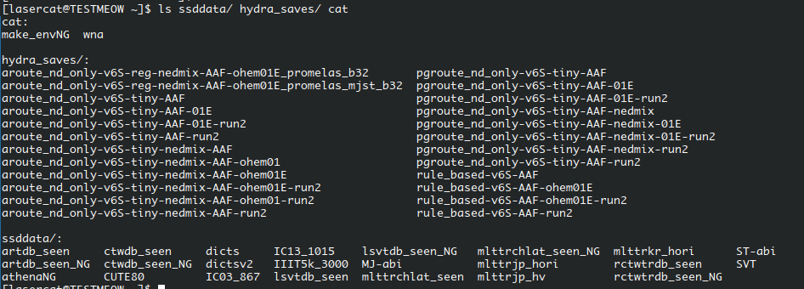

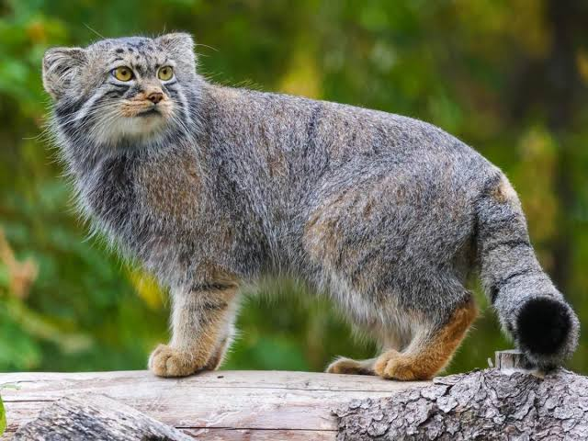

Reproducing ablative studies
1. run ablative.py (in a screen session as it takes some time):
python ablative.py 2>&1 | tee all.log
(our log is uploaded to github)
----------------------------------------------------------------------------------------------------------------
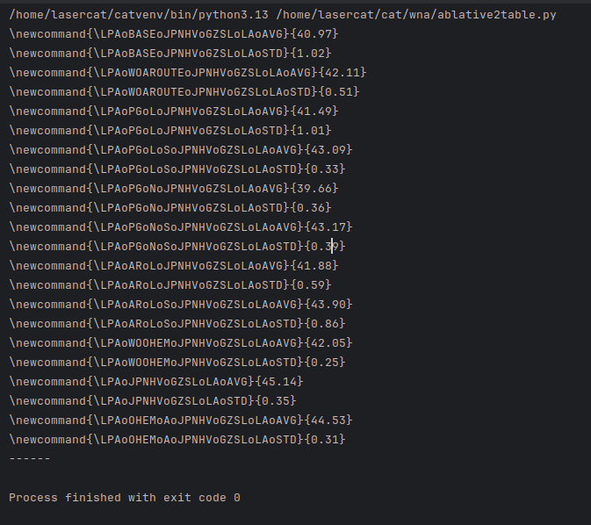
2. After the ablative experiments are finished (usually takes like a dozen hours on a GTX 1650), run ablative2table.py to compute mean and standard deviation:

----------------------------------------------------------------------------------------------------------------
3. save the output text as a txt file, say reprod.txt
(our log can be found in this github repo as reprod.txt)
----------------------------------------------------------------------------------------------------------------
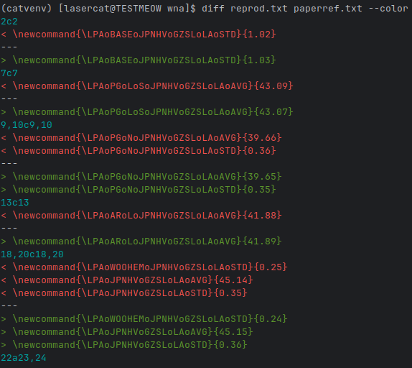
4. diff them:
diff reprod.txt paperref.txt --color

Expect the results to be a bit different here and there due to float errors between different implementations of operators, which can be caused by different torch versions, gpu structures, vram, etc (yes, torch[1] and CUDNN[2] may choose different backend on different hardware)

[1] https://discuss.pytorch.org/t/different-machines-different-results/100126
[2]https://docs.nvidia.com/deeplearning/cudnn/backend/latest/developer/core-concepts.html

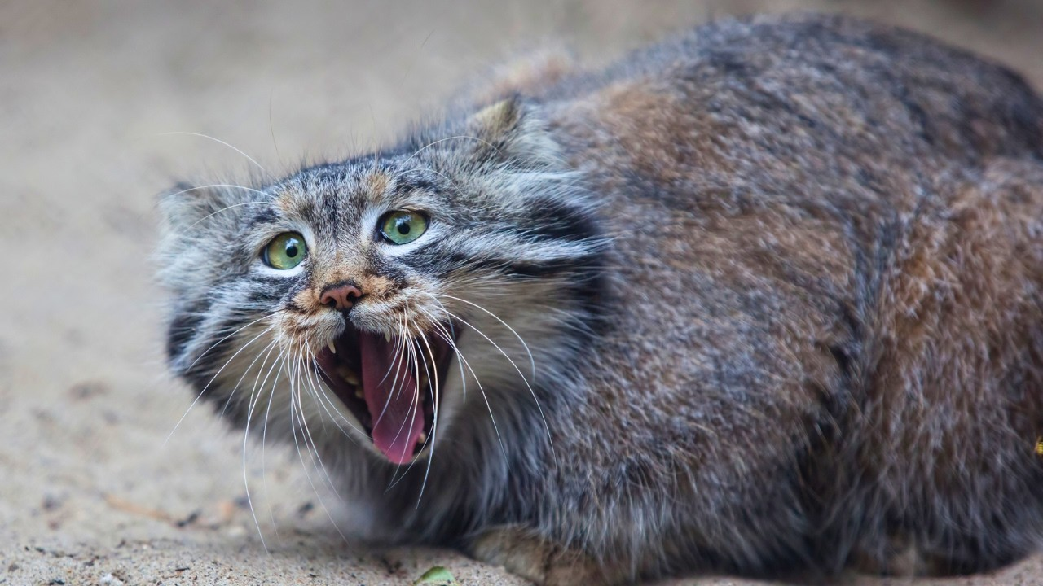

Reproducing Regular Model
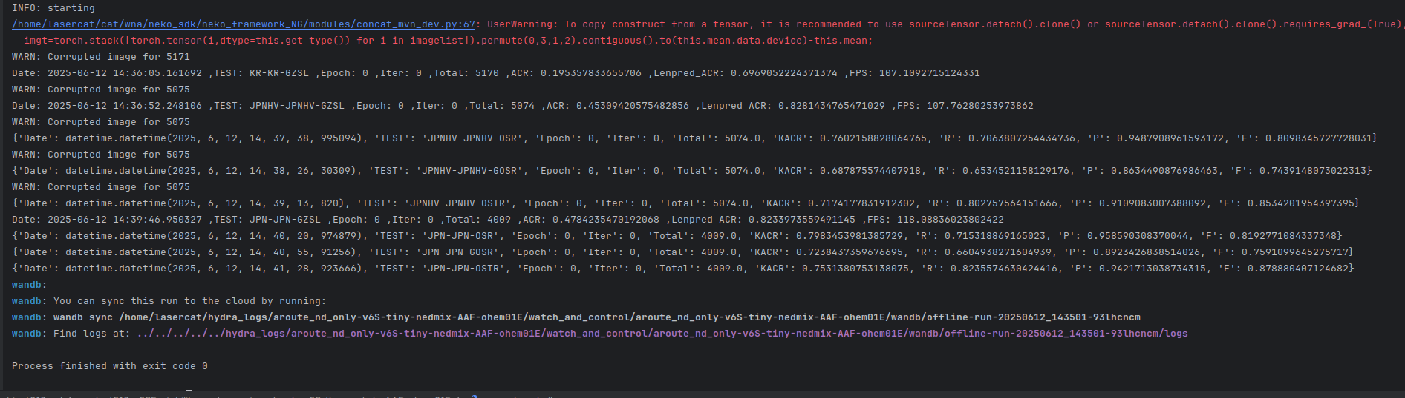
run object310-rel/project310_v6SF_stability-re/aroute_nd_only-v6S-tiny-nedmix-AAF-ohem01E
Let’s map them to the table
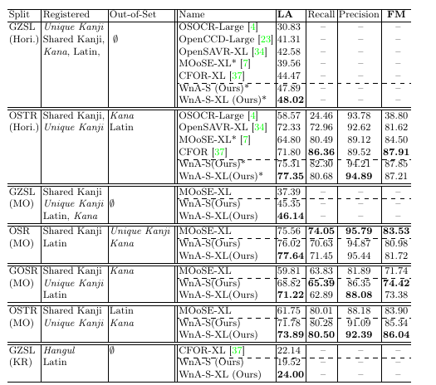
Note the performance differs a bit on this 1650, but not much (utilization btw)
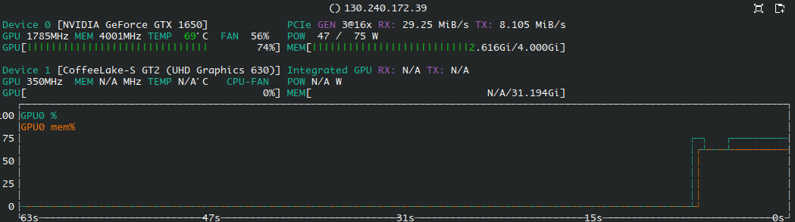
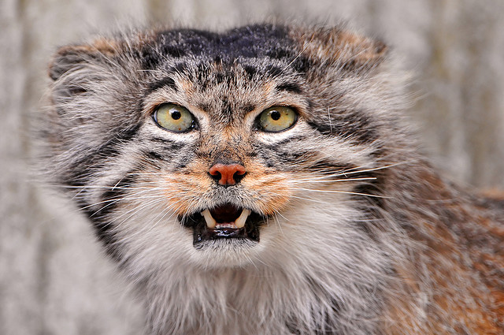

Reproducing Large Model

Open-set
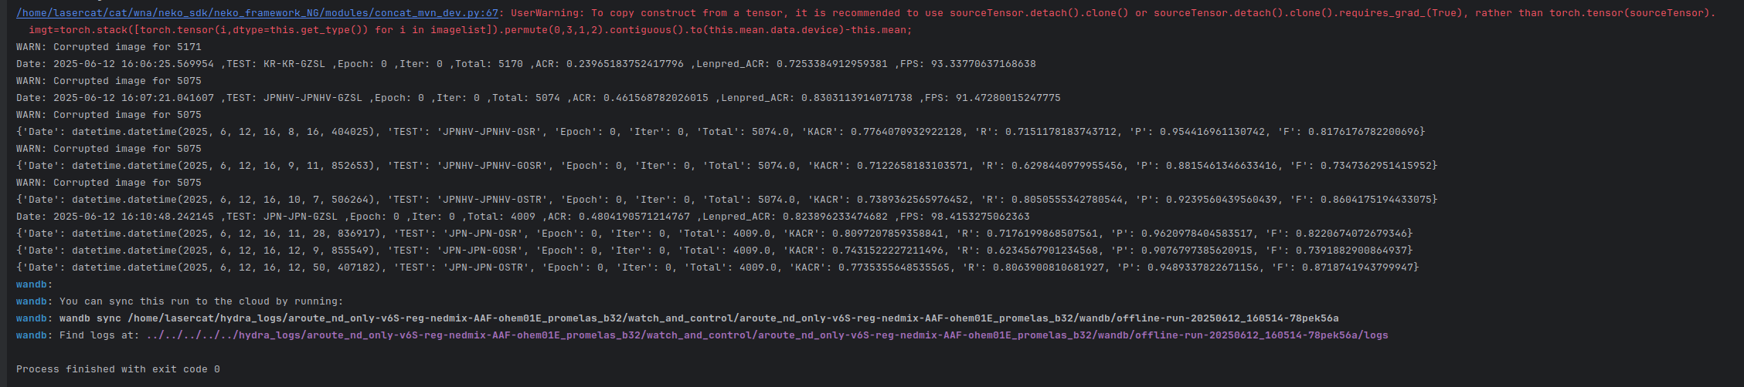
Run object310-rel/XL/aroute_nd_only-v6S-reg-nedmix-AAF-ohem01E_promelas_b32/osocr_benchall.py
Let’s map them to the table
Note the performance differs a bit on this 1650, but not much (utilization btw)
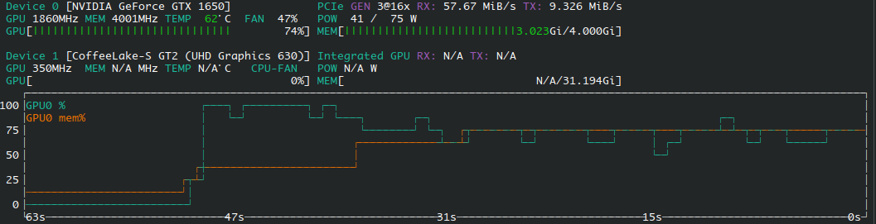

Reproducing Fig 1& Inference on your own data
Run object310-rel/XL/aroute_nd_only-v6S-reg-nedmix-AAF-ohem01E_promelas_b32/athena.py
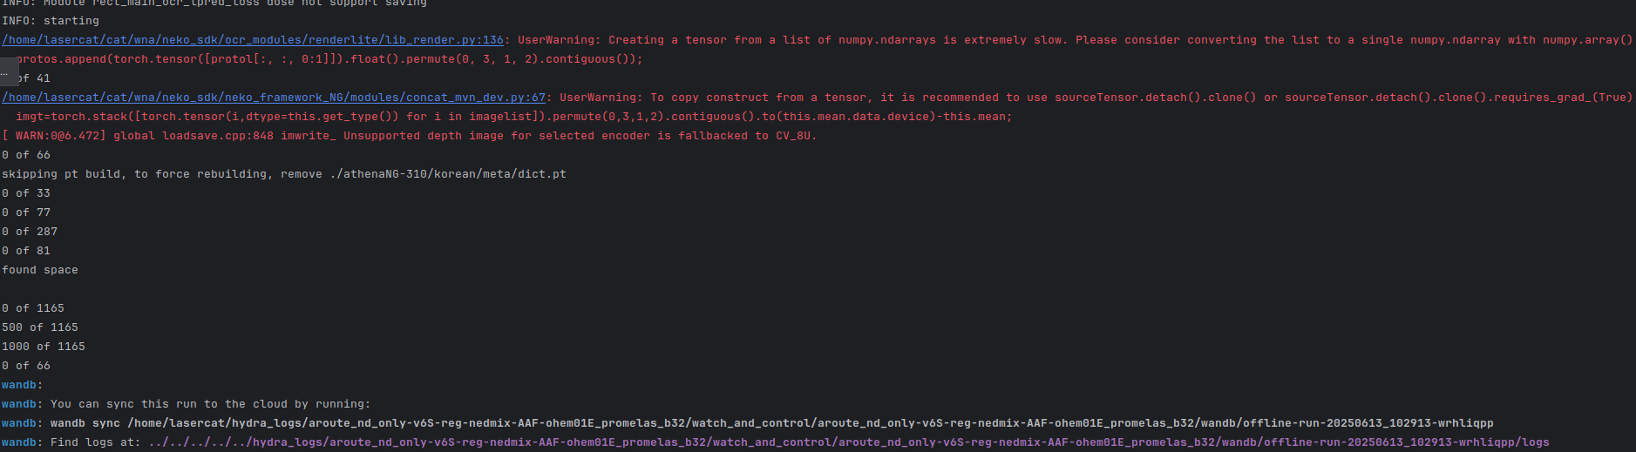
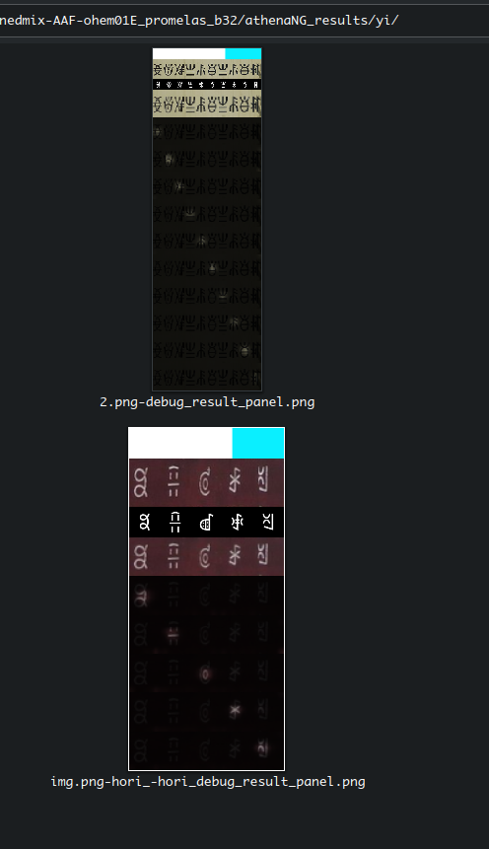
And harvest the results under
object310-rel/XL/aroute_nd_only-v6S-reg-nedmix-AAF-ohem01E_promelas_b32/athenaNG_results
For inferencing your own data, you need to prepare the meta/alphabets.txt, the meta/notofont.ttf, and images.
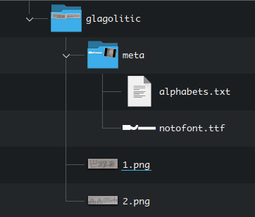
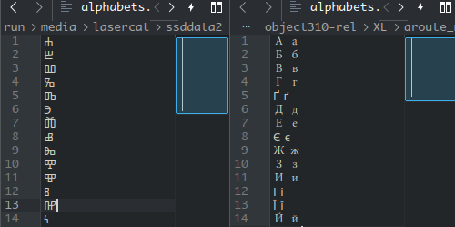
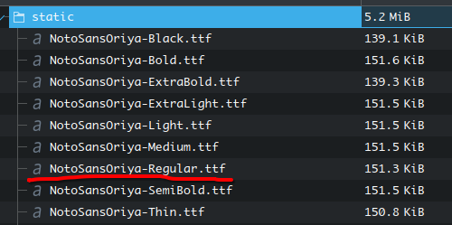
The meta/alphabets.txt contains all alphabets, each a line. If an alphabet has more than one case, split them with space.
For the notofont.ttf, you search for the font here: https://fonts.google.com/noto Download it, extract the regular variant, rename it to notofont.ttf, and add it to the folder.

Close-set
Run object310-rel/XL/aroute_nd_only-v6S-reg-nedmix-AAF-ohem01E_promelas_mjst_b32/test.py

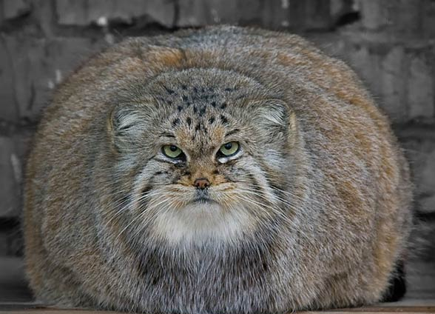

Training from Scratch
Run train.py under the method folder you choose. For example to train the large model:
object310-rel/XL/aroute_nd_only-v6S-reg-nedmix-AAF-ohem01E_promelas_b32/train.py
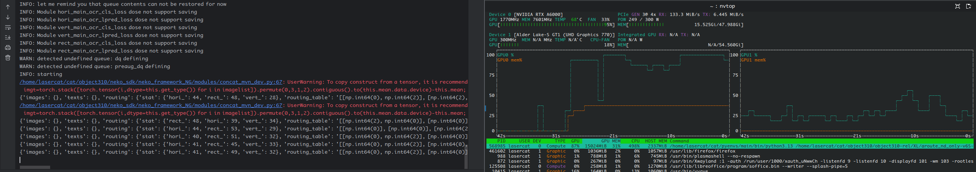
And watch it cook. Utilization BTW
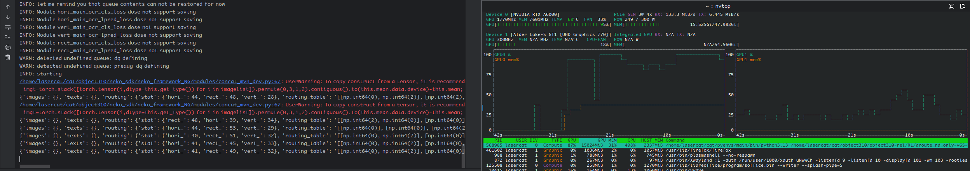
If you want to train with your own data, please try to follow the instructions from the vanilla osocr-data repo, the lmdbs are fully compatible.
The newly added dictsv2/lang/vismeta.pt builders can be reverse engineered from the athena scripts. Writing this manual takes too long already so I am not going to write an extensive document for now… pls understand the coding is developed and maintanced mostly by a single soul (me).
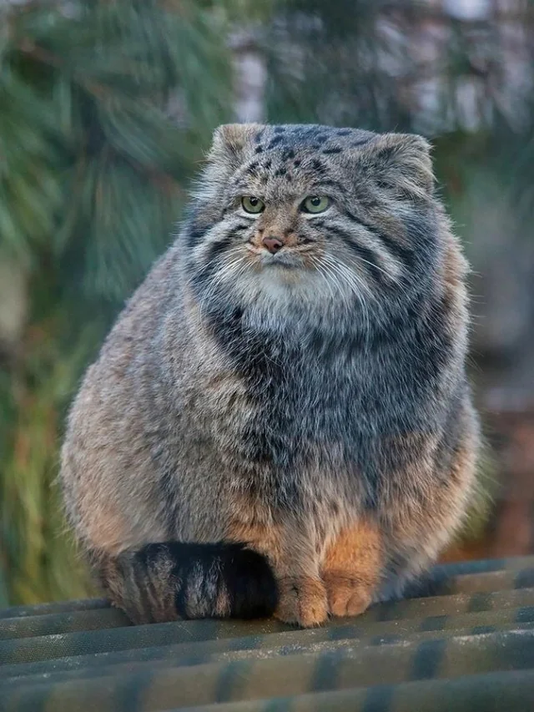
I may come back if this thing gets a journal extesion…

GLHF.

That’s it
If anything is buggy, doesn’t work, or you just want to chat, open an issue or contact us
Chang: lasercat@gmx.us (all time); chang.liu@ltu.se (work time please)
Elisa: elisa.barney@ltu.se

BTW… Since “manul” is spelled like “manual”, so you will see a manul at the end of each section as an end-of-section icon.

See ya && GLHF
