Joggle figure report
Target EuroSys 2027 fall cycle working manuscript

Figure 1 Structural block policy tradeoff
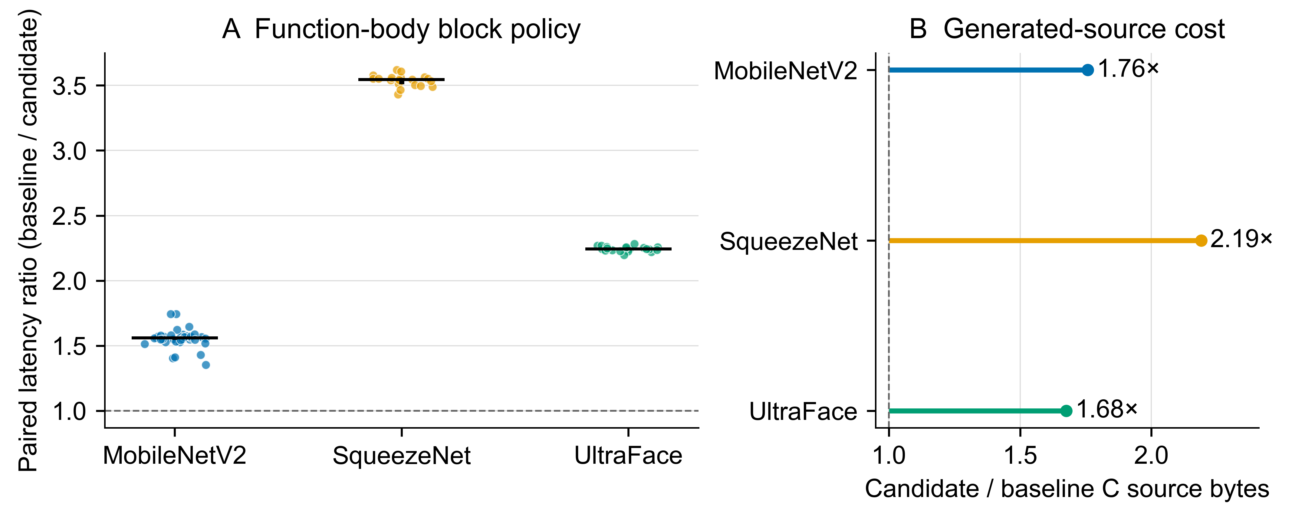
Claim The same operator-independent composition of split, reorder, and scalar promotion improves every paired call in three model pilots, while substantially increasing generated C source size.
Caption Descriptive same-process pilot results for a source-defined function-body block policy. (A) Each point is one adjacent baseline/candidate timed pair; horizontal bars are medians and vertical lines are interquartile ranges. The dashed line denotes equal latency. Observations are repeated technical calls within one unisolated process (n = 40, 20, and 20), not independent experimental units; no inferential test is reported. Candidate and baseline outputs are bit-identical for every pair. (B) Exact generated C source-byte ratios from the corresponding preserved artifact records; the dashed line denotes equal size. These pilots do not compare Joggle with a production runtime.
Citation location Section 5, RQ4 paragraph beginning ‘A later same-process diagnostic selects factors four and seven…’.
Reproducibility paper/figures/block_tradeoff.py reads the three committed *-block-pilot.csv timing files and paper/data/block-artifact-pilot.csv.

Derived values
Model | n | Median ratio | IQR | C bytes ratio
MobileNetV2-7 | 40 | 1.559 | [1.546, 1.573] | 1.757
SqueezeNet-1.1 | 20 | 3.544 | [3.509, 3.559] | 2.189
UltraFace-RFB-320 | 20 | 2.244 | [2.234, 2.258] | 1.675

