## Q1 Virtual Machine Setup

a. Linux White Paper - Downloaded from

<http://www.oracle.com/us/technologies/virtualization/oracle-vm-virtualbox-overview-2981353.pdf>

b. Download Oracle VirtualBox 6.0

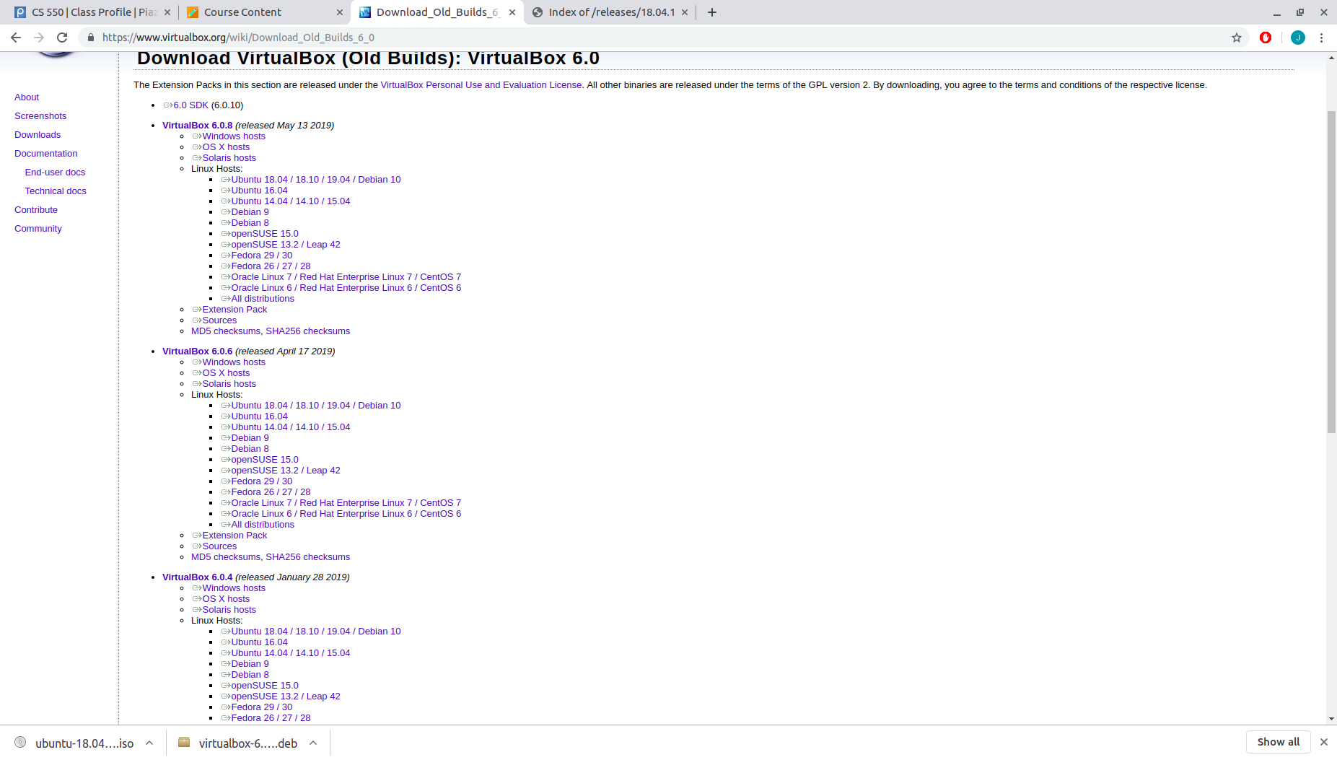

c. Install VirtualBox

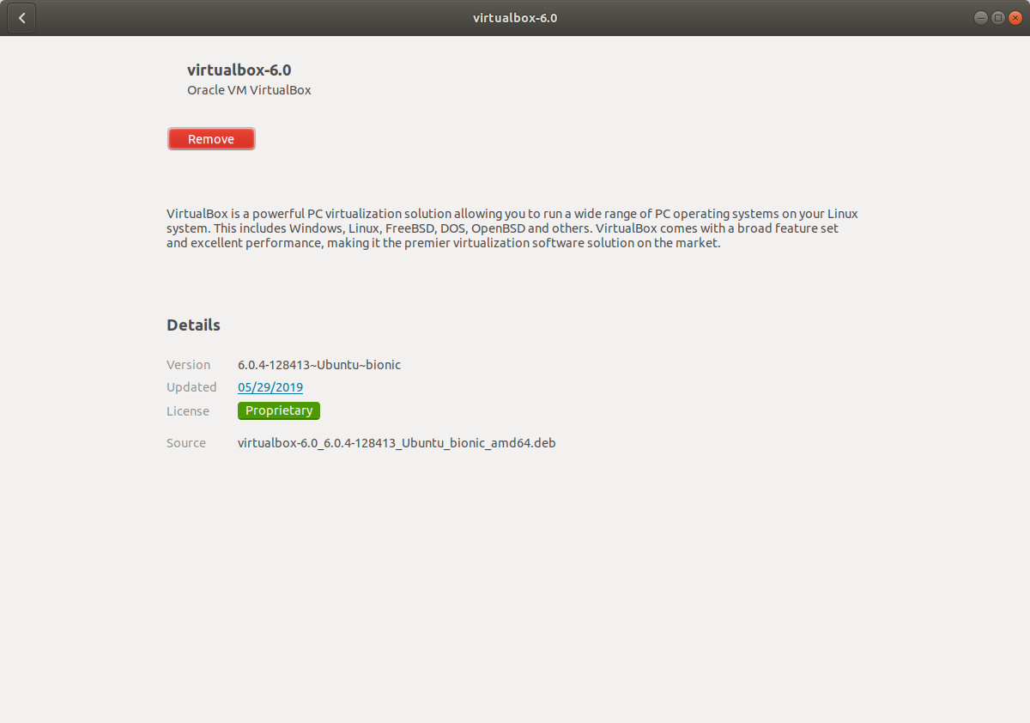

d. Download Ubuntu 18.04 Linux ISO Image

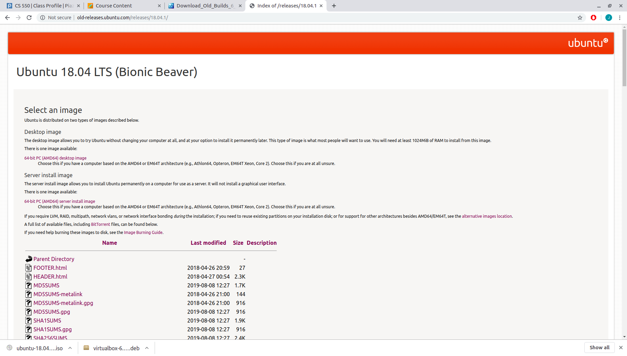

e. Virtual Machine Creation

e.1.

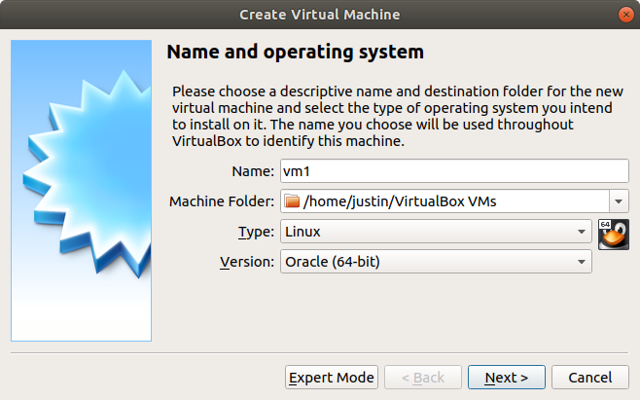

e.2. Memory allocation - 4GB

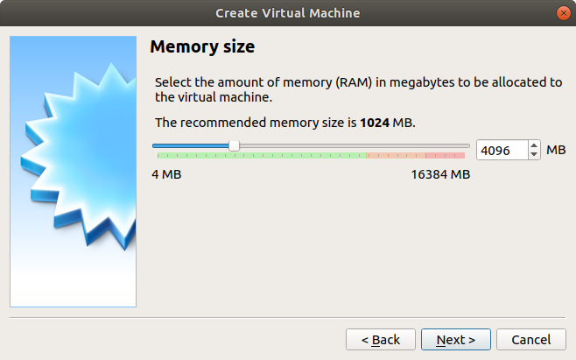

e.3. Virtual hardisk creation

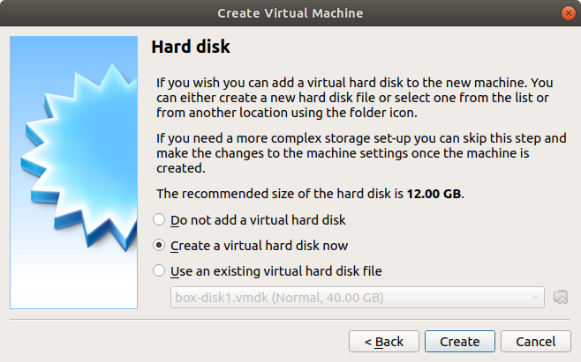

e.4. Virtual hardisk type - VDI

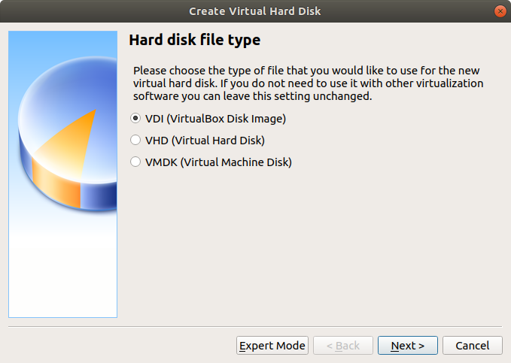

e.5. Dynamically allocated disk

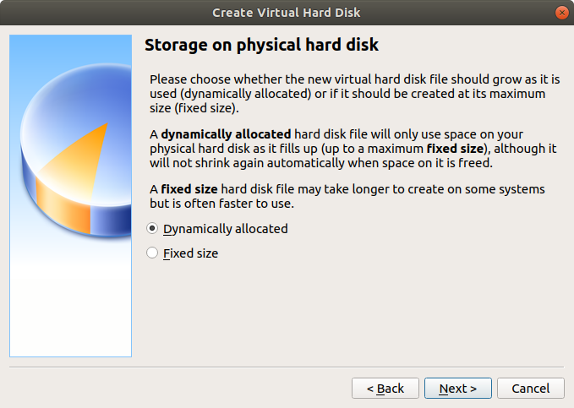

e.6. Disk size - 25.00GB

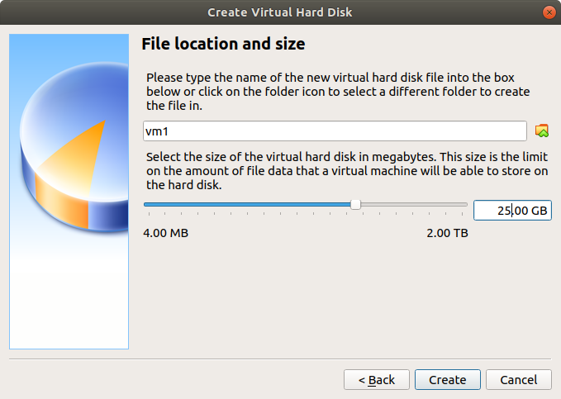

e.7. Processor - 1->2

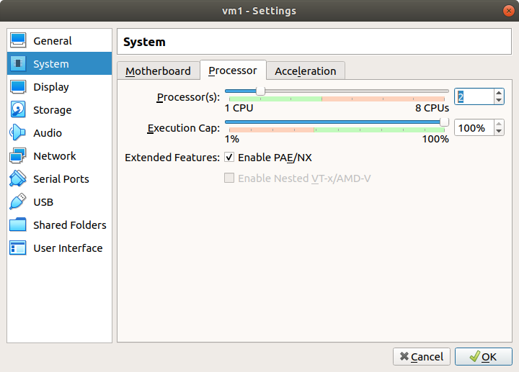

e.8. Network settings, NAT(adapter1) and NAT network(adapter2)

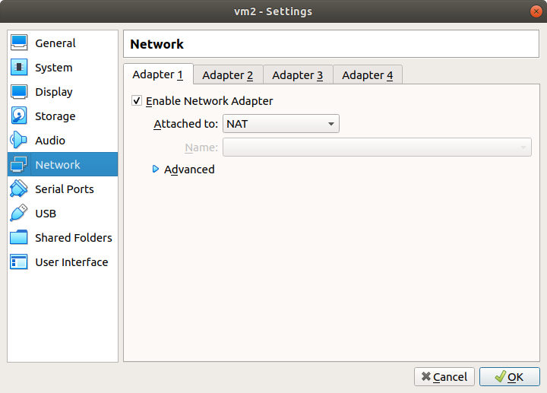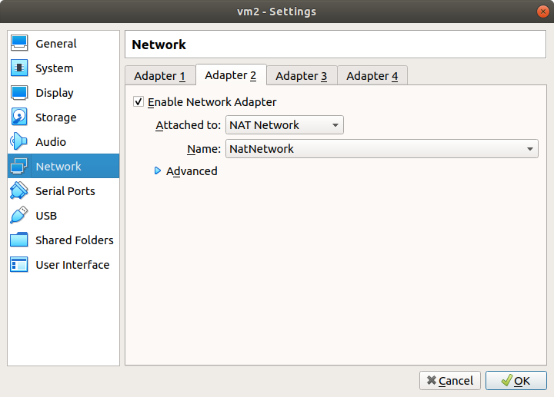

f. Ubuntu Installation

f.1. Select the downloaded ISO Image

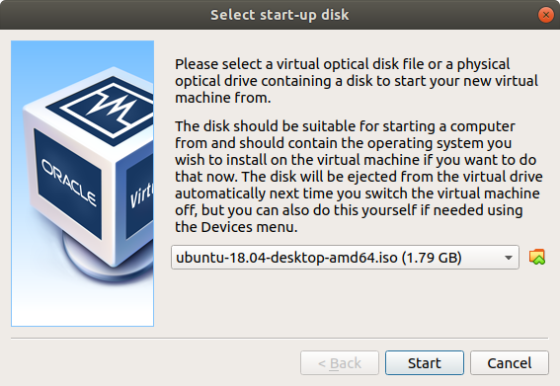

f.2. Setup user account

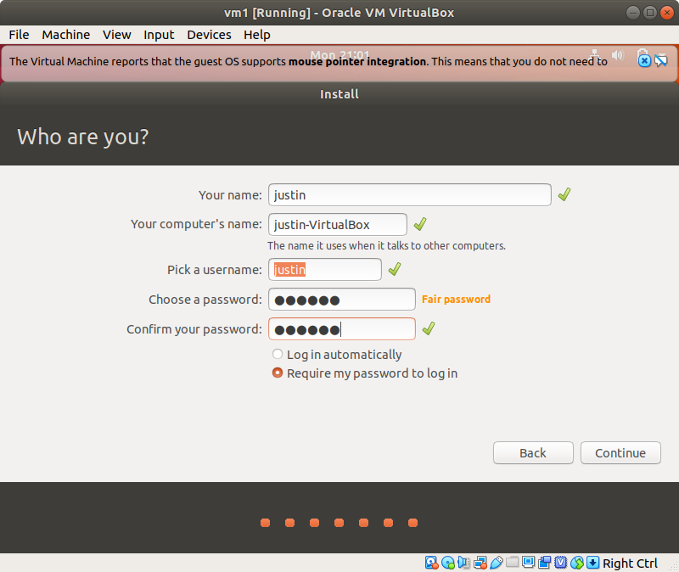

h, i. Turn on firewall (ufw) and block all ports. Open port for ssh and enable ssh access.

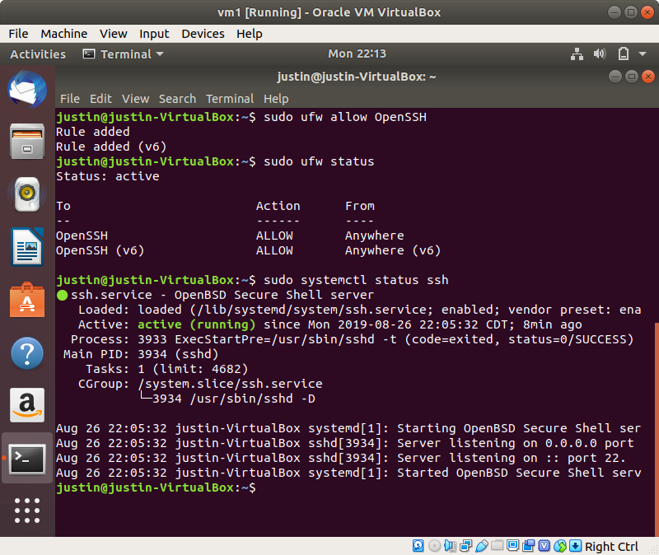

j. Create another VM with the same specification

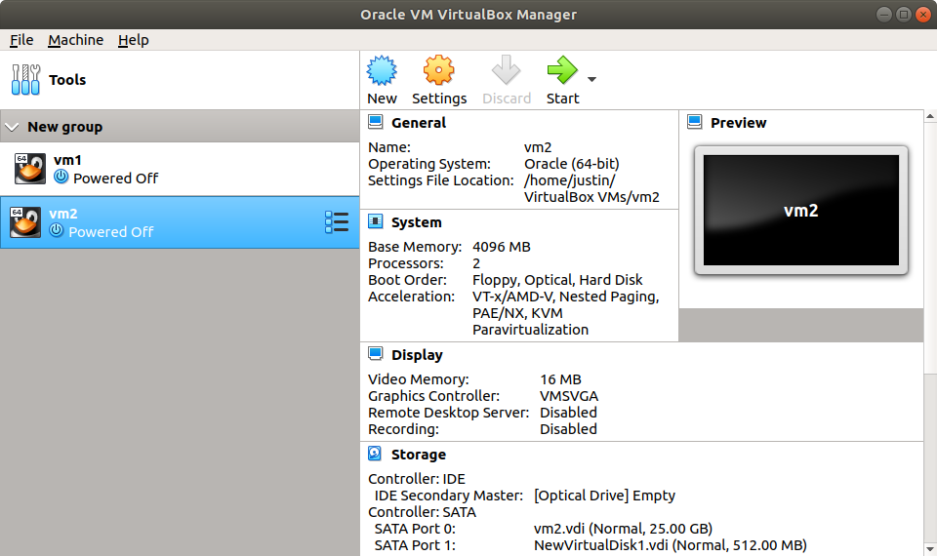

k. Create public/private keys, and install them for ssh authentication.

k.1. Create public/private key pair in vm2

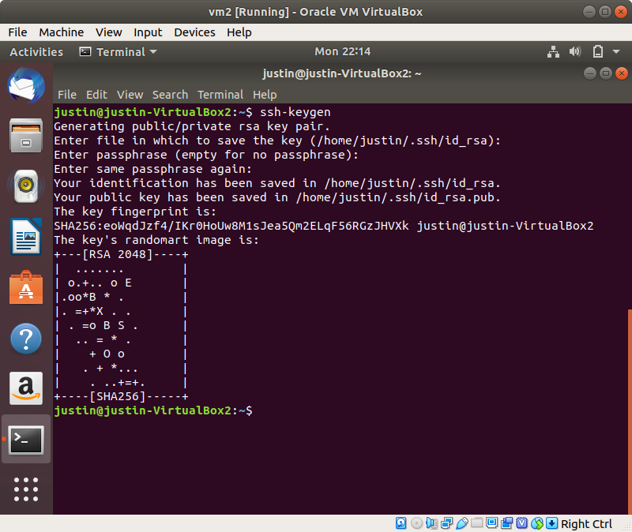

k.2. scp the public key from vm2 to vm1, and add the pub key to authorized_keys

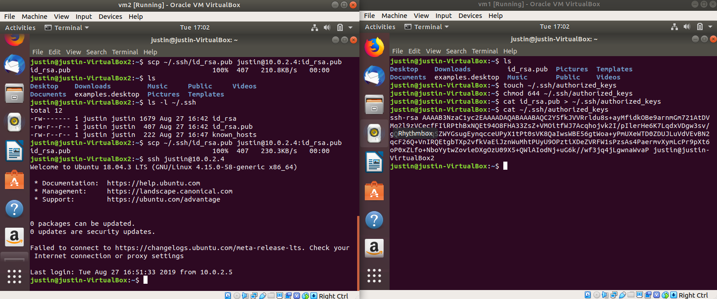

l. Login to vm1 from vm2, using the specified private key

