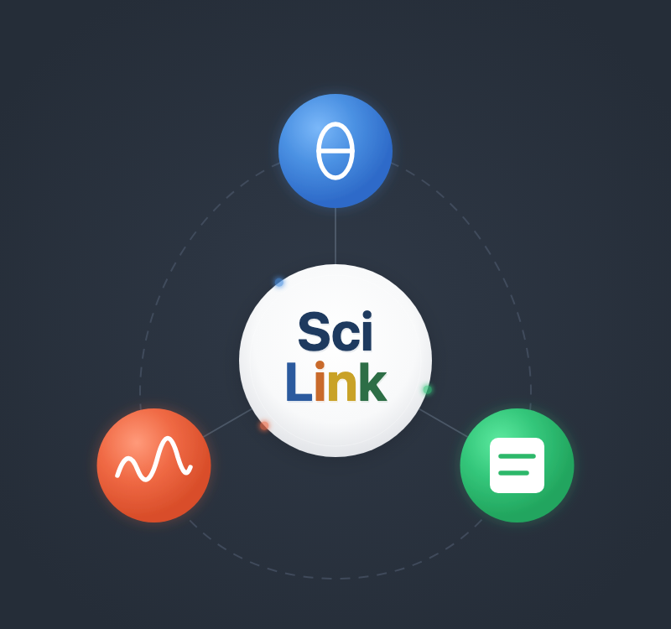
Pre-Installation Guide

⚠ IMPORTANT ⚠
Please complete every step in this guide BEFORE the workshop.
This is a single two-hour session, so there will be no installation time on the day.
Arrive with SciLink installed and the web UI verified (Step 4). API keys will be provided on-site.

Repository: https://github.com/ziatdinovmax/SciLink — reference only; no need to clone

Temporary short-term API credentials will be provided at the start of the workshop.

1 Install Visual Studio Code
VS Code is the editor we will use at the workshop — we will run a few scripts in it before moving to the SciLink web UI. It provides an integrated terminal, Python debugging, and Jupyter notebook support.
Download: https://code.visualstudio.com/download
Required extensions (install from the Extensions sidebar in VS Code):
- Python — Language support and debugging
- Jupyter — Run notebooks inside VS Code
2 Install Miniconda
Miniconda provides a lightweight Python environment manager. SciLink requires Python 3.12 or newer.
Download: https://www.anaconda.com/docs/getting-started/miniconda/install
On that page choose your operating system, then Miniconda (not Anaconda Distribution), then the Graphical Installer. Keep all installer defaults. If Anaconda is already installed on your computer, skip this step and use it as is.
After installation, open a terminal (on Windows, use the Anaconda Prompt) and create the workshop environment:
conda create -n scilink python=3.12 -y
conda activate scilink
Your prompt should now begin with (scilink). If it does not, the environment is not active and the next steps will install into the wrong Python. Confirm the Python version with:
python --version
This must print Python 3.12.x. Any older version means the scilink environment is not the active one.
3 Install SciLink with the Web UI
With the scilink environment activated, install SciLink together with its browser-based interface. This single command also pulls in every dependency (PyTorch, AtomAI, and others). If you already installed version 0.0.45 from the earlier copy of this guide, run the same command in the scilink environment; it upgrades in place:
pip install "scilink[web]==0.0.76"
Keep the quotes — on macOS/zsh the brackets are misread without them. Version 0.0.76 is pinned so everyone arrives with the same release.
pip install anthropic
(Not needed for SciLink; only for the demo scripts we run at the workshop today)

💡 Some packages (PyTorch, AtomAI) are large and may take 5–10 minutes. Please use a stable internet connection and do this before arriving at the workshop.
4 Verify the Installation
Launch the web UI from the scilink environment:
scilink-web
Your browser should open the SciLink interface (at http://127.0.0.1:8422); if it does not, copy the Local URL printed in the terminal into your browser. No API credentials are needed for this test — just confirm the page loads, then press Ctrl+C in the terminal to stop it.
Pre-Workshop Checklist

☐ VS Code installed with the Python and Jupyter extensions
☐ Miniconda installed, scilink environment created with Python 3.12
☐ pip install "scilink[web]==0.0.76" completed without errors
☐ pip install anthropic completed without errors
☐ scilink-web launches and the interface opens in your browser
☐ Brought 1–2 of your own datasets to analyze at the workshop — e.g., a microscopy image (.tif/.png), a spectrum or curve (.csv), or a hyperspectral datacube (.npy/.h5)

? Troubleshooting
"conda" command not found
→ Close and reopen your terminal after installing Miniconda. On Windows, use the Anaconda Prompt.
pip install fails with permission error
→ Make sure the scilink environment is activated: conda activate scilink
"Could not find a version that satisfies the requirement scilink[web]==0.0.76 (from versions: )"
→ pip is running under a Python older than 3.12, almost always because the scilink environment is not active (the prompt does not start with (scilink)). Run conda activate scilink, check that python --version prints 3.12.x, then run the pip install again.
"no matches found: scilink[web]"
→ Your shell is interpreting the brackets. Put the package name in quotes: pip install "scilink[web]==0.0.76"
PyTorch installation is very slow
→ Normal — PyTorch is ~2 GB. Use a stable connection and be patient.
"scilink-web" command not found after installing
→ Make sure the scilink environment is activated (conda activate scilink). Confirm the install with: pip show scilink
Browser does not open when running scilink-web
→ Open http://127.0.0.1:8422 in your browser. If port 8422 is busy, run scilink-web --port 8423 and open that port instead.
The terminal mentions Streamlit, or the page that opens looks different from the one described in Step 4
→ You ran scilink ui (with a space), which starts an older interface that will not be used at the workshop. Stop it with Ctrl+C and run scilink-web (with a hyphen).

PNWAVS Workshop · September 9, 2026 · Pacific Northwest National Laboratory

