|  |  |
| --- | --- |
| ***School of Creative Arts and Engineering*** |  |

**Assignment Front Sheet**

**An easily visible copy of this sheet must be attached to each item of assessed coursework to ensure that marks are properly credited and to assist in providing feedback.**

|  |  |
| --- | --- |
| **Part “A” - Information for the students** | |
| **Student's Name or number: Zhang Yixun 05191256** |  |
| **Award:** | **Level:** |
| **Module Title: *Professional Development & Engineering Applications*** | **Module code: *ELEC40223-DZ225011*** |
| **Assignment Title: *System Design Assignment*** | |
| **Submission Date: *01/11/2021*** | |
| **Module Tutor: *Abdel-Hamid Soliman*** | |

|  |  |  |  |
| --- | --- | --- | --- |
| **Part “B” - Assessment criteria for all students** | | | |
| **Criteria** | **Marks** | | **Comments** |
| **Correct formatting and layout**  (*The use of correct submission format*) |  | 15 |  |
| **Task 1**  (*Proposed system overview*) |  | 10 |  |
| **Task 2**  (*Physical quantities identifications and measurements*) |  | 10 |  |
| **Task 3**  (*Sensors/actuators selection)* |  | 15 |  |
| **Task 4**  (*Data acquisition system specifications*) |  | 10 |  |
| **Task 5**  (*Processing/control unit selection*) |  | 15 |  |
| **Task 6**  (*Telecommunication media selection*) |  | 15 |  |
| **Task 7**  *(Power source selection)* |  | 10 |  |
| **Overall Mark** |  | 100% |  |
| **Module Tutor Signature:** |  |  |  |
| **Second Marker Signature:** |  |  |  |

|  |  |  |  |
| --- | --- | --- | --- |
| **Part “C” – Presentation Assessment Criteria** | | | |
| **Criteria** | **Marks** | | **Comments** |
| **PowerPoint slides structure** |  | **20** |  |
| **Slides contents** |  | **30** |  |
| **Oral presentation** |  | **50** |  |
| **Total Mark** |  | **100** |  |
| **Module Tutor Signature:** |  | | |
| **Second Marker Signature:** |  | | |

# Abstract

Throughout 2020, the whole world is making efforts to fight against the COVID-19. Under the pandemic situation, some people choose to carry forward with heavy burdens, and some resolutely choose the latter during annual leave and work. I’d like to make a smart system to reduce work pressure to prevent the virus. Wearing the masks has a crucial function in protecting ourselves and our family (WHO, n.d.) . In this paper, I’ll introduce a Smart Mask Identification System, which can automatically identify whether passers-by are wearing masks and warn to those who violates the rules. To achieve the goal, I use LabView to catch the photos of passers-by, then calls python programs which imports open-cv (a free library of artificial intelligence) to identify human faces and masks. Finally, circle the faces with “no mask” in red or “mask” in green.

**Key words:** smart system; masks identification; LabView; python; open-cv; artificial intelligence

# Contents

Abstract 2

Contents 3

Introduction 4

Define the issue 4

Define the solution 4

Determine quantities 5

Choose the sensors 6

Data acquisition system 8

Processing Unit 11

Communications 13

Power requirements 14

Appendix 16

Bibliography 16

Programs 17

LabVIEW 17

Python 19

PowerPoints 21

# Introduction

## Define the issue

Some people are not aware of wearing masks. In middle or high-risk areas, this is very dangerous and is not conducive to the health of their selves and their families. If the guards or polices do not warn them on time, they might be infected or infect others.

## Define the solution

Based on the situation, I design the Smart Mask Identification System to help them to warn those who violates the rules.

The project is divided into three parts, data acquisition system, processing unit, the communication media. The project makes a good use of database. Data acquisition system calls cameras or monitors to catch the photos of passers-by or visitors, then save them in the database (due to the limited capable of the database of the cameras, the picture will be cleaned every so often). Send data packets to the processing unit through the TCP/IP protocol, the latter will first perform mask identification, if wearing a mask, then pass, if not wearing a mask, then perform face identification, contact the person by phone number, ID number, etc., and send a warning, if the face identification or mask identification is not successful, call the data acquisition system to capture again.

The project benefits a lot, because it can automatically monitor the masks of passers-by, which can greatly reduce work pressure of preventing the virus.

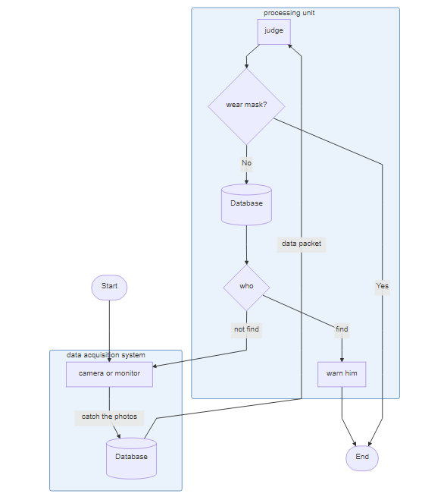

# Determine quantities

We need acquire and measure face photos to analyze and save in the database. Thus, we use camera to capture the photos and save them as SDI stream (CCDC, 2011), and then transmit the signal.

# Choose the sensors

Assuming that the usage scenario is on a road, the camera should be installed at a location such as traffic lights, road traffic signs, or a transportation hub like a subway station or high-speed rail station, and the camera should be installed at the security checkpoint. Based on this factor, we chose to use a monitor. Common camera brands are Sony, Panasonic, Canon, JVC, GoPro, etc. However, though these brands have high quality products, their high prices are unacceptable, because we need a myriad of monitors to install on the roads. In other words, we do not need high quality, we focus on practicality.

In this paper, I choose some of monitors that can be easily found on Taobao website.

|  |  |  |  |
| --- | --- | --- | --- |
| Brands | TP-LINK | MERCURY | EZVIZ |
| Model | TL-IPC534H-W4-W20 | MIPC3126W-4 | C3WN |
| Pixel | 300W | 300W | 200W |
| Focal length | 4mm | 4mm | 3.6mm |
| Network | Wi-Fi | Wi-Fi | Wi-Fi |
| Trace mode | intelligent tracking | intelligent tracking | intelligent tracking |
| Storage mode | memory card | memory card + cloud storage | memory card + cloud storage |
| Power supply | Power supply | Power supply | Power supply |
| Classification of waterproof | IP66 | IP66 | IP66 |
| Price | ￥ 299.00 | ￥ 189.00 | ￥ 229.00 |

Undoubtedly, if we only consider which product to choose from these few parameters, we will use MIPC3126W-4.

Common camera sensors include CCD and CMOS. CCD is a charge-couled device, and CMOS is a complementary metal oxide semiconductor. In principle, both sensors generate charge under light conditions, and the transfer of charge generates current. Rectification and amplification, analog-to-digital conversion to form a digital signal, and finally output to a special DSP processing chip in the form of a binary digital image matrix (Golowczynski, 2016). Their main differences as follow.

|  |  |  |
| --- | --- | --- |
|  | CCD | CMOS |
| Different photosensitive elements | larger area ratio of the effective photosensitive area to the whole photosensitive element | The image detail loss is serious and the noise is obvious |
| Different noise levels | The electrical signal strength of each image point is increased by the same magnitude | The electrical signal of each pixel is first amplified and converted into a digital signal, and then gathered to form a binary digital image matrix |
| Different cost | If one of the pixels cannot be operated, the entire row of data cannot be transmitted, so the yield rate of controlling the CCD sensor is low | Using the most used CMOS process for general semiconductor circuits, the process is relatively simple and the cost is low |

Similarly, we do not need high quality, so we can choose the cheaper CMOS sensor.

# Data acquisition system

Smart CMOS image sensors are mainly aimed at two different fields. One is to enhance or improve the basic characteristics of CMOS image sensors, such as dynamic range, speed, and sensitivity. Another function is to realize new functions, such as three-dimensional range search, target tracking and modulated light detection. For both fields, many architectures and/or structures, as well as materials, have been proposed and demonstrated.

A CMOS image sensor generally consists of an imaging area, which consists of an array of pixels, vertical and horizontal access circuitry, and readout circuitry.

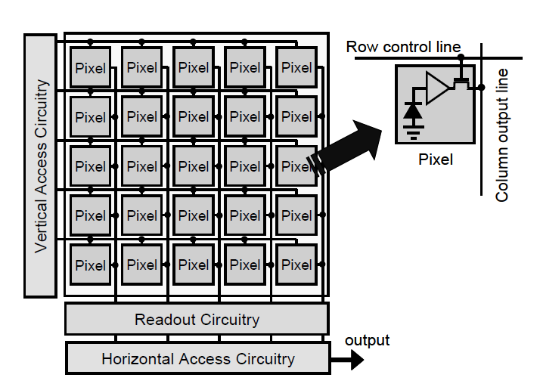

When light is incident on a semiconductor, a part of the incident light is reflected while the rest is absorbed in the semiconductor and produces electron–hole pairs inside the semiconductor, as shown in Fig. 2.2. Such electron–hole pairs are called photo-generated carriers. The number of photo-generated carriers depends on the semiconductor material and is described by the absorption coefficient *α*.

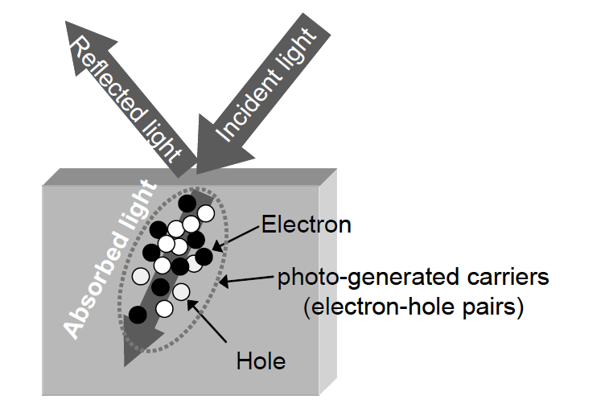

It should be noted that *α* is defined as the ratio of decrease of light power *ΔP/P* when the light travels a distance *Δz*.



The following equation is derived:



The absorption length  is defined as:



It is emphasized that the absorption coefficient is a function of photon energy  or wavelength  , where  and  are Planck’s constant and the frequency of the light. The value of the absorption length  thus depends on wavelength (Ohta, 2008). Due to space limitations, no detailed research is done.

# Processing Unit

At the beginning I proposed two solutions. One is to use python + OpenCV for machine learning and obtain mask recognition files, and then analyze and recognize the face photos obtained by calling LabView, and finally give a judgment. The second method is to transfer the photos to the network artificial intelligence database for big data comparison and analysis, and finally give the result. I will give comparison as follow.

|  |  |  |
| --- | --- | --- |
|  | OpenCV | Website |
| Effectiveness | Low | High |
| Safety[1] | High | Low |
| Accuracy | Low | High |
| Duration | Short | Long |
| Confidence level | Low | High |
| Cost | Low | High |

Thus, we choose python + OpenCV, which is much easier and more practical. The running logic of the program is as follows. First, the program read photos path, and carry out gray process which is not only necessary to analyze but also a compulsory process. Then, call haarcascade_frontalface_default.xml of OpenCV and obtain the faces’ coordinates. After that, cut all of faces that occurred in any photos and rename them in a uniform format. Next, we should divide these faces into two parts: “wearing masks” and “not wearing masks”, which we name positive samples and negative samples respectively. Finally, use opencv_createsamples.exe to machine learning and obtain our mask identification cascade.

I did 16 times training. After 15th training, I got a suitable hit rate and false alarm rate, then 16th is terminated automatically.

|  |  |  |  |  |
| --- | --- | --- | --- | --- |
|  | HR | FA | times | Total time |
| 0th | 1 | 0.136364 | 1 | 0:00 |
| 1st | 1 | 0.272727 | 1 | 0:01 |
| 2nd | 1 | 0.436364 | 2 | 0:02 |
| 3rd | 1 | 0.481818 | 2 | 0:03 |
| 4th | 1 | 0.272727 | 4 | 0:04 |
| 5th | 1 | 0.3 | 3 | 0:05 |
| 6th | 1 | 0.345455 | 3 | 0:06 |
| 7th | 1 | 0.490909 | 3 | 0:08 |
| 8th | 1 | 0.163636 | 3 | 0:10 |
| 9th | 1 | 0.4 | 3 | 0:13 |
| 10th | 1 | 0.345455 | 3 | 0:16 |
| 11th | 1 | 0.2 | 3 | 0:22 |
| 12th | 1 | 0.345455 | 3 | 0:38 |
| 13th | 1 | 0.4 | 2 | 1:12 |
| 14th | 1 | 0.309091 | 4 | 13:39 |
| 15th | 1 | 0.327273 | 1 | 18:52 |
| 16th | - | - | - | - |

# Communications

We need to communicate with the database or processing unit, so we should choose Internet to achieve.

|  |  |  |
| --- | --- | --- |
|  | Wired network | Wireless network |
| Transfer speed | High | Low |
| Stability | High | Low |
| Resistance | High | Low |
| Safety | High | Low |
| Applicability | Low | High |
| Convenience | Low | High |
| Cost | Low | High |

After comprehensive consideration, in some places we do not need high-quality transmission, but only need convenient installation. At this time, we should choose a wireless network. There are also places where it is more convenient to install a wired network than a wireless network. At this time, you should choose a more stable wired network. This is also the main factor in choosing the installation location.

# Power requirements

The common power supply method is still cable power supply, but many monitors use solar power. Then compare the differences between these two power supplies.

|  |  |  |
| --- | --- | --- |
|  | Cable power supply | Solar power |
| Stability | High | Low |
| Resistance | High | Low |
| Applicability | Low | High |
| Convenience | Low | High |
| Cost | Low | High |

I tend to use solar energy, which is a kind of clean energy and has great benefits for protecting the environment. (Xie Yu, 2021)

# Appendix

## Bibliography

[1] CCDC, 2. C. C. a. D. C., 2011. *Design and Research of Video Fire Detection System Based on FPGA.* Mian Yang, Si Chuan, China, s.n.

[2] Golowczynski, M., 2016. *Digital camera sensors explained.* [Online]   
Available at: https://www.whatdigitalcamera.com/technical-guides/technology-guides/sensors-explained-11457

[3] Ohta, J., 2008. *Smart CMOS Image Sensors and Applications.* first edition ed. Boca Raton: CRC press.

[4] WHO, n.d. *Coronavirus disease (COVID-19): Masks.* [Online]   
Available at: https://www.who.int/news-room/q-a-detail/coronavirus-disease-covid-19-masks

[5] Xie Yu, W. D. S., 2021. Can new energy vehicles subsidy curb the urban air pollution? Empirical evidence from pilot cities in China.. *10.1016/J.SCITOTENV.2020.142232*.

## Programs

### LabVIEW

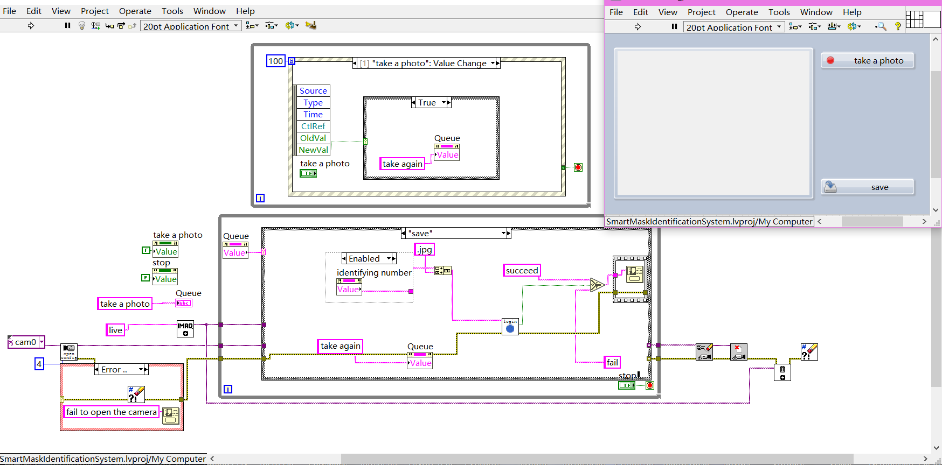

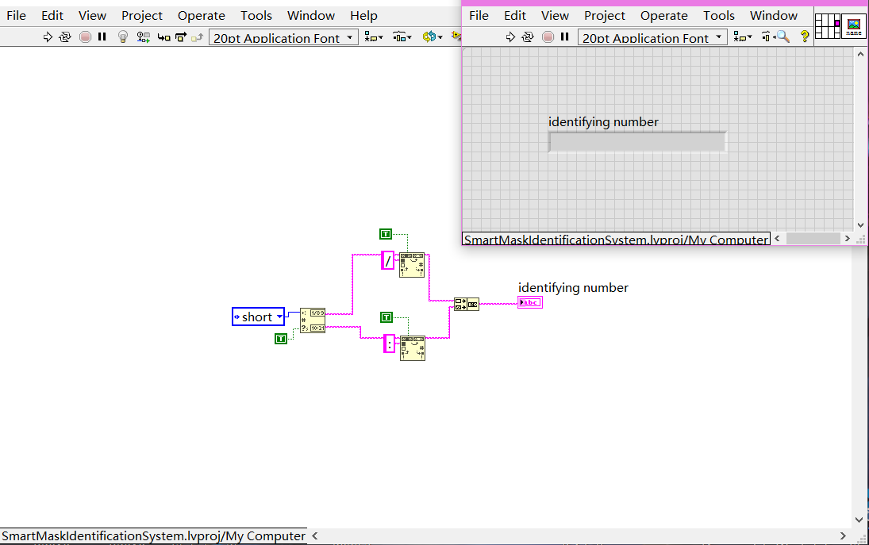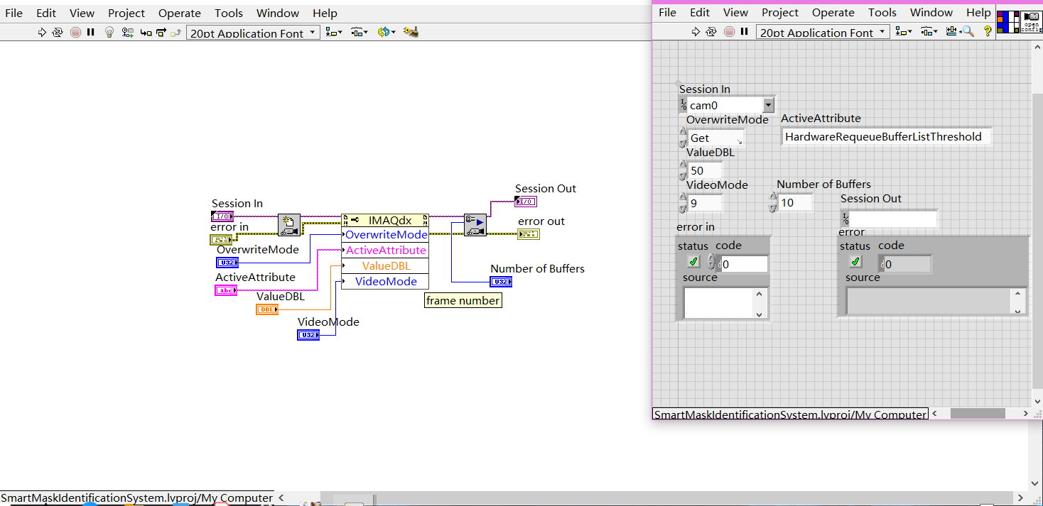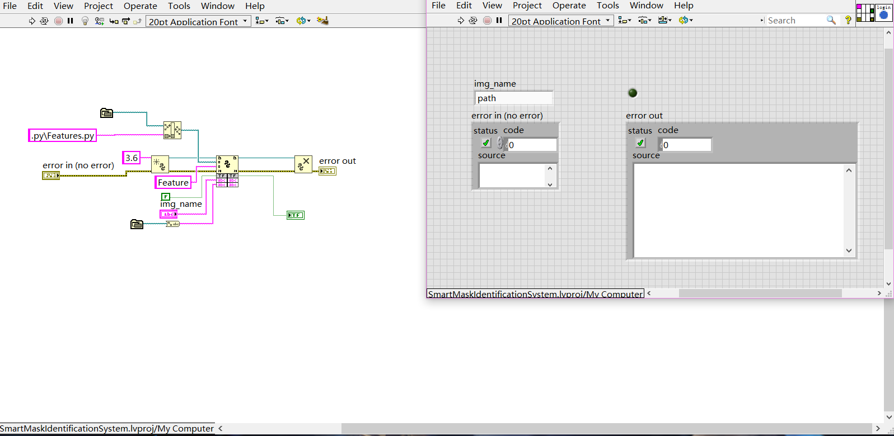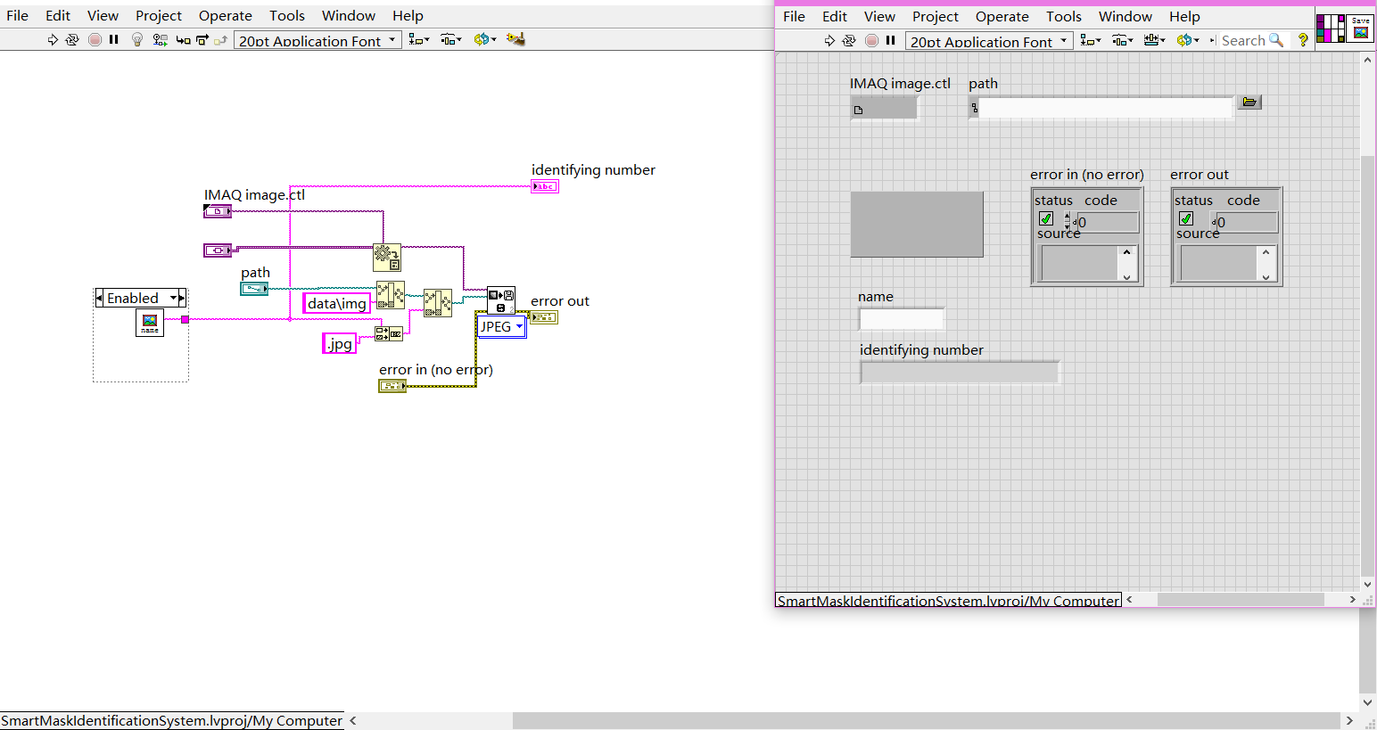

### Python

I. processImages.py

1. # -*- coding: utf-8 -*-
2. """
3. Created on Sun Jan  3 12:03:46 2021
5. @author: Lancibe
6. """
7. **import** pandas as pd
8. **import** cv2
9. names=pd.read_excel('E:\\projects\\Smart_Mask_Identification_System\\data\\pos.xlsx')['names'] # read all names of photos
10. i=100000 # rename
11. j=0
12. **for** imagepath **in** names:
13. # read photos
14. img = cv2.imread(imagepath)
15. # gray process
16. gray = cv2.cvtColor(img, cv2.COLOR_BGR2GRAY)
17. # identify faces
18. detector = cv2.CascadeClassifier('E:\\projects\\Smart_Mask_Identification_System\\haarcascade_frontalface_default.xml')
19. # obtain the coordinates
20. faces = detector.detectMultiScale(gray, 1.1, 5)
21. **for** (x, y, w, h) **in** faces:
22. # cut pics
23. gray = gray[y:y+h,x:x+w]  # cutting coordinates are [y0:y1, x0:x1]
24. # if has face
25. **try**:
26. # save after-processing pics
27. cv2.imwrite('E:\\projects\\Smart_Mask_Identification_System\\data\\After_Processed\\'+str(i)+'.jpg', gray)
28. # cv2.waitKey(3000)
29. i += 1
30. **except**:
31. **print**()
32. j+=1
33. **print**(j)

II. judge.py

1. # -*- coding: utf-8 -*-
2. """
3. Created on Mon Jan  4 10:04:47 2021
5. @author: Lancibe
6. """
7. **import** cv2
9. **def** judge(imagedir):
10. imagedir='E:\\projects\\Smart_Mask_Identification_System\\data\\img\\'+imagedir
11. img=cv2.imread(imagedir)
12. gray = cv2.cvtColor(img, cv2.COLOR_BGR2GRAY)  # gray process
14. detector= cv2.CascadeClassifier('E:\\projects\\Smart_Mask_Identification_System\\haarcascade_frontalface_default.xml')
15. mask_detector=cv2.CascadeClassifier('E:\\projects\\Smart_Mask_Identification_System\\bin\\xml\\cascade.xml')
16. faces = detector.detectMultiScale(gray, 1.01, 4)  # identify faces
17. masks = mask_detector.detectMultiScale(gray, 1.01, 3)  # identify masks
18. **print**( "faces num= " + str(len(faces)) + "masks num= " + str(len(masks)))
20. **if**(len(faces) | len(masks)):
21. **for** (x, y, w, h) **in** faces:
22. img = cv2.rectangle(img, (x, y), (x + w, y + h), (0, 0, 255), 2)  # draw a square in face area
23. img = cv2.putText(img , "nomask", (x,y), cv2.FONT_HERSHEY_SIMPLEX, 1, (0,0,255), 2)
25. **for** (mx, my,mw, mh) **in** masks:
26. img = cv2.rectangle(img, (mx, my), (mx + mw, my + mh), (0, 255, 0), 2)  # draw a square in mask area
27. img = cv2.putText(img , "mask", (mx,my), cv2.FONT_HERSHEY_SIMPLEX, 1, (0,255,0), 2) # print characters

30. cv2.imshow('result',img)
31. cv2.waitKey(0)
32. cv2.destroyAllWindows()

## PowerPoints

1. When considering the company’s sense of responsibility and whether it will sell customer privacy, OpenCV is not very secure, and when considering hacker attacks, uploading user photos to the network is not very secure.