Laboratory Logbook

…..…/…..…/ 2021

Module title: Professional Development & Engineering Applications Module Code: ELEC41010-DZ225011
Student Name: ………Zhang Yixun…….…. Student ID: …05191256….
Lab session: …1…… Date: …1…/…31…/ 2021

- What have you done during a particular lab session (with date)? (Include separate sheet if required)
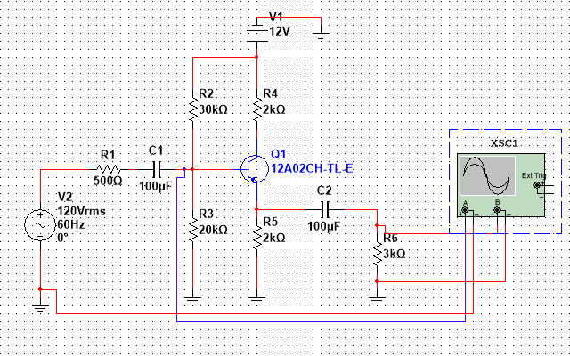

- What experimental result/ simulation result have you obtained during that lab session? (Include separate sheet if required)
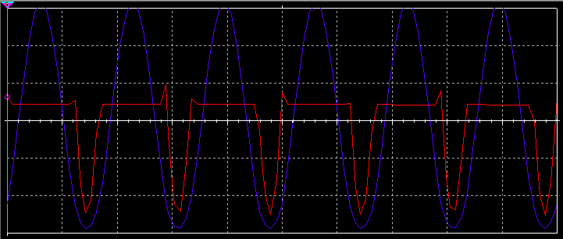
- What have you learnt and what kind of professional experience have you obtained during the session?
I learned how to use Multisim, how to select and place components, and simulated the circuits in the textbook.
The output waveform is distorted because the parameters of the components do not meet the requirements.
Through this experiment, I have further improved the use of electronic components.
If it is required, you can attach additional sheets.

