Laboratory Logbook

…..…/…..…/ 2021

Module title: Professional Development & Engineering Applications Module Code: ELEC41010-DZ225011
Student Name: ………Zhang Yixun………….…. Student ID: …05191256……..
Lab session: …2…… Date: …1…/…5…/ 2021

- What have you done during a particular lab session (with date)? (Include separate sheet if required)

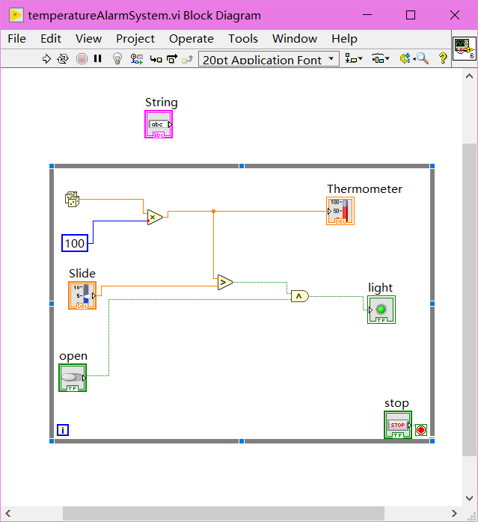
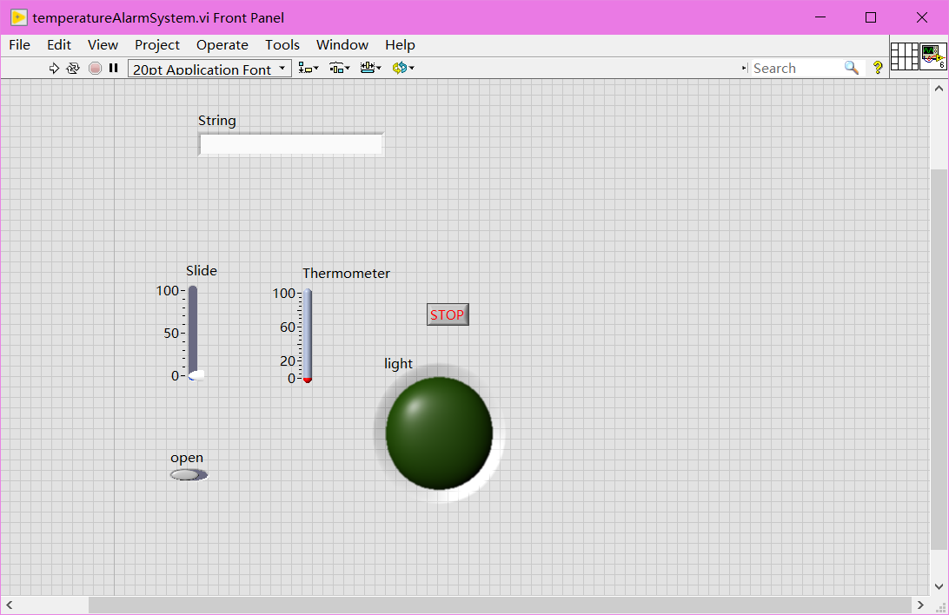

- What experimental result/ simulation result have you obtained during that lab session? (Include separate sheet if required)
Learned the basic operation and working principle of LabVIEW.
Design a simple and workable system
- What have you learnt and what kind of professional experience have you obtained during the session?
Through this experiment, I have a further understanding of virtual instrument technology, understand
its programming environment, have a preliminary understanding of LabVIEW, become familiar with its
development environment, and master the basic operations. During the experiment, I mainly referred
to the content of the lecture notes. The main difficulty in the production of thermometers comes from
the meaning of the graphics and finding the corresponding graphics panel, through the understanding
of the lecture content, and the actual operation of the experiment successfully completed.
If it is required, you can attach additional sheets.

