# VSCode 插件配置

#### 安装插件：vetur，eslint，prettier

配置eslint规则： 如下图，commond+, 进入vscode配置页，输入eslint，找到Eslint > Trace:Server,点击下方：Edit it setting.json,将如下代码粘贴到配置中，保存即可

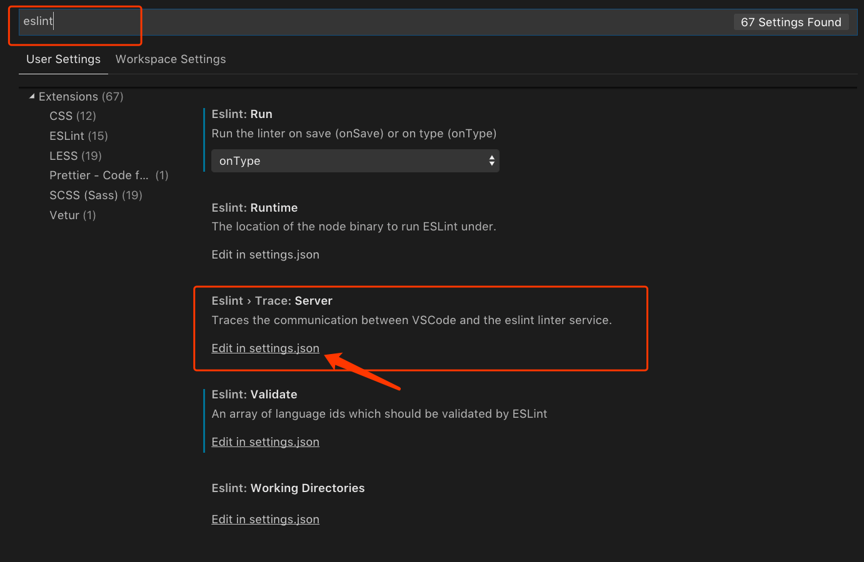

avatar

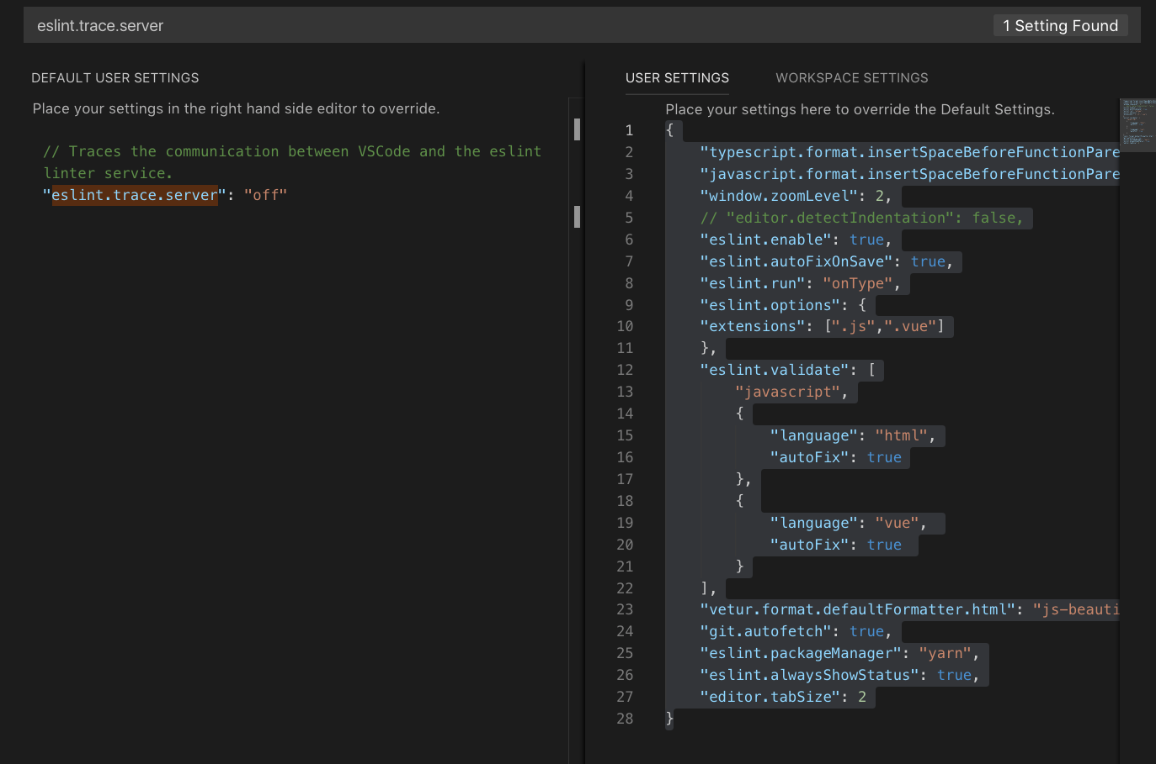

avatar

{  
 "typescript.format.insertSpaceBeforeFunctionParenthesis": true,  
 "javascript.format.insertSpaceBeforeFunctionParenthesis": true,  
 "window.zoomLevel": 2,  
 // "editor.detectIndentation": false,  
 "eslint.enable": true,  
 "eslint.autoFixOnSave": true,  
 "eslint.run": "onType",  
 "eslint.options": {  
 "extensions": [  
 ".js",  
 ".vue"  
 ]  
 },  
 "eslint.validate": [  
 "javascript",  
 {  
 "language": "html",  
 "autoFix": true  
 },  
 {  
 "language": "vue",  
 "autoFix": true  
 }  
 ],  
 "vetur.format.defaultFormatter.html": "js-beautify-html",  
 "git.autofetch": true,  
 "eslint.packageManager": "yarn",  
 "eslint.alwaysShowStatus": true,  
 "editor.tabSize": 2  
}