Task: Identify and Fix the Layout Problems
Description:
This exercise uses a deliberately broken layout and you need to inspect the CSS and fix them.

What is wrong in the original CSS?
- Everything is positioned with position: absolute.
  - This removes the normal document flow.
  - Elements overlap each other and are hard to maintain.
  - When the browser width changes, the layout does not adapt.
- Fixed widths and fixed heights are used everywhere.
  - The page is locked to a 1200px container and large absolute coordinates.
  - On smaller screens, content may be cut off or pushed outside the viewport.
- The layout depends on manually guessed coordinates.
  - The header, hero section, and cards are placed by exact pixels.
  - This is brittle and difficult to update later.
- The page is not responsive.
  - There is no flexible layout for mobile devices or different viewport sizes.
  - A better solution uses normal flow, flexbox, or CSS Grid.
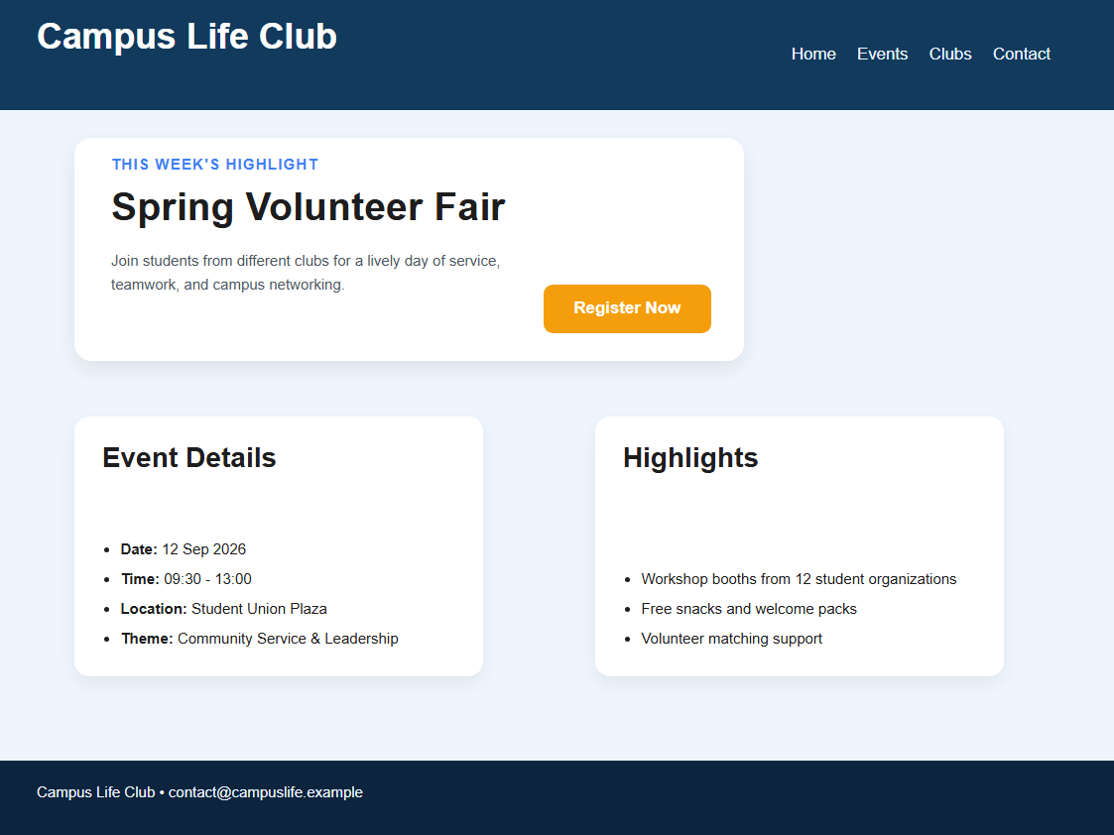
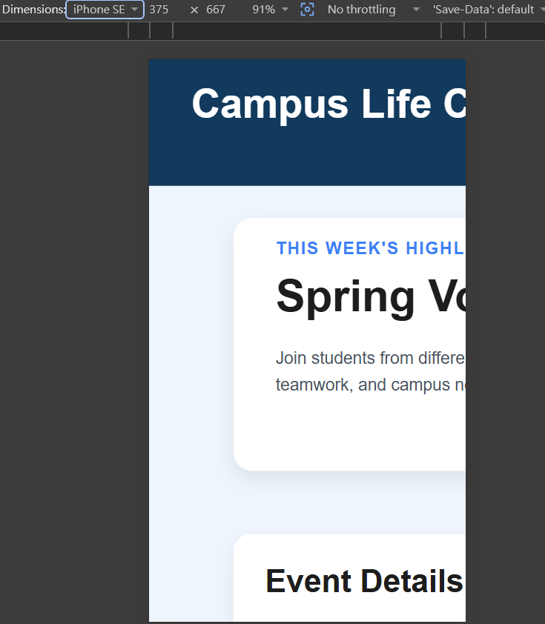
Desired and maintainable layout should be:
- keep elements in the normal document flow when possible;
- use flexbox or grid for alignment and spacing;
- rely on relative sizing such as max-width, padding and gap instead of fixed pixel placements;
- keep each section independent and easy to modify.
