Phone: Xiaomi Redmi 3S

Sensor: Samsung S5K3L8

Pixel Size: 1.127 micro-m

Focal length: 4.23 mm

**House #1**

Address: Shalom Aleyhem 3

|  |  |  |
| --- | --- | --- |
| C:\Users\Shafir\Downloads\unnamed (2).png | C:\Users\Shafir\Downloads\unnamed (1).png | C:\Users\Shafir\Downloads\unnamed.png |

**House #2**

Address: Haifa, Shalom Aleyhem 1

|  |  |  |
| --- | --- | --- |
| C:\Users\Shafir\Downloads\unnamed (3).png | C:\Users\Shafir\Downloads\unnamed (4).png | C:\Users\Shafir\Downloads\unnamed (5).png |

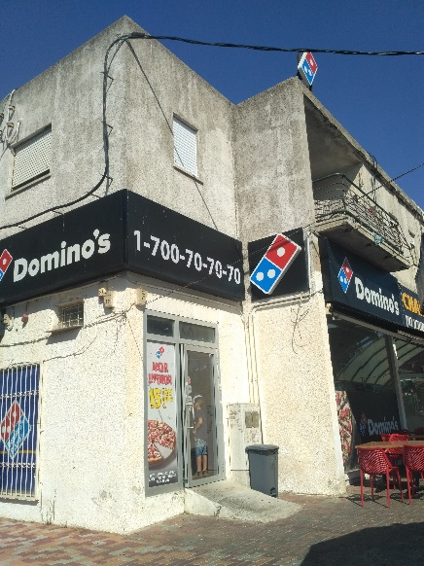 Notice that building is incorrectly mapped !!!

**House #3**

Address: Haifa, Shalom Aleyhem 6

|  |  |  |
| --- | --- | --- |
| C:\Users\Shafir\Downloads\unnamed (6).png | C:\Users\Shafir\Downloads\unnamed (7).png | C:\Users\Shafir\Downloads\unnamed (8).png |