Appendices
“Drivers of coastal benthic communities in a complex environmental setting”
Yuting Vicky Lin¹, Pierre-Alexandre Château², Yoko Nozawa^{3,4,5}, Chih-Lin Wei¹, Rainer Ferdinand Wunderlich^{6, 7}, Vianney Denis^{1,*}

¹Institute of Oceanography, National Taiwan University, Taipei 10617, Taiwan
²Department of Marine Environment and Engineering, National Sun Yat-Sen University, Kaohsiung 80420, Taiwan
³Tropical Biosphere Research Center, University of the Ryukyus, Okinawa 905-0227, Japan
⁴Biodiversity Research Center, Academia Sinica, Taipei 11529, Taiwan
⁵Department of Marine Science, Faculty of Fisheries and Marine Science, Universitas Diponegoro, Semarang 50275, Indonesia
⁶Department of Bioenvironmental Systems Engineering, National Taiwan University, Taipei 10617, Taiwan
⁷INRAE, UR EABX, 33612 Cestas, France

*Author for correspondence
Email: vianneydenis@ntu.edu.tw
Address: Institute of Oceanography, National Taiwan University, Number 1, Section 4, Roosevelt Road, Da’an District, Taipei 10617, Taiwan

Appendices

Appendix A. Benthic identification performance of CoralNet ID 22264
Our CoralNet ID 22264 benthic label system, trained with 66,490 annotated points, features three hierarchical layers: 18 major benthic categories, 40 morpho-functional categories combining major and morphological information, and 229 labels merging genus and morphological details. The average accuracies for major benthic, morpho-functional categories are 77% and 73%, respectively, with varying accuracies for individual categories or labels (see Tables A.1. and A.2.).
The average accuracies are strongly pulled down by rare and under-training categories, while the commonly seen categories are generally well-trained and hence contain excellent accuracies. Taking the layer of major benthic category as an example, the commonly seen major benthic categories, including octocorals (93%, n = 5,425), stony corals (90%, n = 15,377), turf (71%, n = 23,441), and CCA (71%, n = 12,416), generally have great accuracies. In contrast, rare categories with insufficient training exhibit extremely low accuracies (6 out of 18 major benthic categories have less than 50 training points, and their accuracies range between 0% to 4%). Consequently, the identification in our morpho-functional benthic matrix is reliable in spite of the 73%’s accuracy, since it is mostly comprising well-trained categories, rather than the poorly-trained ones.

Table A.1. Accuracies and the number of training points for 18 major benthic categories
Major category | Number of training points | Accuracy
Octocoral | 5425 | 93.03%
Zoanthid | 624 | 91.67%
Stony coral | 15377 | 90.34%
Unstable substrate | 3236 | 77.38%
Cyanobacteria | 251 | 74.10%
Sponge | 755 | 71.92%
Turf | 23441 | 71.38%
Crustose coralline algae | 12416 | 71.31%
TWS | 1790 | 71.06%
Macroalgae | 2150 | 62.98%
Stable substrate | 905 | 53.59%
Other mobile invertebrates | 97 | 51.55%
Ascidian | 22 | 4.55%
Other sessile invertebrates | 1 | 0.00%
Actinaria | 0 | 0.00%
Artificial Debris | 0 | 0.00%
Corallimorpharia | 0 | 0.00%
Seagrass | 0 | 0.00%

Table A.2. Accuracy and the number of training points on 40 morpho-functional categories
Morpho-functional category | Number of training points | Accuracy | Categories used in this study
Octocoral digitate | 2321 | 88.80% | Y
Octocoral lobate | 730 | 88.22% | Y
StonyCoral bushy | 1384 | 82.80% | Y
StonyCoral table | 1581 | 82.42% | Y
Octocoral cluster | 710 | 80.99% | Y
Sponge massive | 347 | 79.83% | Y
StonyCoral foliose | 777 | 78.64% | Y
Octocoral bushy | 1398 | 78.33% | Y
StonyCoral arborescent | 558 | 77.96% | Y
StonyCoral encrusting | 9571 | 77.64% | Y
Substrate unstable | 3236 | 77.38%
Cyanobacteria filamentous | 251 | 74.10% | Y
Turf filamentous | 23496 | 71.41% | Y
CCA crustose | 12416 | 71.31% | Y
Other | 1888 | 70.82%
Zoanthid encrusting | 267 | 70.41% | Y
Zoanthid massive | 357 | 70.31% | Y
StonyCoral massive | 1061 | 69.84% | Y
Octocoral arborescent | 51 | 66.67% | Y
Sponge encrusting | 248 | 65.32% | Y
Octocoral encrusting | 140 | 60.71% | Y
Macroalgae corticated foliose | 843 | 57.89% | Y
Substrate stable | 905 | 53.59%
StonyCoral columnar | 445 | 50.79% | Y
Macroalgae articulated calcareous | 1119 | 50.67% | Y
Macroalgae corticated macrophyte | 133 | 45.86% | Y
Octocoral massive | 75 | 32.00% | Y
Sponge repent | 160 | 25.62% | Y
Ascidian erect single | 18 | 5.56% | Y
Actinaria encrusting | 0 | 0.00%
Macroalgae foliose | 0 | 0.00%
Ascidian clustered | 4 | 0.00%
Bryozoan busy | 0 | 0.00%
Octocoral fan | 0 | 0.00%
Octocoral whip | 0 | 0.00%
Seagrass | 0 | 0.00% | Y
Sponge arborescent | 0 | 0.00%
Sponge flabellate | 0 | 0.00%
Sponge globular | 0 | 0.00%
Sponge table | 0 | 0.00%

Appendix B. A probabilistic approach to calculating benthic covers.
When trying to identify a label, CoralNet doesn’t provide a unique, unambiguous answer. Instead, it provides five suggestions that are ranked according to the confidence level the algorithm assigns to each suggestion. For example, a particular bushy soft coral point may be identified as:
1. table-like stony coral (35% confidence)
2. bushy soft coral (25% confidence)
3. filamentous macroalgae (10% confidence)
4. rubble (8% confidence)
5. crustose coralline algae (5% confidence)
Users are allowed to choose only one label to represent the point. It can either be manually chosen by the users themselves, or by setting up a certain threshold of confidence in CoralNet to let the algorithm automatically make the identification. Herein, we call this the Suggestion 1 approach.
An accuracy level of 67% means that suggestion 1 is correct 67% of the time. However, when suggestion 1 is not correct, it is quite likely that the second suggestion is correct. As a matter of fact, the percentages of correct answers for all five suggestions are as follows: 66.7%, 11.5%, 3.9%, 2.15%, and 1.28%. This means that more than half of the labels misidentified by suggestion 1 were correctly identified by the second suggestion.
Realizing this, we decided that we needed to consider all suggestions when calculating the cover on an image. This can be easily done by assuming a probabilistic approach. Instead of accepting suggestion 1 as-is, we consider a labeled point as a vector of five probabilities. These probabilities are the contributions of the five confidence levels to their sum for this point. In our example, instead of assuming that the point is table-like stony coral, we assume:
1. 0.35/(0.35+0.25+0.10+0.08+0.05) = 42% table-like stony coral
2. 0.25/(0.35+0.25+0.10+0.08+0.05) = 30% bushy soft coral
3. 0.10/(0.35+0.25+0.10+0.08+0.05) = 12% filamentous macroalgae
4. 0.08/(0.35+0.25+0.10+0.08+0.05) = 10% rubble
5. 0.05/(0.35+0.25+0.10+0.08+0.05) = 6% crustose coralline algae
By doing so, we reduce the contribution of (incorrect) table-like stony coral from 100% to only 42% and increase the contribution of (correct) bushy soft coral from 0% to 30%. Unsurprisingly, this approach increases the number of errors that are made when identifying a point, since at least four errors are introduced for each point. However, it considerably reduces their amplitude. Overall, when running throughout the 2,692 images of the (training) dataset, the probabilistic approach proves to be consistently better than the Suggestion 1 approach by resulting in an 8.3% lower total squared error (Figure B.1.).

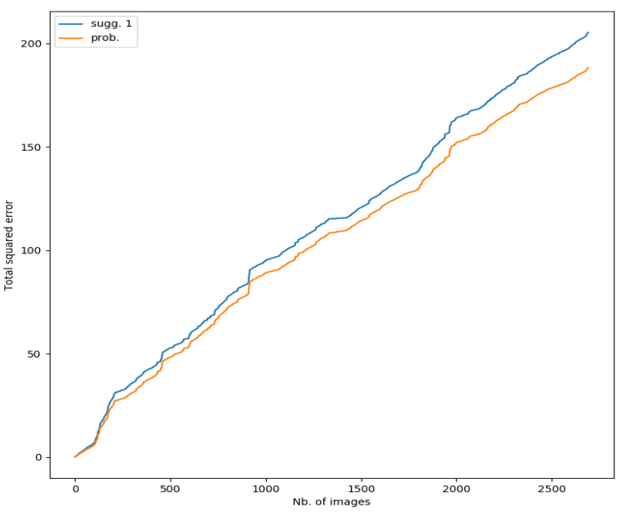
Figure B.1. Total squared error in cover estimation: Suggestion 1 vs. Probabilistic

Appendix C. Data description and sources of 21 environmental factors.
Variable Type | Environmental factors | Resolution | Period extracted | Calculation and units | Source
Physical | Mean SST, SD SST | 5-km grid data | 2006-2015 (10 years) | Means and standard deviations from 10 years’ monthly data were calculated for each sampling location. The missing values of locations were replaced by the values from the closest grid where the values are available. Unit: degree Celsius. | NOAA Global Coral Bleaching Monitoring¹
Physical | Light intensity | 4-km grid data | 2006-2015 (10 years) | Means of kd490 and photosynthetic active radiation (PAR) from 10 years’ monthly data were calculated for each sampling location. Light intensity at surveyed depth was then computed using a standard depth-dependent exponential function (Assis et al. 2017):  $$Mean PAR×exp⁡(-mean kd490×surveyed depth(m)).$$  The missing values of locations were estimated by Kriging interpolation. Unit: $E×m^{-2}×{year}^{-1}$. | Aqua MODIS, NPP, L3SMI, Global, 4km²
Physical | Wave exposure | 2.5 arcmin grid (~4.6 km at the equator) | 1979-2020 (42 years) | Mean wave exposure from 42 years of daily data was extracted for each sampling location. No missing data.  Unit:$kW×m^{-1}$. | Yeager et al. (2017)
Physical | Wave height | 0.25-degree grid data | 2008-2017 (10 years) | Maximum wave height from 10 years’ monthly data was extracted for each sampling location. The missing values of locations were replaced by the values from the closest grid where the values are available. Unit: meter | Open Whether Data, Central Weather Bureau, Taiwan³
Physical | Mean Chl a, SD Chl a | 4-km grid data | 2006-2015 (10 years) | Means and standard deviations from 10 years’ monthly data were calculated for each sampling location. The missing values of locations were replaced by the values from the closest grid where the values are available. Unit: $mg×m^{-3}$. | Global Ocean Chlorophyll, PP and PFT from Satellite Observations: Monthly and Daily Interpolated⁴
Physical | Unstable substrate cover | Transect | 2016-2020 (same as the benthic sampling period) | The covers of unstable subtract (i.e., sand, rubbles) on the canopy layer of reefs were extracted from each of 433 transects. Unit: Percentage (absolute cover). | Benthic survey of the current study
Chemical | Nitrate | Taiwan – 119 stations; Dongsha – 80 stations | Taiwan – 2012-2015 (4 years);  Dongsha – 2013 – 2014 (2 years) | The annual mean was calculated for all the stations. Kriging interpolation was then used to estimate the mean of nitrate from 2-4 years’ seasonal data in each sampling location. Unit: μM. | iOcean, Ocean Conservation Administration, Taiwan⁵. Dongsha’s data was provided by the laboratory of FK Shiah
Chemical | Nitrite | Taiwan – 119 stations; Dongsha – 80 stations | Taiwan – 2012-2015 (4 years);  Dongsha – 2013 – 2014 (2 years) | The annual mean was calculated for all the stations. Kriging interpolation was then used to estimate the mean of nitrate from 2-4 years’ seasonal data in each sampling location. Unit: μM. | iOcean, Ocean Conservation Administration, Taiwan⁵. Dongsha’s data was provided by the laboratory of FK Shiah
Chemical | Phosphate | Taiwan – 119 stations; Dongsha – 80 stations | Taiwan – 2012-2015 (4 years);  Dongsha – 2013 – 2014 (2 years) | The annual mean was calculated for all the stations. Kriging interpolation was then used to estimate the mean of nitrate from 2-4 years’ seasonal data in each sampling location. Unit: μM. | iOcean, Ocean Conservation Administration, Taiwan⁵. Dongsha’s data was provided by the laboratory of FK Shiah
Historical | DHW | 5-km grid data | 2006-2020 (15 years) | The maximum degree heating weeks (DHW) the sampling locations had experienced in the past decade. Unit: °C-weeks. | NOAA Global Coral Bleaching Monitoring¹
Historical | DHW recovery |  | 2006-2020 (15 years) | The time gap between the year the maximum DHW occurred and the year of sampling. Unit: year. | NOAA Global Coral Bleaching Monitoring¹
Historical | Typhoon frequency* |  | 2006-2020 (15 years) | The frequency of severe typhoons happened in the past decade before the benthic samplings. Unit: ${decade}^{-1}$ | Typhoon Database, Central Weather Bureau, Taiwan⁶.
Historical | Typhoon disturbance | 639 weather stations around Taiwan | 2006-2020 (15 years) | The highest hourly average wind speed recorded in the nearest weather stations of sampling locations for the nearest severe typhoon. Unit: $m×s^{-1}$. | CWB observation data inquire system, Central Weather Bureau, Taiwan⁷. Dongsha’s data was provided by Prof. Po-Hsiung Lin in the Department of Atmospheric Science, National Taiwan, University
Historical | Typhoon recovery |  | 2006-2020 (15 years) | The time gap between the year the nearest severe typhoon occurred and the year of sampling. Unit: year. | CWB observation data inquire system, Central Weather Bureau, Taiwan⁷
Land-based | Anthropogenic land use | Land use data in 366 districts of Taiwan | 10 years (2006-2015) | The area of the agricultural, aquacultural, and urban land use in the township located within a 10 km radius of sampling locations. | MOI Open Data, Ministry of Interior, Taiwan⁸
Land-based | Forest land use | Land use data in 366 townships of Taiwan | 10 years (2006-2015) | The area of the forest land use in the township located within a 10 km radius of sampling locations. | MOI Open Data, Ministry of Interior, Taiwan⁸
Land-based | Population density | 30-degree second grid (~1km) | 2015 | The average population density within a 10 km radius of sampling locations. | Gridded Population of the World (GPW), v4, 2015, Socioeconomic data and application center, NASA⁹
Land-based | Tourist visits | 295 scenic spots in Taiwan | 4 years (2012-2015) | The number of visit times in the scenic spots located within a 10 km radius of sampling locations. | Tourism statistics database of the Taiwan Tourism Bureau, Taiwan¹⁰
Land-based | Management status | 46 marine protected areas in Taiwan | The year of sampling | The marine protected status of sampling locations was classified into “fully no-take,” “open access,” and “restrictions on fishing gear, catch size, species, and/or any recreational activities | The marine protected area database of Functional Reef Ecology Laboratory, Taiwan

¹ NOAA Global Coral Bleaching Monitoring: https://coastwatch.pfeg.noaa.gov/erddap/griddap/NOAA_DHW_monthly.html?fbclid=IwAR19k1fpzgwvu4vf4-BCP9VKMhhjmTjCSQpY2a3C1r7m568cizUqN10ctIs
² Aqua MODIS, NPP, L3SMI, Global, 4km: https://coastwatch.pfeg.noaa.gov/erddap/griddap/erdMH1par0mday.html and https://coastwatch.pfeg.noaa.gov/erddap/griddap/erdMH1kd490mday.html
³ Open Whether Data, Central Weather Bureau, Taiwan: https://opendata.cwb.gov.tw/dataset/climate/C-B0086-001
⁴ Global Ocean Chlorophyll, PP and PFT from Satellite Observations: Monthly and Daily Interpolated: https://resources.marine.copernicus.eu/product-detail/OCEANCOLOUR_GLO_CHL_L4_REP_OBSERVATIONS_009_082/INFORMATION
⁵ iOcean, Ocean Conservation Administration, Taiwan: https://iocean.oca.gov.tw/OCA_OceanConservation/PUBLIC/Marine_WaterQuality.aspx
⁶ Typhoon Database, Central Weather Bureau, Taiwan: https://rdc28.cwb.gov.tw/
⁷ CWB observation data inquire system, Central Weather Bureau, Taiwan: https://e-service.cwb.gov.tw/HistoryDataQuery/
⁸ MOI Open Data, Ministry of Interior, Taiwan: https://data.moi.gov.tw/MoiOD/Data/DataDetail.aspx?oid=7A9A79DE-0E19-4A5D-94B6-3397181178E5
⁹ Gridded Population of the World (GPW), v4, 2015, Socioeconomic data and application center, NASA: https://sedac.ciesin.columbia.edu/data/set/gpw-v4-population-density-rev11
¹⁰ Tourism statistics database of the Taiwan Tourism Bureau, Taiwan: https://stat.taiwan.net.tw/introduction
All the data were downloaded between January 2022 and February 2022.

* A severe typhoon is characterized as a typhoon with maximum wind speeds equal to or exceeding 33 m/s, a radius greater than 300 km, and a land warning lasting for at least two days, as adapted from Puotinen et al. (2020). This classification is used because typhoons meeting or surpassing these criteria have the potential to inflict severe physical damage to nearby reefs. To account for Taiwan's intricate topography, typhoons passing over the region have been categorized into ten distinct paths based on historical data spanning the past century (see Figure C.1). Given this complex terrain, the impact of typhoons in each of four specific regions, the East, North and Northeast, South, and Central regions, was determined in conjunction with the respective typhoon paths (refer to Table C.1). As a result, we have compiled a list of severe typhoons that occurred in the decade preceding the benthic surveys conducted in each sampling location. From this compilation, we extracted data pertaining to three variables associated with typhoon disturbances: the frequency of severe typhoons (typhoon frequency), the maximum wind speed generated by the nearest severe typhoon (typhoon disturbance), and the recovery period following the nearest severe typhoon (typhoon recovery).

Table C.1. Impacts of 10 typhoon paths on four regions of Taiwan.
 | 1 | 2 | 3 | 4 | 5 | 6 | 7 | 8 | 9 | 10
East |  | ✓ | ✓ | ✓ | ✓ |  |  | ✓
North and Northeast | ✓ | ✓ | ✓ | ✓ |  | ✓
South |  |  | ✓ |  |  |  | ✓ |  | ✓
Central |  |  | ✓ | ✓ |  |  | ✓ |  | ✓

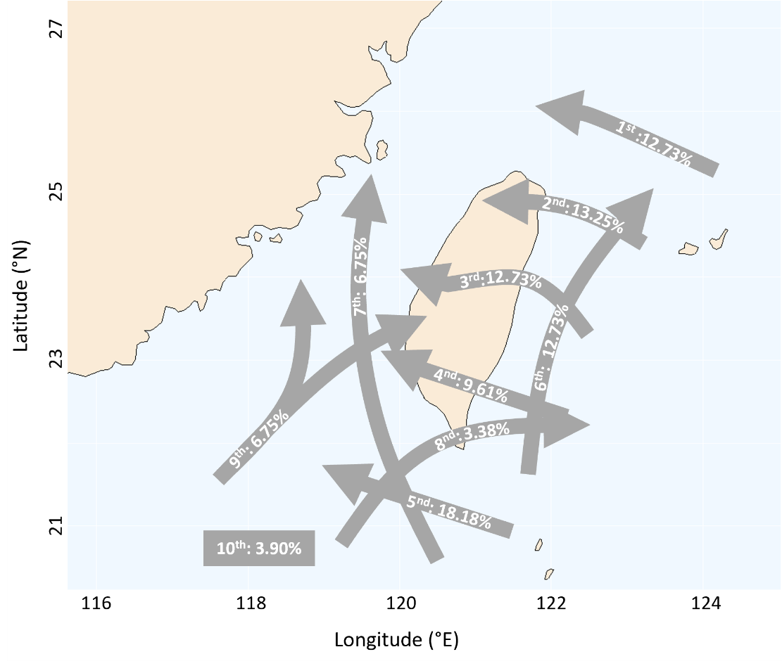
Figure C.1. Ten paths of the typhoons that can influence Taiwan from 1911 to 2021. The figure was adapted from the Typhoon Database, Central Weather Bureau, Taiwan.

References
Carlson RR, Foo SA, Asner GP (2019) Land use impacts on coral reef health: a ridge-to-reef perspective. Front Mar Sci 6:562
Cugier P, Struski C, Blanchard M, Mazurié J, Pouvreau S, Olivier F, Trigui JR, Thiébaut E (2010) Assessing the role of benthic filter feeders on phytoplankton production in a shellfish farming site: Mont Saint Michel Bay, France. J Mar Syst 82:21-34
De'ath G, Fabricius K (2008) Water quality of the Great Barrier Reef: distribution, effects of reef biota and trigger values for the protection of ecosystem health Report to the Great Barrier Reef Marine Park Authority. Great Barrier Reef Marine Park Authority, Australia
Fox MD, Williams GJ, Johnson MD, Radice VZ, Zgliczynski BJ, Kelly ELA, Rohwer FL, Sandin SA, Smith JE (2018) Gradients in primary production predict trophic strategies of mixotrophic corals across spatial scales. Curr Biol 28:3355-3363
Gil MA, Renfro B, Figueroa-Zavala B, Penié I, Dunton KH (2015) Rapid tourism growth and declining coral reefs in Akumal, Mexico. Mar Biol 162:2225-2233
Kleypas J, McManus JW, Menez LAB (1999) Environmental limits to coral reef development: where do we draw the line? Am Zool 39:146-159
Lange ID, Benkwitt CE, McDevitt-Irwin JM, Tietjen KL, Taylor B, Chinkin M, Gunn RL, Palmisciano M, Steyaert M, Wilson B, East HK, Turner J, Graham NAJ, Perry CT (2021) Wave exposure shapes reef community composition and recovery trajectories at a remote coral atoll. Coral Reefs 40:1819-1829
Magdaong ET, Fujii M, Yamano H, Licuanan WY, Maypa A, Campos WL, Alcala AC, White AT, Apistar D, Martinez R (2013) Long-term change in coral cover and the effectiveness of marine protected areas in the Philippines: a meta-analysis. Hydrobiologia 733:5-17
Puotinen M, Drost E, Lowe R, Depczynski M, Radford B, Heyward A, Gilmour J (2020) Towards modelling the future risk of cyclone wave damage to the world's coral reefs. Glob Change Biol 26:4302-4315
Ribas-Deulofeu L, Denis V, Château PA, Chen CA (2021) Impacts of heat stress and storm events on the benthic communities of Kenting National Park (Taiwan). PeerJ 9:e11744
Sherman C, Schmidt W, Appeldoorn R, Hutchinson Y, Ruiz H, Nemeth M, Bejarano I, Motta JJC, Xu H (2016) Sediment dynamics and their potential influence on insular-slope mesophotic coral ecosystems. Cont Shelf Res 129:1-9
Stuart-Smith RD, Brown CJ, Ceccarelli DM, Edgar GJ (2018) Ecosystem restructuring along the Great Barrier Reef following mass coral bleaching. Nature 560:92-96
Tamir R, Eyal G, Kramer N, Laverick JH, Loya Y (2019) Light environment drives the shallow to mesophotic coral community transition. Ecosphere 10:e02839
Yeager LA, Marchand P, Gill DA, Baum JK, McPherson JM (2017) Marine Socio-Environmental Covariates: queryable global layers of environmental and anthropogenic variables for marine ecosystem studies. Ecology 98:1976-1976

Appendix D. Best number of partitions identified by the 26 indices from k-means approach.
Index | Best number of partitions
KL | 5
CH | 5
Hartigan | 5
CCC | 14
Scott | 3
Marriot | 3
TrCovW | 5
TraceW | 5
Friedman | 14
Rubin | 5
Cindex | 15
DB | 5
Silhouette | 5
Duda | 3
PseudoT2 | 3
Beale | 3
Ratkowsky | 4
Ball | 3
PtBiserial | 5
Frey | 1
McClain | 2
Dunn | 6
Hubert | 0
SDindex | 5
Dindex | 0
SDbw | 14
See Charrad et al. (2014) for the detailed computation of the 26 indices.
Charrad M, Ghazzali N, Boiteau V, Niknafs A (2014) NbClust: An R Package for determining the relevant number of clusters in a data set. J Stat Softw 61:1-3

Appendix E. Stability of transects.

Site no. | Transect | Stability
1 | Dongsha_EastInnerAtoll_5m_T1 | 0.9
1 | Dongsha_EastInnerAtoll_5m_T2 | 0.9
1 | Dongsha_EastInnerAtoll_5m_T3 | 0.9
1 | Dongsha_EastInnerAtoll_5m_T4 | 0.9
1 | Dongsha_EastInnerAtoll_5m_T5 | 0.9
2 | Dongsha_EastOuterAtoll_10m_T1 | 0.92
2 | Dongsha_EastOuterAtoll_10m_T2 | 0.92
2 | Dongsha_EastOuterAtoll_10m_T3 | 0.92
2 | Dongsha_EastOuterAtoll_10m_T4 | 0.76
2 | Dongsha_EastOuterAtoll_10m_T5 | 0.92
3 | Dongsha_EastOuterAtoll_20m_T1 | 0.92
3 | Dongsha_EastOuterAtoll_20m_T2 | 0.92
3 | Dongsha_EastOuterAtoll_20m_T3 | 0.92
3 | Dongsha_EastOuterAtoll_20m_T4 | 0.92
3 | Dongsha_EastOuterAtoll_20m_T5 | 0.92
4 | Dongsha_NorthInnerAtoll_5m_T1 | 0.9
4 | Dongsha_NorthInnerAtoll_5m_T2 | 0.9
4 | Dongsha_NorthInnerAtoll_5m_T3 | 0.9
4 | Dongsha_NorthInnerAtoll_5m_T4 | 0.59
4 | Dongsha_NorthInnerAtoll_5m_T5 | 0.59
5 | Dongsha_NorthOuterAtoll_10m_T1 | 0.92
5 | Dongsha_NorthOuterAtoll_10m_T2 | 0.92
5 | Dongsha_NorthOuterAtoll_10m_T3 | 0.92
5 | Dongsha_NorthOuterAtoll_10m_T4 | 0.92
5 | Dongsha_NorthOuterAtoll_10m_T5 | 0.92
6 | Dongsha_NorthOuterAtoll_20m_T1 | 0.92
6 | Dongsha_NorthOuterAtoll_20m_T2 | 0.92
6 | Dongsha_NorthOuterAtoll_20m_T3 | 0.92
6 | Dongsha_NorthOuterAtoll_20m_T4 | 0.92
6 | Dongsha_NorthOuterAtoll_20m_T5 | 0.92
7 | Dongsha_SouthInnerAtoll_5m_T1 | 0.9
7 | Dongsha_SouthInnerAtoll_5m_T2 | 0.9
7 | Dongsha_SouthInnerAtoll_5m_T3 | 0.9
7 | Dongsha_SouthInnerAtoll_5m_T4 | 0.9
7 | Dongsha_SouthInnerAtoll_5m_T5 | 0.9
8 | Dongsha_SouthOuterAtoll_10m_T1 | 0.9
8 | Dongsha_SouthOuterAtoll_10m_T2 | 0.9
8 | Dongsha_SouthOuterAtoll_10m_T3 | 0.9
8 | Dongsha_SouthOuterAtoll_10m_T4 | 0.9
8 | Dongsha_SouthOuterAtoll_10m_T5 | 0.63
9 | Dongsha_SouthOuterAtoll_20m_T1 | 0.9
9 | Dongsha_SouthOuterAtoll_20m_T2 | 0.9
9 | Dongsha_SouthOuterAtoll_20m_T3 | 0.9
9 | Dongsha_SouthOuterAtoll_20m_T4 | 0.9
9 | Dongsha_SouthOuterAtoll_20m_T5 | 0.66
10 | Dongsha_SouthwestOuterAtoll_10m_T1 | 0.9
10 | Dongsha_SouthwestOuterAtoll_10m_T2 | 0.9
10 | Dongsha_SouthwestOuterAtoll_10m_T3 | 0.9
10 | Dongsha_SouthwestOuterAtoll_10m_T4 | 0.9
10 | Dongsha_SouthwestOuterAtoll_10m_T5 | 0.9
11 | Dongsha_SouthwestOuterAtoll_20m_T1 | 0.93
11 | Dongsha_SouthwestOuterAtoll_20m_T2 | 0.9
11 | Dongsha_SouthwestOuterAtoll_20m_T3 | 0.82
11 | Dongsha_SouthwestOuterAtoll_20m_T4 | 0.9
12 | Dongsha_WestInnerAtoll_5m_T1 | 0.93
12 | Dongsha_WestInnerAtoll_5m_T2 | 0.93
12 | Dongsha_WestInnerAtoll_5m_T3 | 0.93
12 | Dongsha_WestInnerAtoll_5m_T4 | 0.93
12 | Dongsha_WestInnerAtoll_5m_T5 | 0.93
13 | East_Fenniaolin_5m_T1 | 0.92
13 | East_Fenniaolin_5m_T2 | 0.92
13 | East_Fenniaolin_5m_T3 | 0.92
13 | East_Fenniaolin_5m_T4 | 0.72
13 | East_Fenniaolin_5m_T5 | 0.92
14 | East_Jiamuziwan_5m_T1 | 0.82
14 | East_Jiamuziwan_5m_T2 | 0.86
14 | East_Jiamuziwan_5m_T3 | 0.9
14 | East_Jiamuziwan_5m_T4 | 0.86
14 | East_Jiamuziwan_5m_T5 | 0.82
15 | East_Jihui_15m_T1 | 0.77
15 | East_Jihui_15m_T2 | 0.73
15 | East_Jihui_15m_T3 | 0.8
15 | East_Jihui_15m_T4 | 0.56
15 | East_Jihui_15m_T5 | 0.78
16 | East_Jihui_5m_T1 | 0.9
16 | East_Jihui_5m_T2 | 0.9
16 | East_Jihui_5m_T3 | 0.82
16 | East_Jihui_5m_T4 | 0.9
16 | East_Jihui_5m_T5 | 0.78
17 | East_Jiqi_5m_T1 | 0.92
17 | East_Jiqi_5m_T2 | 0.92
17 | East_Jiqi_5m_T3 | 0.92
17 | East_Jiqi_5m_T4 | 0.92
17 | East_Jiqi_5m_T5 | 0.92
18 | East_Shitiping_10m_T1 | 0.92
18 | East_Shitiping_10m_T2 | 0.92
18 | East_Shitiping_10m_T3 | 0.92
18 | East_Shitiping_10m_T4 | 0.69
18 | East_Shitiping_10m_T5 | 0.92
19 | East_Shitiping_5m_T1 | 0.9
19 | East_Shitiping_5m_T2 | 0.73
19 | East_Shitiping_5m_T3 | 0.82
19 | East_Shitiping_5m_T4 | 0.92
19 | East_Shitiping_5m_T5 | 0.92
20 | East_Shiyusan_5m_T1 | 0.93
20 | East_Shiyusan_5m_T2 | 0.93
20 | East_Shiyusan_5m_T3 | 0.93
20 | East_Shiyusan_5m_T4 | 0.93
20 | East_Shiyusan_5m_T5 | 0.93
21 | East_Xiaoyeliu_10m_T1 | 0.93
21 | East_Xiaoyeliu_10m_T2 | 0.79
21 | East_Xiaoyeliu_10m_T3 | 0.93
21 | East_Xiaoyeliu_10m_T4 | 0.93
21 | East_Xiaoyeliu_10m_T5 | 0.93
22 | East_Xiaoyeliu_5m_T1 | 0.82
22 | East_Xiaoyeliu_5m_T2 | 0.9
22 | East_Xiaoyeliu_5m_T3 | 0.92
22 | East_Xiaoyeliu_5m_T4 | 0.73
22 | East_Xiaoyeliu_5m_T5 | 0.72
23 | East_Xinshe_5m_T1 | 0.92
23 | East_Xinshe_5m_T2 | 0.92
23 | East_Xinshe_5m_T3 | 0.92
23 | East_Xinshe_5m_T4 | 0.92
23 | East_Xinshe_5m_T5 | 0.92
24 | GreenIsland_Chaikou_10m_T1 | 0.9
24 | GreenIsland_Chaikou_10m_T2 | 0.9
24 | GreenIsland_Chaikou_10m_T3 | 0.9
24 | GreenIsland_Chaikou_10m_T4 | 0.92
24 | GreenIsland_Chaikou_10m_T5 | 0.92
25 | GreenIsland_Dabaisha_10m_T1 | 1
25 | GreenIsland_Dabaisha_10m_T2 | 1
25 | GreenIsland_Dabaisha_10m_T3 | 1
25 | GreenIsland_Dabaisha_10m_T4 | 1
25 | GreenIsland_Dabaisha_10m_T5 | 1
26 | GreenIsland_Dabaisha_40m_T1 | 0.92
26 | GreenIsland_Dabaisha_40m_T2 | 0.92
26 | GreenIsland_Dabaisha_40m_T3 | 1
26 | GreenIsland_Dabaisha_40m_T4 | 1
26 | GreenIsland_Dabaisha_40m_T5 | 1
27 | GreenIsland_Gongguan_10m_T1 | 0.9
27 | GreenIsland_Gongguan_10m_T2 | 0.9
27 | GreenIsland_Gongguan_10m_T3 | 0.9
27 | GreenIsland_Gongguan_10m_T4 | 0.9
27 | GreenIsland_Gongguan_10m_T5 | 0.9
28 | GreenIsland_Guiwan_10m_T1 | 1
28 | GreenIsland_Guiwan_10m_T2 | 1
28 | GreenIsland_Guiwan_10m_T3 | 1
28 | GreenIsland_Guiwan_10m_T4 | 1
28 | GreenIsland_Guiwan_10m_T5 | 1
29 | GreenIsland_Guiwan_40m_T1 | 1
29 | GreenIsland_Guiwan_40m_T2 | 1
29 | GreenIsland_Guiwan_40m_T3 | 1
29 | GreenIsland_Guiwan_40m_T4 | 1
29 | GreenIsland_Guiwan_40m_T5 | 1
30 | GreenIsland_Shilang_10m_T1 | 1
30 | GreenIsland_Shilang_10m_T2 | 1
30 | GreenIsland_Shilang_10m_T3 | 1
30 | GreenIsland_Shilang_10m_T4 | 1
30 | GreenIsland_Shilang_10m_T5 | 1
31 | GreenIsland_Shilang_40m_T1 | 0.93
31 | GreenIsland_Shilang_40m_T2 | 0.84
31 | GreenIsland_Shilang_40m_T3 | 0.72
31 | GreenIsland_Shilang_40m_T4 | 0.93
31 | GreenIsland_Shilang_40m_T5 | 0.93
32 | Kenting_Hongchaikeng_10m_T1 | 0.88
32 | Kenting_Hongchaikeng_10m_T2 | 0.6
32 | Kenting_Hongchaikeng_10m_T4 | 0.65
32 | Kenting_Hongchaikeng_10m_T5 | 0.9
33 | Kenting_Hongchaikeng_40m_T1 | 0.92
33 | Kenting_Hongchaikeng_40m_T2 | 0.92
33 | Kenting_Hongchaikeng_40m_T3 | 0.92
33 | Kenting_Hongchaikeng_40m_T4 | 0.92
33 | Kenting_Hongchaikeng_40m_T5 | 0.92
34 | Kenting_Longkeng_10m_T1 | 0.76
34 | Kenting_Longkeng_10m_T2 | 0.92
34 | Kenting_Longkeng_10m_T3 | 0.69
34 | Kenting_Longkeng_10m_T4 | 0.62
34 | Kenting_Longkeng_10m_T5 | 0.92
35 | Kenting_Longkeng_40m_T1 | 0.93
35 | Kenting_Longkeng_40m_T2 | 0.93
35 | Kenting_Longkeng_40m_T3 | 0.93
35 | Kenting_Longkeng_40m_T4 | 0.93
35 | Kenting_Longkeng_40m_T5 | 0.93
36 | Kenting_Maobitou_10m_T1 | 0.92
36 | Kenting_Maobitou_10m_T2 | 0.92
36 | Kenting_Maobitou_10m_T3 | 0.92
36 | Kenting_Maobitou_10m_T4 | 0.78
36 | Kenting_Maobitou_10m_T5 | 0.92
37 | Kenting_Maobitou_40m_T1 | 0.93
37 | Kenting_Maobitou_40m_T2 | 0.93
37 | Kenting_Maobitou_40m_T3 | 0.93
37 | Kenting_Maobitou_40m_T4 | 0.93
37 | Kenting_Maobitou_40m_T5 | 0.93
38 | Kenting_Xiaowan_10m_T1 | 0.92
38 | Kenting_Xiaowan_10m_T2 | 0.86
38 | Kenting_Xiaowan_10m_T3 | 0.82
38 | Kenting_Xiaowan_10m_T4 | 0.77
38 | Kenting_Xiaowan_10m_T5 | 0.62
39 | Kenting_Xiaowan_40m_T1 | 0.93
39 | Kenting_Xiaowan_40m_T2 | 0.93
39 | Kenting_Xiaowan_40m_T3 | 0.93
39 | Kenting_Xiaowan_40m_T4 | 0.93
39 | Kenting_Xiaowan_40m_T5 | 0.93
40 | North_825_5m_T1 | 0.9
40 | North_825_5m_T2 | 0.9
40 | North_825_5m_T3 | 0.9
40 | North_825_5m_T4 | 0.86
40 | North_825_5m_T5 | 0.9
41 | North_Bitoujiao_10m_T1 | 0.58
41 | North_Bitoujiao_10m_T2 | 0.93
41 | North_Bitoujiao_10m_T3 | 0.68
41 | North_Bitoujiao_10m_T4 | 0.92
41 | North_Bitoujiao_10m_T5 | 0.7
42 | North_Bitoujiao_15m_T1 | 0.69
42 | North_Bitoujiao_15m_T2 | 0.74
42 | North_Bitoujiao_15m_T3 | 0.85
42 | North_Bitoujiao_15m_T4 | 0.93
42 | North_Bitoujiao_15m_T5 | 0.93
43 | North_Bitoujiao_40m_T1 | 0.92
43 | North_Bitoujiao_40m_T2 | 0.92
43 | North_Bitoujiao_40m_T3 | 0.92
43 | North_Bitoujiao_40m_T4 | 0.92
43 | North_Bitoujiao_40m_T5 | 0.92
44 | North_Bitoujiao_5m_T1 | 0.93
44 | North_Bitoujiao_5m_T2 | 0.93
44 | North_Bitoujiao_5m_T3 | 0.92
44 | North_Bitoujiao_5m_T4 | 0.72
44 | North_Bitoujiao_5m_T5 | 0.6
45 | North_Chaojing_15m_T1 | 0.5
45 | North_Chaojing_15m_T2 | 0.47
45 | North_Chaojing_15m_T3 | 0.9
45 | North_Chaojing_15m_T4 | 0.9
45 | North_Chaojing_15m_T5 | 0.92
46 | North_Chaojing_5m_T1 | 0.85
46 | North_Chaojing_5m_T2 | 0.82
46 | North_Chaojing_5m_T3 | 0.93
46 | North_Chaojing_5m_T4 | 0.93
46 | North_Chaojing_5m_T5 | 0.93
47 | North_GuianHarbor_10m_T1 | 0.93
47 | North_GuianHarbor_10m_T2 | 0.93
47 | North_GuianHarbor_10m_T3 | 0.93
47 | North_GuianHarbor_10m_T4 | 0.93
47 | North_GuianHarbor_10m_T5 | 0.93
48 | North_Guishandao1_10m_T1 | 0.92
48 | North_Guishandao1_10m_T2 | 0.92
48 | North_Guishandao1_10m_T3 | 0.92
48 | North_Guishandao1_10m_T4 | 0.92
48 | North_Guishandao1_10m_T5 | 0.92
49 | North_Guishandao2_10m_T1 | 0.69
49 | North_Guishandao2_10m_T2 | 0.92
49 | North_Guishandao2_10m_T3 | 0.92
49 | North_Guishandao2_10m_T4 | 0.92
49 | North_Guishandao2_10m_T5 | 0.9
50 | North_KeelungIsland_10m_T1 | 0.61
50 | North_KeelungIsland_10m_T2 | 0.54
50 | North_KeelungIsland_10m_T3 | 0.77
50 | North_KeelungIsland_10m_T4 | 0.92
50 | North_KeelungIsland_10m_T5 | 0.92
51 | North_KeelungIsland_40m_T1 | 0.93
51 | North_KeelungIsland_40m_T2 | 0.93
51 | North_KeelungIsland_40m_T3 | 0.93
51 | North_KeelungIsland_40m_T4 | 0.93
51 | North_KeelungIsland_40m_T5 | 0.93
52 | North_Longdong_15m_T1 | 0.93
52 | North_Longdong_15m_T2 | 0.93
52 | North_Longdong_15m_T3 | 0.93
52 | North_Longdong_15m_T4 | 0.93
52 | North_Longdong_15m_T5 | 0.82
53 | North_Longdong_5m_T1 | 0.93
53 | North_Longdong_5m_T2 | 0.93
53 | North_Longdong_5m_T3 | 0.93
53 | North_Longdong_5m_T4 | 0.93
53 | North_Longdong_5m_T5 | 0.93
54 | North_Magang_10m_T1 | 0.68
54 | North_Magang_10m_T2 | 0.77
54 | North_Magang_10m_T3 | 0.92
54 | North_Magang_10m_T4 | 0.92
54 | North_Magang_10m_T5 | 0.88
55 | North_Maoao_10m_T1 | 0.93
55 | North_Maoao_10m_T2 | 0.93
55 | North_Maoao_10m_T3 | 0.93
55 | North_Maoao_10m_T4 | 0.93
55 | North_Maoao_10m_T5 | 0.93
56 | North_Meiyanshan_15m_T1 | 0.93
56 | North_Meiyanshan_15m_T2 | 0.93
56 | North_Meiyanshan_15m_T3 | 0.93
56 | North_Meiyanshan_15m_T4 | 0.93
56 | North_Meiyanshan_15m_T5 | 0.93
57 | North_Meiyanshan_5m_T1 | 0.93
57 | North_Meiyanshan_5m_T2 | 0.93
57 | North_Meiyanshan_5m_T3 | 0.93
57 | North_Meiyanshan_5m_T4 | 0.93
57 | North_Meiyanshan_5m_T5 | 0.93
58 | North_Shenao_15m_T1 | 0.93
58 | North_Shenao_15m_T2 | 0.9
58 | North_Shenao_15m_T3 | 0.8
58 | North_Shenao_15m_T4 | 0.9
58 | North_Shenao_15m_T5 | 0.93
59 | North_Shenao_5m_T1 | 0.93
59 | North_Shenao_5m_T2 | 0.93
59 | North_Shenao_5m_T3 | 0.93
59 | North_Shenao_5m_T4 | 0.93
59 | North_Shenao_5m_T5 | 0.93
60 | North_Shicheng_10m_T1 | 0.9
60 | North_Shicheng_10m_T2 | 0.88
60 | North_Shicheng_10m_T3 | 0.9
60 | North_Shicheng_10m_T4 | 0.93
60 | North_Shicheng_10m_T5 | 0.93
61 | North_Yeliu_10m_T1 | 0.58
61 | North_Yeliu_10m_T2 | 0.58
61 | North_Yeliu_10m_T3 | 0.56
61 | North_Yeliu_10m_T4 | 0.74
61 | North_Yeliu_10m_T5 | 0.9
62 | OrchidIsland_Dongchin_10m_T1 | 0.92
62 | OrchidIsland_Dongchin_10m_T2 | 0.92
62 | OrchidIsland_Dongchin_10m_T3 | 0.92
62 | OrchidIsland_Dongchin_10m_T4 | 0.77
62 | OrchidIsland_Dongchin_10m_T5 | 0.93
63 | OrchidIsland_Landong_10m_T1 | 0.43
63 | OrchidIsland_Landong_10m_T2 | 0.9
63 | OrchidIsland_Landong_10m_T3 | 0.9
63 | OrchidIsland_Landong_10m_T4 | 0.92
63 | OrchidIsland_Landong_10m_T5 | 0.92
64 | OrchidIsland_Laurenyan_10m_T1 | 0.9
64 | OrchidIsland_Laurenyan_10m_T2 | 0.9
64 | OrchidIsland_Laurenyan_10m_T3 | 0.9
64 | OrchidIsland_Laurenyan_10m_T4 | 0.6
64 | OrchidIsland_Laurenyan_10m_T5 | 0.9
65 | OrchidIsland_Mujiyan_10m_T1 | 0.9
65 | OrchidIsland_Mujiyan_10m_T2 | 0.9
65 | OrchidIsland_Mujiyan_10m_T3 | 0.9
65 | OrchidIsland_Mujiyan_10m_T4 | 0.9
65 | OrchidIsland_Mujiyan_10m_T5 | 0.9
66 | OrchidIsland_Qingqingcaoyuan_10m_T1 | 0.9
66 | OrchidIsland_Qingqingcaoyuan_10m_T2 | 0.9
66 | OrchidIsland_Qingqingcaoyuan_10m_T3 | 0.9
66 | OrchidIsland_Qingqingcaoyuan_10m_T4 | 0.9
66 | OrchidIsland_Qingqingcaoyuan_10m_T5 | 0.9
67 | OrchidIsland_Shuangshiyan_10m_T1 | 0.9
67 | OrchidIsland_Shuangshiyan_10m_T2 | 0.9
67 | OrchidIsland_Shuangshiyan_10m_T3 | 0.9
67 | OrchidIsland_Shuangshiyan_10m_T4 | 0.9
67 | OrchidIsland_Shuangshiyan_10m_T5 | 0.9
68 | OrchidIsland_Yayo_10m_T1 | 0.9
68 | OrchidIsland_Yayo_10m_T2 | 0.56
68 | OrchidIsland_Yayo_10m_T3 | 0.81
68 | OrchidIsland_Yayo_10m_T4 | 0.77
68 | OrchidIsland_Yayo_10m_T5 | 0.9
69 | Penghu_Gupoyu_5m_T1 | 0.92
69 | Penghu_Gupoyu_5m_T2 | 0.92
69 | Penghu_Gupoyu_5m_T3 | 0.92
69 | Penghu_Gupoyu_5m_T4 | 0.92
69 | Penghu_Gupoyu_5m_T5 | 0.92
70 | Penghu_HujingyuNorth_5m_T1 | 0.9
70 | Penghu_HujingyuNorth_5m_T2 | 0.9
70 | Penghu_HujingyuNorth_5m_T3 | 0.9
70 | Penghu_HujingyuNorth_5m_T4 | 0.9
70 | Penghu_HujingyuNorth_5m_T5 | 0.86
71 | Penghu_HujingyuWest_5m_T1 | 0.92
71 | Penghu_HujingyuWest_5m_T2 | 0.92
71 | Penghu_HujingyuWest_5m_T3 | 0.92
71 | Penghu_HujingyuWest_5m_T4 | 0.92
71 | Penghu_HujingyuWest_5m_T5 | 0.61
72 | Penghu_Jingyudong_5m_T1 | 0.92
72 | Penghu_Jingyudong_5m_T2 | 0.92
72 | Penghu_Jingyudong_5m_T3 | 0.92
72 | Penghu_Jingyudong_5m_T4 | 0.92
72 | Penghu_Jingyudong_5m_T5 | 0.92
73 | Penghu_Keelungyu_5m_T1 | 0.9
73 | Penghu_Keelungyu_5m_T2 | 0.9
73 | Penghu_Keelungyu_5m_T3 | 0.9
73 | Penghu_Keelungyu_5m_T4 | 0.9
73 | Penghu_Keelungyu_5m_T5 | 0.9
74 | Penghu_Qingwan_5m_T1 | 0.92
74 | Penghu_Qingwan_5m_T2 | 0.92
74 | Penghu_Qingwan_5m_T3 | 0.92
74 | Penghu_Qingwan_5m_T4 | 0.92
74 | Penghu_Qingwan_5m_T5 | 0.92
75 | Penghu_Sijiaoyu_5m_T1 | 0.82
75 | Penghu_Sijiaoyu_5m_T2 | 0.86
75 | Penghu_Sijiaoyu_5m_T3 | 0.78
75 | Penghu_Sijiaoyu_5m_T4 | 0.9
75 | Penghu_Sijiaoyu_5m_T5 | 0.9
76 | Penghu_TiezhenyuNorth_5m_T1 | 0.92
76 | Penghu_TiezhenyuNorth_5m_T2 | 0.92
76 | Penghu_TiezhenyuNorth_5m_T3 | 0.92
76 | Penghu_TiezhenyuNorth_5m_T4 | 0.68
76 | Penghu_TiezhenyuNorth_5m_T5 | 0.69
77 | Penghu_Tongpanyu_10m_T1 | 0.81
77 | Penghu_Tongpanyu_10m_T2 | 0.92
77 | Penghu_Tongpanyu_10m_T3 | 0.92
77 | Penghu_Tongpanyu_10m_T4 | 0.92
77 | Penghu_Tongpanyu_10m_T5 | 0.9
78 | Penghu_Xiaomenyu_5m_T1 | 0.9
78 | Penghu_Xiaomenyu_5m_T2 | 0.9
78 | Penghu_Xiaomenyu_5m_T3 | 0.9
78 | Penghu_Xiaomenyu_5m_T4 | 0.9
78 | Penghu_Xiaomenyu_5m_T5 | 0.9
79 | Xiaoliuqiu_Dafu_10m_T1 | 0.92
79 | Xiaoliuqiu_Dafu_10m_T2 | 0.92
79 | Xiaoliuqiu_Dafu_10m_T3 | 0.92
79 | Xiaoliuqiu_Dafu_10m_T4 | 0.92
79 | Xiaoliuqiu_Dafu_10m_T5 | 0.92
80 | Xiaoliuqiu_Duziping_10m_T1 | 0.73
80 | Xiaoliuqiu_Duziping_10m_T2 | 0.92
80 | Xiaoliuqiu_Duziping_10m_T3 | 0.92
80 | Xiaoliuqiu_Duziping_10m_T4 | 0.92
80 | Xiaoliuqiu_Duziping_10m_T5 | 0.92
81 | Xiaoliuqiu_Houshi_10m_T1 | 0.92
81 | Xiaoliuqiu_Houshi_10m_T2 | 0.92
81 | Xiaoliuqiu_Houshi_10m_T3 | 0.92
81 | Xiaoliuqiu_Houshi_10m_T4 | 0.92
81 | Xiaoliuqiu_Houshi_10m_T5 | 0.92
82 | Xiaoliuqiu_Huapingyan_10m_T1 | 0.92
82 | Xiaoliuqiu_Huapingyan_10m_T2 | 0.92
82 | Xiaoliuqiu_Huapingyan_10m_T3 | 0.92
82 | Xiaoliuqiu_Huapingyan_10m_T4 | 0.92
82 | Xiaoliuqiu_Huapingyan_10m_T5 | 0.92
83 | Xiaoliuqiu_Longxiadong_10m_T1 | 0.92
83 | Xiaoliuqiu_Longxiadong_10m_T2 | 0.92
83 | Xiaoliuqiu_Longxiadong_10m_T3 | 0.92
83 | Xiaoliuqiu_Longxiadong_10m_T4 | 0.92
83 | Xiaoliuqiu_Longxiadong_10m_T5 | 0.92
84 | Xiaoliuqiu_Meirendong_10m_T1 | 0.92
84 | Xiaoliuqiu_Meirendong_10m_T2 | 0.92
84 | Xiaoliuqiu_Meirendong_10m_T3 | 0.77
84 | Xiaoliuqiu_Meirendong_10m_T4 | 0.9
84 | Xiaoliuqiu_Meirendong_10m_T5 | 0.92
85 | Xiaoliuqiu_Shanfu_10m_T1 | 0.92
85 | Xiaoliuqiu_Shanfu_10m_T2 | 0.92
85 | Xiaoliuqiu_Shanfu_10m_T3 | 0.9
85 | Xiaoliuqiu_Shanfu_10m_T4 | 0.88
85 | Xiaoliuqiu_Shanfu_10m_T5 | 0.81
86 | Xiaoliuqiu_Wuguidong_10m_T1 | 0.92
86 | Xiaoliuqiu_Wuguidong_10m_T2 | 0.92
86 | Xiaoliuqiu_Wuguidong_10m_T3 | 0.92
86 | Xiaoliuqiu_Wuguidong_10m_T4 | 0.92
86 | Xiaoliuqiu_Wuguidong_10m_T5 | 0.92
87 | Xiaoliuqiu_ZhongaoBeach_5m_T1 | 0.92
87 | Xiaoliuqiu_ZhongaoBeach_5m_T2 | 0.92
87 | Xiaoliuqiu_ZhongaoBeach_5m_T3 | 0.92
87 | Xiaoliuqiu_ZhongaoBeach_5m_T4 | 0.92
87 | Xiaoliuqiu_ZhongaoBeach_5m_T5 | 0.92

Appendix F. Moran's I test on the occurrence of each community.
Community | CCA | Turf & Stony Coral | Turf | Digitate Octocoral | Bushy Octocoral
Moran's I test on the occurrence | P < 0.001 | P < 0.001 | P < 0.001 | P < 0.001 | P < 0.001
Moran's I coefficient | 0.572 | 0.678 | 0.534 | 0.787 | 0.572
Moran's I expected coefficient | -0.002 | -0.002 | -0.002 | -0.002 | -0.002

Appendix G. Results of Indicator species analysis.
Benthic community | Morpho-functional groups | Indicator Value | p-value
Bushy Octocoral | StonyCoral arborescent | 0.559 | 0.001
Bushy Octocoral | StonyCoral bushy | 0.553 | 0.001
Bushy Octocoral | StonyCoral table | 0.598 | 0.001
Bushy Octocoral | Octocoral arborescent | 0.635 | 0.001
Bushy Octocoral | Octocoral bushy | 0.856 | 0.001
Bushy Octocoral | Octocoral cluster | 0.833 | 0.001
Bushy Octocoral | Octocoral encrusting | 0.935 | 0.001
Bushy Octocoral | Sponge massive | 0.652 | 0.001
CCA | Macroalgae articulated calcareous | 0.619 | 0.001
CCA | CCA crustose | 0.536 | 0.001
CCA | Sponge encrusting | 0.499 | 0.013
CCA | Sponge repent | 0.536 | 0.002
Digitate Octocoral | Ascidian erect single | 0.457 | 0.001
Digitate Octocoral | Cyanobacteria filamentous | 0.451 | 0.019
Digitate Octocoral | Octocoral digitate | 0.824 | 0.001
Digitate Octocoral | Octocoral lobate | 0.856 | 0.001
Digitate Octocoral | Octocoral massive | 0.791 | 0.001
Turf | Macroalgae corticated foliose | 0.499 | 0.018
Turf | Macroalgae corticated macrophyte | 0.492 | 0.037
Turf | Seagrass | 0.119 | 0.766
Turf | Turf filamentous | 0.51 | 0.001
Turf & Stony Coral | StonyCoral columnar | 0.679 | 0.001
Turf & Stony Coral | StonyCoral encrusting | 0.529 | 0.001
Turf & Stony Coral | StonyCoral foliose | 0.533 | 0.003
Turf & Stony Coral | StonyCoral massive | 0.538 | 0.001
Turf & Stony Coral | Zoanthid encrusting | 0.472 | 0.006
Turf & Stony Coral | Zoanthid massive | 0.316 | 0.095
* Morpho-functional groups that significantly indicate the communities were in bold.

Appendix H. Shepard plot for non-metric multidimensional scaling (nMDS).
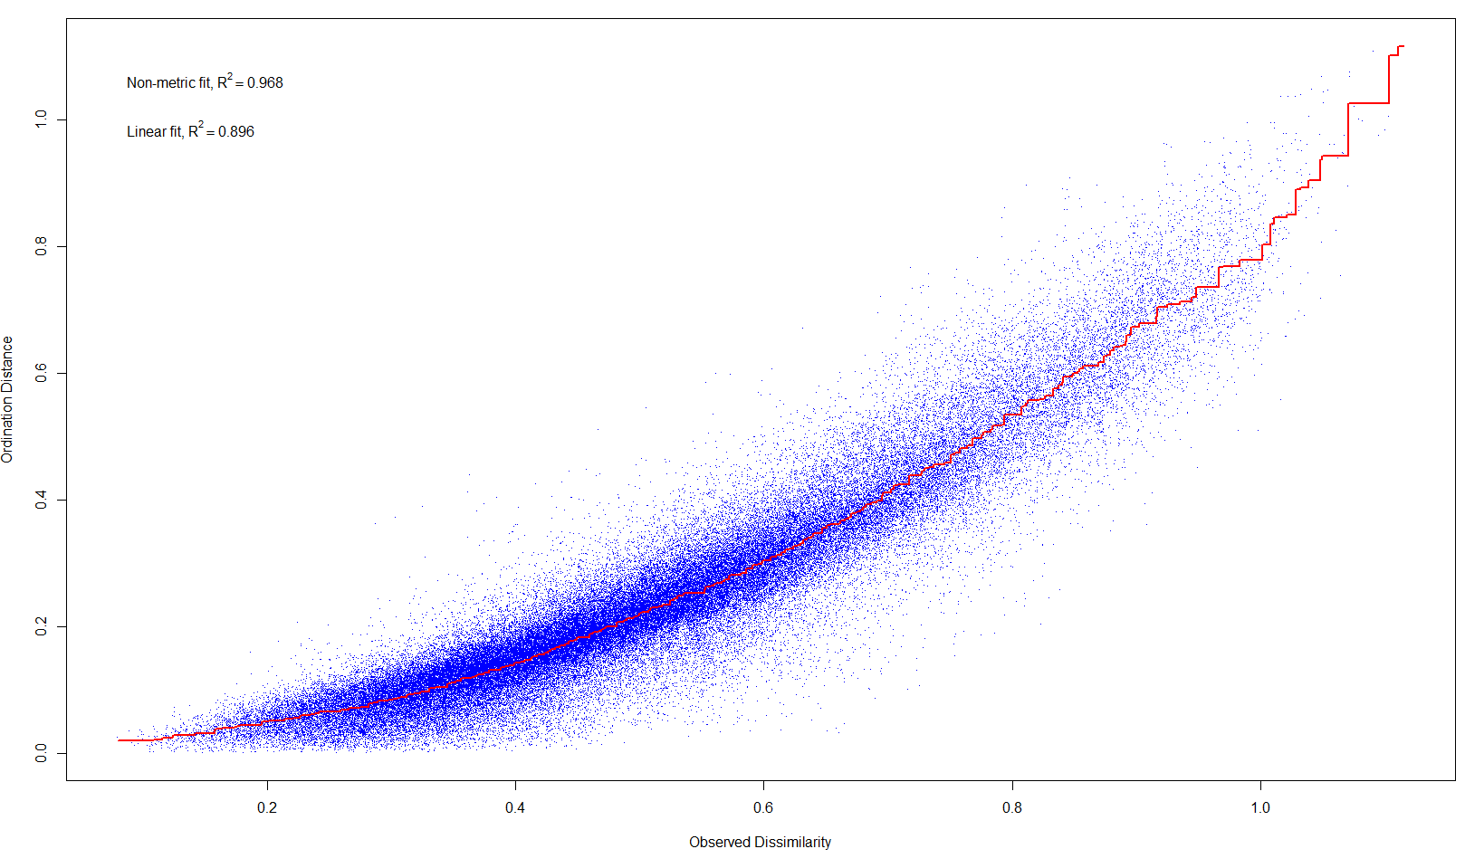
Figure H.1. The relationship between the actual distance among 433 transects and the ordination distance on the nMDS plot. The linear fit R² = 0.896 and the ranked R² = 0.968.

Appendix I. Hyperparameter tuning and performance of CRFs.
CRFs | CCA community | Turf & Stony Coral community | Turf community | Digitate Octocoral community | Bushy Octocoral community | General
Type of tree | regression | regression | regression | regression | regression | classification
No. of trees | 2,000 | 2,000 | 2,000 | 2,000 | 2,000 | 2,000
No. of splits | 5 | 5 | 5 | 5 | 5 | 5
Mean squared error¹ | 0.066 | 0.088 | 0.093 | 0.026 | 0.016 | x
Variance explained (%)² | 55.41 | 42.61 | 48.26 | 46.18 | 69.13 | x
Out-of-bag error (%)³ | x | x | x | x | x | 25.17
x: cannot be computed
¹Mean squared error (MSE) is a measure of accuracy to indicate the difference between the estimated values generated by the regression-based conditional random forest model (CRF) and the observed values. The formula of MSE is given as
$$MSE= \sum_{i=1}^{n}{\frac{{(y_{i}-\hat{y_{i}})}^{2}}{n}}$$
Where $y_{i}$ is the value of response variable $Y$ in the i^{th} observation, $\hat{y_{i}}$represents the values of response variable $Y$ in the i^{th} observation predicted by the CRF, and n means the number of observations.

²Variance explained (R²) is a measure of the proportion of the variance that can be explained by the environmental factors provided in the given CRF. The variance explained is calculated as
$$R^{2}=1- \frac{\sum_{i}{{(y_{i}-\hat{y_{i}})}^{2}}}{\sum_{i}{{(y_{i}-\overline{y_{i}})}^{2}}}$$
Where $y_{i}$ is the value of response variable $Y$ in the i^{th} observation, $\hat{y_{i}}$represents the values of response variable $Y$ in the i^{th} observation predicted by the CRF, and $\overline{y_{i}}$ is the mean of all values of response variables. In other words, the mean-square error of the model is first computed and divided by the variance of the observations, and then subtract this value from one.
³Out-of-bag error (OOB) is a measure of accuracy for classification-based CRF to estimate the misclassification rate in the given CRF. A confusion matrix indicating the performance of CRF is first produced. From this matrix, the OOB error is calculated as the number of correctly classified observations divided by the total number of observations, and then subtract this value from one.

Appendix J. Importance of environmental factors in CRFs.
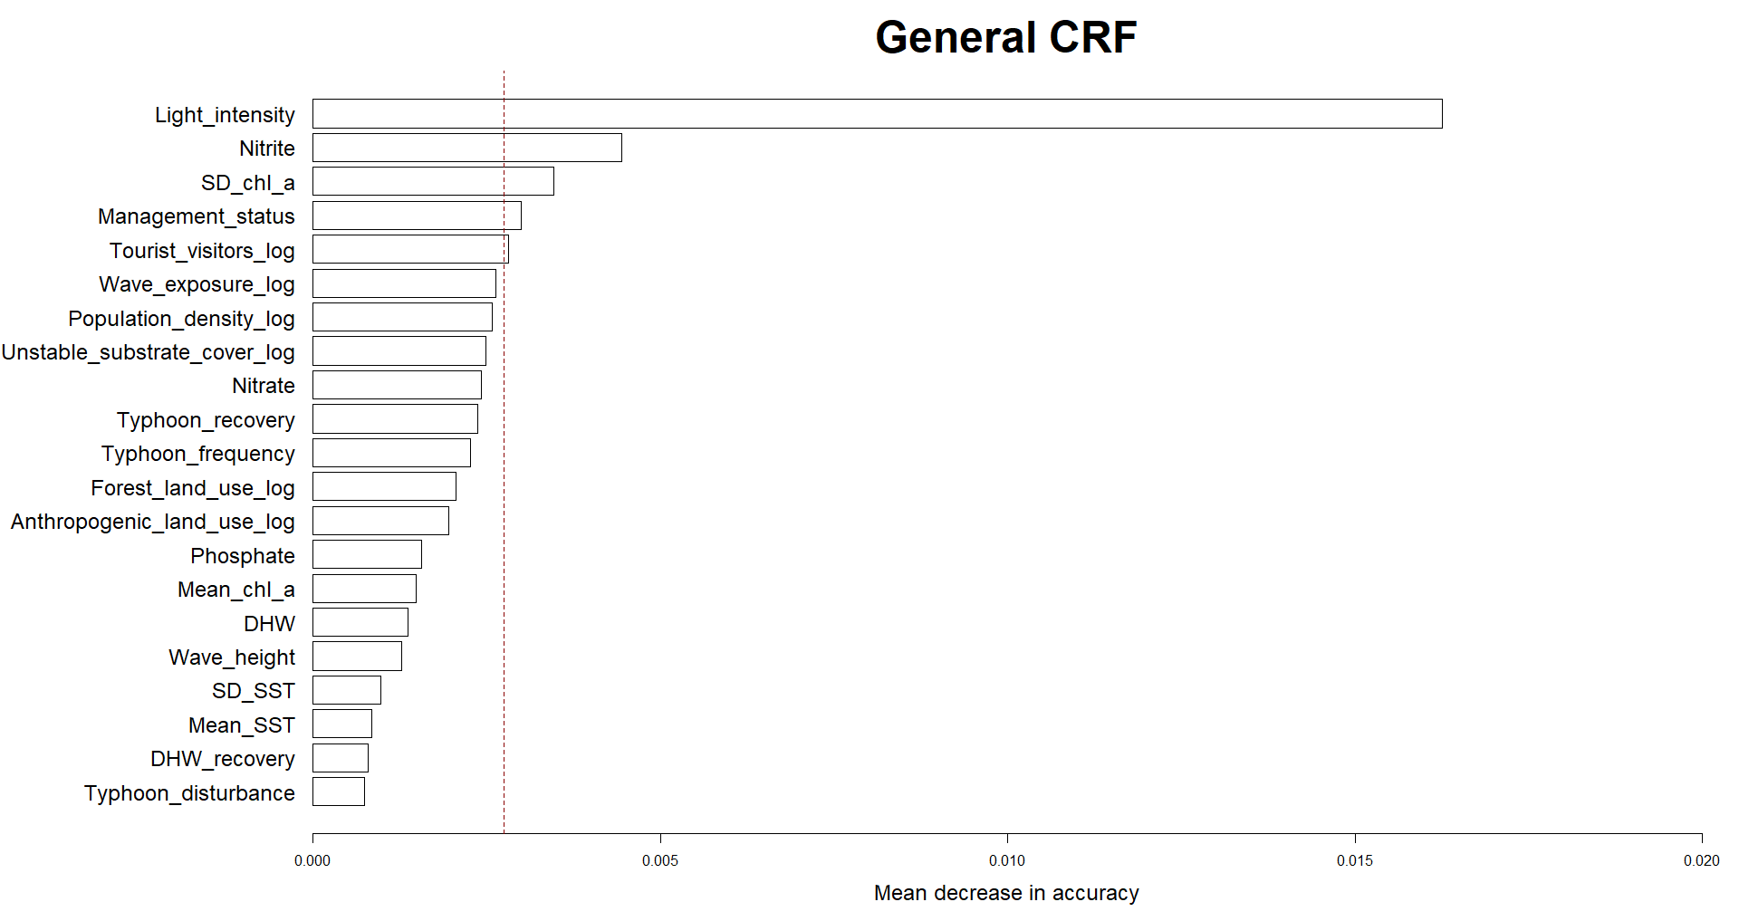
Figure J.1. The importance of environmental factors in general CRF. Red dashed lines indicate the mean importance of all environmental factors.

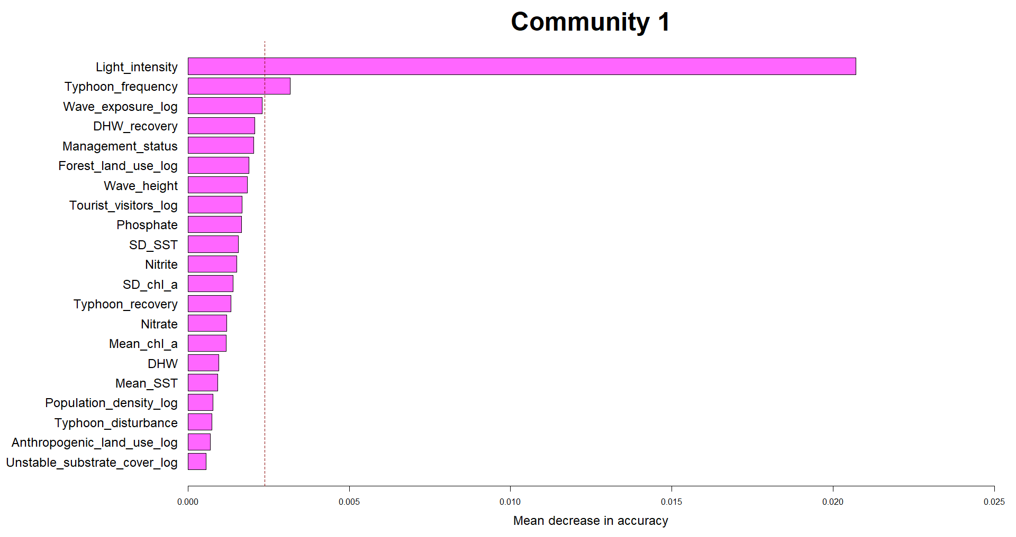
Figure J.2. The importance of environmental factors in individual CRF of the CCA community. Red dashed lines indicate the mean importance of all environmental factors.

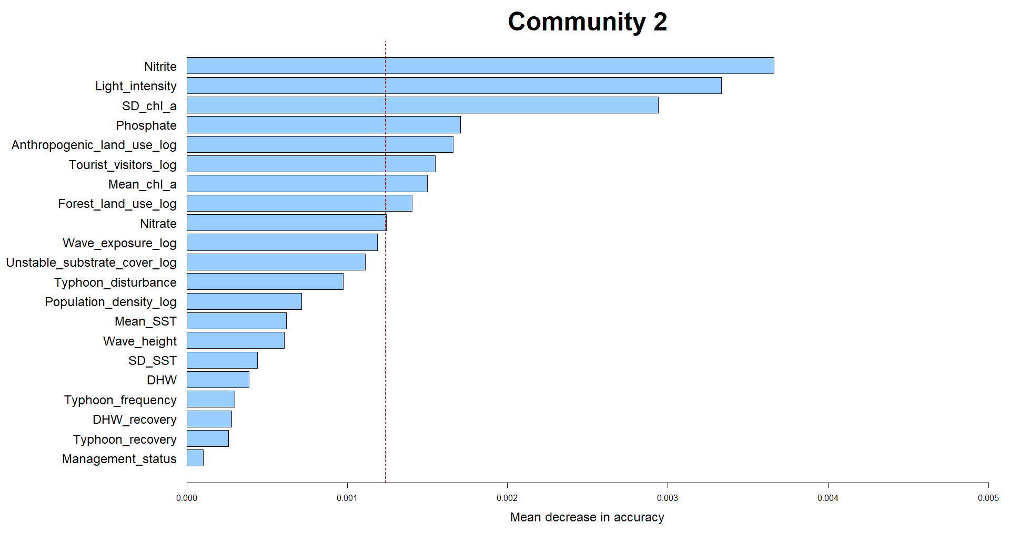
Figure J.3. The importance of environmental factors in individual CRF of the Turf and Stony Coral community. Red dashed lines indicate the mean importance of all environmental factors.

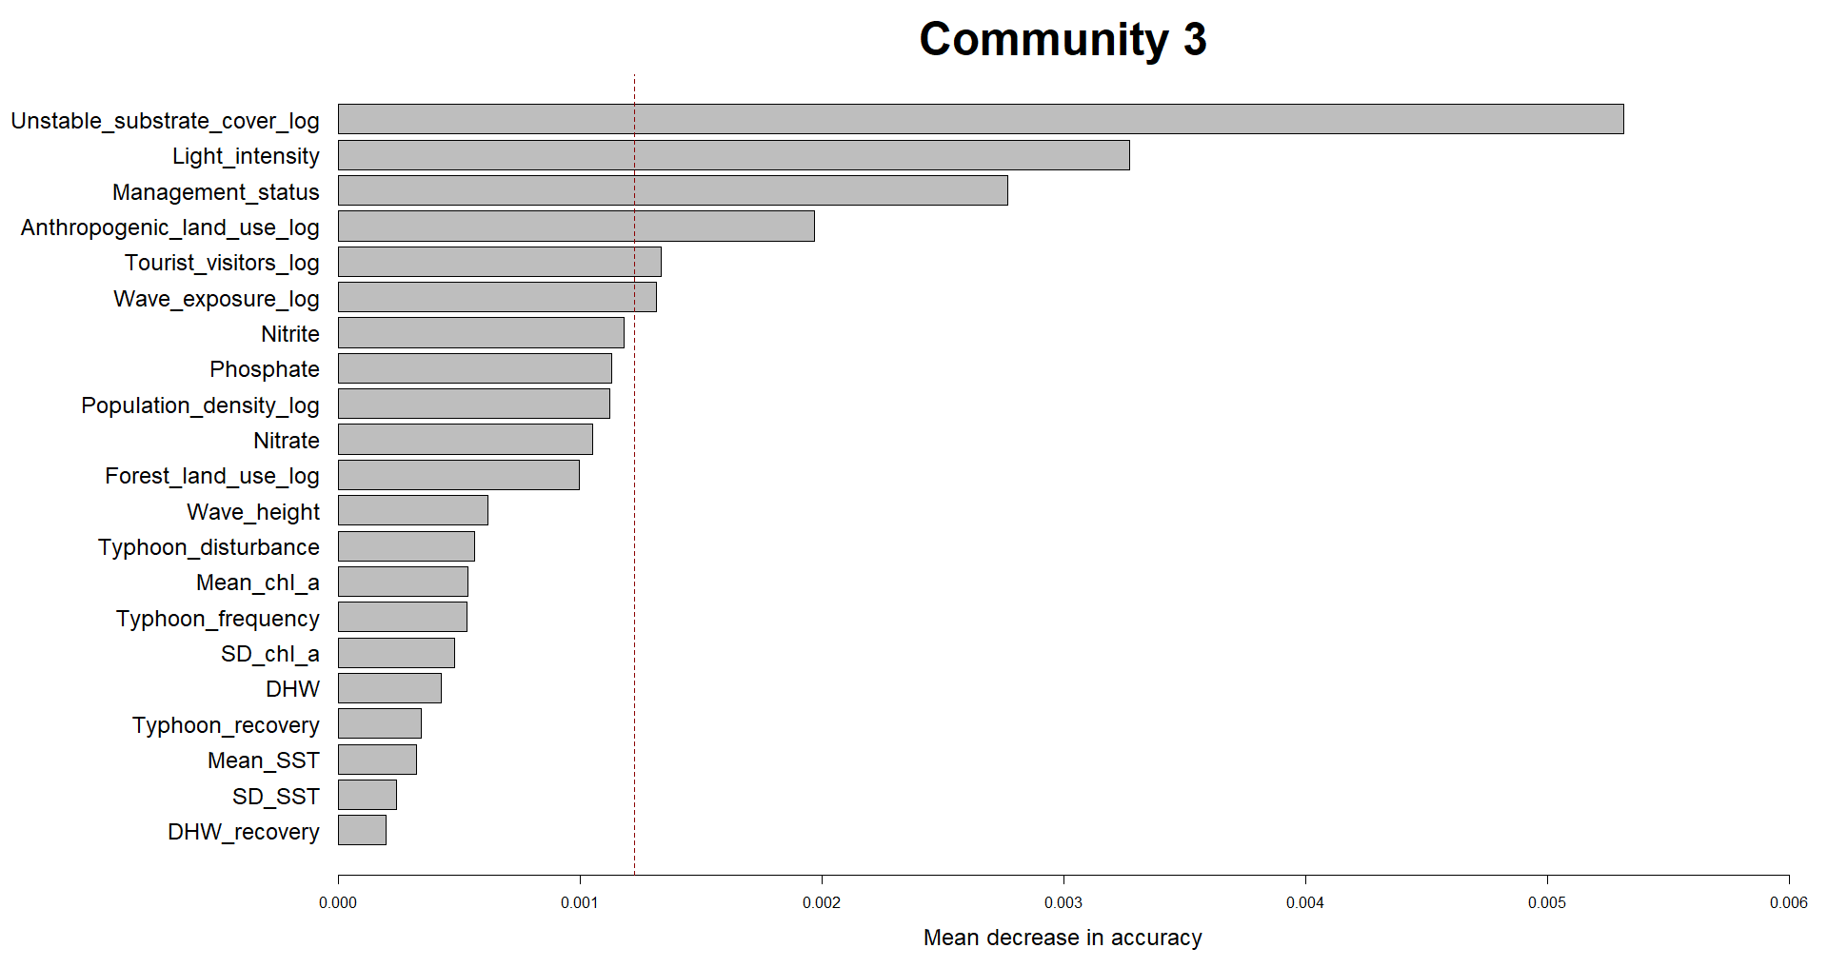 Figure J.4. The importance of environmental factors in individual CRF of the Turf community. Red dashed lines indicate the mean importance of all environmental factors.

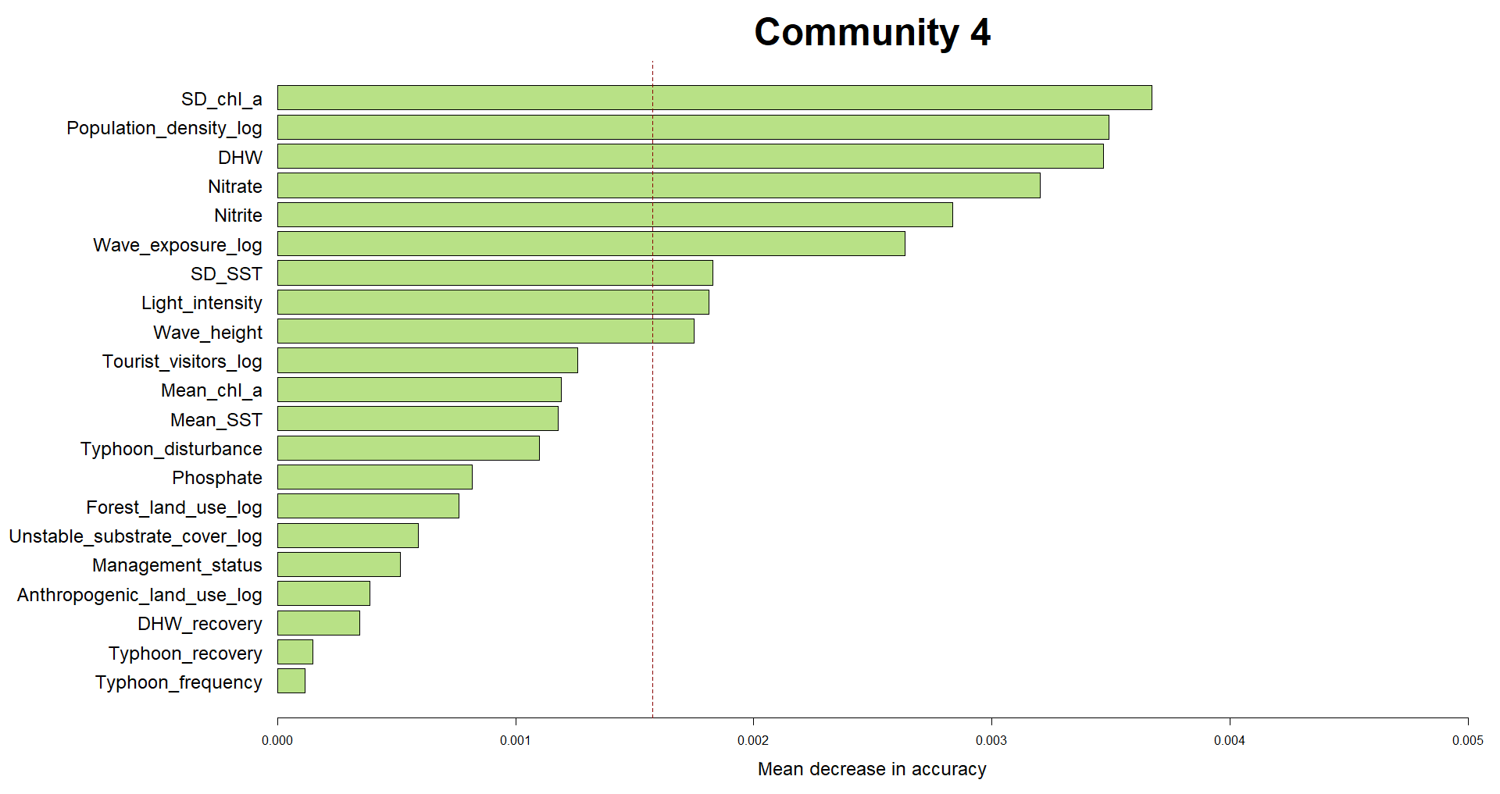 Figure J.5. The importance of environmental factors in individual CRF of the Digitate Octocoral community. Red dashed lines indicate the mean importance of all environmental factors.

Figure J.6. The importance of environmental factors in individual CRF of the Bushy Octocoral community. Red dashed lines indicate the mean importance of all environmental factors.

Appendix K. Partial dependence plots showing the partial dependency of environmental factors on delineated communities.
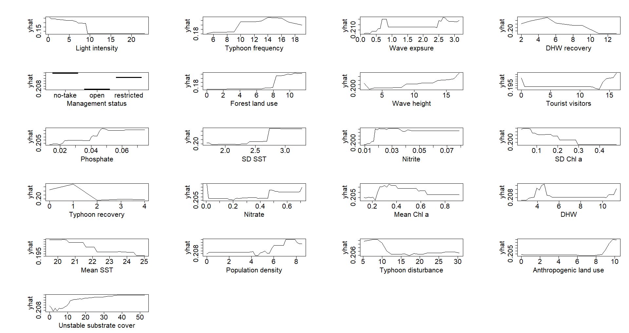
Figure K.1. The partial dependency of environmental factors on the CCA community. The sequence of plots follows the importance of environmental factors (the most to the least importance: top left to bottom right).

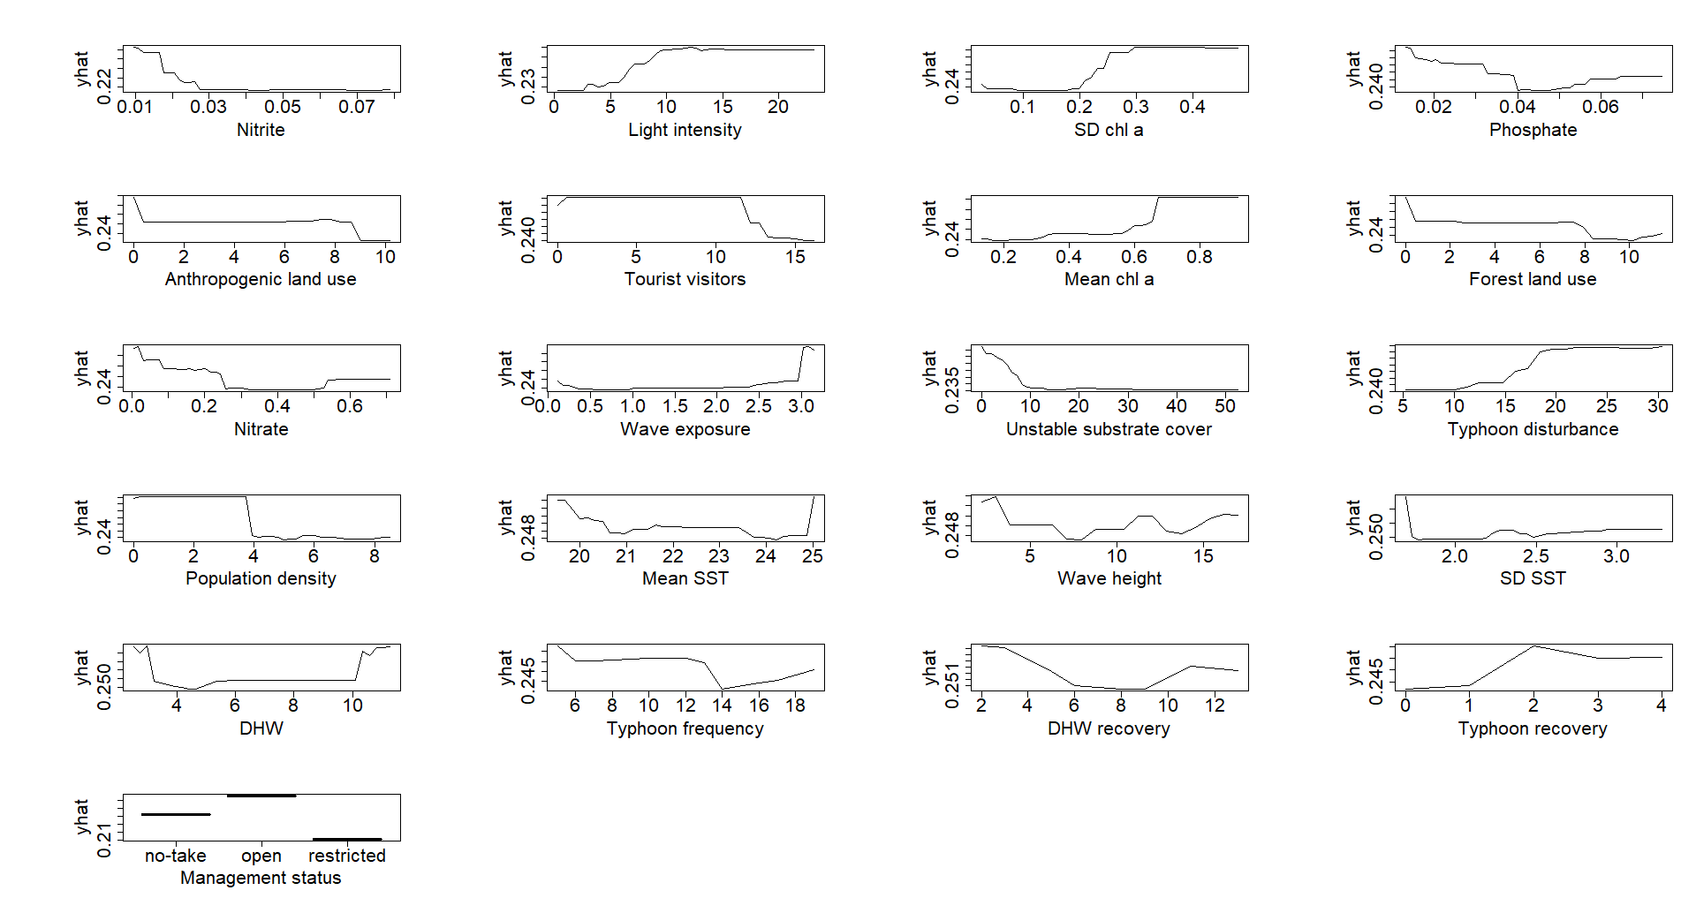
Figure K.2. The partial dependency of environmental factors on the Turf and Stony Coral community. The sequence of plots follows the importance of environmental factors (the most to the least importance: top left to bottom right).

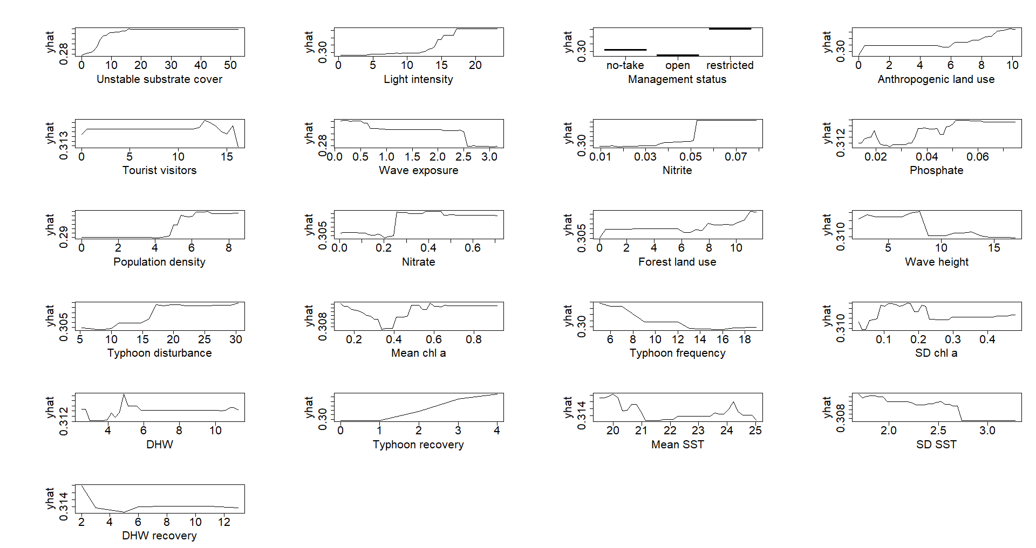 Figure K.3. The partial dependency of environmental factors on the Turf community. The sequence of plots follows the importance of environmental factors (the most to the least importance: top left to bottom right).

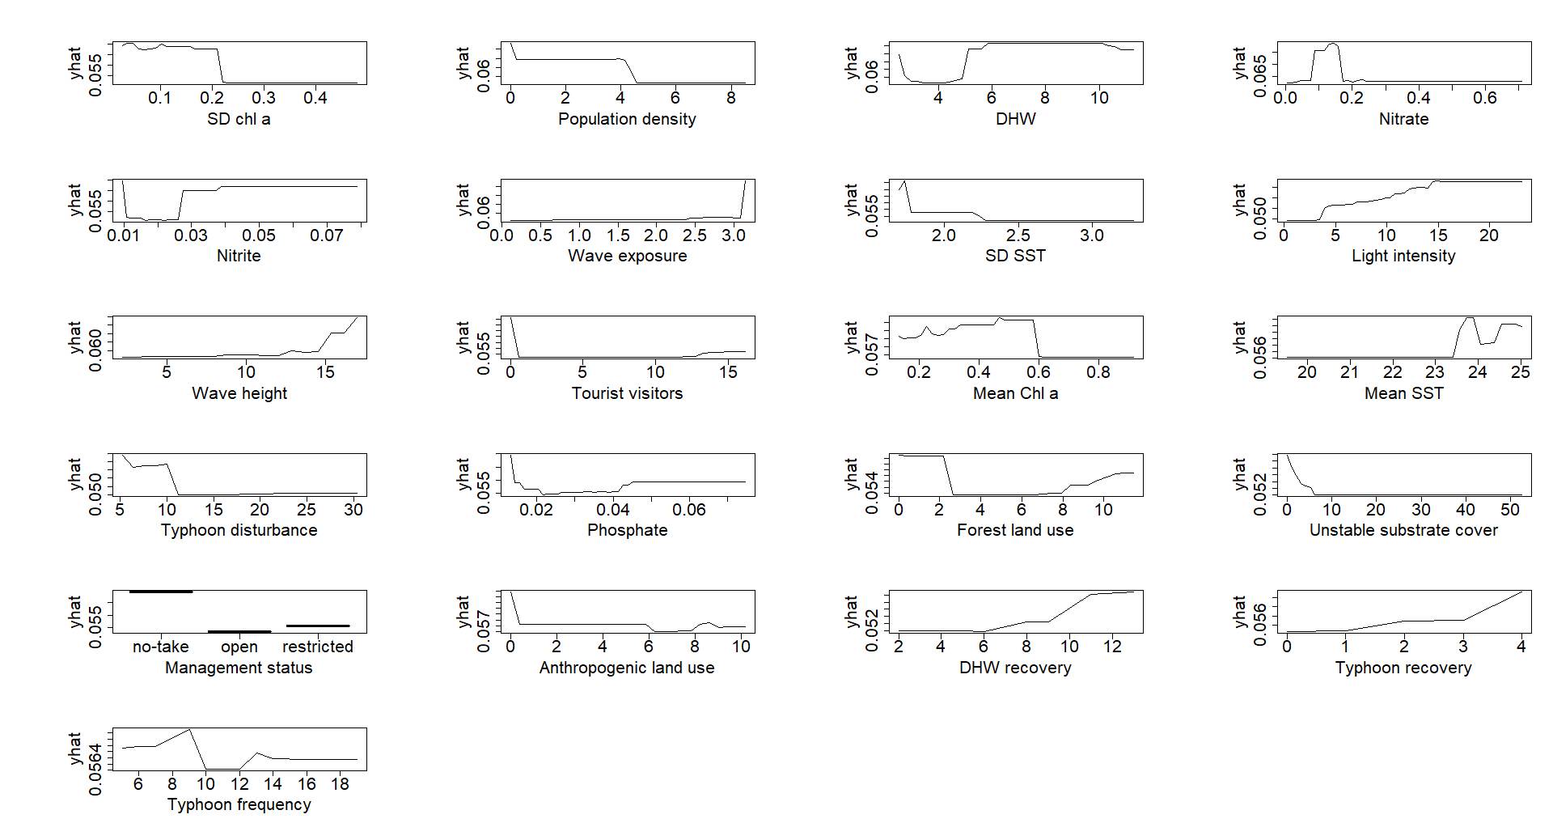
Figure K.4. The partial dependency of environmental factors on the Digitate Octocoral community. The sequence of plots follows the importance of environmental factors (the most to the least importance: top left to bottom right).

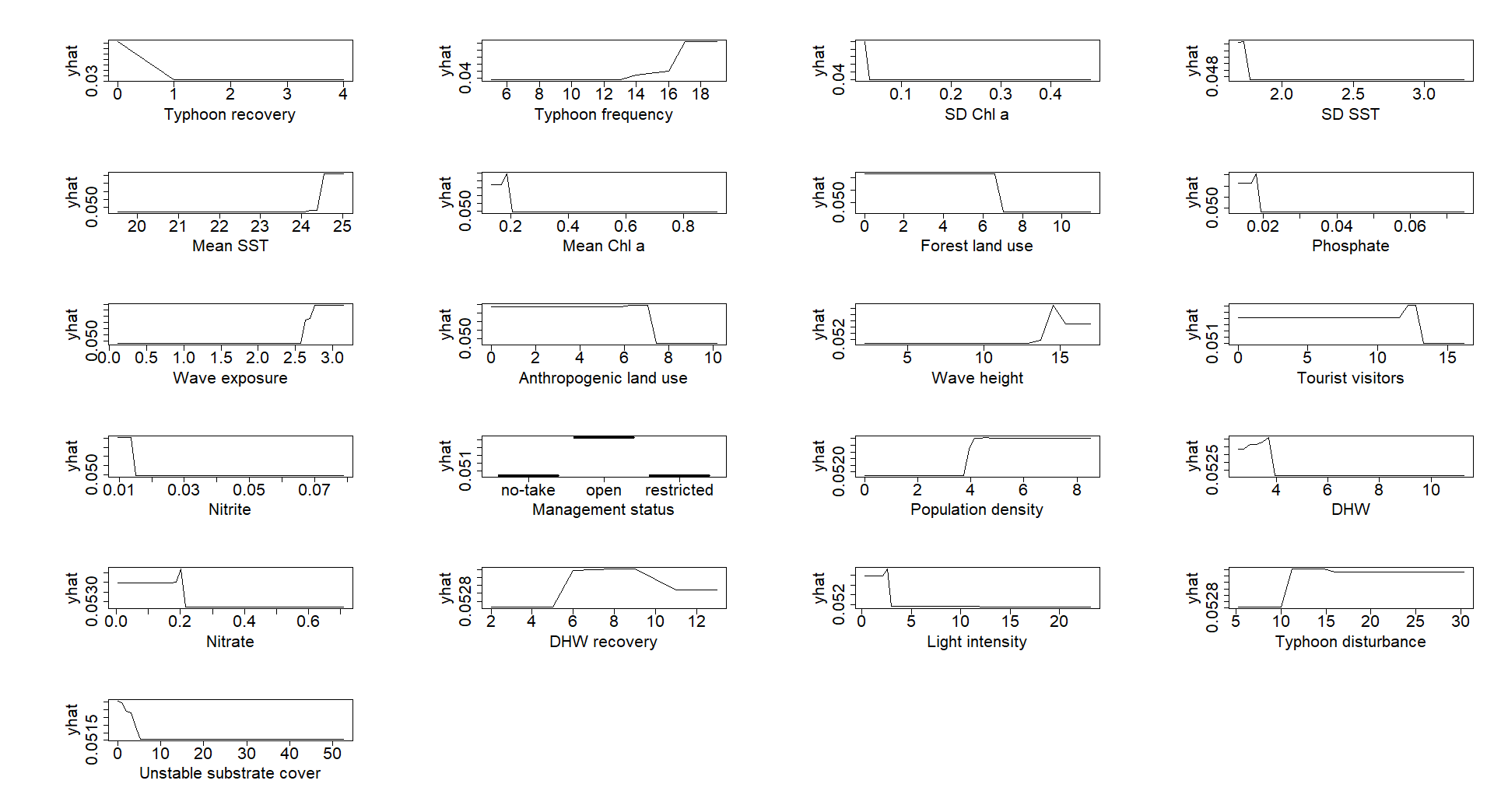
Figure K.5. The partial dependency of environmental factors on the Bushy Octocoral community. The sequence of plots follows the importance of environmental factors (the most to the least importance: top left to bottom right).

