2.1

A processing sketch translates the movement of an on screen ball to the tilt of an servo motor, which holds a box containing a cylindrical game piece, causing the piece to roll according the position of the on screen ball.

|  |  |
| --- | --- |
| MacOSX:Users:jacklambermont:Downloads:gg:JPEG:20150228_131559.jpg | MacOSX:Users:jacklambermont:Downloads:gg:JPEG:20150228_131601.jpg |
| MacOSX:Users:jacklambermont:Downloads:gg:JPEG:20150228_134359.jpg | MacOSX:Users:jacklambermont:Downloads:gg:JPEG:20150228_134348.jpg |

|  |  |
| --- | --- |
| MacOSX:Users:jacklambermont:Downloads:gg:JPEG:20150228_134828.jpg | MacOSX:Users:jacklambermont:Downloads:gg:JPEG:20150228_134917.jpg |

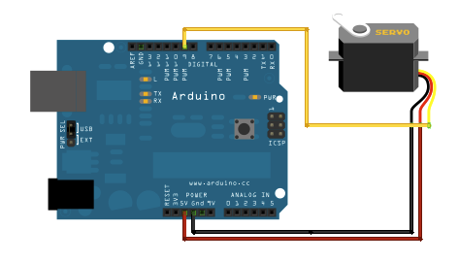

processing code:

<https://github.com/landermint/DGIF-2B03---Lab-5/blob/master/sketch_2_1/sketch_2_1.pde>

arduino code:

<https://github.com/landermint/DGIF-2B03---Lab-5/blob/master/_2.1/_2.1.ino>

2.2

A light sensor allows for the opening and closing of a mouth in processing, as well as an adjustment of the background brightness.

|  |  |
| --- | --- |
| MacOSX:Users:jacklambermont:Downloads:gg:JPEG:20150303_161041.jpg | MacOSX:Users:jacklambermont:Downloads:gg:JPEG:20150303_161031.jpg |

