

**CSEE Undergraduate Advising Project**

**Team**

**Daniel Lesko**

**Josh Weesner**

**Victor Gee**

**By Daniel Lesko**

**For CSMC 331 – Lupoli**

**Table of Contents**

**Wire Frame Design………………………...1**

**Use Case Diagram………………………….2**

**Student Advising Webpage………………3**

**Database Setup……………………………..4**

**Presentation Video Link…………………..5**

**Wire Frame Design**

index.php

**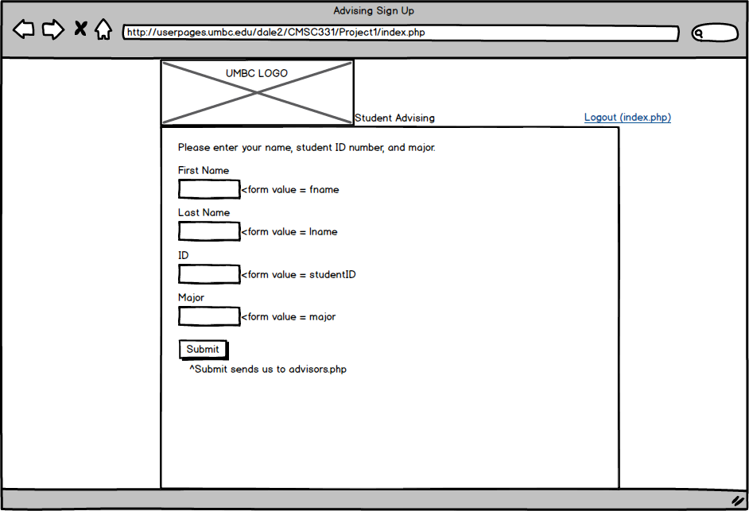**

advisors.php – view if no appointment has been made yet**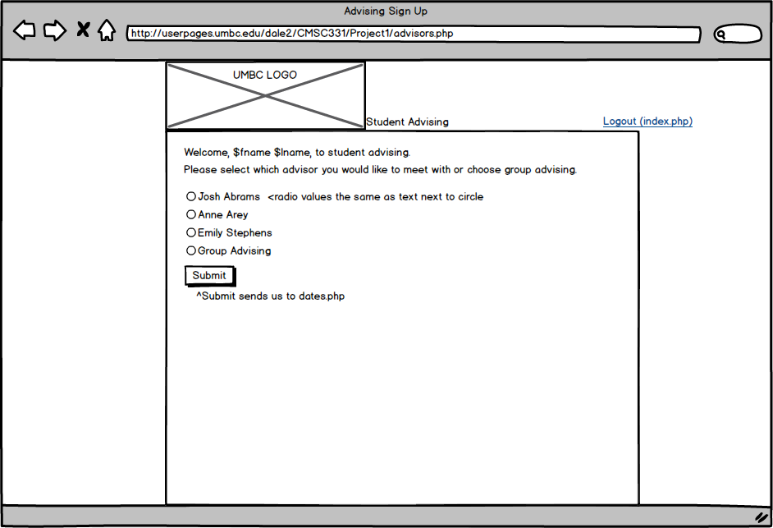**

readvisors.php – same page as advisors.php but this receives session data from

results.php

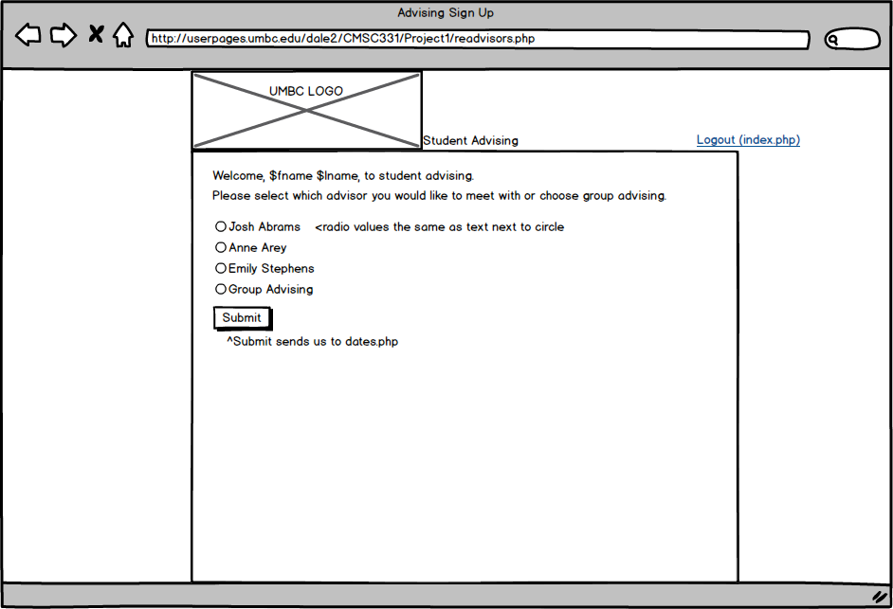

advising.php – view if an appointment has already been made

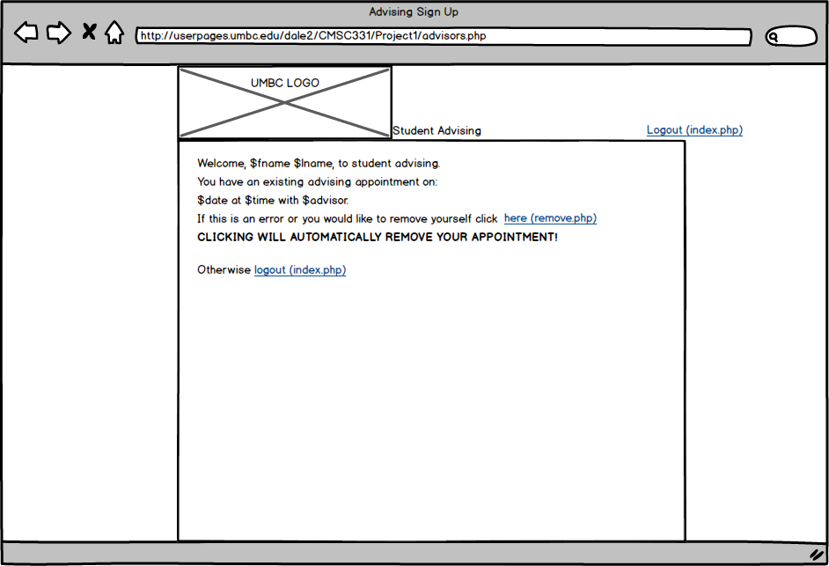

dates.php

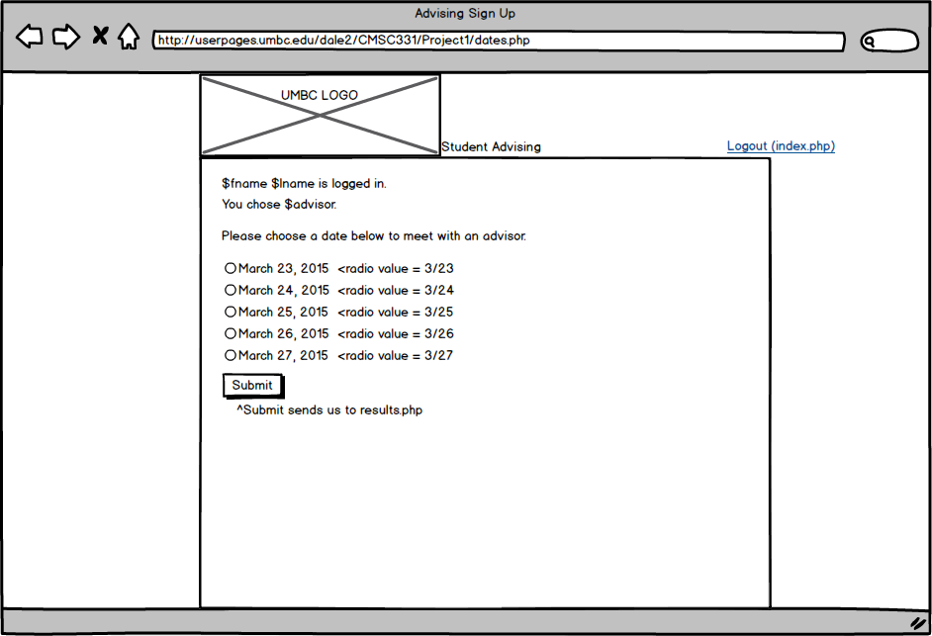

results.php

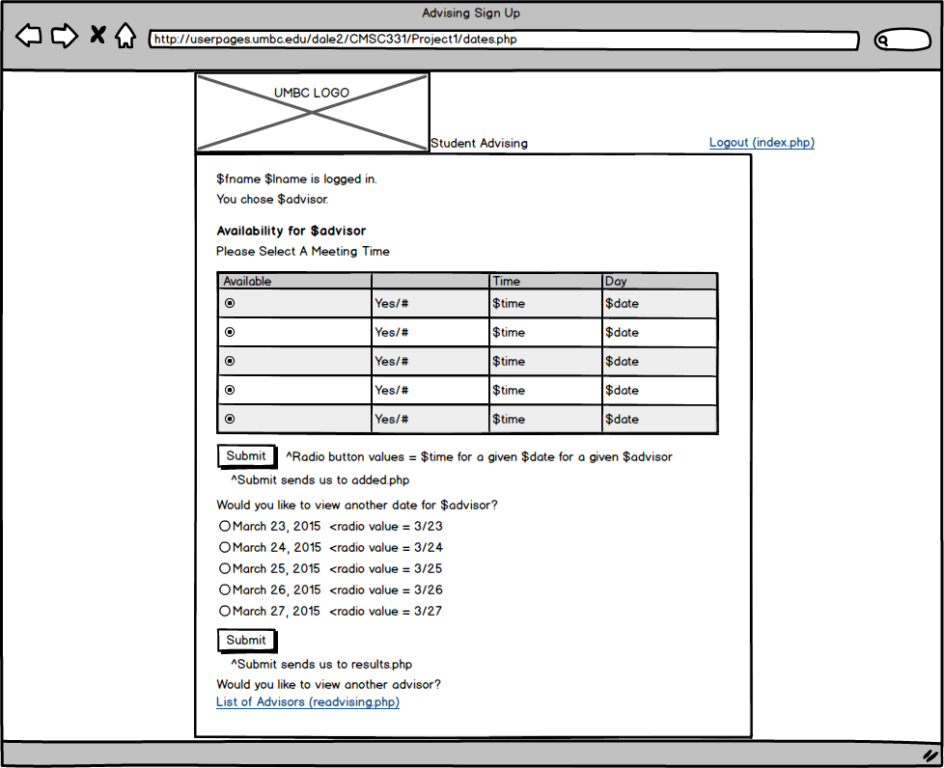

added.php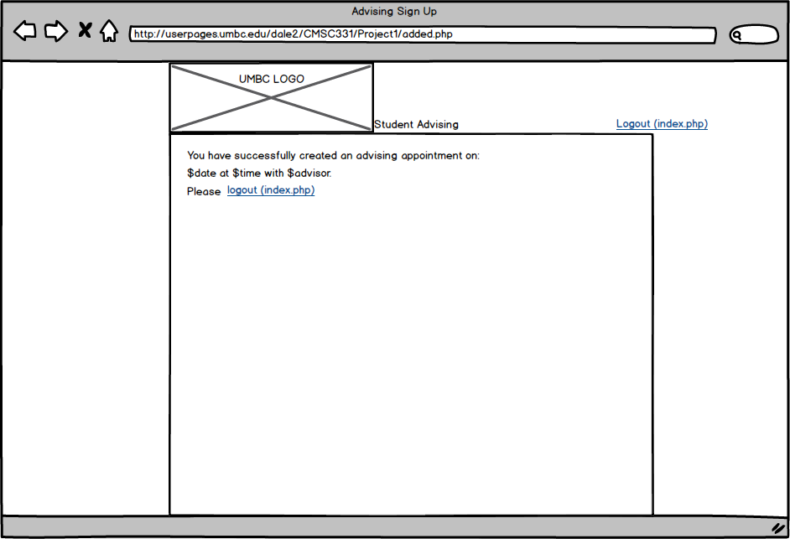

remove.php

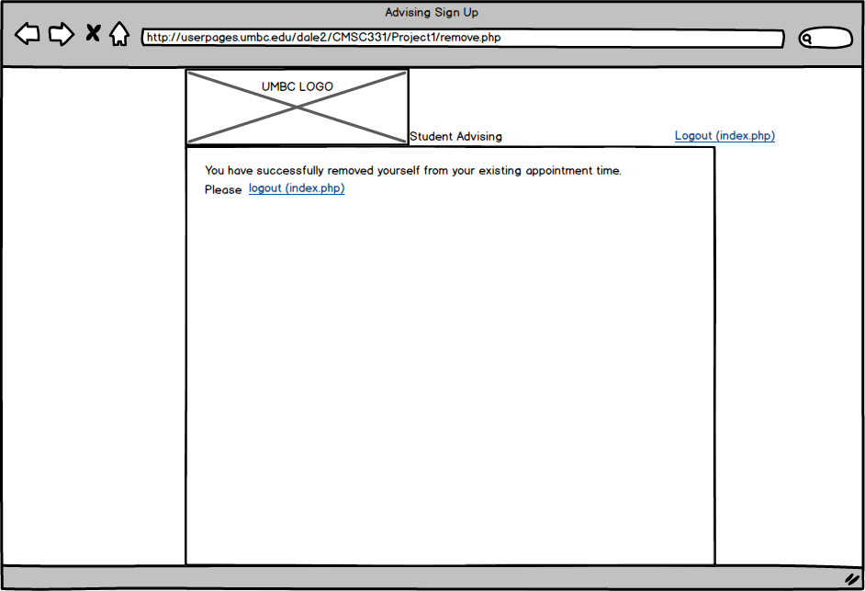

**Use Case Diagram**

**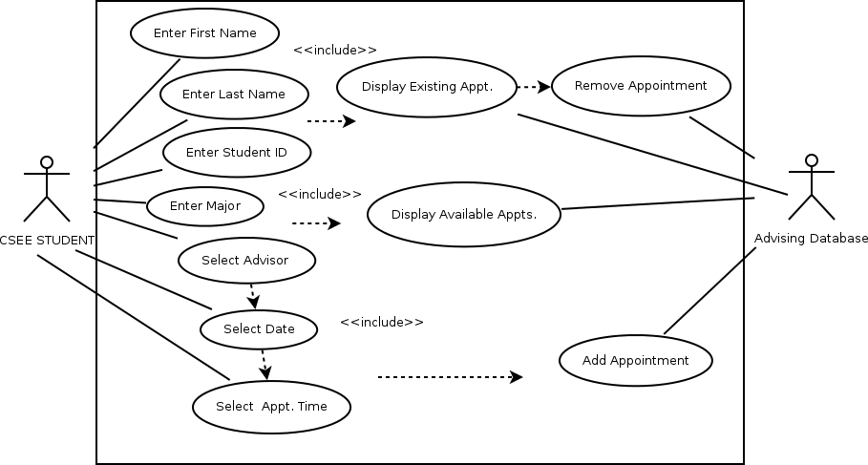**

The student enters their first name, last name, student ID, and major. The website sends the information to the database to determine whether an appointment has already been made. If so, the current appointment is displayed and the option to remove the appointment appears. Otherwise the student will select an advisor, a date, and a then a time to meet with the advisor from a list of available appointments supplied by the database. Once the student selects an appointment they will be added to the database.

**Student Advising Webpage**

**Challenges**

Determining how to pass variables between pages was a challenge at first until I found out how to do PHP sessions. It was also a challenge determining how I was going to display the data in the database in my website tables such as the number of group advising appointments still available for a given time slot. I found some nice queries that returned exactly the data that I needed to display. I also feel as if my project goes above and beyond because there is an error trap to see if a student has already made an appointment when they reenter their information and if so, it displays the appointment information along with an option to remove, but it was difficult to determine an easy way to do this.

**Adding A Student For One On One Advising**

(Josh Weesner for example) – index.php

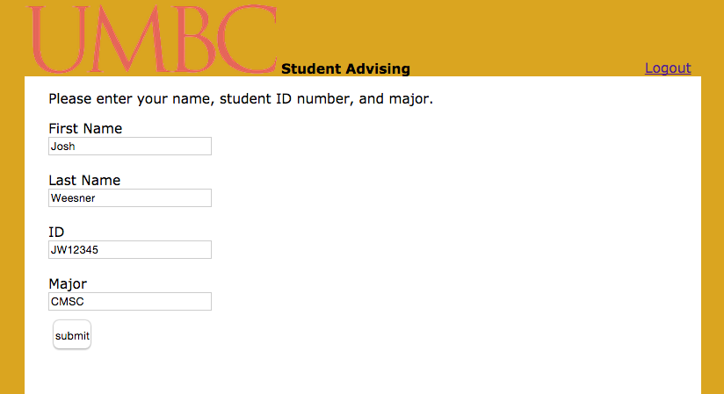

Selecting An Advisor (Josh Abrams) – advisors.php

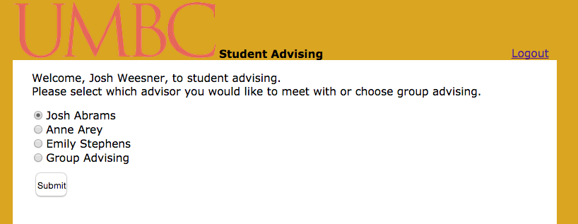

Selecting A Date (March 23, 2015) – dates.php

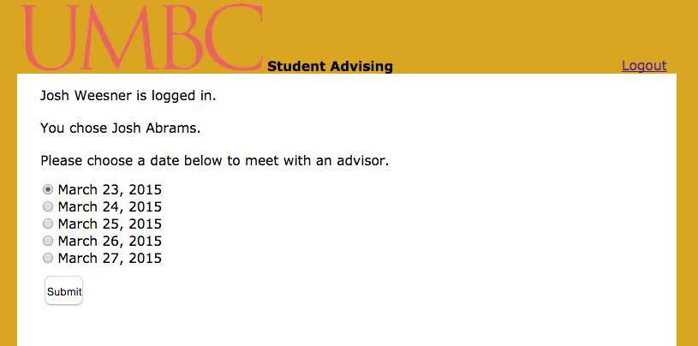

Selecting A Time (09:00 AM) And Creating the Appointment – results.php

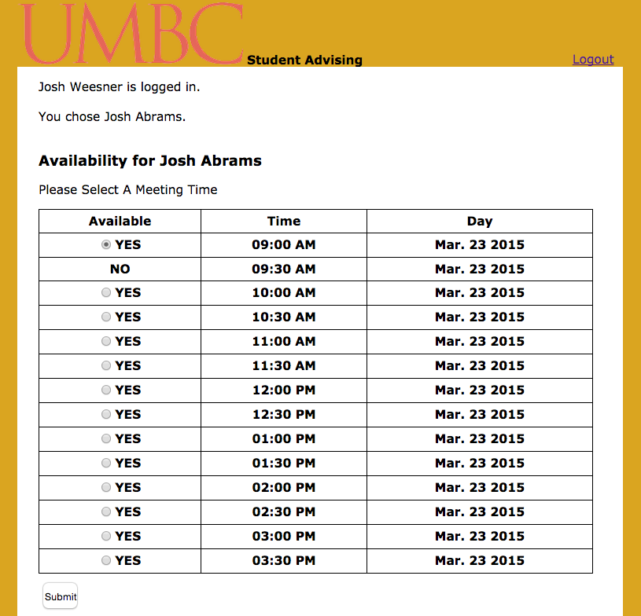

Success Message and Reiterating The Appointment Specs – added.php

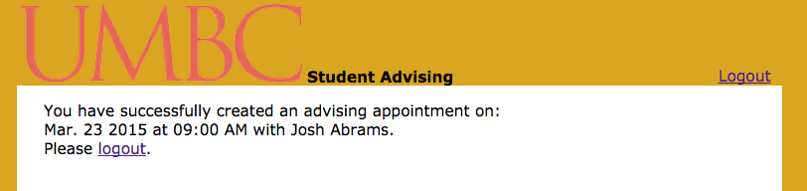

**Adding A Student For Group Advising**

(Victor Gee for example) – index.php

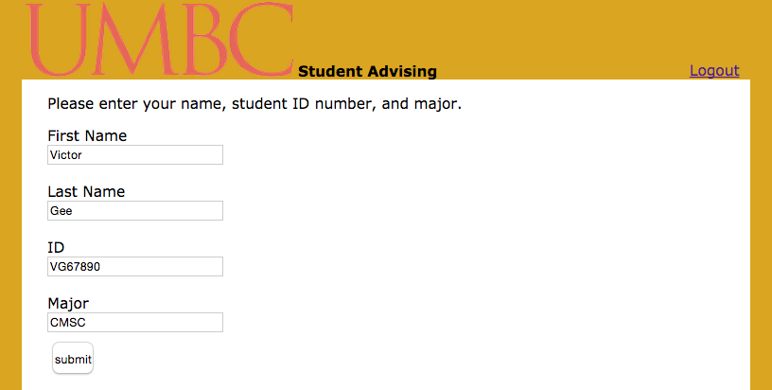

Selecting Group Advising – advisors.php

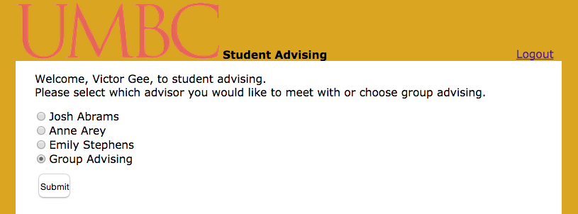

Selecting A Date (March 23, 2015) – dates.php

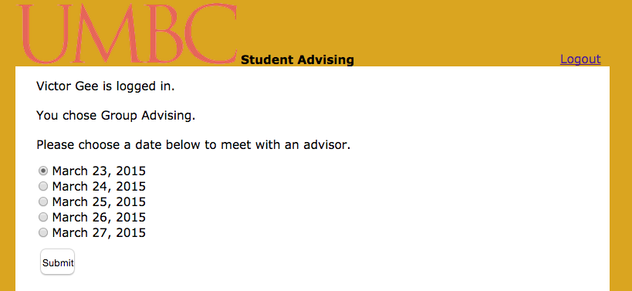

Selecting A Time (01:00 PM) and Creating an Appointment – results.php

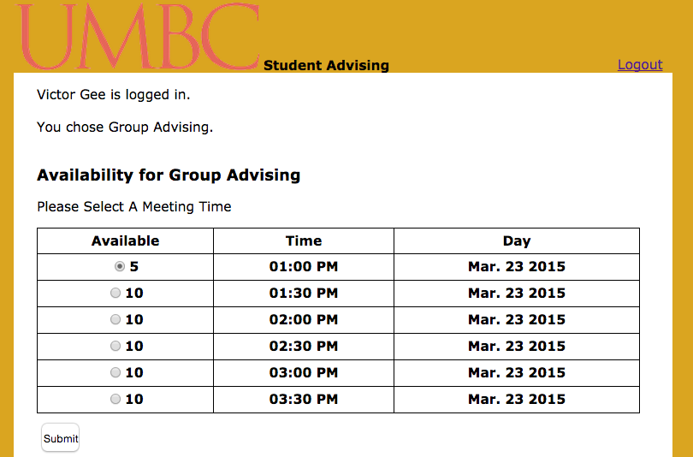

Success Message and Reiterating The Appointment Specs – added.php

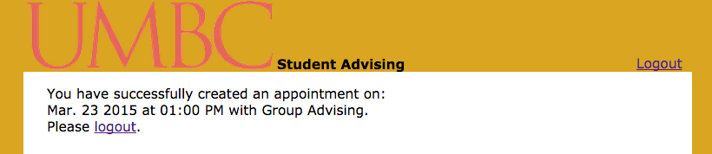

**If Student Has Already Created An Appointment:**

(Josh Weesner for Example) – index.php

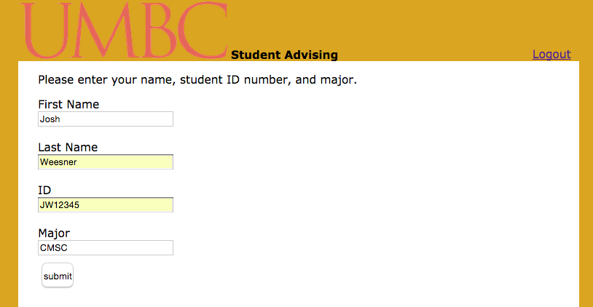

Previous Appointment Is Displayed, Option to Remove – advisors.php

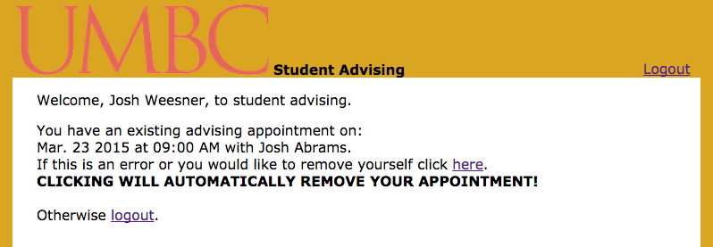

Removal of Appointment – remove.php

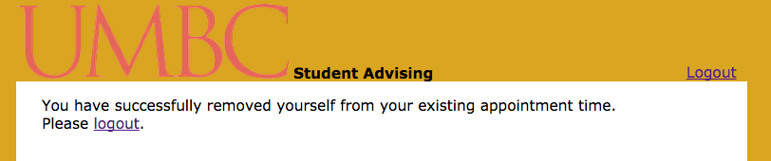

**Table Display After Student is Added for One on One**

After Josh Weesner created an appointment with Josh Abrams in the example above another student would see the table appear as such: – results.php

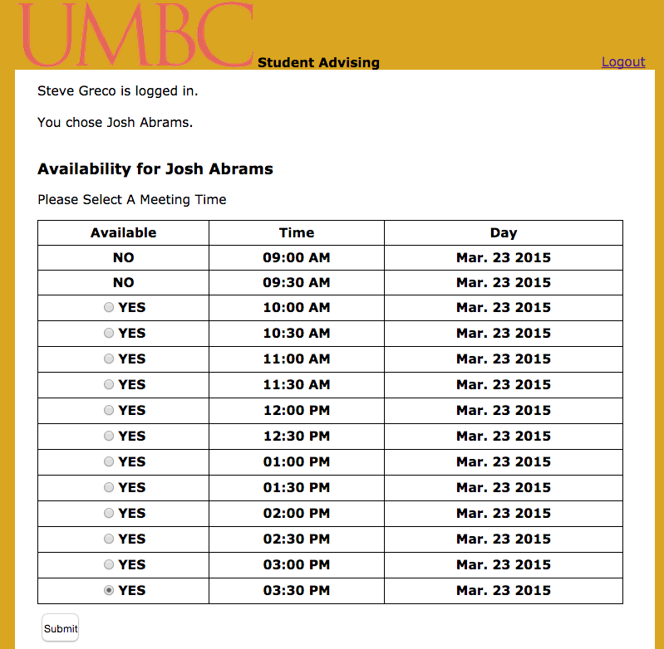

Notice how the appointment availability changed from “Yes” with a radio box to simply “No”

**Table Display After Student is Added for Group Advising**

After Victor Gee created an appointment with Group Advising in the example above another student would see the table appear as such: – results.php

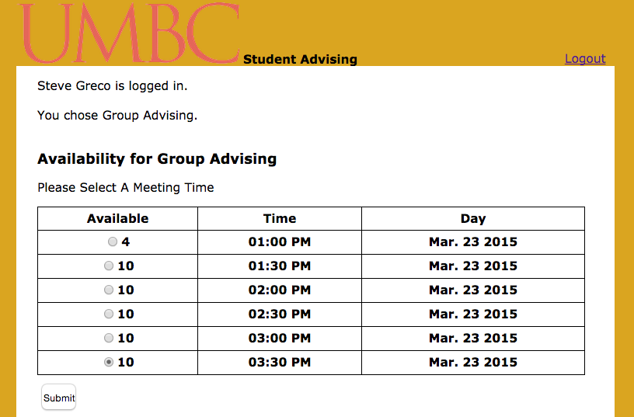

Notice how the number of available slots changed from “5” to “4”.

When all the slots are taken up for group advising a 0 will be displayed without a radio button as seen below: - results.php

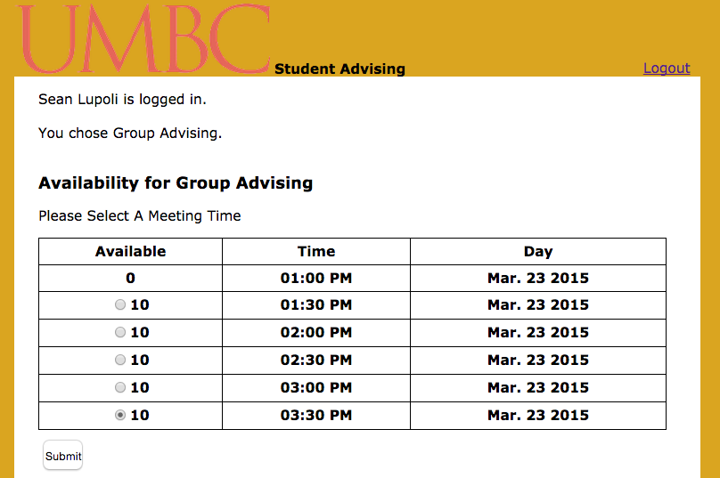

If a student does not find an available appointment they want they can choose to look at another date or go back to the list of advisors page. – results.php



**Code**

**index.php**

<!DOCTYPE html PUBLIC "-//W3C//DTD XHTML 1.0 Transitional//EN"

"http://www.w3.org/TR/xhtml1/DTD/xhtml1-transitional.dtd">

<html xmlns="http://www.w3.org/1999/xhtml" xml:lang="en" lang="en">

<head>

<title>Advising Sign Up</title>

<!-- ============================================================== -->

<meta name="resource-type" content="document" />

<meta name="distribution" content="global" />

<meta http-equiv="Content-Type" content="text/html; charset=ISO-8859-1" />

<meta http-equiv="Content-Language" content="en-us" />

<meta name="description" content="UMBC Advising" />

<meta name="keywords" content="UMBC, Advising" />

<!-- ============================================================== -->

<base target="\_top" />

<link rel="stylesheet" type="text/css" href="styler.css" />

<base target="\_top" />

<link rel="stylesheet" type="text/css" href="template.css" />

<link rel="icon" type="image/png" href="icon.png" />

</head>

<body>

<!-- Styling - Same on Every Page -->

<div class="topContainer">

<div class="leftTopContainer">

<img src="umbcLogo.png" width="261" height="72" alt="umbcLogo" />

<b>Student Advising</b>

</div>

<div class="rightTopContainer">

<div class="rightTopContent">

<a href="index.php">Logout</a>

</div>

</div>

</div>

<div class="container">

<div class="inner-container">

<!-- Form to enter student first name, lastname, ID, and major -->

<p>

Please enter your name, student ID number, and major.<br>

<form action="advisors.php" method="post" name="Form1">

First Name <br>

<input type="text" size="25" maxlength="50" name="fname"><br> <br />

Last Name <br>

<input type="text" size="25" maxlength="50" name="lname"><br> <br />

ID <br>

<input type="text" size="25" maxlength="10" name="studentID"><br> <br />

Major <br>

<input type="text" size="25" maxlength="4" name="major"><br> <br />

<input type='submit' value='submit'>

</form>

<br /><br />

</p>

</div>

</div>

</body>

</html>

**advisors.php**

<?php

session\_start();

?>

<!-- ^^ starts a php session for data to be passed between pages -->

<!DOCTYPE html PUBLIC "-//W3C//DTD XHTML 1.0 Transitional//EN"

"http://www.w3.org/TR/xhtml1/DTD/xhtml1-transitional.dtd">

<html xmlns="http://www.w3.org/1999/xhtml" xml:lang="en" lang="en">

<head>

<title>Advising Sign Up</title>

<!-- ============================================================== -->

<meta name="resource-type" content="document" />

<meta name="distribution" content="global" />

<meta http-equiv="Content-Type" content="text/html; charset=ISO-8859-1" />

<meta http-equiv="Content-Language" content="en-us" />

<meta name="description" content="UMBC Advising" />

<meta name="keywords" content="UMBC, Advising" />

<!-- ============================================================== -->

<base target="\_top" />

<link rel="stylesheet" type="text/css" href="styler.css" />

<base target="\_top" />

<link rel="stylesheet" type="text/css" href="template.css" />

<link rel="icon" type="image/png" href="icon.png" />

</head>

<body>

<div class="topContainer">

<div class="leftTopContainer">

<img src="umbcLogo.png" width="261" height="72" alt="umbcLogo" />

<b>Student Advising</b>

</div>

<div class="rightTopContainer">

<div class="rightTopContent">

<a href="index.php">Logout</a>

</div>

</div>

</div>

<div class="container">

<div class="inner-container">

<p>

<?php

//Allows us to connect to the database

include('../CommonMethods.php');

$debug = false;

$COMMON = new Common($debug);

//Accepts data from form on index.php

$fname = ($\_POST['fname']);

$lname = ($\_POST['lname']);

$studentID = strtoupper(($\_POST['studentID']));

$major = ($\_POST['major']);

//Creates session variables to be passed between pages

$\_SESSION['studentID'] = $studentID;

$\_SESSION['fname'] = $fname;

$\_SESSION['lname'] = $lname;

$\_SESSION['major'] = $major;

echo ("Welcome, " . $fname . " " . $lname . ", to student advising.<br>");

//These variables are used to check if a student already has an appointment and will accept advisor name

$letsSee = 0;

$advisorName = "";

$realName= "";

//MUST EDIT THIS TO ADD ANY NEW ADVISOR NAMES

$advisorArray = array("jAbrams", "aArey", "eStephens", "gAdvising");

//This is a loop to check each database to see if a student has already signed up for an advising appt.

//CHECKS EVERY ADVISOR TABLE, MUST ADD ADVISOR TO ARRAY IF YOU ADD ANOTHER ADVISOR

for ($i = 0; $i < count($advisorArray); $i++ )

{

//This counts each instance student ID shows up

$sql = "SELECT count(\*), '$advisorArray[$i]' as `$advisorArray[$i]` FROM `$advisorArray[$i]` WHERE `studentID` = '$studentID'";

$rs = $COMMON->executeQuery($sql, $\_SERVER["SCRIPT\_NAME"]);

$isThere = mysql\_fetch\_row($rs);

//If there is an instance it gets added to $letsSee and the advisor name gets instantiated

if ($isThere[0] > 0)

{

$letsSee += $isThere[0];

$advisorName = $isThere[1];

}

}

//If the student already has an existing appointment

if ($letsSee > 0)

{

//We query the database the get the information about the appointment

$sql = "SELECT TIME\_FORMAT(`time` , '%h:%i %p') , DATE\_FORMAT( `date` , '%b. %d %Y' )

FROM `$advisorName`

WHERE `studentID` = '$studentID'";

$rs = $COMMON->executeQuery($sql, $\_SERVER["SCRIPT\_NAME"]);

$apptTime = mysql\_fetch\_row($rs);

echo("<p>You have an existing advising appointment on: <br> $apptTime[1] at $apptTime[0] with");

//MUST EDIT THIS TO ADD ANY NEW ADVISOR NAMES

//This is formattting for the advisor name

if($advisorName == "gAdvising"){

$realName = "Group Advising";

}

else if ($advisorName == "jAbrams"){

$realName = "Josh Abrams";

}

else if ($advisorName == "eStephens"){

$realName = "Emily Stephens";

}

else if ($advisorName == "aArey"){

$realName = "Anne Arey";

}

$\_SESSION['advisorName'] = $advisorName;

echo(" $realName.<br>

If this is an error or you would like to remove yourself click <a href='remove.php'>here</a>.<br>

<b>CLICKING WILL AUTOMATICALLY REMOVE YOUR APPOINTMENT!</b><br><br>

Otherwise <a href='index.php'>logout</a>.<br>");

}

else

{

echo("Please select which advisor you would like to meet with or choose group advising.");

//Radio buttons to select which advisor the student wants to see

//MUST EDIT TO ADD ANY NEW ADVISOR NAMES TO THE LIST

echo("<form action='dates.php' method='post' name='Form1'>

<input type='radio' name='advisor' value='Josh Abrams' checked>Josh Abrams

<br>

<input type='radio' name='advisor' value='Anne Arey'>Anne Arey

<br>

<input type='radio' name='advisor' value='Emily Stephens'>Emily Stephens

<br>

<input type='radio' name='advisor' value='Group Advising'>Group Advising

<br> <br />

<input type='submit' name='submit' value='Submit'>

</form>");

}

?>

<br /> <br />

<!-- MUST EDIT THIS TO ADD ANY NEW ADVISOR NAMES -->

<!-- Radio buttons to select which advisor the student wants to see

<form action="dates.php" method="post" name="Form1">

<input type="radio" name="advisor" value="Josh Abrams" checked>Josh Abrams

<br>

<input type="radio" name="advisor" value="Anne Arey">Anne Arey

<br>

<input type="radio" name="advisor" value="Emily Stephens">Emily Stephens

<br>

<input type="radio" name="advisor" value="Group Advising">Group Advising

<br> <br />

<input type="submit" name="submit" value="Submit">

</form> -->

</p>

</div>

</div>

</body>

</html>

**readvisors.php**

<?php

session\_start();

?>

<!DOCTYPE html PUBLIC "-//W3C//DTD XHTML 1.0 Transitional//EN"

"http://www.w3.org/TR/xhtml1/DTD/xhtml1-transitional.dtd">

<html xmlns="http://www.w3.org/1999/xhtml" xml:lang="en" lang="en">

<head>

<title>Advising Sign Up</title>

<!-- ============================================================== -->

<meta name="resource-type" content="document" />

<meta name="distribution" content="global" />

<meta http-equiv="Content-Type" content="text/html; charset=ISO-8859-1" />

<meta http-equiv="Content-Language" content="en-us" />

<meta name="description" content="UMBC Advising" />

<meta name="keywords" content="UMBC, Advising" />

<!-- ============================================================== -->

<base target="\_top" />

<link rel="stylesheet" type="text/css" href="styler.css" />

<base target="\_top" />

<link rel="stylesheet" type="text/css" href="template.css" />

<link rel="icon" type="image/png" href="icon.png" />

</head>

<body>

<div class="topContainer">

<div class="leftTopContainer">

<img src="umbcLogo.png" width="261" height="72" alt="umbcLogo" />

<b>Student Advising</b>

</div>

<div class="rightTopContainer">

<div class="rightTopContent">

<a href="index.php">Logout</a>

</div>

</div>

</div>

<div class="container">

<div class="inner-container">

<p>

<?php

//This page is different than advisor because we are not accepting post data,

//Instead we are accepting session data from results.php

//accepts session variables

$fname = ($\_SESSION['fname']);

$lname = ($\_SESSION['lname']);

$studentID = ($\_SESSION['studentID']);

$major = ($\_SESSION['major']);

//recreates the variables for the next page

$\_SESSION['studentID'] = $studentID;

$\_SESSION['fname'] = $fname;

$\_SESSION['lname'] = $lname;

$\_SESSION['major'] = $major;

echo ("Welcome, " . $fname . " " . $lname . ", to student advising.");

?>

<br /> <br />

Please select which advisor you would like to meet with or choose group advising.

<br /><br />

<!-- MUST EDIT THIS TO ADD ANY NEW ADVISOR NAMES -->

<!-- Radio form to allow student to choose advisor -->

<form action="dates.php" method="post" name="Form1">

<input type="radio" name="advisor" value="Josh Abrams" checked>Josh Abrams

<br>

<input type="radio" name="advisor" value="Anne Arey">Anne Arey

<br>

<input type="radio" name="advisor" value="Emily Stephens">Emily Stephens

<br>

<input type="radio" name="advisor" value="Group Advising">Group Advising

<br> <br />

<input type="submit" name="submit" value="Submit">

</form>

</p>

</div>

</div>

</body>

</html>

**dates.php**

<?php

session\_start();

?>

<!DOCTYPE html PUBLIC "-//W3C//DTD XHTML 1.0 Transitional//EN"

"http://www.w3.org/TR/xhtml1/DTD/xhtml1-transitional.dtd">

<html xmlns="http://www.w3.org/1999/xhtml" xml:lang="en" lang="en">

<head>

<title>Advising Sign Up</title>

<!-- ============================================================== -->

<meta name="resource-type" content="document" />

<meta name="distribution" content="global" />

<meta http-equiv="Content-Type" content="text/html; charset=ISO-8859-1" />

<meta http-equiv="Content-Language" content="en-us" />

<meta name="description" content="UMBC Advising" />

<meta name="keywords" content="UMBC, Advising" />

<!-- ============================================================== -->

<base target="\_top" />

<link rel="stylesheet" type="text/css" href="styler.css" />

<base target="\_top" />

<link rel="stylesheet" type="text/css" href="template.css" />

<link rel="icon" type="image/png" href="icon.png" />

</head>

<body>

<div class="topContainer">

<div class="leftTopContainer">

<img src="umbcLogo.png" width="261" height="72" alt="umbcLogo" />

<b>Student Advising</b>

</div>

<div class="rightTopContainer">

<div class="rightTopContent">

<a href="index.php">Logout</a>

</div>

</div>

</div>

<div class="container">

<div class="inner-container">

<p>

<?php

//accepts session and post data here

$fname = ($\_SESSION['fname']);

$lname = ($\_SESSION['lname']);

$studentID = ($\_SESSION['studentID']);

$major = ($\_SESSION['major']);

$advisor = ($\_POST['advisor']);

//recreates new session data here

$\_SESSION['studentID'] = $studentID;

$\_SESSION['fname'] = $fname;

$\_SESSION['lname'] = $lname;

$\_SESSION['major'] = $major;

$\_SESSION['advisor'] = $advisor;

echo($fname . " " . $lname . " is logged in.");

echo("<br \n> <br \n>");

//reiterates what advisor the student chose

echo ("You chose " . $advisor . ".");

echo ("<br><br>");

echo ("Please choose a date below to meet with an advisor.");

//Radio for to allow student to choose what date they would like to meet with the advisor

//For the scope of this project I have created 5 different days students can meet with advisor

//MUST EDIT THIS TO ADD MORE DATES IN!!

echo("

<form action='results.php' method='post' name='Form1'>

<input type='radio' name='date' value='3/23' checked>March 23, 2015

<br>

<input type='radio' name='date' value='3/24'>March 24, 2015

<br>

<input type='radio' name='date' value='3/25'>March 25, 2015

<br>

<input type='radio' name='date' value='3/26'>March 26, 2015

<br>

<input type='radio' name='date' value='3/27'>March 27, 2015

<br> <br />

<input type='submit' name='submit' value='Submit'>

</form> "

);

?>

</p>

</div>

</div>

</body>

</html>

**results.php**

<?php

session\_start();

?>

<!DOCTYPE html PUBLIC "-//W3C//DTD XHTML 1.0 Transitional//EN"

"http://www.w3.org/TR/xhtml1/DTD/xhtml1-transitional.dtd">

<html xmlns="http://www.w3.org/1999/xhtml" xml:lang="en" lang="en">

<head>

<title>Advising Sign Up</title>

<!-- ============================================================== -->

<meta name="resource-type" content="document" />

<meta name="distribution" content="global" />

<meta http-equiv="Content-Type" content="text/html; charset=ISO-8859-1" />

<meta http-equiv="Content-Language" content="en-us" />

<meta name="description" content="UMBC Advising" />

<meta name="keywords" content="UMBC, Advising" />

<!-- ============================================================== -->

<base target="\_top" />

<link rel="stylesheet" type="text/css" href="styler.css" />

<base target="\_top" />

<link rel="stylesheet" type="text/css" href="template.css" />

<link rel="icon" type="image/png" href="icon.png" />

</head>

<body>

<div class="topContainer">

<div class="leftTopContainer">

<img src="umbcLogo.png" width="261" height="72" alt="umbcLogo" />

<b>Student Advising</b>

</div>

<div class="rightTopContainer">

<div class="rightTopContent">

<a href="index.php">Logout</a>

</div>

</div>

</div>

<div class="container">

<div class="inner-container">

<p>

<?php

//We include this so we can log into our database

include('../CommonMethods.php');

$debug = false;

$COMMON = new Common($debug);

//Create variables to accept session and posted data

$date = ($\_POST['date']);

$fname = ($\_SESSION['fname']);

$lname = ($\_SESSION['lname']);

$studentID = ($\_SESSION['studentID']);

$major = ($\_SESSION['major']);

$advisor = ($\_SESSION['advisor']);

//Recreate session variables to send to the next page

$\_SESSION['studentID'] = $studentID;

$\_SESSION['fname'] = $fname;

$\_SESSION['lname'] = $lname;

$\_SESSION['major'] = $major;

$\_SESSION['date'] = $date;

$\_SESSION['advisor'] = $advisor;

//Algorithm to assign $sqlAdvisor a string based on which advisor the student previously chose

//This allows us to properly query our data base

//THIS MUST EDITTED TO ADD ANY NEW ADVISORS

if ($advisor == "Josh Abrams")

{

$sqlAdvisor = "jAbrams";

}

else if ($advisor == "Anne Arey")

{

$sqlAdvisor = "aArey";

}

else if ($advisor == "Emily Stephens")

{

$sqlAdvisor = "eStephens";

}

else if ($advisor == "Group Advising")

{

$sqlAdvisor = "gAdvising";

}

//creates session variable of $sqlAdvisor for later use

$\_SESSION['sqlAdvisor'] = $sqlAdvisor;

//Assigns chose dates to an $sqlDate so we can properly query our database

//MUST BE EDITTED TO ADD ANY NEW DATES

if ($date == "3/23")

{

$sqlDate = "2015-03-23";

}

else if ($date == "3/24")

{

$sqlDate = "2015-03-24";

}

else if ($date == "3/25")

{

$sqlDate = "2015-03-25";

}

else if ($date == "3/26")

{

$sqlDate = "2015-03-26";

}

else if ($date == "3/27")

{

$sqlDate = "2015-03-27";

}

//creates session variable of $sqlDate for later use

$\_SESSION['sqlDate'] = $sqlDate;

//Reiterates name who who student chose

echo($fname . " " . $lname . " is logged in.");

echo("<br \n> <br \n>");

echo ("You chose " . $advisor . ".");

echo ("<br><br>");

echo ("<h3>Availability for " . $advisor . "</h3>");

echo ("<p>Please Select A Meeting Time</p>");

//If the student chose group advising

if ($sqlAdvisor == "gAdvising")

{

//This returns only one instance of each time in the database

$sql = "SELECT `date` , MAX( `time` )

FROM `gAdvising`

WHERE `date` = '$sqlDate'

GROUP BY `time`";

//This formats the time so it is easy for our user to understand

$sqlFormat = "SELECT DATE\_FORMAT( `date` , '%b. %d %Y' ) , MAX(TIME\_FORMAT(`time` , '%h:%i %p'))

FROM `gAdvising`

WHERE `date` = '$sqlDate'

GROUP BY `time`";

//Calls to the database

$rs = $COMMON->executeQuery($sql, $\_SERVER["SCRIPT\_NAME"]);

$rsFormat = $COMMON->executeQuery($sqlFormat, $\_SERVER["SCRIPT\_NAME"]);

//Tables setup

echo ("<table style='width:95%'>

<tr> <th>Available</th>

<th>Time</th>

<th>Day</th>

</tr>");

echo("<form action='added.php' method='post' name='Form1'>");

while (($row = mysql\_fetch\_row($rs)) && ($rowFormat = mysql\_fetch\_row($rsFormat)))

{

echo("<tr>");

//This counts the number of available slots for the group advising appointments

$sql2 = "SELECT COUNT( `available` )

FROM `gAdvising`

WHERE `time` = '$row[1]'

AND `date` = '$row[0]' AND `available` = 1";

//Calls to the data base

$rs2 = $COMMON->executeQuery($sql2, $\_SERVER["SCRIPT\_NAME"]);

$row2 = mysql\_fetch\_row($rs2);

//Row formatting, if there is an available slot, put a radio button for the table

if ($row2[0] > 0)

{

echo("<th><input type='radio' name='time' value='$row[1]' checked>".$row2[0]."</th>");

}

else

{

echo("<th>".$row2[0]."</th>");

}

echo("<th>".$rowFormat[1]."</th>");

echo("<th>".$rowFormat[0]."</th>");

echo("</tr>");

}

echo("</table><br>");

echo("<input type='submit' name='submit' value='Submit'>");

echo("</form> <br><br>");

}

//If the student chose anything else except group advising

else

{

//This queries for the properly formatted time and date

$sqlFormat = "SELECT `available` , TIME\_FORMAT(`time` , '%h:%i %p') , DATE\_FORMAT( `date` , '%b. %d %Y' )

FROM `$sqlAdvisor`

WHERE `date` = '$sqlDate'";

//Regular query

$sqlTime = "SELECT `available` , `time` , `date`

FROM `$sqlAdvisor`

WHERE `date` = '$sqlDate'";

//Call to the database

$rsFormat = $COMMON->executeQuery($sqlFormat, $\_SERVER["SCRIPT\_NAME"]);

$rsTime = $COMMON->executeQuery($sqlTime, $\_SERVER["SCRIPT\_NAME"]);

//Table setup

echo ("<table style='width:95%'>

<tr> <th>Available</th>

<th>Time</th>

<th>Day</th>

</tr>");

//Form setup

echo("<form action='added.php' method='post' name='Form1'>");

while (($rowFormat = mysql\_fetch\_row($rsFormat)) && ($rowTime = mysql\_fetch\_row($rsTime)))

{

echo("<tr>");

//More formatting for the table, puts a yes or no if available

for ($i = 0; $i<count($rowFormat); $i++)

{

if ($rowFormat[0] == 1)

{

$rowFormat[0] = "YES";

}

else if ($rowFormat[0] == 0)

{

$rowFormat[0] = "NO";

}

//If a slot is available make the option to choose the slot

if ($i == 0)

{

if ($rowFormat[0] == "YES")

{

echo("<th><input type='radio' name='time' value='$rowTime[1]' checked>".$rowFormat[$i]."</th>");

}

else

{

echo("<th>".$rowFormat[$i]."</th>");

}

}

else

{

echo("<th>".$rowFormat[$i]."</th>");

}

}

echo("</tr>");

}

echo("</table><br>");

echo("<input type='submit' name='submit' value='Submit'>");

echo("</form> <br><br>");

}

//Allow the user to pick a different date if they would like

//MUST BE EDITTED IF MORE DATES ARE TO BE ADDED!!!!

echo ("Would you like to view another date for $advisor? <br>");

echo("

<form action='results.php' method='post' name='Form1'>

<input type='radio' name='date' value='3/23' checked>March 23, 2015

<br>

<input type='radio' name='date' value='3/24'>March 24, 2015

<br>

<input type='radio' name='date' value='3/25'>March 25, 2015

<br>

<input type='radio' name='date' value='3/26'>March 26, 2015

<br>

<input type='radio' name='date' value='3/27'>March 27, 2015

<br> <br />

<input type='submit' name='submit' value='Submit'>

</form> <br>");

//Links back to llst of advisors

echo ("Would you like to view another advisor? <br>");

echo("<a href='readvisors.php'>List of Advisors</a>");

?>

</p>

</div>

</div>

</body>

</html>

**added.php**

<?php

session\_start();

?>

<!DOCTYPE html PUBLIC "-//W3C//DTD XHTML 1.0 Transitional//EN"

"http://www.w3.org/TR/xhtml1/DTD/xhtml1-transitional.dtd">

<html xmlns="http://www.w3.org/1999/xhtml" xml:lang="en" lang="en">

<head>

<title>Advising Sign Up</title>

<!-- ============================================================== -->

<meta name="resource-type" content="document" />

<meta name="distribution" content="global" />

<meta http-equiv="Content-Type" content="text/html; charset=ISO-8859-1" />

<meta http-equiv="Content-Language" content="en-us" />

<meta name="description" content="UMBC Advising" />

<meta name="keywords" content="UMBC, Advising" />

<!-- ============================================================== -->

<base target="\_top" />

<link rel="stylesheet" type="text/css" href="styler.css" />

<base target="\_top" />

<link rel="stylesheet" type="text/css" href="template.css" />

<link rel="icon" type="image/png" href="icon.png" />

</head>

<body>

<div class="topContainer">

<div class="leftTopContainer">

<img src="umbcLogo.png" width="261" height="72" alt="umbcLogo" />

<b>Student Advising</b>

</div>

<div class="rightTopContainer">

<div class="rightTopContent">

<a href="index.php">Logout</a>

</div>

</div>

</div>

<div class="container">

<div class="inner-container">

<p>

<?php

//Stage1

//$var\_dump($\_POST);

//Stage2

include('../CommonMethods.php');

$debug = false;

$COMMON = new Common($debug);

//Accepts session and posted data

$time = ($\_POST['time']);

$date = ($\_SESSION['date']);

$fname = ($\_SESSION['fname']);

$lname = ($\_SESSION['lname']);

$studentID = ($\_SESSION['studentID']);

$major = ($\_SESSION['major']);

$advisor = ($\_SESSION['advisor']);

$sqlAdvisor = ($\_SESSION['sqlAdvisor']);

$sqlDate = ($\_SESSION['sqlDate']);

//Recreates instance of session data

$\_SESSION['studentID'] = $studentID;

$\_SESSION['fname'] = $fname;

$\_SESSION['lname'] = $lname;

$\_SESSION['major'] = $major;

$\_SESSION['date'] = $date;

$\_SESSION['advisor'] = $advisor;

//These variables are used to check if a student already has an appointment and will accept advisor name

$letsSee = 0;

$advisorName = "";

$realName= "";

//MUST EDIT THIS TO ADD ANY NEW ADVISOR NAMES

$advisorArray = array("jAbrams", "aArey", "eStephens", "gAdvising");

//This is a loop to check each database to see if a student has already signed up for an advising appt.

//CHECKS EVERY ADVISOR TABLE, MUST ADD ADVISOR TO ARRAY IF YOU ADD ANOTHER ADVISOR

for ($i = 0; $i < count($advisorArray); $i++ )

{

//This counts each instance student ID shows up

$sql = "SELECT count(\*), '$advisorArray[$i]' as `$advisorArray[$i]` FROM `$advisorArray[$i]` WHERE `studentID` = '$studentID'";

$rs = $COMMON->executeQuery($sql, $\_SERVER["SCRIPT\_NAME"]);

$isThere = mysql\_fetch\_row($rs);

//If there is an instance it gets added to $letsSee and the advisor name gets instantiated

if ($isThere[0] > 0)

{

$letsSee += $isThere[0];

$advisorName = $isThere[1];

}

}

//If the student already has an existing appointment

if ($letsSee > 0)

{

//We query the database the get the information about the appointment

$sql = "SELECT TIME\_FORMAT(`time` , '%h:%i %p') , DATE\_FORMAT( `date` , '%b. %d %Y' )

FROM `$advisorName`

WHERE `studentID` = '$studentID'";

$rs = $COMMON->executeQuery($sql, $\_SERVER["SCRIPT\_NAME"]);

$apptTime = mysql\_fetch\_row($rs);

echo("<p>You have an existing advising appointment on: <br> $apptTime[1] at $apptTime[0] with");

//MUST EDIT THIS TO ADD ANY NEW ADVISOR NAMES

//This is formattting for the advisor name

if($advisorName == "gAdvising"){

$realName = "Group Advising";

}

else if ($advisorName == "jAbrams"){

$realName = "Josh Abrams";

}

else if ($advisorName == "eStephens"){

$realName = "Emily Stephens";

}

else if ($advisorName == "aArey"){

$realName = "Anne Arey";

}

$\_SESSION['advisorName'] = $advisorName;

echo(" $realName.<br>

If this an error please remove yourself by clicking <a href='remove.php'>here</a>.

<b>CLICKING WILL AUTOMATICALLY REMOVE YOUR APPOINTMENT!</b><br><br>

Otherwise <a href='index.php'>logout</a>.<br>");

}

//If a student doesn't have an existing appointment and they chose group advising

else if ($sqlAdvisor == "gAdvising")

{

//Finds the first available appointment slot for group advising

$sql = "SELECT `apptNum`

FROM `gAdvising`

WHERE `available` = '1'

AND `time` = '$time'

AND `date` = '$sqlDate'

LIMIT 1";

$rs = $COMMON->executeQuery($sql, $\_SERVER["SCRIPT\_NAME"]);

$apptNum = mysql\_fetch\_row($rs);

//Update the appointment as necessary

$sql = "UPDATE `dale2`.`$sqlAdvisor` SET `studentID` = '$studentID',

`fname` = '$fname',

`lname` = '$lname',

`major` = '$major',

`available` = '0' WHERE `apptNum` = '$apptNum[0]'";

$rs = $COMMON->executeQuery($sql, $\_SERVER["SCRIPT\_NAME"]);

//Requeries the database to pull all the information about the appointment

$sql = "SELECT TIME\_FORMAT(`time` , '%h:%i %p') , DATE\_FORMAT( `date` , '%b. %d %Y' )

FROM `$sqlAdvisor`

WHERE `apptNum` = '$apptNum[0]'";

$rs = $COMMON->executeQuery($sql, $\_SERVER["SCRIPT\_NAME"]);

$apptTime = mysql\_fetch\_row($rs);

//Reiterates the chosen appointment time to the student then asks them to logout

echo("You have successfully created an appointment on:<br>

$apptTime[1] at $apptTime[0] with Group Advising. <br>

Please <a href='index.php'>logout</a>.");

}

//If the student chose any other advisor besides group advising

else

{

//We update the correct appointment time

$sql = "UPDATE `dale2`.`$sqlAdvisor` SET `studentID` = '$studentID',

`fname` = '$fname',

`lname` = '$lname',

`major` = '$major',

`available` = '0' WHERE `time` ='$time' AND `date` = '$sqlDate'";

$rs = $COMMON->executeQuery($sql, $\_SERVER["SCRIPT\_NAME"]);

//Requery the database to get the appointment information

$sql = "SELECT TIME\_FORMAT(`time` , '%h:%i %p') , DATE\_FORMAT( `date` , '%b. %d %Y' )

FROM `$sqlAdvisor`

WHERE `time` ='$time' AND `date` = '$sqlDate'";

$rs = $COMMON->executeQuery($sql, $\_SERVER["SCRIPT\_NAME"]);

$apptTime = mysql\_fetch\_row($rs);

//Reiterate the appointment information back to the student to make sure all is well

echo("You have successfully created an advising appointment on: <br> $apptTime[1] at $apptTime[0] with");

//MUST EDIT THIS TO ADD ANY NEW ADVISOR NAMES

if($sqlAdvisor == "gAdvising"){

$realName = "Group Advising";

}

else if ($sqlAdvisor == "jAbrams"){

$realName = "Josh Abrams";

}

else if ($sqlAdvisor == "eStephens"){

$realName = "Emily Stephens";

}

else if ($sqlAdvisor == "aArey"){

$realName = "Anne Arey";

}

echo(" $realName.<br>Please <a href='index.php'>logout</a>.");

}

?>

</p>

</div>

</div>

</body>

</html>

**remove.php**

<?php

session\_start();

?>

<!DOCTYPE html PUBLIC "-//W3C//DTD XHTML 1.0 Transitional//EN"

"http://www.w3.org/TR/xhtml1/DTD/xhtml1-transitional.dtd">

<html xmlns="http://www.w3.org/1999/xhtml" xml:lang="en" lang="en">

<head>

<title>Advising Sign Up</title>

<!-- ============================================================== -->

<meta name="resource-type" content="document" />

<meta name="distribution" content="global" />

<meta http-equiv="Content-Type" content="text/html; charset=ISO-8859-1" />

<meta http-equiv="Content-Language" content="en-us" />

<meta name="description" content="UMBC Advising" />

<meta name="keywords" content="UMBC, Advising" />

<!-- ============================================================== -->

<base target="\_top" />

<link rel="stylesheet" type="text/css" href="styler.css" />

<base target="\_top" />

<link rel="stylesheet" type="text/css" href="template.css" />

<link rel="icon" type="image/png" href="icon.png" />

</head>

<body>

<div class="topContainer">

<div class="leftTopContainer">

<img src="umbcLogo.png" width="261" height="72" alt="umbcLogo" />

<b>Student Advising</b>

</div>

<div class="rightTopContainer">

<div class="rightTopContent">

<a href="index.php">Logout</a>

</div>

</div>

</div>

<div class="container">

<div class="inner-container">

<p>

<?php

include('../CommonMethods.php');

$debug = false;

$COMMON = new Common($debug);

//Accepts session data

$fname = ($\_SESSION['fname']);

$lname = ($\_SESSION['lname']);

$studentID = ($\_SESSION['studentID']);

$major = ($\_SESSION['major']);

//Recreate session variables although this is not needed at this point

$\_SESSION['studentID'] = $studentID;

$\_SESSION['fname'] = $fname;

$\_SESSION['lname'] = $lname;

$\_SESSION['major'] = $major;

//Recreates the advising array

//MUST BE EDITTED IF MORE ADVISORS ARE TO BE ADDED!!!

$advisorArray = array("jAbrams", "aArey", "eStephens", "gAdvising");

//Much like when we are checking for an existing appointment

//We find if there has already been an appointment created

for ($i = 0; $i < count($advisorArray); $i++ )

{

$sql = "SELECT count(\*), '$advisorArray[$i]' as `$advisorArray[$i]` FROM `$advisorArray[$i]` WHERE `studentID` = '$studentID'";

$rs = $COMMON->executeQuery($sql, $\_SERVER["SCRIPT\_NAME"]);

$isThere = mysql\_fetch\_row($rs);

//If there is we set $letsSee to 1 and set the advisor name.

if ($isThere[0] > 0)

{

$letsSee += $isThere[0];

$advisorName = $isThere[1];

}

}

//If $letsSee is greater than 0 the previous appointment gets deleted

if ($letsSee > 0)

{

//Updates database to remove student information from appt slot

$sql = "UPDATE `dale2`.`$advisorName` SET `studentID` = NULL,

`fname` = NULL,

`lname` = NULL,

`major` = NULL,

`available` = '1' WHERE `studentID` ='$studentID'";

$rs = $COMMON->executeQuery($sql, $\_SERVER["SCRIPT\_NAME"]);

//Displays message that removal was successful

echo("You have successfully removed yourself from your existing appointment time. <br>Please <a href='index.php'>logout</a>.");

}

//Otherwise the student did not have an appointment to remove

else

{

echo("You did not have an existing advising appointment. <br>Please <a href='index.php'>logout</a>.");

}

?>

</p>

</div>

</div>

</body>

</html>

**Database Setup**

**Challenges**

The largest challenge I faced was how to setup the tables themselves. I didn’t know if I wanted to do one large table or if I wanted to break the table up for each advisor. I opted for the latter and it ultimately seemed to be pretty effective. Once I created the tables the real challenge was coding the website, not with the database.

**Before a Student Is Added**

**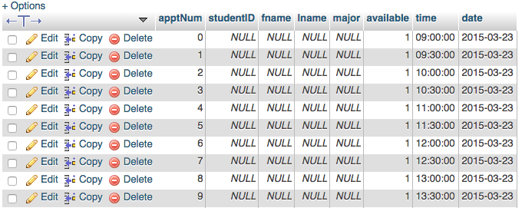**

**After a Student Is Added**

**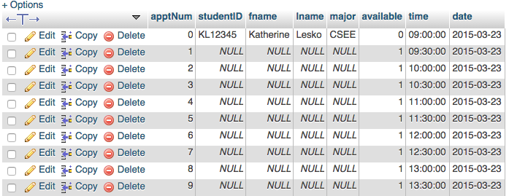**

**Structure**

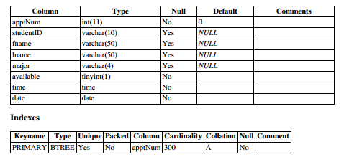

Above is the structure for all of the tables although there are 4 separate tables total. One each for Josh Abrams, Emily Stephens, Anne Arey, and Group Advising.

**Browse**

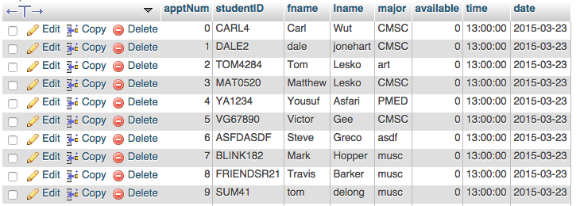

This is what a full appointment looks like for one group advising time slot. 10 students for 13:00:00 aka 1:00pm.

**Presentation Video Link**

[http://youtu.be/4NKGs1IoKAM](http://youtu.be/4NKGs1IoKAM" \t "_blank)