

**CSEE Undergraduate Advising Project**

**Part 2**

**Team**

**Daniel Lesko**

**David Learn**

**Yadikaer Yasheng**

**For CSMC 331 – Lupoli**

**Table of Contents**

**Web Page………………………………………3**

**Database Setup…………………………….17**

**Video Script………………………………….25**

**Web Page**

**Index.php**

Page to choose either student or advisor sign in. (Wouldn’t be seen in real life)

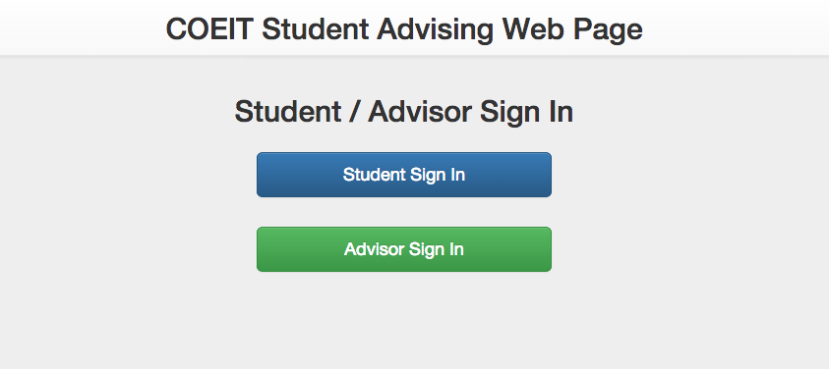

**Student View**

**studentIndex.php**

Accepts student information for advising sign up.

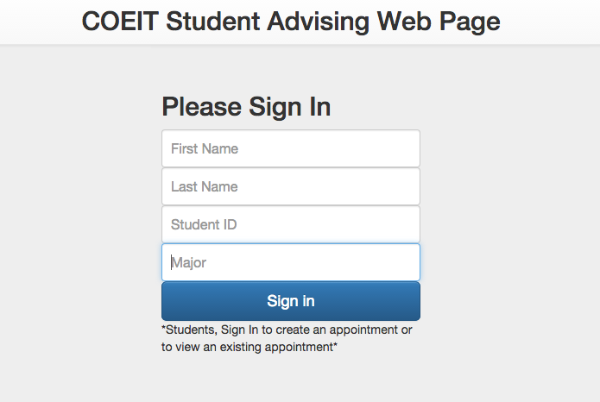

**schedule.php – Doesn’t have appointment**

This page shows the students what appointments are available by allowing them to select a date and then an appointment.

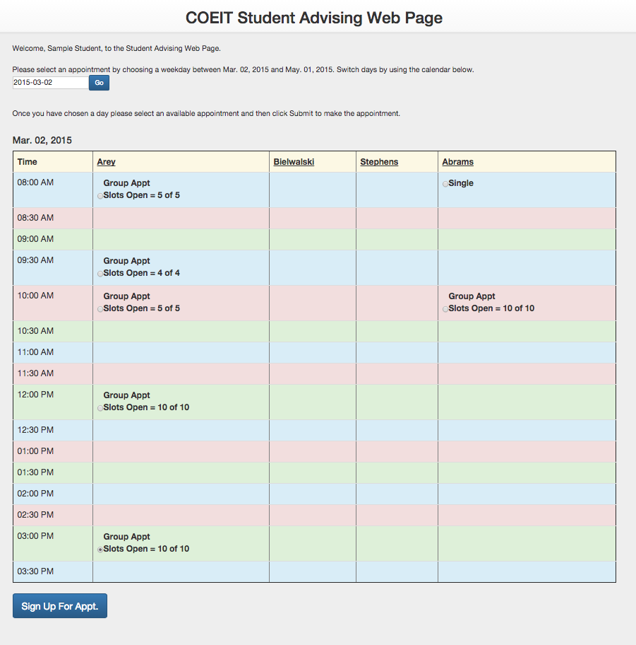

**schedule.php – Does have appointment**

If the student already has an appointment then the page displays the appointment information and gives them the option to remove the appointment.

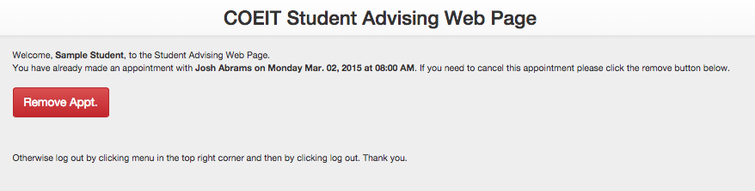

**added.php**

A success statement is created once the student makes an appointment and then gives them the option to remove it if it was a mistake.

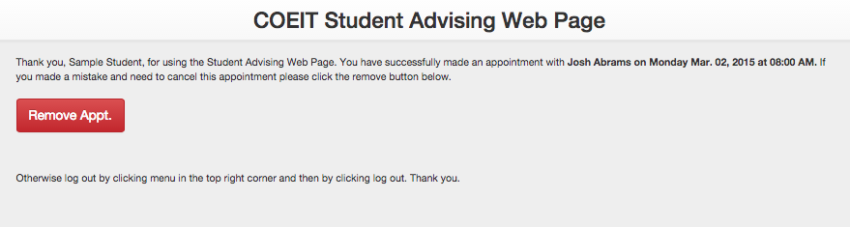

**remove.php**

If the student chooses to remove an appointment a similar message as above is displayed except this time it gives them the option to create a new appointment.

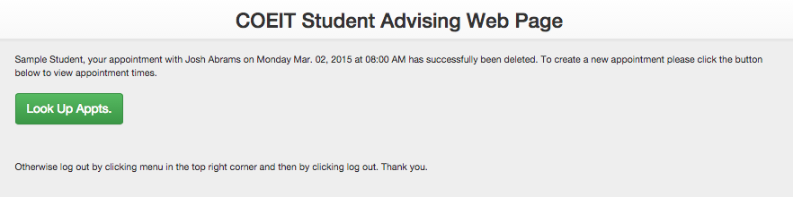

In the upper right hand corner of every student page a drop down menu displaying a link to more advisor information (hosted by UMBC) and a logout link (which goes back to studentIndex.php) is present as displayed below:

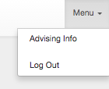

**Advisor View**

**advisorIndex.php**

Just another simple page to collect information about which advisor is using the page. (For the purposes of this project we allowed the advisors to go in and edit each other’s availability)

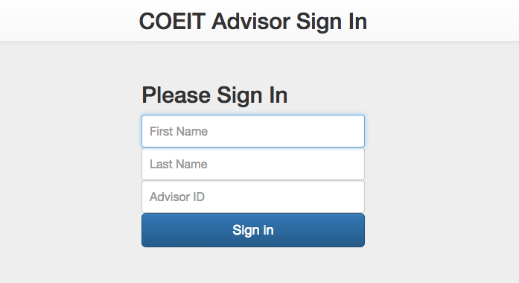

**advisorHome.php**

This page was the real body and backbone of the project. All of the useful tools for the advisors can be found on or from this page. Just like the student page, it also displays scheduled times for each advisor which can be singly printed. We also give the option to print the current week at a glance for all the advising staff or for just a single advisor. There is search bar that collects a student ID and displays student information in a new page, and in the menu for the advisors there are links to add and edit their availabilities as well as a home button (advisorHome.php) and a logout button (advisorIndex.php). (Shown below)

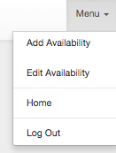

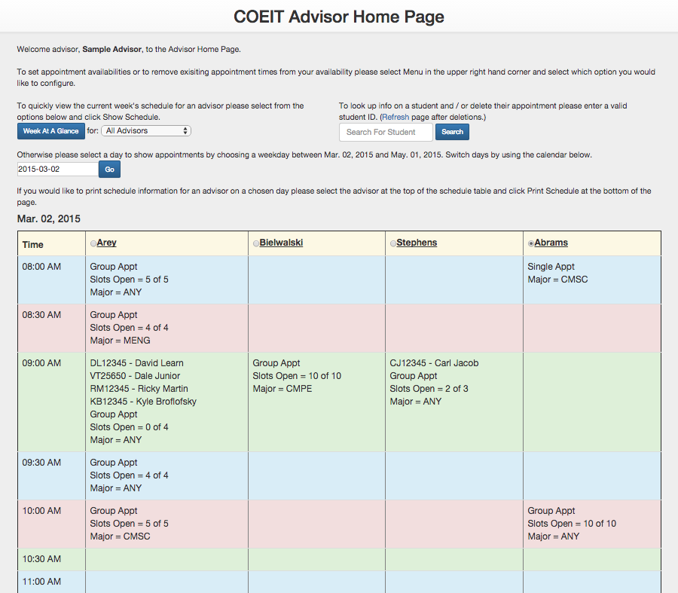

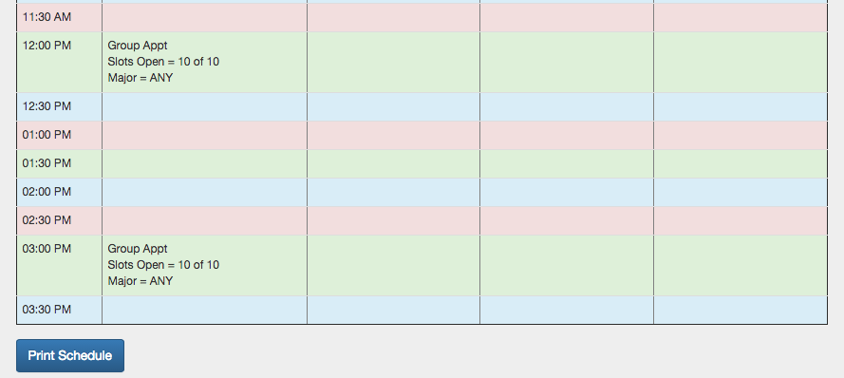

**advisorSetAvail.php**

Starting from the menu options on advisorHome.php and working down we first see the Add Availability link. On this page we can choose appointments by selecting an advisor, date range, specific days, and then we select how many slots will be added to an appointment and which major the appointment will be open for. An example is shown below for Catherine Bielwalksi on Tuesday March 03, 2015 where 2 MENG student appointments will be created at 10:00 AM.

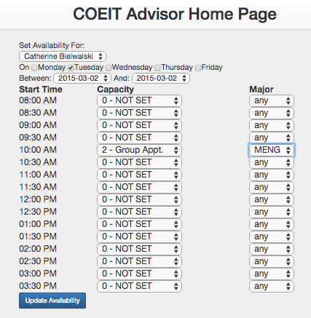

We can see the adjustment back over one the advisorHome.php page.

Changes are made on updateAdvisorAvail.php with links home or to set more appts.

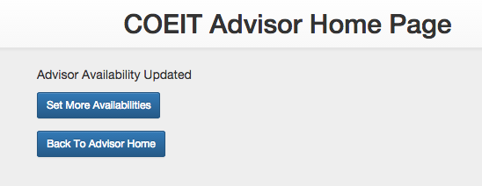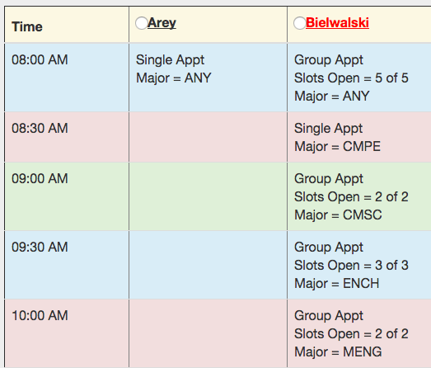

updateAdvisorAvail.php



**advisorChangeAvail.php**

Much like the add availability, this page allows us to alter existing appointments. This page will be used once an advisor has already set their appointment times for the semester in case they need to make any changes. We will see an example below of remove the 2 MENG appointments that we had created above for Bielwalski. The appt. info is displayed for current appointments and will only change if one is detected. The changes are then made on modifyAdvisorAvail.php where there are links to home or change more appts.

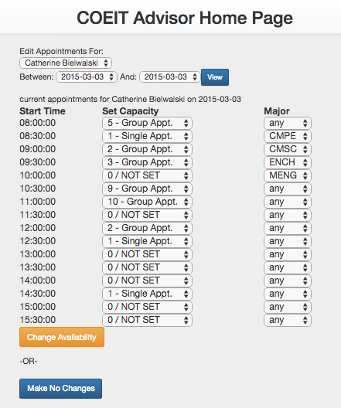

modifyAdvisorAvail.php

Now advisorHome.php will look like this on March 3. This page is very powerful and will remove students from appointments if they have been made.

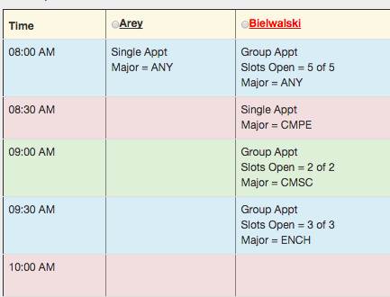

The week at a glance button

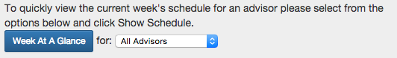

will direct the user to a print page that prints every advisor or only a selected advisor’s schedule for the week as seen below on

**advisorShowSchedule.php**

Note: A print dialogue is immediately popped up.

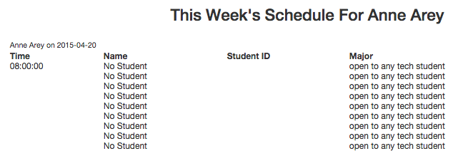

Similarly, selecting a date on a the advisorHome.php page and then an advisor allows you to print an advisor’s schedule for the given day as shown below:

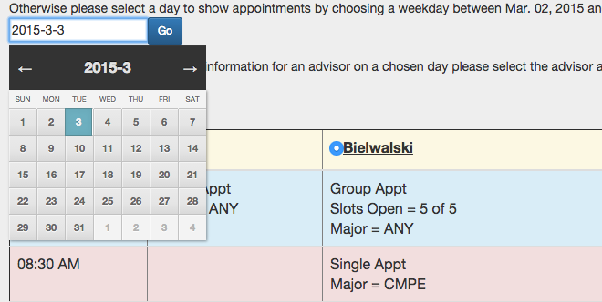

Selecting the Print Schedule button on the bottom of the page sends us to:

**advisorDaySchedule.php**

Note: A Print dialogue is immediately popped up here as well.

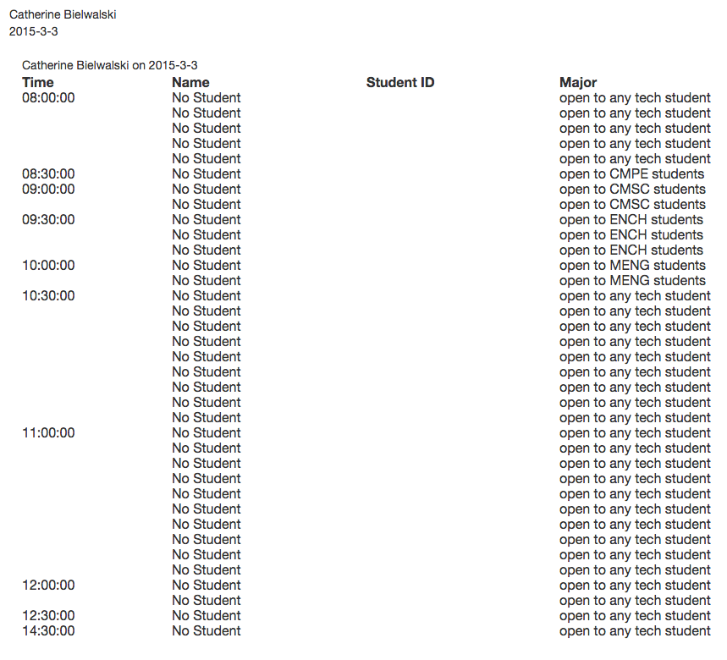

The search for student ID widget is one of the most useful things and something that the advisors asked us to include.

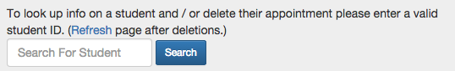

It accepts a student ID and directs us to

**studentInfo.php**

The advisor can then decide to remove the students appointment in which we are

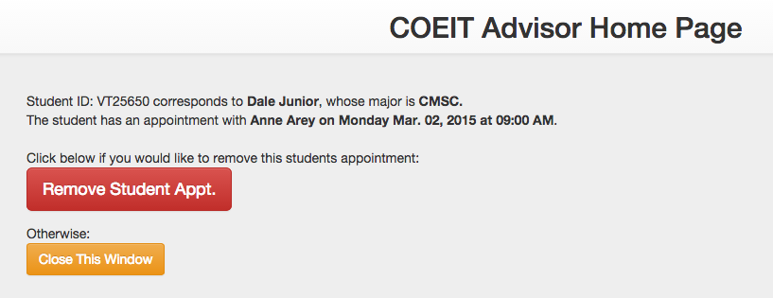

directed to:

**advisorRemoveStudent.php**

This is very similar to the student remove page. 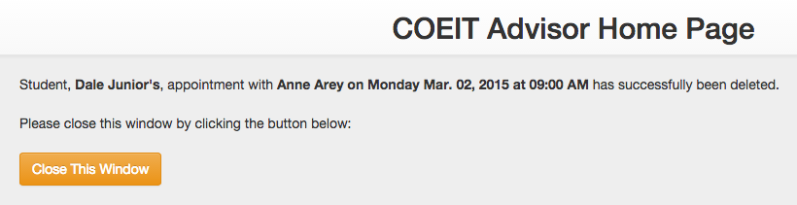

If we did not have a valid student ID the only option is to close the window as seen below:

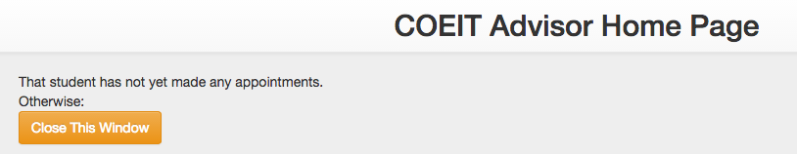

For both the student side and the advisor side, if an incorrect date is selected an error message will appear on either home page as such:

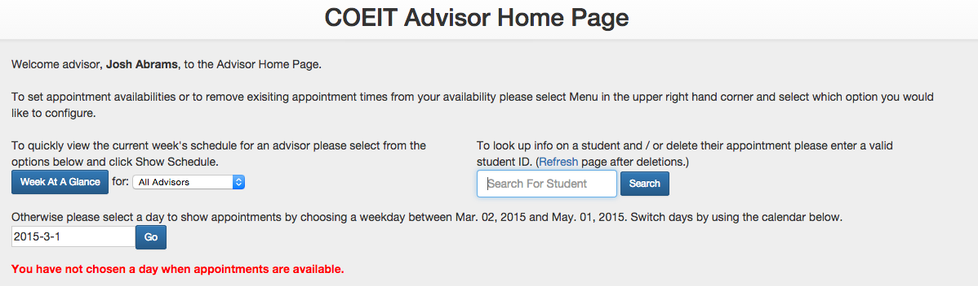

We also disabled use of the back button so that our php session data does not get interfered with. Because of this you will notice that some pages open up in new tabs and will always have the necessary links to either close the page or direct you back to where you want to be without having to use the back button. This feature is shown below:

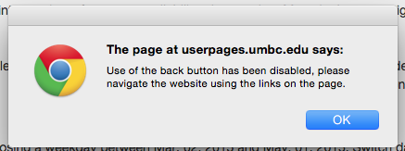

**Database Setup**

**Static Tables**

For our project we have a number of static tables that we felt should only be accessible through phpMyAdmin itself.

**Advisors Table**

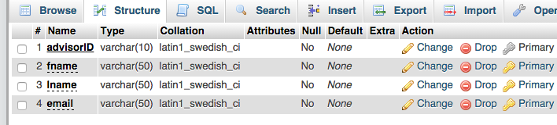

Note: Primary key is advisorID.

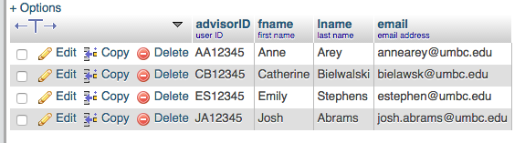

We gave the IDs the possibility of 10 chars in case the university needed to create more user IDs. This table is static as there are only 4 advisors right now and we didn’t think it would be helpful for users on the front end to add in new advisors at will. Our project is coded dynamically in such a way that it will change of new advisors were to be added. To see a demonstration of this see below:

We added a new advisor named Sample Advisor

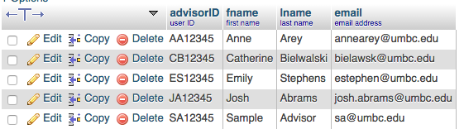

On advisorHome.php we can see

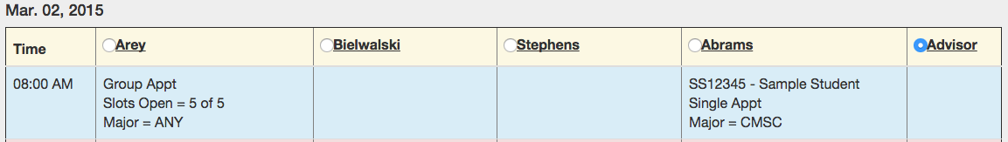

that Sample Advisor was added to the table of advising appointments.

**dates Table**

The dates table is a list of every day that advising appointments would meet. Again we decided to make this accessible only through the back end so that new appointment dates were not added at random. Below is a sample of dates:

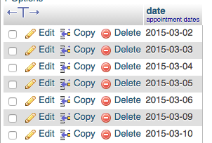

:::Desktop:Screen Shot 2015-05-11 at 9.41.51 PM.png

Just like the advisors table, our project will automatically adjust to any new dates that are added.

**times Table**

The times table is very similar to the dates table. Again, just a list of possible times that the advisors could meet with students. A sample of times as well as the structure of the table is show below.

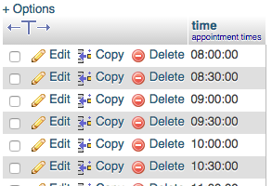

:::Desktop:Screen Shot 2015-05-11 at 9.45.32 PM.png

Our project will adjust to allow for any new times that could be added.

To illustrate that times and dates are dynamic I will add March 1, 2015 to the dates table and 7AM to the times table. 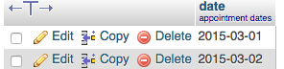

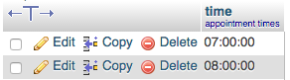

Now we will see on advisorHome.php that it is a valid day to create appointments and the option to select appointments at 7AM will appear.

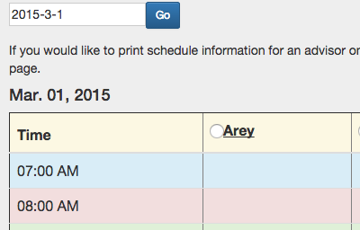

**majors Table**

This table is rarely used except for instantiating the drop down menus when advisors are setting appointment availability. We just wanted to have the majors coded into a table in case the advising staff decides they want to take on majors. This table will most likely always stay static on both the front end and back end until some sort of decision to add new majors is made.

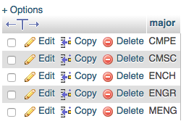

:::Desktop:Screen Shot 2015-05-11 at 9.52.56 PM.png

**Dynamic Tables**

These are the tables that are ultimately updated exclusively through user, front end interaction.

**students Table**

The students table gets added to every time a new student makes an appointment or removes an appointment. We wanted to be able to keep track of only students that currently had appointments so that way we can prevent them from making more than one appointment at a time.

Before Adding Daniel Lesko to the table.

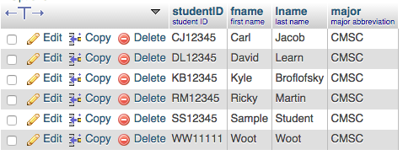

After Adding Daniel Lesko to the table.

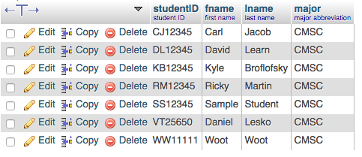

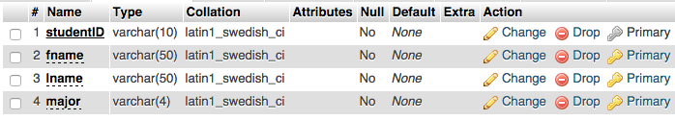

Note: Primary key is studentID.

**appointments Table**

This is the table that corresponds to many of the front end tools. Many calculations are performed on this table and it is what ultimately keeps track of all the appointment information once an appointment time is created. The way this table works is that advisors will create an opening for an appointment and then a student will be able to select the appointment and add themselves to it. The way that this table is formatted is that it is a composite of all of the primary keys from the static tables listed above and the students table.

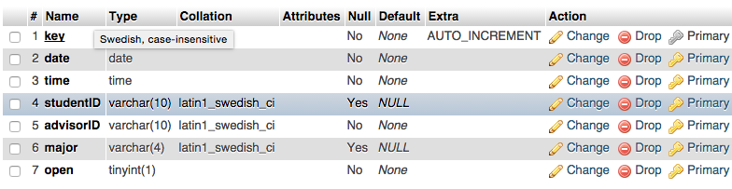

Note: Key is the primary key for this table. It is only used for quick back-end indexing and updating.

Before Adding Daniel Lesko to the 10AM appointment with Josh Abrams on March 2, 2015.

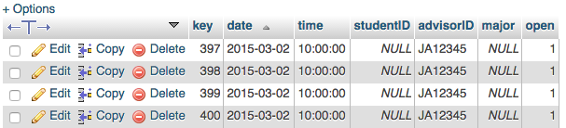

After

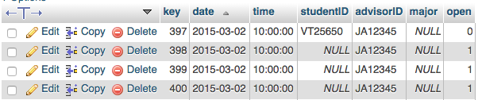

**Video / Demonstration Script**

studentIndex.php

This page collects student first name, last name, ID, and major.

schedule.php

Students here can select which appointment they would like to make by selecting a date from the calendar and then by selecting an open appointment from the table and hitting submit appointment.

added.php

Once the appointment has been made the option to remove the appointment appears or the student can simply logout.

If the student decided they wanted to login again to create a new appointment they will not be allowed to until they remove their existing appointment.

Advisor Home page  
    Because adding and editing advisor schedules are somewhat rare in their day to day work, the Add and Modify pages are linked from a menu in the upper right corner which also contains a link back to the homepage and the log out page  
    The more common actions of viewing this weeks schedule and searching for a student's apointment are more centrally located  
    Next is the date selection widget followed by the selected day's schedule with a print option below.

AdvisorShowSchedule (week at a glance)  
    The week at a glance page opens in a new window and shows this week's schedule for the selected advisors.  
    This page is set to the week of the 20th due to this presentation taking place after the end of advising for the semester.

StudentInfo  
    Looking up a studentID shows you that students major and current appt time/date/advisor with the option to remove the student from that appt

DateSelector  
    Clicking on the date selector launches a calender widget that allows different dates to be selected.  
    Clicking GO shows that day's schedule on the home page  
    Selecting an advisor from the top of the schedule and clicking "print schedule" prints that day's schedule for that advisor

Add  
    The add availabilty page allows apointment capacity and major to be ADD, not changed, for any advisor repeating for any chosen day of the week within the date range.   
    Due to prior user experience data, Inverted date selections are corrected automatically and single-day selections ignore a lack of checked weekday boxes.  
add confirm  
    Links back to add and to home and will refer the user to the modify availabilty page if they attempted to edit an existing apointment.

EDIT  
    The edit availabilty page prompts the user to select an advisor and a date range, and then shows them the current state of all apoinments in that range. Both capacity and major can be modified for any appointment. Students that are signed up for an edited apointment are re-enrolled if possiable on a first come first served basis.  
EDIT CONFIRMATION PAGE

    the edit confrimation page links back to the edit page and the home page and will show the user a list of any students that were removed from an apoinment due to editing.