COEIT Advising Webpage

Daniel Lesko, David Learn, Yadikaer Yasheng

­

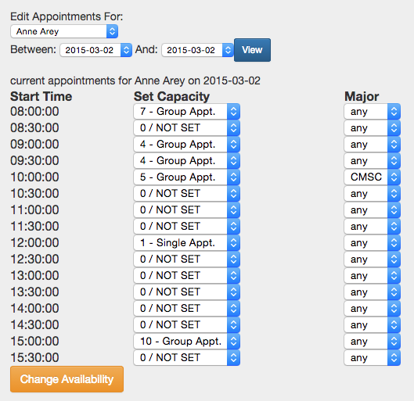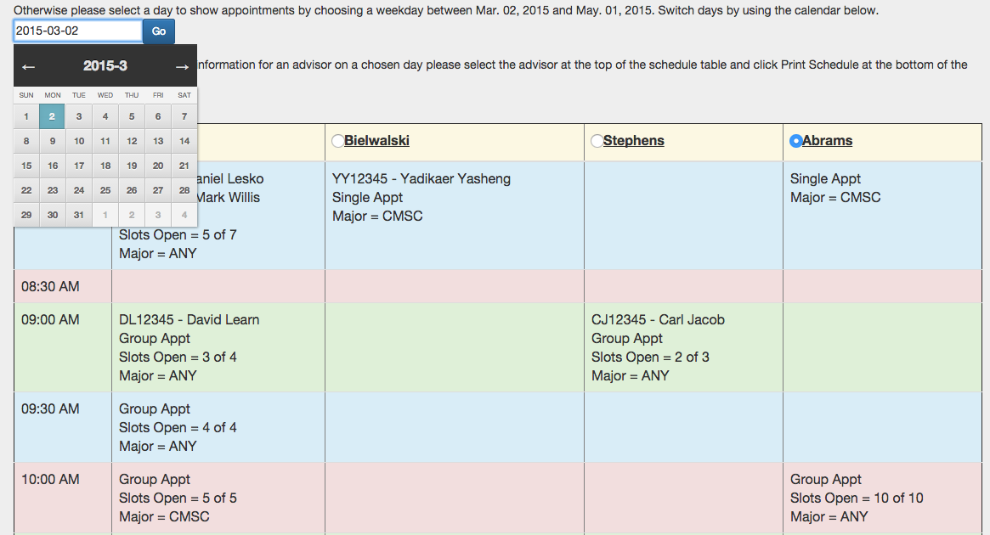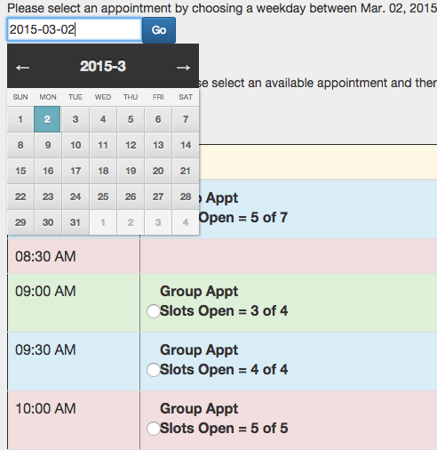

Add / Update Advisor Availability at the Click of a Button!

**ADVISORS**

Easily view and print schedules

Quickly View Appointments and Sign Up In Just a Few Clicks!

**STUDENTS**

**ADVISORS**