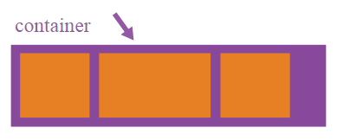

**Properties for the Parent  
(flex container)**

**display**

This defines a flex container; inline or block depending on the given value. It enables a flex context for all its direct children.

.container {

display: flex; /* or inline-flex */

}

Note that CSS columns have no effect on a flex container.

**flex-direction**

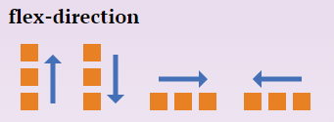

This establishes the main-axis, thus defining the direction flex items are placed in the flex container. Flexbox is (aside from optional wrapping) a single-direction layout concept. Think of flex items as primarily laying out either in horizontal rows or vertical columns.

.container {

flex-direction: row | row-reverse | column | column-reverse;

}

* row (default): left to right in ltr; right to left inrtl
* row-reverse: right to left in ltr; left to right in rtl
* column: same as row but top to bottom
* column-reverse: same as row-reverse but bottom to top

**flex-wrap**

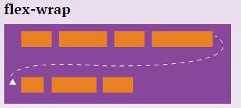

By default, flex items will all try to fit onto one line. You can change that and allow the items to wrap as needed with this property. Direction also plays a role here, determining the direction new lines are stacked in.

.container{

flex-wrap: nowrap | wrap | wrap-reverse;

}

* nowrap (default): single-line / left to right inltr; right to left in rtl
* wrap: multi-line / left to right in ltr; right to left in rtl
* wrap-reverse: multi-line / right to left in ltr; left to right in rtl

**flex-flow (Applies to: parent flex container element)**

This is a shorthand flex-direction and flex-wrapproperties, which together define the flex container's main and cross axes. Default is row nowrap.

flex-flow: <‘flex-direction’> || <‘flex-wrap’>

**justify-content**

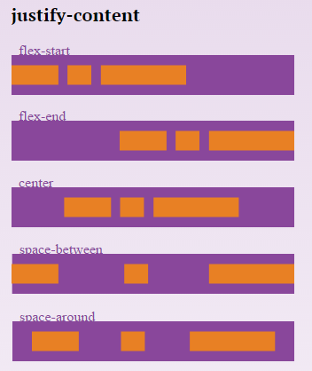

This defines the alignment along the main axis. It helps distribute extra free space left over when either all the flex items on a line are inflexible, or are flexible but have reached their maximum size. It also exerts some control over the alignment of items when they overflow the line.

.container {

justify-content: flex-start | flex-end | center | space-between | space-around;

}

* flex-start (default): items are packed toward the start line
* flex-end: items are packed toward to end line
* center: items are centered along the line
* space-between: items are evenly distributed in the line; first item is on the start line, last item on the end line
* space-around: items are evenly distributed in the line with equal space around them. Note that visually the spaces aren't equal, since all the items have equal space on both sides. The first item will have one unit of space against the container edge, but two units of space between the next item because that next item has its own spacing that applies.

**align-items**

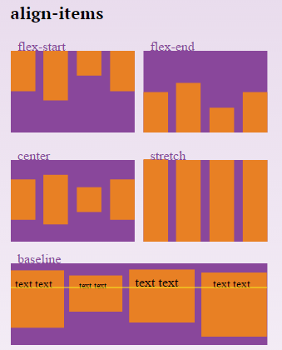

This defines the default behaviour for how flex items are laid out along the cross axis on the current line. Think of it as the justify-content version for the cross-axis (perpendicular to the main-axis).

.container {

align-items: flex-start | flex-end | center | baseline | stretch;

}

* flex-start: cross-start margin edge of the items is placed on the cross-start line
* flex-end: cross-end margin edge of the items is placed on the cross-end line
* center: items are centered in the cross-axis
* baseline: items are aligned such as their baselines align
* stretch (default): stretch to fill the container (still respect min-width/max-width)

**align-content**

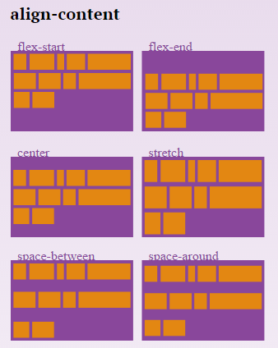

This aligns a flex container's lines within when there is extra space in the cross-axis, similar to how justify-content aligns individual items within the main-axis.

**Note:** this property has no effect when there is only one line of flex items.

.container {

align-content: flex-start | flex-end | center | space-between | space-around | stretch;

}

* flex-start: lines packed to the start of the container
* flex-end: lines packed to the end of the container
* center: lines packed to the center of the container
* space-between: lines evenly distributed; the first line is at the start of the container while the last one is at the end
* space-around: lines evenly distributed with equal space around each line
* stretch (default): lines stretch to take up the remaining space

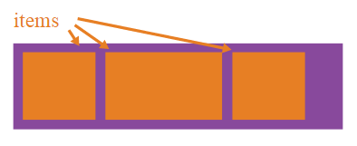

## Properties for the Children (flex items)

#### order

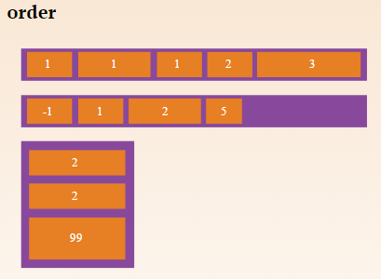

By default, flex items are laid out in the source order. However, the order property controls the order in which they appear in the flex container.

.item {

order: <integer>;

}

#### flex-grow

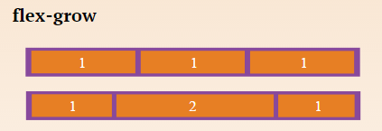

This defines the ability for a flex item to grow if necessary. It accepts a unitless value that serves as a proportion. It dictates what amount of the available space inside the flex container the item should take up.

If all items have flex-grow set to 1, the remaining space in the container will be distributed equally to all children. If one of the children a value of 2, the remaining space would take up twice as much space as the others (or it will try to, at least).

.item {

flex-grow: <number>; /* default 0 */

}

Negative numbers are invalid.

#### flex-shrink

This defines the ability for a flex item to shrink if necessary.

.item {

flex-shrink: <number>; /* default 1 */

}

Negative numbers are invalid.

#### flex-basis

This defines the default size of an element before the remaining space is distributed. It can be a length (e.g. 20%, 5rem, etc.) or a keyword. The auto keyword means "look at my width or height property" (which was temporarily done by the main-size keyword until deprecated). The content keyword means "size it based on the item's content" - this keyword isn't well supported yet, so it's hard to test and harder to know what it's brethren max-content, min-content, andfit-content do.

.item {

flex-basis: <length> | auto; /* default auto */

}

If set to 0, the extra space around content isn't factored in. If set to auto, the extra space is distributed based on its flex-grow value. [See this graphic.](http://www.w3.org/TR/css3-flexbox/images/rel-vs-abs-flex.svg)

#### flex

This is the shorthand for flex-grow, flex-shrinkand flex-basis combined. The second and third parameters (flex-shrink and flex-basis) are optional. Default is 0 1 auto.

.item {

flex: none | [ <'flex-grow'> <'flex-shrink'>? || <'flex-basis'> ]

}

**It is recommended that you use this shorthand property** rather than set the individual properties. The short hand sets the other values intelligently.

#### align-self

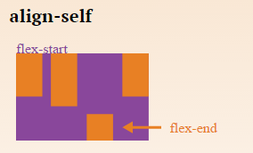  
This allows the default alignment (or the one specified by align-items) to be overridden for individual flex items.

Please see the align-items explanation to understand the available values.

.item {

align-self: auto | flex-start | flex-end | center | baseline | stretch;

}

Note that float, clear and vertical-align have no effect on a flex item.

Sacado de: <https://css-tricks.com/snippets/css/a-guide-to-flexbox/>