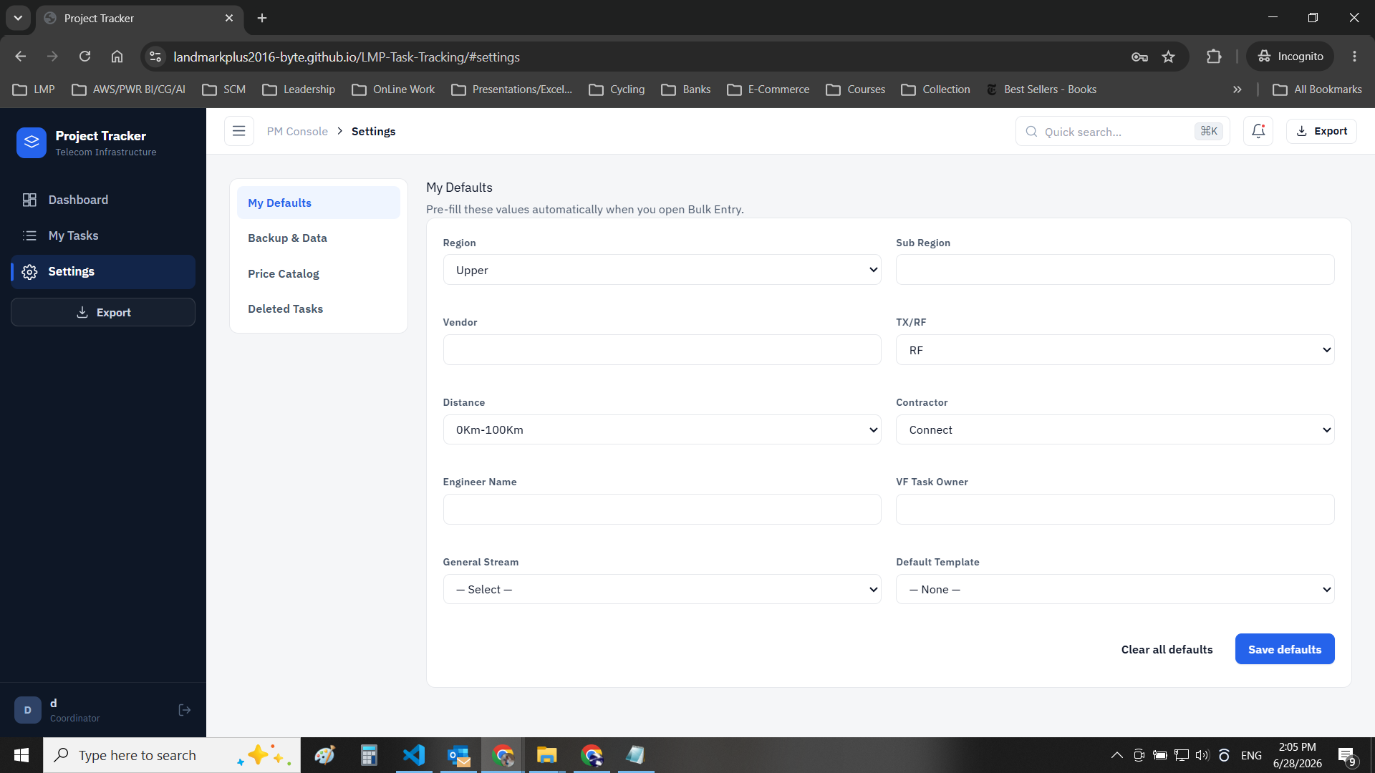
Here in the coordinator setting page I want to create a default template and I enter the data when I click save nothing is happening also it should have more than one template in order to select from them when I add new task

