MO123

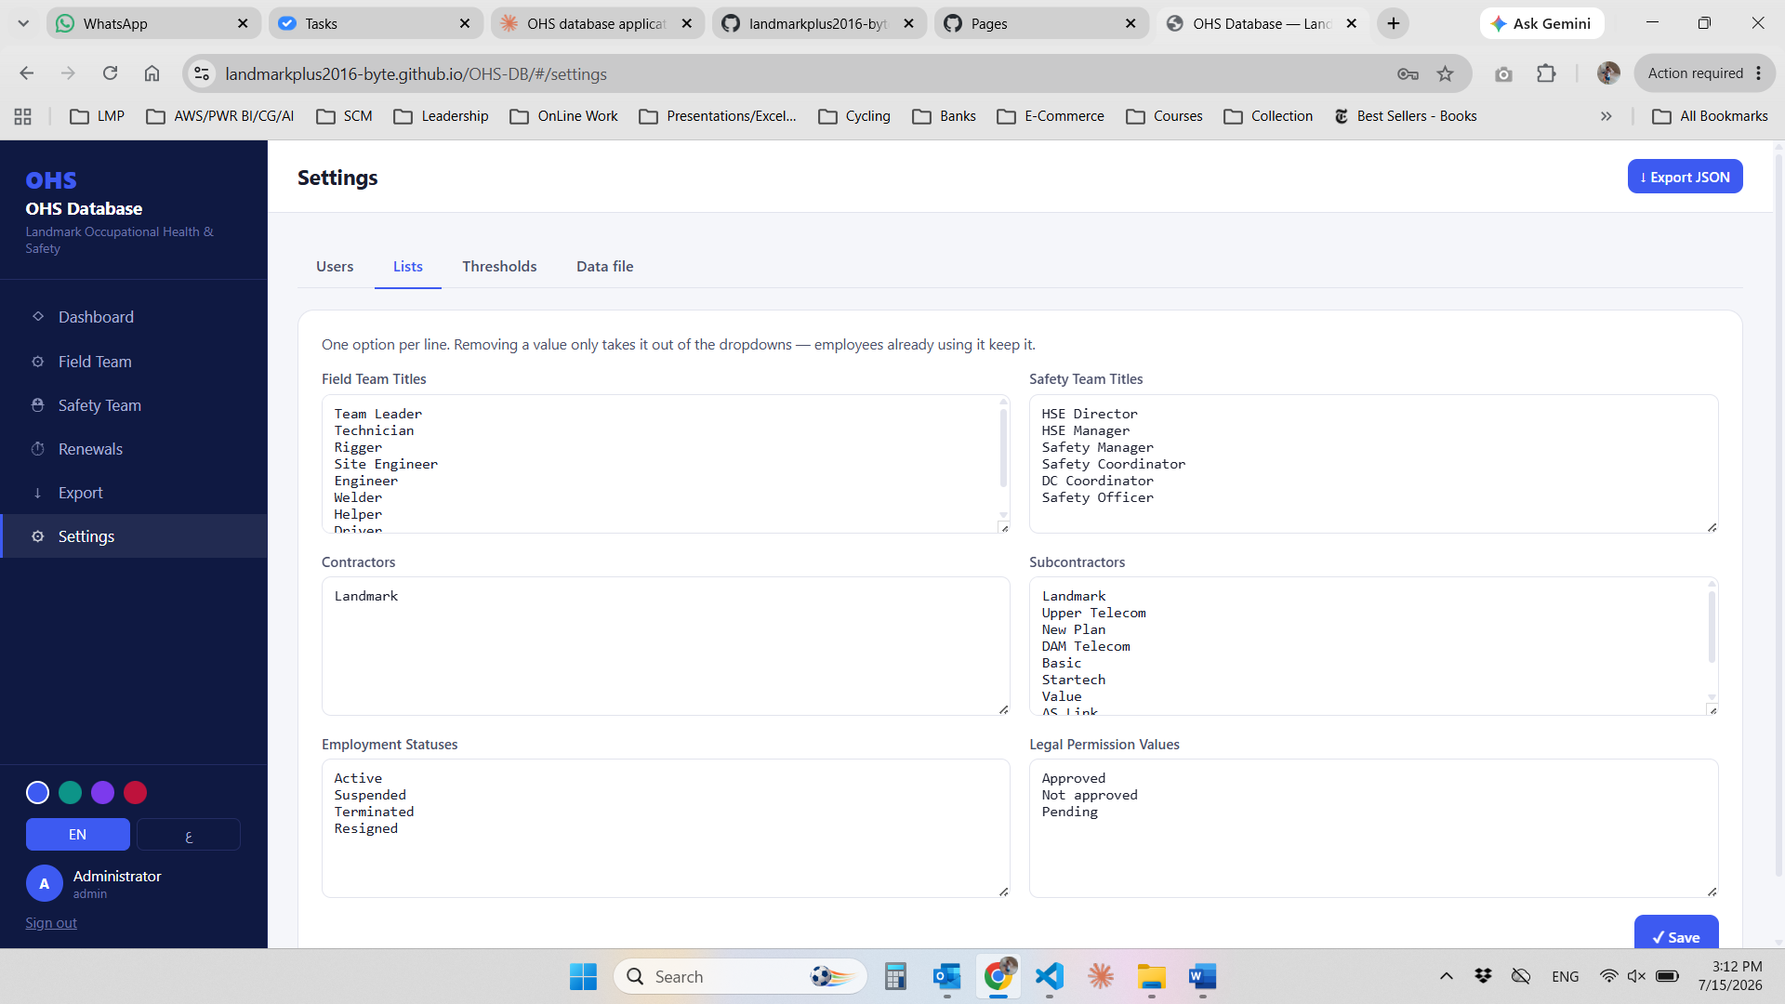

In the attached screen in the setting page, lists fields are typing but there could be deleting for any field by mistake, I want to make it that in each list a can add and if I want to change or delete it will ask before the delete

I need to make the following changes:

Check all fields titles and I want to capitalize the 1st letter of each field in the system
Change this field Legal permission to VF Approval
Change this field Emergency Coordinator to Electric Safety
Change this field اختبارات المخدرات to تحليل مخدرات عشوائي
Change this field المؤهلات to الشهادات المعتمدة

Im tying to setup the officer app but im getting this error here is the drive link where the Snapshot and app script link what could be wrong:

I need to fix the following:
When I change any employee status to resigned it is not appearing in the dash bord still the active employee card is showing all are active
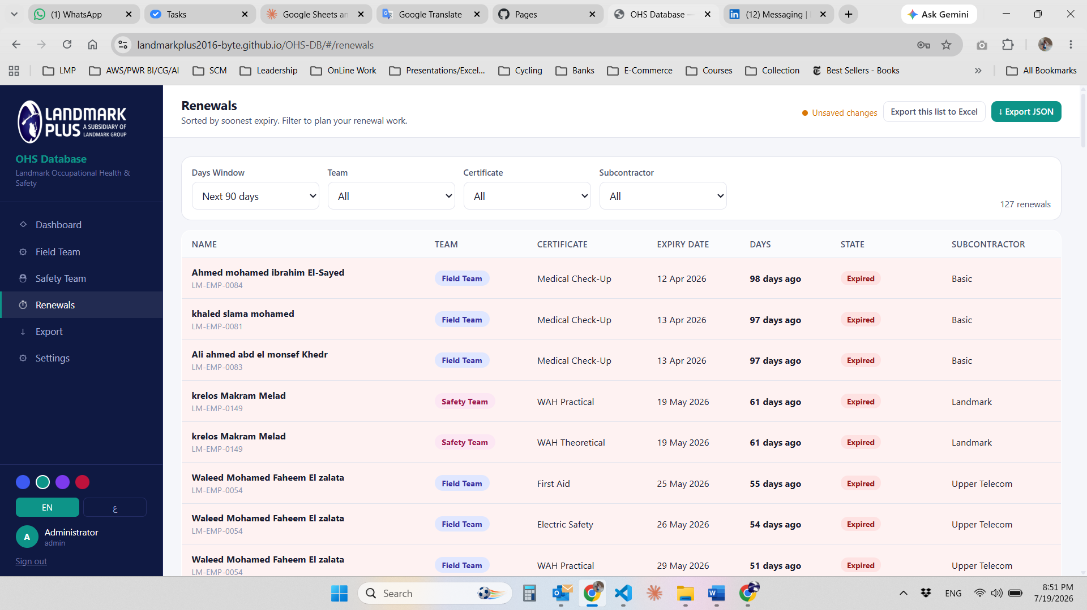
Here in the attached screen I don’t understand the days window field what it is used for and when I select any of the list I don’t see any changes in the filters or maybe cause I don’t understand it

For the resigned employees I want them to be highlighted by red the entire row, in the field team and in the safety team pages
I want to add N/A check box to all certificates below its date when checked this certificate is not needed for this employee and this will fix the missing cert as there a lot of cert that might not be needed for an employee

I want to add new feature for this app I don’t know if we create a new tab or what let me know what you think, the feature is to select an employee to conduct the random drug test or for short RDT the rules are as following:

We have a medical check up that is done when the employee is hired after a period of 3 months we must conduct the RDT
We should cover 120% RDT yearly
We need 10% on a monthly basis so after 10 months we complete the 100%
Then in the last 2 months of the year we need 10% in feb and 10% in mar these will be from the already done test before so they will be repeated RDT
Our year starts from apr ends in mar

So in the new tab the system will select the employees
One thing to highlight I want this to be applied to all field teams and for the safety teams only on safety officers

I there is any thing not clear lets discuss it before we build anything

I need to add the following:
For each employee that I change his status to suspended the entire row will be colored by yellow, and to add a check box in every certificate so I can choose the suspended course and when I check it, it will color the entire box with yellow as we did in the case of NA

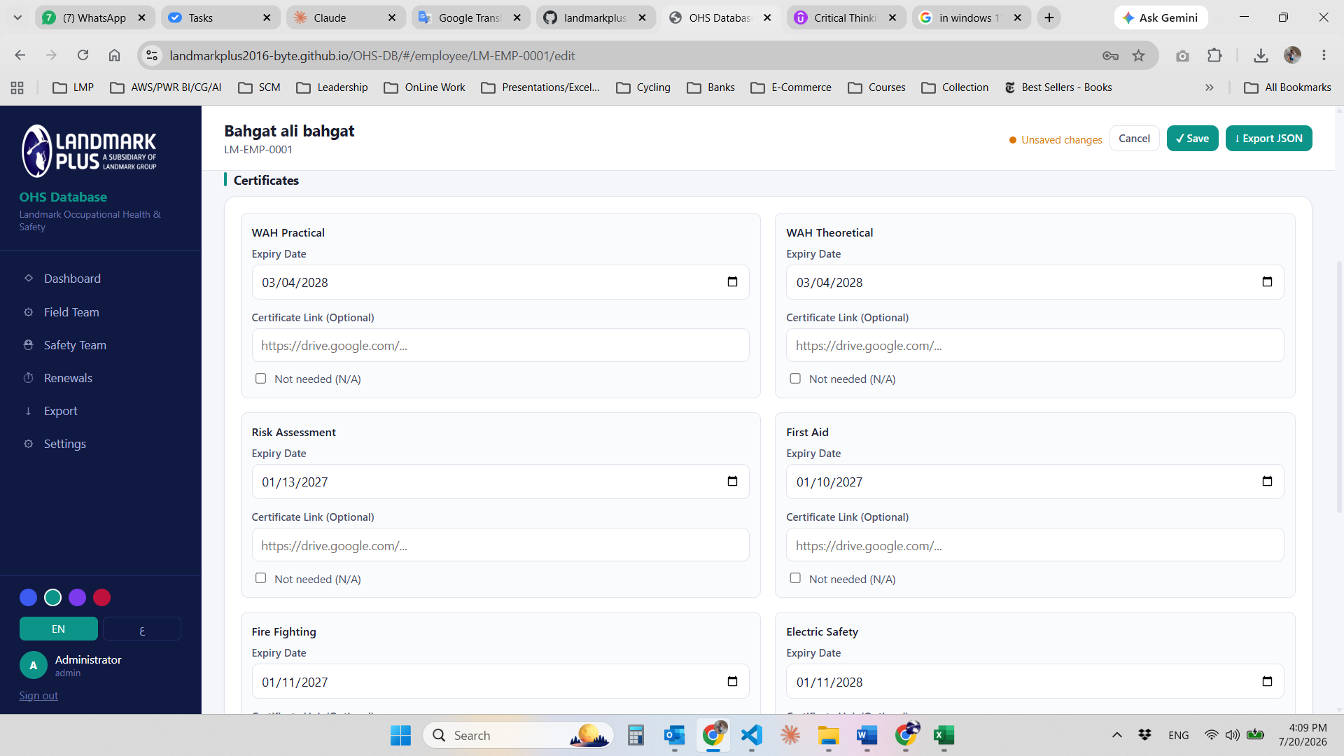
I want to also to make the terminated to act like the resigned in order that we color the row, ans I would like to move them both in a new tab and name it Resigned and Terminated

- Where does the 10% come from — fixed pool or rolling? At the start of the fiscal year (Apr 1), do we lock in "the pool" (everyone eligible on that date) and use that same list all year? Or does the pool refresh each month to include people who cross their 3-month mark mid-year? Rolling pool, pool refresh as we have hiring resigning during the year
- In the Apr–Jan phase, must each employee be tested exactly once before anyone is repeated? i.e. if someone was tested in May, they should NOT be picked again in June–Jan — only eligible for the Feb/Mar repeat rounds. Correct? yes
- How are the 10% picked? Random? Round-robin? Weighted toward people who haven't been tested in the longest time? Do you want the admin to be able to override the selection (swap someone out)? Random, as at the end we need all employees to be tested
- Feb/Mar repeat pool — any preference? Purely random from the 100% already tested? Or bias toward earliest-tested (longest since last test)? random
- What happens when a selected test isn't actually done? e.g. employee on leave, refused, no-show. Does the system re-pick? Does that person roll into next month? Do we track "selected but not completed"? system re-pick until he is available
- Recording the result: Right now employees have drug_tests.rdt_1, rdt_2 (field) and rdt (safety) — just dates. For this feature we probably need a proper log: date, selected_by, completed (yes/no), result (pass/fail?), notes. Is tracking pass/fail in scope, or just "test was done on this date"? yes add the log
- Rounding of 10%: If the pool is 137 people, 10% = 13.7 → do we round to 14 every month, or alternate 13/14, or does the admin just see "≈14" and pick the exact number? Round it as at the end we will test less so it will be ok
- Officers' visibility: Should safety officers using the mobile app see anything about RDT status on the verdict card? Or is this purely an admin planning tool? Admin only
- Historical data: Do we need to backfill from the existing rdt_1/rdt_2/rdt fields, or does the new system start clean from a chosen fiscal year start? I think we will start fresh as ill upload fresh data ill need you to till me what will do for the RDT fields dates we have now should we keep in the list view or not

*
I want for the courses when I select the NA box the suspended box to be dimed also as it will not be needed, also change the box name from “Suspended course” to “
Suspended Course”
And for all the no date curses, that means it is not needed so lets check the NA box when ever I upload the new database and dim its card also, as it is now when I check the NA box
Also I want to ask about the RDT, now when an employee from the selected list is completed that means he will not be picked up again until we finish all the 100% is this correct, and what if we didn’t fully complete this month RDT will the remaining employees will go to the next months selection, and if someone missed the rdt for what ever reason how im I going to replace him as there is nothing in the system to show the replacement or maybe there are but I didn’t see it

now i want to add a new module to the sys with the following fields to be filled:
Team
3rd Party SN
Item
Brand
Date of Manufacture
Serial No
3rd Party Inspection END Date
Internal Inspection Wave 1
Internal Inspection Wave 2
Internal Inspection Wave 3
Comments
Rejection Date

This module will be responsible for tracking safety equipment with our teams, any terminated equipment’s will be moved to a separate page the same way we treated the terminated and resigned employees, for the officer part of the app I want them to be able to access this list also.

The system is starting to get big and im going to expand it with other modules so what do you think if we make the google sheet that we already using for login to be the backend of every data in the sys so when the admin add or edit any of the data it will be reflected automatically in the sheet and also it will be easer for the officer, no need for the backup that the admin is doing now.
Let me know what you think and lets discuss the options and what would it take to do this, is it going to be a lot of coding rework or it would be easy.

