
REPUBLIC OF THE PHILIPPINES
DANGEROUS DRUGS BOARD
━━━━━━━━━━━━━━━━━━━━━━━━━━━━
DAPE-MA
SYSTEM ADMINISTRATOR TRAINING
Technical operations pack for IT staff who install,
update, and support the production platform
Document type | Internal training (IT / operations)
Companion manual | DAPE-MA Administrator Manual (staff)
Audience | System administrators, Super Admins, DDB ICT
Version | 1.0 · November 2026
Classification | Official use only — do not publish passwords
This pack is for people who keep the server running.
Content officers should use the Administrator Manual instead.
DANGEROUS DRUGS BOARD
3rd Floor DDB-PDEA Bldg.,
National Government Center,
NIA Road, Brgy. Pinyahan
1100 Quezon City, Philippines
www.ddb.gov.ph

Contents
1. About this training
2. Platform architecture
3. Environments and configuration
4. Identity, roles, and security operations
5. API contract and content workflow
6. Server install and first boot
7. Updates, Git, and the mobile APK
8. Mail, queue, and backups
9. Monitoring, logs, and incidents
10. Training checklist and sign-off

1. About this training
DAPE-MA is the Dangerous Drugs Board (DDB) mobile information platform. Staff publish content from a web Admin Control Panel. The Laravel API stores that content and serves it to the Flutter Android/iOS app.
This course trains system administrators: people who keep the servers, certificates, database, and releases healthy. It does not replace the staff Administrator Manual.
Figure 1. Admin sign-in is the front door for operators. Production requires a 6-digit email code after password.
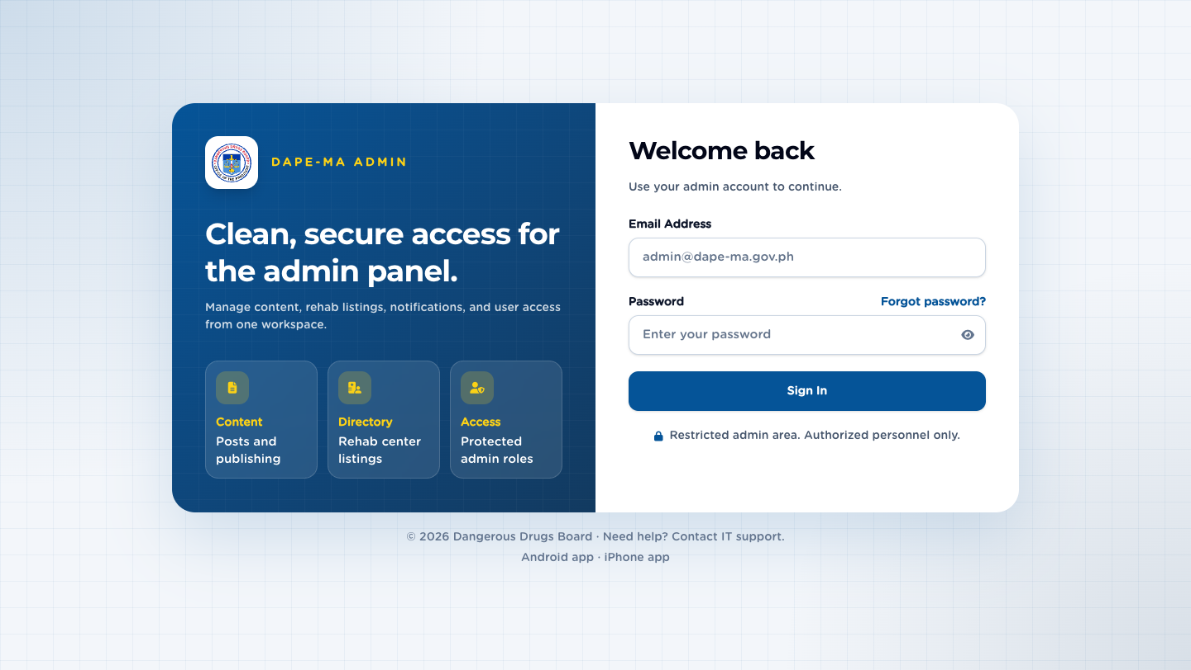
Figure 1. Admin login

1.1 Learning outcomes
By the end of this pack you will be able to:
- Name the three parts of the system (API, Admin SPA, mobile app) and which Git repository owns each.
- Describe the production host path, public URL, and health checks.
- Assign the smallest staff role that fits a job and retire accounts the same day someone leaves.
- Pull a production update with deploy/update.sh without skipping hooks.
- Place a new Android APK on the public download URL.
- Read logs, restart the queue worker, and restore from backup.

1.2 How this pack is used
Session | Chapters | Time
Day 1 — picture of the system | 1–4 | 2 hours
Day 2 — host operations | 5–7 | 3 hours
Day 3 — incidents and sign-off | 8–10 | 2 hours

Hands-on work uses a non-production clone first. Do not run installer or seed commands on live until a Super Admin confirms the window.
Important. Do not write database passwords, installer credentials, or private keys into this document, tickets, or chat. Store them in the approved DDB secret store.

1.3 Related documents
Document | Audience
docs/DAPE-MA-ADMINISTRATOR-MANUAL.docx | Editors, publishers, Super Admins using /admin
deploy/INSTALL-FROM-SCRATCH.md | First install on a blank Ubuntu 24.04 VPS
deploy/README.md | Ubuntu automation and HTTPS notes
This training pack | IT operators and Super Admins who own the host

2. Architecture

2.1 Three products, one backend
Layer | Technology | Repository | What it does
API + Admin | Laravel 12, Sanctum, Axios SPA, Tailwind, DataTables | landogz/dapa-ma-laravel (spelling on GitHub) | JSON APIs under /api/v1/, Admin Control Panel at /admin
Mobile app | Flutter | landogz/dape-ma-flutter | Android/iOS client. Talks only to /api/v1/ with a Bearer token
Public download | File in Laravel public/download/ | Same Laravel repo | https://dapemade.ddb.gov.ph/download/dape-ma.apk

The admin UI is 100% API-based. Saving, searching, and deleting never submit a classic HTML form. The same APIs power Flutter.
Figure 2. Dashboard after a Super Admin signs in. Counts come from /api/v1/ — the Blade page is a shell.
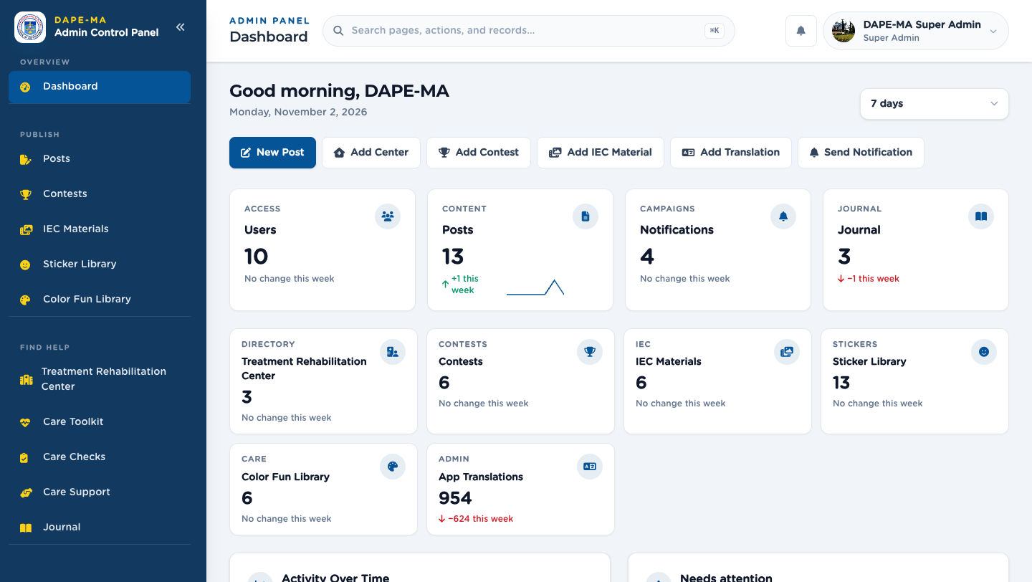
Figure 2. Dashboard

2.2 Request path (production)
- Browser or app calls https://dapemade.ddb.gov.ph/... on port 443 only (Network Admin does not allow HTTP 80).
- Nginx serves public/ and forwards PHP to PHP 8.3-FPM.
- Laravel routes:
- /admin/* — staff SPA (Sanctum token in sessionStorage plus an admin gate cookie)
- /api/v1/* — JSON for admin and mobile
- /download/dape-ma.apk — Android package
- MySQL 8 stores accounts, content, workflow, audit, queues, and cache (database drivers).
- Supervisor runs php artisan queue:work. Cron runs schedule:run every minute.

2.3 Standard API envelope
Success:
{ "status": true, "message": "...", "data": {} }

Error:
{ "status": false, "message": "...", "errors": {} }

Health (no environment leak):
GET https://dapemade.ddb.gov.ph/api/v1/health
GET https://dapemade.ddb.gov.ph/up

2.4 Module pattern
Every admin feature follows the same folders:
Piece | Path
Thin API controller | app/Http/Controllers/API/
Service (business rules) | app/Services/
Repository (queries) | app/Repositories/
FormRequest validation | app/Http/Requests/
SPA module (Axios) | resources/js/modules/

Controllers must stay thin. Do not put publish/archive rules in a Blade view.

2.5 Exercise
On a training host, open /api/v1/health in a browser. Confirm JSON status: true and that the payload does not include APP_ENV or stack traces.

3. Environments and URLs

3.1 Map
Environment | Typical URL | APP_ENV | Login OTP | Demo sign-in buttons
Local Mac (XAMPP / artisan serve) | http://127.0.0.1:8000 | local | Skipped | Allowed for training
Production (DDB) | https://dapemade.ddb.gov.ph | production | Required (6-digit email) | Must be off

Login OTP is required whenever APP_ENV is not local (App\Support\Auth\LoginOtp). Staging with APP_ENV=staging therefore also requires a code.

3.2 Production paths
Item | Value
App directory | /var/www/dape-ma-laravel
Web root | /var/www/dape-ma-laravel/public
Web user | www-data
Nginx site | dapemade.ddb.gov.ph listen 443 ssl http2
Certificate | Wildcard *.ddb.gov.ph installed under /etc/ssl/
APK | public/download/dape-ma.apk
Update script | sudo bash /var/www/dape-ma-laravel/deploy/update.sh
Git branch | main

3.3 Critical `.env` keys
Operators edit /var/www/dape-ma-laravel/.env then recache config. Never commit .env.
Key | Production expectation
APP_ENV | production
APP_DEBUG | false
APP_URL | https://dapemade.ddb.gov.ph
APP_KEY | Set (php artisan key:generate once)
APP_NAME / MAIL_FROM_NAME | DAPE-MA
DB_CONNECTION | mysql
DB_HOST | 127.0.0.1 if MySQL is local; private IP if split servers
QUEUE_CONNECTION | database
CACHE_STORE | database
SESSION_DRIVER | database
MAIL_MAILER | Real SMTP/API in production (not log)
MAIL_FROM_ADDRESS | DDB-approved mailbox
DAPE_SHOW_DEMO_LOGIN | false
FCM_SERVER_KEY | Firebase Cloud Messaging legacy server key (not a JSON service account)

After any .env change:
cd /var/www/dape-ma-laravel
sudo -u www-data php artisan config:cache

3.4 Demo login
Quick sign-in buttons appear only when demo mode is on. Production must keep:
DAPE_SHOW_DEMO_LOGIN=false

If someone left it true after a seed:
sudo sed -i 's/^DAPE_SHOW_DEMO_LOGIN=.*/DAPE_SHOW_DEMO_LOGIN=false/' /var/www/dape-ma-laravel/.env
sudo -u www-data php artisan config:cache

Then change every seeded password (superadmin@yopmail.com and friends).

3.5 Exercise
Compare local .env with production. List three keys that must differ (APP_DEBUG, APP_ENV, DAPE_SHOW_DEMO_LOGIN). Do not copy secret values into your notes.

4. Identity, roles, and security
Figure 3. Users is Super Admin only. This is where you create staff, set roles, suspend, and force a password change.
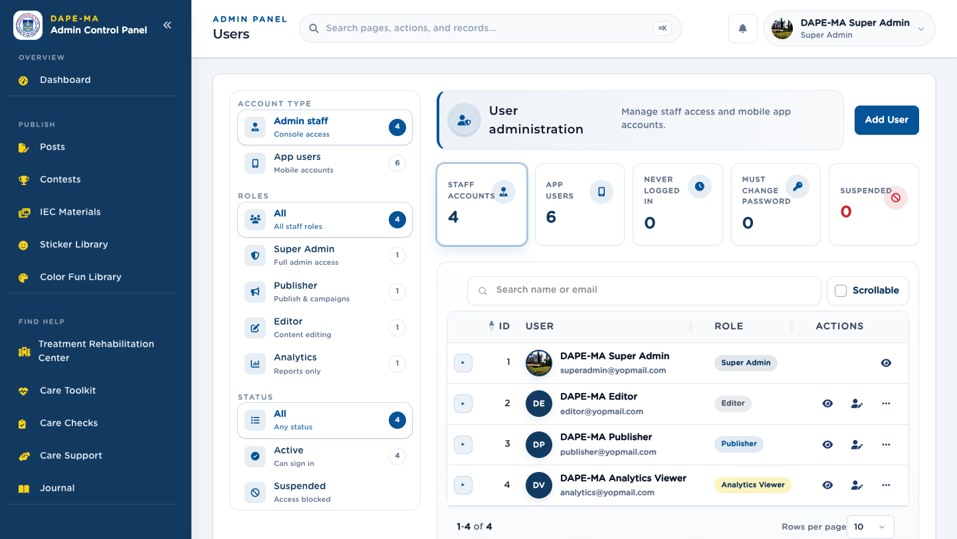
Figure 3. Users

4.1 Staff roles
Role | Code | Access
Super Admin | super_admin | Full console: users, content, publishing, analytics, journal, audit, settings
Publisher | publisher | Review queue, campaigns, notifications. Not Users, Analytics, or Journal
Editor | editor | Draft, submit, archive, restore-to-review. Cannot publish live
Analytics Viewer | analytics_viewer | Analytics only
App user | app_user | Mobile app only — not an admin role

Give the smallest role that fits the job. Most content staff should be Publisher, not Super Admin.
Mobile accounts (app_user) must never receive admin menus.

4.2 Sign-in flow (technical)
- POST /api/v1/auth/login with email and password.
- Suspended accounts receive 403 and no token.
- If APP_ENV=local, login completes and a full Sanctum token is issued.
- Otherwise Laravel emails a 6-digit code. The API returns a pending token (requires_verification: true).
- POST /api/v1/auth/login-code (or verify-login-code) completes login and replaces the pending token.
- Admin pages also set an httpOnly admin gate cookie (dape_admin_gate). It is excepted from cookie encryption so the SPA and middleware stay in sync.
- If must_change_password is true (admin-set or expired), middleware password.current blocks other APIs until the user sets their own password on Edit Profile.
Figure 4. Forced password change lands on Edit Profile.
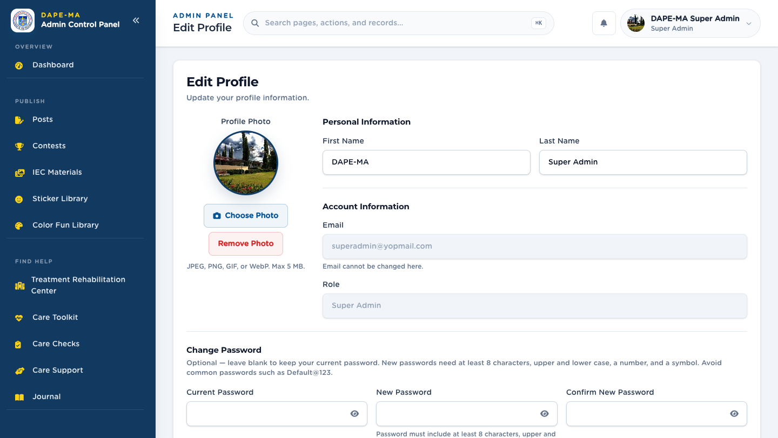
Figure 4. Edit Profile

4.3 Password policy (all new passwords)
Applies to register, reset, change, and admin-set passwords. Login current password is not checked for complexity.
Rule | Value
Minimum length | 8
Upper and lower case | Required
Number | Required
Symbol | Required
Breached passwords | Rejected (Password::uncompromised() / Have I Been Pwned)
Expiration | 90 days after password_changed_at (null = not expired)
Reuse | Current hash plus last 5 in password_histories
Admin-created / reset | Sets must_change_password

Hint shown in the UI: Password must include at least 8 characters, upper and lower case, a number, a symbol.
Persist passwords only through App\Services\Password\PasswordService so history and timestamps stay correct.

4.4 Other security controls
- Laravel Sanctum Bearer tokens; revoke on password change and logout.
- CSRF on the SPA session.
- FormRequest validation on writes.
- API rate limiting and throttles on auth.
- Philippine phone numbers only (App\Support\Phone\PhilippinePhoneNumber).
- Address fields use LibreMap autocomplete via GET /api/v1/geocode/search (Nominatim proxy). Do not call Nominatim from the browser.
- HTML Body fields go through CKEditor and are sanitized on save/render.
- Successful mutations should appear in Audit Trail (/admin/audit-trail) without passwords or secrets in meta.
- First public register cannot create super_admin once one exists. After that, staff are added only from Users.

4.5 When someone joins or leaves
Join:
- Users → Add User (name, work email, role, temporary password).
- Tell them they must change the password on first sign-in.
- Confirm they see only the menus they need.
Leave:
- Delete or suspend the account the same day.
- Confirm they cannot sign in.
- Do not reuse that mailbox for a different person without a new account.

4.6 Exercise
On a training database, create an Editor, sign in as that user, and confirm Users / Analytics / Journal are hidden. Delete the account afterward.

5. APIs and content workflow

5.1 Prefixes you will support
Prefix | Consumers
/api/v1/ | Admin SPA and Flutter
/admin/ | Staff pages (Blade shells; data still via Axios)
/install/ | First-time web installer — disable after go-live

Public-ish reads (posts, rehab, translations, legal pages, IEC, contests) exist for the app. Admin writes sit under /api/v1/admin/... and require a verified staff token.

5.2 Workflow states
Most publishable records use:
Status | Meaning
Draft | Editor working copy
Pending review | Waiting for a Publisher
Scheduled | Approved, not live yet (posts)
Published | Live in the app
Archived | Hidden from the app

Editor: draft, submit, archive published/pending, restore → pending review.
Publisher: approve, reject, publish.
Super Admin: publish and restore immediately.
Archive is not a hard delete. Restore does not skip the publisher unless the actor is Super Admin.

5.3 Lists operators should know
Every admin DataTable:
- Search, sort, pagination
- Actions column (tooltips) plus right-click / long-press menu
- Scrollable checkbox beside Search — keeps all columns visible, horizontal scroll, Actions pinned on the right
- Confirmations use SweetAlert2; success/error use toasts
Mobile (≤1023 px) uses card/summary rows unless Scrollable is on.

5.4 App Translations vs CMS Body
What | Where
App chrome (buttons, titles, empty states) | /admin/app-translations — keys must match Flutter AppStrings
CMS Body (posts, legal pages, Kid Listo quotes) | Module Body fields (CKEditor HTML) — not the translation catalog

After adding a translation key, seed:
php artisan db:seed --class=AppTranslationSeeder --force

The live app polls the catalog on launch, every 20 seconds, and on resume.

5.5 Word blocking
Blocked words replace matches with **** in user-generated text (comments, journal). The app syncs the list automatically. Editors archive; restore waits for a Publisher.

5.6 Exercise
As Editor, archive a published test post. Confirm it disappears from the public API feed. Restore it and confirm it sits in Pending until a Publisher (or Super Admin) publishes.

6. Production server and first install

6.1 Stack (Ubuntu 24.04)
Piece | Notes
Nginx | Document root → /var/www/dape-ma-laravel/public, TLS 1.2/1.3, client_max_body_size 14M
PHP 8.3-FPM | gd, mbstring, mysql, zip, intl, opcache, bcmath
MySQL 8 | App database + least-privilege user
Composer | --no-dev --optimize-autoloader on production
Supervisor | dape-ma-queue → queue:work
Cron | * * * * * php artisan schedule:run
UFW | SSH + HTTPS (port 80 may be blocked by Network Admin)

Security headers on Nginx: X-Frame-Options SAMEORIGIN, X-Content-Type-Options nosniff, Referrer-Policy strict-origin-when-cross-origin, Strict-Transport-Security.
PHP-FPM must pass HTTP_AUTHORIZATION so Sanctum Bearer tokens work.

6.2 First install (blank VPS)
Follow deploy/INSTALL-FROM-SCRATCH.md. Summary:
- DNS A record → server IP.
- SSH as a sudo user.
- sudo apt update && sudo apt install -y git
- Clone https://github.com/landogz/dapa-ma-laravel.git
- sudo bash deploy/install-ubuntu.sh (sets Nginx, PHP, MySQL, Composer, queue, cron).
- Open /install/ in a browser: requirements → app URL → database → migrate/seed.
- Sign in, change the Super Admin password, set DAPE_SHOW_DEMO_LOGIN=false.
- Move public/install aside so the installer cannot run again:
sudo mv /var/www/dape-ma-laravel/public/install /var/www/dape-ma-laravel/public/install.bak

Installer lock file: storage/app/installed. Delete it only if you intentionally re-run /install/.
Credentials generated by the script (if any) live in /var/www/dape-ma-laravel/.install-credentials. Do not commit that file.

6.3 HTTPS on DDB
Port 80 is often blocked. Use the wildcard cert from the DDB installer folder, not the system CA bundle alone:
cd /var/www/dape-ma-laravel
sudo git config --global --add safe.directory /var/www/dape-ma-laravel
sudo bash deploy/apply-nginx-ssl.sh

Template: deploy/nginx-dape-ma-ssl.conf. Server name: dapemade.ddb.gov.ph.

6.4 Split database
If MySQL is on another host, set DB_HOST to that private IP only after mysql -h THAT_IP … works from the app host. If MySQL is on the app server, use 127.0.0.1.

6.5 File permissions
sudo chown -R www-data:www-data /var/www/dape-ma-laravel
sudo find /var/www/dape-ma-laravel/storage /var/www/dape-ma-laravel/bootstrap/cache -type d -exec chmod 775 {} \;

Prefer committed public/build/ assets. Do not require Node on production unless INSTALL_NODE=1 is explicitly needed.

6.6 Exercise
On a training VM only, run the health URL and php artisan about. Confirm APP_ENV and debug are production-safe. Do not run the installer against live.

7. Updates and the mobile APK

7.1 Code update (Laravel)
On the DDB app host, after GitHub main has the commits:
sudo bash /var/www/dape-ma-laravel/deploy/update.sh

The script:
- git fetch / git pull --ff-only origin main
- composer install --no-dev --optimize-autoloader
- php artisan migrate --force
- Seeds BlockedWordSeeder, AppOptionSeeder, AppTranslationSeeder (safe, additive)
- storage:link, optimize:clear, config/route/view cache
- Restores www-data ownership and 775 on storage
- Reloads PHP-FPM 8.3 (or 8.2)
- Restarts Supervisor dape-ma-queue:*
Do not skip hooks. Do not force-push main.
To skip migrate/seed in an emergency only:
sudo SKIP_MIGRATE=1 bash /var/www/dape-ma-laravel/deploy/update.sh

Then run migrate as soon as the window allows.

7.2 Flutter / APK (required when the app changes)
Any change under dape-ma-flutter/dape_ma_mobile/ that ships in the app needs a release APK on the public URL — not only a simulator build.
From dape-ma-flutter/dape_ma_mobile:
flutter build apk --release

Copy:
From | To
build/app/outputs/flutter-apk/app-release.apk | dape-ma-laravel/public/download/dape-ma.apk

Public URL:
https://dapemade.ddb.gov.ph/download/dape-ma.apk

Nginx serves that path as application/vnd.android.package-archive with Cache-Control: no-store so staff do not keep an old file.
Then:
- Commit and push Flutter.
- Commit and push Laravel including public/download/dape-ma.apk.
- Pull on the server with deploy/update.sh.
Point the app at production in lib/core/network/endpoints.dart:
useLocalApi = false
_productionBaseUrl = 'https://dapemade.ddb.gov.ph/api/v1'

7.3 What not to do
- Leave a new mobile build only on a simulator.
- Serve yesterday’s APK after Flutter behavior changed.
- End a release after GitHub push without pulling production.
- Run npm run build on the live host as a substitute for committed public/build/ unless that is the agreed process.

7.4 Exercise
On staging, run update.sh, then curl -I https://HOST/api/v1/health and curl -I https://HOST/download/dape-ma.apk. Confirm HTTP 200 and that the APK Content-Type is an Android package.

8. Mail, queue, and backups

8.1 Outbound email
Every message uses the DAPE-MA branded Markdown mail shell (resources/views/vendor/mail/).
Rule | Value
From name | DAPE-MA (MAIL_FROM_NAME)
Sign-off | Dangerous Drugs Board (do not print config('app.name') in mail views)
Seal | public/email/ddb-seal.png
6-digit codes | Passed as a line so they render as the code block

Production must not use MAIL_MAILER=log. OTP, password reset, and login codes fail silently for users if mail is still logging to disk.
Preview layouts with MailMessage::render(). Do not send live mail just to check HTML.

8.2 Queue and scheduler
Process | How it runs
queue:work | Supervisor program dape-ma-queue
schedule:run | Cron every minute as www-data

If notifications or mail sit unpublished:
sudo supervisorctl status dape-ma-queue:*
sudo supervisorctl restart dape-ma-queue:*
sudo tail -n 80 /var/www/dape-ma-laravel/storage/logs/laravel.log

Failed jobs live in the failed_jobs table when using the database driver.

8.3 What to back up
Item | Why
MySQL database | Accounts, content, workflow, audit, queue
storage/app | Uploads (post images, IEC media, rehab files)
.env | Off-server secret store — not Git
TLS key/cert | DDB installer cert path / /etc/ssl
public/download/dape-ma.apk | If not always rebuilt from Flutter CI

Suggested nightly (adjust to DDB backup policy):
mysqldump -u BACKUP_USER -p DAPE_MA | gzip > /secure/backups/dape-ma-$(date +%F).sql.gz

Keep dumps off the app host. Test a restore on a spare VM quarterly.

8.4 Restore outline
- Put the host in maintenance (php artisan down) if users are live.
- Restore MySQL from the dated dump.
- Restore storage/app file-for-file.
- Confirm .env APP_KEY matches the dump (encrypted columns).
- php artisan migrate --force (should be no-op if dump is current).
- php artisan optimize:clear && php artisan config:cache
- php artisan up
- Hit /api/v1/health and sign in as Super Admin.
Important. Restoring a dump onto a host with a different APP_KEY will make encrypted fields unreadable.

8.5 Exercise
On training, take a mysqldump, change a harmless App Translation, restore the dump, and confirm the translation rolled back.

9. Monitoring, logs, and incidents

9.1 Daily health (5 minutes)
Check | Command or URL
API | curl -fsS https://dapemade.ddb.gov.ph/api/v1/health
Laravel up | curl -fsS https://dapemade.ddb.gov.ph/up
Admin login page | https://dapemade.ddb.gov.ph/admin/login
PHP-FPM | systemctl is-active php8.3-fpm
Nginx | systemctl is-active nginx
Queue | sudo supervisorctl status dape-ma-queue:*
Disk | df -h /
APK | curl -sI https://dapemade.ddb.gov.ph/download/dape-ma.apk

9.2 Log files
Log | Path
Laravel | /var/www/dape-ma-laravel/storage/logs/laravel.log
Nginx access | /var/log/nginx/dape-ma-access.log
Nginx error | /var/log/nginx/dape-ma-error.log
Installer (first setup) | /var/log/dape-ma-install.log
PHP-FPM | journalctl -u php8.3-fpm

Production LOG_LEVEL should be warning or error, not debug.

9.3 Audit Trail
Staff mutations should show under /admin/audit-trail (Super Admin). Use it after a disputed publish, user delete, or permission change. Meta must not contain passwords, tokens, or FCM keys.

9.4 Common incidents
Symptom | First action
/admin loops to login | Token vs admin gate cookie. Confirm dape_admin_gate is not encrypted. Do not wipe sessions blindly.
500 after deploy | storage/logs/laravel.log, then php artisan migrate --force if a migration was skipped
OTP never arrives | MAIL_MAILER, from-address, queue worker
App shows old labels | Seed AppTranslationSeeder, wait 20s, or reopen the app
App shows old features | APK URL still serving previous dape-ma.apk
413 on upload | Nginx client_max_body_size 14M and PHP upload_max_filesize
Address autocomplete empty | /api/v1/geocode/search proxy; do not call Nominatim from the browser
Queue stuck | supervisorctl restart dape-ma-queue:*
Disk full | Logs and old dumps under /var

9.5 Maintenance window
cd /var/www/dape-ma-laravel
sudo -u www-data php artisan down
# perform update or restore
sudo -u www-data php artisan up

Tell Publishers before a down window. The mobile app will fail API calls until up.

9.6 Exercise
Tail laravel.log while signing in on production-like mail. Confirm either a successful code send or a clear mailer error — never an empty log with a user still waiting.

10. Training checklist and sign-off
Use this page in class. The trainer initials each line only after the trainee does the task on a non-production host (or on production with an approved change ticket).

10.1 Knowledge
# | The trainee can explain… | Initials
K1 | API vs Admin SPA vs Flutter, and which GitHub repo is which
K2 | Why production requires login OTP and local does not
K3 | Difference between Super Admin, Publisher, Editor, Analytics Viewer
K4 | Password policy, 90-day expiry, and must_change_password
K5 | What deploy/update.sh does (pull, migrate, seed, cache, queue)
K6 | Why a Flutter change is not live until the APK is on /download/dape-ma.apk and production has pulled
K7 | App Translations vs CMS Body
K8 | Where backups live and why APP_KEY must match a restore

10.2 Hands-on (training host)
# | Task | Initials
H1 | Open /api/v1/health and /up
H2 | Create an Editor user, sign in as that user, confirm Users is hidden, delete the user
H3 | Toggle Scrollable on a DataTable and restore default
H4 | Archive and restore a draft/published item as Editor
H5 | Read laravel.log and Nginx error log
H6 | supervisorctl status on the queue worker
H7 | Dry-run: recite the production update command without executing on live
H8 | Locate public/download/dape-ma.apk and the public URL
H9 | Confirm DAPE_SHOW_DEMO_LOGIN is false in a production-like .env
H10 | Find Audit Trail for a user create/delete

10.3 Production go-live gate
Do not hand over the live host until:
- ☐ APP_DEBUG=false, APP_ENV=production
- ☐ DAPE_SHOW_DEMO_LOGIN=false
- ☐ /install/ is moved or blocked
- ☐ Seeded demo passwords are changed
- ☐ TLS 1.2+ on 443; health URL returns JSON without env dumps
- ☐ Mail sends a real OTP to a test Super Admin
- ☐ Queue worker is RUNNING
- ☐ Nightly backup job is registered and a restore was tested once
- ☐ APK URL downloads the current release
- ☐ Super Admin accounts are named people, not shared mailboxes

10.4 Sign-off
Role | Name | Date | Signature
Trainee (System Administrator)
Trainer / Super Admin
Records / IT supervisor

After sign-off, give the trainee:
- This Word file (DAPE-MA-SYSADMIN-TRAINING.docx)
- The staff Administrator Manual (DAPE-MA-ADMINISTRATOR-MANUAL.docx)
- Access to deploy/INSTALL-FROM-SCRATCH.md in the repo (not printed secrets)
End of the DAPE-MA System Administrator Training pack.

