
DANGEROUS DRUGS BOARD

DAPE-MA
ADMINISTRATOR MANUAL
VERSION 1.0
Staff how-to guide for the DAPE-MA Admin Control Panel

DANGEROUS DRUGS BOARD
3rd Floor DDB-PDEA Bldg.,
National Government Center,
NIA Road, Brgy. Pinyahan
1100 Quezon City, Philippines
www.ddb.gov.ph

Contents
Right-click and choose Update Field to refresh this table of contents.
Chapter | Page
Where to find everything
1. How to sign in
1.1 Sign in
1.2 Forgot password
1.3 First-time setup
1.4 Forced password change
1.5 Edit your profile and sign out
2. Administrator duties
2.1 Which role to give
2.2 When someone joins
2.3 When someone leaves
3. How lists work
3.1 Search and sort
3.2 Actions column
3.3 Right-click / long-press
3.4 Confirmations and toasts
3.5 Phones and small screens
4. Dashboard
4.1 What you see
4.2 Search everything
5. Posts
5.1 Create a post
5.2 Statuses
5.3 View, comments, and ratings
5.4 Edit, schedule, archive, delete
6. Contests
6.1 Add a contest
6.2 Review submissions
6.3 Edit or delete
7. IEC Materials
7.1 Add IEC material
7.2 Preview, edit, archive
8. Rehab Centers
8.1 Add a rehab center
8.2 Edit or delete
9. Care Toolkit
9.1 Add a question
10. Care Checks
10.1 How to read the page
11. Care Support
11.1 Add a resource
12. Journal
12.1 Filter and review
13. Hope Directory
13.1 Add an organization
14. Hope Events
14.1 Add an event
15. Notifications
15.1 Send a campaign
15.2 History
16. Analytics
16.1 What the numbers mean
16.2 Export
17. Users
17.1 Add a user
17.2 Edit, change role, delete
18. Settings
18.1 Legal pages
18.2 Kid Listo quotes
19. Lookups
19.1 Add or edit an option
20. App Translations
20.1 Edit a string
20.2 Add a translation
21. Word Blocking
21.1 Add a blocked word
22. Troubleshooting and security
22.1 Troubleshooting
22.2 Security checklist
23. Quick reference

Where to find everything
This manual is for DAPE-MA administrators and content staff. Use it the same way you would a desk guide: find the page in the left menu, then follow the click-this-then-that steps.
The DAPE-MA Admin Control Panel is the web workspace at /admin. Content you save here appears in the DAPE-MA mobile app (Android and iPhone) after the app refreshes.
I want to… | Left menu | Chapter
Sign in, reset a password, or change my own profile | Sign In / account menu | 1
Know who should have which role | Users | 2, 17
Search, sort, or use Actions on any list | (every list page) | 3
See counts and jump to a task | Dashboard | 4
Write or publish a post, manage comments | Content → Posts | 5
Run a song, poster, or video contest | Content → Contests | 6
Add an IEC GIF, image, or YouTube clip | Content → IEC Materials | 7
List a rehab facility on the map | Services → Rehab Centers | 8
Edit Stress / Anxiety / Sleep questions | Care → Care Toolkit | 9
Review self-care check results | Care → Care Checks | 10
Update hotlines and crisis resources | Care → Care Support | 11
Review journal skies and entries | Care → Journal | 12
Maintain Hope partner organizations | Hope → Hope Directory | 13
Publish Hope events and seminars | Hope → Hope Events | 14
Send an in-app inbox campaign | Reach → Notifications | 15
Read usage charts or export CSV | Reach → Analytics | 16
Add a staff user or change a role | Administration → Users | 17
Edit Privacy Policy, Terms, Privacy Notice, Kid Listo quotes | Administration → Settings | 18
Change sky colors, feelings, and journal catalogs | Administration → Lookups | 19
Change English / Filipino app labels | Administration → App Translations | 20
Block a word in comments and journal text | Administration → Word Blocking | 21
Fix a problem | — | 22
Look up a task quickly | — | 23

Figure 1. Left menu groups (1 Overview, 2 Content, 3 Services, 4 Care, 5 Hope, 6 Reach, 7 Administration). The search bar at the top finds pages, actions, and records.
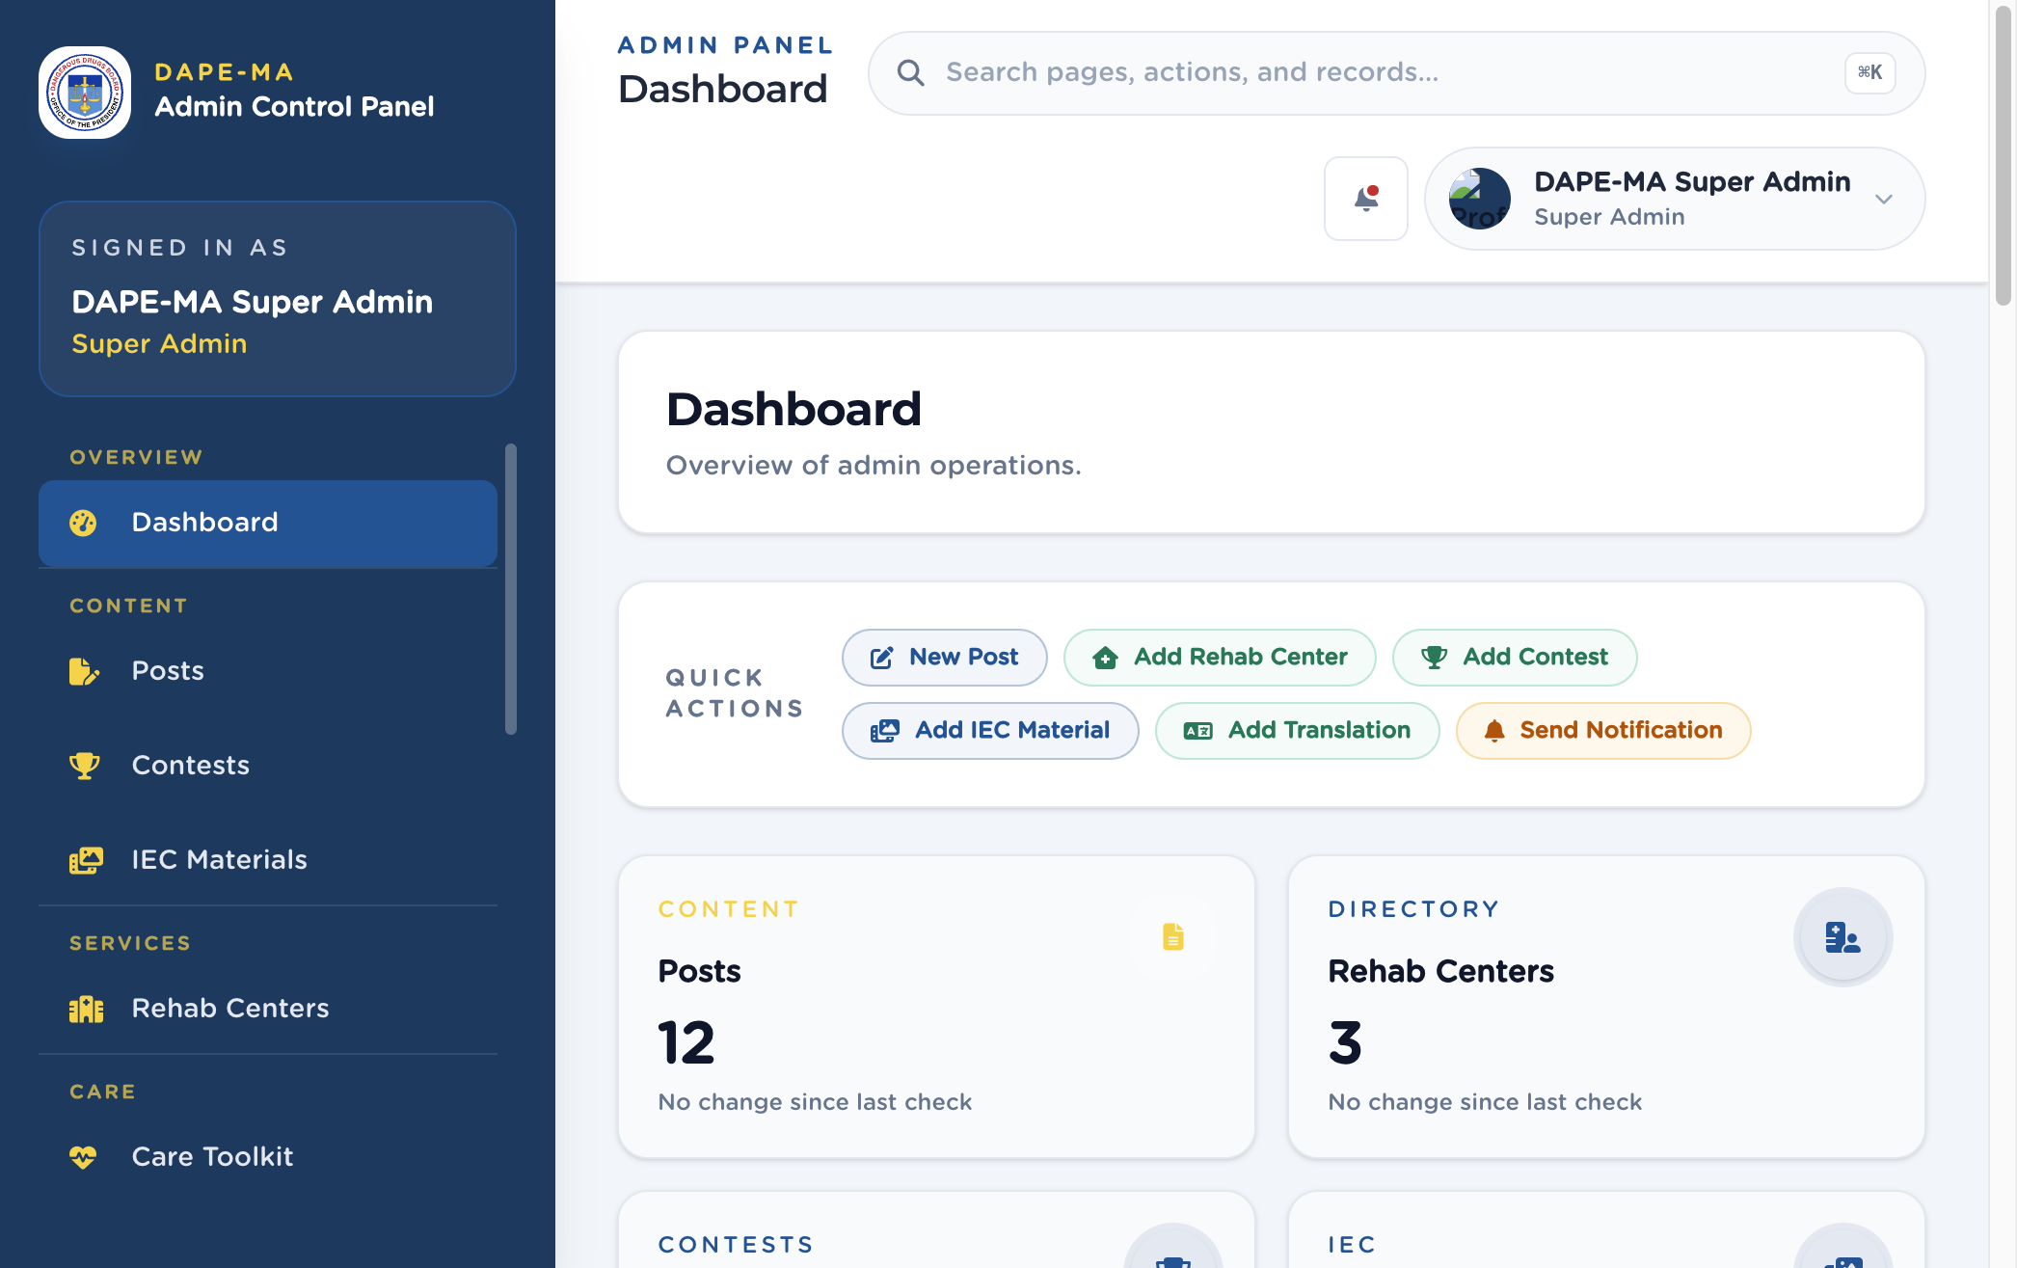
Figure 1. Left menu and Dashboard
Important. Trainings is not in the current left menu and is not covered here. Do not document installer database passwords, Code Snippets, or plugin updates — this is not a WordPress site.

1. How to sign in
Open the admin sign-in page: /admin/login.
Figure 2. Sign-in screen. 1 Email Address, 2 Password, 3 Forgot password?, 4 Sign In.
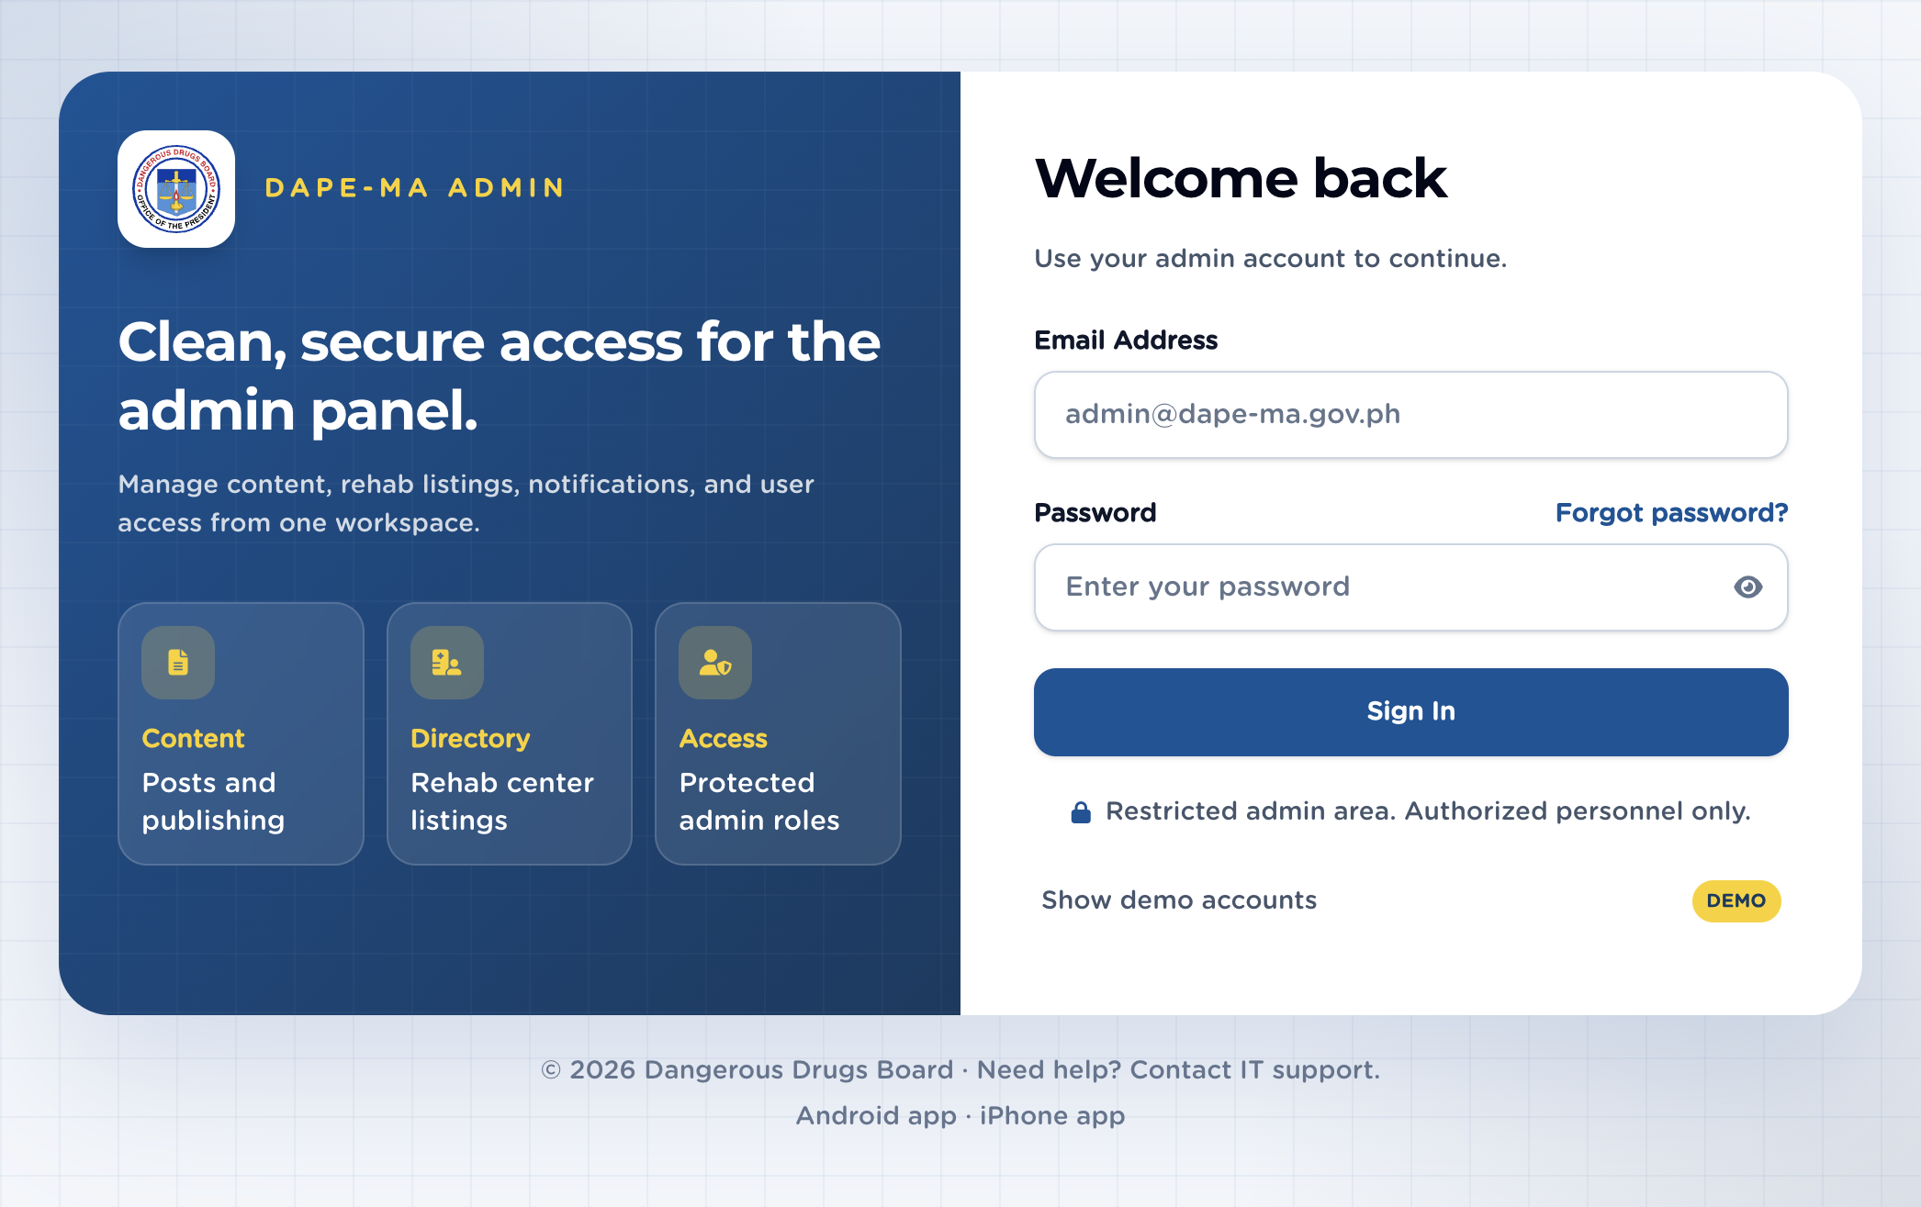
Figure 2. Admin login

1.1 Sign in
- Enter your Email Address.
- Enter your Password.
- Click Sign In.
- You land on the Dashboard.
If you see a 6-digit verification step, check that email inbox and type the code. Use Forgot password? if you cannot sign in.
Important. Passwords you create or reset must include at least 8 characters, upper and lower case, a number, and a symbol. Known breached passwords are rejected. The sign-in current password is not checked for complexity.

1.2 Forgot password
- On the sign-in screen, click Forgot password?
- Enter your email and click Send reset code.
- Open the email from DAPE-MA and enter the 6-digit code.
- Set a New password and Confirm new password, then save.
- Sign in with the new password.

1.3 First-time setup
Create the first administrator (/admin/register) appears only when no Super Admin exists yet. After that, new staff are added from Users → Add User.

1.4 Forced password change
If an administrator set a temporary password for you, the next sign-in opens Edit Profile so you can choose your own password. You cannot use the rest of the admin panel until you change it.
Passwords expire 90 days after they were last changed. Existing accounts with no change date are not expired.

1.5 Edit your profile and sign out
- Click your name and photo at the top right.
- Click Edit Profile to change your photo, first name, last name, or password.
- Click Sign Out when you are finished.
Email and role cannot be changed on your profile. A Super Admin changes roles on Users.
Figure 3. Edit Profile. 1 Photo, 2 First / Last name, 3 Email and role (read-only), 4 Change password.
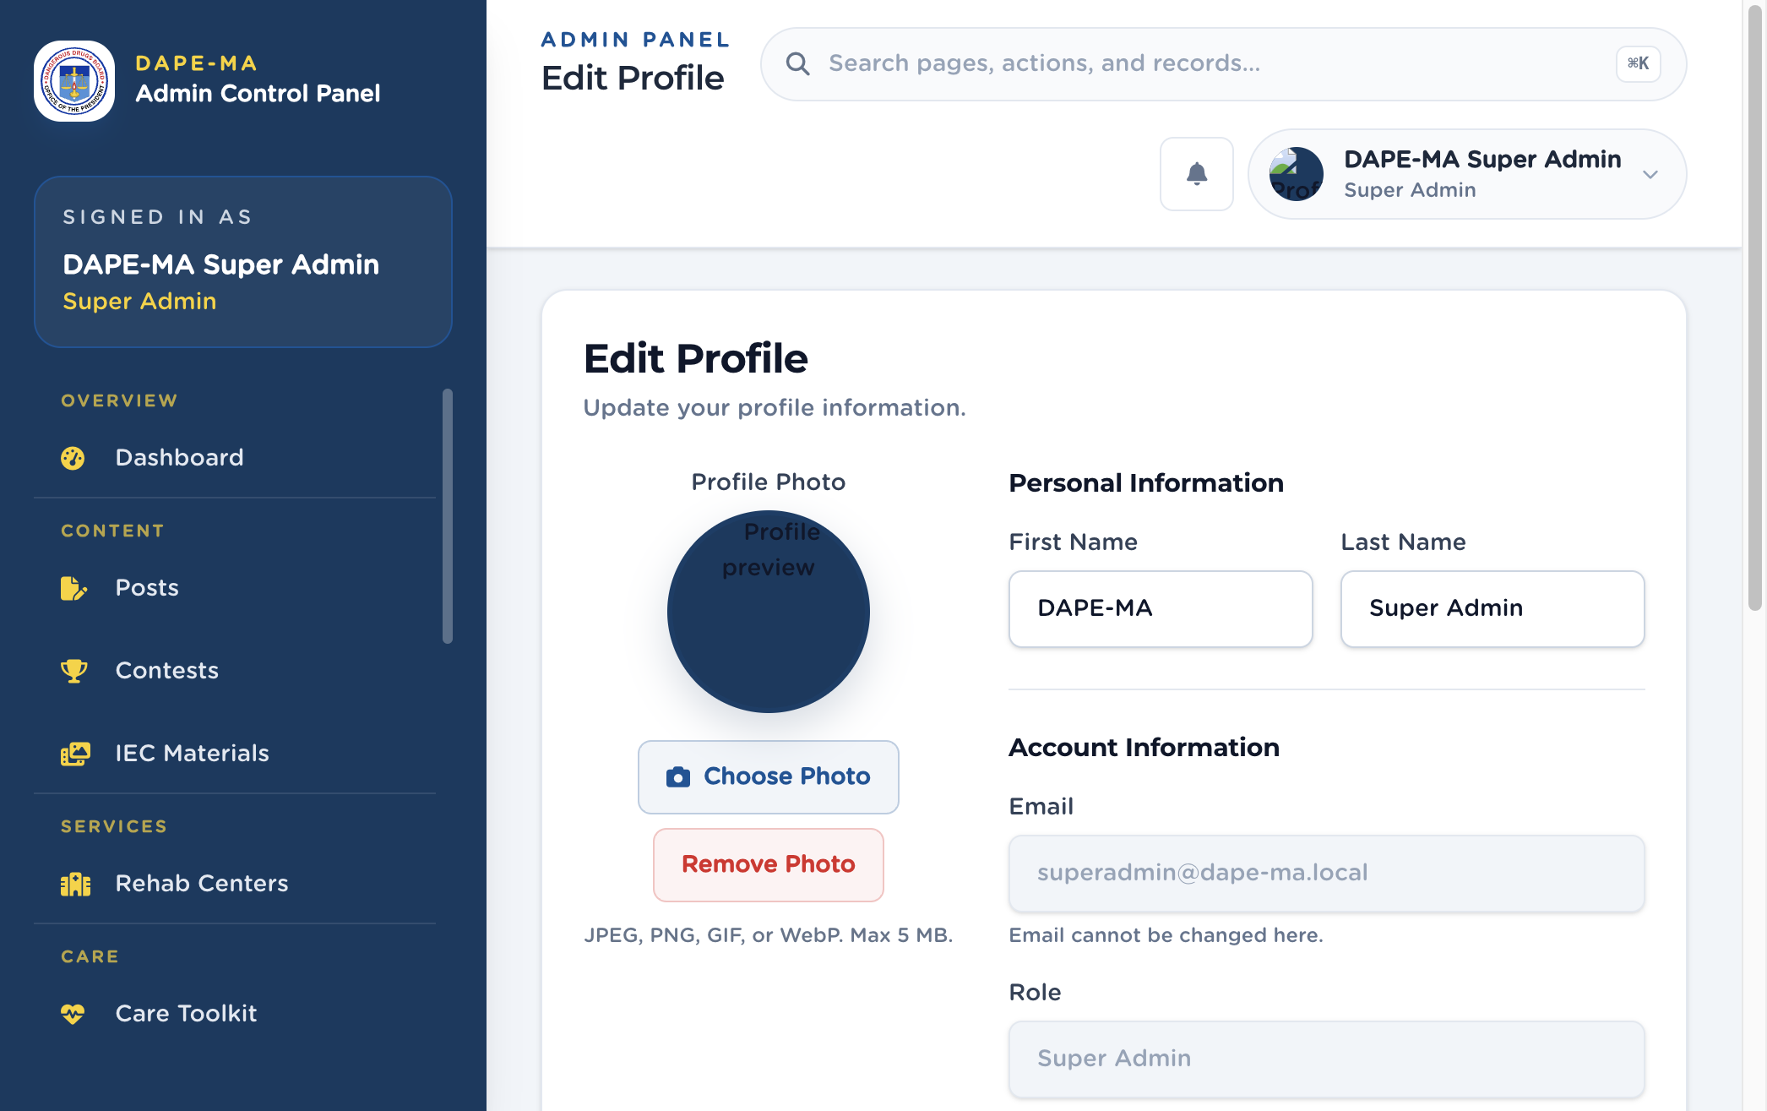
Figure 3. Edit Profile

2. Administrator duties
How often | Task | Where
Every sign-in | Confirm you are on the correct account (name and role in the left panel). | Sidebar “Signed in as”
Weekly | Skim Dashboard counts and Analytics for unusual drops. | chapters 4, 16
Weekly | Review Posts comments and Journal entries that may need deletion. | chapters 5, 12
When someone joins | Add the person on Users and give the smallest role that fits the job. | chapter 17
When someone leaves | Delete or demote the account the same day. | chapter 17
When a hotline changes | Update Care Support and test the Philippine phone format. | chapter 11
When app wording is wrong | Edit App Translations (UI labels) — not the post Body. | chapter 20
Monthly | Walk Settings legal pages (English and Tagalog Body). | chapter 18

2.1 Which role to give
Role | What they can open
Super Admin | Everything, including Users, Analytics, and Journal.
Publisher | Content, rehab centers, contests, IEC, care toolkit/checks/support, Hope, notifications, settings, lookups, translations, word blocking. Not Users, Analytics, or Journal.
Editor | Posts only.
Analytics Viewer | Analytics only.

Tip. Most content staff should be Publisher, not Super Admin. Keep Super Admin for a small IT / records set.

2.2 When someone joins
- Click Users, then Add User.
- Fill name, work email, role, and a temporary password that meets the policy.
- Tell them they must change the password on first sign-in.
- Ask them to confirm they can open only the menus they need.

2.3 When someone leaves
- Click Users.
- Find the row, click the trash Delete User action (or right-click the row → Delete).
- Confirm in the dialog. A toast confirms the account is gone.

3. How lists work
Almost every admin page uses the same list. Learn it once.
Figure 4. A typical list (Posts). 1 Page title and primary button, 2 Search, 3 Sortable columns, 4 Actions (view, edit, more), 5 Rows per page.
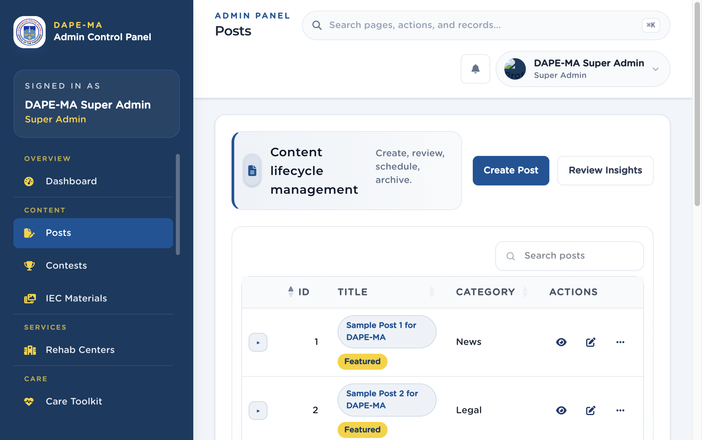
Figure 4. Posts list

3.1 Search and sort
- Type in Search to filter the current table.
- Click a column header (Title, Name, Date) to sort. Click again to reverse.
- Use Show extra columns when the table hides fields on a narrower screen.
The top search bar (Search pages, actions, and records… or ⌘K) searches the whole admin, not only the current table.

3.2 Actions column
The last column stays on the right on desktop.
- The first two icons are the main commands (often View and Edit).
- Extra commands sit under More actions (…).
- Hover an icon to see the tooltip (View, Edit, Delete).
- On a phone, each row becomes a card with labeled buttons.

3.3 Right-click / long-press
Right-click a row (or long-press on a phone) to open the same commands as the Actions column. The browser’s own menu is turned off on those rows.

3.4 Confirmations and toasts
- Delete, archive, reject, and other yes/no prompts use a confirmation dialog with Cancel and a confirm button.
- After a save or delete succeeds or fails, a toast appears in the corner — not another large success window.

3.5 Phones and small screens
On a phone (~320–430 px):
- Tap the menu (☰) to open the left sidebar.
- Lists switch to stacked cards so titles stay readable.
- Buttons are large enough to tap. You do not need hover.
Tip. If a page looks empty, wait a moment for the list to load, then try Search. If you still see nothing, you may not have permission for that menu.

4. Dashboard
Left menu: Overview → Dashboard (/admin/dashboard).
Figure 5. Dashboard. 1 Search, 2 Account menu, 3 Quick Actions, 4 Count cards.
Figure 5. Dashboard

4.1 What you see
- Quick Actions: New Post, Add Rehab Center, Add Contest, Add IEC Material, Add Translation, Send Notification. Each opens the same dialog as the matching menu page.
- Count cards: Posts, Rehab Centers, Contests, IEC Materials, App Translations, Notifications, Users, Journal. Tap a card to open that page.
- Activity Over Time and Recent Activity summarize recent app and content events.
- Top Content lists most-viewed posts.

4.2 Search everything
- Click the search box (or press ⌘K).
- Type at least two letters.
- Results include pages, actions, and matching records. Use the arrow keys and Enter, or tap a result.
On a phone, tap the search icon to open the same panel.

5. Posts
Left menu: Content → Posts (/admin/posts).
Posts are articles the mobile app shows in Home and categories. Super Admins publish immediately. Editors create drafts for review.

5.1 Create a post
- Click Create Post (Editors see Create Draft).
- Optional: choose a Featured Image (JPG, PNG, WEBP, or GIF, up to 5 MB).
- Tick Featured post if it should appear in the mobile carousel.
- Enter Title.
- Write Body / rich text content in the editor (headings, bold, italic, links, numbered and bulleted lists).
- Choose a Category.
- Set Comments to Enabled or Disabled.
- Optional: paste a YouTube URL.
- Click Create & Publish (Super Admin) or Create Draft (Editor).
Figure 6. Create Post dialog. 1 Featured Image, 2 Featured post, 3 Title, 4 Body editor, 5 Category, 6 Comments, 7 Create & Publish.
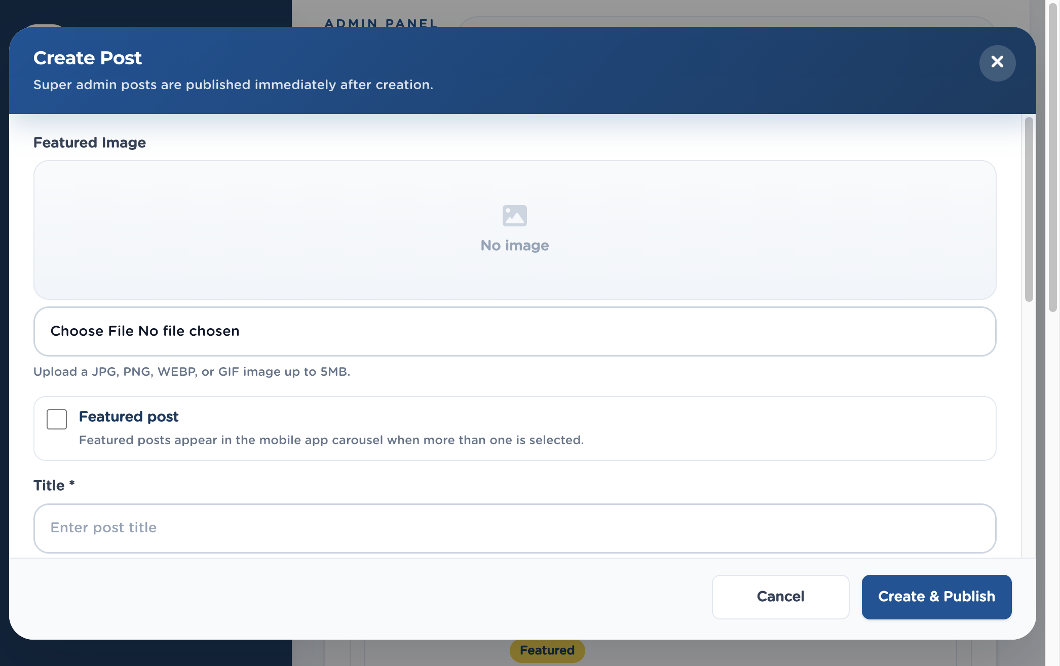
Figure 6. Create Post
Tip. Super Admin posts go live as soon as you create them. Editors submit drafts; a Super Admin (or Publisher with review actions) approves, schedules, or publishes.

5.2 Statuses
Status | Meaning
Draft | Not public. Keep working.
Pending review | Waiting for an approver.
Scheduled | Goes live at the date and time you set.
Published | Visible in the app.
Archived | Taken down but not deleted.

5.3 View, comments, and ratings
- Click the eye View action (or the title).
- Read the post body as it will appear.
- Open Comments to read user comments. Click Delete on a comment to remove it after confirmation.
- Open Ratings and Reactions to see engagement.

5.4 Edit, schedule, archive, delete
From Actions or right-click:
- Edit — change title, body, image, category, comments, YouTube, featured flag, and (when allowed) status.
- Submit — send a draft for review.
- Reject — return a pending post with review notes.
- Approve & Schedule — pick a go-live date and time.
- Publish now — make it public immediately.
- Archive / Delete — confirm in the dialog.
Important. Deleting a post cannot be undone. Archive if you might need it later.

6. Contests
Left menu: Content → Contests (/admin/contests).
Song, Poster, and Video contests are managed on this one page. Filter by type and status on the left.
Figure 7. Contests. 1 Types, 2 Statuses, 3 Add Contest, 4 Search and Actions.
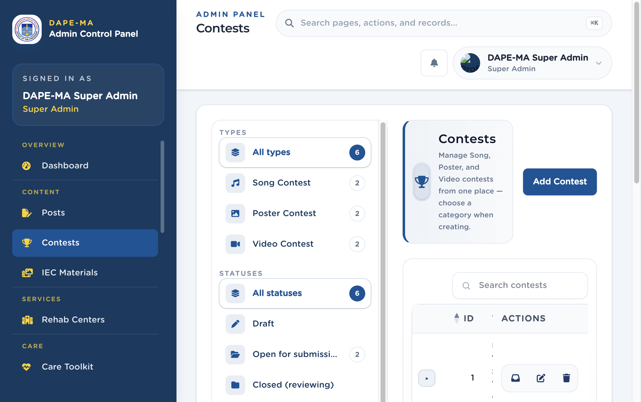
Figure 7. Contests

6.1 Add a contest
- Click Add Contest.
- Choose Category: Song Contest, Poster Contest, or Video Contest. (You cannot change category after save.)
- For Song contests, choose allowed entry types: Song + Playlist, Song only, or Playlist only.
- Enter Contest title, optional Theme, and Contest year.
- Set Submission starts and Submission ends.
- Set Status (Draft, Open for submissions, Closed (reviewing), Completed).
- Set Visibility to Active in app or Hidden.
- Add Description and Contest rules (shown on the contest detail screen).
- Click Create.

6.2 Review submissions
- Click the submissions / review action on the row.
- Open an entry to view the song, poster, or video.
- Use the status filters when judging.

6.3 Edit or delete
Edit from the pencil action. Delete Contest also deletes all submissions under it — confirm only if you mean it.

7. IEC Materials
Left menu: Content → IEC Materials (/admin/iec-materials).
IEC (Information, Education, and Communication) items fill the mobile gallery: animated GIFs, still images, YouTube clips, or Lottie JSON URLs.
Figure 8. IEC Materials list. 1 Add IEC Material, 2 Preview, title, topic, 3 Actions (preview, edit, delete).
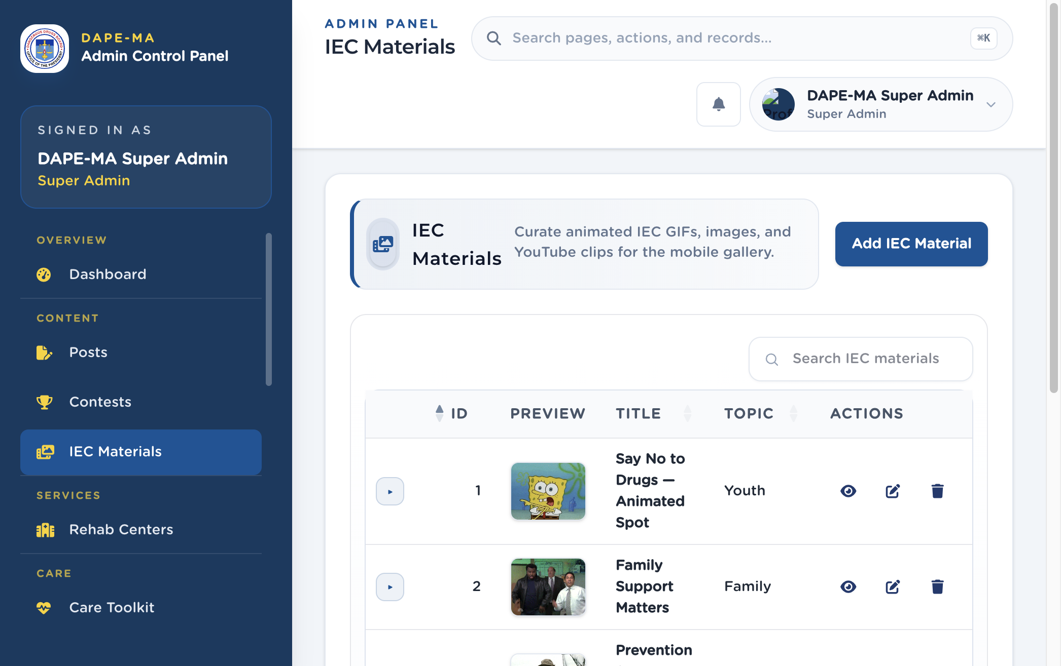
Figure 8. IEC Materials

7.1 Add IEC material
- Click Add IEC Material.
- Enter the title and topic (Prevention, Awareness, Youth, Family, Recovery).
- Choose media type: Animated GIF, Image, YouTube, or Lottie JSON URL.
- Upload the file or paste the URL.
- Set publish / archive status as shown in the form.
- Save. A toast confirms the item is created.

7.2 Preview, edit, archive
- Preview opens the animation or clip without leaving the page.
- Edit updates title, topic, or file.
- Delete removes it after confirmation.
Tip. Keep file sizes reasonable so the app downloads quickly on mobile data.

8. Rehab Centers
Left menu: Services → Rehab Centers (/admin/rehab-centers).
This directory drives rehab listings in the mobile app, including the map pin.
Figure 9. Rehab Centers. 1 Add Rehab Center, 2 Facility map with pins, 3 List below the map.
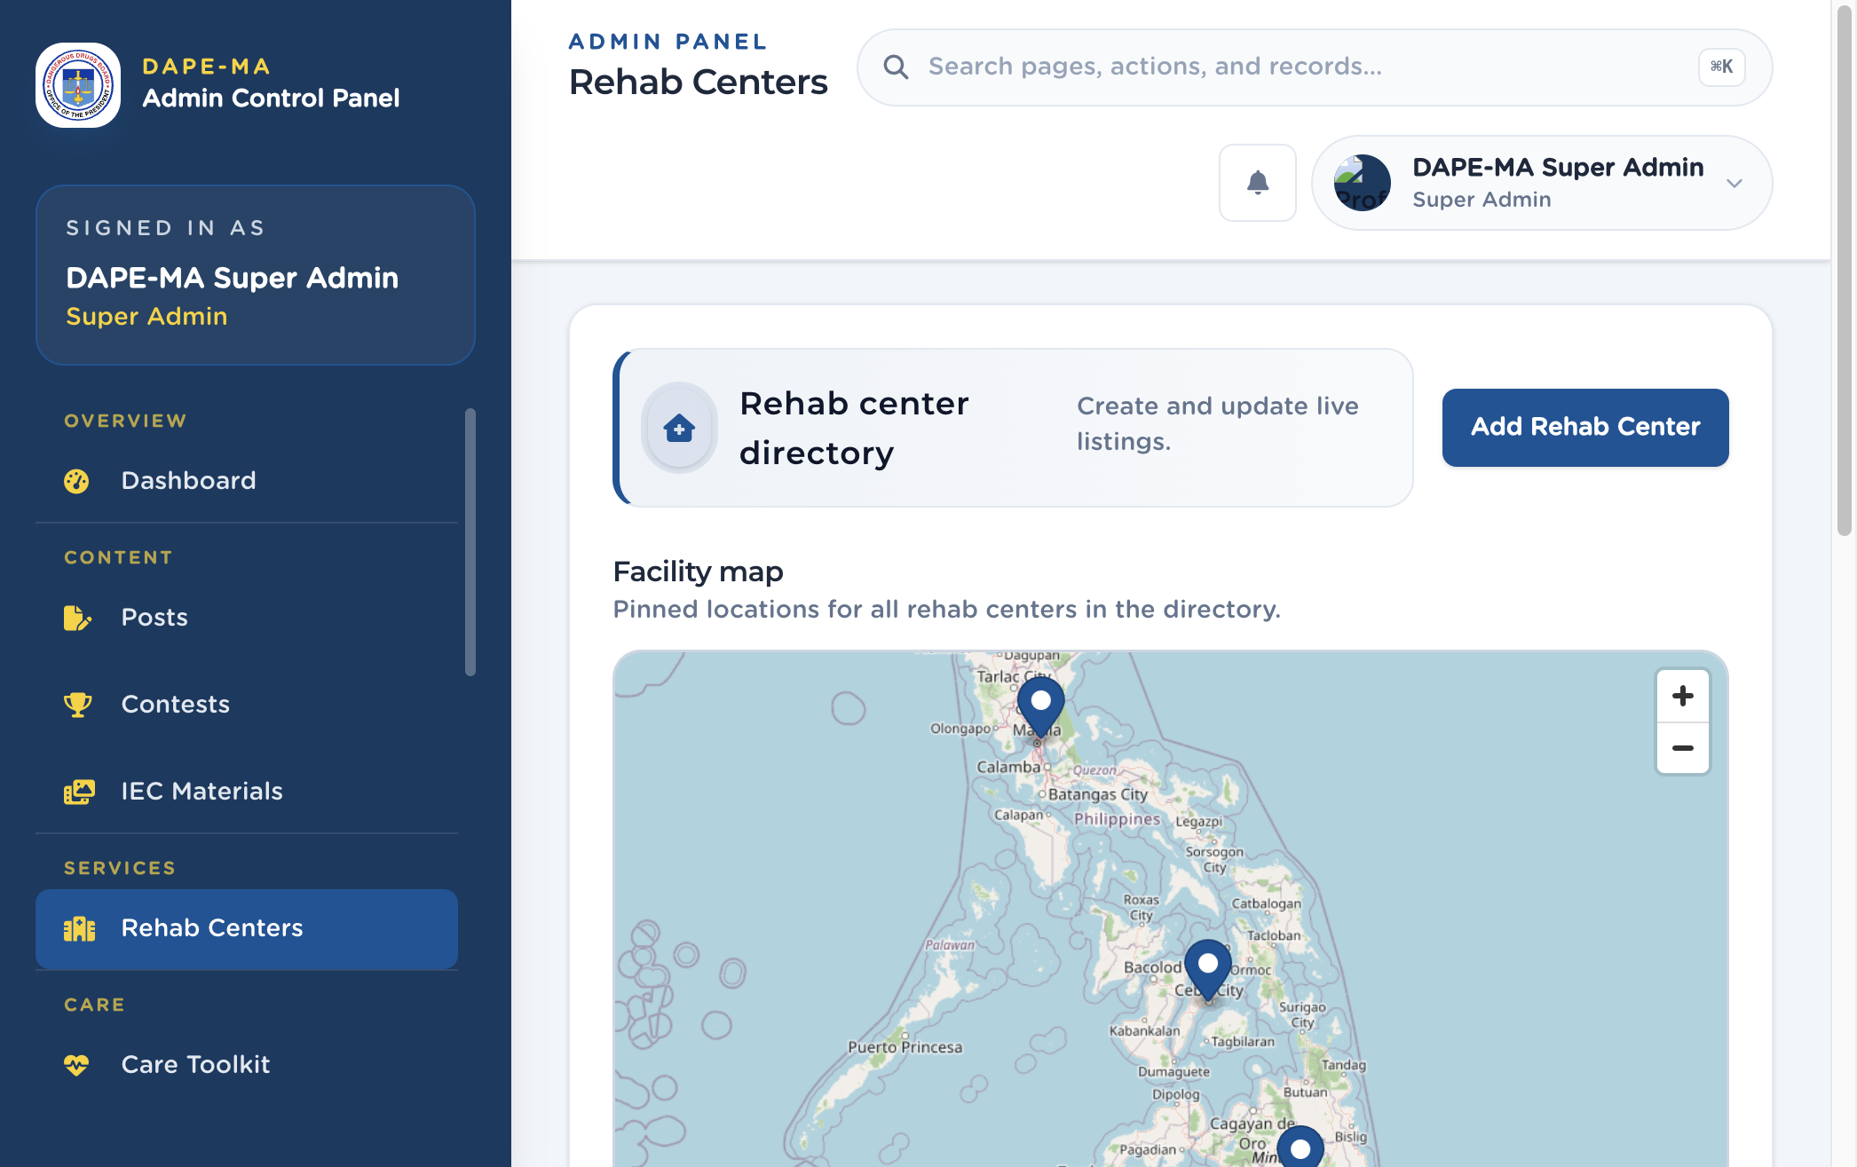
Figure 9. Rehab Centers

8.1 Add a rehab center
- Click Add Rehab Center.
- Enter Name.
- Start typing in Address. After three characters, Philippine place suggestions appear. Click a suggestion — the field fills and the map pin moves. The suggestion list stays closed until you change the text.
- You can also search or tap the map to drop the pin. Region and province fill from the pin.
- Optional: Contact and Website URL.
- Set Status Active or Inactive.
- Click Create. You must pin a location before save.
Important. Do not type a foreign address. Suggestions come from the shared Philippine map search. Phone-like contact values should be Philippine numbers when you collect a phone.

8.2 Edit or delete
Use Edit rehab center or Delete rehab center on the row. Deleting cannot be undone.

9. Care Toolkit
Left menu: Care → Care Toolkit (/admin/care-toolkit).
These questions power Stress, Anxiety, and Sleep checks in the mobile Self-care Toolkit.
Figure 10. Care Toolkit. 1 Toolkit filters, 2 Add Question, 3 Question list.
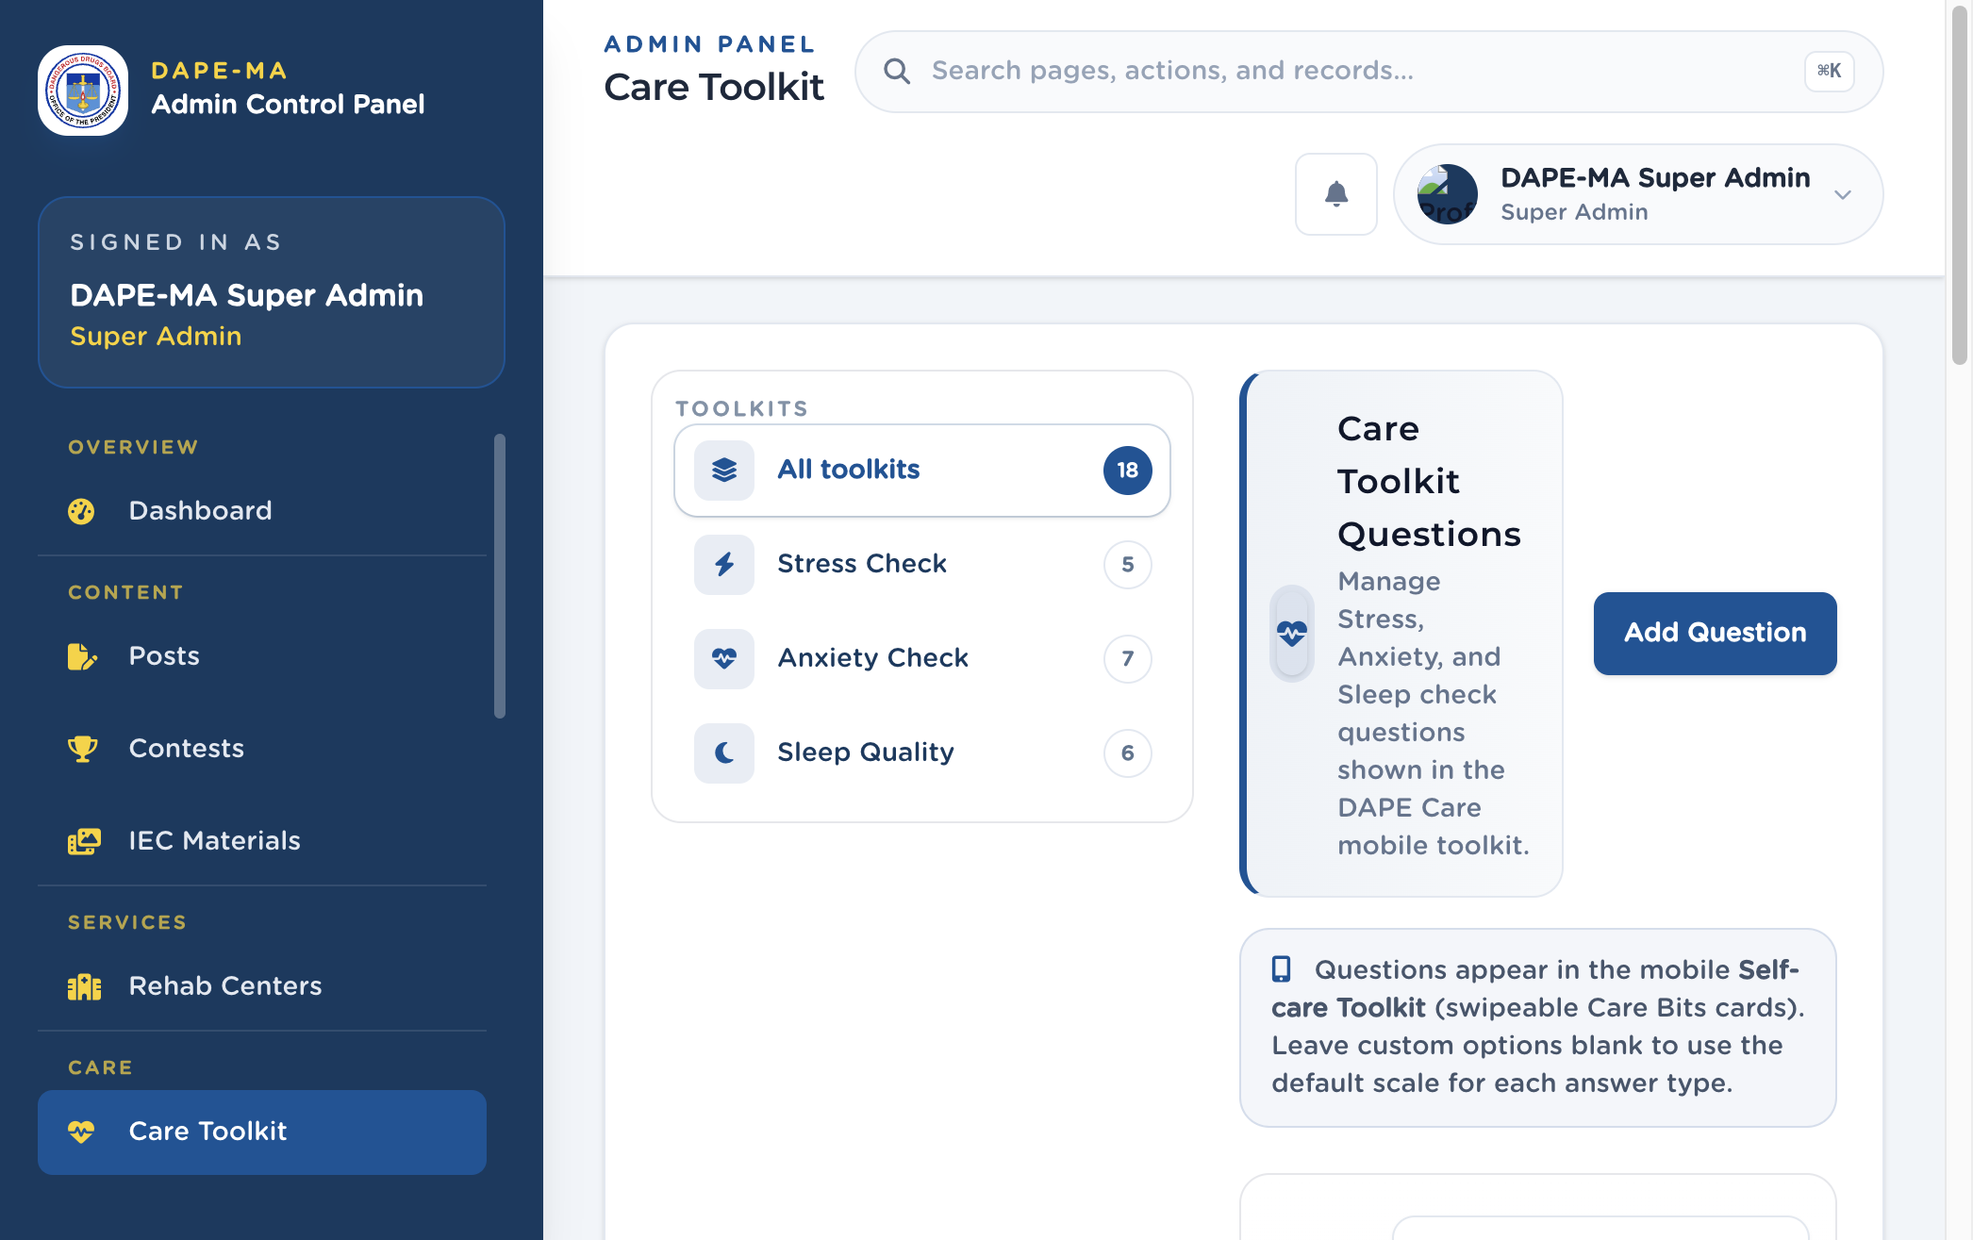
Figure 10. Care Toolkit

9.1 Add a question
- Click Add Question.
- Choose Toolkit: Stress Check, Anxiety Check, or Sleep Quality.
- Choose Answer type: 5-point scale (Never → Very Often), 4-point scale, or Time input (HH:MM).
- Enter Question (English) and Question (Tagalog).
- Optional custom options (one per line). Leave blank to use the default scale.
- Set sort order and active status as shown.
- Save.
Filter the list with All toolkits, Stress Check, Anxiety Check, or Sleep Quality.
Important. Changing a live question changes what users see on the next check. Do not rewrite scoring scales without checking with the program owner.

10. Care Checks
Left menu: Care → Care Checks (/admin/care-checks).
This page shows submitted Stress, Anxiety, and Sleep Quality results from the mobile app. It is self-reported screening for reflection only — not a clinical diagnosis.
Figure 11. Care Checks. 1 Range (7 / 30 / 90 days), 2 Export CSV, 3 Completions and people cards.
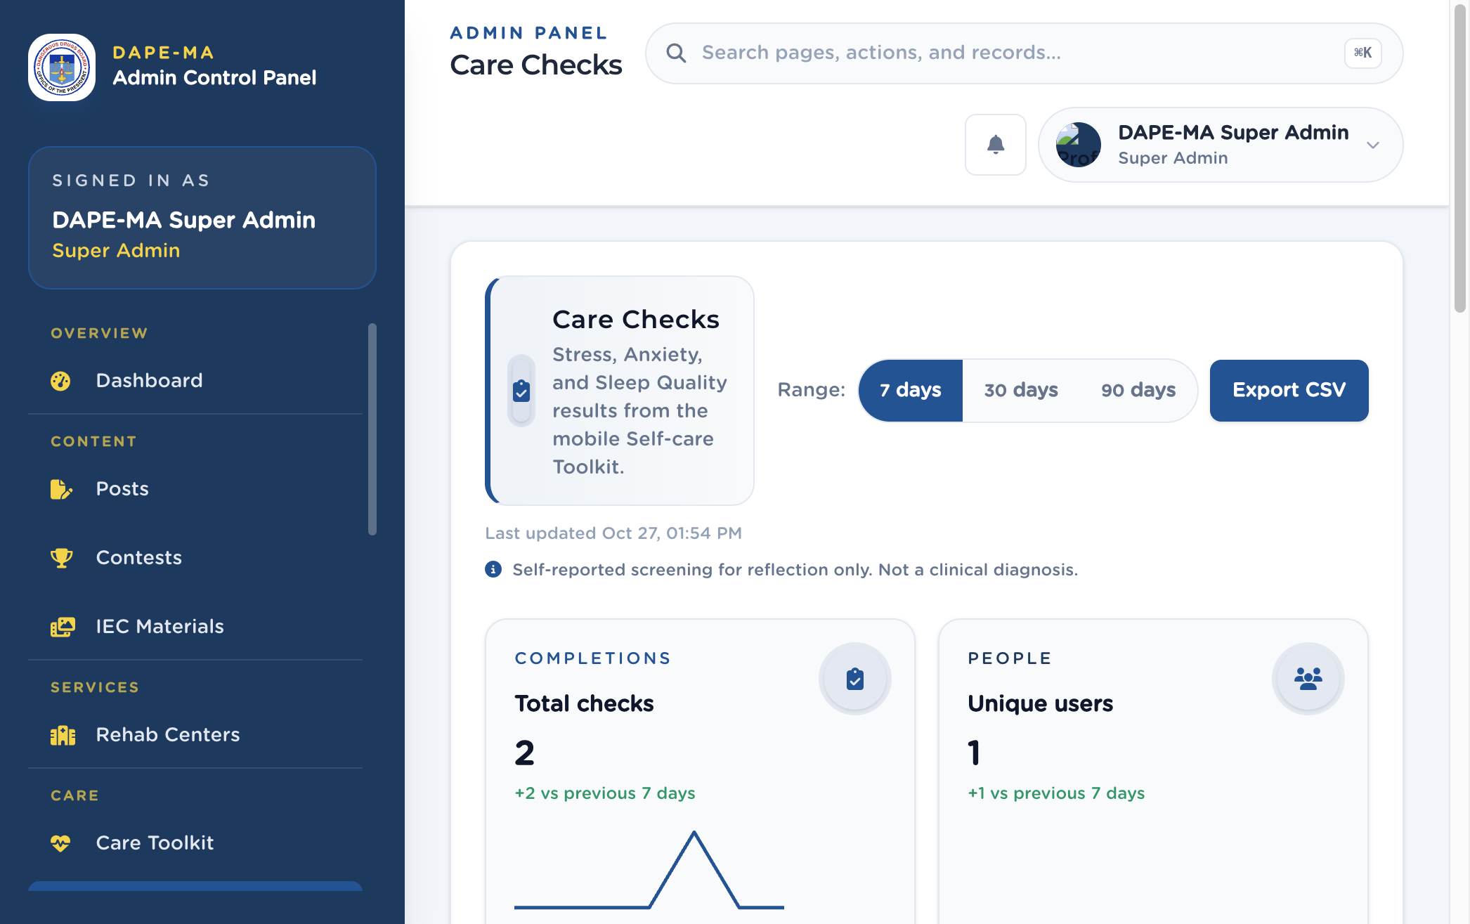
Figure 11. Care Checks

10.1 How to read the page
- Switch 7 days, 30 days, or 90 days.
- Filter by check type and lower / higher tier.
- Open a row to see the user’s result, score, and date.
- Click Export CSV to download the filtered set.
Use this page to watch volume, not to diagnose a person. Follow your office protocol if a result suggests someone may need support — point them to Care Support hotlines.

11. Care Support
Left menu: Care → Care Support (/admin/care-support).
Hotlines, counseling entries, and crisis resources shown in DAPE Care.
Figure 12. Care Support. 1 Categories, 2 Add Resource.
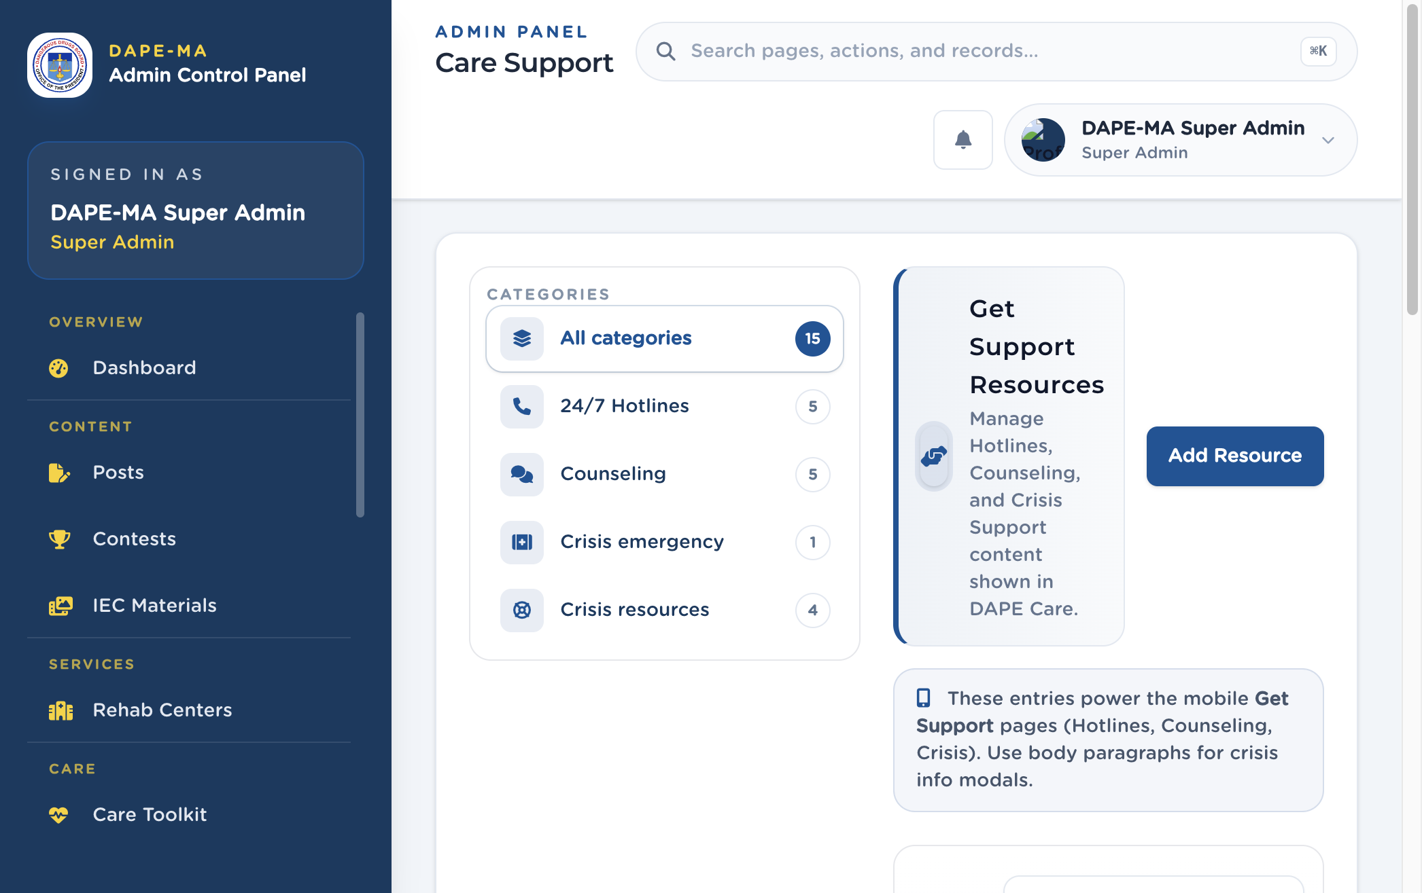
Figure 12. Care Support

11.1 Add a resource
- Click Add Resource.
- Choose Category: 24/7 Hotline, Counseling, Crisis emergency banner, or Crisis info resource.
- Enter Title (English) and Title (Tagalog).
- Fill role, description, website, and other fields as shown.
- For hotlines, enter a Philippine phone number. Short codes such as 1553, 911, or #33733 are allowed on this page. Separate several numbers with |.
- Crisis resources can include modal body paragraphs (one per line).
- Save.
Important. Phone fields accept Philippine mobile and landline formats only (09XXXXXXXXX, +63 …). Do not enter a US or other country number.

12. Journal
Left menu: Care → Journal (/admin/diary). Super Admin only.
Users write private journal notes in the mobile Journal. Staff use this page to review entries for moderation.
Figure 13. Journal. 1 Users filter, 2 Skies (color mood) filter, 3 Search entries, 4 View / delete.
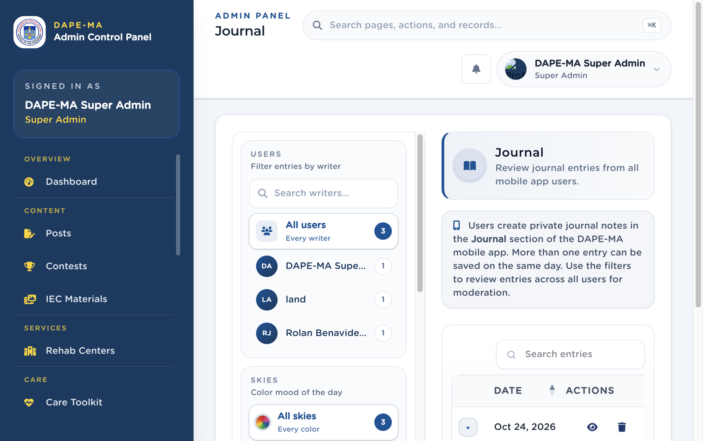
Figure 13. Journal

12.1 Filter and review
- Under Users, pick All users or a writer (search by name).
- Under Skies, pick a color mood (or All skies).
- Optional: switch 7 / 30 / 90 day summary range.
- Click View to read the entry, sky, feelings, and notes.
- Delete only when the entry must be removed. Confirm in the dialog.
Sky colors, feeling chips, and “what shaped your day” labels come from Lookups. If a sky color is missing in the app, add or edit it there.

13. Hope Directory
Left menu: Hope → Hope Directory (/admin/hope-directory).
Government, NGO, and school partners listed in the DAPE Hope Official Directory.
Figure 14. Hope Directory. 1 Category filters, 2 Add Organization.
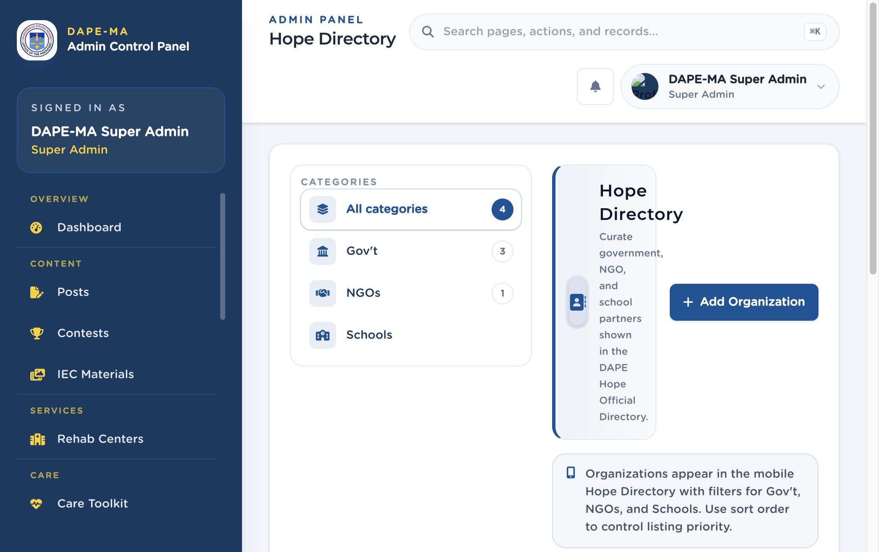
Figure 14. Hope Directory

13.1 Add an organization
- Click Add Organization.
- Enter Name and optional description.
- Choose Category: Gov’t, NGOs, or Schools.
- Start typing Address and pick a Philippine suggestion.
- Enter a Philippine Phone if you have one.
- Optional email, logo, sort order, and Active / Inactive.
- Save.
Sort order controls listing priority in the app. Inactive partners stay in the admin list but do not appear in the app.

14. Hope Events
Left menu: Hope → Hope Events (/admin/hope-events).
Youth, parent, and community events shown in DAPE Hope.
Figure 15. Hope Events. 1 Audience filters, 2 Add Event.
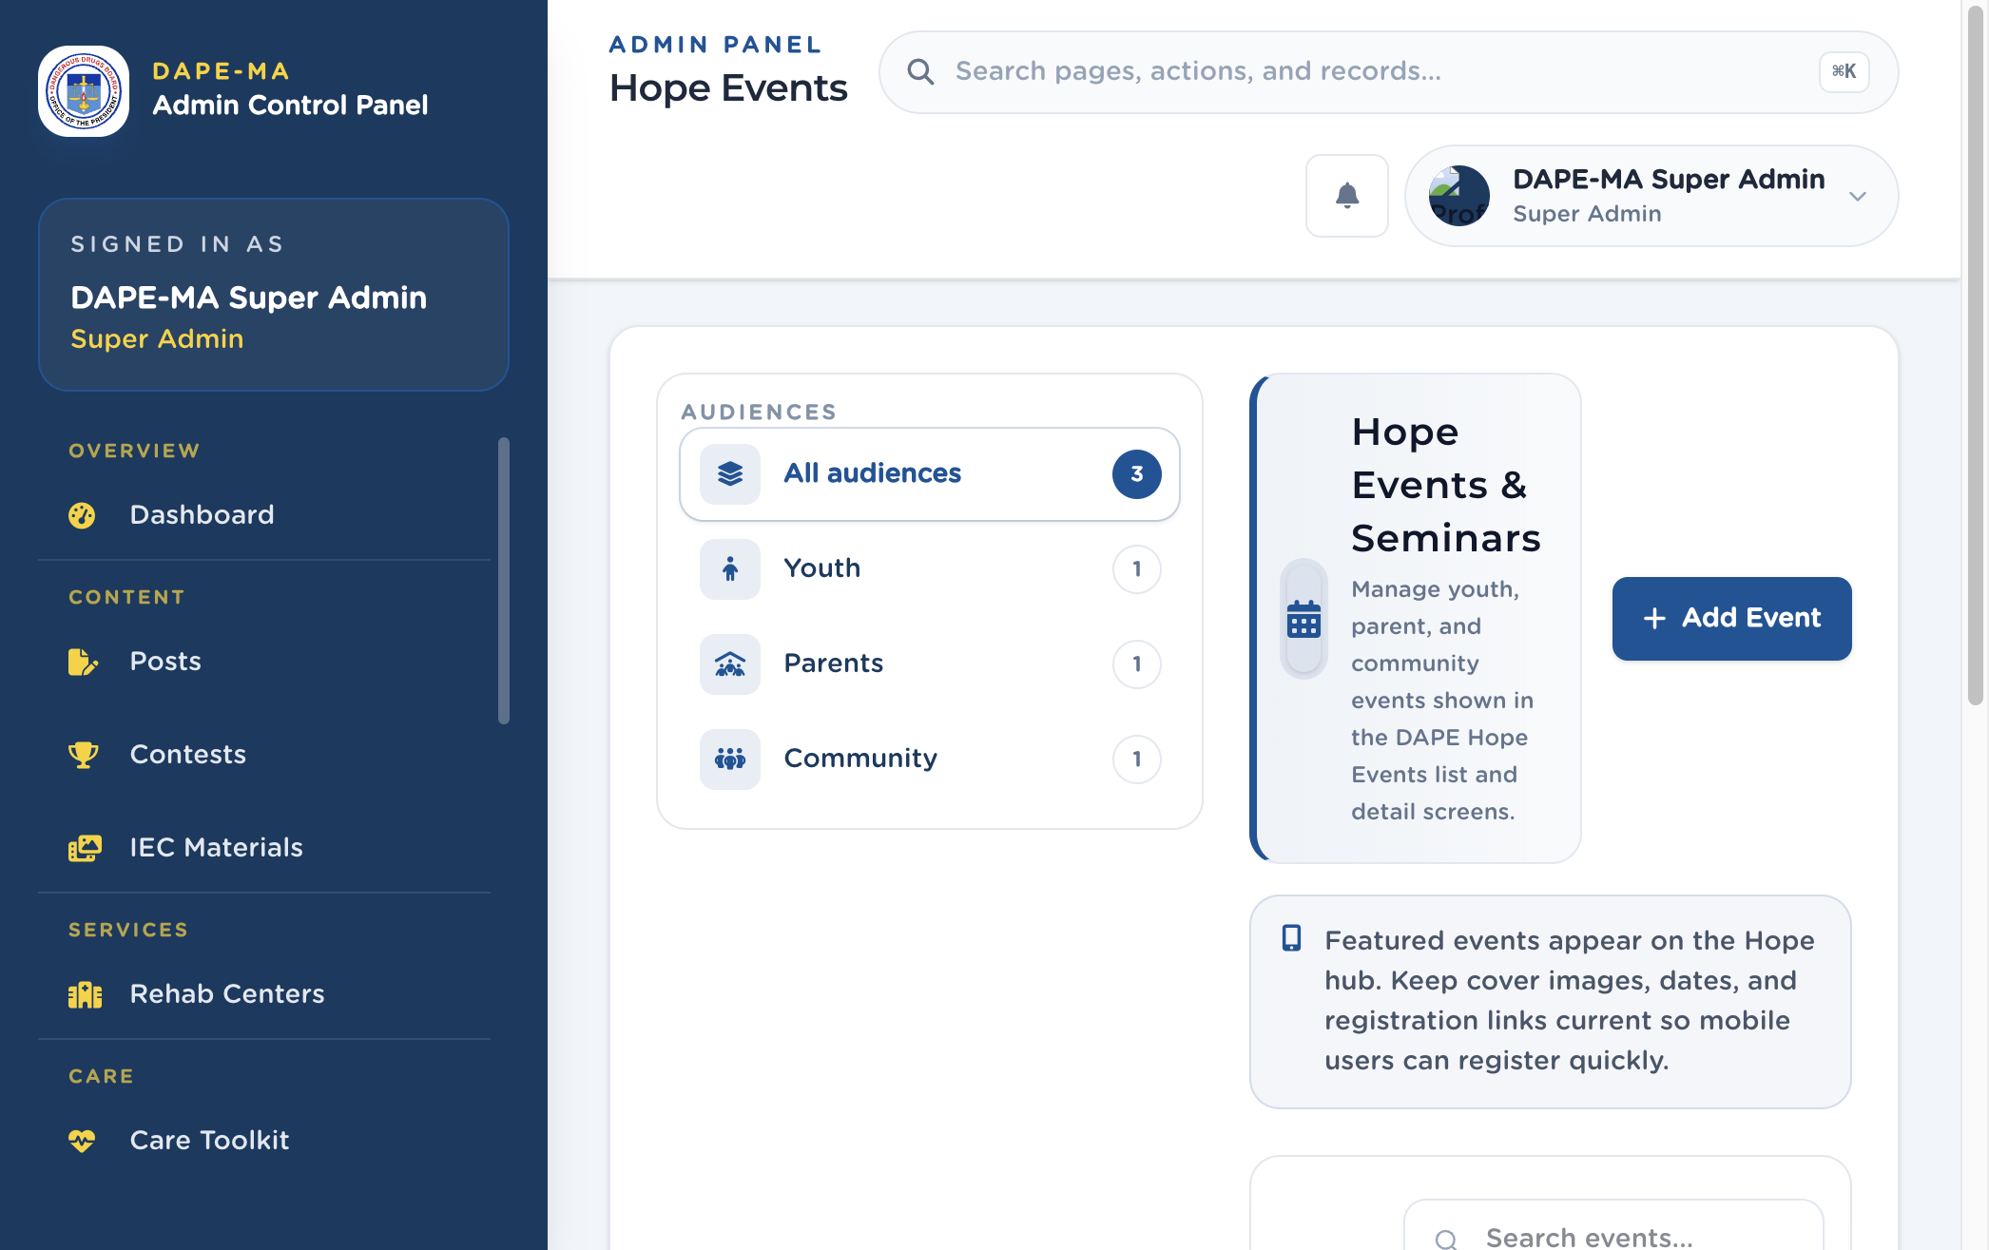
Figure 15. Hope Events

14.1 Add an event
- Click Add Event.
- Enter the title, details, dates, and audience (Youth, Parents, Community).
- Add a cover image when the form asks for one.
- Set slots, registration link, featured flag, and Active / Hidden as shown.
- Save.
Featured events appear on the Hope hub. Keep dates and registration links current.
Some events include a Share action for a public link. Use it only when your office wants the event on the web.

15. Notifications
Left menu: Reach → Notifications (/admin/notifications).
Send inbox alerts to mobile app users and review campaign history.
Figure 16. Notifications. 1 Audience filters, 2 Send Notification.
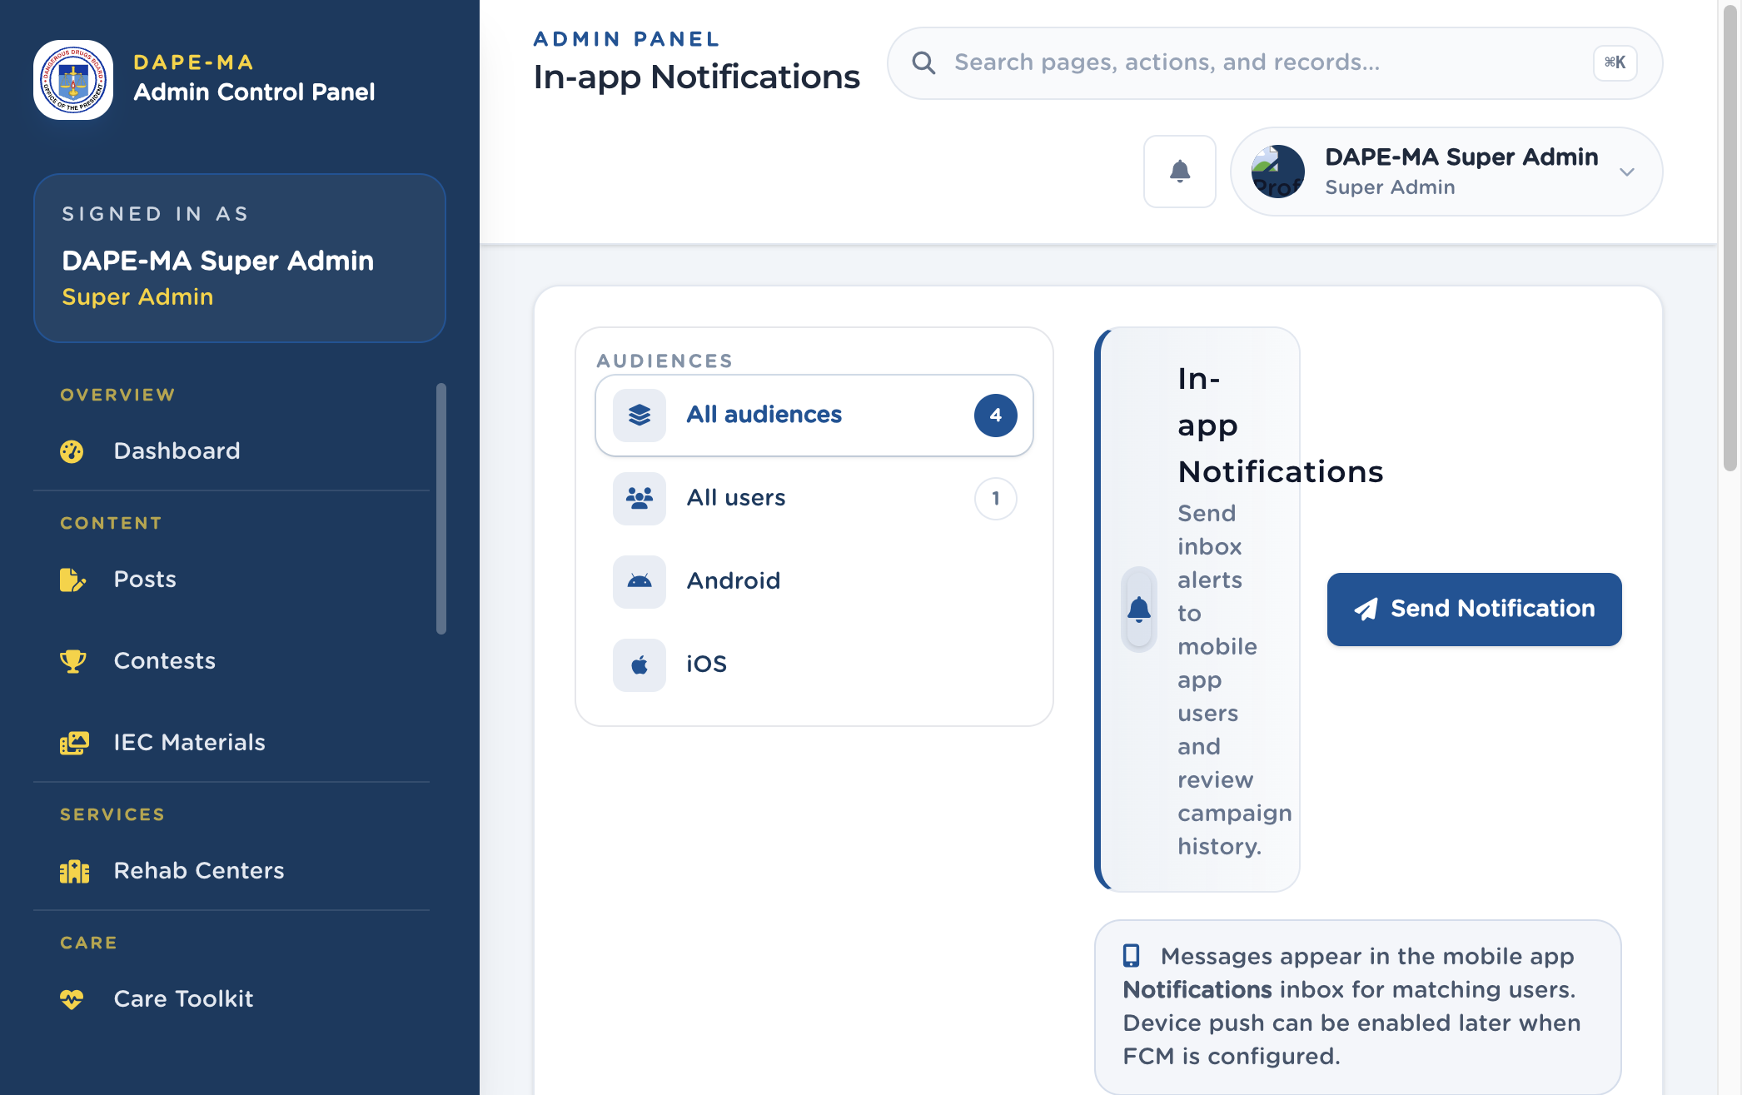
Figure 16. Notifications

15.1 Send a campaign
- Click Send Notification.
- Enter Title and Message body.
- Optional: link a Related Post.
- Choose Audience: All Users, Android Users, or iOS Users.
- Confirm send.
Messages appear in the mobile Notifications inbox for matching users. Device push can be enabled later when FCM is configured.

15.2 History
Filter by audience. View opens the campaign. Delete removes it from history after confirmation.

16. Analytics
Left menu: Reach → Analytics (/admin/analytics). Super Admin and Analytics Viewer.
Figure 17. Analytics command center. 1 Range (Today / 7 days / 30 days), 2 Refresh, 3 Export CSV.
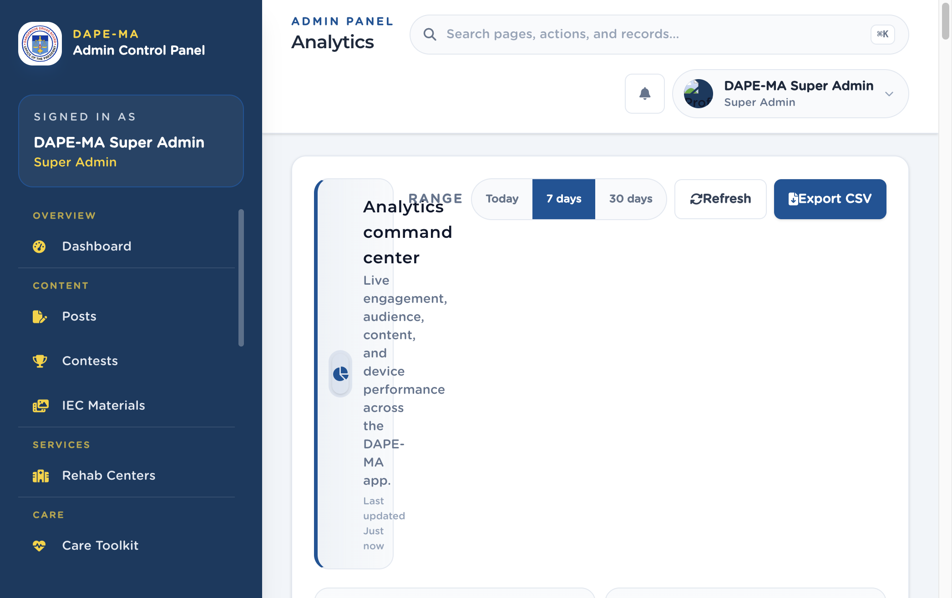
Figure 17. Analytics

16.1 What the numbers mean
Card | Meaning
Total events | All tracked actions in the range.
Views | Post and content views.
Unique users | Signed-in people who generated at least one event.
Engagement rate | Bookmarks + shares divided by views.
Sessions, bookmarks, searches, shares, reviews | Counts for those actions.
Avg rating | Average stars across rated posts.

Further down: daily activity, hourly heatmap, events by type, engagement funnel, device breakdown (Android / iOS / web), top viewed and top rated posts, top categories, weekday performance, rating distribution, and a live recent-activity feed.

16.2 Export
- Click Export CSV.
- Choose Today, Last 7 days, or Last 30 days.
- Click Download CSV.

17. Users
Left menu: Administration → Users (/admin/users). Super Admin only.
Figure 18. Users list. 1 Add User, 2 Search, 3 Actions (Edit, Change Role, Delete). Your own row shows Current account.
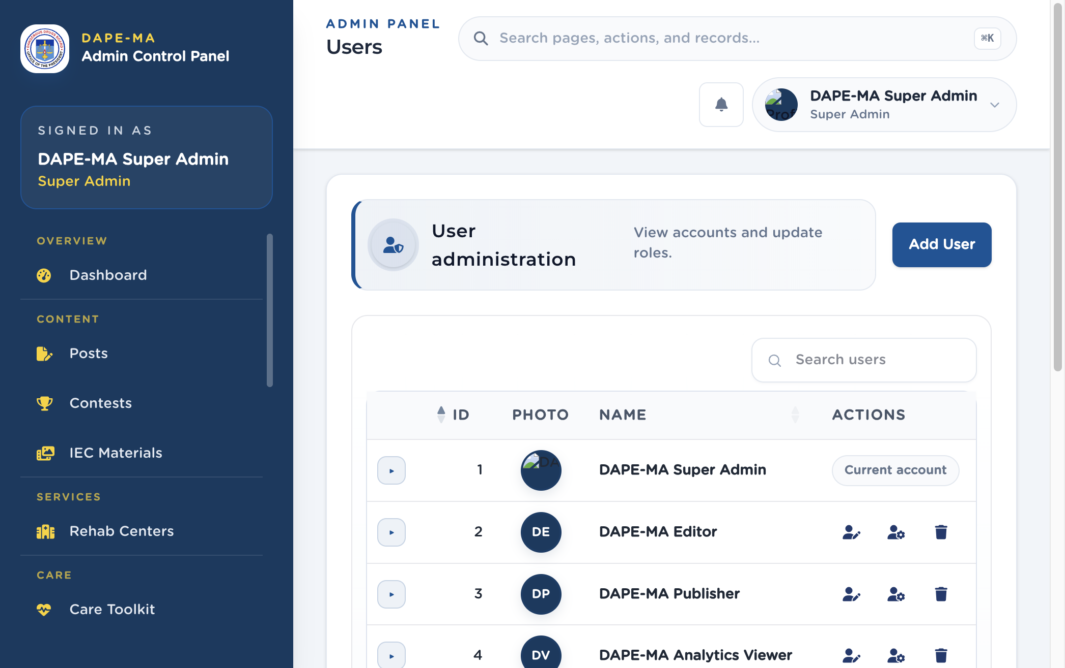
Figure 18. Users

17.1 Add a user
- Click Add User.
- Enter Full Name and Email Address.
- Choose Role (see the table in chapter 2).
- Enter Password and Confirm Password that meet the hint: at least 8 characters, upper and lower case, a number, a symbol.
- Click Create User.
The new person must change that password on first sign-in.
Figure 19. Add User dialog. 1 Name, 2 Email, 3 Role, 4 Password and policy checklist, 5 Create User.
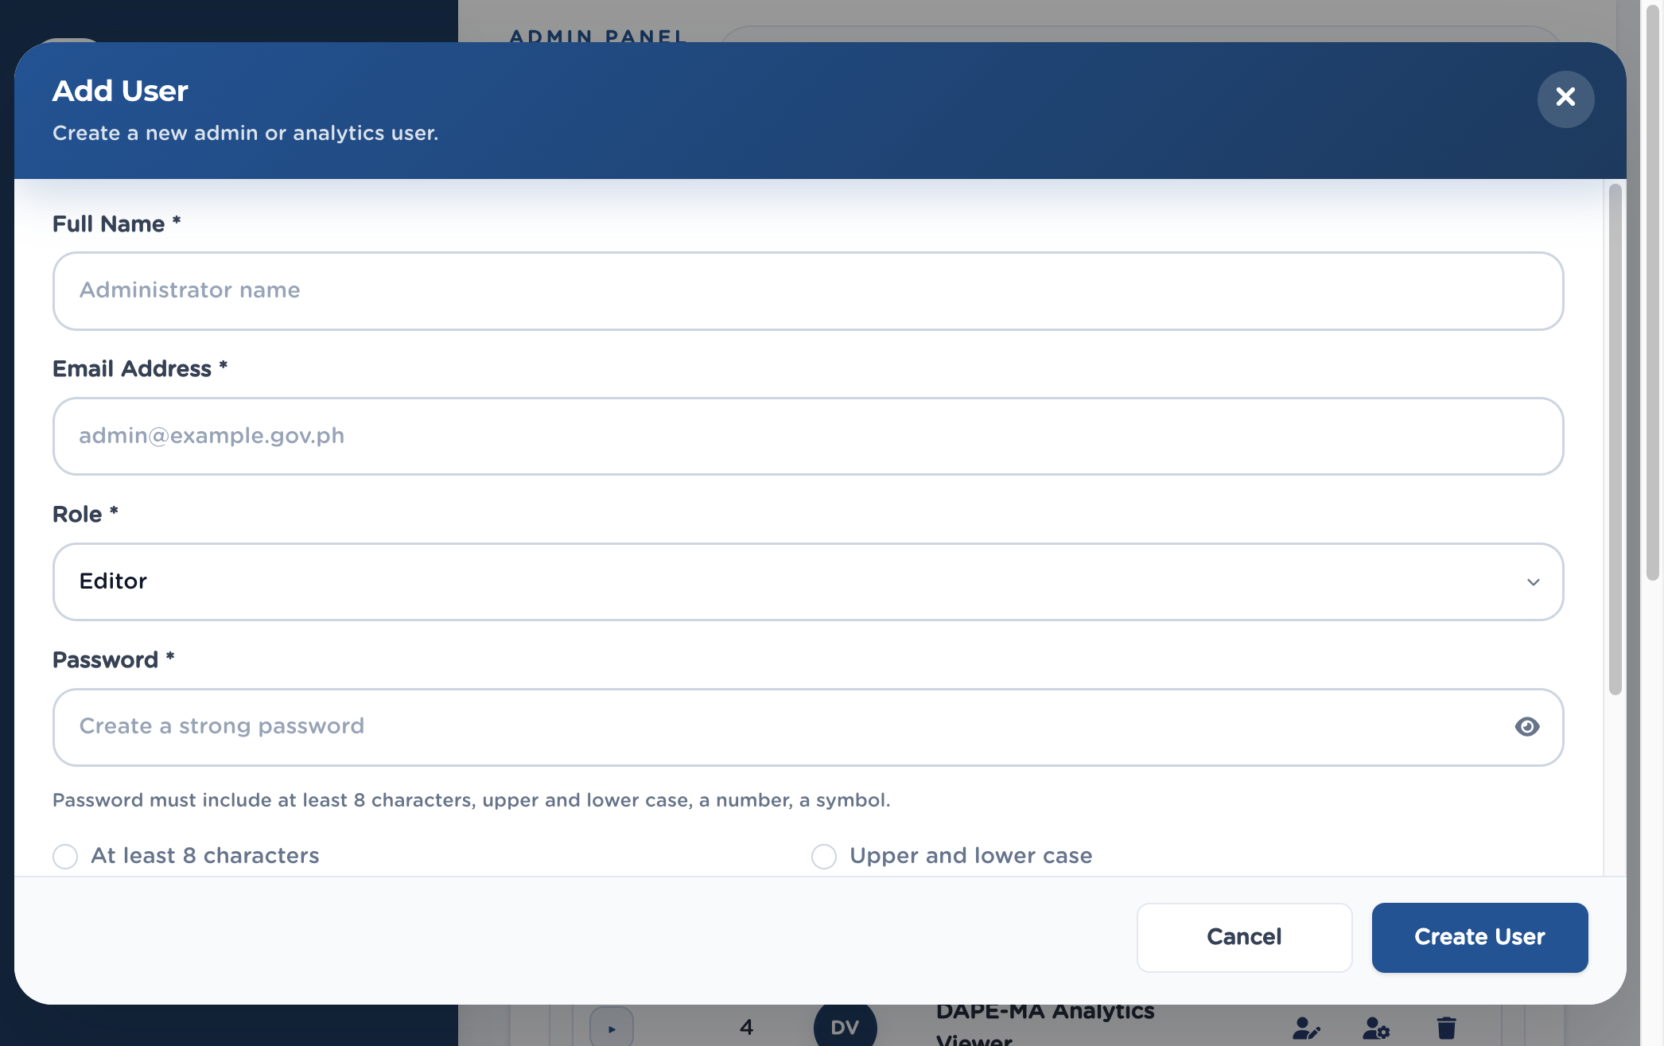
Figure 19. Add User

17.2 Edit, change role, delete
- Edit User — name, email, optional new password (leave blank to keep the current password).
- Change Role — pick Super Admin, Editor, Publisher, Analytics Viewer, or App User.
- Delete User — permanent. You cannot delete your own account.
Important. App User is for mobile accounts listed here, not for staff who need the admin panel.

18. Settings
Left menu: Administration → Settings (/admin/settings).
Legal pages for the mobile Settings screens, plus Kid Listo quotes.
Figure 20. Settings. 1 Terms of Use, 2 Privacy Policy, 3 Privacy Notice, 4 Kid Listo Quotes (below).
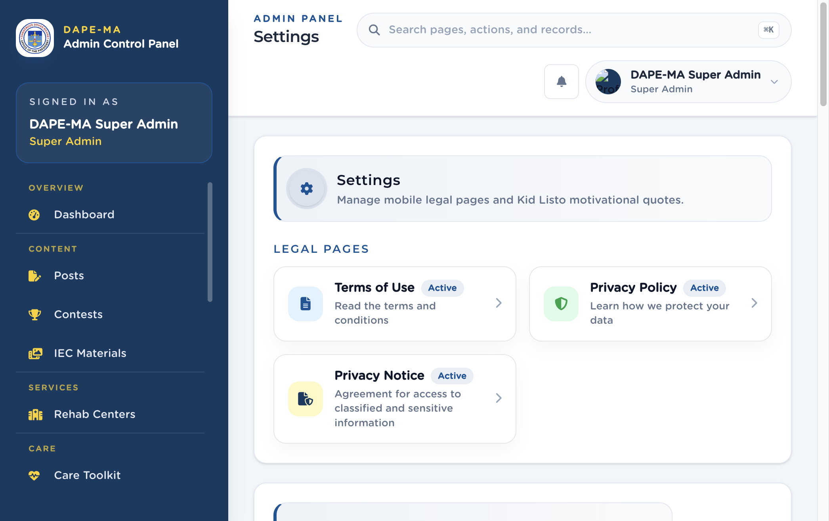
Figure 20. Settings

18.1 Legal pages
- Click Privacy Policy, Terms of Use, or Privacy Notice.
- Edit Title and Subtitle in English and Tagalog.
- Edit Body (English) and Body (Tagalog) in the same rich-text editor used for posts (headings, bold, lists, links).
- Set Active or Hidden.
- Save. Updates appear in the mobile Settings screens.
Important. Body fields are not a plain text box. Numbered lists must show 1, 2, 3 in the editor and in the app.

18.2 Kid Listo quotes
- Click Add Quote.
- Enter the quote in English and Tagalog, optional attribution, and active status.
- Save. Quotes appear randomly on the mobile Kid Listo screen.
Edit or delete from the quotes table Actions.

19. Lookups
Left menu: Administration → Lookups (/admin/lookups).
Option lists used in registration and the journal: pronouns, persona, sky colors, feelings, and what shaped your day.
Figure 21. Lookups. 1 Catalogs, 2 Add option.
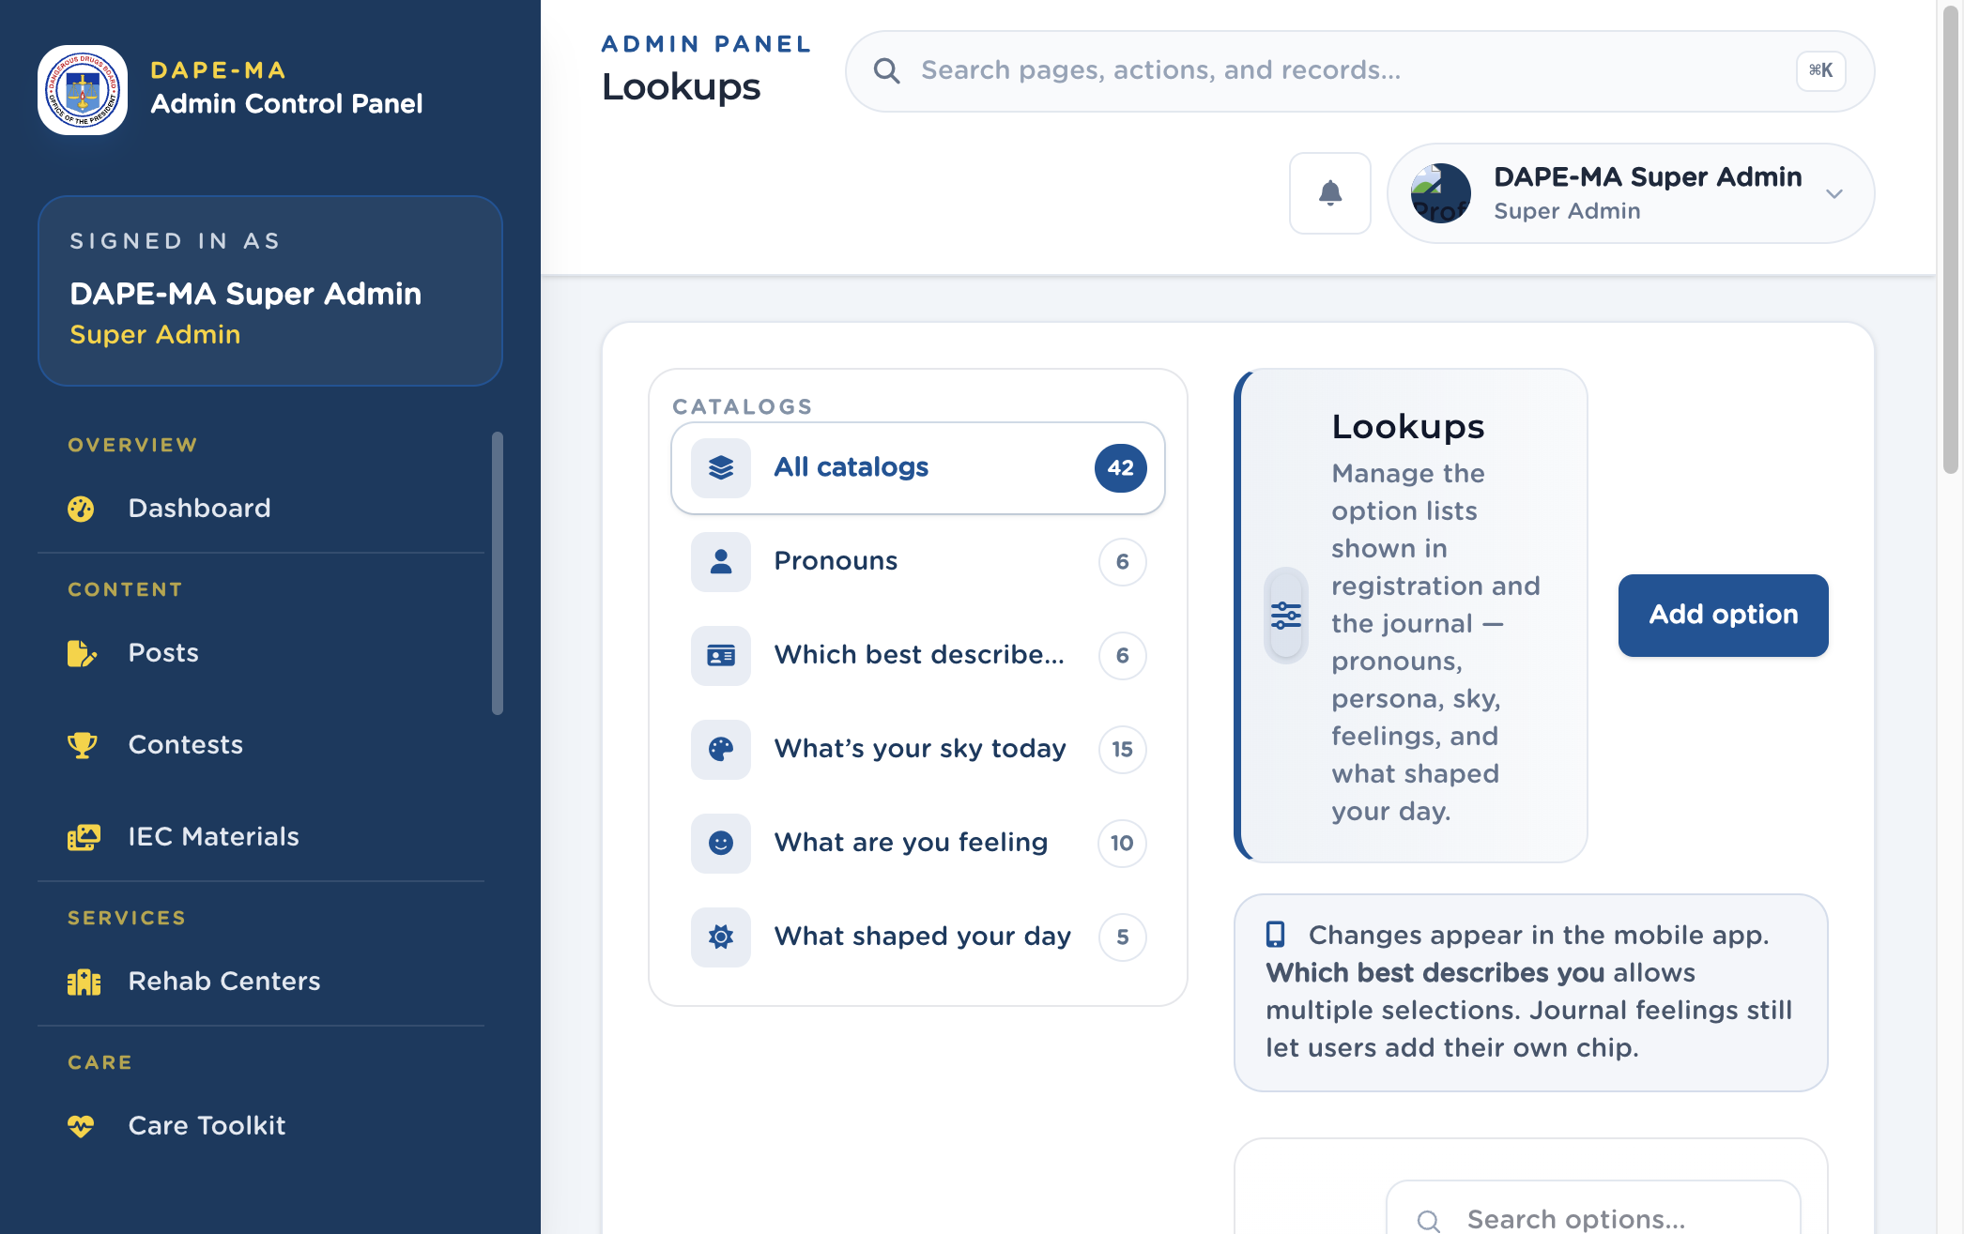
Figure 21. Lookups

19.1 Add or edit an option
- Pick a catalog on the left (or All catalogs).
- Click Add option (or Edit on a row).
- Enter Label (English) and Label (Tagalog).
- Optional subtitle (shown under sky color names in the app).
- Optional Icon — if you set an icon on a sky color (for example Red / sky_red), the mobile journal shows it.
- Accent color is used when a feeling chip is selected.
- Save.
Tip. Unselected feeling chips stay a default color. The accent applies only when the user selects that feeling.

20. App Translations
Left menu: Administration → App Translations (/admin/app-translations).
English and Filipino labels for app chrome (buttons, titles, empty states). This is not where you write post body or Kid Listo quote text.
Figure 22. App Translations. 1 Groups, 2 Add Translation, 3 Key list.
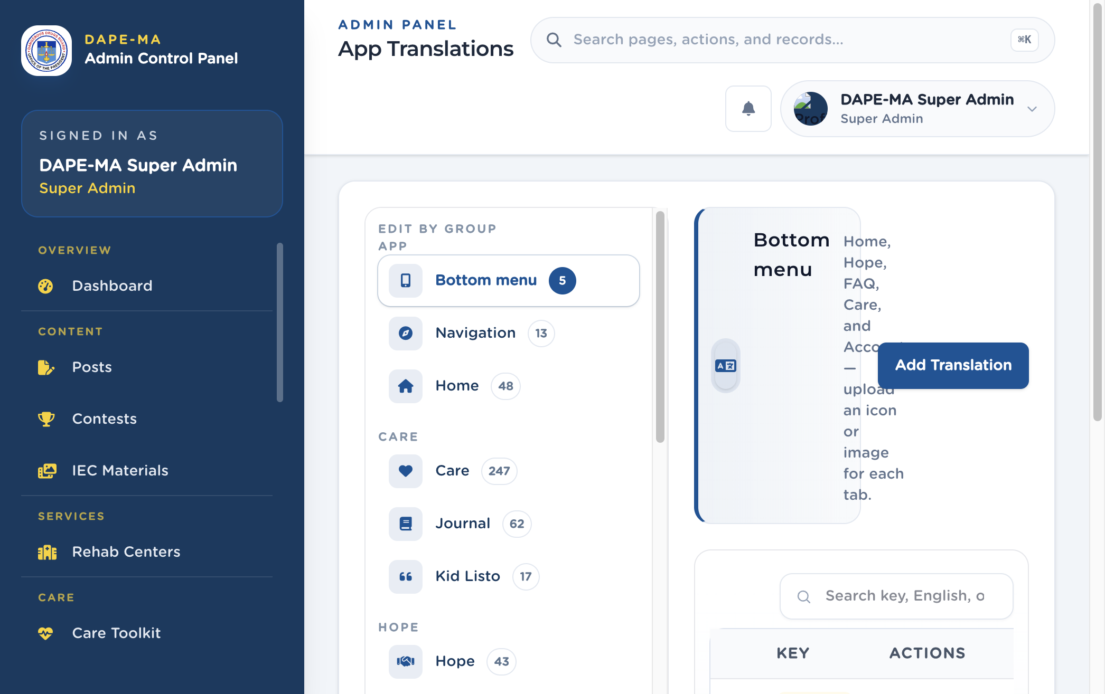
Figure 22. App Translations

20.1 Edit a string
- Click a group (Bottom menu, Navigation, Home, Care, Journal, Hope, and so on).
- Search by key, English, or Filipino.
- Click Edit. Change English and Filipino. The key is locked after create.
- Save. The live app picks up catalog changes on launch, about every 20 seconds, and when the app returns to the foreground.

20.2 Add a translation
Use Add Translation only when a new app label needs a key. The key must match the name used in the app. Do not invent keys for CMS post body.
Bottom menu keys can include an icon or image for each tab.

21. Word Blocking
Left menu: Administration → Word Blocking (/admin/word-blocking).
Words the mobile app replaces with **** in comments, journal notes, profiles, and other user text. Matching is whole-word and case-insensitive. The app syncs this list automatically.
Figure 23. Word Blocking. 1 Status filters, 2 Add word, 3 Word list.
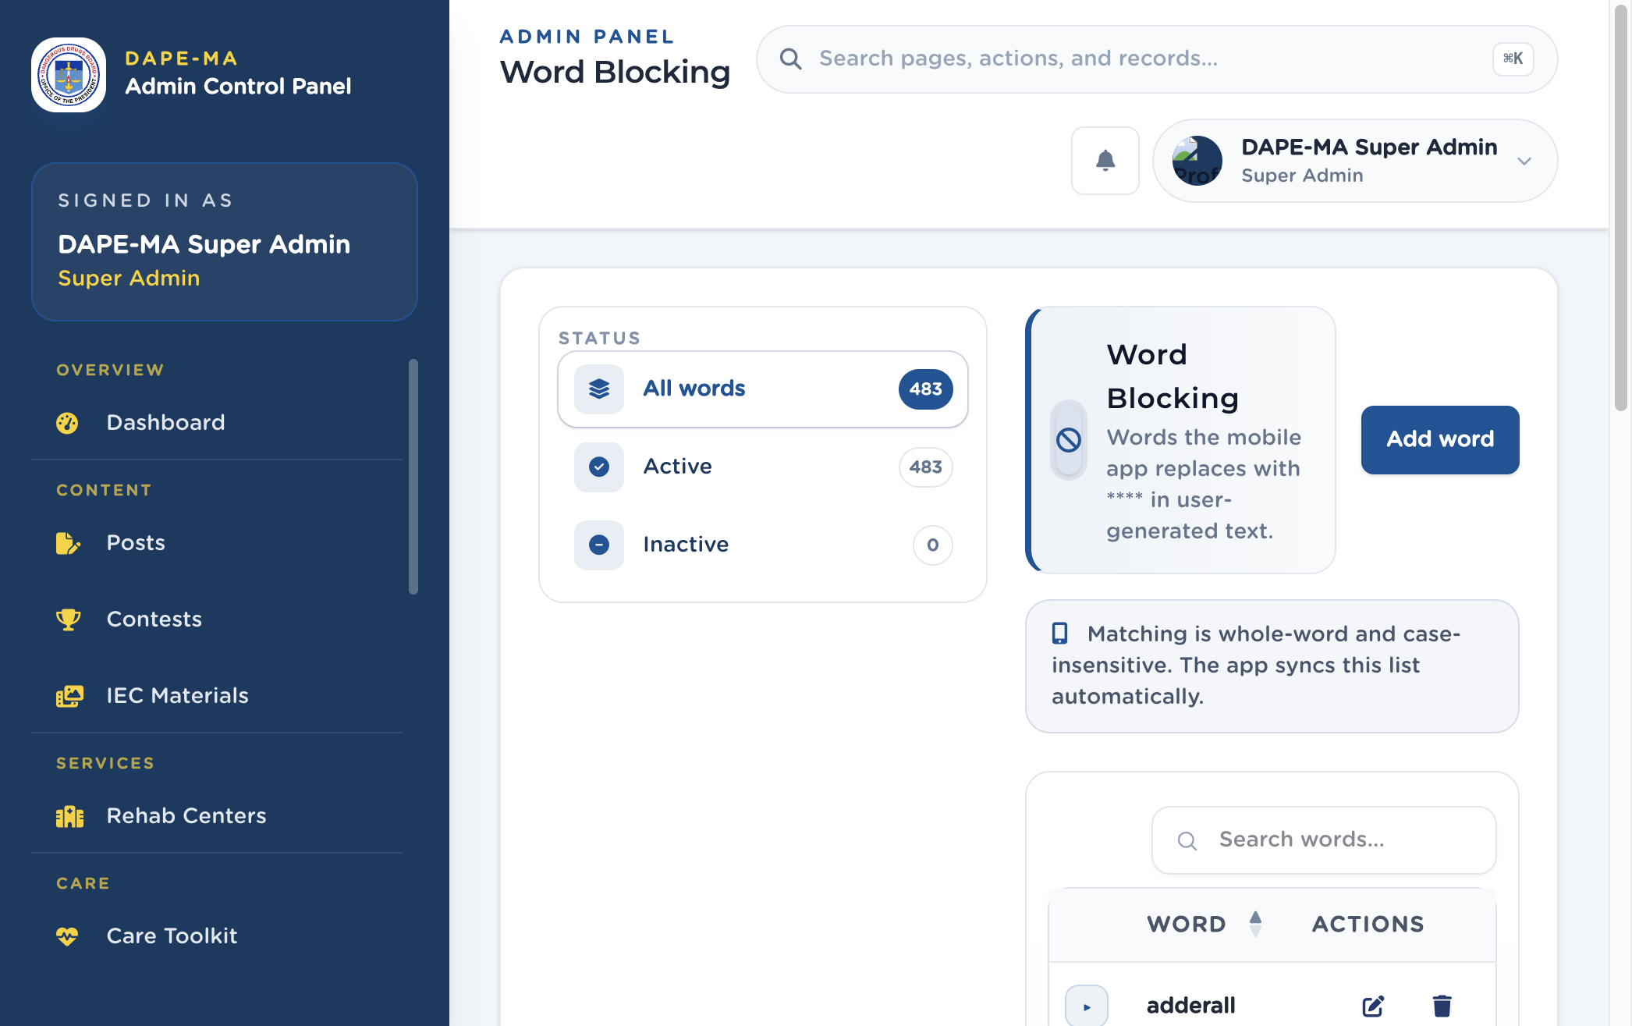
Figure 23. Word Blocking

21.1 Add a blocked word
- Click Add word.
- Type the word (at least 2 characters).
- Set Active or Inactive.
- Save.
Edit or delete from Actions. Inactive words stay in the list but are not applied.

22. Troubleshooting and security

22.1 Troubleshooting
Symptom | What to try
Sign In does nothing / error under the field | Check email spelling. Use Forgot password. Confirm you are on /admin/login.
“You do not have permission” | Your role does not include that menu. Ask a Super Admin.
List is empty | Clear Search. Wait for load. Check filters (All types / All statuses).
Address suggestions do not appear | Type at least 3 letters of a Philippine place. Do not paste a foreign address.
Phone will not save | Use a Philippine mobile or landline. Hotlines may use short codes and `\
Password rejected | 8+ characters, upper and lower case, a number, a symbol. Do not reuse the last 5 passwords. Avoid known leaked passwords.
Forced to change password | An admin set a temporary password, or it expired after 90 days. Set a new one on Edit Profile.
Comment will not delete | Open View on the post → Comments → Delete, then confirm.
Numbered lists look wrong in Body | Use the editor’s Numbered List button. Do not type 1. as plain text only.
App still shows old label | Edit App Translations, not Posts. Wait up to 20 seconds or reopen the app.
Map pin missing on rehab save | Search, pick a suggestion, or tap the map so region and province fill.
Toast error after save | Read the message. Required fields are marked with *.

22.2 Security checklist
- [ ] Super Admin accounts are limited to people who must manage Users and Journal.
- [ ] Staff who only write posts are Editor; content + directories are Publisher.
- [ ] When someone leaves, delete the user the same day.
- [ ] Temporary passwords are unique and force a change on first sign-in.
- [ ] You sign out on shared computers.
- [ ] You do not send passwords by unsecured chat. Prefer a password reset email.
- [ ] Legal pages (Privacy Policy, Terms, Privacy Notice) stay accurate in English and Tagalog.
- [ ] You do not paste secrets, database passwords, or installer credentials into this admin.

23. Quick reference
I want to… | Go to
Sign in | /admin/login
Dashboard | Overview → Dashboard
Create a post | Content → Posts → Create Post
Delete a comment | Posts → View → Comments → Delete
Add a contest | Content → Contests → Add Contest
Add IEC material | Content → IEC Materials → Add IEC Material
Pin a rehab center | Services → Rehab Centers → Add Rehab Center
Edit self-care questions | Care → Care Toolkit → Add Question
Export care results | Care → Care Checks → Export CSV
Update a hotline | Care → Care Support → Add Resource / Edit
Review a journal entry | Care → Journal → View
Add a Hope partner | Hope → Hope Directory → Add Organization
Add a Hope event | Hope → Hope Events → Add Event
Send an inbox alert | Reach → Notifications → Send Notification
Download analytics | Reach → Analytics → Export CSV
Add staff | Administration → Users → Add User
Edit Privacy Policy | Administration → Settings → Privacy Policy
Change a sky color | Administration → Lookups
Change an app button label | Administration → App Translations
Block a word | Administration → Word Blocking → Add word
Edit my photo or password | Account menu → Edit Profile
Sign out | Account menu → Sign Out

End of the DAPE-MA Administrator Manual.

