Cities

**“B”**

-Open and Save Cities and lists of people

-Common between cities

**“A”**

-Merge

-More than 2 cities

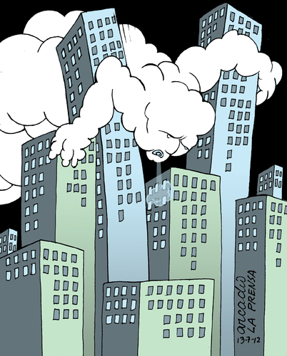

**Menus:**

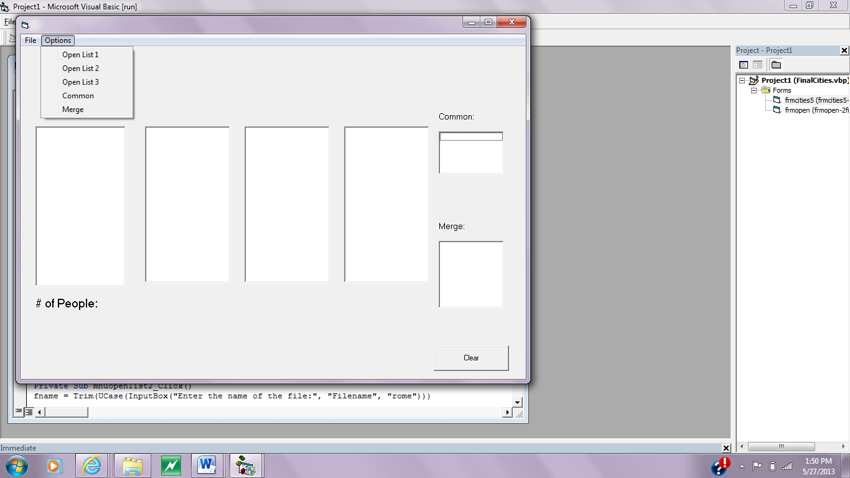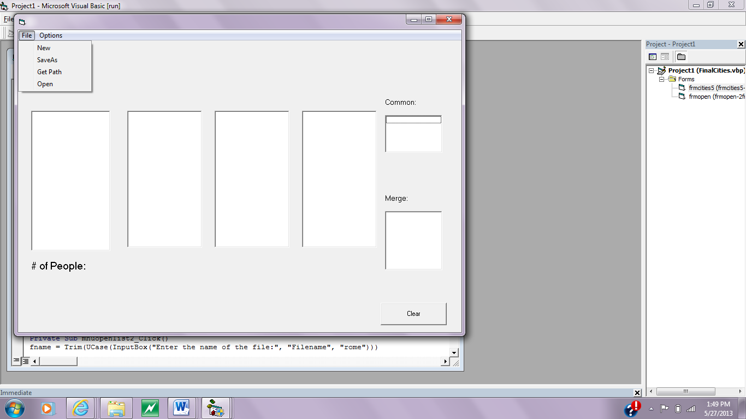

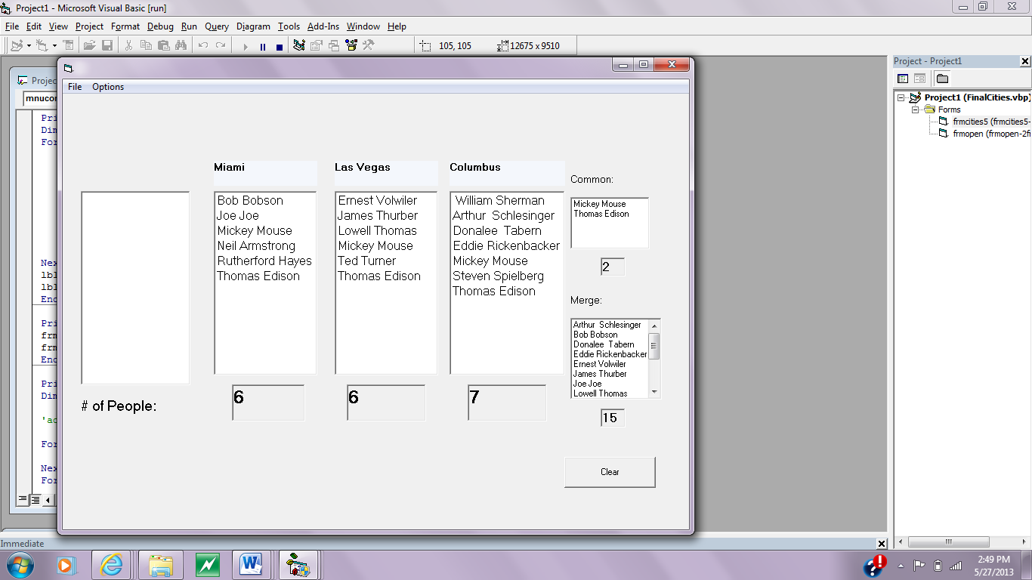**Full Form**