Paint

**“B”**

**\*-Draw in color**

**\*-Declare, Fill, Work with, Save and Retrieve Arrays (.dat files)**

[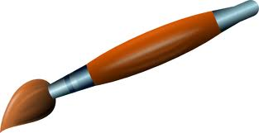](http://www.google.com/url?sa=i&rct=j&q=&esrc=s&frm=1&source=images&cd=&cad=rja&docid=3b1RWAiawQ5EcM&tbnid=KhXJ7iMyrP9tNM:&ved=0CAUQjRw&url=http://qin9.info/paint-brush-clip-art-vector-clip-art-online-royalty-free-3.html&ei=Z92jUafdAcqFyQGzxIG4DQ&psig=AFQjCNFkF9GcyDbuD03KOLaM2zbHQLTUpw&ust=1369779922995386)

**“A”**

**\*-Color Picker**

**\*-3 horizontal scrollbars**

**\*-Save and retrieve in color**

**-*Fix drawlines**

**-*Scrollbar for line size**

**-Draw Shapes**

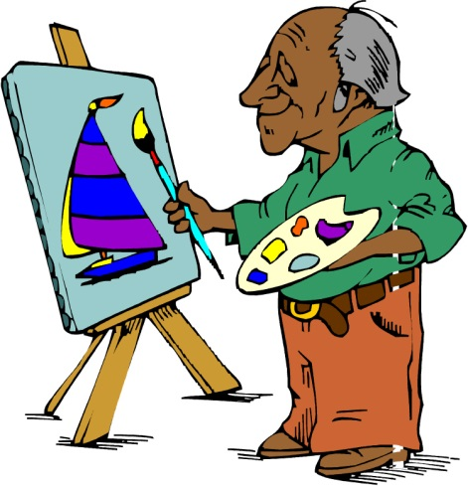

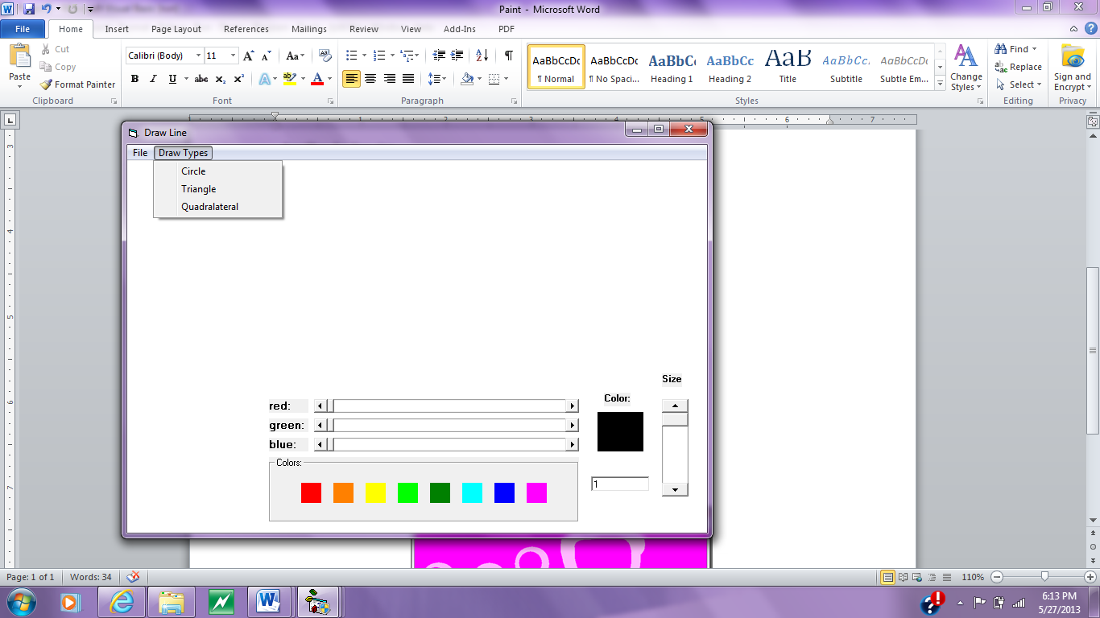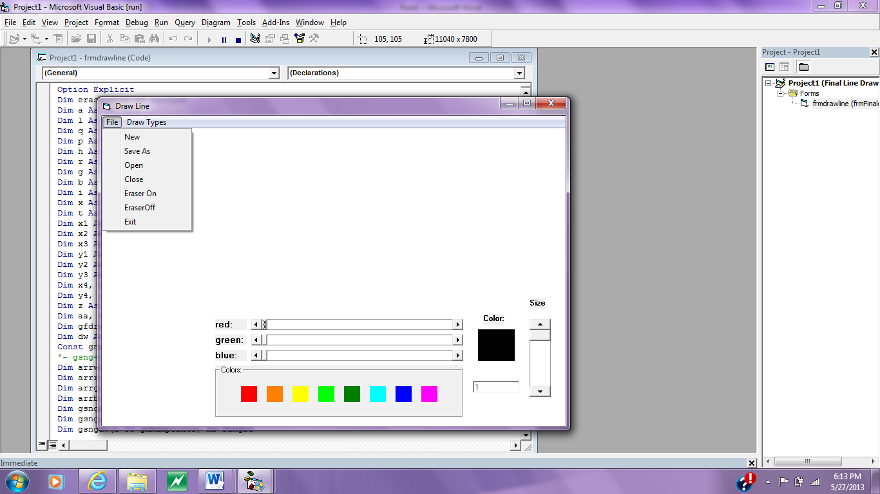Menus:

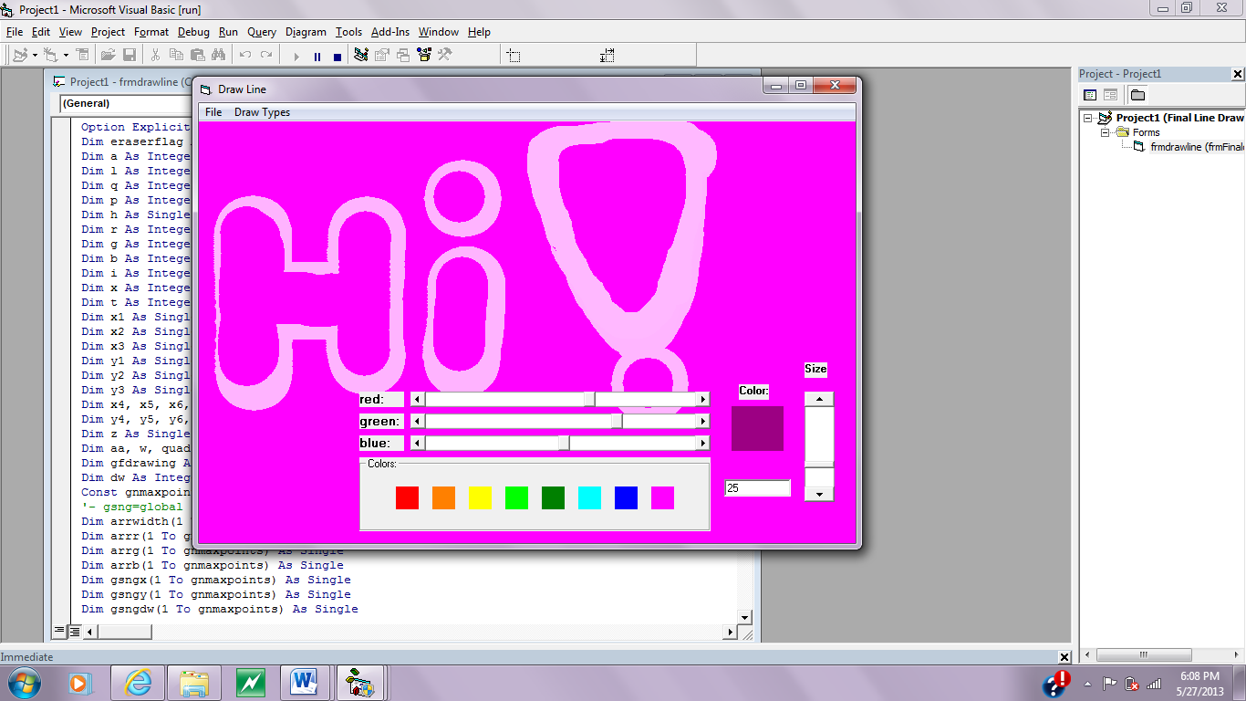Full Form:

Scrollbar for line size

3 horizontal scrollbars